

eRental

Name: Sotan Ioachim
Group: 30236

Table of Contents
Deliverable 1 3
Project Specification 3
Functional Requirements 3
Use Cases Identification 3
Supplementary Specification 5
Non-functional Requirements 5
Design Constraints 5
Glossary 6
Deliverable 2 6
Domain Model 6
Architectural Design 6
Package Design 6
Component and Deployment Diagram 6

​
​
​
​
​
​
​
​
​
​
​
​
​
​
​
​
​
​
​
​
​
​​

​
​
​

Deliverable 1

Project Specification
The eRental is rent a car web app is an online platform that enables users to rent vehicles for a specified period. The platform allows users to search for available cars, compare prices, and make reservations.

Functional Requirements
1. User registration and authentication
2. User profile management
3. Vehicle search functionality
4. Vehicle price comparison
5. User rental
6. Admin vehicle management

Use Case
Model 1

Use Cases Identification
Use Case 1: Register a new user
Level: User Goal
Primary Actor: Unregistered User
Main success scenario:
1. Unregistered User visits the registration page.
2. Unregistered User fills out the registration form with the required information.
3. Unregistered User submits the form.
4. System validates the information and creates a new user account.
5. System sends a confirmation email to the user.

Use Case 2: Authenticate a user

Level: User Goal
Primary Actor: Registered User
Main success scenario:
1. Registered User visits the login page.
2. Registered User enters their username and password.
3. System validates the credentials.
4. System logs the user in and redirects them to their dashboard.

Use Case 3: Vehicle search listing
Level: User Goal
Primary Actor: Registered User
Main success scenario:
1. User is on the dashboard page.
2. User decides on the search criteria.
3. User fills the search bar.
4. System validates the search criteria.
5. System displays the vehicles that match the criteria.

Use Case 4: Vehicle price comparison
Level: User Goal
Primary Actor: Register User
Main success scenario:
1. User visits the vehicle listing dashboard.
2. User selects the order by price listing.
3. System sorts the vehicles by price.
4. System display the sorted vehicles.

Use Case 5: User rental
Level: User Goal
Primary Actor: User
Main success scenario:
1. User visits the vehicle listing page.
2. User selects the desired vehicle.
3. User places a rental.
4. System validates the rental.
5. System sends confirmation email to the user.

Use Case 6: Admin vehicle management
Level: Admin Goal
Primary Actor: Registered Admin
Main success scenario:
1. Admin visits the listing vehicle page.
2. Admin selects add/delete vehicle option on the admin dashboard.
3. Admin adds details of the new vehicle or updates an existing vehicle.
4. System registers the saved changes.

UML Use Case Diagrams
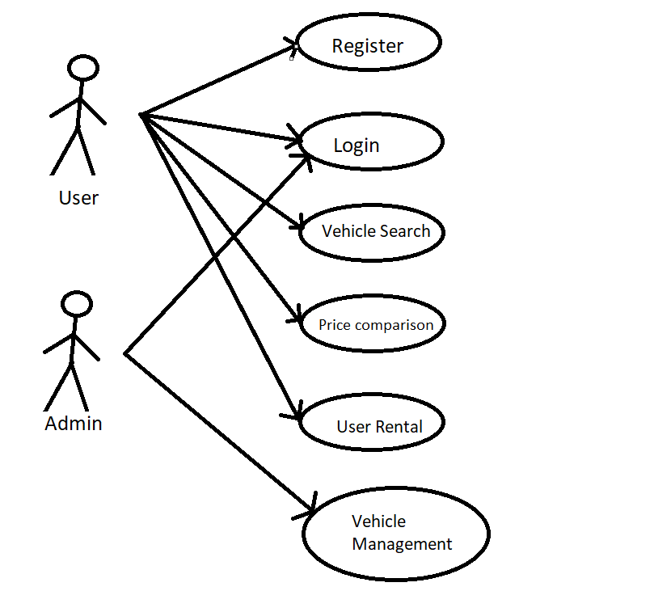

Supplementary Specification

Non-functional Requirements
- Usability: The application should have an intuitive user interface, making it easy for users to navigate and find the information they need.
- Scalability: The system should be able to handle a growing number of users and vehicle listed without significant performance degradation.
- Security: User data must be protected, and sensitive information like passwords should be securely stored using encryption and hashing techniques.
- Responsiveness: The application should provide quick response times and load times, ensuring a smooth user experience.

Design Constraints
- The project must be developed using C# and .Net Core as the back-end framework.
- Front-end development should use a modern JavaScript framework (e.g., React, Angular, or Vue.js).
- The database should be designed using a relational database management system (e.g., PostgreSQL, MySQL, or SQL Server).
- The application should follow a RESTful API design.
- Code should adhere to best practices, including proper documentation and testing.

Glossary
- Rental Seeker: A user who is looking for a vehicle to rent and applies for a rental service on the platform.
- Rental: A record of a Rental Seeker requesting a specific vehicle, including information such as the user, the vehicle, and rental duration.
- Authentication - The process of verifying a user's identity by checking their entered credentials (username and password) against the stored user information.

Deliverable 2

Domain Model
The domain model for this app would represent the various entities, attributes, and relationships involved in the rental process. The app has the following entities:

- Customer: Represents the people who rent cars from the app. Attributes might include customer ID, name, address, phone number, email address, and payment information.
- Vehicle: Represents the vehicles available for rent through the app. Attributes might include car ID, make, model, year, color, number of seats, and rental rate.
- Rental: Represents a rental transaction between a customer and a car. Attributes might include rental ID, start date, end date, total cost, and rental status.

And the following are the main relations between the above entities:

- A customer can rent multiple cars, and a car can be rented by multiple customers.
- A rental involves one customer and one car.
- A rental takes place at one rental location, and a location can have multiple rentals.
- A reservation involves one customer, one car, and one rental location.
- A payment is associated with one rental transaction and one customer.
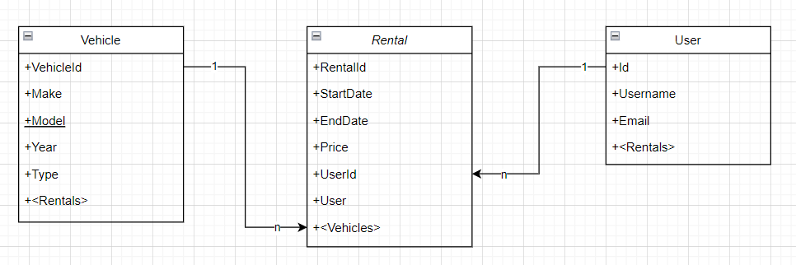

Architectural Design
Conceptual Architecture
Architecture Style:
The architectural style used in this application is a three-tier architecture that separates the application into three main layers: Model, View, and Controller.

Presentation Layer:
The presentation layer is responsible for handling the user interface of the application. It consists of a web-based interface that allows users to interact with the application. This layer will be developed using ASP.NET Core MVC, which provides a robust framework for building web-based user interfaces. The presentation layer will also use Blazar and Razor files to create an interactive and responsive interface for the users.

Business Layer:
The business layer is responsible for handling the business logic of the application. It consists of various classes that perform operations on the data layer and provide services to the presentation layer. This layer will be developed using C# and will use Entity Framework Core to communicate with the data layer.

Data Layer:
The data layer is responsible for handling the storage and retrieval of data for the application. It consists of a database that stores all the data related to the application. This layer will be developed using SQL Server and will use Entity Framework Core to interact with the database.

Overall, this architecture will provide a scalable, secure, and reliable platform for users to rent cars and manage their rental transactions.

Package Design
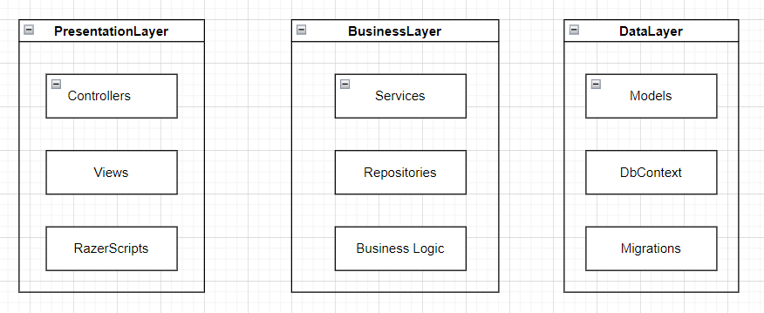

Component and Deployment Diagram

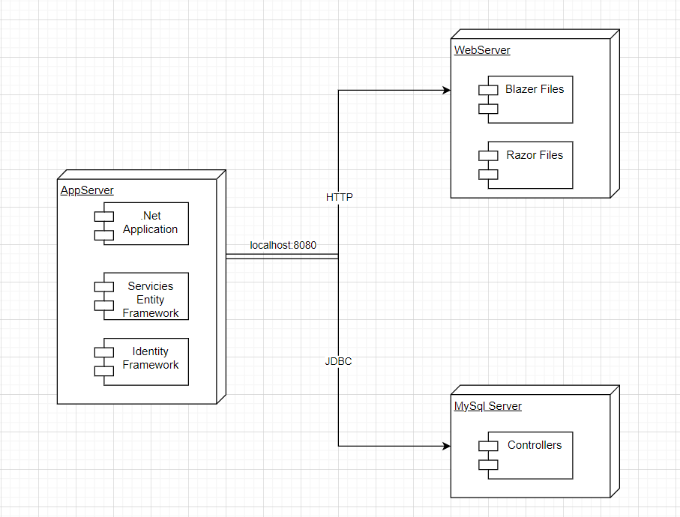

Deliverable 3

Design Model

Dynamic Behavior
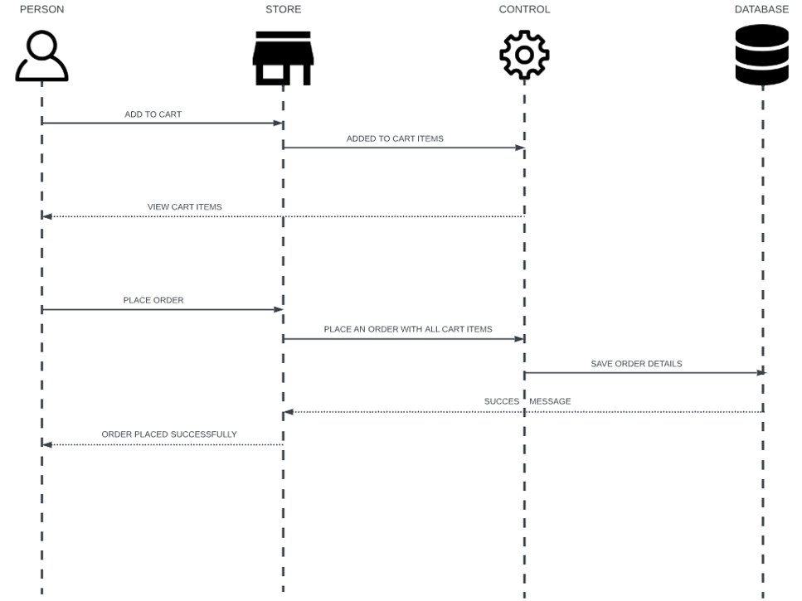

Class Diagram
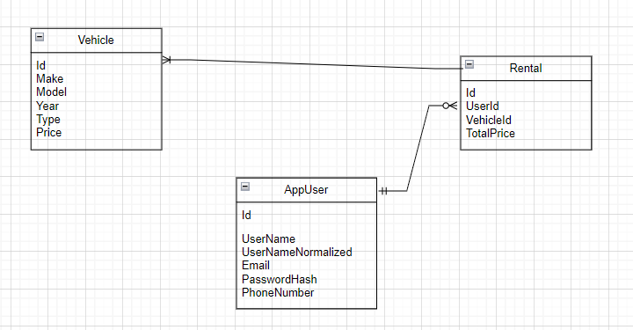

Data Model
Entities:
- User - represent users who access the web site in order to rent a car.
- Id
- Username
- UserNameNormalized
- Email
- PasswordHash
- PhoneNumber
- Vehicle - represent the vehicles available for rental.
- Id
- Make
- Model
- Year
- Type
- Price
- Rental - represents a rental detail table between a user and a vehicle.
- RentalId
- UserId
- VehicleId
- TotalPrice

System Testing
Unit Testing is a type of software testing where individual units or components of a software are tested. The purpose is to validate that each unit of the software code performs as expected. Unit Testing is done during the development (coding phase) of an application by the developers. Unit Tests isolate a section of code and verify its correctness. A unit may be an individual function, method, procedure, module, or object.

Future Improvements
Here are some potential future improvements for a web application that has product, order, and user functionality:

- Implement Payment System: Enable users to finalize the rental process by integrating a payment system. This will allow users to make payments for the rented vehicle securely and efficiently.
- Add Real-Time Availability: Provide real-time availability status for each vehicle. Update the availability status as soon as a vehicle is rented or returned, giving users accurate information about vehicle availability.
- User Ratings and Reviews: Introduce a rating and review system where users can provide feedback and rate their rental experience. This will help other users make informed decisions and improve overall user satisfaction.
- Implement Notifications: Set up notifications to inform users about the status of their rental requests, reminders for upcoming rentals, and important updates related to the application. This will enhance communication and keep users engaged.
- Integrate Mapping and Navigation: Include mapping and navigation functionalities to help users locate rental vehicles easily. This can be accomplished by integrating APIs like Google Maps to provide directions and distance calculations.
- Offer Multiple Rental Options: Expand the rental options by introducing different rental durations (e.g., hourly, daily, weekly) to cater to varying user needs. This will provide users with more flexibility and increase the usability of the application.
- Enhance Admin Dashboard: Improve the admin dashboard with additional features such as analytics, visualizations, and insights about the rental activity. This will help administrators make data-driven decisions and monitor the overall performance of the application.
- Mobile-Friendly Interface: Optimize the web application for mobile devices by implementing a responsive design. This will ensure that users can access and use the application seamlessly on smartphones and tablets, expanding the reach and usability of the platform.

Conclusion

In conclusion, my web application successfully provides user and admin functionalities for vehicle rentals. I have implemented the core features such as user account creation, vehicle listing, and the ability to rent vehicles. However, there are several future improvements that I plan to implement to enhance the application and provide a better user experience.

To run the client side of the application, I utilize SQL Server and Razor files. SQL Server serves as the database management system, allowing efficient storage and retrieval of data related to user accounts, vehicle listings, and rental records. With SQL Server, I can ensure data integrity and optimize queries for seamless performance. Additionally, Razor files play a crucial role in generating dynamic HTML content and integrating it with C# code, enabling me to create interactive and responsive user interfaces. By leveraging the power of SQL Server and Razor files, I can provide a robust and user-friendly client-side experience in my application.

To further enhance the application, I plan to implement a payment system, real-time availability updates, user ratings and reviews, notifications, mapping and navigation features, multiple rental options, an enhanced admin dashboard, and a mobile-friendly interface. These improvements will enhance functionality, user satisfaction, and overall usability. By incorporating these enhancements, my web application will offer a seamless and efficient vehicle rental experience for users.

Bibliography

https://docs.microsoft.com/en-us/aspnet/web-forms/
https://www.pluralsight.com/courses/aspnet-core-building-web-applications
https://www.udemy.com/course/the-complete-aspnet-mvc-5-course/

https://www.youtube.com/playlist?list=PL4cUxeGkcC9gmaC6yjd1vMhn-5bya5cc4

https://www.csharp-station.com/tutorial.aspx

https://www.codecademy.com/learn/learn-c-sharp

