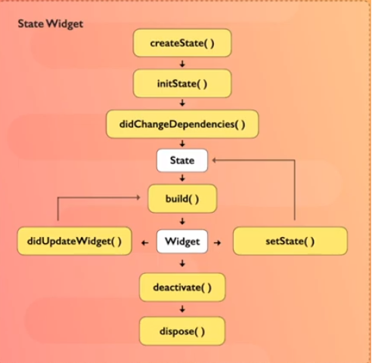
Não mostra seta de retorno
AppBar(
automaticallyImplyLeading: false,
);

Buscar CEP
% flutter pub add search_cep
% flutter pub add postmon

import 'package:search_cep/search_cep.dart';

https://pub.dev/packages/brasil_fields

Deixar de encontrar os imports:
flutter clean
flutter packages get
flutter packages upgrade Optional- use if you want to upgrade packages)
Restart Android Studio or Visual Studio

> flutter gen-l10n

> flutter pub run flutter_launcher_icons:main
> flutter pub run flutter_native_splash:create

> dart pub upgrade

> flutter pub add sqflite

> flutter pub get → Resolve dependências

INVALID DEPFILE: FLUTTER-FLUTTER
> flutter clean
> flutter pub get

> flutter emulators
> flutter emulators --launch <emulator id>

> flutter create --org br.com.teste teste
> flutter create --project-name teste --platforms=android,ios ./teste

Path → C:\Program Files (x86)\Android\android-sdk

MÉTODO EM ARQUIVO EXTERNO:
https://www.digitalocean.com/community/tutorials/flutter-widget-communication

pub.dev

Curso: https://www.youtube.com/@drantunes

https://www.kindacode.com/article/flutter-sqlite/

sqLite https://www.youtube.com/watch?v=Sml_GeBfGlY

https://www.tutorjoes.in/flutter_framework_tutorial/CRUD_operation_using_Flutter_and_SQLite_in_flutter

Criar tela: https://app.flutterflow.io/project/tutorial-ptadaj

Aula 15 https://www.youtube.com/watch?v=mkqofr1-Wy0&list=PL5EmR7zuTn_aX0pG4oWTyKKQT25Hkq2XG&index=19

CRUD https://www.youtube.com/watch?v=ViahqKZzZ7Y&t=3901s

MaterialApp Scaffold https://www.macoratti.net/19/07/flut_scaffd1.htm

Lista (e outros) https://codepen.io/rubensdemelo/pen/QWjJBJG

https://app.dbdesigner.net/designer/schema/595227

Códigos
https://dartpad.dartlang.org/?
https://www.jdoodle.com/online-java-compiler/
https://sqlite.org/fiddle/index.html

Como começar https://www.youtube.com/watch?v=cQbWd2tnfdc&t=28s

Gravações free
Obs Studio <== Camera LogiTech 920
ydai.pro

Trocar nome da aplicação, splash e ícone

Nome da aplicação
Em android/app/src/main/AndroidManifest.xml trocar o nome em android:label

<manifest xmlns:android="http://schemas.android.com/apk/res/android"
package="br.com.t2tecnologia.garage_plus">
<application
android:label="Garage+"

Em ios/Runner/Info.plist trocar o nome em CFBundleName

<plist version="1.0">
<dict>
...
<string>6.0</string>
<key>CFBundleName</key>
<string>Garage+</string>
<key>CFBundlePackageType</key>
Splash e ícone:

Em pubspec.yaml adicionar os packages

dependencies:
flutter:
sdk: flutter
http: any
intl: any
flutter_native_splash: ^2.2.19
flutter_launcher_icons: any #^0.9.1

cupertino_icons: ^1.0.2

flutter_native_splash:
color: "#3F51B5"
image: "assets/app/splash.png"
android: true
ios: true
flutter_icons:
image_path: "assets/app/icon_ios.png"
ios: true
remove_alpha_ios: true
android: "launcher_icon"
adaptive_icon_background: "#FFFFFF"
adaptive_icon_foreground: "assets/app/icon_android.png"

Salvar.

Se a IDE não rodou flutter pub get, rodar no terminal.

Rodar no terminal:
flutter pub run flutter_native_splash:create
e
flutter pub run flutter_launcher_icons:main

O ícone Android precisa ter fundo transparente, o ios não pode ter fundo transparente.
remove_alpha_ios: true remove a transparência no ios se por acaso o ícone tiver fundo transparente

List<Author> authors = [ Author( name: 'J.K. Rowling', books: [ Book(title: 'Harry Potter and the Philosopher\'s Stone', genre: 'Fantasy'), ],
),
Author(
name: 'Agatha Christie',
books: [
Book(title: 'Murder on the Orient Express', genre: 'Mystery'),
Book(title: 'Death on the Nile', genre: 'Mystery'),
],
),
];

ListView.builder(
itemCount: authors.length,
itemBuilder: (BuildContext context, int index) {
return ListTile(
title: Text(authors[index].name),
subtitle: Column(
crossAxisAlignment: CrossAxisAlignment.start,
children: authors[index].books.map((book) {
return Text('${book.title} - ${book.genre}');
}).toList(),
),
);
},
);

