Daily Questions : 25/2/2026

1. https://datalemur.com/questions/sql-histogram-tweets

Solution :

with c1 as (
SELECT user_id, count(tweet_id) as tweet_bucket
FROM tweets
where EXTRACT(year from tweet_date) = 2022
group by user_id
)
select tweet_bucket , count(user_id) as users_num
from c1
group by tweet_bucket;

2. https://datalemur.com/questions/two-consecutive-sixes
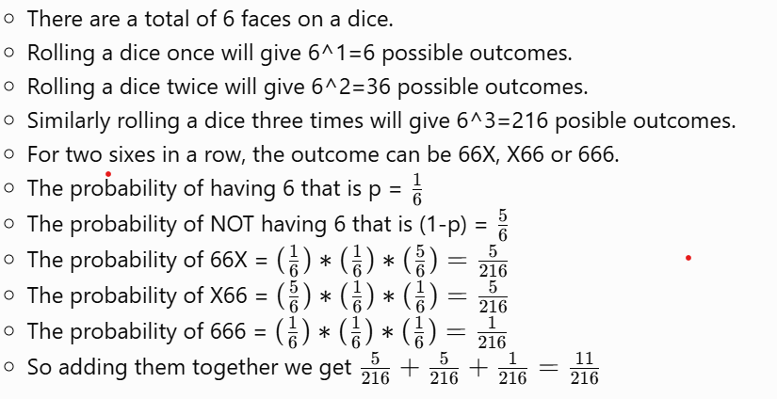

3. https://datalemur.com/questions/coin-fairness-test
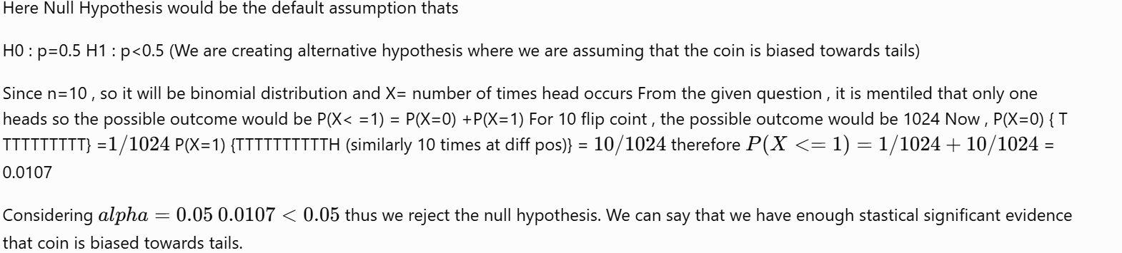

4. https://datalemur.com/questions/precision-recall-tradeoff
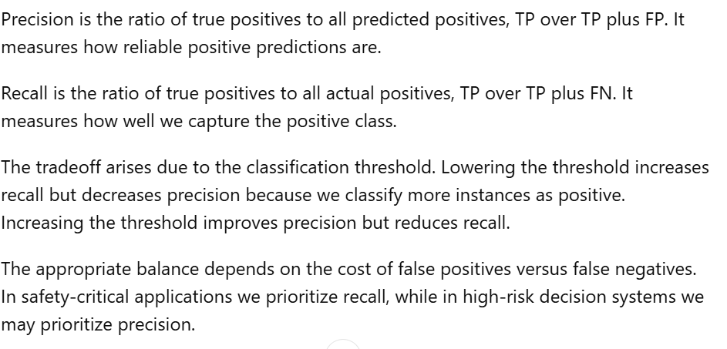

5. https://www.deep-ml.com/problems/137

