GIT :Version control system

The git is a distributed version control and scource code management system.

Installation

The installation of git is easy .
Just Log on to the terminal as root and type in
apt-get install git

Small setup
Adding user name to git

git config --global user.name "username"
git config --global user.email "emailid"
Usage

The usage of git is as simple as using any other command line tool.

It all starts with

git init

This command initializes the git repository in the current folder.
(It creates a .git folder in the current folder)

Now let's see what the git is doing ie see its status
to do that we will have to give

git status

This gives the output about what git has done something like this

# On branch master
#
# Initial commit
#
nothing to commit (create/copy files and use "git add" to track)

Because we have done nothing we have nothing to commit and also notice that you are on the branch master

So two new terms
- commit: This is a state of the git where all the changes are saved.Its like a snapshot of the work that you have done. So in future you can come back to that commit state and revert the changes that you dont want to use.
- Branch: The branch is the a copy of the project. By default the main copy is called master.
So we can create new branches, merge two branches etc.

And git generally gives hints what would be the next logical step like in the above step it tells you to use “git add ” . You can ask for help using -h option for ex to know about options of status type in “git status -h”.

To know all the options available with git type in “git”.The output would be

usage: git [--version] [--exec-path[=<path>]] [--html-path] [--man-path] [--info-path]
[-p|--paginate|--no-pager] [--no-replace-objects] [--bare]
[--git-dir=<path>] [--work-tree=<path>] [--namespace=<name>]
[-c name=value] [--help]
<command> [<args>]

The most commonly used git commands are:
add Add file contents to the index
bisect Find by binary search the change that introduced a bug
branch List, create, or delete branches
checkout Checkout a branch or paths to the working tree
clone Clone a repository into a new directory
commit Record changes to the repository
diff Show changes between commits, commit and working tree, etc
fetch Download objects and refs from another repository
grep Print lines matching a pattern
init Create an empty git repository or reinitialize an existing one
log Show commit logs
merge Join two or more development histories together
mv Move or rename a file, a directory, or a symlink
pull Fetch from and merge with another repository or a local branch
push Update remote refs along with associated objects
rebase Forward-port local commits to the updated upstream head
reset Reset current HEAD to the specified state
rm Remove files from the working tree and from the index
show Show various types of objects
status Show the working tree status
tag Create, list, delete or verify a tag object signed with GPG

GIT: add, commit.

The git after initiation does not track changes. To inform git to keep track of changes type in

git add <filename>

this will track changes that happen to the file . The changes can be seen by typing

git diff

and to check which files have been modified use status.
To create a commit you will have to give

git commit -m “commit message”

The files whose changes have to be stored will have to be added before commit. Or instead you can directly type in

git commit -am “commit message”

This adds and commits at the same time.

Git color notation
This small setting in git will help in differentiating things. When enabled the git output in colored form. To get this type in

git config color.ui true

After commiting if we make any changes and if you want to see the changes you have made type in

git show
It also shows the last commit along with the changes that you made after commit.
Now lets say that we made few changes to few files and have not commited and we dont want the changes that we have not commited. To do that type in

git checkout <file name>

Log, Reflog

Now lets check the work we have done. So to check the work that we did type in

git log

this shows the detailed log of the commits made.
For a shorter version use

git reflog

The logs can also be seen in a gui application before that we will have to install the application to do that type in :

apt-get install gitk

After installation got to the git initialization folder ie project folder and type in

gitk

This shows the logs in a GUI

Going back

The going back is done by using reset. For this we need the reference log and the command is

git reset --hard <reference flag>

The Git Flow

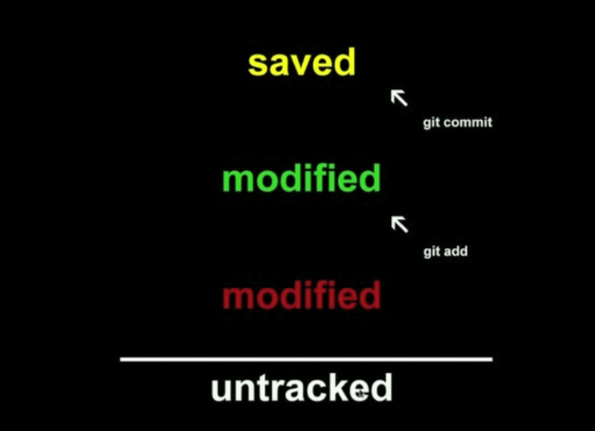
Commited
After commits
Staged
Both file and changes
are addeds
Unstaged
The file is tracked but the
Changes are not added
Untracked
The file is not tracked

The state of a file in git is described in the image above

untracked: This is a file that the git does not track so git is not concerned with the file

unstaged : The file is tracked but the changes are not added to commit so the changes are not commited (Changed but not updated)

staged: The file is tracked an changes are also added and are ready to be commited

Saved: The file and its changes are saved (committed)

The state of the file can be seen by using status.of git and color ui must be enabled.

The undo in git

To move a file from staged to unstaged type in

git reset HEAD <filename>

to ignore (untrack )a file in the current directory first create a file names .gitignore and add the file name to the file one line at a time.

To untrack a file that is already added file use

git rm –-cached <filename>

The servers

The files till now works on one local system. But now if you want to work with multiple people you will have to put it on an other server where other people can access it.

So to give your project multiple access you should have ssh installed on the system and the ssh keys of the people whom you want to give access should be added to the file authorized_keys in .ssh folder in homefolder of the user.

In the GUI systems like github or gitlabs you can add your ssh keys directly in the options

And to add remote repository to your local system use

git remote add [-t <branch>] [-m <master>] [-f] [--mirror=<fetch|push>] <name> <url>

for example:

git remote add origin git@github.com:user1/test2.git

From here the repository is in github.com with username user1 the project test2 the url “git@github.com:user1/test2.git” is generally given by the git hub.

Now the server is setup, ready and multiple users can directly work on the server.
To start working on the code the other user will have to clone the current repository by

git clone <url>

This clones the current repository into the current folder
Here we can make changes commits and all
and then upload it to the server by (watch for error “rejected”)

git push <branch generally “origin master”>

This generally goes to server if there were no changes. But if there are changes you will have to first pull the code first. Then if there are any changes in the code that have been done by someone else there wil be conflicts These have to be resolved . The changes can be located using the mergetool. To use this type in .

git mergetool

Then after locating the cahnges you will have to first talk to your team about the changes that are to be retained or removed. And finally commit.

Or else you can directly open the conflict files and edit them and then push it.

Branching

The branching of code is creating a new copy of the code and work on different branches on different features and then merge them. This features is used to specify versions sometimes.

So to list all your branches type in

git branch -a

This by default displays the all the branches on the server(red) and on your local system(green). And * indicates which branch you are on
So now to create a new branch on your local system type in

git checkout -b <branch name>

This creates a new branch and shifts us to there. To shift from one branch to another usr

git checkout <branch name>

and when ever we type in status the it shows the branch you are in and other details. When you edit the file with a text editor in the same command line then the editor shows only the text in concerned branch. When we push we will have to specify the branch name which we want to push to. When we push the new branch it is automatically created.

Merging branches

Now to combine two branches switch to the main branch(master) and type in

git merge <the other branch name>

and to delete the old branch type in

git branch -d <old branch name>

This deletes the branch only on local system and if you want to delete it from the main server type in

git push origin :<old branch name>

References

http://git-scm.com/book

youtube playlist

http://www.youtube.com/watch?v=vaNGbk6HN9Y
http://www.youtube.com/watch?v=DQUcmNO4diQ
http://www.youtube.com/watch?v=Y7qPI9Nx3nc
http://www.youtube.com/watch?v=3nSoTC3GHn8
http://www.youtube.com/watch?v=7RrP9kbHFnc
http://www.youtube.com/watch?v=4De86_igTTk
http://www.youtube.com/watch?v=nUuOitvzFrQ
http://www.youtube.com/watch?v=MQ9Yv8csyMU

