**SPRINTS**

SPRINT 1

1.Admin Module

The backend of the store will make the task of managing store, processing orders and keeping customers up to date, as efficient as possible. To access the backend we’ll log into the store by clicking on login. This is the same login screen for admin and would use it. Clicking on “Sign In” the admin can login.

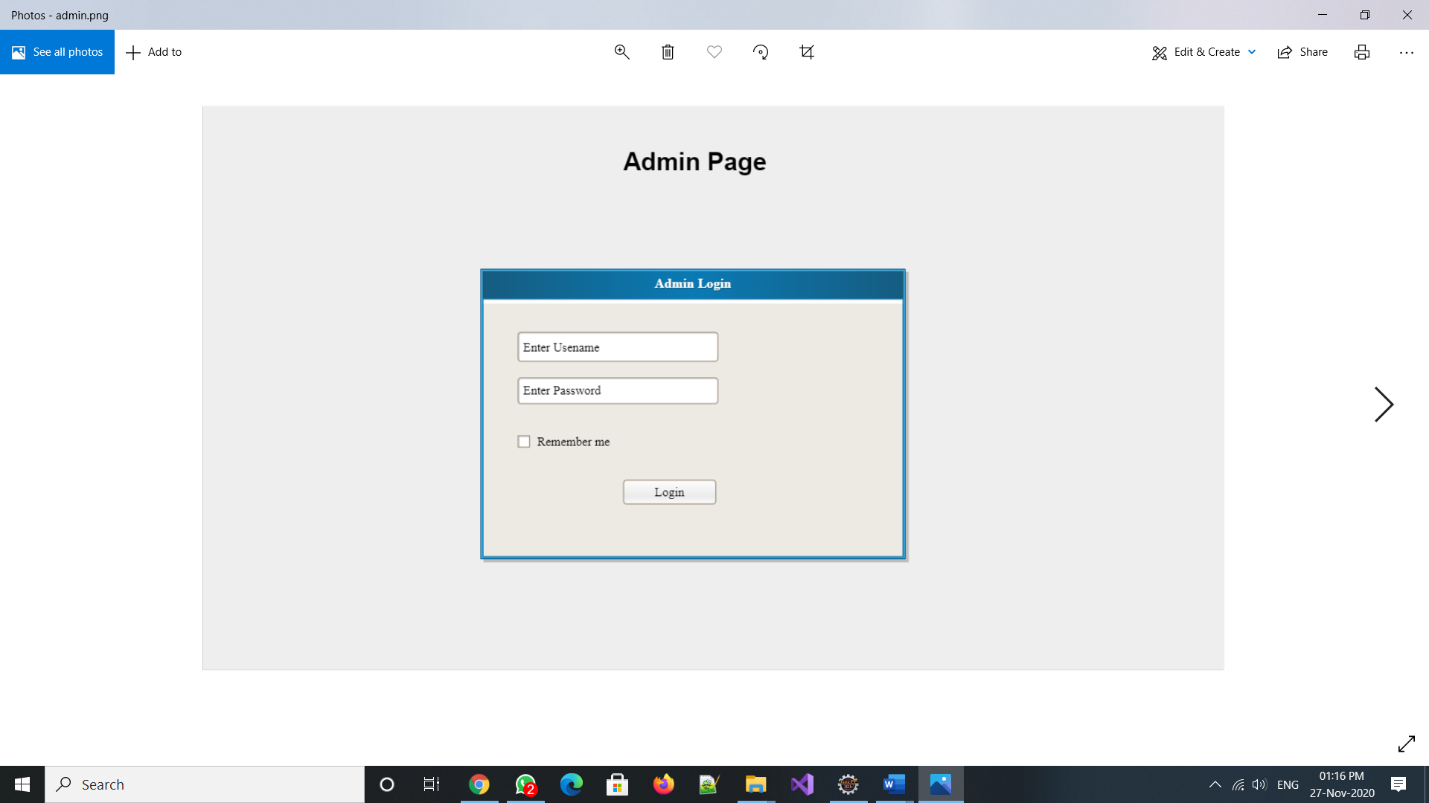

Once logged into the administration backend you will see a screen similar to the below image. From here we’ll be able to further manage the store settings, the product catalog and users and orders.

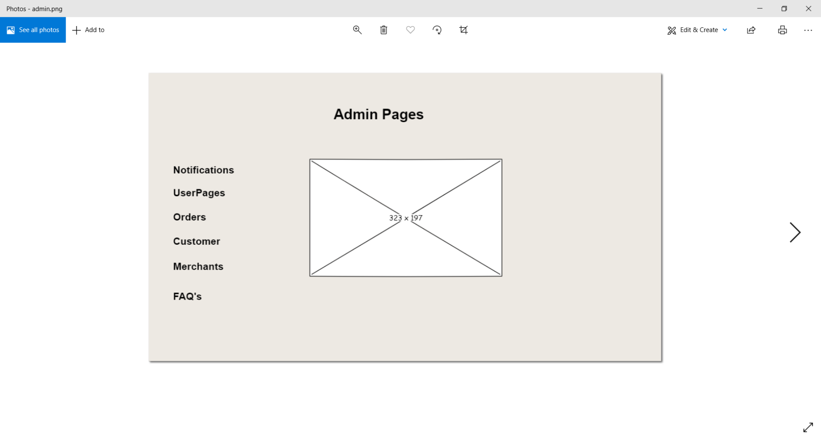

ORDER RULES

In order rules you can set some basic rules for new orders. These rules :

Last Order Number – At any time we can change the last order number so that the next order generated by the shopping cart will be this number plus 1. If set to 1000, the next order generated will be 1001. This is useful when converting from another shopping cart to Storefront.

SHIP ADDRESS

The address will be set to default on which the customer orders the product majority of the time.

PEOPLE MANAGEMENT BY ADMIN

Admin can access users by clicking on “People” and then “Users” this will bring up the Users Management Screen as shown below. Admin can edit user details as per the requirement.

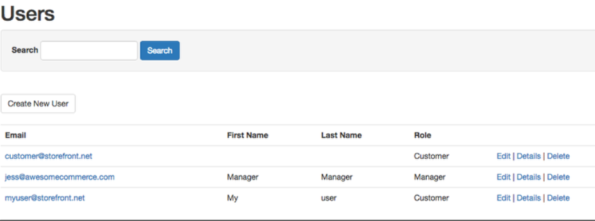

#### TRANSACTION REPORT

The transactions report brings up a report listing all of the transactions for a particular date range as shown below.

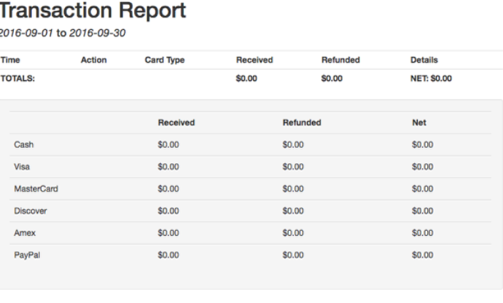

#### PRODUCT SALES REPORT

The Product Sales Report lists the product sales by Product Name, SKU, Quantity, Average Price and Gross Sales for the product. It too can be set to a specific date range as shown below.

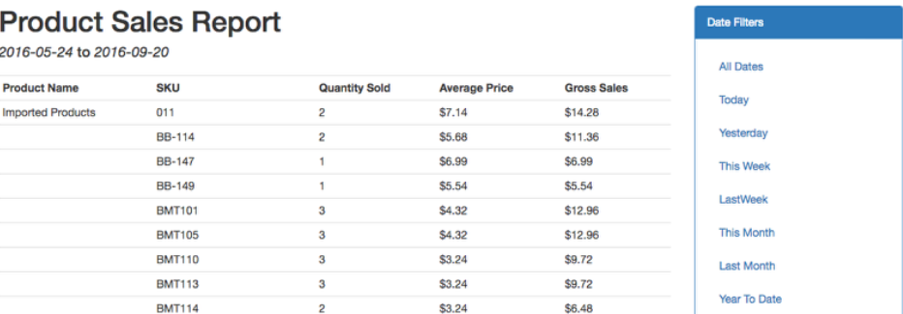

Notifications

Admin will get notification in case there is any updates to be done on transactions status.

Admin will get alert notifications in case there is any problem at merchant side or customer side.

MERCHANT

1.Merchant Login Page

Merchants can login through this page and can do various functions like processing order.

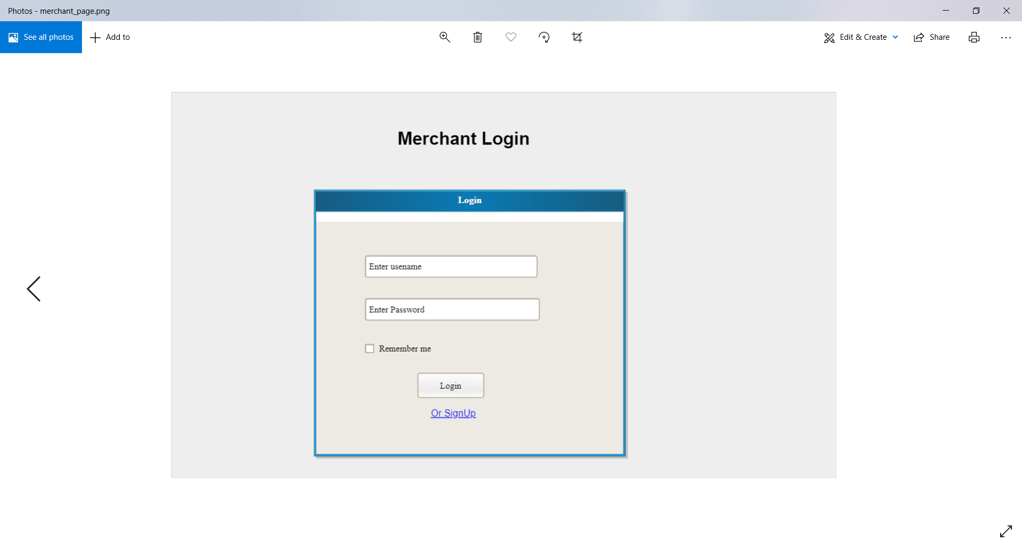

2.Merchant Home Page

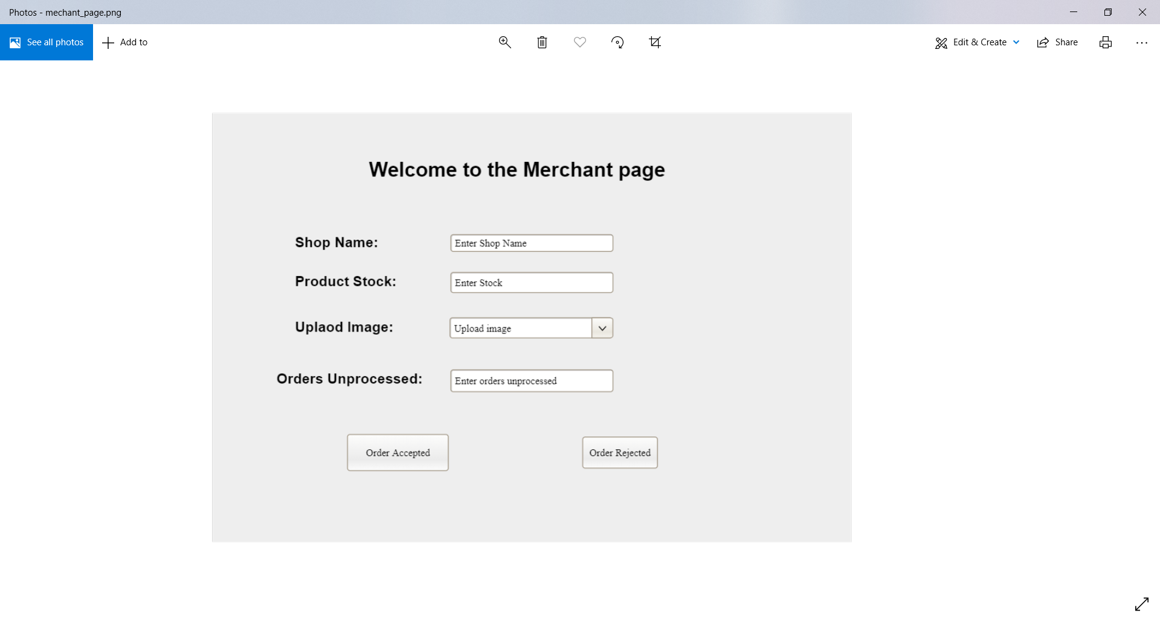

PRODUCT MANAGEMENT

The products page is broken into three different areas:

1. The Add New Product button  – If you wish to add a new product simply click the “Add New Product” button.
2. The Product Listings – This is a list of all of your products currently in our catalog and provides easy access to edit those products.
3. Search & Filter Box – This box makes searching and filtering products extremely easy.

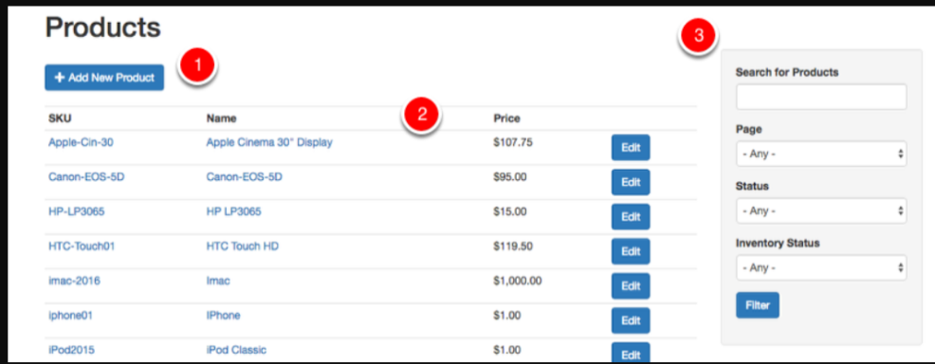

EDITING PAGE SETTINGS

To edit the page settings for a page simply click on the page name from the Pages menu.  This brings up the “Edit Page” screen as shown below

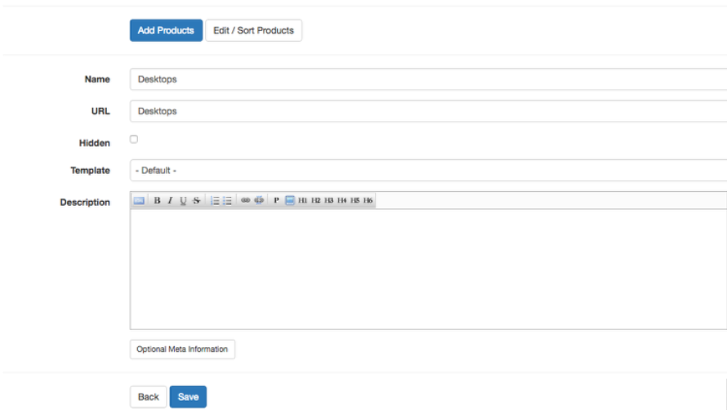

Adding a Product

To add a product you’ll click on the “Add New Product” button from the Products menu

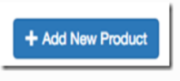

#### Editing Products

After saving a new product we’ll get the edit product screen which looks like this:

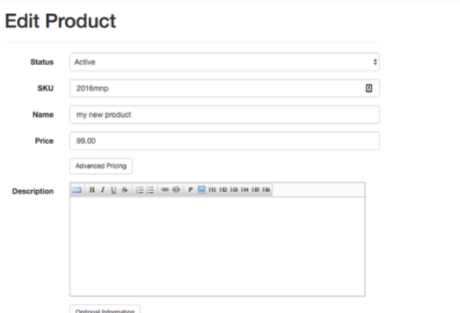

ORDERS

Once selected a list of your orders will display as well as their current status.

Merchant can see the list of orders.

1. Order ID Number
2. Date of the Order
3. Order Amount
4. Customer Email Address (hidden here)
5. Status Icons:  Paid, Shipped, Complete
6. View Order Button

CUSTOMER

Customer can see the home page as shown below:

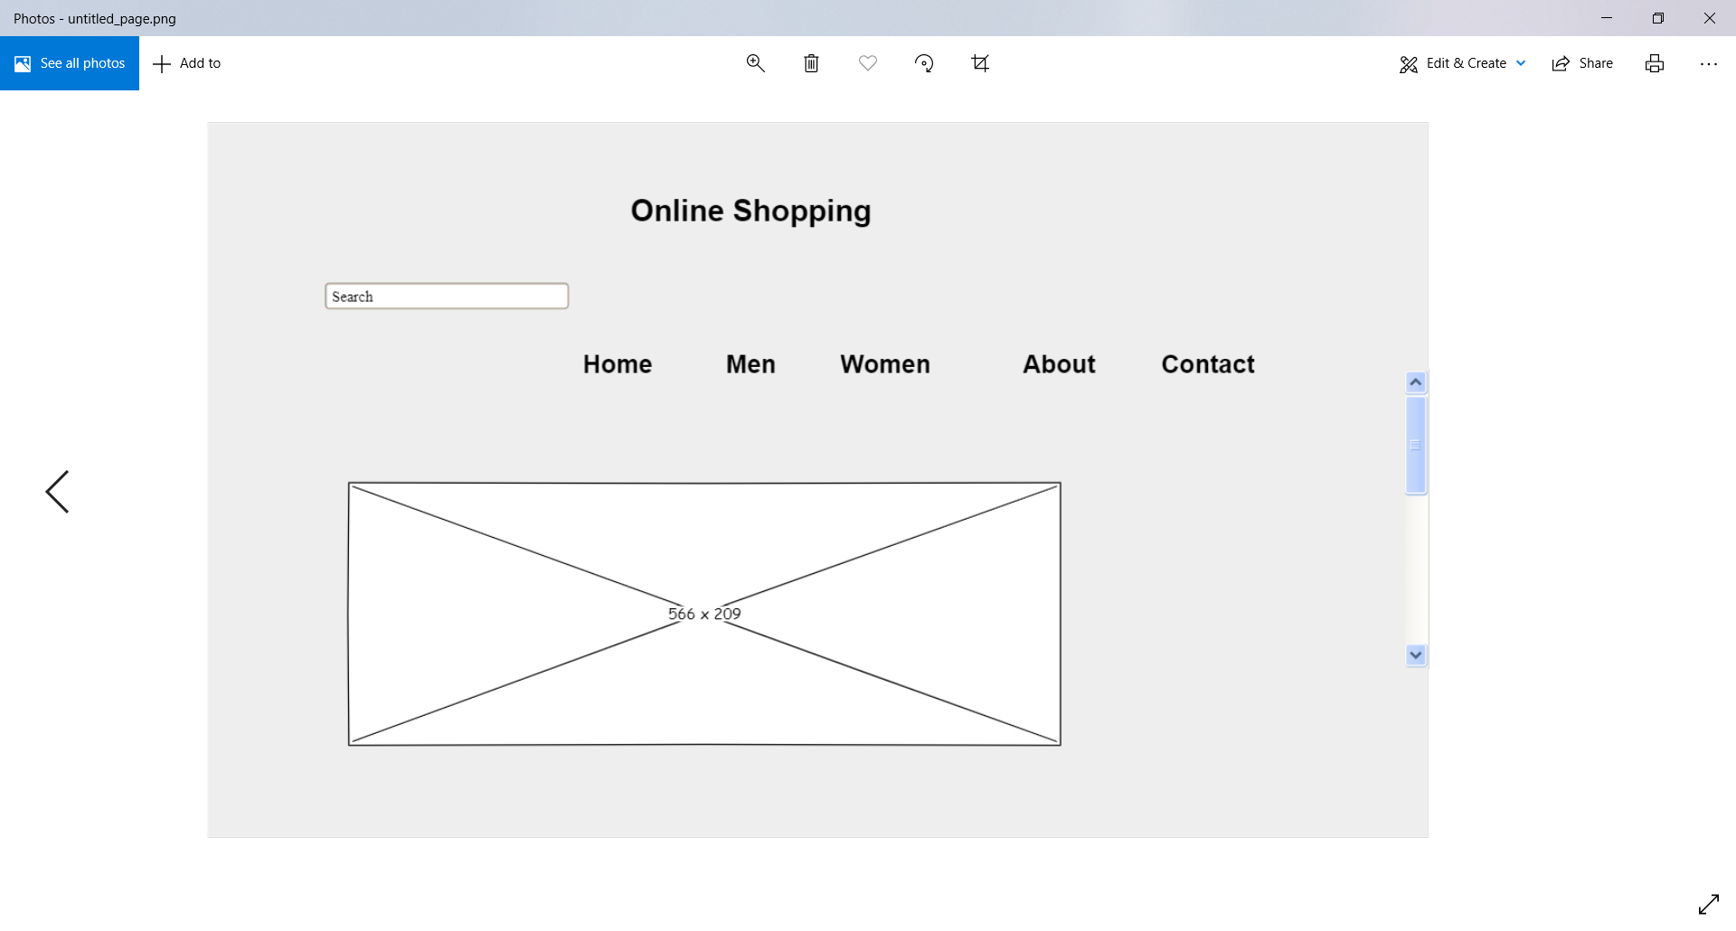

1. Here customer can browse through various products and order and add to shopping cart as per the requirements.
2. When customer places an order if he is ordering for the first time then the credit card details needs to be asked.
3. Here user can check if the shipping address is same as billing address if not,then the user has to enter the new shipping address.

SPRINT 2

SHOPPING CART

When add to cart is clicked by the user it should be added to the cart and if the product is already present then it should be increased by 1 and if not, the product should be added.

When the product is added to the cart the product stock in the product table should not be decreased.

CONTACT US

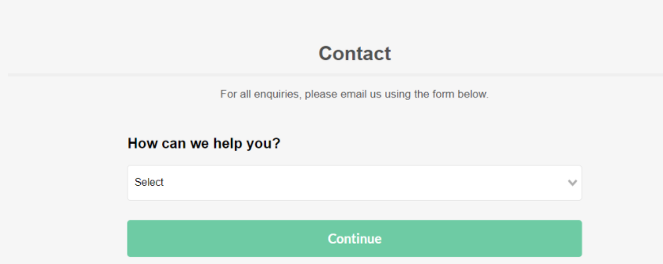

Here Customer can contact us if there is any issue or queries related to product.

FEEDBACK

Customer can give us the feedback.

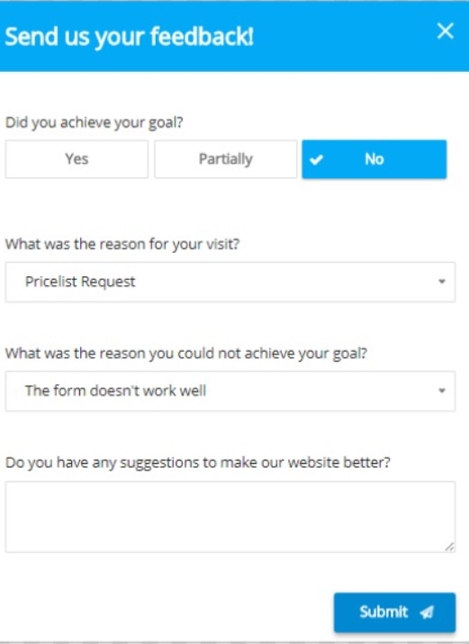

SIGN UP

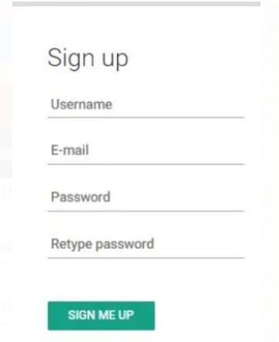

Customer can sign up the account and then register for the specific site.

SPRINT 3

WISHLIST

Customer can add on his favourites to the wishlist according to his choices.by clicking the button add to favourites.

FAQ’s

Customers can have a look on FAQ if they are having any doubt regarding the website or product while purchasing the product.

SIGNUP WITH SOCIAL MEDIA



Customer can sign up through his/her social media account and link it with social media.