Week 1 Deliverable: VLAN Configuration Basics

Project Summary
This document summarizes the VLAN configuration and test results for Week 1. The topology and IP addressing are taken from the provided network diagram.

Observed Topology & Notes
Topology observed from the diagram: three physical switches (SW1, SW2, SW3) each hosting access ports for local PCs. Firewalls (FW1, FW2, FW3) exist in the core, but Week 1 is Layer-2 only (no inter-VLAN routing configured on the FortiGates).
Important note: The diagram labels VLAN membership per device, but some devices use the same VLAN ID while having different IP network ranges on different switches. If you intend those VLAN IDs to represent the same broadcast domain across switches, their IP network MUST be the same. If they are separate site-local networks, use unique VLAN IDs or document them as separate L2 domains.

VLAN / IP Assignments (from diagram)
Device | VLAN ID (label) | IP Address | Network (in diagram) | Switch / Port (example)
PC1A | VLAN1 | 192.168.1.2 | 192.168.1.0/29 | FW1 - port2
PC1B | VLAN3 | 192.168.1.3 | 192.168.1.0/29 | FW1 - port2
PC2A | VLAN2 | 192.168.2.2 | 192.168.2.0/29 | FW2 - port4
PC2B | VLAN3 | 192.168.2.3 | 192.168.2.0/29 | FW2 - port4
Server | VLAN3 | 192.168.2.4 | 192.168.2.0/29 | FW2 - port4
PC3A | VLAN1 | 192.168.3.2 | 192.168.3.0/29 | FW3 - port1
PC3B | VLAN2 | 192.168.3.3 | 192.168.3.0/29 | FW3 - port1

Recommended Layer-2 Switch Configuration (examples)
- On each access switch (example Cisco-like commands):
1) Create VLANs on the switch:
vlan 10
name VLAN1
vlan 20
name VLAN2
vlan 30
name VLAN3
2) Configure access ports for end devices (example):
interface FastEthernet0/1
switchport mode access
switchport access vlan 10
interface FastEthernet0/2
switchport mode access
switchport access vlan 30
3) Configure trunk port toward core/firewall (if present):
interface FastEthernet0/24
switchport mode trunk
switchport trunk allowed vlan 10,20,30

Test Plan and Results (Week 1 expectations)
- Expected: Devices in the same VLAN and same IP network should be able to ping each other.
- Expected: Devices in different VLANs (different broadcast domains) should NOT be able to ping (no Layer-3 routing configured yet).
Observed/test results from diagram addressing:
- PC2B (192.168.2.3) <-> Server (192.168.2.4): SAME VLAN (VLAN3) and SAME network (192.168.2.0/29) → Ping SHOULD succeed.
- Any hosts labeled with the same VLAN ID but placed in different IP networks (e.g., PC1A VLAN1 192.168.1.2 vs PC3A VLAN1 192.168.3.2) → These are NOT in the same L2/L3 domain and ping WILL fail unless centralized/trunked and subnet reconciled.

Recommendations / Fixes
1. Decide whether VLAN IDs (VLAN1, VLAN2, VLAN3) are meant to represent global broadcast domains across the whole topology or are local/site-specific. If global, make sure the same VLAN ID spans switches via trunks and reuse the same IP network across those switches. If local, use different VLAN IDs per site to avoid confusion.
2. Document trunk links: which switch ports connect to FortiGate/firewall and which VLANs they carry.
3. Keep a consistent IP addressing plan and default gateway plan for each VLAN (these gateway IPs will be configured on the FortiGate in Week 2).
4. Add the 'show' commands outputs to your deliverable: `show vlan brief`, `show interfaces trunk`, and `show run interface` snapshots.

Deliverable Files Included
- This Word document (Week1_VLAN_Deliverable.docx)
- Optional: Network diagram (inserted if requested)

Final Network Diagram (Updated)
The following diagram represents the final and corrected VLAN topology:
The following diagram represents the final topology as implemented in Week 1:
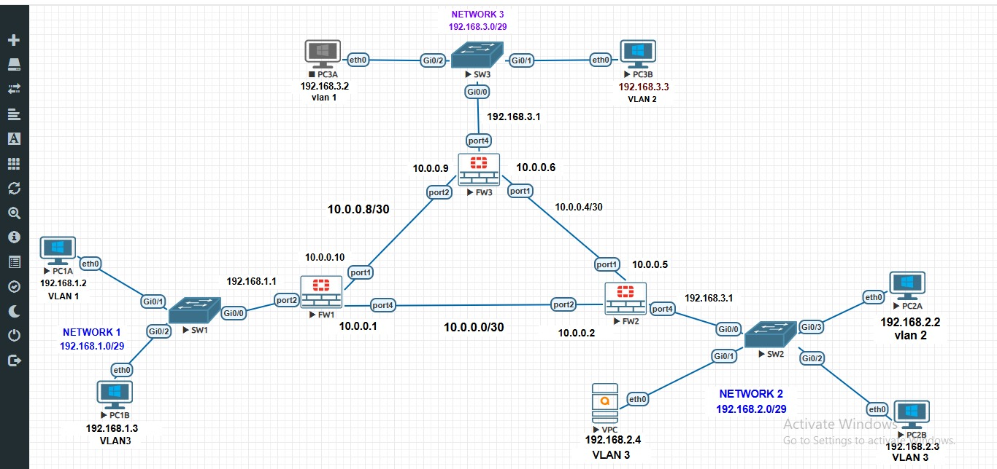

Switch Configuration Commands
Below are the configuration commands used for VLAN creation, port assignment, and verification on the Layer 2 switches according to the Week 1 topology.

1. VLAN Creation
enable
configure terminal
vlan 10
name VLAN1
vlan 20
name VLAN2
vlan 30
name VLAN3
exit

2. SW1 Configuration
interface Gig0/1
switchport mode access
switchport access vlan 10
exit
interface Gig0/2
switchport mode access
switchport access vlan 30
exit
interface Gig0/0
switchport mode trunk
switchport trunk allowed vlan 10,30

3. SW2 Configuration
interface Gig0/3
switchport mode access
switchport access vlan 20
exit
interface Gig0/2
switchport mode access
switchport access vlan 30
exit
interface Gig0/0
switchport mode trunk
switchport trunk allowed vlan 20,30

4. SW3 Configuration
interface Gig0/2
switchport mode access
switchport access vlan 10
exit
interface Gig0/1
switchport mode access
switchport access vlan 20
exit
interface Gig0/0
switchport mode trunk
switchport trunk allowed vlan 10,20

5. Verification Commands
show vlan brief
show interfaces trunk
show running-config interface

6. Ping Test Results
The following summarizes expected Ping results according to VLAN and subnet configurations.
From | To | Expected Result | Reason
PC2B | Server | ✅ Success | Same VLAN3 and same subnet
PC1A | PC1B | ❌ Fail | Different VLANs
PC1A | PC2A | ❌ Fail | Different VLANs, no routing

