**DATA FLOW DIAGRAM :**

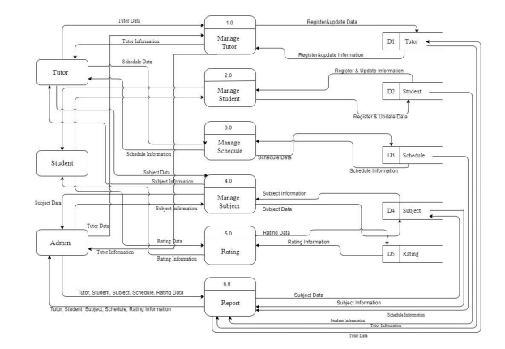

**DATA FLOW DIAGRAM LEVEL 1**

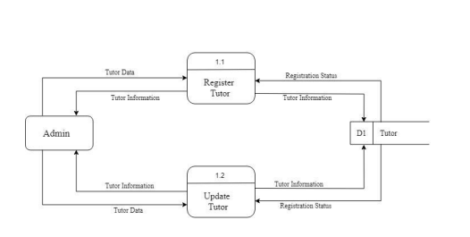

**DATA FLOW DIAGRAM LEVEL 2**

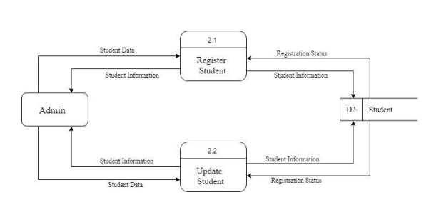

**DATA FLOW DIAGRAM LEVEL 3**

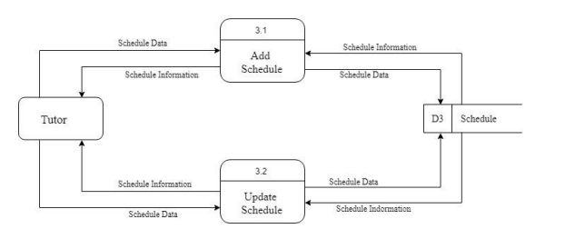

**DATA FLOW DIAGRAM LEVEL 4**

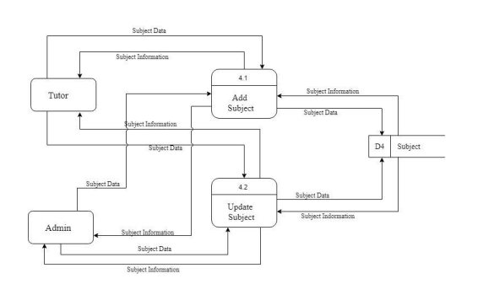

**ENTITY RELATIONSHIP DIAGRAM**

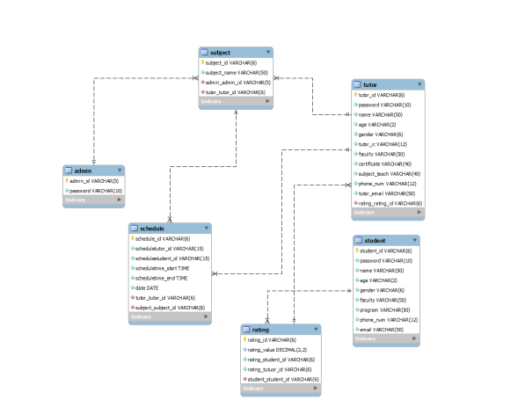

**USECASE DIAGRAM:**

A use-case diagram is a graph of actors, a set of use cases enclosed by a system boundary, participation associations between the actors and the use-cases, and generalization among the use cases.In general, the *use-case* defines the outside (actors) and inside(use-case) of the system’s typical behavior. A use-case is shown as an ellipse containing the name of the use-case and is initiated by actors. An *Actor* is anything that interacts with a use-case. This is symbolized by a stick figure with the name of the actor below the figure.

