**# {receiptNumber}**

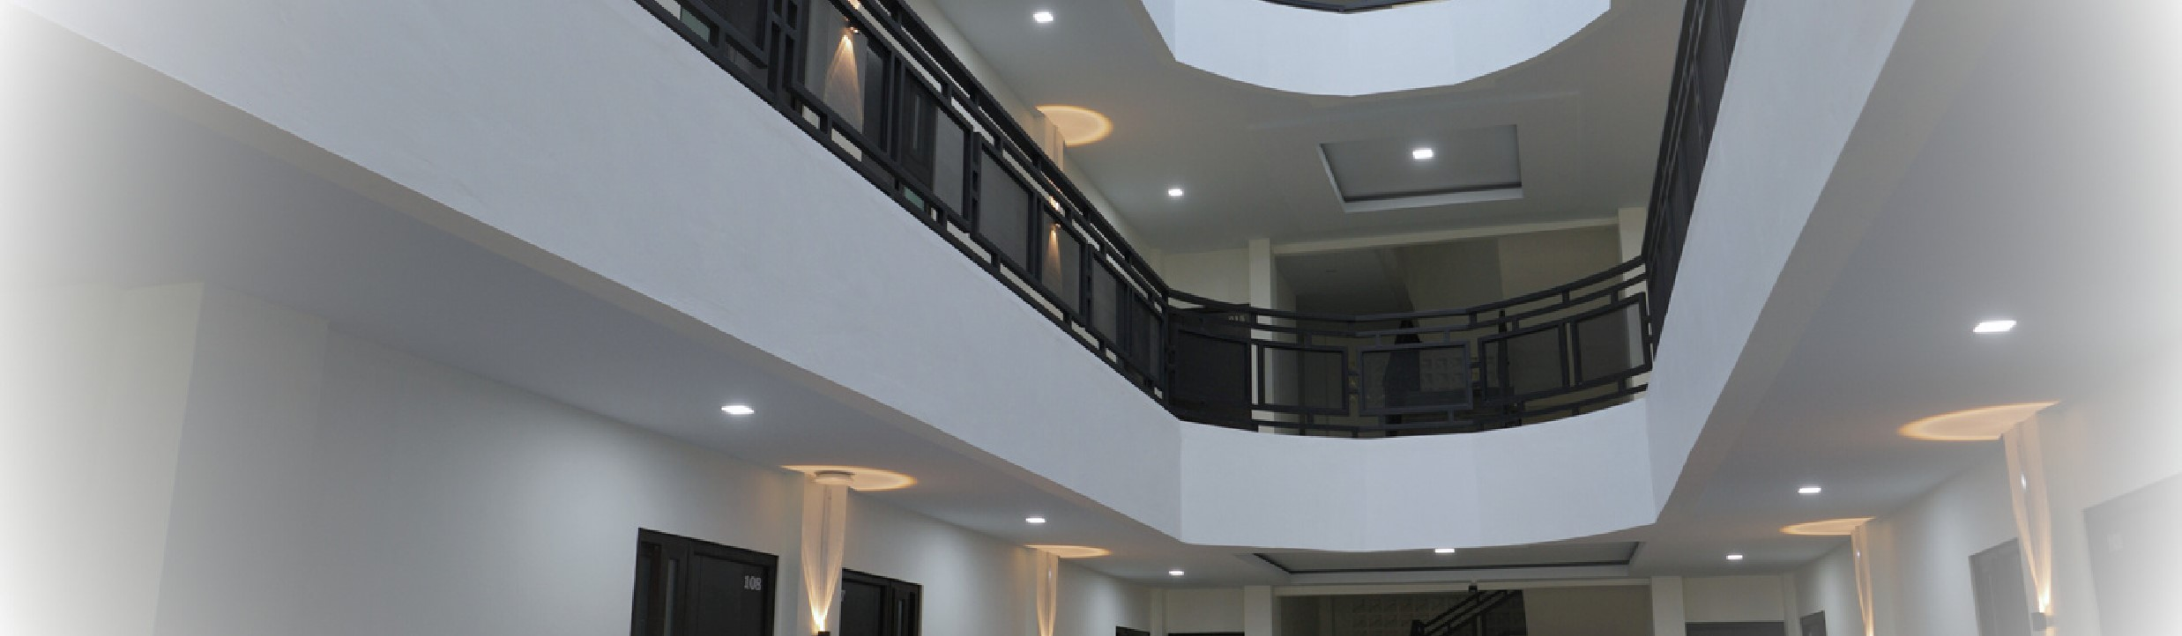

**RECEIPT**

C

O

Z

Y

L

I

V

I

N

G

S

P

A

C

E

I

N

B

A

N

D

A

A

C

E

H

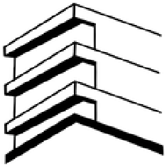

**GUEST : {guestName} BOOK DATE : {startDate} – {endDate}**

**SUMAN RESIDENCE**

Lr.Apel Lamgugob, Kec. Syiah Kuala,

Kota Banda Aceh, 23115

# DESCRIPTION QTY PRICE TOTAL

{description} {quantity} {priceIdr} IDR 500.000

Lr.Apel Lamgugob, Kec. Syiah

Kuala, Kota Banda Aceh, 23115

SumanResidence338@gmail.com

+62 8126 5945 003 (

Admin

)

+62 8221 1040 701 (

Owner

)

**PAID {paidPrice}**

**UNPAID {unpaidPrice}**

**TOTAL {finalTotal}**

# PAYMENT INFORMATION

Name : Natasya Nadhifa

Account Number : 7193308575 (BSI)