Canopy Exploration

Gregor Thomas

January 22, 2020

This is a working document for exploring the Canopy data and is intendend to provide directional information and to guide ongoing discussions, including whether this is the direction the client would like us to further pursue.

*The information below is a draft and will be continued to be reviewd and revised.*

# Descriptives

In the confirmation data, there are 76 tier 2 (T2) tags and responses from 173 schools. The graph below shows the distribution of the number of confirmed T2 tags per school. There are a handful (3) schools with no confirmed tags, and one school each with 69 and 70 tags (Avalon School and Meadows Valley School PK-12, respectively); 50% of schools have between 24 and 47 tags, with the median school having 36 tags.

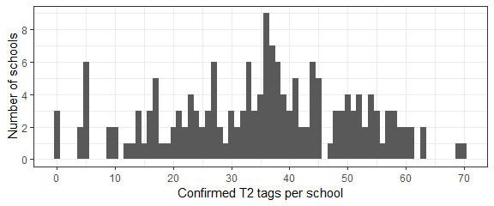

# Nomination vs Confirmation Divergence

The tag confirmations do not diverge far from the nominations. Schools much more frequently *confirmed tags for which they were not nominated* than *disconfirmed tags for which they were nominated*. Detailed metrics follow. Overall, the agreement between nominations and confirmations are very high.

In this section (and throughout this analysis, so far) we use de-duplicated nominations. That is, if multiple nominators suggested the same tag for a school, it is counted as a single nomination. This keeps the scale of the analysis at the tag-school level, without introducing complexity of considering nominators as well. Additional analysis could be done including the individual nominator data (34 schools were nominated by multiple individual), to see if duplicated nominations are more likely to be confirmed, to assess the “accuracy” of individual nominators, etc.

Considering all tags (tiers 1 and 2), the overall agreement between nomination and confirmation was 95.7%. By school, 72.3% did not make any changes to their nominations. One school, Minnesota New Country School, was nominated for 64 T2 tags, but did not confirm (or add) any T2 tags, so we are ignoring it’s T2 confirmation data.

In the confirmation process, schools were much more likely to add tags they were not nominated for than to remove tags they were nominated for. Several summary statistics are provided in the table below, broken out by tag tier. Graphical illustrations follow.

| tier | accuracy | precision | sensitivity | n_nom_confirmed | n_tag_added | n_tag_removed |
| --- | --- | --- | --- | --- | --- | --- |
| T1 | 0.947 | 0.990 | 0.908 | 998 | 101 | 10 |
| T2 | 0.961 | 0.992 | 0.915 | 1916 | 178 | 16 |

The technical terms in the table are borrowed from data science. *Accuracy* is the proportion of matches between nomination and confirmation (both nominated and confirmed or neither nominated nor confirmed count as matches). *Precision* (aka *positive predictive value*) is the proportion of (positive) nominations that were confirmed. *Sensitivity* is the proportion of (positive) confirmations that were nominated. Then we have three counts: *n nom confirmed* is the number of tag nomination that were confirmed, *n tag added* is the number of tags schools confirmed that were not nominated, and *n tag removed* is the paltry number of nominations that schools did not confirm.

The high precision values, especially high for Tier 1 tags, is a proportional way to measure how small the number of disconfirmed tags are relative to confirmed tags. Sensitivity is similar, but for added tags rather than removed tags.

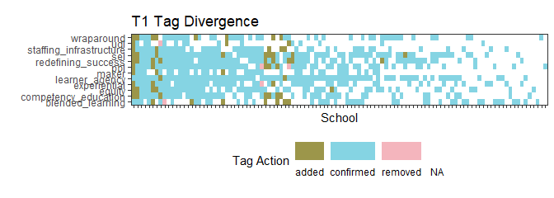

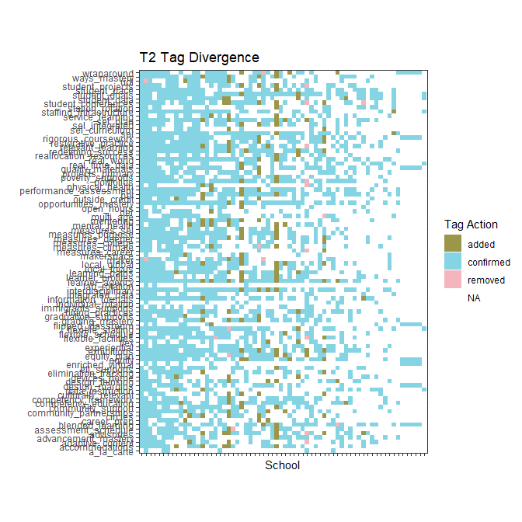

Individual tag statistics are in the tables below. All Tier 1 tags are presented and the top and bottom most added Tier 2 tags.

| tier | tag | n_nom_confirmed | n_tag_added | n_tag_removed |
| --- | --- | --- | --- | --- |
| T1 | redefining_success | 93 | 13 | 0 |
| T1 | wraparound | 69 | 12 | 1 |
| T1 | sel | 109 | 11 | 0 |
| T1 | competency_education | 82 | 11 | 0 |
| T1 | learner_agency | 122 | 9 | 0 |
| T1 | equity | 91 | 9 | 0 |
| T1 | blended_learning | 80 | 9 | 2 |
| T1 | pbl | 100 | 8 | 2 |
| T1 | staffing_infrastructure | 77 | 6 | 0 |
| T1 | maker | 53 | 5 | 2 |
| T1 | udl | 36 | 5 | 2 |
| T1 | experiential | 86 | 3 | 1 |

Most and least added Tier 2 tags:

| tier | tag | n_nom_confirmed | n_tag_added | n_tag_removed |
| --- | --- | --- | --- | --- |
| T2 | advisories | 27 | 6 | 1 |
| T2 | mental_health | 18 | 6 | 0 |
| T2 | exhibitions | 38 | 5 | 0 |
| T2 | sel_plan | 37 | 5 | 0 |
| T2 | learning_paths | 31 | 5 | 0 |
| T2 | integrated_data | 18 | 0 | 0 |
| T2 | enriched_virtual | 11 | 0 | 0 |
| T2 | individual_rotation | 10 | 0 | 0 |
| T2 | a_la_carte | 6 | 0 | 0 |
| T2 | lab_rotation | 4 | 0 | 0 |

With this apparent reluctance of schools administrators to disconfirm tags for which they were nominated, it seems natural to ask if schools that were nominated for tier 2 tags ended up confirming more tags, on average, than those that were not nominated at the tier 2 level. As it turns out, this was not the case. Schools that were only nominated at the Tier 1 level selected, on average, 37.1121495 Tier 2 tags, while schools nominated at the Tier 2 level selected 31.7272727 Tier 2 tags.

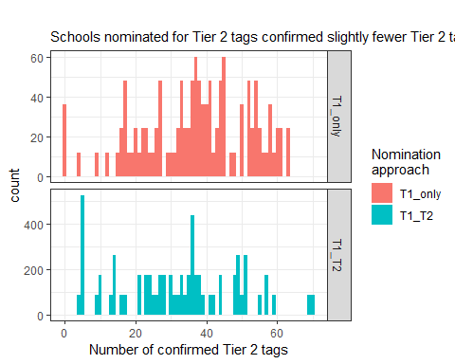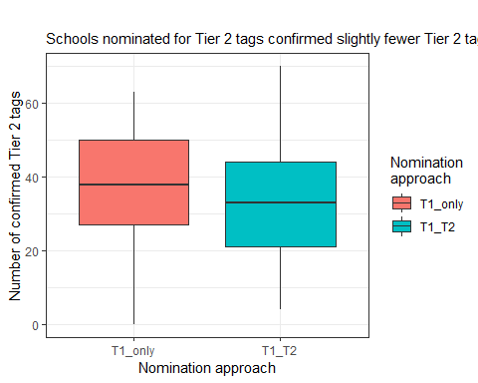

# Clustering

To understand the relationship between Tier 2 tags, we begin by looking at a heat map of correlations. The rows and columns are ordered to cluster similar correlations together, hence the more blue on the left side, and higher correlations on the right.

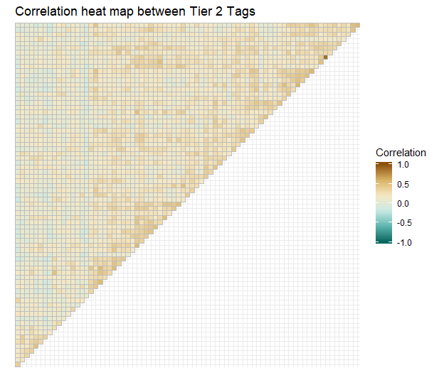

Looking at the distribution of correlations, we see more-or-less a bell curve, with a mean of 0.18, and one outlier pair, measures_sel and measures_climate, with an extremely high correlation of 0.87. This is a robust outlier, with 99 schools confirming measures_sel, 96 confirming measures_climate, and 92 of those overlapping.

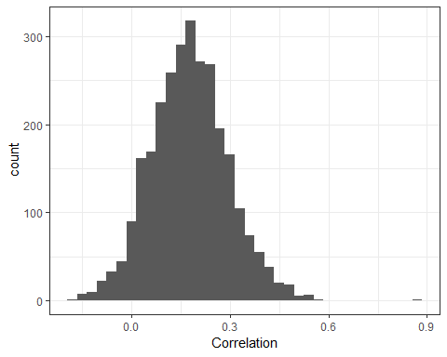

The table below shows the most and least correlated tags (top and bottom 6).

| Var1 | Var2 | Correlation |
| --- | --- | --- |
| measures_sel | measures_climate | 0.871 |
| exhibitions | portfolios | 0.572 |
| interdisciplinary | real_world | 0.547 |
| local_focus | local_global | 0.546 |
| poverty_supports | hiring_practices | 0.538 |
| graduation_supports | measures_college | 0.538 |
| station_rotation | advisories | -0.142 |
| flipped_classroom | advisories | -0.143 |
| enriched_virtual | student_goals | -0.145 |
| enriched_virtual | sel_plan | -0.149 |
| station_rotation | design_margins | -0.159 |
| flipped_classroom | flexible_schedule | -0.166 |

# Clustering Methods

We’ll try a few clustering methods to explore the nuances they each give us and make sure our results are robust. First, hierarchical agglomerative clustering, then exploratory factor analysis. We will also look at the data as a network graph with weighted edges, and use community detection (as if it was a social network).

For now, we’ll focus on the confirmed data.

### Hierarchical clustering

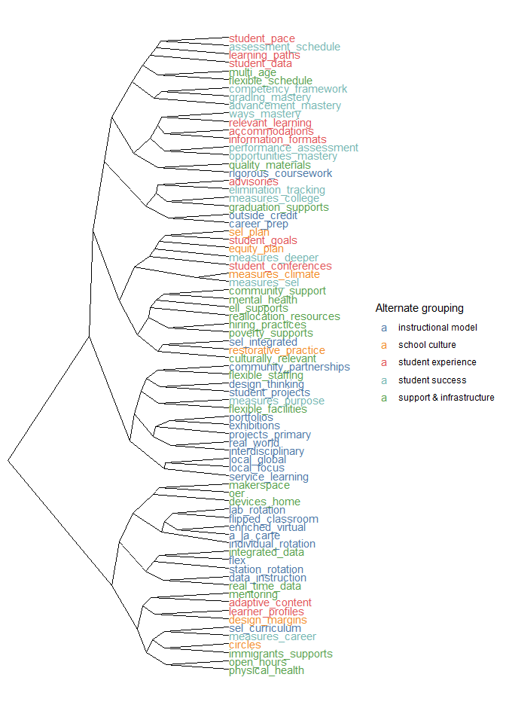

## Exploratory Factor Analysis

With EFA, we first need to run diagnostics to select the optimal number of clusters.

The principal axis method and minimum residual methods recommend 4 clusters, but 5 and 6 clusters are also fairly close. We’ll start with 5 clusters and explore more as needed.

## Loading required namespace: GPArotation

##   
## Loadings:  
## MR1 MR3 MR4 MR2   
## station_rotation 0.567  
## flipped_classroom 0.328  
## lab_rotation 0.519  
## individual_rotation 0.542  
## flex 0.356  
## a_la_carte   
## enriched_virtual   
## opportunities_mastery 0.425   
## advancement_mastery 0.401  
## performance_assessment 0.573   
## grading_mastery 0.371   
## assessment_schedule 0.425   
## competency_framework 0.304   
## equity_plan 0.411   
## reallocation_resources 0.374   
## design_margins   
## restorative_practice 0.545   
## culturally_relevant 0.593   
## rigorous_coursework   
## elimination_tracking 0.446   
## graduation_supports 0.676   
## poverty_supports 0.554   
## immigrants_supports 0.527   
## ell_supports 0.498   
## flexible_staffing   
## flexible_facilities 0.366   
## flexible_schedule   
## real_time_data 0.616  
## quality_materials   
## oer   
## multi_age 0.426   
## devices_home 0.403   
## integrated_data 0.446  
## student_goals 0.320   
## student_pace 0.441  
## learning_paths 0.387   
## learner_profiles   
## student_conferences 0.395 0.318   
## student_data 0.363  
## projects_primary 0.647   
## student_projects 0.508   
## interdisciplinary 0.677   
## real_world 0.579   
## exhibitions 0.593   
## portfolios 0.716   
## career_prep 0.702   
## outside_credit 0.604   
## service_learning 0.469   
## local_focus 0.433   
## local_global 0.484   
## design_thinking 0.505   
## community_partnerships 0.308 0.395   
## makerspace   
## measures_college 0.609   
## measures_career 0.321   
## measures_deeper 0.334   
## measures_purpose 0.356   
## measures_sel 0.502   
## measures_climate 0.466   
## sel_plan 0.530   
## sel_curriculum 0.384   
## sel_integrated 0.509   
## circles 0.727   
## advisories 0.430   
## hiring_practices 0.401   
## relevant_learning 0.371   
## information_formats   
## ways_mastery 0.441   
## accommodations   
## data_instruction 0.533  
## adaptive_content 0.321  
## mentoring 0.304 0.323   
## mental_health 0.534   
## physical_health 0.431   
## community_support 0.620   
## open_hours 0.318   
##   
## MR1 MR3 MR4 MR2  
## SS loadings 6.213 5.872 4.442 3.944  
## Proportion Var 0.082 0.077 0.058 0.052  
## Cumulative Var 0.082 0.159 0.217 0.269

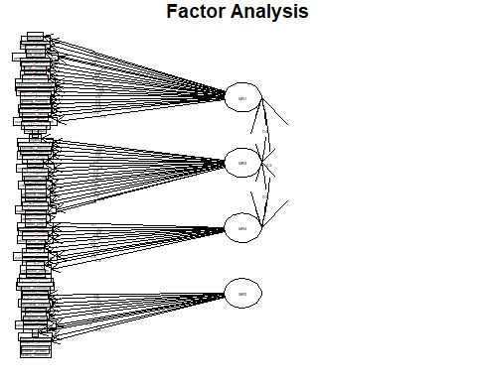

## Factor Analysis using method = minres  
## Call: fa(r = conf_cor, nfactors = 5, rotate = "oblimin", fm = "minres")  
## Standardized loadings (pattern matrix) based upon correlation matrix  
## item MR3 MR5 MR1 MR4 MR2 h2 u2 com  
## circles 63 0.71 0.14 -0.09 -0.12 -0.10 0.508 0.49 1.2  
## poverty_supports 22 0.62 -0.18 0.19 0.09 0.08 0.510 0.49 1.5  
## community_support 75 0.60 -0.02 -0.17 0.22 0.12 0.468 0.53 1.5  
## culturally_relevant 18 0.59 0.08 -0.02 0.02 -0.03 0.383 0.62 1.1  
## immigrants_supports 23 0.57 -0.16 0.06 0.13 -0.05 0.366 0.63 1.3  
## restorative_practice 17 0.56 0.13 0.09 -0.02 -0.11 0.397 0.60 1.2  
## sel_plan 60 0.55 0.04 0.11 -0.01 0.11 0.393 0.61 1.2  
## mental_health 73 0.54 -0.03 -0.03 0.21 0.03 0.386 0.61 1.3  
## ell_supports 24 0.50 -0.06 0.00 0.09 0.22 0.355 0.65 1.5  
## sel_integrated 62 0.50 0.20 0.03 -0.03 -0.02 0.342 0.66 1.3  
## measures_sel 58 0.47 0.31 0.05 -0.15 0.14 0.419 0.58 2.2  
## equity_plan 14 0.45 0.06 0.22 0.10 -0.03 0.376 0.62 1.6  
## hiring_practices 65 0.45 -0.04 0.25 0.15 0.11 0.440 0.56 2.0  
## measures_climate 59 0.43 0.30 -0.01 -0.07 0.15 0.359 0.64 2.1  
## reallocation_resources 15 0.42 -0.10 0.22 -0.02 0.13 0.288 0.71 1.9  
## physical_health 74 0.42 -0.02 -0.08 0.08 0.13 0.215 0.79 1.4  
## local_focus 49 0.39 0.36 -0.09 0.04 -0.04 0.349 0.65 2.2  
## sel_curriculum 61 0.37 0.16 -0.01 -0.15 0.05 0.174 0.83 1.8  
## student_conferences 38 0.33 0.29 0.21 -0.17 -0.02 0.310 0.69 3.3  
## open_hours 76 0.30 0.09 -0.06 0.17 0.09 0.179 0.82 2.1  
## measures_purpose 57 0.29 0.19 0.29 0.04 -0.02 0.337 0.66 2.8  
## design_margins 16 0.21 -0.04 0.10 0.13 -0.07 0.095 0.91 2.5  
## quality_materials 29 0.16 0.01 0.10 0.07 0.16 0.103 0.90 3.0  
## local_global 50 0.21 0.66 -0.15 0.04 -0.05 0.521 0.48 1.3  
## projects_primary 40 -0.05 0.64 0.11 0.01 -0.04 0.445 0.55 1.1  
## interdisciplinary 42 0.04 0.60 0.21 0.00 -0.01 0.490 0.51 1.2  
## service_learning 48 -0.03 0.58 -0.05 0.18 0.12 0.408 0.59 1.3  
## design_thinking 51 -0.01 0.56 0.04 -0.02 0.24 0.381 0.62 1.4  
## exhibitions 44 0.08 0.47 0.24 0.11 -0.21 0.451 0.55 2.1  
## real_world 43 0.06 0.46 0.26 0.12 -0.09 0.423 0.58 1.9  
## student_projects 41 0.02 0.44 0.18 0.15 -0.02 0.340 0.66 1.6  
## flexible_facilities 26 0.11 0.35 0.12 0.01 0.30 0.315 0.69 2.5  
## makerspace 53 -0.07 0.35 -0.07 0.12 0.13 0.143 0.86 1.7  
## flexible_staffing 25 0.15 0.35 -0.01 0.19 0.03 0.254 0.75 2.0  
## measures_deeper 56 0.13 0.32 0.09 0.27 0.04 0.325 0.67 2.5  
## oer 30 0.07 0.27 -0.02 0.21 0.25 0.242 0.76 3.0  
## grading_mastery 11 0.10 -0.04 0.65 -0.02 -0.13 0.432 0.57 1.1  
## assessment_schedule 12 -0.07 0.04 0.63 0.10 0.09 0.457 0.54 1.1  
## performance_assessment 10 0.04 0.22 0.59 0.00 -0.03 0.480 0.52 1.3  
## advancement_mastery 9 0.00 -0.17 0.58 -0.06 0.19 0.359 0.64 1.4  
## competency_framework 13 -0.02 -0.04 0.54 0.10 -0.05 0.306 0.69 1.1  
## portfolios 45 -0.03 0.43 0.51 -0.08 -0.08 0.504 0.50 2.1  
## opportunities_mastery 8 0.02 0.13 0.50 0.01 0.13 0.351 0.65 1.3  
## student_pace 35 -0.01 -0.07 0.41 0.10 0.30 0.317 0.68 2.0  
## student_goals 34 0.17 0.07 0.41 0.06 0.03 0.295 0.71 1.5  
## accommodations 69 0.23 0.01 0.34 0.16 0.15 0.357 0.64 2.7  
## ways_mastery 68 -0.01 0.26 0.34 0.25 0.05 0.370 0.63 2.8  
## flexible_schedule 27 0.12 0.05 0.31 0.20 0.01 0.241 0.76 2.1  
## relevant_learning 66 0.20 0.21 0.31 0.11 0.12 0.357 0.64 3.3  
## career_prep 46 -0.09 0.11 -0.05 0.75 0.00 0.552 0.45 1.1  
## graduation_supports 21 0.21 -0.10 0.14 0.62 0.02 0.567 0.43 1.4  
## outside_credit 47 -0.06 0.13 0.04 0.61 -0.09 0.418 0.58 1.2  
## measures_college 54 0.18 -0.08 0.07 0.58 0.04 0.454 0.55 1.3  
## community_partnerships 52 0.07 0.42 -0.09 0.46 -0.12 0.478 0.52 2.3  
## devices_home 32 0.00 -0.04 -0.01 0.42 0.23 0.249 0.75 1.6  
## multi_age 31 -0.03 0.10 0.23 0.39 -0.03 0.281 0.72 1.8  
## elimination_tracking 20 0.22 -0.02 0.21 0.38 -0.15 0.339 0.66 2.7  
## advisories 64 0.31 0.04 0.12 0.37 -0.27 0.390 0.61 3.1  
## measures_career 55 0.16 0.20 -0.07 0.36 -0.02 0.251 0.75 2.1  
## learning_paths 36 0.00 0.05 0.29 0.35 0.15 0.329 0.67 2.4  
## mentoring 72 0.29 0.07 -0.06 0.34 0.10 0.289 0.71 2.3  
## a_la_carte 6 -0.14 0.01 -0.01 0.32 0.23 0.161 0.84 2.2  
## information_formats 67 0.08 0.12 0.21 0.25 0.18 0.269 0.73 3.6  
## enriched_virtual 7 -0.09 -0.07 -0.10 0.24 0.20 0.098 0.90 2.8  
## rigorous_coursework 19 0.09 0.07 0.11 0.23 0.15 0.159 0.84 2.9  
## learner_profiles 37 0.10 0.12 0.18 0.20 0.19 0.237 0.76 4.2  
## station_rotation 1 0.15 0.06 -0.12 -0.21 0.66 0.472 0.53 1.4  
## real_time_data 28 0.06 -0.12 0.13 -0.01 0.57 0.384 0.62 1.2  
## lab_rotation 3 -0.21 0.20 0.12 0.09 0.55 0.379 0.62 1.8  
## individual_rotation 4 -0.07 -0.04 0.07 -0.01 0.54 0.297 0.70 1.1  
## data_instruction 70 0.17 -0.02 0.07 -0.05 0.52 0.339 0.66 1.3  
## integrated_data 33 0.11 -0.09 -0.06 0.28 0.48 0.368 0.63 1.8  
## flipped_classroom 2 -0.19 0.06 -0.10 0.19 0.41 0.212 0.79 2.1  
## flex 5 0.06 -0.05 0.05 0.07 0.35 0.152 0.85 1.2  
## adaptive_content 71 0.12 0.13 0.15 0.00 0.30 0.199 0.80 2.3  
## student_data 39 0.11 -0.10 0.21 0.23 0.29 0.269 0.73 3.4  
##   
## MR3 MR5 MR1 MR4 MR2  
## SS loadings 6.95 5.23 5.08 4.95 3.70  
## Proportion Var 0.09 0.07 0.07 0.07 0.05  
## Cumulative Var 0.09 0.16 0.23 0.29 0.34  
## Proportion Explained 0.27 0.20 0.20 0.19 0.14  
## Cumulative Proportion 0.27 0.47 0.67 0.86 1.00  
##   
## With factor correlations of   
## MR3 MR5 MR1 MR4 MR2  
## MR3 1.00 0.29 0.28 0.30 0.16  
## MR5 0.29 1.00 0.27 0.22 0.00  
## MR1 0.28 0.27 1.00 0.29 0.14  
## MR4 0.30 0.22 0.29 1.00 0.13  
## MR2 0.16 0.00 0.14 0.13 1.00  
##   
## Mean item complexity = 1.9  
## Test of the hypothesis that 5 factors are sufficient.  
##   
## The degrees of freedom for the null model are 2850 and the objective function was 46.95  
## The degrees of freedom for the model are 2480 and the objective function was 24.3   
##   
## The root mean square of the residuals (RMSR) is 0.06   
## The df corrected root mean square of the residuals is 0.06   
##   
## Fit based upon off diagonal values = 0.93  
## Measures of factor score adequacy   
## MR3 MR5 MR1 MR4 MR2  
## Correlation of (regression) scores with factors 0.95 0.94 0.93 0.94 0.92  
## Multiple R square of scores with factors 0.91 0.88 0.87 0.88 0.84  
## Minimum correlation of possible factor scores 0.81 0.77 0.75 0.76 0.68

##   
## Loadings:  
## MR3 MR5 MR1 MR4 MR2   
## station_rotation 0.657  
## flipped_classroom 0.410  
## lab_rotation 0.549  
## individual_rotation 0.540  
## flex 0.347  
## a_la_carte 0.325   
## enriched_virtual   
## opportunities_mastery 0.502   
## advancement_mastery 0.576   
## performance_assessment 0.589   
## grading_mastery 0.647   
## assessment_schedule 0.627   
## competency_framework 0.537   
## equity_plan 0.453   
## reallocation_resources 0.424   
## design_margins   
## restorative_practice 0.562   
## culturally_relevant 0.593   
## rigorous_coursework   
## elimination_tracking 0.376   
## graduation_supports 0.623   
## poverty_supports 0.619   
## immigrants_supports 0.572   
## ell_supports 0.501   
## flexible_staffing 0.345   
## flexible_facilities 0.348 0.303  
## flexible_schedule 0.311   
## real_time_data 0.573  
## quality_materials   
## oer 0.273   
## multi_age 0.393   
## devices_home 0.423   
## integrated_data 0.276 0.484  
## student_goals 0.410   
## student_pace 0.413 0.298  
## learning_paths 0.289 0.349   
## learner_profiles   
## student_conferences 0.325 0.292   
## student_data 0.287  
## projects_primary 0.641   
## student_projects 0.441   
## interdisciplinary 0.601   
## real_world 0.456   
## exhibitions 0.472   
## portfolios 0.426 0.505   
## career_prep 0.749   
## outside_credit 0.613   
## service_learning 0.583   
## local_focus 0.388 0.364   
## local_global 0.658   
## design_thinking 0.560   
## community_partnerships 0.418 0.464   
## makerspace 0.347   
## measures_college 0.579   
## measures_career 0.355   
## measures_deeper 0.325   
## measures_purpose 0.295 0.292   
## measures_sel 0.472 0.311   
## measures_climate 0.428 0.298   
## sel_plan 0.547   
## sel_curriculum 0.366   
## sel_integrated 0.500   
## circles 0.713   
## advisories 0.305 0.371 -0.272  
## hiring_practices 0.451   
## relevant_learning 0.306   
## information_formats   
## ways_mastery 0.338   
## accommodations 0.344   
## data_instruction 0.523  
## adaptive_content 0.298  
## mentoring 0.287 0.339   
## mental_health 0.540   
## physical_health 0.417   
## community_support 0.600   
## open_hours 0.297   
##   
## MR3 MR5 MR1 MR4 MR2  
## SS loadings 5.993 4.491 4.222 4.131 3.477  
## Proportion Var 0.079 0.059 0.056 0.054 0.046  
## Cumulative Var 0.079 0.138 0.194 0.248 0.294

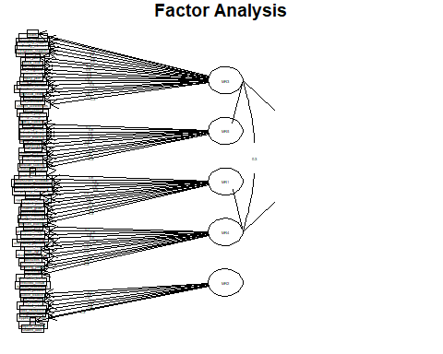

##   
## Loadings:  
## MR5 MR3 MR4 MR1 MR2 MR6   
## station_rotation 0.667   
## flipped_classroom 0.450   
## lab_rotation 0.528   
## individual_rotation 0.527   
## flex 0.337   
## a_la_carte 0.352   
## enriched_virtual   
## opportunities_mastery 0.479   
## advancement_mastery 0.582   
## performance_assessment 0.302 0.556   
## grading_mastery 0.627   
## assessment_schedule 0.608   
## competency_framework 0.523   
## equity_plan 0.445   
## reallocation_resources 0.416   
## design_margins   
## restorative_practice 0.389 0.352  
## culturally_relevant 0.505   
## rigorous_coursework -0.340  
## elimination_tracking 0.356   
## graduation_supports 0.609   
## poverty_supports 0.568   
## immigrants_supports 0.624   
## ell_supports 0.521   
## flexible_staffing 0.308  
## flexible_facilities   
## flexible_schedule 0.311 0.371  
## real_time_data 0.568   
## quality_materials   
## oer   
## multi_age 0.465 0.360  
## devices_home 0.451   
## integrated_data 0.491   
## student_goals 0.399   
## student_pace 0.413   
## learning_paths 0.347   
## learner_profiles   
## student_conferences   
## student_data   
## projects_primary 0.603   
## student_projects 0.453   
## interdisciplinary 0.697   
## real_world 0.564   
## exhibitions 0.544   
## portfolios 0.470 0.460   
## career_prep 0.735   
## outside_credit 0.597   
## service_learning 0.564   
## local_focus 0.438 0.357   
## local_global 0.670   
## design_thinking 0.541   
## community_partnerships 0.430 0.452   
## makerspace 0.320  
## measures_college 0.549   
## measures_career 0.329   
## measures_deeper   
## measures_purpose   
## measures_sel 0.690  
## measures_climate 0.620  
## sel_plan 0.322 0.492  
## sel_curriculum   
## sel_integrated 0.414  
## circles 0.595   
## advisories 0.378   
## hiring_practices 0.396   
## relevant_learning   
## information_formats   
## ways_mastery 0.322 0.310   
## accommodations 0.334   
## data_instruction 0.537   
## adaptive_content 0.301   
## mentoring 0.329   
## mental_health 0.454   
## physical_health 0.360   
## community_support 0.549   
## open_hours   
##   
## MR5 MR3 MR4 MR1 MR2 MR6  
## SS loadings 4.644 4.547 4.081 3.909 3.455 3.066  
## Proportion Var 0.061 0.060 0.054 0.051 0.045 0.040  
## Cumulative Var 0.061 0.121 0.175 0.226 0.272 0.312

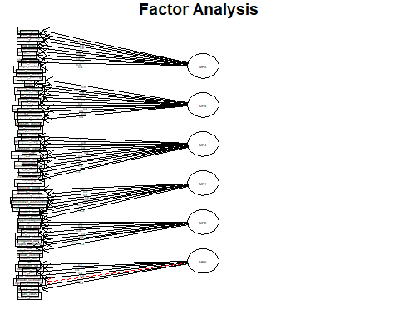

## Next steps