# Web Application Development

# Web project

# Bookstore online

**Member**: Đặng Việt Hùng - ITITIU17046

Lê Thị Phương Linh - ITITIU17075

Trương Ngân Châu - ITITIU17043

Trần Minh Ngọc - ITITIU17068

**Class**: Thursday, Friday morning

**Instructors:** Nguyễn Văn Sinh

Phạm Quốc Sơn Lâm

1. **Overview: Information about our website: assumption, content, tools, techniques and database.**

* **Introduction:**
* Books are very important in our lives. And reading books brings many benefits to us. It helps people improve their knowledge, improve their focus, and strengthen their thinking and analytical skills, and is a completely free form of entertainment.
* So where do people find interesting, interesting, and useful books? In modern life, people can easily find useful books they want. They can be found online, bought from bookstores or borrowed from libraries. But if you own the book, you will be more comfortable reading, you can note any ideas that come from your brain without having to worry about the book.
* Therefore, we designed to create an Online Bookstore System, where people can easily find the books they want.
* **Assumption:**
* Suppose you have many books and you want to sell them. How can you sell books in a city where rent is expensive? The solution is online sales.
* We build a website that help people to come and buy books that make you feel happy, fun and creative.
* On our website, people can also review and rate the books they have purchased to help other readers know more about the book.
* Our store has many different types of books. There are books that have a genre, there are books that have many genres like: fiction, romantic, action, non-fiction, education, ….
* **Tools: some tools that we use to build system.**
* Main IDE: NetBean 8.2
* Server: Tomcat 8.9.27.0
* Database management: Microsoft SQL Server Management Studio
* GitHub: <https://github.com/project-gr/BookStore_online>
* **Techniques:**
* Html, Css
* Jsp
* Servlet
* Java, JavaScript
* JavaBean
* JDBC
* Session
* **Database:**

1. Tables:
2. Database diagram:

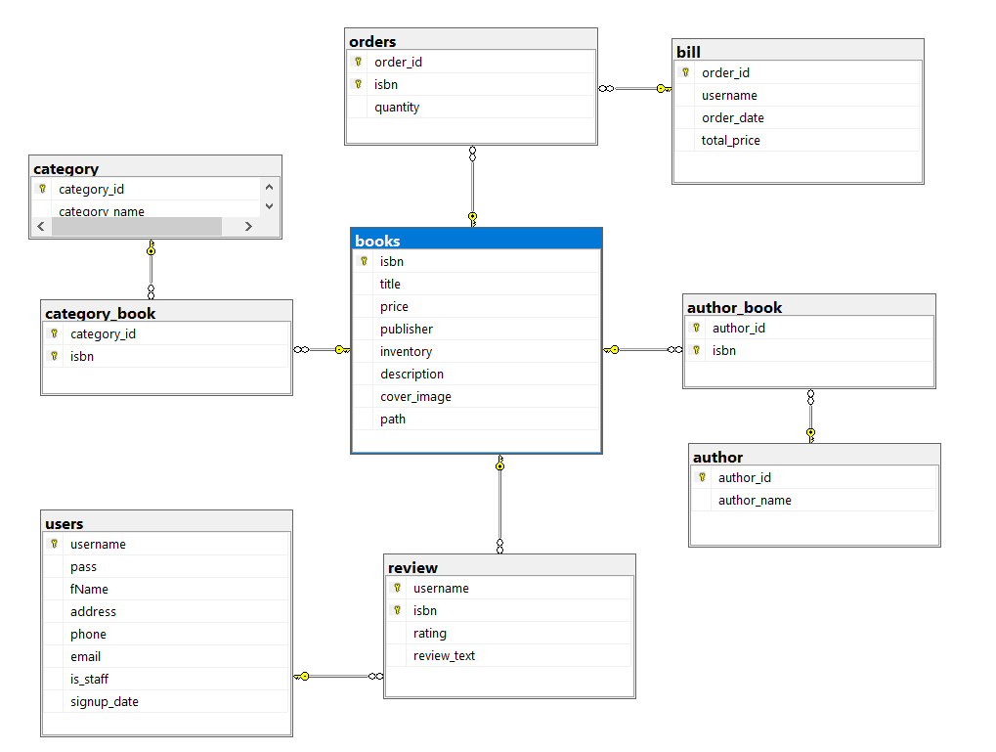

1. Entity relationship diagram (ERD):

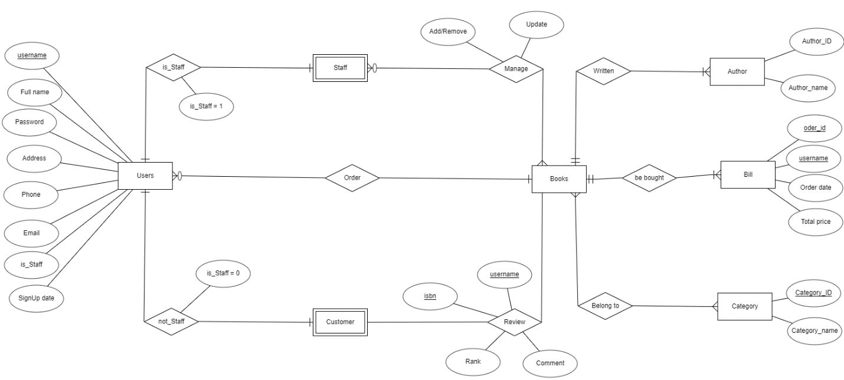

1. Relational model:
2. Use case diagram:
3. **Content:**