1. 建立food資料庫

CREATE DATABASE "Food";

1. 重置自動遞加
   1. 第一種(因為有FOREIGN KEY 條件約束，所以不能用)

TRUNCATE TABLE store_info

* 1. 第二種(會刪除原本所有資料)

DELETE store_info;

DBCC CHECKIDENT(' store_info ', RESEED, 0);

1. 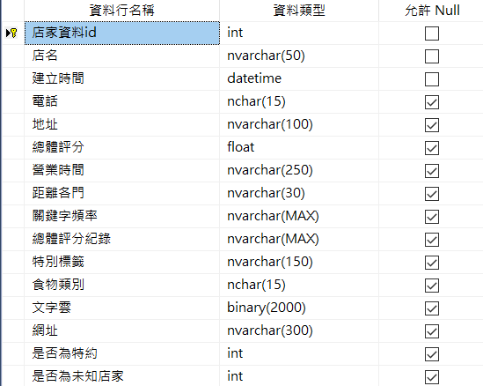建立store_info資料表

CREATE TABLE store_info

(

store_info_id int PRIMARY KEY NOT NULL IDENTITY (1, 1),

store_name nvarchar(70) NOT NULL,

create_time datetime NOT NULL,

phone_number nchar(15) NULL,

address nvarchar(100) NULL,

total_score float(53) NULL,

business_hour nvarchar(350) NULL,

distance nvarchar(30) NULL,

latitude_longitude nvarchar(30) NULL,

keyword_record nvarchar(MAX) NULL,

total_score_record nvarchar(MAX) NULL,

special_label nvarchar(150) NULL,

food_category nchar(15) NULL,

wordcloud varchar(MAX) NULL,

url nvarchar(300) NULL,

is_appointed_store int NULL,

is_unknown_store int NULL

)

1. 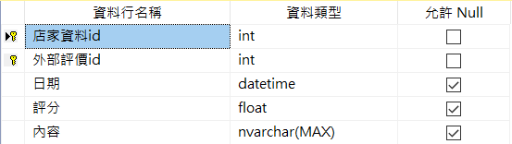建立 store_external_comment資料表

CREATE TABLE store_external_comment

(

store_info_id int NOT NULL,

external_comment_id int NOT NULL IDENTITY (1, 1),

create_time datetime NULL,

score float(53) NULL,

content nvarchar(MAX) NULL,

PRIMARY KEY(external_comment_id)

)

1. 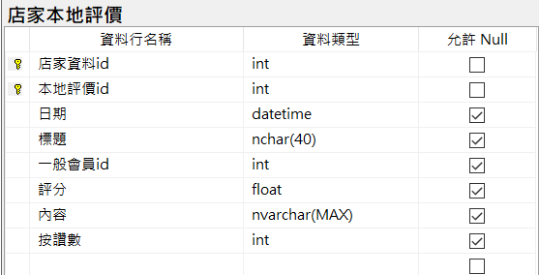建立store_local_comment資料表

CREATE TABLE store_local_comment

(

store_info_id int NOT NULL,

local_comment_id int NOT NULL IDENTITY (1, 1),

create_time datetime NULL,

title nchar(40) NULL,

member_id int NULL,

score float(53) NULL,

content nvarchar(MAX) NULL,

image varchar(MAX) NULL,

like_num int NULL,

PRIMARY KEY(local_comment_id)

)

此表不用了

1. ~~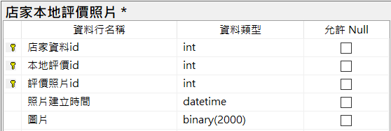建立store_local_comment_image資料表~~

~~CREATE TABLE store_local_comment_image~~

~~(~~

~~store_info_id int NOT NULL,~~

~~local_comment_id int NOT NULL,~~

~~comment_image_id int NOT NULL IDENTITY (1, 1),~~

~~create_time datetime NOT NULL,~~

~~image varchar(MAX) NOT NULL,~~

~~PRIMARY KEY(comment_image_id)~~

~~)~~

1. 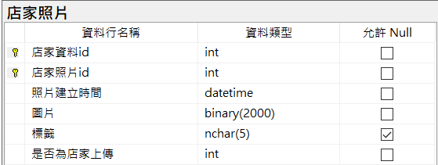建立store_image資料表

CREATE TABLE store_image

(

store_info_id int NOT NULL,

store_image_id int NOT NULL IDENTITY (1, 1),

create_time datetime NOT NULL,

image varchar(MAX) NOT NULL,

label nchar(5) NULL,

is_from_store_owner int NOT NULL,

PRIMARY KEY(store_image_id)

)

1. 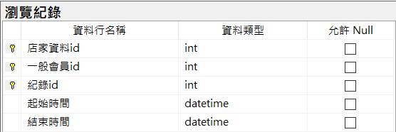建立browsing_history資料表

CREATE TABLE browsing_history

(

store_info_id int NOT NULL,

member_id int NOT NULL,

history_id int NOT NULL IDENTITY (1, 1),

start_time datetime NOT NULL,

end_time datetime NOT NULL,

PRIMARY KEY(history_id)

)

1. 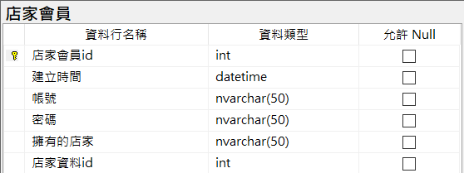建立store_owner資料表

CREATE TABLE store_owner

(

store_owner_id int PRIMARY KEY NOT NULL IDENTITY (1, 1),

create_time datetime NOT NULL,

account nvarchar(50) NOT NULL,

password nvarchar(50) NOT NULL,

store_nane nvarchar(50) NOT NULL,

store_info_id int NOT NULL

)

1. 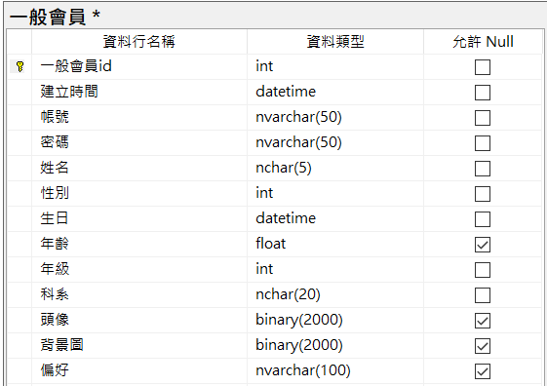建立member資料表

CREATE TABLE member

(

member_id int PRIMARY KEY NOT NULL IDENTITY (1, 1),

create_time datetime NOT NULL,

account nvarchar(50) NOT NULL,

password nvarchar(50) NOT NULL,

name nchar(5) NOT NULL,

gender int NOT NULL,

birthday datetime NOT NULL,

age float(53) NULL,

grade int NOT NULL,

department nchar(20) NOT NULL,

avatar varchar(MAX) NULL,

background varchar(MAX) NULL,

preference nvarchar(MAX) NULL

)

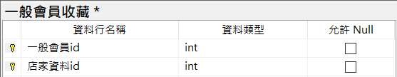

1. 建立member_collection資料表

CREATE TABLE member_collection_id

(

member_id int NOT NULL,

store_info_id int NOT NULL,

create_time datetime NOT NULL,

PRIMARY KEY(member_id, store_info_id)

)

1. 全部(直接複製下面，到資料庫貼上，格式會自動轉換)

CREATE TABLE store_info

(

store_info_id int PRIMARY KEY NOT NULL IDENTITY (1, 1),

store_name nvarchar(70) NOT NULL,

create_time datetime NOT NULL,

phone_number nchar(15) NULL,

address nvarchar(100) NULL,

total_score float(53) NULL,

business_hour nvarchar(350) NULL,

distance nvarchar(30) NULL,

latitude_longitude nvarchar(30) NULL,

keyword_record nvarchar(MAX) NULL,

total_score_record nvarchar(MAX) NULL,

special_label nvarchar(150) NULL,

food_category nchar(15) NULL,

wordcloud varchar(MAX) NULL,

url nvarchar(300) NULL,

is_appointed_store int NULL,

is_unknown_store int NULL

)

CREATE TABLE store_external_comment

(

store_info_id int NOT NULL,

external_comment_id int NOT NULL IDENTITY (1, 1),

create_time datetime NULL,

score float(53) NULL,

content nvarchar(MAX) NULL,

PRIMARY KEY(external_comment_id)

)

CREATE TABLE store_local_comment

(

store_info_id int NOT NULL,

local_comment_id int NOT NULL IDENTITY (1, 1),

create_time datetime NULL,

title nchar(40) NULL,

member_id int NULL,

score float(53) NULL,

content nvarchar(MAX) NULL,

image varchar(MAX) NULL,

like_num int NULL,

PRIMARY KEY(local_comment_id)

)

CREATE TABLE store_image

(

store_info_id int NOT NULL,

store_image_id int NOT NULL IDENTITY (1, 1),

create_time datetime NOT NULL,

image varchar(MAX) NOT NULL,

label nchar(5) NULL,

is_from_store_owner int NOT NULL,

PRIMARY KEY(store_image_id)

)

CREATE TABLE browsing_history

(

store_info_id int NOT NULL,

member_id int NOT NULL,

history_id int NOT NULL IDENTITY (1, 1),

start_time datetime NOT NULL,

end_time datetime NOT NULL,

PRIMARY KEY(history_id)

)

CREATE TABLE store_owner

(

store_owner_id int PRIMARY KEY NOT NULL IDENTITY (1, 1),

create_time datetime NOT NULL,

account nvarchar(50) NOT NULL,

password nvarchar(50) NOT NULL,

store_nane nvarchar(50) NOT NULL,

store_info_id int NOT NULL

)

CREATE TABLE member

(

member_id int PRIMARY KEY NOT NULL IDENTITY (1, 1),

create_time datetime NOT NULL,

account nvarchar(50) NOT NULL,

password nvarchar(50) NOT NULL,

name nchar(5) NOT NULL,

gender int NOT NULL,

birthday datetime NOT NULL,

age float(53) NULL,

grade int NOT NULL,

department nchar(20) NOT NULL,

avatar varchar(MAX) NULL,

background varchar(MAX) NULL,

preference nvarchar(MAX) NULL

)

CREATE TABLE member_collection_id

(

member_id int NOT NULL,

store_info_id int NOT NULL,

create_time datetime NOT NULL,

PRIMARY KEY(member_id, store_info_id)

)

1. 後一頁有資料庫關聯圖

