A
Project Report
On
ONLINE JOB PORTAL
Submitted in partial fulfillment for the award of degree of
Master of Computer Application
(2017-2020)



Under the Guidance of: Submitted by:
Jashandeep kaur Gurmeet Kaur
Asst. Prof. Uni Roll No:
Department of Computer Sc. & Applications 2140-13-133

MALWA COLLEGE, BATHINDA

Affiliated to Punjabi University, Patiala
Approved by AICTE –New Delhi

Dated: 08/05/2020

CERTIFICATE

It is certified that the project entitled Online Job Portal is submitted in partial fulfillment of the requirement for the award of degree of M.C.A in the Department of Computer Science & Applications, Malwa College, Bathinda. This project has been done by Gurmeet kaur a bonafide student of the department, in Gurukull infosystems from Bathinda to under my supervision.

Training In-Charge
Name: Arti Makkar
Designation: Trainer Head
Address of Company: Bathinda

CANDIDATE DECLARATION

I hereby declare that Project entitled “ Online Job Portal” submitted to Punjabi University ,Patiala for partial fulfillment of the requirement for the award of degree of Master of Computer Application for Session 2017-2020 from MALWA COLLEGE,BATHINDA has not previously formed the basis for the award of any other degree, diploma or other title .The above mentioned project is my own work.

Place: Bathinda Gurmeet Kaur
Date:08/05/2020

CERTIFICTE

This is to certify that the project work entitled “Online Job Portal” submitted to Department of Computer Science & Applications in partial fulfillment of the requirement for the award of degree of Master of Computer Applications has been done by Ms/Mr. Gurmeet Kaur under my guidance.

Signature of Deputy Director Signature of Supervisor
Dr.Sarbjeet Kaur Dhillon Jashandeep kaur

Date. 08/05/2020. Date: 08/05/2020

ACKNOWLEDGEMENT

First and for most we would like to express our gratitude to our guide MR. R K Chopra sir & other faculty member for giving us wonderful opportunity to work on the project. We are very thankful to him who was always ready to lend their helping hand to us. This project has giving us fair exposure to some of the very interesting features of “Online Job Portal” and “Java” along beyond doubt it will help us in the short and long run. We are very grateful to him introducing me to some of very exciting features of “Online Job Portal”.

We are also thankful to all my teachers of Malwa College,Bathinda. Who were simply full ideas and whenever there was any need they shared those great ideas and concept with us And in the end, we would like to thank all those who helped us during the testing phase of the project.

THAKING YOU………

DECLERATION

I hereby declare that this project report entitled “Online Job Portal” submitting for partially fulfillment of the requirement for the Major Project. This report is only for educational purpose and not for any other purpose.

Gurmeet Kaur 2140-13-133

INDEX

Sr no. | Topics | Page no.
1. | Introduction | 9
2 | Objective | 11
3 | Requirement Analysis | 12
4 | Overview | 14
5 | System Specification | 17
6 | SDLC | 18
7 | System Analysis | 20

8 | Feasibility Study | 21
9 | System Design | 23
10 | E – R Diagram | 26
11 | Database | 28
12 | Source Code | 30
13 | Snap Short | 56

14 | Testing | 59
15 | Implementation | 60
16 | Futuristic Scope | 61
17 | Bibliography | 62
18 | Conclusion | 63

INTRODUCTION

Online Job Portal
Online Job Portal is the Simple Job Portal Solution. It is Portal for Job solution where we put simple functioning like post a job and applying job. We put simple basic function in this portal. We would increase this project to another level by putting so many other services, but we didn’t do that because we are showing this project as a minor project. But this project is full filling all the necessary requirement of a job portal
What is Job Portal System?
Job portal is system for basic function like posting a required job by employer and applying a required job by needy. The development of this new system contains the following activities, which try to develop on-line application by keeping the entire process in the view of database integration approach. User gets its username id and password to access their account. Administrator of Job portal has multifunction like registration of employee, employer,
Brief overview of the technology:
Front end: HTML, CSS, JavaScript
- HTML: HTML is used to create and save web document. E.g. Notepad/Notepad++
- CSS : (Cascading Style Sheets) Create attractive Layout
- JavaScript: it is a programming language, commonly use with web browsers.
Back end: Java, MySQL
Architecturally, JSP may be viewed as a high-level abstraction of Java servlets. JSP pages are loaded in the server and are operated from a structured special installed Java server packet called a Java EE Web Application, often packaged as a .war or .ear file archive.
JSP allows Java code and certain pre-defined actions to be interleaved with static web markup content, with the resulting page being compiled and executed on the server to deliver an HTML or XML document. The compiled pages and any dependent Java libraries use Java bytecode rather than a native software format, and must therefore be executed within a Java virtual machine (JVM) that integrates with the host operating system to provide an abstract platform-neutral environment.
JSP syntax is a fluid mix of two basic content forms: servlet elements and markup. Markup is typically standard HTML or XML, while servlet elements are delimited blocks of Java code which may be intermixed with the markup. When the page is requested the Java code is executed and its output is added, in situ, with the surrounding markup to create the final page. JSP pages must be compiled to Java bytecode classes before they can be executed, but such compilation is needed only when a change to the source JSP file has occurred.
The JSP syntax adds additional XML-like tags, called JSP actions, to invoke built-in functionality. Additionally, the technology allows for the creation of JSP tag libraries that act as extensions to the standard HTML or XML tags. JVM operated tag libraries provide a platform independent way of extending the capabilities of a web server. Note that not all commercial Java servers are Java EE specification compliant.
MySQL is a relational database management system (RDBMS)^{[2]} that runs as a server providing multi-user access to a number of databases. The SQL phrase stands for Structured Query Language.
The software components used in our project are as under:
- Eclipse
- MySQL database

OBJECTIVE

Starting the project, we should fully know about the meaning of project. There are seven letters in the word “PROJECT”. Each character has its own technical meaning.
P – planning : this deals with the idea at thinking and which are required for project.
R – Resource : the money problem will be solved and resources from which collected.
O – Operating : the procedure from which getting job is prepared in a systematic way is known as operation.
J – Joint effort : this is directly proper to a operation output is a made of several person working sincerely is known as JOIN EFFORT.
E – Engineering : A well educated engineer can do this work in a better way to find out better result. Hence the project is as engineer function.
C – Cooperation : To make the project successfully, it is necessary for its success and completion of project.
T – Technique : It must as it gives a better shape. It is not possible to complete the project without technique.

The project is a system that gives the systematic way of planning and working.
Or
It representing the temporary task, in a scientific manner carried out of engineers to achieve a goal.

REQUIREMENT ANALYSIS

A Subject People are Interested In
The most successful blogs are written about topics that have a broad appeal. The more people who are interested in the topic you write about at your blog, the more people will search for information on that topic and want to read about it.

Passion for Your Subject
As a blogger, you have to write about your blog's subject a lot. The writing is nonstop. If you don't love your blog's topic, it will show. Readers can detect when a blogger is just going through the motions rather than speaking from the heart.

Commitment
Successful blogging requires a massive amount of sweat equity and dedication. Building a successful blog requires more than just publishing a new post a few times a week. The most successful blogs are updated frequently (often several times each day), and the bloggers behind those blogs work relentlessly to promote their blogs and drive traffic to them.

Time
Building a successful blog requires a massive time investment. Growing a blog doesn't stop with publishing post. Top bloggers spend a lot of time everyday promoting their blogs, researching and reading to drive traffic to it.

A Desire to Network
Socializing is a critical component of developing a successful blog. Blogging by nature is a social medium, and successful blogs become so primarily because of the strong sense of community surrounding them. Top bloggers take time to respond to comments and interact with their blogs' readers as well as network on social sites, forums and more all in an effort to further promote their blogs.

A Desire to Keep Learning
The blogosphere is ever-changing, which means top bloggers are always looking for new ways to enhance their blogs by persistently researching anything and everything related to blogging.

A Love of Research and Reading
Successful bloggers read a lot in order to stay updated on their blogs' topics and the blogosphere as a whole.

Creativity
A successful blog is typically updated very frequently. That means successful blogs always provide fresh, unique content to their readers. Writing that new content requires a great deal of creativity to keep readers from feeling bored or from feeling like the blog does not bring them any value.

Patience
Blogging success does not happen overnight. Be prepared to stay dedicated to promoting your blog for the long haul. Eventually, your hard work should pay off with increased traffic and a significant growth in popularity of your blog. The key is to not give up.

OVERVIEW
The importance of placement system is increasing day by day. Thousands of applicants are depending placement cell. But the applicants are facing so many problems. This project is an attempt to minimize the problems of an applicant to find a correct job. If we can make it an online computerized and a mobile alert process it will be so fast and convenient for the applicants. Far from upsetting matters, however, new technologies have predominantly made life better and considerably easier for most 0people, and so it must be concluded that they should be welcomed.
Software does not require a dedicated computer and can be run on almost any PC running Windows OS The package includes the MOB JOBS software and a normal cell phone and data cable. It uses a normal SIM card from a GSM operator with a local mobile number. In functionality it is similar to the four digit short codes but unlike short codes that is billed according to the agreement between the content provider and the service provider and can only be reached from certain networks a long code (Local GSM number) can be accessed from almost anywhere in the world for the price of an Normal SMS depending on location and tariff of the Local GSM operator. Receiving the response is an incoming SMS and is free.
Existing system
The existing system is a manual system of limitations like accuracy, expense, low speed and efficiency and unformatted outputs. In the existing system, all data processing is done manually. All the files and record books are replaced by the software system. When there are a lot of issues such as retrieval and storage of the information and keeping track of them becomes a tedious task. By implementing a computerized system, the limitation in the present system will be reduced. Manpower can be reduced to a great extent and efficiency and accuracy can be increased to manifold. More over consumption of time can be reduced to far greater extend by the implementation of the proposed system.
Proposed system
In the proposed system we propose to computerize the above-mentioned activities. In the existing system, all data processing is done manually. When there are a lot of issues such as retrieval and storage of the information and keeping track of them becomes a tedious task. By implementing a computerized system, the limitation in the present system will be reduced. Manpower can be reduced to a great extent and efficiency and accuracy can be increased to manifold. More over consumption of time can be reduced to far greater extend by the implementation of the proposed system.
The proposed computer based information system is aimed at eliminating the limitations of the existing system via increasing speed of information retrieval, by increasing processing speed, data security and hence give accurate reports. The proposed system fully satisfies user needs. All most all the limitations of the existing system are reduced in a great manner. Details are stored in various files from which data can be accessed and manipulated easily.
In the proposed system there are two sections one is administration part in which the following processes are carried out.

Merits of proposed system
- A lot of manual work which is time consuming and tedious can be reduced.
- Eliminates wrong entries and hence give accurate report.
- Reduce paper work and extra cost.
- Data redundancy can be avoided.
- Data security.
- Information retrieval is faster.
- User friendliness.
- Flexibility.
- The number of registers can be reduced.
- The new system provides data consistency and integrity so that data at any time represent the current status.
- The system should provide better security and control over data.

Module description
1). Applicant registration
2). Company registration
3). Job search
4). Vacancy Registration
5). Message
1) Applicant registration:
The applicant can register into the site by providing his details and he can set his username and password for logging in later.
2) Company registration:
The authority of the company can register into the site by providing its details and they can set its username and password for logging in. They can also specify their requirements for each vacancy.
3) Job search:
Applicants can search for the job vacancies in the fields of their choice and apply as interested.
4) Vacancy registration:
Authority of the company can provide all the necessary information about the vacancies in each post along with eligibility criteria.
5) Message:
Software selects the apt ones from the registered applicants for each post and informs them by a mobile alert. The message includes interview details.

SYSTEM SPECIFICATION
Hardware requirements
Minimum Requirements
Processors : Intel Pentium Pro or Processor running at 133 MHz
Hard Disk : 1.2 GB Hard Disk
RAM : Client Level – Minimum 128MB
Recommended Requirements for peek performance
Processors : Intel Pentium III running at 450 MHz
RAM : Client Level – Minimum 512MB
Display Type: SVGA Color Monitor
Keyboard : Enhanced 104 Standard
Mouse : PS/2 2 Button

Software requirements

Operating System : WINDOWS 2000/2003/
XP/WINDOWS 7/WINDOWS VISTA
Tools used:
Front end: ECLIPSE
Back end: MYSQL ,TOMCAT SERVER

SDLC

Software development life cycle

The software development life cycle (SDLC) is a framework defining tasks performed at each step in the software development process. SDLC is a structure followed by a development team within the software organization. It consists of a detailed plan describing how to develop, maintain and replace specific software. The life cycle defines a methodology for improving the quality of software and the overall development process.
This term is also known as the software development process.

SDLC consists of following activities:
Planning:
The most important parts of software development, requirement gathering or requirement analysis are usually done by the most skilled and experienced software engineers in the organization. After the requirements are gathered from the client, a scope document is created in which the scope of the project is determined and documented.
Implementation:

The software engineers start writing the code according to the client's requirements.
Testing:
This is the process of finding defects or bugs in the created software.
Documentation:
Every step in the project is documented for future reference and for the improvement of the software in the development process. The design documentation may include writing the application programming interface (API).

Deployment and maintenance:

The software is deployed after it has been approved for release.

Maintaining:

Software maintenance is done for future reference. Software improvement and new requirements (change requests) can take longer than the time needed to create the initial development of the software.

There are several software development models followed by various organizations:
Waterfall Model:
This model involves finishing the first phase completely before commencing the next one. When each phase is completed successfully, it is reviewed to see if the project is on track and whether it is feasible to continue.
V-Shaped Model:
This model focuses on execution of processes in a sequential manner, similar to the waterfall model but with more importance placed on testing. Testing procedures are written even before the commencement of writing code. A system plan is generated before starting the development phase.
Incremental Model:

This life cycle model involves multiple development cycles. The cycles are divided up into smaller iterations. These iterations can be easily managed and go through a set of phases including requirements, design, implementation and testing. A working version of the software is produced during the first iteration, so working software is created early in the development process.

SYSTEM ANALYSIS

System analysis is the process of examining a business situation for the purpose of developing a system solution to a problem or devising improvements to such a situation. Before the development of any system can begin, a project proposal is prepared by the users of the potential system and/or by systems analysts and submitted to an appropriate managerial structure within the organization.

Assuming that a new system is to be developed, the next phase is a system analysis. Analysis involved a detailed study of the current system, leading to specifications of a new system. Analysis is a detailed study of various operations performed by a system and their relationship with in and outside the system. During analysis, data are collected on the available files, decision points and transactions handled by the present system. Interviews, on-site observation and questionnaire are the tools used for system analysis. Using the following step it becomes easy to draw the exact boundary of the new system under consideration :

Keeping in view the problems and new requirements workout the pros and cons including new areas of the system.

All procedures, requirement must be analysed and documented in the form of detailed data flow diagrams, data dictionary, logical data structures and miniature specifications. System analysis also includes sub-dividing of complex process involving the entire system, identifiers of data stores and manual processes.

The main points to be discussed in system analysis are :
Specification of what the new system is to accomplish based on the user requirements.

Functional hierarchy showing the function to be performed by the new system and their relationship with each other.
Function network which are similar to function hierarchy but they highlight the those functions which are common to more than one procedure.
FEASIBILITY STUDY

The feasibility study investigates the problem and the information needs of the stakeholders. It seeks to determine the resources required to provide an information systems solution, the cost and benefits of such a solution, and the feasibility of such a solution. The analyst conducting the study gathers information using a variety of methods, the most popular of which are:
- Interviewing users, employees, managers, and customers.
- Developing and administering questionnaires to interested stakeholders, such as potential users of the information system.
- Observing or monitoring users of the current system to determine their needs as well as their satisfaction and dissatisfaction with the current system.
- Collecting, examining, and analyzing documents, reports, layouts, procedures, manuals, and any other documentation relating to the operations of the current system.
- Modeling, observing, and simulating the work activities of the current system.
The goal of the feasibility study is to consider alternative information systems solutions, evaluate their feasibility, and propose the alternative most suitable to the organization. The feasibility of a proposed solution is evaluated in terms of its components. These components are:

Economic feasibility
The economic viability of the proposed system. The proposed project's cost and benefits are evaluated. Tangible costs include fixed and variable costs, while tangible benefits include cost savings, increased revenue, and increased profit. A project is approved only if it covers its cost in a given period of time. However, a project may be approved only on its intangible benefits such as those relating to government regulations, the image of the organization, or similar considerations.

Technical feasibility
The possibility that the organization has or can procure the necessary resources. This is demonstrated if the needed hardware and software are available in the marketplace or can be developed by the time of implementation.

Operational feasibility
The ability, desire, and willingness of the stakeholders to use, support, and operate the proposed computer information system. The stakeholders include management, employees, customers, and suppliers. The stakeholders are interested in systems that are easy to operate, make few, if any, errors, produce the desired information, and fall within the objectives of the organization.

SYSTEM DESIGN

What is systems design?

Systems design is simply the design of systems. It implies a systematic and rigorous approach to design—an approach demanded by the scale and complexity of many systems problems.

Where did it come from?

Systems design first appeared shortly before World War II as engineers grappled with complex communications and control problems. They formalized their work in the new disciplines of information theory, operations research, and cybernetics. In the 1960s, members of the design methods movement (especially Horst Rittel and others at Ulm and Berkeley) transferred this knowledge to the design world. Systems design continues to flourish at schools interested in design planning and within the world of computer science. Among its most important legacies is a research field known as design rationale, which concerns systems for making and documenting design decisions.

What can designers learn from systems design?

Today, ideas from design methods and systems design may be more relevant to designers than ever before—as more and more designers collaborate on designing software and complex information spaces. Frameworks suggested by systems design are especially useful in modeling interaction and conversation. They are also useful in modeling the design process itself.

What is the most important thing to be aware of in systems design?

A systems approach to design asks:
For this situation, what is the system?
What is the environment?
What goal does the system have in relation to its environment?
What is the feedback loop by which the system corrects its actions?
How does the system measure whether it has achieved its goal?
Who defines the system, environment, goal, etc.—and monitors it?
What resources does the system have for maintaining the relationship it desires?
Are its resources sufficient to meet its purpose?

Is systems design incompatible with user-centered design?

A systems approach to design is entirely compatible with a user-centered approach. Indeed, the core of both approaches is understanding user goals. A systems approach looks at users in relation to a context and in terms of their interaction with devices, with each other, and with themselves.

What is the relationship between systems design and cybernetics?

Cybernetics (the science of feedback) provides an approach to systems and a set of frameworks and tools. Among the most important ideas for designers:
Definition of a system depends on point of view.
We are responsible for our actions.
All interaction is a form of conversation
All conversation involves goals, understandings, and agreement.

Are there times when systems design isn’t appropriate?

A systems approach to design is most appropriate for projects involving large systems or systems of systems. Such projects typically involve many people, from many disciplines, working together over an extended period of time. They need tools to cope with their project’s complexity: to define goals, facilitate communications, and manage processes. Solo designers working on small projects may find the same tools a bit cumbersome for their needs.

E-R DIAGRAM
Table structures
The structure of all tables included in the project is as under:-
1.Interview
+-----------+-------------+------+-----+---------+-------+
| Field | Type | Null | Key | Default | Extra |
+-----------+-------------+------+-----+---------+-------+
| can_uname | varchar(50) | YES | MUL | NULL | |
| com_name | varchar(50) | YES | MUL | NULL | |
| iv_date | date | YES | | NULL | |
| iv_time | varchar(20) | YES | | NULL | |
| iv_place | varchar(50) | YES | | NULL | |
+-----------+-------------+------+-----+---------+-------+
2.Employer
+----------+-------------+------+-----+---------+-------+
| Field | Type | Null | Key | Default | Extra |
+----------+-------------+------+-----+---------+-------+
| emp_name | varchar(50) | NO | PRI | | |
| emp_pass | varchar(50) | YES | | NULL | |
| emp_web | varchar(50) | YES | | NULL | |
+----------+-------------+------+-----+---------+-------+

3.Applicant
+----------+-------------+------+-----+---------+-------+
| Field | Type | Null | Key | Default | Extra |
+----------+-------------+------+-----+---------+-------+
| fname | varchar(50) | NO | | NULL | |
| lname | varchar(50) | NO | | NULL | |
| gender | varchar(10) | NO | | NULL | |
| username | varchar(50) | NO | PRI | NULL | |
| password | varchar(50) | NO | | NULL | |
| email | varchar(50) | NO | | NULL | |
+----------+-------------+------+-----+---------+-------+
4.Job
mysql> desc job;
+----------+-------------+------+-----+---------+-------+
| Field | Type | Null | Key | Default | Extra |
+----------+-------------+------+-----+---------+-------+
| c_name | varchar(50) | NO | PRI | | |
| c_web | varchar(50) | YES | | NULL | |
| vacancy | int(50) | YES | | NULL | |
| salary | int(50) | YES | | NULL | |
| job_desc | varchar(50) | YES | | NULL | |
| location | varchar(50) | YES | | NULL | |
| sel_post | varchar(50) | YES | | NULL | |
| iv_date | date | YES | | NULL | |
| iv_time | varchar(20) | YES | | NULL | |
| iv_place | varchar(50) | YES | | NULL | |
+----------+-------------+------+-----+---------+-------+
DATA BASE

Tables used in Online Job Portal
We have created 6 Tables in java_jobportal Database
Table Applicant
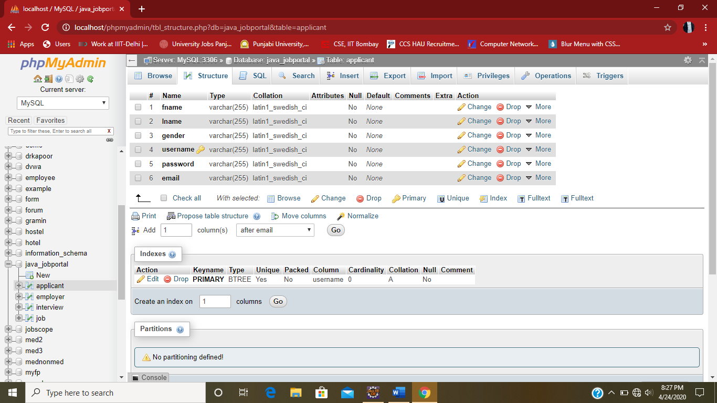
Table Employer
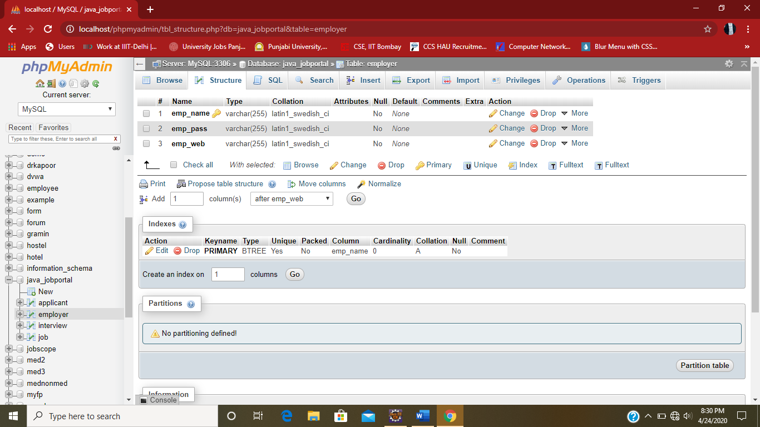

Table Job
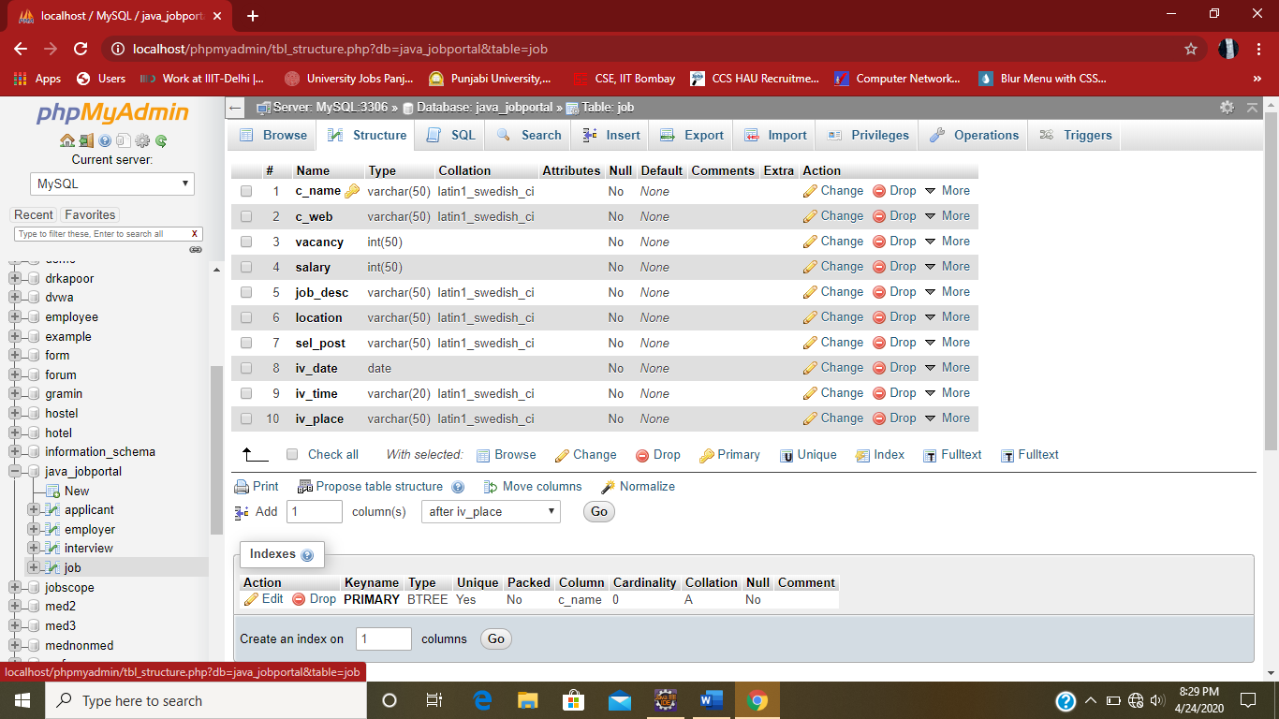
Table Interview
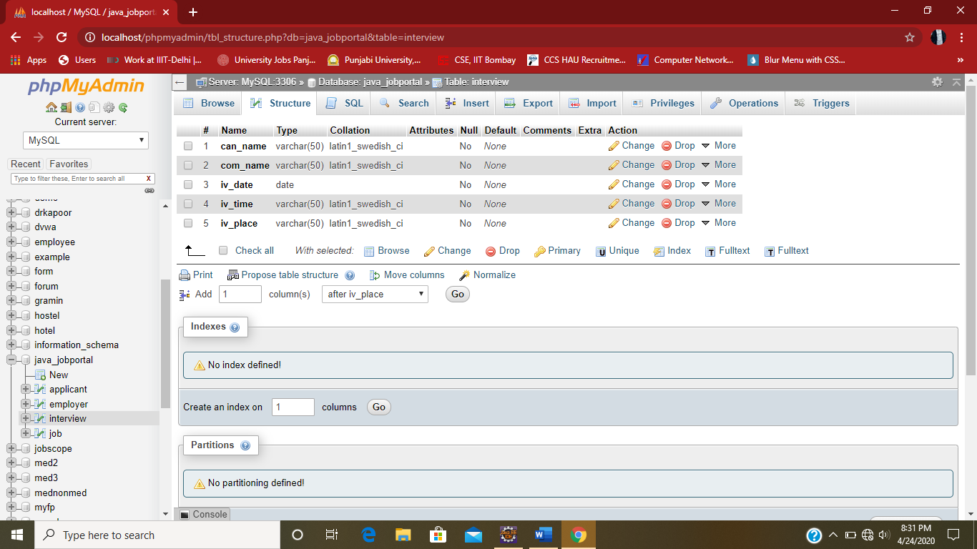

SOURCE CODE
PAGE: home1.jsp

<%@ page language="java" contentType="text/html; charset=ISO-8859-1"
pageEncoding="ISO-8859-1"%>
<!DOCTYPE html PUBLIC "-//W3C//DTD HTML 4.01 Transitional//EN" "http://www.w3.org/TR/html4/loose.dtd">
<html>
<head>
<meta http-equiv="Content-Type" content="text/html; ">
<title>Getjobs.com1 </title>
</head>
<MARQUEE behavior=alternate BGCOLOR="WHITE" TEXT="WHITE"><BLINK BGCOLOR="BLUE"><B><I><H1 ><p style="font-family:calibri;color:blue;font-size:45px;" >INFOSYS,HP,COGNIZANT,TRAVISCA,DEOLITE and MANY MORE</p></H1></I></B></BLINK></MARQUEE>
<BODY bgcolor="#ffffff" background="a.jpg">

<center><br><br>
<FONT FACE="COPPERPLATE GOTHIC BOLD" SIZE="5" COLOR="BLUE">GETJOBS.COM</center><br><center>
<table BORDER=10 WIDTH=200 HEIGHT=150 BGCOLOR="WHITE" >

<tr>

<td ALIGN=CENTER VALIGN=MIDDLE><A HREF="LOGIN_A.jsp" value=home><STRONG><p style="font-family:arial;color:blue;font-size:40px;">APPLICANT LOGIN</p></STRONG></A></td>
</tr>
<tr>
<td ALIGN=CENTER VALIGN=MIDDLE><A HREF="login_e.jsp" value=about ><STRONG>EMPLOYER LOGIN</STRONG></A></td>
</tr>

</table>
<script language="Javascript">
function linksomepage_onclick()
{
alert("REGISTER FIRST IF NEW USER OR SIGNIN");
return true;
}
</script><br><br><span style="padding-left:0px"><img src="1.gif" width="100" height="100" align = left span style="padding-left:30px">
<br>
<table>
<tr>
<td>
<font color="blue" face="impact" size="2"> <a href="" name="linkSomepage" onclick="return linksomepage_onclick()">Advertising/PR</a><br>
<td>
<font color="blue" face="impact" size="2"><a href="" name="linkSomepage" onclick="return linksomepage_onclick()">Arts/Entertainment/<br>Publishing</a><br>
<tr>
<td>
<font color="blue" face="impact" size="2"><a href="" name="linkSomepage" onclick="return linksomepage_onclick()">College</a><br>
<td>
<font color="blue" face="impact" size="2"><a href="" name="linkSomepage" onclick="return linksomepage_onclick()">Education/Training</a><br>
<td>
<font color="blue" face="impact" size="2"><a href="" name="linkSomepage" onclick="return linksomepage_onclick()">Engineering/Architecture</a><br>
<tr>
<td>
<font color="blue" face="impact" size="2"> <a href="" name="linkSomepage" onclick="return linksomepage_onclick()">Entrepreneurial/Start-up</a><br>
<td>
<font color="blue" face="impact" size="2"><a href="" name="linkSomepage" onclick="return linksomepage_onclick()">Entry Level</a><br>
<td>
<font color="blue" face="impact" size="2"><a href="" name="linkSomepage" onclick="return linksomepage_onclick()">Government</a><br>
<tr>
<td>
<font color="blue" face="impact" size="2"><a href="" name="linkSomepage" onclick="return linksomepage_onclick()">Health Care</a><br>
<td>
<font color="blue" face="impact" size="2"><a href="" name="linkSomepage" onclick="return linksomepage_onclick()">Hospitality/Travel</a><br>
<td>
<font color="blue" face="impact" size="2"><a href="" name="linkSomepage" onclick="return linksomepage_onclick()">Human Resources</a><br>
<tr>
<td>
<font color="blue" face="impact" size="2"><a href="" name="linkSomepage" onclick="return linksomepage_onclick()">Insurance</a><br>
<td>

<td>
<font color="blue" face="impact" size="2"> <a href="" name="linkSomepage" onclick="return linksomepage_onclick()">Internet/New Media</a><br>
<tr>
<td>
<font color="blue" face="impact" size="2"><a href="" name="linkSomepage" onclick="return linksomepage_onclick()">Legal</a><br>
<td>
<font color="blue" face="impact" size="2"><a href="" name="linkSomepage" onclick="return linksomepage_onclick()">Manufacturing/Operations</a><br>
<td>
<tr>
<td>
<font color="blue" face="impact" size="2"><a href="" name="linkSomepage" onclick="return linksomepage_onclick()">Marketing</a><br>

<td>
<font color="blue" face="impact" size="2"><a href="" name="linkSomepage" onclick="return linksomepage_onclick()">Pharmaceutical/Biotech</a><br>

<td>
<font color="blue" face="impact" size="2"><a href="" name="linkSomepage" onclick="return linksomepage_onclick()">Real Estate/Construction/<br>Facilities</a><br>
<tr>
<td><font color="blue" face="impact" size="2"><a href="" name="linkSomepage" onclick="return linksomepage_onclick()">Retail</a><br>
<td>
<font color="blue" face="impact" size="2"><a href="" name="linkSomepage" onclick="return linksomepage_onclick()">Sales</a><br>
<td>
<font color="blue" face="impact" size="2"><a href="" name="linkSomepage" onclick="return linksomepage_onclick()">Tech Contract</a><br>

<tr>
<td><font color="blue" face="impact" size="2"><a href="" name="linkSomepage" onclick="return linksomepage_onclick()">Technology</a><br>

<td><font color="blue" face="impact" size="2"><a href="" name="linkSomepage" onclick="return linksomepage_onclick()">Telecommunications</a><br>
<td>
<font color="blue" face="impact" size="2"><a href="" name="linkSomepage" onclick="return linksomepage_onclick()">Temp Jobs</a><br>
</table>
<br><br>
<center><font face="impact" size="1" color="black">GETJOBS.COM is a registered organization</font> </center>

</body>
</html>

PAGE: login_a.jsp

<%@ page language="java" contentType="text/html; charset=ISO-8859-1"
pageEncoding="ISO-8859-1" import="java.sql.*"%>
<!DOCTYPE html PUBLIC "-//W3C//DTD HTML 4.01 Transitional//EN" "http://www.w3.org/TR/html4/loose.dtd">
<html>
<head>
<meta http-equiv="Content-Type" content="text/html; charset=ISO-8859-1">
<title>Insert title here</title>
<script type="text/javascript" language="javascript">
function chk_onclick()
{
var myform=document.pform;
if(myform.username.value=="" || myform.passwd.value=="")
{
alert("PLEASE COMPLETE ALL THE SPECIFICATION");
if(myform.username.value=="")
{
myform.username.focus();
}
else
{
myform.passwd.focus();
}
}

}
</script>
</head>
<body background="c.jpg">
<font face="verdana,arial" size=-1>
<center><table cellpadding=2 cellspacing=0 border=0 height=500 width=600>

<tr><td bgcolor="blue"><B>APPLICANT'S LOGIN</B>
<table cellpadding=0 cellspacing=0 border=0 width=100%><tr>
<img src="login-icon.gif" width="100" height="100">
<td bgcolor="blue" align=center style="padding:2;padding-bottom:4">

<b><font size=-1 color="white"
face="verdana,arial"><b>Enter your login and password</b></font></td></tr>
<tr><td bgcolor="white" style="padding:5"><br>

<form method="post" action="LOGIN_A.jsp" name=pform>

<center><table>
<tr><td><font face="verdana,arial" size=-1>USERNAME:</td><td>
<input type="text" name="username"></td></tr>
<tr><td><font face="verdana,arial" size=-1>PASSWORD:</td><td>
<input type="password" name="passwd"></td></tr>
<tr><td><font face="verdana,arial" size=-1>&nbsp;
</td><td><font face="verdana,arial" size=-1>
<input type="submit" value="SUBMIT" name=chkform onclick="chk_onclick()"></td></tr>
<tr><td colspan=2><font face="verdana,arial" size=-1>&nbsp;</td></tr>

<tr><td colspan=2><font face="verdana,arial" size=-1>Not member yet? Click <a

href="1.jsp">here</a> to register.</td></tr>
<td align="right" valign="bottom"><img src="1.gif" width="5" height="5" ></td>
</table></center>
</form>
</td></tr></table></td></tr></table>
</body>
</html>
<%

String k1=request.getParameter("username");
session.setAttribute("t1",k1);
if(k1!=null){
try{
//int flag=2;
//String k1=request.getParameter("username");
String k2=request.getParameter("passwd");
Class.forName("sun.jdbc.odbc.JdbcOdbcDriver");
Connection c=DriverManager.getConnection("jdbc:odbc:abc","root","root");
Statement s =c.createStatement();
String sql = "select * from applicant where username='"+k1+"'";// and password='"+k2+"'";
ResultSet rs=s.executeQuery(sql);
rs.next();
String pass=rs.getString(5);

if(k2.equals(pass))
{
%>
<jsp:forward page="app_home.jsp" />
<%}
else
{
%><script type="text/javascript" language="javascript">
alert("Your ID and Password do not match.Enter a valid Login Id and Password.");
</script>
<%}

}catch(Exception e)
{
%><script type="text/javascript" language="javascript">
alert("INVALID USER ID");
</script>
<%}
}
%>

PAGE: app_home.jsp

<%@ page language="java" contentType="text/html; charset=ISO-8859-1"
pageEncoding="ISO-8859-1" import = "java.sql.*"%>
<!DOCTYPE HTML PUBLIC "-//W3C//DTD HTML 4.01 Transitional//EN" "http://www.w3c.org/TR/1999/REC-html401-19991224/loose.dtd">
<HTML><HEAD><FONT SIZE="4"COLOR="blue" FACE="roman">CANDIDATE HOME PAGE
</FONT><br>
<FONT SIZE="4"COLOR="blue" FACE="roman">WELCOME
<%=session.getAttribute("t1") %></FONT>
<TITLE>APPLICANT HOME PAGE</TITLE>
<META content="text/html; charset=windows-1252" http-equiv=Content-Type>
<META name=GENERATOR content="MSHTML 9.00.8080.16413"></HEAD>
<BODY BGCOLOR="#4EE2EC" >
<form NAME="CREATEACCTFORM" action="app_home.jsp" METHOD="POST" >
<table width="780" border="0" align="center" cellpadding="0" cellspacing="0">
<table width="100%" border="0" cellpadding="7" cellspacing="0" class="bg_white">
<tr>
<td width="400" align="right" bgcolor="#736AFF">Search Jobs</td>
</tr>
<tr>
<table border="0" align="center" cellpadding="0" cellspacing="0">
<tr>
<span id="email_msg">
</span>
</tr>

</table>

<div id="EMAILID" style="width:250px; margin-left:205px; margin-top:-20px; _margin-left:20px; _margin-top:0px; position:absolute;"></div>
<div id="ERR_EMAIL" style="padding: 2px; width: 400px; display: none;" class="txt_red small_1"></div>
</td>

</tr>

<tr>
<td align="right" valign="top">Location: </td>

<td valign="top" >

<select name="loc" style="width:165" ><option > - Select -</option><option >DELHI</option><option>BANGLORE</option><option>CHENNAI</option><option>GURGAON</option><option>HYDERABAD</option><option>MUMBAI</option><option>KOLKATA</option><option>PUNE</option><option>NOIDA</option><option>KANPUR</option></select>

<br>

</tr>

<tr>
<td align="right" valign="top"><span class="txt_orange"></span> Skills:&nbsp</td>
<td valign="top" ><select name="SKILLS" style="width:165" ><option > - Select - </option><option>ITI</option><option>C</option><option>C++</option><option>JAVA</option><option>GOOD TYPING SPEED</option></select>
<br>
<div id="UNAME" style="width:250px; margin-left:205px; margin-top:-20px; _margin-left:20px; _margin-top:0px; position:absolute;"></div>

<div id="ERR_UNAME" style="padding: 2px; width: 400px; display: none;" class="txt_red small_1"></div>
</td>

</tr>
<tr>
<td align="right" valign="top"><span class="txt_orange"></span>Functional Area: </td>
<td valign="top" >
<div id="UNAME" style="width:250px; margin-left:205px; margin-top:-20px; _margin-left:20px; _margin-top:0px; position:absolute;"></div>

<div id="ERR_UNAME" style="padding: 2px; width: 400px; display: none;" class="txt_red small_1"></div>
</td>

</tr><tr>
<select name="area" style="width:165" id="industry" ><option> - Select - </option><option>Any</option><option>Automotive</option><option>Banking</option><option >Bio Technology</option><option>Chemicals</option><option>Construction</option><option>Consumer Goods</option><option>Education</option><option>Entertainment</option><option>Insurance</option><option>BPO</option><option>Hardware</option><option>Software</option></select>
<br>
<td align="right" valign="top"><span class="txt_orange"></span> Key Word: </td>
<select name="key" style="width:165" ><option> - Select - </option><option>Sales Executive</option><option>Teacher</option><option>Manager</option><option>Accounting</option><option>Technician</option><option> Software Professional</option><option>Software Tester</option><option>IT Professional</option></select>

<td valign="top" ><br>
<input maxlength="255" size="30" name="userName" type="submit" value="SEARCH" >
<div id="UNAME" style="width:250px; margin-left:205px; margin-top:-20px; _margin-left:20px; _margin-top:0px; position:absolute;"></div>

<div id="ERR_UNAME" style="padding: 2px; width: 400px; display: none;" class="txt_red small_1"></div>
</td>

</tr>
</table>

<%
String s1=request.getParameter("loc");
String s2=request.getParameter("area");
String s3=request.getParameter("key");
session.setAttribute("a1",s1);
session.setAttribute("a2",s2);
session.setAttribute("a3",s3);
if(s1!=null && s2!=null && s3!=null){
try{

//String s1=request.getParameter("loc");
//String s2=request.getParameter("area");
//String s3=request.getParameter("key");
Class.forName("sun.jdbc.odbc.JdbcOdbcDriver");
Connection c=DriverManager.getConnection("jdbc:odbc:abc","root","root");
Statement s =c.createStatement();
String sql = "select * from job where location='"+s1+"' and job_desc='"+s2+"' and sel_post='"+s3+"'";
//out.println(s1);
//out.println(s2);
//out.println(s3);
ResultSet rs=s.executeQuery(sql);
if(rs.next())
{
%>
<jsp:forward page="job-selct.jsp"/>
<%
}
else
{
%><script type="text/javascript" language="javascript">
alert("SORRY,NO SUCH JOB AVAILABLE.");
</script>
<%
}
out.println("success");
}catch(Exception e ){out.println(e);
}
}
%>
</table>
</form>
<form method="post" action="view.jsp">
<input maxlength="255" size="30" value="VIEW APPLICATIONS" type="submit" >
</form>
</body>
</html>

PAGE: interview.jsp

<%@ page language="java" contentType="text/html; charset=ISO-8859-1"
pageEncoding="ISO-8859-1" import="java.sql.*"%>
<!DOCTYPE html PUBLIC "-//W3C//DTD HTML 4.01 Transitional//EN" "http://www.w3.org/TR/html4/loose.dtd">
<html>
<head>
<meta http-equiv="Content-Type" content="text/html; charset=ISO-8859-1">
<title>Insert title here</title>
<script language="javascript" src="cal2.js">
/*
Xin's Popup calendar script- Xin Yang (http://www.yxscripts.com/)
Script featured on/available at http://www.dynamicdrive.com/
This notice must stay intact for use
*/
</script>
<script language="javascript" src="cal_conf2.js"></script>
</head>
<body BGCOLOR="#4EE2EC">
<form action="app_home.jsp" method="post">
<%
try{
String c1=(String)session.getAttribute("t1");
String b1=(String)session.getAttribute("a1");
String b2=(String)session.getAttribute("a2");
String b3=(String)session.getAttribute("a3");
Class.forName("sun.jdbc.odbc.JdbcOdbcDriver");
Connection c=DriverManager.getConnection("jdbc:odbc:abc","root","root");
Statement s =c.createStatement();
String sql ="select * from job where location='"+b1+"' and job_desc='"+b2+"' and sel_post='"+b3+"'";
ResultSet rs=s.executeQuery(sql);
rs.next();
%>
<table BORDER=10 WIDTH=350 HEIGHT=150 BGCOLOR="WHITE" align="center">

<tr>

<td>
<FONT SIZE="4"COLOR="blue" FACE="roman">Username:<%=session.getAttribute("t1") %></FONT><br></td>
<tr><td><FONT SIZE="4"COLOR="blue" FACE="roman">Company:<%out.println(rs.getString(1));%></FONT><br></td></tr>
<tr><td> <FONT SIZE="4"COLOR="blue" FACE="roman">Vacancies:<%out.println(rs.getString(3));%></FONT><br></td></tr>
<tr><td> <FONT SIZE="4"COLOR="blue" FACE="roman">Salary: <%out.println(rs.getString(4));%></FONT><br></td></tr>
<tr><td> <FONT SIZE="4"COLOR="blue" FACE="roman">Job Post: <%out.println(rs.getString(7));%></FONT><br></td></tr>
<tr><td> <FONT SIZE="4"COLOR="blue" FACE="roman">Location: <%out.println(rs.getString(6));%></FONT><br></td></tr>
<tr><td> <FONT SIZE="4"COLOR="blue" FACE="roman">Interview date: <%out.println(rs.getString(8));%></FONT><br></td></tr>
<tr><td> <FONT SIZE="4"COLOR="blue" FACE="roman">Interview Time: <%out.println(rs.getString(9));%></FONT><br></td></tr>
<tr><td> <FONT SIZE="4"COLOR="blue" FACE="roman">Interview Place: <%out.println(rs.getString(10));%></FONT><br></td></tr>
</table>
<%
Statement m =c.createStatement();
String sq1 ="select * from interview where can_uname='"+c1+"' and com_name='"+rs.getString(1)+"'";
ResultSet rs1=m.executeQuery(sq1);
boolean a=rs1.next();
if(a==false)
{
out.println("success1");
out.println(rs.getString(8));
out.println(rs.getString(9));
out.println(rs.getString(10));
Statement p =c.createStatement();
String sq ="insert into interview values('"+c1+"','"+rs.getString(1)+"','"+rs.getString(8)+"','"+rs.getString(9)+"','"+rs.getString(10)+"')";
p.execute(sq);
out.println("success");
}
else if(a==true)
{
%><script type="text/javascript" language="javascript">
alert("YOU HAVE ALREADY REGISTERED FOR THIS COMPANY.");
</script>
<%
}
String m1=request.getParameter("rs.getString(1)");
session.setAttribute("v1",m1);
out.println("success");
}catch(Exception e ){out.println(e);
}

%>
<INPUT type="submit" value="OK" ><BR>
</form>

<form method="post" action="app_home.jsp">
<INPUT type="submit" value="BACK" ><BR>
</form>
</body>
</html>

PAGE: view.jsp

<%@ page language="java" contentType="text/html; charset=ISO-8859-1"
pageEncoding="ISO-8859-1" import="java.sql.*"%>
<!DOCTYPE html PUBLIC "-//W3C//DTD HTML 4.01 Transitional//EN" "http://www.w3.org/TR/html4/loose.dtd">
<html>
<head>
<meta http-equiv="Content-Type" content="text/html; charset=ISO-8859-1">
<title>Insert title here</title>
</head>
<body>
<form method="post" action="app_home.jsp">
<%
try{
String c1=(String)session.getAttribute("t1");
String b1=(String)session.getAttribute("v1");
Class.forName("sun.jdbc.odbc.JdbcOdbcDriver");
Connection c=DriverManager.getConnection("jdbc:odbc:abc","root","root");
Statement s =c.createStatement();
String sql ="select * from interview where can_uname='"+c1+"'";
ResultSet rs=s.executeQuery(sql);
while(rs.next())
{
int i=0;
i=i+1;

%>
<FONT SIZE="4"COLOR="blue" FACE="roman"><b>APPLICATION:</b><%=i%></FONT><br>
<FONT SIZE="4"COLOR="blue" FACE="roman">Username:<%out.println(rs.getString(1));%></FONT><br>
<FONT SIZE="4"COLOR="blue" FACE="roman">Company:<%out.println(rs.getString(2));%></FONT><br>
<FONT SIZE="4"COLOR="blue" FACE="roman">Interview date: <%out.println(rs.getString(3));%></FONT><br>
<FONT SIZE="4"COLOR="blue" FACE="roman">Interview Time: <%out.println(rs.getString(4));%></FONT><br>
<FONT SIZE="4"COLOR="blue" FACE="roman">Interview Place: <%out.println(rs.getString(5));%></FONT><br>

<%
}

}catch(Exception e ){out.println(e);
}
%>
<input type="submit" value="OK">
</form>
</body>
</html>

PAGE: job_select.jsp

<%@ page language="java" contentType="text/html; charset=ISO-8859-1"
pageEncoding="ISO-8859-1" import="java.sql.*"%>
<!DOCTYPE html PUBLIC "-//W3C//DTD HTML 4.01 Transitional//EN" "http://www.w3.org/TR/html4/loose.dtd">
<html>
<head>
<meta http-equiv="Content-Type" content="text/html; charset=ISO-8859-1">
<title>SELECT JOB</title>
</head>
<body BGCOLOR="#4EE2EC" >
<form method="post" action="interview.jsp">
<%
try{
String b1=(String)session.getAttribute("a1");
String b2=(String)session.getAttribute("a2");
String b3=(String)session.getAttribute("a3");
//out.println(b1);
Class.forName("sun.jdbc.odbc.JdbcOdbcDriver");
Connection c=DriverManager.getConnection("jdbc:odbc:abc","root","root");
Statement s =c.createStatement();
String sql ="select * from job where location='"+b1+"' and job_desc='"+b2+"' and sel_post='"+b3+"'";
ResultSet rs=s.executeQuery(sql);
rs.next();
%><table BORDER=10 WIDTH=200 HEIGHT=150 BGCOLOR="WHITE" align="center">

<tr>

<td><FONT SIZE="4"COLOR="blue" FACE="roman">Company:<%out.println(rs.getString(1));%></FONT><br></td></tr>
<tr>
<td><FONT SIZE="4"COLOR="blue" FACE="roman">Vacancies:<%out.println(rs.getString(3));%></FONT><br>
</td></tr>
<tr><td><FONT SIZE="4"COLOR="blue" FACE="roman">Salary: <%out.println(rs.getString(4));%></FONT><br></td></tr>
<tr><td><FONT SIZE="4"COLOR="blue" FACE="roman">Job Post: <%out.println(rs.getString(7));%></FONT><br></td></tr>
<tr><td><FONT SIZE="4"COLOR="blue" FACE="roman">Location: <%out.println(rs.getString(6));%></FONT><br></td></tr>

</table>
<INPUT type="submit" value="APPLY" align="center">
<%
}catch(Exception e ){out.println(e);
}

%>
</form>
<form method="post" action="app_home.jsp">
<INPUT type="submit" value="BACK" ><BR>

</form>
</body>
</html>

PAGE: 1.jsp

<%@ page language="java" contentType="text/html; charset=ISO-8859-1"
pageEncoding="ISO-8859-1" import = "java.sql.*"%>
<!DOCTYPE HTML PUBLIC "-//W3C//DTD HTML 4.01 Transitional//EN" "http://www.w3c.org/TR/1999/REC-html401-19991224/loose.dtd">
<HTML><HEAD><FONT SIZE="4"COLOR="blue" FACE="roman">Candidate Information Page :
</FONT>

<TITLE>APPLICANT LOGIN PAGE</TITLE>
<META content="text/html; charset=windows-1252" http-equiv=Content-Type>
<META name=GENERATOR content="MSHTML 9.00.8080.16413"></HEAD>
<BODY BGCOLOR="#4EE2EC" >
<form NAME="CREATEACCTFORM" action="1.jsp" METHOD="POST" >
<table width="780" border="0" align="center" cellpadding="0" cellspacing="0">

<table width="100%" border="0" cellpadding="7" cellspacing="0" class="bg_white">

<tr>
<td colspan="2" align="right" valign="top" class="border_green_btm bg_grey" style="padding:0px 10px 0px 0px;"><span class="txt_orange">*</span> Required fields</td>

</tr>

<tr>
<td width="400" align="right" bgcolor="#736AFF">Login Information</td>

</tr>

<tr>
<td align="right" valign="top"><span class="txt_orange">*</span> Email address:</td>

<td valign="top" >
<input type="text" maxlength="255" size="30" id="email" name="email" onFocus="hintEvent('EMAILID');" onBlur="hintEvent('EMAILID', 'HIDE'); showEmail(); " value="">

<table border="0" align="center" cellpadding="0" cellspacing="0">
<tr>

<span id="email_msg">

</span>

</tr>

</table>

<div id="EMAILID" style="width:250px; margin-left:205px; margin-top:-20px; _margin-left:20px; _margin-top:0px; position:absolute;"></div>
<div id="ERR_EMAIL" style="padding: 2px; width: 400px; display: none;" class="txt_red small_1"></div>
</td>

</tr>
<tr>
<td align="right" valign="top"><span class="txt_orange">*</span> First name:</td>

<td valign="top" >
<input maxlength="50" size="30" name="firstName" type="text" onFocus="hintEvent('FNAME');" onBlur="hintEvent('FNAME', 'HIDE');" value="">&nbsp;&nbsp;
<div id="FNAME" style="width:170px; margin-left:200px; margin-top:-20px; _margin-left:5px; _margin-top:0px; position:absolute;"></div>
<div id="ERR_FNAME" style="padding: 2px; width: 400px; display: none;" class="txt_red small_1"></div>

</td>
</tr>

<tr>
<td align="right" valign="top">Last name: </td>

<td valign="top" >
<input maxlength="24" size="30" name="lastName" type="text" value="">
</tr>

<tr>
<td align="right" valign="top"><span class="txt_orange">*</span> Desired username:</td>
<td valign="top" ><input maxlength="255" size="30" name="userName" onFocus="hintEvent('UNAME');" onblur="hintEvent('UNAME', 'HIDE');" type="text" value="">
<div id="UNAME" style="width:250px; margin-left:205px; margin-top:-20px; _margin-left:20px; _margin-top:0px; position:absolute;"></div>

<div id="ERR_UNAME" style="padding: 2px; width: 400px; display: none;" class="txt_red small_1"></div>
</td>

</tr>
<tr>

<td align="right" valign="top"><span class="txt_orange">*</span> Choose a password: </td>
<td valign="top" >
<input maxlength="32" size="30" name="passwd" type="password" value="">

<div id="PASS" style="width:250px; margin-left:205px; margin-top:-20px; _margin-left:20px; _margin-top:0px; position:absolute;"></div>

<div id="ERR_PASS" style="padding: 2px; width: 400px; display: none;" class="txt_red small_1"></div>
</td>
</tr>
<tr>
<td align="right" valign="top"><span class="txt_orange">*</span> Re-enter password: </td>
<td valign="top" >

<input name="passwd_temp" size="30" maxlength="32" type="password" value="">

<div id="PASS_TEMP" style="width:250px; margin-left:205px; margin-top:-20px; _margin-left:20px; _margin-top:0px; position:absolute;"></div>
<div id="ERR_PASS_TEMP" style="padding: 2px; width: 400px; display: none;" class="txt_red small_1"></div>
</td>

</tr>
<tr>
<td colspan="2" align="right" valign="top" style="background:url(http://media.monsterindia.com/v2.1/dots.gif) repeat-x; padding:0px;"><img src="http://media.monsterindia.com/v2.1/trans.gif" width="1" height="1" /></td>
</tr>
<tr>

<td width="400" align="right" bgcolor="#736AFF">Personal Details </td>
<td >&nbsp;</td>
</tr>

<tr>
<td align="right"><span class="txt_orange">*</span> Gender:</td>

<td >
<table cellspacing="0" cellpadding="0" border="0" id="gender_border">
<tr><td>
<input name="gender" type="radio" value="m" onFocus="hintEvent('GENDER1');" onBlur="hintEvent('GENDER1', 'HIDE');">
Male&nbsp;&nbsp;&nbsp;
<input name="gender" type="radio" value="f" onFocus="hintEvent('GENDER1');" onBlur="hintEvent('GENDER1', 'HIDE');">

Female </td>

</tr>
</table>
<div id="GENDER1" style="width:250px; margin-left:250px; margin-top:-60px; _margin-left:20px; _margin-top:0px; position:absolute;"></div>
<div id="ERR_GENDER1" style="padding: 2px; width: 400px; display: none;" class="txt_red small_1"></div>

</td>
</tr>
<tr>
<td colspan="2" align="right" valign="top" style="background:url(http://media.monsterindia.com/v2.1/dots.gif) repeat-x; padding:0px;"><img src="http://media.monsterindia.com/v2.1/trans.gif" width="1" height="1" /></td>

</tr><tr>
<td width="400" align="right" bgcolor="#736AFF">Professional Details </td>
<td >&nbsp;</td>
</tr>

<tr>
<td align="right"><span class="txt_orange">*</span> Total experience:</td>

<td >
<table cellspacing="0" cellpadding="0" border="0" id="exp_in_months_border">
<tr><td>
<select name="exp_in_years" class="Form_fields">
<option value="">- Select -</option>
<option value="0">0</option>
<option value="1">1</option>

<option value="2">2</option>
<option value="3">3</option>
<option value="4">4</option>
<option value="5">5</option>
<option value="6">6</option>
<option value="7">7</option>

<option value="8">8</option>
<option value="9">9</option>
<option value="10">10</option>
<option value="11">11</option>
<option value="12">12</option>
<option value="13">13</option>

<option value="14">14</option>
<option value="15">15</option>
<option value="16">16</option>
<option value="17">17</option>
<option value="18">18</option>
<option value="19">19</option>

<option value="20">20</option>
<option value="21">21</option>
<option value="22">22</option>
<option value="23">23</option>
<option value="24">24</option>
<option value="25">25</option>

<option value="26">26</option>
<option value="27">27</option>
<option value="28">28</option>
<option value="29">29</option>
<option value="30">30</option>
<option value="31">31</option>

<option value="32">32</option>
<option value="33">33</option>
<option value="34">34</option>
<option value="35">35</option>
<option value="36">36</option>
<option value="37">37</option>

<option value="38">38</option>
<option value="39">39</option>
<option value="40">40</option>
<option value="41">41</option>
<option value="42">42</option>
<option value="43">43</option>

<option value="44">44</option>
<option value="45">45</option>
<option value="46">46</option>
<option value="47">47</option>
<option value="48">48</option>
<option value="49">49</option>

<option value="50">50</option>
</select>&nbsp;Years <select name="exp_in_months" class="Form_fields" onFocus="hintEvent('WORK_EXP');" onBlur="hintEvent('WORK_EXP', 'HIDE');">
<option value="">- Select -</option>
<option value="00">0</option>
<option value="01">1</option>
<option value="02">2</option>

<option value="03">3</option>
<option value="04">4</option>
<option value="05">5</option>
<option value="06">6</option>
<option value="07">7</option>
<option value="08">8</option>

<option value="09">9</option>
<option value="10">10</option>
<option value="11">11</option>
</select>&nbsp;Months </td></tr>
</table>

<div id="WORK_EXP" style="width:250px; margin-left:250px; margin-top:-60px; _margin-left:20px; _margin-top:0px; position:absolute;"></div>

<div id="ERR_WORK_EXP" style="padding: 2px; width: 400px; display: none;" class="txt_red small_1"></div>
</td>
</tr>

<tr>
<td align="right" valign="top"><span class="txt_orange">* </span>Current / Preferred industry:</td>
<td valign="top" >
<table cellspacing="0" cellpadding="0" border="0" id="industry_border">
<tr><td>

<select name="industry" size="8" id="industry" onchange="loadFA(this,document.CREATEACCTFORM.jobCategory,0);displayAllFunction();" onFocus="hintEvent('CUR_INDUSTRY');" onBlur="hintEvent('CUR_INDUSTRY', 'HIDE');" multiple="multiple"><option value=''> - Select - </option><option value='65' >Any</option><option value='4' >Automotive/ Ancillaries</option><option value='5' >Banking/ Financial Services</option><option value='8' >Bio Technology & Life Sciences</option><option value='10' >Chemicals/ Plastic/ Rubber</option><option value='11' >Construction</option><option value='13' >Consumer Goods/ FMCG</option><option value='16' >Education</option><option value='17' >Entertainment/ Media/ Publishing</option><option value='27' >Insurance</option><option value='30' >ITES/ BPO/ KPO</option><option value='31' >IT/ Computers - Hardware</option><option value='32' >IT/ Computers - Software</option><option value='34' >Machinery/ Equipment Mfg.</option><option value='41' >Oil/ Gas/ Petroleum</option><option value='42' >Pharmaceuticals</option><option value='45' >Power</option><option value='48' >Real Estate</option><option value='49' >Retailing</option><option value='51' >Telecom</option><option value='1' >Advertising</option><option value='2' >Agriculture/ Dairy Based</option><option value='3' >Airlines</option><option value='6' >Beauty/Fitness/PersonalCare/SPA</option><option value='7' >Beverages/ Liquor</option><option value='9' >Cement</option><option value='12' >Consultancy</option><option value='14' >Courier/ Freight/ Transportation</option><option value='15' >Dotcom</option><option value='18' >Fertilizer/ Pesticides</option><option value='19' >Food & Packaged Food</option><option value='20' >Textiles / Yarn / Fabrics / Garments</option><option value='21' >Gems & Jewellery</option><option value='22' >Government/ PSU/ Defence</option><option value='23' >Home Appliances (TV, Fridge, AC etc.)</option><option value='24' >Hospitals/ Health Care</option><option value='25' >Hotels/ Restaurant</option><option value='26' >Import / Export</option><option value='28' >Iron/ Steel</option><option value='29' >ISP</option><option value='33' >Leather</option><option value='35' >Market Research</option><option value='36' >Medical Transcription</option><option value='37' >Mining</option><option value='38' >NGO</option><option value='39' >Non-Ferrous Metals (Aluminium, Zinc etc.)</option><option value='40' >Office Equipment</option><option value='43' >Paints</option><option value='44' >Paper</option><option value='46' >Printing/ Packaging</option><option value='47' >Public Relations (PR)</option><option value='50' >Shipping</option><option value='66' >Sugar</option><option value='52' >Travel/ Tourism</option><option value='53' >Tyres</option><option value='54' >Wood</option><option value='55' >Other</option></select> </td></tr>

</table>

<div id="CUR_INDUSTRY" style="width:250px; margin-left:285px; margin-top:-50px; _margin-left:275px; _margin-top:-60px; position:absolute;"></div>
<div id="ERR_INDUS" style="padding: 2px; width: 400px; display: none;" class="txt_red small_1"></div>
</td>
</tr>

<tr>
<td align="right"> Key skills: </td>

<td >
<input maxlength="100" size="35" id="keySkills" name="keySkills" type="text" onFocus="hintEvent('SKILLS');" onBlur="hintEvent('SKILLS', 'HIDE');" value="">

<div id="SKILLS" style="width:330px; margin-left:240px; margin-top:-20px; _margin-left:20px; _margin-top:0px; position:absolute;"></div>
<div id="ERR_KEYSKILL" style="padding: 2px; width: 400px; display: none;" class="txt_red small_1"></div>
</td>
</tr>

<tr>
<td colspan="2" align="right" valign="top" style="background:url(http://media.monsterindia.com/v2.1/dots.gif) repeat-x; padding:0px;"><img src="http://media.monsterindia.com/v2.1/trans.gif" width="1" height="1" /></td>

</tr>

<tr>
<td align="right">&nbsp;</td>

<td >
<table width="350" border="0" cellpadding="0" cellspacing="0">

<tr>
<td valign="bottom" class="bg_grey" >&nbsp;</td>

<td height="40" valign="bottom" class="bg_grey"><span class="button"><span>
<input type="submit" name="submit1" value="Submit"></span></span>
</td>

</table>

<%
String s5=request.getParameter("userName");
String s1=request.getParameter("firstName");
String s2=request.getParameter("lastName");
String s3=request.getParameter("gender");
String s6=request.getParameter("passwd");
String s7=request.getParameter("email");
if(s5!=null && s1!=null && s2!=null && s3!=null && s6!=null && s7!=null)
{
try{
out.println("success");

//String s4=request.getParameter("mobile");
//int a=Integer.parseInt(s4);

Class.forName("sun.jdbc.odbc.JdbcOdbcDriver");
Connection c=DriverManager.getConnection("jdbc:odbc:abc","root","root");

Statement s =c.createStatement();
String sql = "insert into applicant values('"+s1+"','"+s2+"','"+s3+"','"+s5+"','"+s6+"','"+s7+"')";

s.execute(sql);

}catch(Exception e ){out.println(e);}
}
%>
</td>
</tr>

</table>
</form>
<form method="post" action="done.jsp">
<BR><input type="submit" value="LOGIN">
</form>
</body>
</html>

PAGE: emp_reg.jsp

<%@ page language="java" contentType="text/html; charset=ISO-8859-1"
pageEncoding="ISO-8859-1" import = "java.sql.*"%>
<!DOCTYPE HTML PUBLIC "-//W3C//DTD HTML 4.01 Transitional//EN" "http://www.w3c.org/TR/1999/REC-html401-19991224/loose.dtd">
<HTML><HEAD><FONT SIZE="4"COLOR="blue" FACE="roman">Candidate Information Page :
</FONT>

<TITLE>APPLICANT LOGIN PAGE</TITLE>
<META content="text/html; charset=windows-1252" http-equiv=Content-Type>
<META name=GENERATOR content="MSHTML 9.00.8080.16413"></HEAD>
<BODY BGCOLOR="#4EE2EC" >
<form NAME="CREATEACCTFORM" action="emp_reg.jsp" METHOD="POST" >
<table width="780" border="0" align="center" cellpadding="0" cellspacing="0">

<table width="100%" border="0" cellpadding="7" cellspacing="0" class="bg_white">

<tr>
<td colspan="2" align="right" valign="top" class="border_green_btm bg_grey" style="padding:0px 10px 0px 0px;"><span class="txt_orange">*</span> Required fields</td>

</tr>

<tr>
<td width="400" align="right" bgcolor="#736AFF">Login Information</td>

</tr>

<tr>
<td align="right" valign="top"><span class="txt_orange">*</span> Desired username:</td>
<td valign="top" ><input maxlength="255" size="30" name="username" onFocus="hintEvent('UNAME');" onblur="hintEvent('UNAME', 'HIDE');" type="text" value="">
<div id="UNAME" style="width:250px; margin-left:205px; margin-top:-20px; _margin-left:20px; _margin-top:0px; position:absolute;"></div>

<div id="ERR_UNAME" style="padding: 2px; width: 400px; display: none;" class="txt_red small_1"></div>
</td>

</tr>
<tr>

<td align="right" valign="top"><span class="txt_orange">*</span> Choose a password: </td>
<td valign="top" >
<input maxlength="32" size="30" name="passwd" type="password" value="">

<div id="PASS" style="width:250px; margin-left:205px; margin-top:-20px; _margin-left:20px; _margin-top:0px; position:absolute;"></div>

<div id="ERR_PASS" style="padding: 2px; width: 400px; display: none;" class="txt_red small_1"></div>
</td>
</tr>
<tr>
<td align="right" valign="top"><span class="txt_orange">*</span> Re-enter password: </td>
<td valign="top" >

<input name="passwd_temp" size="30" maxlength="32" type="password" value="">

<div id="PASS_TEMP" style="width:250px; margin-left:205px; margin-top:-20px; _margin-left:20px; _margin-top:0px; position:absolute;"></div>
<div id="ERR_PASS_TEMP" style="padding: 2px; width: 400px; display: none;" class="txt_red small_1"></div>
</td>

</tr>

<tr>
<td align="right" valign="top"><span class="txt_orange">* </span>
Web address: </td>

<td >

<table cellspacing="0" cellpadding="0" border="0" id="currentloc_border">
<tr><td>
<input type="text" name="web" value="">
</table>

</td>

</tr>
<table width="350" border="0" cellpadding="0" cellspacing="0">

<tr>
<td valign="bottom" class="bg_grey" >&nbsp;</td>

<td height="40" valign="bottom" class="bg_grey"><span class="button"><span>
<input type="submit" name="submit1" value="Submit"></span></span>
</td>

</table>
<%

String s1=request.getParameter("username");
String s2=request.getParameter("passwd");
String s3=request.getParameter("web");
out.println(s1);
out.println(s2);
if(s1!=null && s2!=null && s3!=null )
{
try{
out.println("success");
Class.forName("sun.jdbc.odbc.JdbcOdbcDriver");
Connection c=DriverManager.getConnection("jdbc:odbc:abc","root","root");
Statement s =c.createStatement();
String sql = "insert into employer values('"+s1+"','"+s2+"','"+s3+"')";
s.execute(sql);

}catch(Exception e ){out.println(e);}
}
%>

</table>
</form>
<form method="post" action="done_emp.jsp">
<table cellspacing="0" cellpadding="0" border="0" id="currentloc_border">
<tr><td>
<BR>&nbsp<input type="submit" value="SUBMIT">
</table>

</form>
</body>
</html>

PAGE: emp_home.jsp

<%@ page language="java" contentType="text/html; charset=ISO-8859-1"
pageEncoding="ISO-8859-1" import = "java.sql.*"%>
<!DOCTYPE HTML PUBLIC "-//W3C//DTD HTML 4.01 Transitional//EN" "http://www.w3c.org/TR/1999/REC-html401-19991224/loose.dtd">
<HTML><HEAD><FONT SIZE="4"COLOR="blue" FACE="roman">EMPLOYER HOME PAGE
</FONT><br>
<FONT SIZE="4"COLOR="blue" FACE="roman">WELCOME
<%=session.getAttribute("x1") %></FONT>
<TITLE>EMPLOYER HOME PAGE</TITLE>
<META content="text/html; charset=windows-1252" http-equiv=Content-Type>
<META name=GENERATOR content="MSHTML 9.00.8080.16413"></HEAD>
<script type="text/javascript">
window.history.forward();
function.noBack();
{
window.history.forward();
}
</script>
<BODY BGCOLOR="#4EE2EC" >

<form name="form1" action="login_e.jsp" method="post">
<input type="submit" value="LOGOUT" align="right">
</form>

<form NAME="CREATEACCTFORM" action="emp_home.jsp" METHOD="POST" >
<table width="780" border="0" align="center" cellpadding="0" cellspacing="0">

<table width="100%" border="0" cellpadding="7" cellspacing="0" class="bg_white">

<tr>
<td width="400" align="right" bgcolor="#736AFF">Add Jobs</td>

</tr>

<tr>

<table border="0" align="center" cellpadding="0" cellspacing="0">
<tr>

<span id="email_msg">

</span>

</tr>

</table>

<div id="EMAILID" style="width:250px; margin-left:205px; margin-top:-20px; _margin-left:20px; _margin-top:0px; position:absolute;"></div>
<div id="ERR_EMAIL" style="padding: 2px; width: 400px; display: none;" class="txt_red small_1"></div>

</tr>

<tr>
<td align="right" valign="top">Location: </td>

<td valign="top" >

<select name="loc" style="width:165" ><option > - Select -</option><option >DELHI</option><option>BANGLORE</option><option>CHENNAI</option><option>GURGAON</option><option>HYDERABAD</option><option>MUMBAI</option><option>KOLKATA</option><option>PUNE</option><option>NOIDA</option><option>KANPUR</option></select>

<br>

</tr>

<tr>
<td align="right" valign="top"><span class="txt_orange"></span>Functional Area: </td>
<td valign="top" >
<div id="UNAME" style="width:250px; margin-left:205px; margin-top:-20px; _margin-left:20px; _margin-top:0px; position:absolute;"></div>

<div id="ERR_UNAME" style="padding: 2px; width: 400px; display: none;" class="txt_red small_1"></div>
</td>

</tr><tr>
<select name="area" style="width:165" id="industry" ><option> - Select - </option><option>Any</option><option>Automotive</option><option>Banking</option><option >Bio Technology</option><option>Chemicals</option><option>Construction</option><option>Consumer Goods</option><option>Education</option><option>Entertainment</option><option>Insurance</option><option>BPO</option><option>Hardware</option><option>Software</option></select>
<br>
<td align="right" valign="top"><span class="txt_orange"></span> Job Post: </td>
<select name="key" style="width:165" ><option> - Select - </option><option>Sales Executive</option><option>Teacher</option><option>Manager</option><option>Accounting</option><option>Technician</option><option> Software Professional</option><option>Software Tester</option><option>IT Professional</option></select>
<br><td align="right" valign="top"><span class="txt_orange"></span> Vacancy: </td>
<input type="text" name="vac" value=""><bR>
<td align="right" valign="top"><span class="txt_orange"></span> Salary :</td>
<input type="text" name="sal" value=""><bR>
<td align="right" valign="top"><span class="txt_orange"></span> Interview Date: </td>
<input type="text" name="ivdt" value=""><bR>
<td align="right" valign="top"><span class="txt_orange"></span> Interview Time: </td>
<input type="text" name="ivt" value=""><bR>
<td align="right" valign="top"><span class="txt_orange"></span> Interview Place: </td>
<input type="text" name="ivp" value=""><bR>
<td valign="top" ><br>
<input maxlength="255" size="30" name="userName" type="submit" value="ADD" >
<div id="UNAME" style="width:250px; margin-left:205px; margin-top:-20px; _margin-left:20px; _margin-top:0px; position:absolute;"></div>

<div id="ERR_UNAME" style="padding: 2px; width: 400px; display: none;" class="txt_red small_1"></div>
</td>

</tr>

</table>

<%
String s1=request.getParameter("loc");
String s2=request.getParameter("area");
String s3=request.getParameter("key");
String s4=request.getParameter("vac");
String s5=request.getParameter("sal");
String s6=request.getParameter("ivdt");
String s7=request.getParameter("ivt");
String s8=request.getParameter("ivp");
if(s1!=null && s2!=null && s3!=null && s4!=null && s5!=null && s6!=null && s7!=null && s8!=null){
try{
String b1=(String)session.getAttribute("x1");
Class.forName("sun.jdbc.odbc.JdbcOdbcDriver");
Connection c=DriverManager.getConnection("jdbc:odbc:abc","root","root");
Statement s =c.createStatement();
String sql = "select * from employer where emp_name='"+b1+"'";
ResultSet rs=s.executeQuery(sql);
rs.next();
Statement a =c.createStatement();
String sql1 = "insert into job values('"+b1+"','"+rs.getString(3)+"','"+s4+"','"+s5+"','"+s2+"','"+s1+"','"+s3+"','"+s6+"','"+s7+"','"+s8+"')";
a.execute(sql1);

}catch(Exception e ){out.println(e);
}
}
%>
</table>
</form>

</body>
</html>

SNAP SHOT

1.Home Page
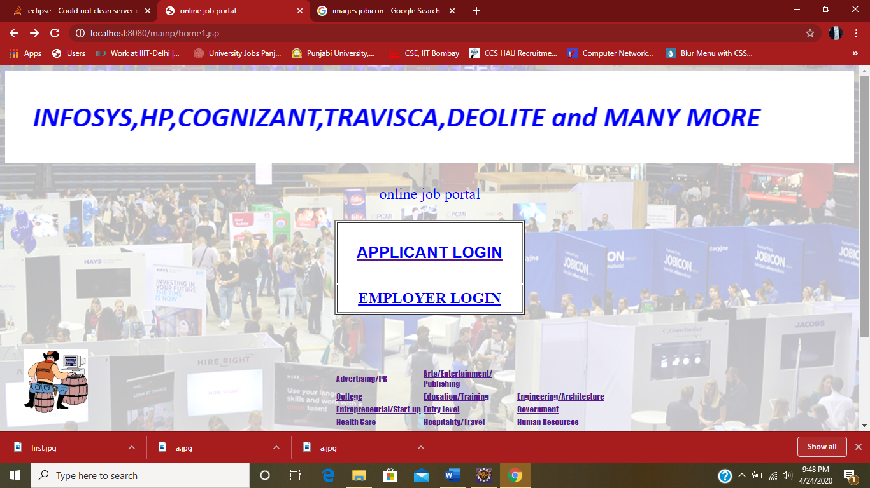
2.Login Page
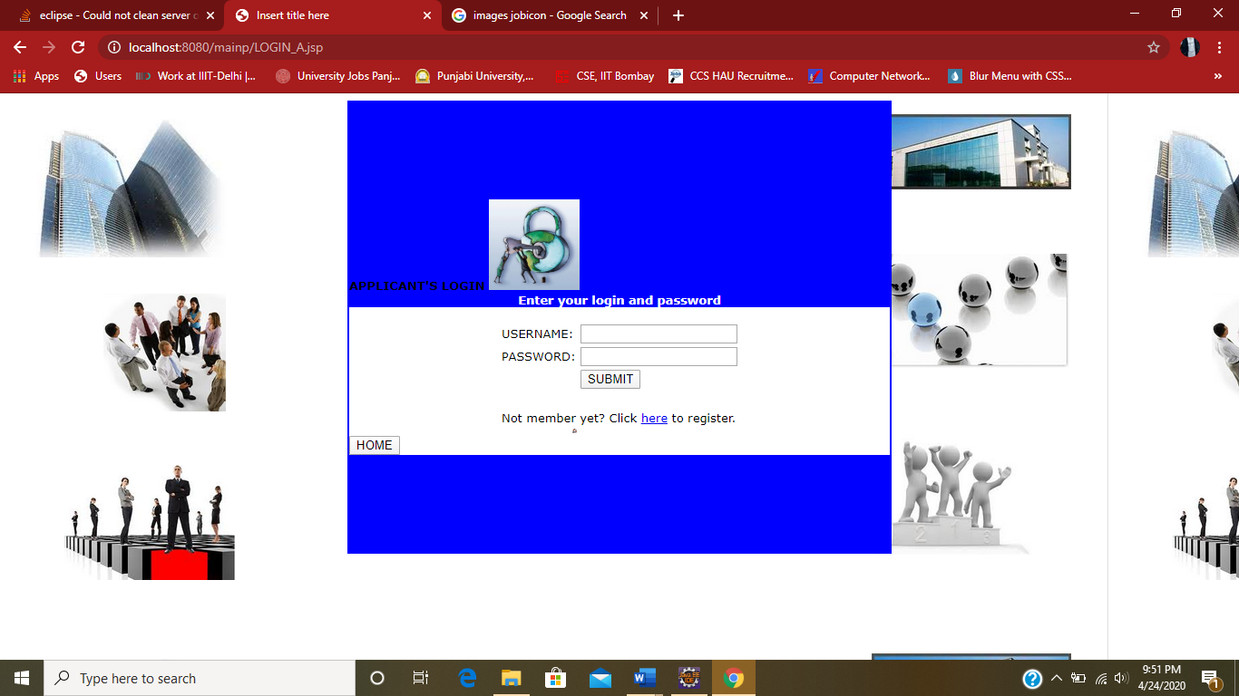
3.Candidate’s Home Page
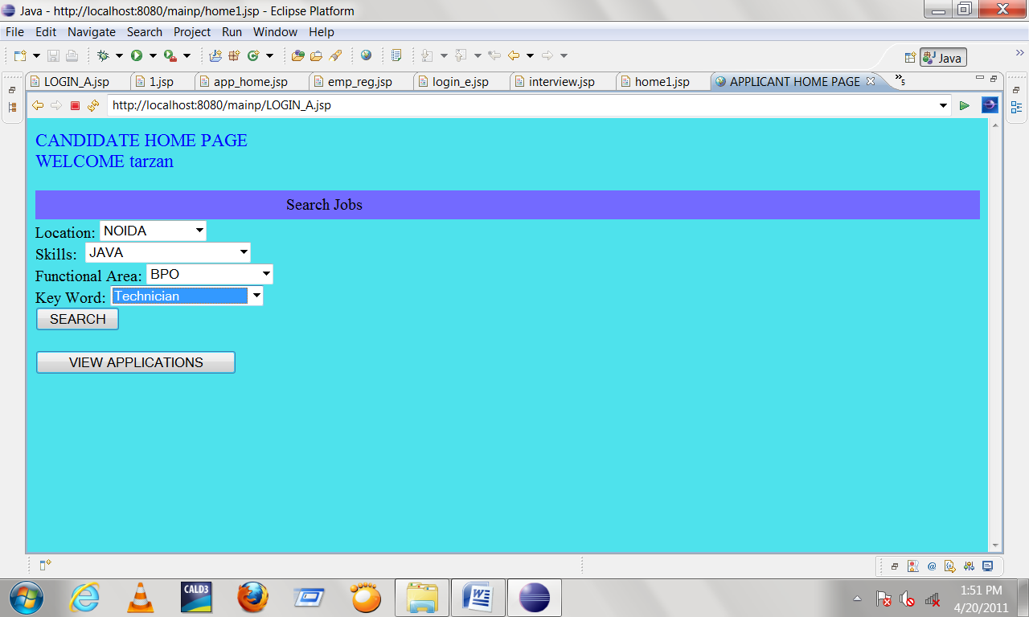
4.Interview Page
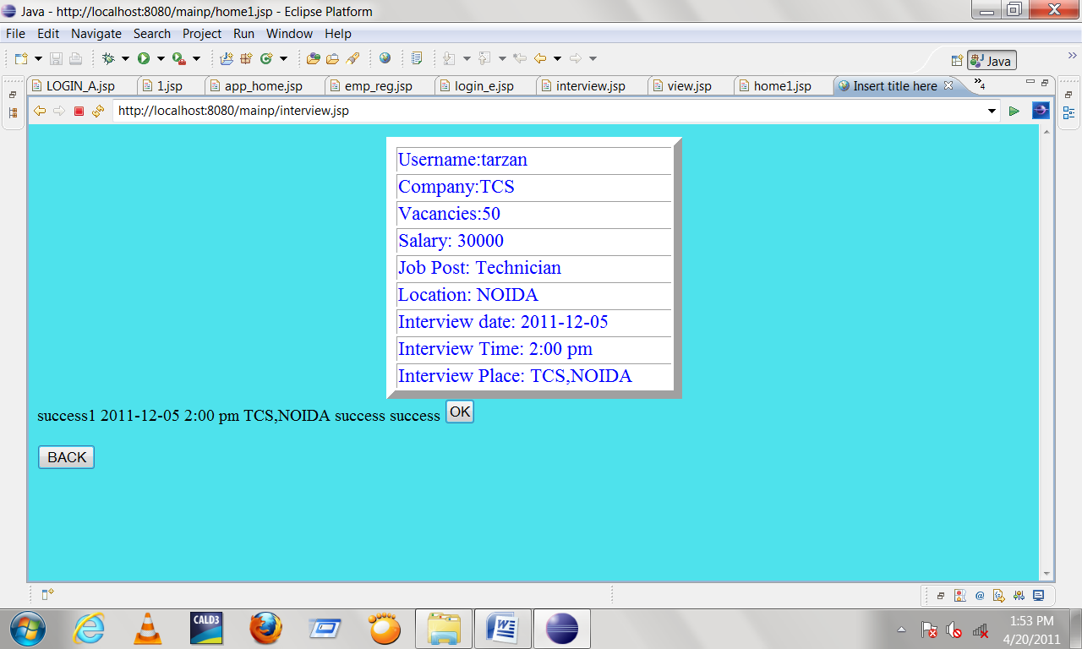

5.Candidate’s Registration Page
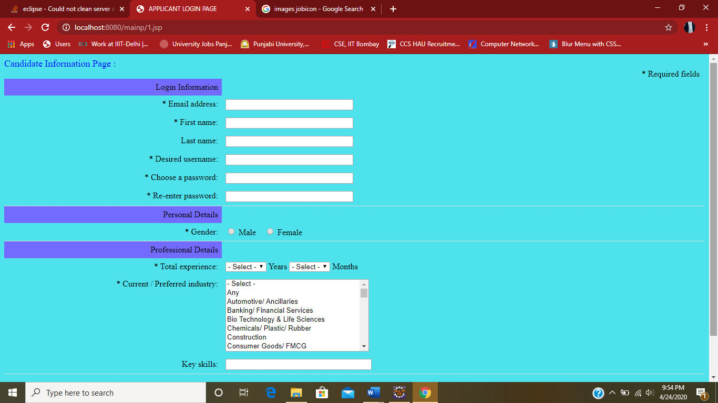
6.Employer Information Page
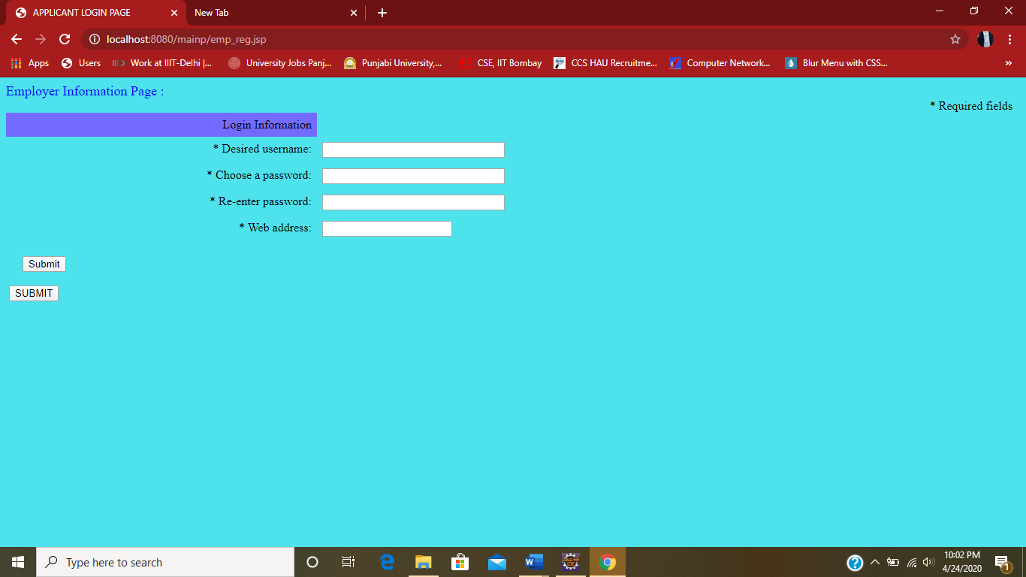

TESTING

Software testing is the process of executing a program or system with the intent of finding errors. Or, it involves any activity aimed at evaluating an attribute or capability of a program or system and determining that it meet its required results. Software is not unlike other physical processes where inputs are received and output are produced. Where software differs is in the manner in which it is fails. Most physical systems fails in a fixed (and reasonable small) set of ways. By contrast, software can fail in many bizarre ways. Detecting all of the different failure modes for software is generally infeasible.
Module testing
Here testing is done at each module level. Each case has been thoroughly tested to discover pitfalls.
System testing
Here testing is done after all the modules have been integrated.

IMPLEMENTATION

The implementation phase is less creative than system design. It is primarily concerned with user training, site preparation and file conversion. During file testing, user acceptance is, tested followed by user training. Depending on the nature of system, extensive user training may be required. Conversion usually takes place at about the same time the user is being trained. Programming is thought to be modified as a result of programming effort. Programming provides a “realty test” for the assumption made by analyst.

System testing checks the deadlines and accuracy of the system. To access, update and retrieve data from new files. Once the programs become available, test data are read into the computer and processed against the file provided. For testing, it successful program is then run with “live” data. Otherwise, a diagnostic test to locate and correct errors. In most conversion, parallel run is conducted where the new system simultaneous run both old system. This method, through costly, provided added assurance against errors in the candidate system. This method through costly, provided added assurance against errors in the candidate system and also the user staff an opportunity to gain experience through operation.

FUTURE SCOPE

The future of this project depend on whether the author has enough spare time over the next 2 month to continue with the developing. The author feels that last few remaining features would round off the system. If the author was to try to sell this system then more system testing would have to be done, in a particular a more comprehensive real – world. Testing environment would have to be adopted along with some real words usage. Multiple concurrent users would be command in real world usage but have been difficult to test for considering there was only tester involved in this project. This type of system would benefit for the hardware in case of a system failure for the software in case of newly found bugs, in return of a subscription free.

BIBLIOGRAPHY

JAVA AND MY SQL : JAVA,JSP, SERVLET AND MY SQL
JAVA SCRIPT : JAVA SCRIPT
HTML & CSS : EVEN BAYROUS

CONCLUSION

The Online job portal System is developed using java and sql fully meets the objectives of the system for which it has been developed. The system is operated at a high level of efficiency and all the job seekers and user associated with the system understands its advantage. The system solves the problem. It was intended to solve as requirement specification.

