* Users should **sign in with us** get to all the features that offered by the application.

Screens: Sign Up. Screen, Account Info. Screen, ProfileInfo.screen,

Company Name. Screen.

1. Sing Up. Screen

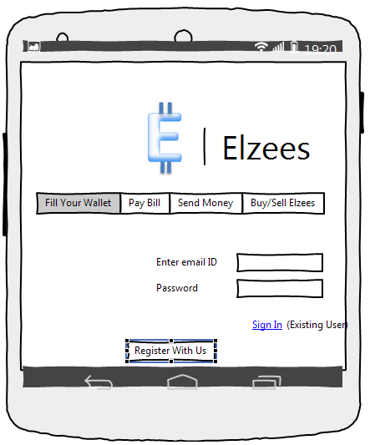

1. Account Info. Screen

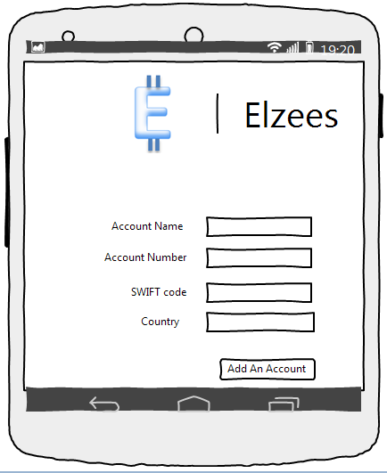

1. Profile Info. Screen

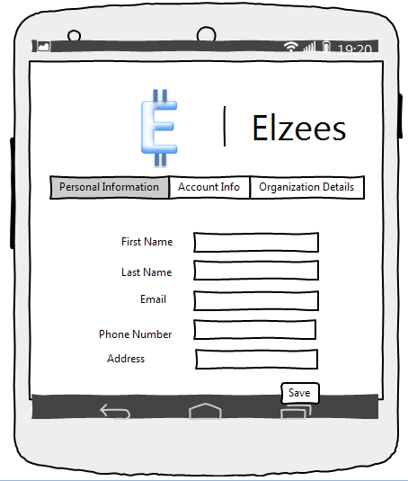

1. Company Name. Screen

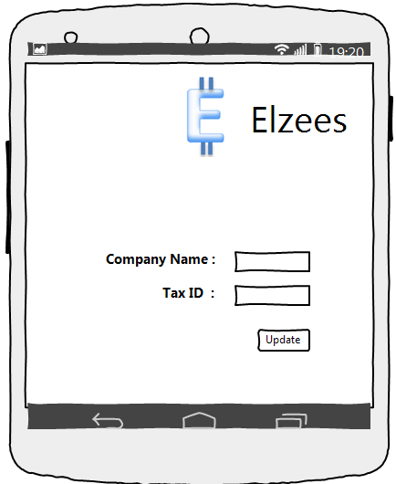

Screens: Fill Your Wallet. Screen, Deposit. Screen, Deposit Confirmation. Screen.

*<<Please note that I have not included the option using credit card to fill your wallet in the mentioned screens>>.*

1. Fill Your Wallet. Screen

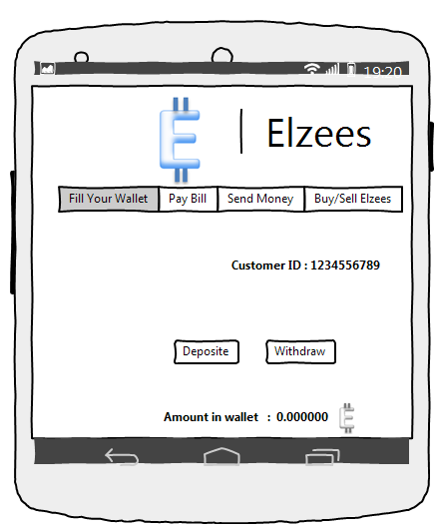

1. Deposit. Screen

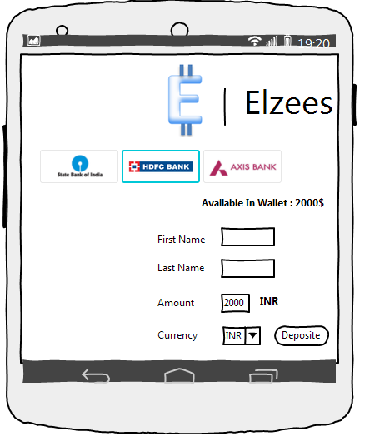

1. Deposit Confirmation. Screen

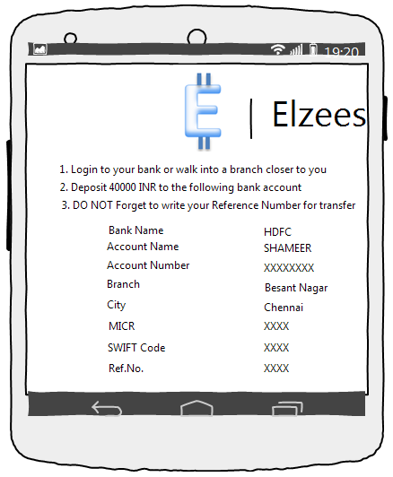



* Users should be able to buy/sell “**Elzees**” using their own wallet.

Screens: Buy elzees. Screen , Sell elzees. Screen.

1. Buy Elzees. Screen

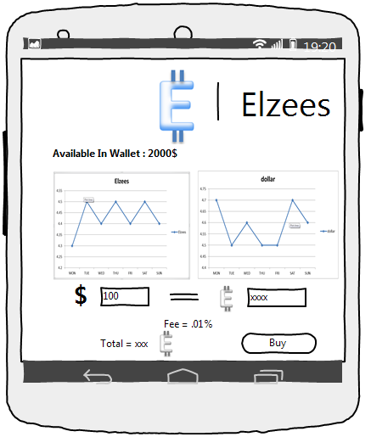

1. Sell Elzees. Screen

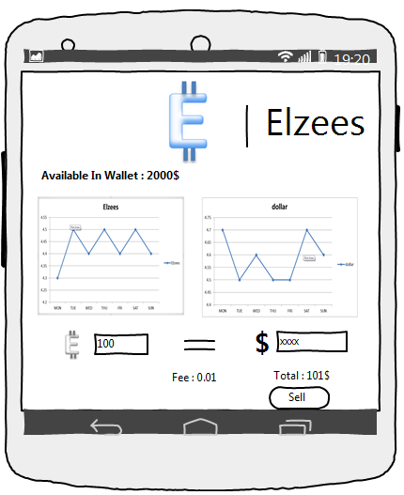

* Users should be able to do “Send Money” transaction

Screen: Send Money. Screen

1. Send Money. Screen

