**EXPERIMENT – 10**

**INSTALL & CONFIGURE JENKINS**

* **CHECK JAVA VERSION**
* **Go to command prompt -> java --version**
* **Check which java version is installed , the same compatible Jenkins version should be installed**
* **If the JDK is not installed , install it and set path in system variables**
* **INSTALL JENKINS**
* **Go to https://www.jenkins.io/**
* **Click on download**
* **In the stable [LTS] click on past releases**
* **Download the compatible version of Jenkins as per Java version**
* **Click on jenkins.war to download**

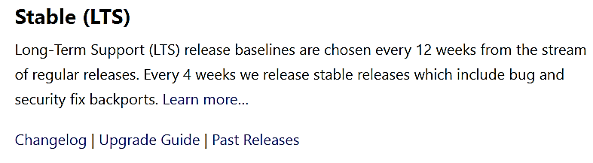 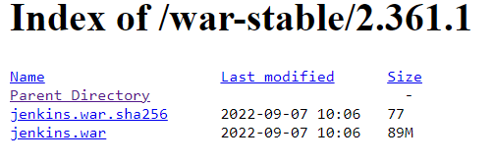

* **After the download is complete go to the folder**
* **Cut the file jenkins.war and paste it in C drive by creating a folder named Jenkins & copy the path of that folder C:\Jenkins\jenkins.war**
* **CONFIGURE JENKINS**
* **Go to command prompt and type the below command**

**java -jar C:\Jenkins\jenkins.war**

* **The Jenkins starts running after this command is typed & displays a sequence of messages**
* **There will be a key generated over the command prompt**
* **This has to copied and use it as a password for installation**

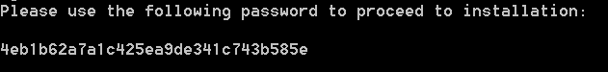

* **Go to Chrome**
* **Type localhost:8080 in the address bar**
* **The default port number of Jenkins is 8080**
* **To unlock Jenkins paste the copied key in administrator password and continue**
* **The Password key can also be found at below location**

**C:\Users\Student\.jenkins\secrets\initialAdminPassword**

* **Click on install selected plugins**

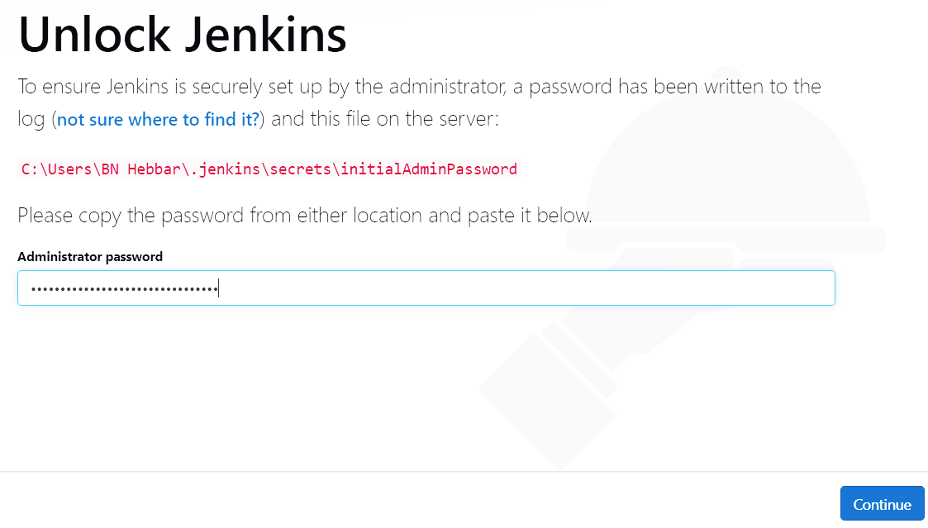 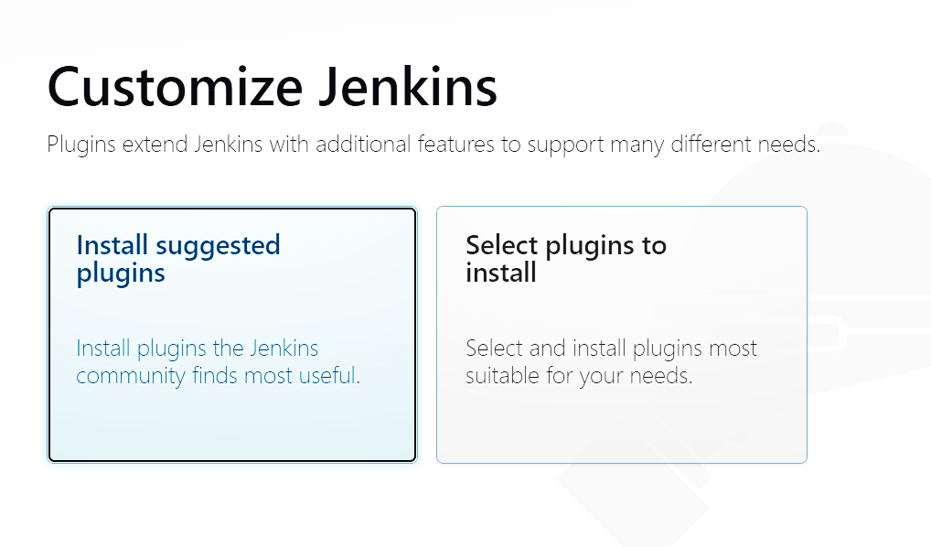

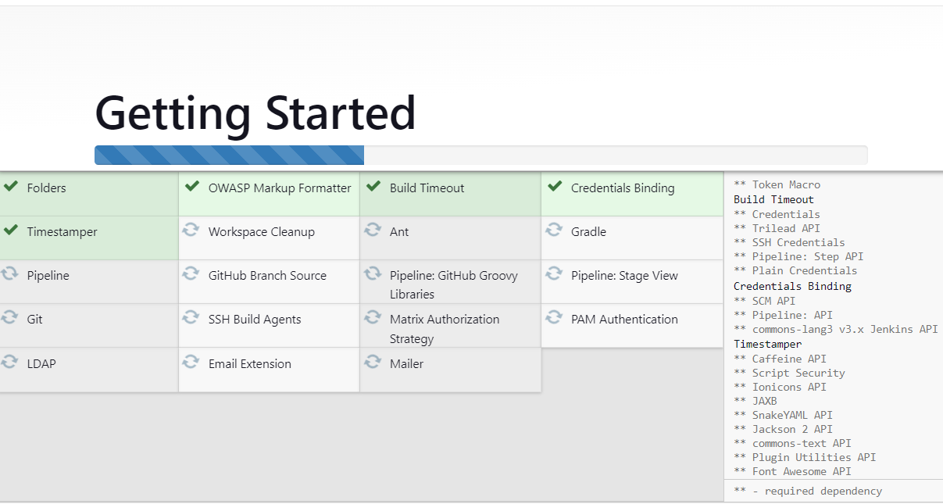

* **Once when the installation is completed the Jenkins dashboard will be displayed**

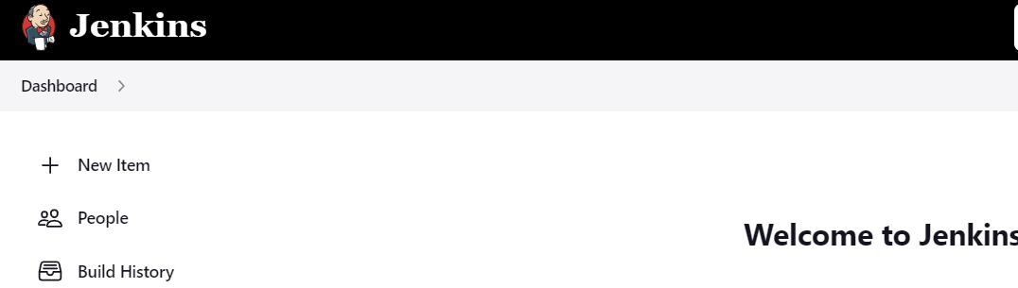

**EXPERIMENT – 10**

**CREATE CONTAINER IMAGE FOR HELLO WORLD PROJECT**

* **CREATING CONTAINER IMAGE**
* **Click on new item**
* **Enter an item name**
* **Select Pipeline -> OK**

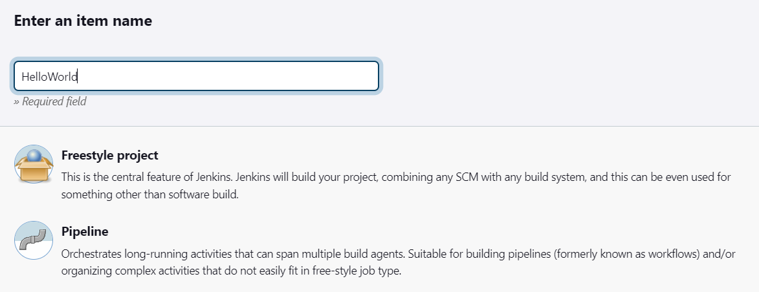

* **Write pipeline script and save**

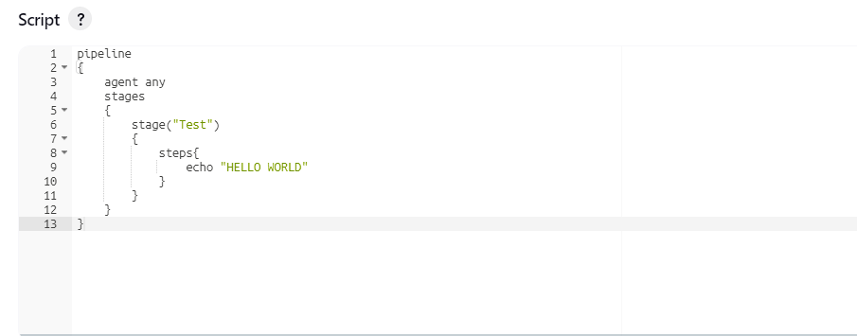

* **Click on Build now in the Dashboard**
* **In the Build History click on Dashboard and select console output**

