System Flow and
Implementation Details
SEE (Visual Assistant) — Flutter Mobile Application
Code-level execution paths, data flows, and implementation mechanics
Codebase analysed: lib/ (35 Dart files), android/.../MainActivity.kt

1. System Flowcharts

1.1 Sensor & Hardware Integration — Camera Frame Pipeline
The camera pipeline has two distinct consumers: ML Kit Object Detection (processed on every frame) and the Gemini Live API (sampled at 1 fps and converted to JPEG via a native platform channel).
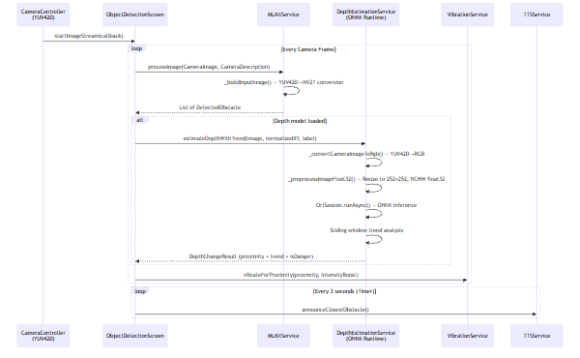

1.2 Microphone Audio Capture Pipeline (16 kHz PCM with Hardware AEC)
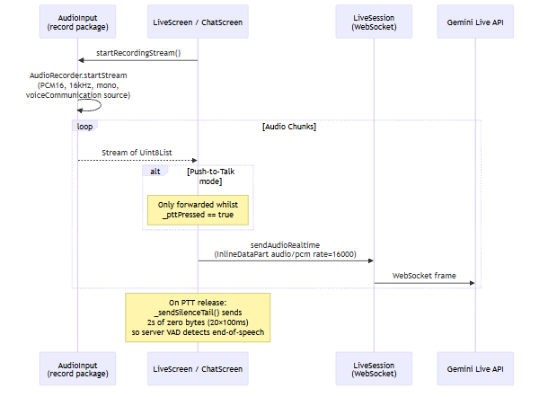

1.3 On-Device ML Inference — Depth Estimation & Object Detection
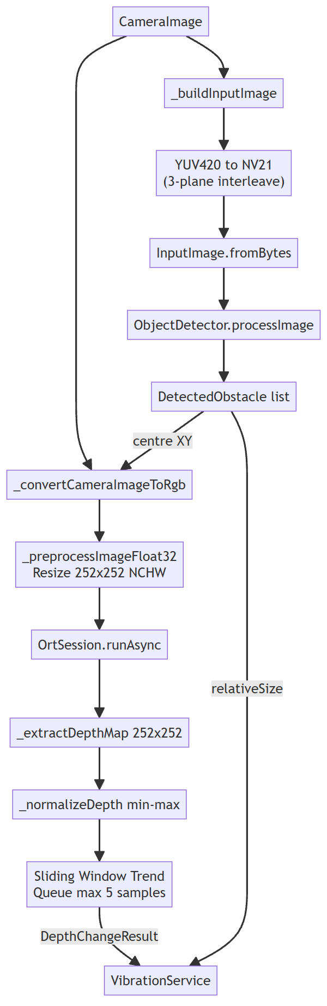

1.4 Real-Time Bidirectional Streaming — Gemini Live API
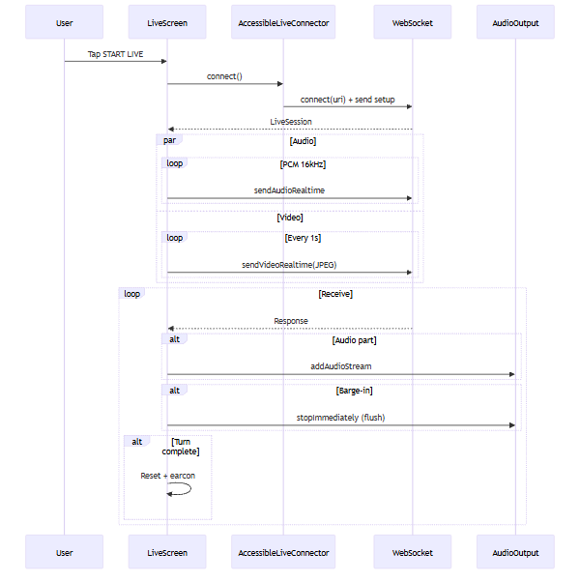

Barge-In Handling Detail
When the server signals msg.interrupted == true:
- AudioOutput.stopImmediately() is called, which invokes the native flush method.
- The native Kotlin code executes audioTrack.pause() → audioTrack.flush() → audioTrack.play(), instantly clearing the playback buffer.
- The _aiIsSpeaking flag is reset and _isFirstAudioChunk is set to true so the next response triggers a fresh earcon.

1.5 Background Fall Detection and SOS Sequence
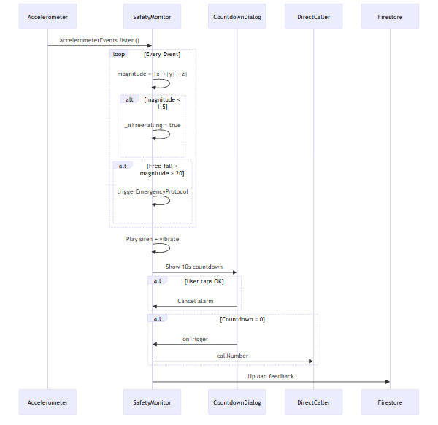

1.6 Chat Message Flow with POI Extraction
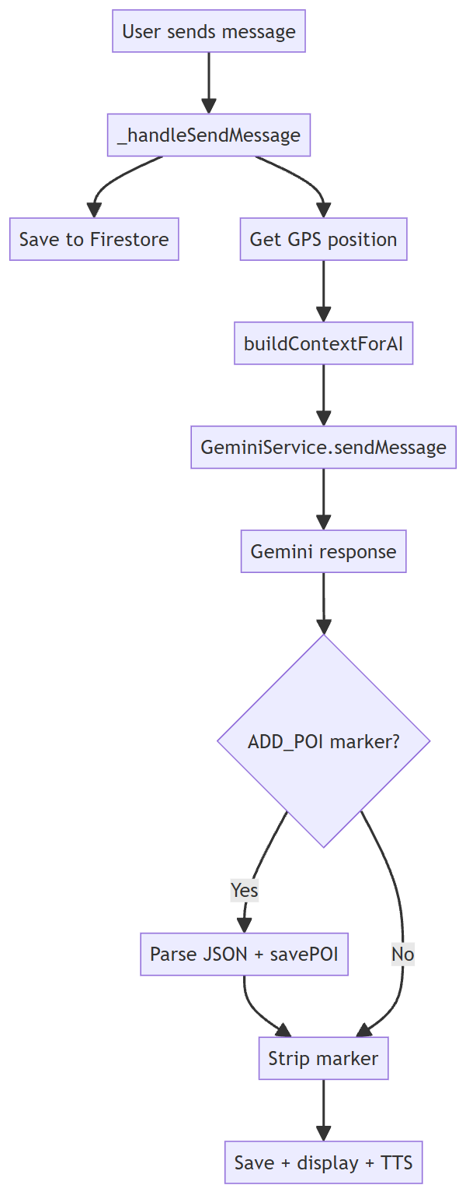

2. Implementation Details

2.1 State Management
The application uses Flutter's built-in StatefulWidget/setState pattern exclusively. There is no provider, bloc, or riverpod dependency.
Domain | State Container | Key Variables
Theme | ThemeNotifier (singleton ChangeNotifier) | _themeMode (light/dark)
Fall Detection | _SafetyMonitorState | _isFreeFalling, _freeFallTimestamp, _isAlertActive, _emergencyPhone
Object Detection | _ObjectDetectionScreenState | _obstacles, _isDetecting, _depthModelLoaded, _streamErrorCount
Live Session | _LiveScreenState | _isConnected, _isStreamingAudio/Video, _aiIsSpeaking, _pushToTalkMode, _pttPressed
Chat | _ChatScreenState | _messages (list), _isLiveMode, _isRecording, _isAiSpeaking, _pendingImageBytes
Depth Estimation | DepthEstimationService | _depthHistory (Map<String, Queue>), _cachedResult, _isProcessing
ML Kit | MLKitService | _isProcessing (frame-level mutex), _frameCount
TTS | TTSService (singleton) | _isReady, _isSpeaking, _lastSpoken, _lastSpokenTime

High-frequency sensor streams (camera, accelerometer) are throttled explicitly:
- Depth estimation: Minimum 333 ms between inferences (max ~3 FPS) via _minInterval.
- Vibration: 300 ms throttle via _lastVibration timestamp comparison.
- TTS obstacle announcements: 3-second Timer.periodic in ObjectDetectionScreen.
- Video frames to Gemini: 1-second Timer.periodic in LiveScreen.
- Location awareness POI announcements: 5-second cooldown in LocationAwarenessService.

2.2 Data Structures & Transformation

YUV420 → NV21 Conversion (Dart, for ML Kit)
Located in ml_kit_service.dart. Copies Y plane row-by-row (respecting bytesPerRow stride), then interleaves V and U planes in VUVU ordering to produce NV21 format.
Uint8List _convertYUV420ToNV21(CameraImage image) {
final int ySize = width * height;
final Uint8List nv21 = Uint8List(ySize + uvSize);
// Copy Y plane row-by-row
for (int y = 0; y < height; y++)
for (int x = 0; x < width; x++)
nv21[y * width + x] = yPlane.bytes[y * yPlane.bytesPerRow + x];
// Interleave V then U (NV21 = VUVU ordering)
int uvIndex = ySize;
for (int y = 0; y < uvHeight; y++)
for (int x = 0; x < uvWidth; x++) {
nv21[uvIndex++] = vPlane.bytes[vIdx]; // V first
nv21[uvIndex++] = uPlane.bytes[uIdx]; // then U
}
return nv21;
}

YUV420 → JPEG (Native Kotlin, for Gemini video)
Located in MainActivity.kt. Uses Android's YuvImage.compressToJpeg() after constructing an NV21 byte array from three YUV planes received via MethodChannel. Quality is set to 40 for bandwidth efficiency.

YUV420 → RGB → Float32 NCHW (Dart, for ONNX Depth)
Located in depth_estimation_service.dart. Performs nearest-neighbour resize to 252×252, normalises to [0.0, 1.0], and arranges in NCHW layout (channel-first).
Float32List _preprocessImageFloat32(Uint8List rgb, int w, int h) {
final data = Float32List(1 * 3 * 252 * 252);
for (int c = 0; c < 3; c++)
for (int y = 0; y < 252; y++)
for (int x = 0; x < 252; x++) {
final srcX = (x * w / 252).round().clamp(0, w - 1);
final srcY = (y * h / 252).round().clamp(0, h - 1);
data[(c*252*252)+(y*252)+x] = rgb[(srcY*w+srcX)*3+c] / 255.0;
}
return data;
}

Temporal Depth Trend — Sliding Window
- Per-object label Queue<DepthSample> with a maximum of 5 samples.
- Trend: changeRate = (currentDepth − oldestDepth) / timeDelta.
- Thresholds: >0.15/s → approaching_fast; >0.05/s → approaching; <−0.15/s → moving_away_fast.
- isDanger flag: isApproaching && currentDepth > 0.5.
- Stale entries (>3 s since last sample) cleaned via _cleanupOldHistory().

Firestore Data Models
conversations/{userId}/topics/{topicId}
├── createdAt, lastUpdated, firstMessage, lastMessage
└── messages/{messageId}
├── role: 'user' | 'assistant' | 'system'
├── content, timestamp, imageUrl?, hasImage
users/{fullName}
├── profile: { fullName, email, phone, emergencyContact* }
└── settings: { visualImpairment, hearingImpairment, ... }
pois/{poiName}
├── name, type, description, safetyNotes
├── location: { lat, lng, address }
└── addedBy, createdAt
fall_detection_feedback/{docId}
├── userPhone, triggerCorrect, callCorrect, timestamp
traffic_feedback/{docId}
├── wasSuccessful, timestamp, deviceTime

POI Extraction from Gemini Response
The chat screen parses Gemini responses for ADD_POI markers using brace-counting (not regex) to reliably extract nested JSON.

2.3 Error Handling & Edge Cases

Camera & Sensor Permissions
Scenario | Handling
Camera permission denied | Full-screen card with "Open Settings" button via openAppSettings().
Location permission denied | Geolocator.requestPermission(); if permanently denied, TTS + retry/settings dialog.
Location permanently denied | AlertDialog with "Open Settings" option.
Microphone permission denied | AudioInput throws Exception('Microphone permission not granted').

Network & API Failures
Scenario | Handling
Gemini API error (chat) | Returns "Error communicating with AI service" — displayed as model message.
Live API WebSocket closed | _receiveLoop() detects 'Closed' and calls _stopAll() to tear down all streams.
Custom VAD connect fails | Falls back to _sdkFallbackConnect() using standard Firebase AI SDK.
Places API (New) HTTP error | Falls back to _searchPlacesOldApi() using legacy Nearby Search endpoint.
Location timeout | 15-second timeout; falls back to Geolocator.getLastKnownPosition().

ML Inference Failures
Scenario | Handling
Stream mode repeated failures | After 100 consecutive empty results, switches to file-based detection (2 s Timer).
ONNX model load failure | Returns false; object detection continues without depth data.
Depth estimation busy | Returns _cachedResult when within 333 ms throttle window.

TTS Engine Binding (Xiaomi/MIUI)
TTSService.initialize() retries configuration up to 5 times with increasing delays (1 s, 2 s, 3 s, 4 s, 5 s). If all attempts fail, _isReady is still set to true so that speak() can retry at call time.

App Lifecycle
- inactive: Calls _stopAll() / cancels timers and disposes camera.
- resumed: Re-initialises the camera.

2.4 Package Implementation

record (Audio Capture)
Configured in audio_input.dart:
- voiceCommunication enables Android's AcousticEchoCanceler, NoiseSuppressor, and AutomaticGainControl.
- modeInCommunication optimises the audio pipeline for two-way communication.
- muteAudio: false ensures AI speech continues to play through the speaker.
RecordConfig(
encoder: AudioEncoder.pcm16bits,
numChannels: 1, sampleRate: 16000,
androidConfig: AndroidRecordConfig(
audioSource: AndroidAudioSource.voiceCommunication,
audioManagerMode: AudioManagerMode.modeInCommunication,
muteAudio: false))

Native AudioTrack (AI Speech Playback)
The AudioOutput class communicates with native Kotlin via MethodChannel('audio_output_channel'). The native implementation in MainActivity.kt:
- Sets AudioManager.MODE_IN_COMMUNICATION globally.
- Creates AudioTrack with USAGE_VOICE_COMMUNICATION at 24 kHz (Gemini's output rate).
- Attaches AcousticEchoCanceler and NoiseSuppressor to the audio session.
- Forces routing to the built-in loudspeaker using setCommunicationDevice() on Android 12+.
- Maximises STREAM_VOICE_CALL volume for blind users.
The flush method (barge-in): audioTrack.pause() → audioTrack.flush() → audioTrack.play().

Firebase AI SDK (firebase_ai)
- Chat mode: generativeModel('gemini-2.5-flash') with generateContent().
- Live mode: liveGenerativeModel('gemini-live-2.5-flash-native-audio') with ResponseModalities.audio.
- Custom VAD: AccessibleLiveConnector bypasses SDK connect() with manual WebSocket + VAD config.

flutter_tts (Text-to-Speech)
- Singleton (TTSService._instance). Language: en-US, rate: 0.5, volume: 1.0.
- Duplicate suppression: same message within 2 s is skipped (unless force: true).
- awaitSpeakCompletion(true) enables synchronous speech.

onnxruntime (Depth Estimation)
- Model: assets/models/depth_anything_v2.onnx (Depth Anything V2, ViT-S).
- Input: Float32List [1, 3, 252, 252] (NCHW). 252 = 18 × 14 (ViT patch size).
- Inference: OrtSession.fromBuffer() → session.runAsync().
- Output: Depth map 252×252, normalised [0.0, 1.0] via min-max.

google_mlkit_object_detection
- Stream mode, classifyObjects: true, multipleObjects: true.
- Position: left / center / right based on centerX vs. image width thirds.
- Proximity: relativeSize = objectArea / imageArea. isClose > 0.10; isVeryClose > 0.25.

vibration + HapticFeedback
Proximity | Method | Pattern
> 0.10 (very close) | _vibrateHeavy() | heavyImpact × 2 (100 ms gap)
> 0.05 (close) | _vibrateMedium() | mediumImpact × 1
> 0.01 (detected) | _vibrateLight() | lightImpact × 1

Approaching objects receive an intensityBoost of 0.2 added to raw proximity, clamped to [0.0, 1.0].

2.5 Earcon System (Accessibility Cues)
Event | Earcon | Implementation
AI starts listening | _playListeningEarcon() | HapticFeedback.lightImpact() + SystemSound.play(click)
User releases PTT | _playProcessingEarcon() | HapticFeedback.mediumImpact() × 2 (100 ms apart)
AI starts responding | _playResponseEarcon() | HapticFeedback.heavyImpact() + SystemSound.play(click)

2.6 Traffic Light Monitoring
- Sends initial prompt asking Gemini to identify pedestrian crossing signal colour.
- Re-prompts every 5 seconds via Timer.periodic; Gemini only speaks on colour change.
- On stop, collects user feedback and uploads to Firestore collection('traffic_feedback').

2.7 Authentication Flow
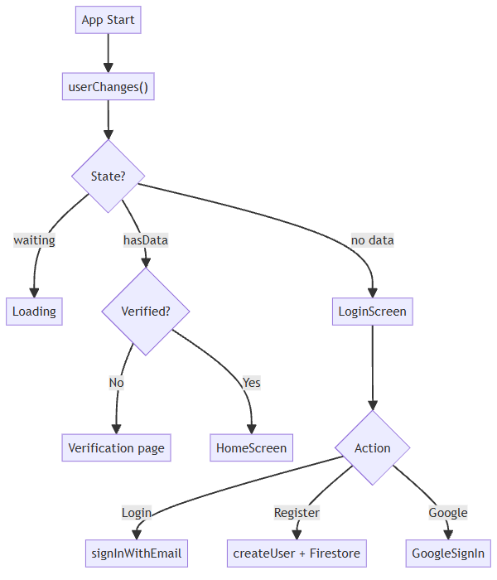

2.8 Navigation & Location Awareness
- Route calculation: NavigationService.getRoute() calls Google Directions API (walking mode).
- Live tracking: Geolocator.getPositionStream(distanceFilter: 5). Advances step when within 10 m.
- Explore mode: LocationAwarenessService tracks with 10 m filter, calls Places API within 100 m radius. Announced POIs stored in Set<String> (max 50).

Report generated from codebase analysis on 26 February 2026.

