|  |
| --- |
|  |
| **Airlines Reservation System** |
| |  |  | | --- | --- | | Group 1: | | | Instructor | Mr. Nguyen Ho Long Hai | | Group Members | Doan Phuoc Trung  Le Xuan Hung  Nguyen Quoc Hung | | Batch | 137+138 | | Semester | 3 | |

**E-Project Document**

|  |
| --- |
|  |



**TEACHER’S EVALUATION**

……………………………………………………………………………….………………………………………………………………………………………………………………………………………………………………………………………………………………………………………………………………………………………………………………………………………………………………………………………………………………………………………………………………………………………………………………………………………………………………………………………………………………………………………………………………………………………………………………………………………………………………………………………………………………………………………………………………………………………………………………………………………………………………………………………………………………………………………………………………………………………………………………………………………………………………………………………………………………………………………………………………………………………………………………………………………………………………………………………………………………………………………………………………………………………………………………………………………………………………………………………………………………………………………………………………………………………………………………………………………………………………………………………………………………………………………………………………………………………………………………………………………………………………………………………………………………………………………………………………………………………………………………………………………………………………………………………………

Contents

I. ACKNOWLEDGEMENTS 3

II. ABSTRACT 4

III. OVERALL PRODUCT DESCRIPTION 5

3.1 PRODUCT PERSPECTIVE 5

3.2 PRODUCT FEATURES 5

IV. PROBLEM DEFINITION 6

1. Index page(User) 6

2. User pages 6

3. Login and sign up 6

V. USẺ USE-CASE DIAGRAM 7

VI. PROJECT PLANNING 8

VII. GUI PROTOTYPE 9

INDEX PAGE 9

MANAGE BOOKING PAGES 10

REGISTER/LOGIN PAGE 11

II. TECHNICAL 12

II. GUI OF WEBSITE 13

III. CHECK LIST 16

IV. CONCLUSION 17

**I. ACKNOWLEDGEMENTS**

First of all, we would like to give our grateful thanks to the principal and teacher of Softech-Aptech Da Nang. We wish to express our deep gratitude to the e-Project Team at the Head office, who guided and helped us. We would like to sincerely acknowledge the kindness of all the people who have given moral support and helped us make a successful project. We would like to thank the following teacher, friends who contributed greatly to the completion of this project, particularly Mr. Nguyen Ho Long Hai, our supervisor, for his enthusiastic help, meaningful advice, brilliant ideas and a great encouragement throughout the study.

Although we have made many attempts but by the limited time and knowledge, our project mistakes and malfunctions is inevitable. We hope that our project will still be considered and evaluated. Finally, we would like to offer many thanks to all our friends and classmates for their valuable suggestions and constructive feedbacks.

*Da Nang,* April 2019

Students:

Doan Phuoc Trung

Le Xuan Hung Nguyen Quoc Hung

# II. ABSTRACT

The objective of the project is to design an Airline Reservation System application which enables the customers to search and book flights, packages. The project has been designed in C#.NET technology and consists of a SQL server and Azure which acts as the database for the project.

Our motivation for the project came from my enthusiasm and strong urge to learn C# and .NET which is one of the fastest growing technologies in today’s world. The Airline Reservation System project mainly consists of two types of users. The customers who access the information provided by the website and the administrator who modifies and updates the information available in the website. All the data needed for the application is stored in the form of tables in the SQL server 2014 and Azure.

The report contains the details of all the tasks carried out during the entire software

development life cycle of the Airline Reservation Project. This document depicts all the details of the project starting from the project design to testing.

# III. OVERALL PRODUCT DESCRIPTION

## 3.1 PRODUCT PERSPECTIVE

The Airline Reservation System project uses the .NET framework 4.6.1 and is completely independent. The project itself is a bigger product and does not need to be introduced into a larger system. The application would be running on a Windows 8/10 Operating system

## 3.2 PRODUCT FEATURES

The Airline Reservation System has the following features:

This project is mainly intended for two types of audiences. One is the customer or the end user and the other is the administrator of the website. Some of the major functions of the product can be categorized under two different categories that are for the administrator and the user.

# IV. PROBLEM DEFINITION

1. **Index page(User)**

This is the page where the user will be navigated after a successful access in website. It displays introductions about website, weather, news and events, login, logout, account registration and navigation bar.

Carousel display many beautiful photos to make a good impression to users and make the site more dynamic

Navigation bar helps user easily view to other pages and login, logout.

With each title, there will be a link to load view-page of the product of each brand.

Area of news and weather will show updated new information and have a click button to load view-page news and events. Next to is the link to our Facebook, Youtube Channel and Instagram, help users know more about us.

1. **User pages**

There are 3 pages; Users can check in, search for information of flights and using paypal. Each page show their information and help user to manage what they’re doing.

1. **Login and sign up**

When the customer login, they have to fill out information on the form including: UserName and Password. They can also login with Facebook or Google account.

If it is the first time for customers to access or visit website, they have to sign up before login. The sign up information includes UserName, Email,Phone Number password and confirm their password.

# V. User Use-Case Diagram



User use case diagram

# VI. PROJECT PLANNING

|  |  |  |  |  |  |
| --- | --- | --- | --- | --- | --- |
| **Week** | **Task name** | **Start day** | **End day** | **Member** | **Status** |
| 1 | Problem definition |  |  | Phuoc Trung | 100% |
| 1 | Translate project content |  |  | Phuoc Trung,Xuan Hung | 100% |
| 1 | Analyze requirement specification |  |  | Phuoc Trung | 100% |
| 2 | Design site map |  |  | Phuoc Trung | 100% |
| 2 | Database |  |  | Phuoc Trung | 100% |
| 3 | Repository |  |  | Quoc Hung, Xuan Hung | 100% |
| 3 | Design layout page |  |  | Phuoc Trung | 100% |
| 4-5 | Design login, sign up, sign out page | Apr 8th | Apr 13th | Xuan Hung | 100% |
| 5 | Test layout responsive |  |  | Phuoc Trung | 100% |
| 6 | Test page content | Apr 14th | Apr 17th | Phuoc Trung, Xuan Hung | 100% |
| 6-7 | Write document | Apr 15th | Apr16th | Xuan Hung | 100% |
| 7 | Build slide | Apr 16th | Apr 17th | Xuan Hung | 100% |

**VII. GUI PROTOTYPE**

## INDEX PAGE

**CAROUSEL**

**NAVIGATION BAR**

**BOOKING VIEW**

**ABOUT**

**NEWS AND EVENTS**

**FOOTER**

## MANAGE BOOKING PAGES

**FLIGHT DEPART**

**FOOTER**

FOOTER

**NAVIGATION BAR**

## REGISTER/LOGIN PAGE

**FORM**

**NAVIGATION BAR**

**FOOTER**

FOOTER

**II. TECHNICAL**

Software: Visual Studio 2017, SQL server 2014, Azure

Web Browser: Chrome, Firefox, Safari, IE, Opera

The technique used to build the Website:

* HTML 5 & CSS 3.
* C#
* ASP.Net MVC
* Bootstrap 3
* JQuery
* Angular JS
* JSON

1. **REFERENCES**

We consulted information on website:

* https://stackoverflow.com/
* https://jquery.com/
* https://www.w3schools.com/
* https://www.bootsnipp.com/
* http://ami.responsivedesign.is/
* https://github.com/

1. **GUI OF WEBSITE**

**GRAPHICAL USER INTERFACE**

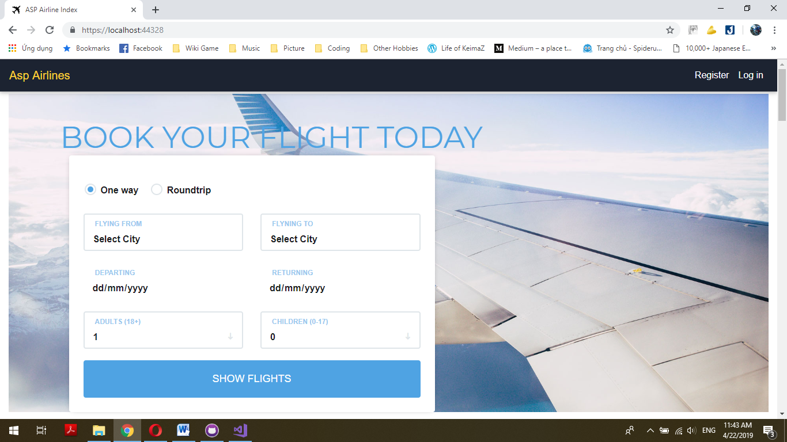

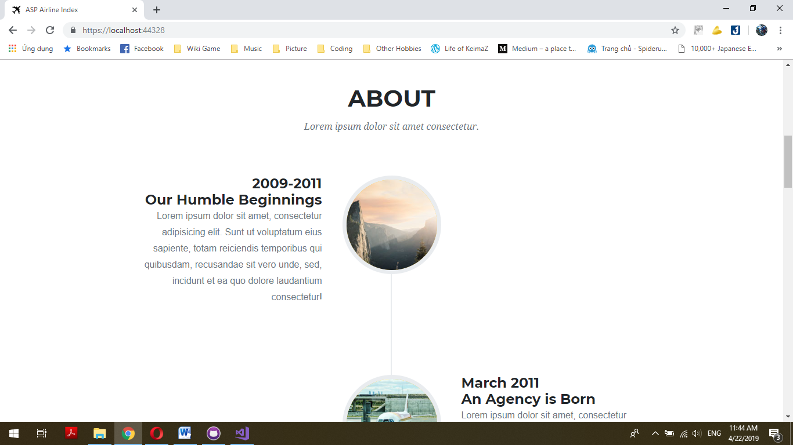

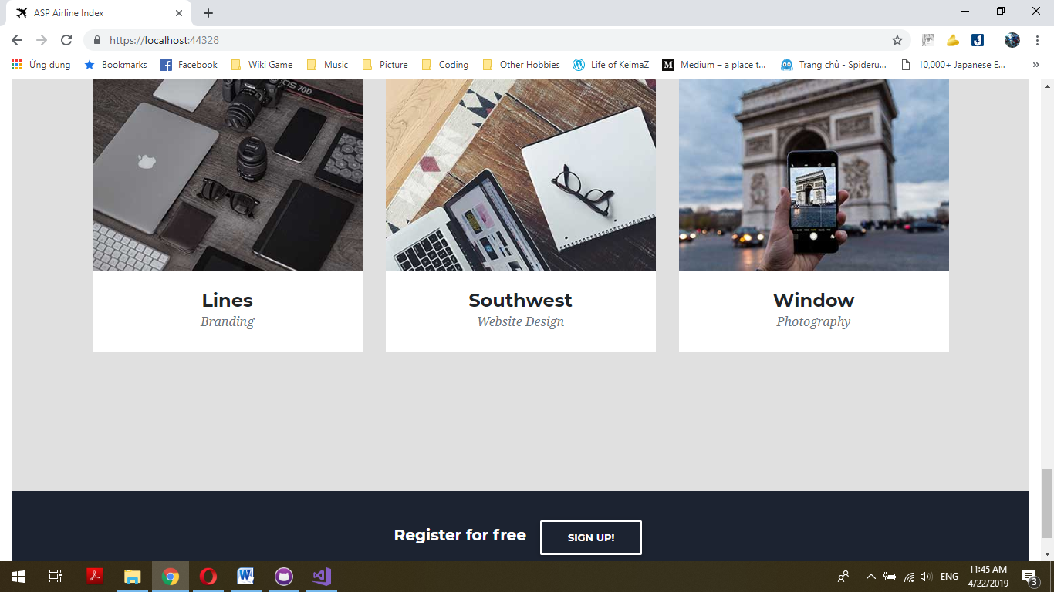

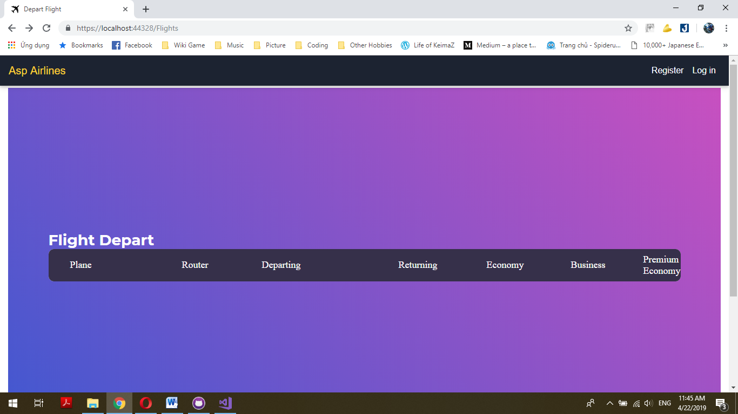

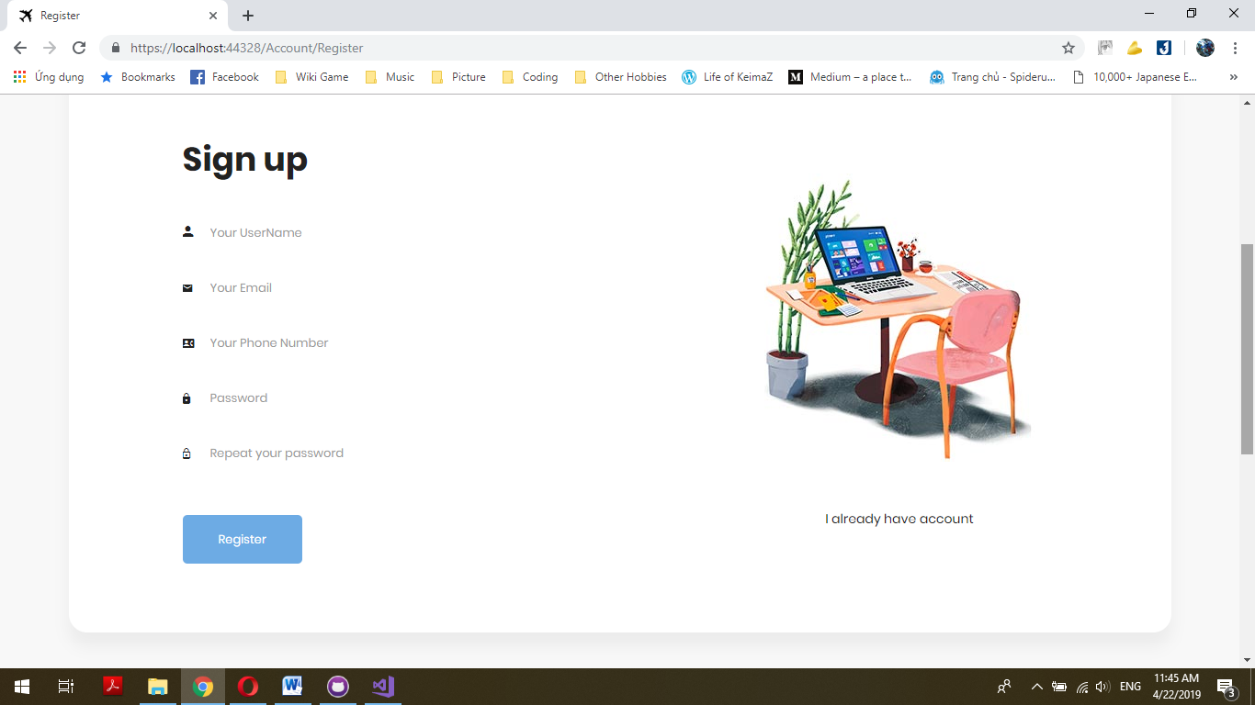

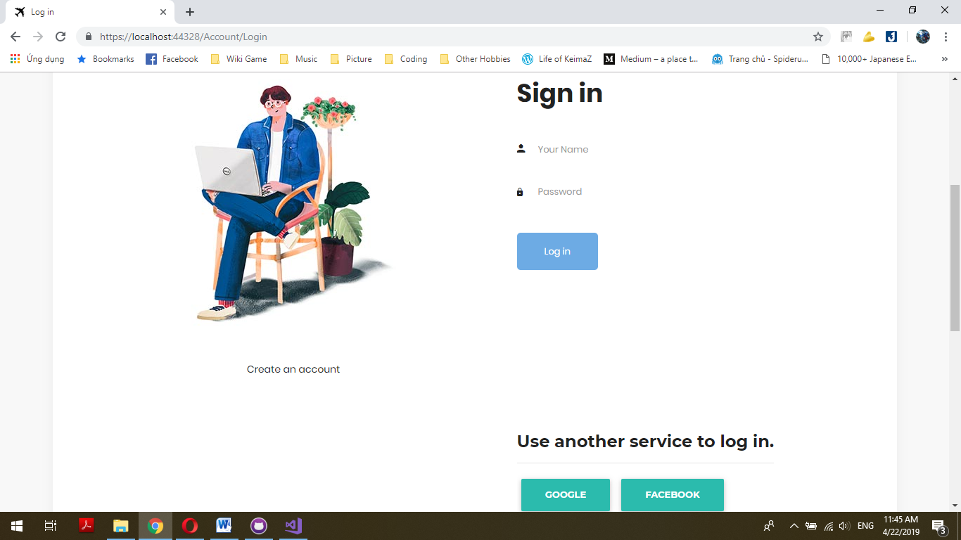

1. **CHECK LIST**
2. Check List of Validation

|  |  |
| --- | --- |
| **Option** | **Validation** |
| Has the hardware and software been correctly chose? | Yes |
| Are there functions for the user to login by Facebook/Google? | Yes |
| Do all the options present in application display the correct result? | Yes |
| Are there Admin page? | Yes |
| Are there functions for the user to find flight info? | Yes |

1. Submission Checklist

|  |  |  |  |  |  |
| --- | --- | --- | --- | --- | --- |
| **No.** | **Particular** | **Yes** | **No** | **N/A** | **Comments** |
| **1** | Is the users table to login the Application on the username and password? |  |  |  |  |
| **2** | Is there a form for users to edit Personal information ? |  |  |  |  |
| **3** | Can the admin login to the admin page privately? |  |  |  |  |
| **4** | Is the user able to find a flight info wherever they want? |  |  |  |  |
| **5** | Is the application user-friendly? |  |  |  | Windows GUI and smartphones is familiar with everyone |

1. **CONCLUSION**

Website includes: Index Page, Check in Page, Pre-paidpackage Page, Flight Information Page, Manage Booking Page, Login, Sign up, Sign out.

However, this website also need to be develop and upgraded.

Here is the development direction:

1. Complete and perfect remain parts of this website.
2. Change background image and color, font and other as required by client
3. Build back-end better for this website
4. Using better skills to improve the website