Week 2 deliveries:
PING TEST:
Client_1:
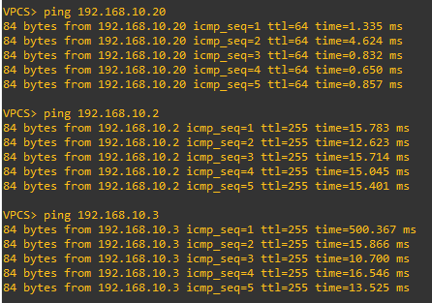

Client_2:
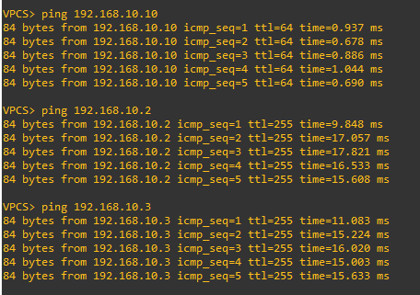

Source \ Destination | R1 (192.168.10.2) | R2 (192.168.10.3) | Client1 (192.168.10.10) | Client2 (192.168.10.20)
Client1 | Success | Success | – | Success
Client2 | Success | Success | Success | –
Router R1 | – | Success | Success | Success
Router R2 | Success | – | Success | Success

HSRP:
Router A:
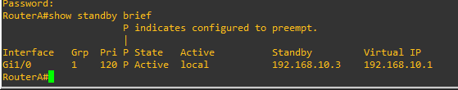

Router B:
