**Hamza S Rana**

[hs.rana483@gmail.com](mailto:hs.rana483@gmail.com)

(347) 450-6536

Princeton, TX

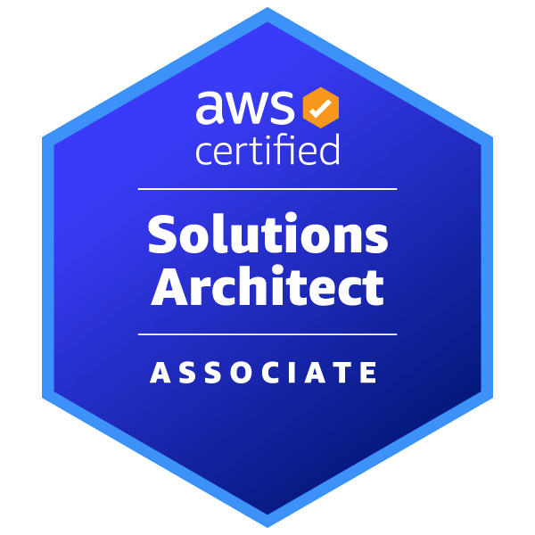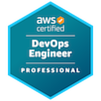

**OBJECTIVE**

Diligent and ambitious IT professional with 8+ years of experience who is looking to implement his multi-cloud technical skills to enhance and support infrastructure and various platforms. Great hands-on core Linux experience across legacy versions to contemporary versions. Team player with stellar technical communication skills with legacy and emerging new technologies embodying DevOps and Code as Infrastructure Ideologies. Self-driven individual who has utilized leadership skills for mentorship as well as work effectively with teams to complete projects. Looking for opportunities in which there is ample opportunity to apply my talent and acquire additional skills.

**SKILLS**

* **Linux (other OS Tools) :**
  + Iptables, Firewall, Tomcat, Disk management, RAID, Samba, WINScp, SCP, Rsync, Kernel tuning/parameters, SAN, NAS, EBS, MS Office Suite, Splunk, Nagios, Cronjobs, Symantec Netbackup, Red Hat Directory Services, Red Hat Identity Management, DHCP, DNS, LVM, NIC bonding, PXE-boot, bash scripting, web servers, databasesVMware,Git, CloudFlare, Python, Nagios, Grafana, GlusterFS, FUSE, XFS, EXT3, EXT4, SSH, UDP, TCP, IPMP, FTP, NFS, SNMP, TELNET, ISP, Firewall
* **Cloud/Virtualization/DevOps:**
  + Jira, Jenkins, Docker, Bitbucket, Ansible, Terraform, AWS EKS, Kubernetes, GIT, Red Hat Satellite, Ansible Tower, AWX, AWS, GCP, Azure, VMware, Python, BASE, YAML, C++, JAVA, Kafka
* **Operating Systems/Hardware:**
  + RedHat, CentOs, Ubuntu, Windows, MacOs, Cisco UCS Blades, HP, Dell

**EXPERIENCE**

**Refinitiv**

**DevOps Engineer | (*August, 2018 - Present)***

* Providing oversight on CI/CD based deployment in all environments from Dev through Prod
* Maintain proficiency with industry best practices in IT security, Integration and Testing.
* Performing blue/green deployment through Jenkins pipeline.
* Performing UI testing with Blaze-meter, J-meter, selenium.
* Implement and maintain monitoring and alerting systems to ensure that engineering environments are running effectively at all times.
* Using Ansible to configure LAMP, LEMP servers at Ubuntu and CentOS servers.
* Hosting web applications on test and prod servers.
* Providing GIT administration
* Setting up Kubernetes clusters and typical deployments using objects like pod affinity, pdb, nodeselector.
* Using Ansible to configure multiple servers and automate the infrastructure tasks and automated deployments using playbooks.
* Integrated security vulnerability check using SonarQube as part of build automation and managed Nexus repositories for Docker images
* Implementing best security practices on AWS cloud by moving infrastructure to VPC
* Experience in securing and scaling Jenkins, Plugin Management and configuring slaves
* Managing AWS subscriptions and IAM
* Setting up AWS infrastructure using services like EC2, VPC, IAM, ELB, S3, CloudWatch, SNS, Autoscaling.
* Implementing containerization environment using Docker and also experienced in writing Dockerfile and Docker Compose
* Experience in defining CI/CD processes using Azure Devops.
* Experience in writing MS Azure cloud’s ARM templates, setup automation for resource provisioning using Azure PowerShell.
* Experience in Azure services (AzureSQL, Azure Storage Account, Azure App Services)
* Familiar with Route53, RDS, Elastic IP’s and managing security groups on AWS.
* Created network architecture on AWS VPC, subnets, Internet Gateway, Route Table and NAT setup.
* Managing and setting up Docker private repositories.
* Installing and configuring various open source tools like AWX (Ansible Tower), Jenkins, Grafana, Asana, Elk, Zabbix and more.
* Able to run stateless and stateful applications on Kubernetes and Health checks, Secrets, Config Maps, add users, set quotas/limits as well as perform node maintenance.
* Provisioning infrastructure on multiple cloud platforms using Terraform.
* Delivering container-based deployments using Docker.
* Support internal and external customers on multiple platforms.
* Developing tools and processes to drive and improve customer experience.
* Analyzing and resolving issues pertaining to merging of source code for GIT.
* Configuring application servers (Tomcat) to deploy the code.
* Taking snapshots of computing instances, machines images and storage, reserving the state iP, submitting DNS requests within Cloud Platforms.
* Utilizing Ansible and Ansible Tower as configuration management tools to automate repetitive tasks, quickly deploys critical applications and proactively manage change.
* Implementing a Continuous Delivery pipeline with Docker and AWS.
* Implementing test environments for Kubernetes and administrating Kubernetes clusters.
* Rotational on-call schedule supporting emergency site maintenance and immediate build and install requests.
* Expertise in writing infrastructure as code using terraform on AWS and GCP to reduce manual deployment time from hours to minutes.
* Utilized Terraform for cloud platform deployment of instances and resources, using state of infrastructure to maintain an upstream productivity of infrastructure.
* Hands-on experience in Python and BASH/SHELL scripting.
* Using GIT and Bitbucket for source control management working with branches as well as branch workflow.

**ALTICE**

**Linux Systems Administrator | *(February 2015 - August 2018)***

* Excellent knowledge in utilities like ssh, scp, rsync, and more.
* Performed Red Hat OS installation using PXE-Boot and kickstart to automate the provisioning and deployment requirements.
* Monitored system/application activities like the cpu, 5 memory, disk and swap space and network throughput using multiple monitoring tools.
* Proficient understanding of SHELL scripts to automate day-to-day administrator tasks from simple to complex.
* Used ServiceNow for ticket management tools for support and change management tasks.
* Developed cron jobs and Shell scripts for automating administration tasks like file systems management, process management, server reboots etc.
* Managed and scheduled server backup accordingly.
* Conducted servers health check once a month.
* Made Linux servers secure via server hardening.
* Worked with Apache, Nginx, Mysql and UFW Firewall.
* Monitored Firewall activity like Event logs, Connection logs and Packet Monitor.
* Racked and stacked bare metal servers and going through VMware ESXi hypervisor.
* Automated system management tasks by writing bash scripts.
* Configured, administered, troubleshoot network communications among servers using Telnet, SSH, TCP dump, Traceroute, Nmap, PING and SSL cert management.
* Troubleshooting network protocols like DNS, TCP/IP , SMTP, SNMP, DHCP and more.
* Proficient in different filesystems and disk management utilities like fdisk, lvm and more.
* Installation in creation of ssl certificates for web servers on linux systems.

**EDUCATION**

Long Island University- (Brooklyn, NY)

Bachelor of Professional Studies

(Graduated – Spring, 2019)

**Certifications**

AWS Certified Solutions Architect - Associate

Completed: January 21, 2023

(Validation number: C1D2QZ91R2VE1693)

AWS Certified DevOps Engineer - Professional

Completed: March 23, 2023

(Validation Number: HNKC4G1C9B141SS9)