GLOBAL HR · PEOPLE OPERATIONS · MULTI-COUNTRY COMPLIANCE  Marta Tomaszewska  Global HR & Operations Specialist  Global HR and operations partner for APMC group teams across 10 countries. Runs Deel people ops for 200+ employees - company-wide time-off policy, HR data, expenses and daily employee support - plus Polish payroll for the post-layoff core team (14, down from ~50). Tracks and plans company spend, owns expense control and financial reporting into APMC. Owns global insurance, offices in Poland and Spain, and Polish subsidiary governance as Board Member of Laminar Global Poland (APMC subsidiary / employing entity). Path: software-house ops → startup HR build-out → post-acquisition people ops, with recruitment support across APMC, Laminar and ARC.  Wrocław, Poland · Open to remote / hybrid  m.tomaszewska1994@gmail.com · +48 538 324 450 · linkedin.com/in/marta-tomaszewska-363790132/ | 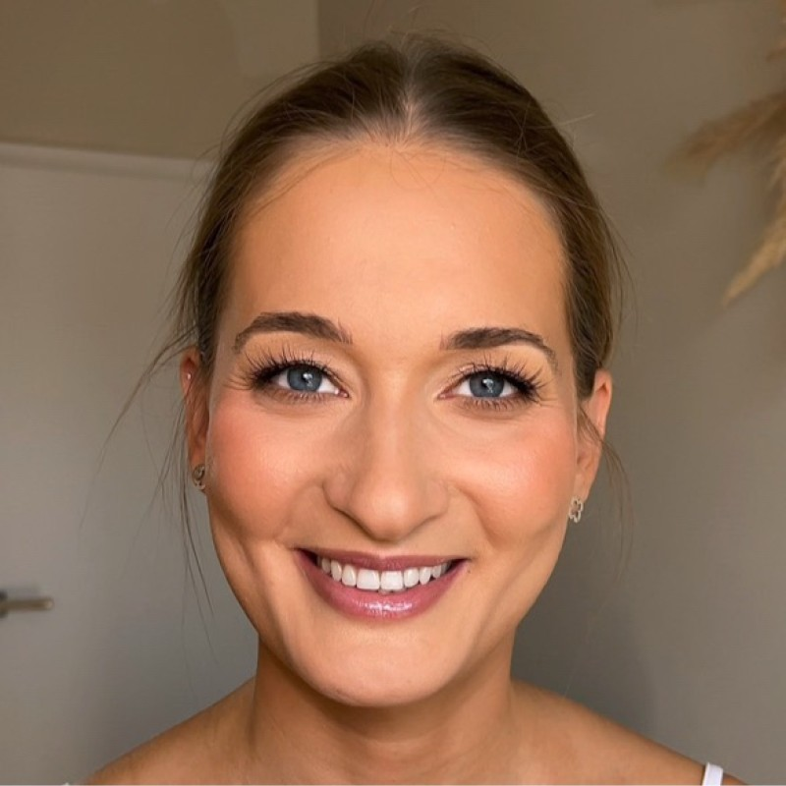

EXPERIENCE
 | A Parent Media Co. Inc. (APMC)  Full-time · Jan 2024 - Present · group role via Laminar Global Poland (subsidiary)

Global HR and Operations Specialist | Oct 2025 - Present
• Primary HR contact for daily people ops across 10 countries on Deel (US, CA, UK, DE, ES, AT, SK, CZ, IN, PL) - contracts, expenses, offboarding and HR data for 200+ employees.
• Designed and rolled out company-wide time-off policies for all of APMC (every employee / country in scope); administer leave in Deel.
• Run Polish payroll for the remaining 14-person core team (down from ~50 pre-layoff); track and plan company expenses and spend, and deliver financial reports into APMC.
• Own global insurance for US, CA, ES, PL - employee liability for 200+ staff plus ~20 other policies adjusted in the last year.
• Manage offices in Poland and Spain; as Board Member, Laminar Global Poland sign PL legal docs and represent the company before authorities. Support recruitment for group hires.

Business & Global Operations Support | Jan 2024 - Oct 2025
• Led post-acquisition people-ops integration of Laminar into APMC; stood up Deel and stabilized HR, expense tracking and payment workflows after headcount reduction.

 | Laminar Global / Laminar Global Poland  Full-time · Apr 2022 - Present · APMC subsidiary since Jan 2024 · employing entity

HR Specialist & Business Support | Apr 2022 - Present
• Built HR / business support from ARC co-founded venture through acquisition; contract remains with Laminar Global Poland.
• Ran payroll for ~50 employees pre-Deel / pre-layoff; coordinated founder & corporate agreements with Osborne Clarke.
• Owned tax / accounting liaison (financial statements, transfer pricing, PIT) and asset register of 70 devices.
• Ran recruitment via an external recruiting agency - role briefs, candidates, contracts and onboarding on the company side.

 | ARC Software  Mar 2022 - Present · full-time through ~2023, then residual subcontract (few hrs / month)

Business Support Specialist | Mar 2022 - Present
• Administered contractor agreements for developers, QA and PMs - peaking at 75 contractors (2023); legal / finance liaison with clients and external accounting.
• Took part in recruitment (dev, QA, PM) - coordination, contracts and starter docs.
• Supported Add Secure (Sweden), Medcase (Israel) and Polish accounts - invoicing, year-end filings; subsidiary docs for ARC DermoBook and Diagno6 PSA.

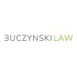 | Buczyński Adwokacka S.K.A.  Full-time · Jul 2020 - Feb 2022 · Wrocław

Office Manager | Jul 2020 - Feb 2022
• Ran law-firm operations: calendars, correspondence, archiving, core HR; liaised with courts and public bodies; managed residence / employment legalization.
• Supported Polish and international clients on operational matters; co-created the firm's visual identity system.

R | REGULATOR Agencja Eventowa  Freelance · Apr 2019 - Sep 2021 · Wrocław

Event Manager | Apr 2019 - Sep 2021
• Delivered public events within fixed budgets - concept, vendors, logistics and on-site execution under tight deadlines.
EDUCATION
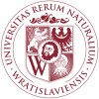 | Wrocław University of Environmental and Life Sciences  Mgr inż. - Landscape Architecture | 2013 - 2019

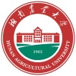 | Hunan Agricultural University  Mgr inż. - Landscape Architecture · dual programme, China | 2017 - 2019

CORE COMPETENCIES
Global HR / People Ops · Multi-country Employment (10) · Deel Administration · HR Data Audit · Leave Policy · Payroll, Expenses & Financial Reporting · Corporate Insurance · Office / Facilities · Board / Subsidiary Docs · Tax & Accounting Liaison · Contractor Management · Recruitment Coordination · Post-acquisition Ops
TOOLS & LANGUAGES
Platforms Deel · MS Office / Google Workspace · Contract & document workflows
Languages Polish - Native · English - C1

