Creating multimedia educational materials with Clic 3.0 Course
Francesc Busquets i Burguera
September 1999

Contents
Contents 2
Course Guide 4
Prerequisites 4
Course Objectives 4
Course Structure 4
Sending the exercises 5
Necessary programmes 5
File Organisation 5
Module 1 7
Presentation 7
The "Clic Corner" 7
An overview of the example activities 7
Types of activities 8
Evaluation of the results 10
The packs 10
The areas of the screen 11
The screen dimensions 11
Explicit and indirect references to contents 12
File organization 13
The process of creating activities 14
Puzzles 14
Simple and complex associations 15
The relationship assignment 16
Guided practices 19
Creating a puzzle from an image 19
Creating a puzzle from a text 20
Creating a normal text-text association 21
Creating a text-image association 22
Creating an association with indirect references 22
Creating an activity pack 24
Exercises 25
Module 2 26
More associations 26
Colours, fonts, background graphics and other options 27
Style automization 30
Word searches 30
Crosswords 31
Calling multimedia contents from Clic 31
Accessibility functions 32
Print functions 33
The information button 33
Guided practices 34
Creating an explore mode activity 34
Integration of sound files 35
Creating a sound-image association 36
Indicate activities 37
Integrating AVI files 37
Creating a word search 38
Creating an activity pack 39
Exercises 40
Module 3 41
Text activities 41
Guided practices 46
Creating a fill in blanks activity 46
Add help windows to a text activity 48
Creating order words activities 49
Creating an order paragraphs activity 50
Creating a dictation 51
Creating an activity pack 55
Exercises 56
Module 4 57
Automatic content generation 57
Activity packs 58
The ClicPac utility 59
Clic reporting system 62
The ClicDB programme 63
Guided practices 65
Creating activities with ARITH2 65
Creating threaded packs 67
Adapting an existing pack 68
Creating a menu of packs 70
Exercises 73
Final Project 74

Course Guide

Prerequisites
To carry out this course basic knowledge and skills in working with Windows and Internet. In particular, you should be familiar with operations such as: creating folders; copying files; changing file and folder names: installing programmes; compressing and decompressing with WinZip, navigating the web; sending and receiving e-mail; etc.
Before starting this course, basic knowledge of creating and handling images and sound are necessary. This course has been programmed along with the common modules Elements of Multimedia Design, Digital Images and Digital Sound.

Course Objectives
The main objectives of the course are to:
- Get to know the Clic 3.0 environment and its didactic possibilities.
- Carry out activities in the various modules that the programme offers.
- Integrate multimedia resources in didactic material.
- Program sequences of organised activities in packs.
- Edit and adapt existing materials to specific didactic requirements.
- Familiarise the user with the workings of the reporting systems and progress monitoring of students.

Course Structure
The estimated time to complete the course is 60 hours. The course consists of 8 modules and a final project:
Module TC01 (Elements of Design) 6 hours
Module TC02 (Digital Images) 6 hours
Module TC03 (Sound Processing) 6 hours
Module 1 6 hours
Module 2 6 hours
Module 3 6 hours
Module 4 6 hours
Final Project 18 hours
The first three modules, which are common to other PIE courses, are organised by a combination of guided practices with an explanation of the course content inserted.
The last four modules are structured as follows:
- A main document where the module contents are explained.
- A combination of guided practices explained step by step. We recommended that the proposed order of exercises is followed as the exercises often use materials created in previous exercises.
- A proposal of exercises to carry out, which you have to do and then send to the course tutor by e-mail.
At the end of the course you will have to write a project consisting of an activity pack which you will also have to send to the course tutor in order to receive a pass for the course.

Sending the exercises
Before sending your materials, they should be compressed in ZIP format (using WinZip or a similar tool).
The materials corresponding to each module's exercises have to be sent together, compressed in a single ZIP file and added to an email message to the course tutor. It is important to include the following information in the message: your name; email address; which module the exercises are from; and a brief description of the contents.

Necessary programmes
Although Clic also works with Windows 3.1, the materials for this course have been designed for a multimedia computer equipped with Windows 95, 98, NT o 2000.
You should check that the sound card controllers are properly installed and that the speakers and microphone are connected and working properly.
You will need the following programmes to do the exercises and the guided practices:
- The Clic 3.0 programme, which can be found on the "Sinera" CD-ROM or downloaded from the The Clic corner.
- A graphics package which allows GIF and BMP formats. We recommend Paint Shop Pro, which can also be downloaded from the resources section of "The Clic corner".
- A sound editor which allows the recording of different resolutions and wave manipulation. CooolEdit 96 could be a good option, this programme can also be downloaded from the resources section of "The Clic corner".
- The WinZip utility, which will let you decompress the exercises that we send you and to compress your exercises so as to save disk space and connection time to the internet.
- You will also have to download and print the manual for Clic version 3.0, which can be found on the "Sinera" CD-ROM and on the information section of "The Clic corner".

File Organisation
Before starting the course you should prepare a set of folders to save the exercises files.
Clic is usually installed in the C:\CLIC folder. In this folder you should create another called Course.
Within Course you need to create five more folders called: Module1, Module2, Module3, Module4 and Project.
Within each of the first four folders you need to create two more and call them Practice and Exercice.
The final result should look like this:
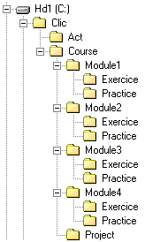
There is a ZIP file at the start of each guided practice which contains the necessary materials to do it. The contents of these ZIP files should be decompressed in the corresponding "Practice" folder for each unit.
There are also ZIP files for some of the exercises, which should be decompressed in the corresponding "Practice" folder for its module.

Module 1

Presentation
Clic is an open programme which allows the carrying out of various educational activities: puzzles, associations, word searches, crosswords, text activities and other types which we will discover over the duration of the modules of this course.
Before starting the guided practices you will need to make some changes to the default settings in Clic:
- Start up Clic and go to the Options - Global options menu
- Notice the area where it says Graph programme. By default it says PBRUSH.EXE, which is the basic drawing programme in Windows. Paintbrush only lets you work with BMP files and we will also be using GIF images in this course. So we will have to change the setting to Paint Shop Pro (or any other programme capable of editing GIF files).
- Click on the Search... button in this area and find the PSP.EXE file, which is normally in the C:\PROGRA~1\PAINTS~1 folder, which is the equivalent of "C:\Program Files\Paint Shop Pro" (Clic is a 16-bit programme and cannot 'see' the folders and files with the long names as in Windows 95, that is why the equivalent expressions, abbreviated to 8 characters must always be used).
- Click OK and, when Clic asks, say Yes you want to keep the changes made.

The "Clic Corner"
This is the name of the Internet site which has all types of information and materials related to Clic. Here you will find the latest versions of the programme, documentation, utilities, a page with Frequently Asked Questions and the best activities created by the users of the programme. The activities are organised by three indices: by thematic area, by educational levels and by languages.
You will also find a search engine in the "Corner", which will let you easily find materials related to specific themes.
The "Clic Corner" home page is:
http://www.xtec.es/recursos/clic
We recommend that you have a look around and download the materials of most interest to you. You can also find the activities whose pages show the CD icon on the CD-ROM.

An overview of the example activities
The best way to get to know Clic is by looking at the example activities which are installed with the programme. Activate the Clic Demo icon and go along, following the menus, which will take you through the different types of activities. If you feel like seeing how the activities have been made, you only have to activate the menus: Edit - Edit activity (basic definition of the contents and operating mode of the activity); and Options - Activity options (visual aspect and other properties). Do not worry if you do not understand the function of each component of these windows; this will become clear over the duration of the course. For now, the idea is just to have a look and understand the different types of activities that the programme allows.

Types of activities
As you have seen in the examples, Clic allows the use of five basic types of activity:
- The puzzles consist of rearranging a disordered piece of information. This information can be in the form of a graphic, text, sound, or a combination of graphics and sound together.
- The associations are intended for the user to find the relations between two sets of information.
- The word searches and crosswords are interactive versions of their well-known printed versions.
- The text activities offer exercises based on words, sentences, letters, and paragraphs of a text which has to be completed, understood, corrected or ordered. The texts may also contain images and windows with an active content.
Some of these activities have different forms, giving 19 different possibilities:
ACTIVITY | MODE | DESCRIPTION
Puzzle | Double | Two grids are shown. One contains the disordered information and the other is empty. The object has to be rearranged in the empty grid by dragging the pieces one by one.
Puzzle | Exchange | The information is swapped within the same grid. In each go two pieces swap position until the object is reordered.
Puzzle | Hole | In the same grid one piece is missing and the others are shuffled. In each go one of the pieces next to the empty space is moved until they are back in the original order.
Puzzle | Memory | Each of the pieces appear twice, but face down. In each go two pieces are turned over and are turned back over if they are not the same. The objective is to find all the pairs.
Association | Normal | There are two sets of information that have the same number of parts. Each part from the original set corresponds to one, and only one, part of the image set.
Association | Complex | Here there are also two sets of information, but these may have a different number of parts and there may be different types of relation between them e.g.: one-to-one, various to one, parts without a relation, etc.
Association | Indicate | There is just one set of information and you have to click on those parts that meet a certain condition.
Association | Explore mode | An initial piece of information is shown and, upon clicking on it, a given piece of information is shown for each element.
Association | Information screen | One set of information is shown and there is the option of activating the multimedia content for each piece of information.
Association | Written answer | A set of information is shown and the corresponding text for each of its parts must be written.
Word search | Normal | The hidden words have to be found in a grid of letters. The neutral cells in the grid (those with no word) are completed with characters chosen at random.
Word search | With associated content | The same as above, but offering the possibility of revealing a piece of an information set (text, sounds, images, etc) each time a new word is found.
Crosswords | Single mode | The word table has to be completed according to its definitions. The definitions may be text, graphics or sound. The programme automatically shows the definitions of the two words which cross in the cursor position.
Text activity | Fill in blanks | The user has to complete certain words, letters and phrases that have been hidden or camouflaged in a text. The solution of each of the elements may be set up in different ways: writing in a blank space; correcting a phrase that contains errors; or selecting from a list of various possible answers.
Text activity | Complete text | Various parts of a text (letters, words, punctuation signs, or phrases) are taken out and the user has to complete it.
Text activity | Identify letters | The user has to point out the letters, numbers, symbols or punctuation marks that meet a certain condition with a click of the mouse.
Text activity | Identify words | The same as above, but here each mouse click points at a whole word.
Text activity | Order words | When designing this activity some of the words are selected to be shuffled around. The user has to put them back in order.
Text activity | Order paragraphs | The paragraphs selected in designing the activity are shuffled and they have to be put back in order.

Evaluation of the results
Clic keeps a record of the actions that the student makes to resolve each of the activities. This is converted into a numeral variable called precision, which indicates the percentage of correct answers for the total of guesses made. A 100% precision indicates that the activity has been solved in the minimum number of guesses and without any errors.
Clic 3.0 allows the precision obtained and the time taken by each student in the different work sessions to be recorded in a database. The ClicDB, which we will see further on, facilitates information queries in this database following various criteria, presenting the information in graphical form where each student's evolution can be seen.

The packs
The activities can be grouped by sequences in activity packs. A pack is, basically, an ordered list of activities which are presented to the student so that they are done one after the other. The progression from one activity to another can be made manually (clicking on the back and forward buttons) or automatically (the programme moves on to the following activity after a certain time). It is also possible to design pack threadings according to the results obtained (global precision and time), so that the programme moves on to an easier or more difficult pack according to the scale of accuracy the user has shown.
Clic uses two types of activity packs: the normal Clic packs are saved in .PAC files and can be freely edited and modified at any time. The compact Clic packs have the .PCC extension and gather all the parts (texts, graphics, associations, puzzles, etc.) needed by the activities which make up the pack in a single file with the exception of external programmes and multimedia files. The compact Clic packs cannot be modified directly and are of the ideal format for distribution of the applications once finished. The ClicPac utility, which we will see in module 4, allows the conversion from open to compact format and vice versa.

The areas of the screen
Clic uses a homogeneous format to present the activities which is split into different areas:
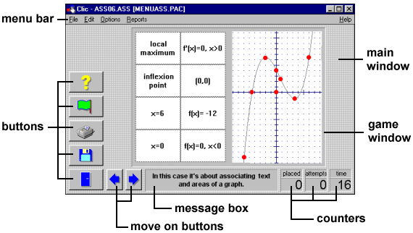
The message box always appears in the lower part of the screen. The activities may have up to two messages; one that appears at the beginning and another that is only shown when the activity has been solved.
The game window is the central area where the activity is carried out. According to the mode that is being used, the contents are usually shown in one or two grids, made up of a variable number of rows and columns.
The counters show the number of attempts, number placed and the time taken. These always appear to the right of the message box.
The buttons allow the student to access various functions: leave the programme (door), open another activity pack (diskette), do the activity again (green flag), ask for help (question mark), print the screen, change the type of puzzle or consult additional information. The buttons can be placed on the left or at the top of the game window.
The move on buttons only appear when a pack is being used, and allow the user to move to the next or previous activity.
The main window gathers together all the parts and can have different colours, shades or background images.
The menu bar, always at the top of the main window (as in all Windows applications), allows access to the different functions for creating and modifying activities.
When designing the activities or packs it can be decided whether to show or hide some of these elements from the user.

The screen dimensions
This is an especially complicated point when designing activities that will be used on other computers. PCs do not have a single screen resolution, they allow the user to select from different options: 640x480, 800x600, 1024x768, etc. An activity made with images that appear perfectly on a monitor configured to 800x600 may be shown cut off or deformed on a screen configured to 640x480.
A decision has to be made before starting to design an application with Clic: if we make the application for monitors with a 640x480 resolution we can guarantee that everyone will be able to see the activities as designed, while if we work with a 800x600 resolution, we will have a larger useable surface but we will limit the number of users that will be able to see it correctly. In newer computers the 800x600 is usual, but this configuration is not possible in some older machines and they always work with a 640x480 resolution.
It is absolutely inadvisable to design activities in higher resolutions (1024x768 etc.). Few users use these configurations and we will almost certainly have problems in guaranteeing that the activities will be correctly seen outside the computer where they have been created.
These are the maximum recommended sizes for the images and text boxes in Clic activities:
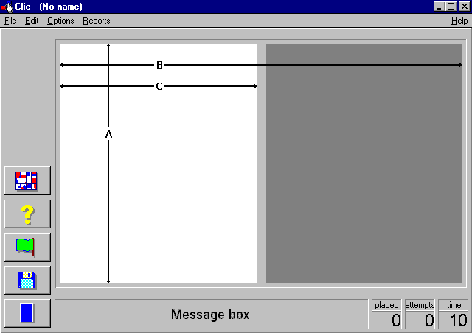 | 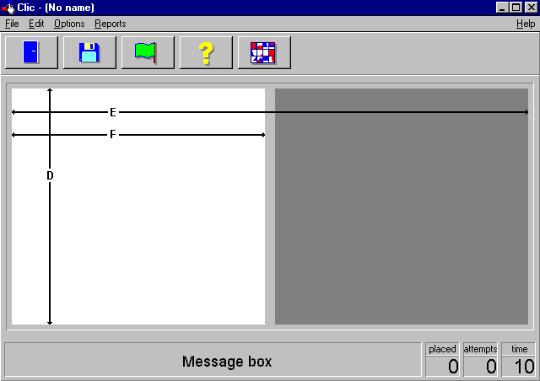
Screen with buttons on the left | Screen with buttons at the top

 | 640x480 screen | 800x600 screen
A | 320 | 440
B | 540 | 700
C | 260 | 340
D | 280 | 500
E | 610 | 770
F | 300 | 380

All of these dimensions have been calculated taking into account that the Windows 95/98 task bar covers a strip at the bottom of the screen.
The E and F values are also applicable to the screens with buttons on the left if all the buttons are hidden or if only one button is visible.

Explicit and indirect references to contents
To design an activity with Clic you have to tell the programme which "ingredients" appear will be used: texts, graphics, sounds, animations, etc. The selection of these contents can be made directly (selecting a file from a list of the available texts and images), or by means of indirect calls.
Indirect calls are always made by writing the name of the file which contains the information that you want to show between curved brackets ({ and }). For example, if {verygood.wav} is given as the text for the good bye message when creating an activity, we will hear the contents of the "verygood.wav" file (which will have been previously recorded) when the activity is finished.
Indirect calls can also be used for other special functions and commands, e.g.: skip to another activity or pack; start up an external programme; record a sound with the microphone; reproduce a previously recorded sound; leave Clic; etc. You will find a full list of the different instructions allowed by the programme in the Import graphics, multimedia resources and other special commands section of the Clic manual.
Multiple references to external files may be combined in a single cell, but only when their contents are compatible. For example, we could write "{hello.bmp}{hello.wav}" in a message box or a cell and that would make the hello.bmp image appear while the hello.wav sound is heard. A sound and a graphic can be selected, but not two different sounds or two different graphics at the same time.

File organization
Clic 3.0 is a 16-bit programme developed for the Windows 3.1 operating system. This means that it is unable to work with files and folders with more than 8 characters in their name, or more than three in the extension. All the "long names" supported by Windows 95 and later versions are shown by their abbreviated version of 8 characters plus 3 for the extension in Clic. For example, if you save a drawing with Windows 95/98 Paint and give it the name "Map of the moon", Clic and all other 16-bit applications will see it as MAPOFT~1.BMP. So, you have to keep in mind that the names given to files that you wish to use later should be kept to 8 letters without spaces, accents or "strange" characters. For the above example, it may have been better to name the file MAPMOON.BMP
It is recommended that all of the files that are used in an activity or pack are located in the same folder. Even though calls related to other folders can be made, the application will be more solid and transportable if you follow this advice.
It is quite normal to work with several files at the same time when creating activities with click. Imagine that you want to make an association between the names of six writers and their photographs. First of all you have to prepare the "primary material" for the activity: look for the photographs; scan them; download them from the Internet; or copy them from a CD-ROM. You will have six files in BMP or GIF format, which will have to be copied in the same folder. Then you will have to prepare two text files: one with the writer's names and the other with the references to the photographs (using the technique of writing the BMP or the GIF name in curved brackets). Finally, you will have to create the Clic activity and define the colours, letter fonts, size of the cells and other graphic elements; all of that will be saved in an ASS file, which is the one that Clic will recognise. In total, 9 different files are needed to create this activity: 6 photographs, 2 text files and an ASS file. It is, therefore, very important to correctly organize the information. If all this material is saved in the same folder it will be much easier afterwards to make changes, copy it to diskettes, send it by Internet, etc.
When you have finished creating an activity pack you can use the ClicPac programme (which is explained in module 4) to compact the different files in a single file. This will help the transport of the application to other computers and will prevent accidental changes. ClicPac will also help us to "clean up", erasing the files which are no longer necessary.

The process of creating activities
The steps to follow to create a Clic activity are:
- Decide of the type of activity and the content it will need, according to the didactic objectives of the application that you want to make.
- Prepare the ingredients of the activity: graphics, texts, sounds, etc.
- Start up Clic, activate the File - New... menu and select the type of activity that you want to make.
- Select the working directory, where the activity will be created (this should be the folder where the "ingredients" are located).
- Adjust the parameters for each activity: number of cells, type of content, font types, welcome message, good bye message etc.
- Confirm and check the workings of the activity.
- Make any changes needed through the Edit - Edit activity (or with the combination of the CTRL+E keys) and Options - Activity options (CTRL+O) menus.
- Save the activity.
When we have quite a few activities it is best to group them together in a pack. To create a pack you only have to activate the File - New... - Activity pack menu and construct the sequence from the list of available activities.

Puzzles
The puzzles consist of shuffling a set of information that the user has to put back in order. This set of information could be an image, a sentence taken apart, a fragmented sound recording, a chronological sequence, etc.
As you have seen in the examples and in the table above, there are four different modes of puzzles. The most common are the exchange and the double modes, which show all the information that needs to be ordered on the screen.
The hole mode restricts movements to the pieces next to the empty cell and is, therefore, the most complicated of all. This is especially so if the content is non-graphic or if there are a lot of pieces.
The memory mode is not really a puzzle as here you do not have to reorder but remember what there is in each cell to find the pairs in the minimum number of attempts.
Some things to take into account when designing a puzzle:
- If text files are used as the content of a puzzle, Clic will assign one line to each cell. The hard returns in text files are used to separate the contents from one cell from the next. This also applies to associations; always one line per cell.
Blank cells appear if an activity is designed with more rows and columns than the number of lines in the text file.
- Background zones with a single colour may appear in some images. When dividing rows and columns, try to make sure that there are never two cells with exactly the same content, as it may visually appear that the puzzle has been solved but the programme detects that there are still two pieces out of place. Here is an example:
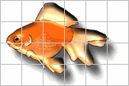
The cells 1, 5, 6, 19 and 24 (starting from the top-left) in this puzzle have exactly the same content; the white background colour. If we do not modify the image or change the number of rows and columns, it will be very difficult to place the blocks correctly according to the programme as these pieces can be changed without noticing any visual difference.
- When a puzzle is made with an image, we need to work on it beforehand with a graphics editor to give it the appropriate dimensions so that it will fit within the Clic game window. If the image is too large (something that usually happens when it comes from a high resolution scanner), we have two options: get the programme to cut the image, leaving out the area which does not fit on the screen or ask it to compress the image, forcing a change in dimensions that does not always give the desired aspect.
In the "double" mode different initial positions for the grids can be chosen: A to the left of B, B to the left of A, A above B and B above A. In the "memory" types you can choose between duplicating the number of horizontal cells ("AB" mode) or vertical cells ("BA" mode).

Simple and complex associations
The associations are one of Clic's most versatile activity types. In an association, there are always two sets of information, named A and B, between whose elements certain pairings are determined. The only exception to this rule are those of the Information screen mode, these are not really associations although they are included in this group.
The content of the A and B grids can be a graphic or a text file and, as with all Clic activities, the text files can be used to call up multimedia elements by writing between brackets.
In the written answer associations the content of B must always be a text, and in the indicate mode it is always the set made up of Yes and No expressions.
In the normal and complex modes the whole content of both grids is always shown and the user has to make the relations with mouse clicks. In the other modes the content of grid B is never completely shown, but the programme uses it to check the answers (in written answer and indicate) or decide which type of message should be shown (in explore mode).
The number of cells is the same for both grids in normal and written answer modes. The number can be different in the other modes.
In the normal, complex, indicate and written answer modes it is also possible to bring in a third set of information, called Solved grid A. The purpose of this third component is to appear when each of the cells in Grid A is solved.

For example, suppose that we have an association where mathematical operations have to be matched to their results and that in this association there is a cell in grid A with the text "2+2"and another in grid B with the text "4": when the user solves the pairing, Clic initially makes the "2+2" cell disappear, showing a grey rectangle in its place which indicates that it has been solved. Another possibility would be to show something other than the grey rectangle when the cell is solved and this is where the third set of information, called Solved grid A, would come into use. In this information set we could include a cell with the text "2+2=4", and the result would be that once the "2+2" cell is solved, the operation and its result would appear together.

Normal association
Normal associations always have the same number of cells in both grids and they also have the same layout of rows and columns. The elements of A and B are matched one by one according to the order in which they have been written or drawn in the content files. For example if the content of A is a text with the following words:
France
Greece
Italy
Portugal
The content of B could be:
Paris
Athens
Rome
Lisbon
Clic automatically assumes that the first word in A is related to the first in B, the second in A with the second in B, and so on. If graphics are used the relation is also made cell by cell starting at the top left.
When a pair has been matched the two related cells disappear, unless a content for Solved grid A has been assigned, in this case the alternative content appears in A and the cell in B disappears.

Complex association
In the complex associations, the number of elements in A (rows and columns) is selected in the edit activity window, and the distribution of B is done in the relationship assignment window, which is explained later. As A and B can have a different number of elements, Clic cannot automatically decide on the correct pairs of cells and so we have to go to the relationship assignment to define the relationships.
When a pair has been matched the content of grid A disappears(or the alternative content appears if Solved grid A is used), but the content in B stays as it was as there may be another element in A which needs it. For example, imagine an association with the set "2+2", "3+2", "2x2", "4+1" in grid A and the expressions "4" and "5" in grid B. If, when solving the match between "3+2" and "5", the cells from A and B disappear, it would be impossible to solve the "4+1" afterwards, as the "5" would have disappeared in the previous go.

The relationship assignment
Clic cannot deduce the relationships between the elements in the A and B windows in Complex, Indicate and Explore mode associations as they may have a different number of cells. To define the correct matches between the pieces you have to go to the edit activity window and, from there, enter the relationship assignment window through this button:
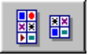
On entering the relationship assignment window the contents of grids A and B are shown in two lists or graphical areas. At the start they both have the same number of elements (those defined by grid A in the edit activity window). The process for defining the relations is as follows:
- If grid B should have a different number of elements from A, start by changing its dimensions with the B Columns and B Rows counters.
- Click on the first element in grid A, the list or graphical area on the left.
- Select the corresponding element from the list or graphical area for B.
- Click on the second element in A.
- Select the corresponding element from B.
- Continue like this, always selecting first from A and then look for its match in B.
If there is any cell in A without an assigned definition, select it and mark the Non assigned cell field. When the activity is started these cell will be hidden from the start or the alternative content will be shown if a file has been selected in the Solved grid A area in the edit activity window.
In some associations there may be a lot of elements in grid A that correspond to a single cell in B. For example, in the "demo" pack activity where the map of the world is explored most of the cells are "WATER":

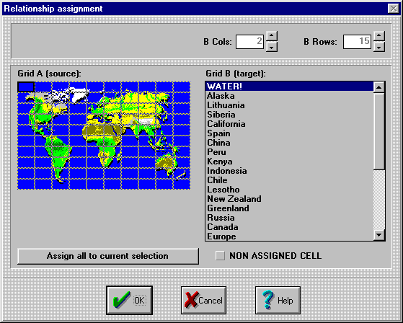

When editing an activity like this, it can be very practical to use the Assign all to current selection button, which gives all the cells in A the same match. In the case of the above activity we would start by selecting an area of the sea on the left, then we would select the text "WATER" and we would click on Assign all to current selection. Then we would go along, selecting the cells where a country or part of the work appears one by one and we would click on the corresponding line on the right.
In the complex associations a field with the text Inverse resolution appears in the relationship assignment screen. Marking this field will result in an activity with different behaviour. All the cells in A will not have to be solved, as in most associations, it will be enough match all the elements from B with one from A. Try marking this option in a complex association, such as ASS02.ASS in the demo. You will see that it is only necessary to find three verbs (one for each of the three tenses) and Clic will assume that the activity is solved.

Guided practices
To do the guided practices for this module you will have to download the PRAC1.ZIP file and decompress its contents in the folder C:\Clic\Course\Module1\Practice

Creating a puzzle from an image
In this first exercise we will make one of the simplest Clic activities; a puzzle based on an image split into rectangles.
- Start up Clic and activate the File - New... - Puzzle menu.
- The programme will ask for the working directory that you wish to use. Search for the C:\Clic\Course\Module1\Practice folder and confirm the operation.
- Note that there are two options in the Content area of the window: Image or Text. In this exercise we will select the option Image.
- Open the list below these two options (where it says NEW IMAGE) and select the AFRICA.GIF file. If the file is not there, it means that you have not correctly selected the working directory or that you have not decompressed the ZIP file as indicated. If this is the case, cancel the operation and start the exercise again from the start.
- Select the Double mode and choose 3 rows and 3 columns.
- In Welcome message write the text:
- Order the pieces of this photo of the world
- ... and in Good bye message:
- Very Good!
- Confirm the operation by clicking the OK button and check that the activity works.
- Activate the File - Save menu and save the activity with the name EARTH1.PUZ
Now we can make some changes that will help improve the visual aspect of the activity:
- Activate Options - Activity options menu and click on the Solid colour button in the Main window area. Select black.
- Do the same with the Game window.
- Confirm the operation and check the result of the changes.
- To avoid the border line of the game window appearing go back to Activity options and unmark the Shaded frames box. Check how it looks now.
To finish we will make the messages appear in black text on a white background:
- Edit the activity(through the Edit - Edit activity menu, or use the shortcut keys CTRL+E).
- Click on the Fonts button.
- Mark the Messages box.
- Click on the Text button and select white. Then change the Background to black. Confirm the operation and check the result of the changes.
- Note that the counters have taken the same colours as those selected for the message box.
- Activate the File - Save menu to save the activity again. As we have already given the file a name we will keep it as the same: EARTH1.PUZ.
Before continuing, let us check the function of Compress image: Edit the activity, changing the position to A above B (the third option from the left) and click on OK. You will see that the image is cut off (the bottom part is missing). Edit the activity again and activate the Compress image box. Now the grid dimensions are adjusted to the scale of the original image original, which the programme compresses so that it fits.
Check how the aspect of the activity changes in the Exchange, Hole and Memory modes. You can do this by editing the activity or directly from the main Clic screen, clicking on the Type of puzzle button, which is above the yellow help sign.
Check what happens when the number of rows or columns are changed, and what the Delimit cells option does.

Creating a puzzle from a text
In this activity the pieces of the puzzle are the lines of a text file instead of being the rectangles that make up an image:
- Activate the File - New... - Puzzle menu. If the programme asks if you wish to save the activity created in the previous exercise, say NO.
The working directory will be the same as in the previous exercise: C:\Clic\Course\Module1\Practice
- Click on the Text field and note that the expression NEW TEXT appears in the drop list.
- Activate the Edit contents menu. The programme will ask what name you want to give the text file that we are going to create. Write PLANETS.
- The Notepad programme will start up, this is the most simple text editor incorporated in Windows. Write the names of the planets, one on each line:
MERCURY
VENUS
EARTH
MARS
JUPITER
SATURN
URANUS
NEPTUNE
PLUTO
- Close Notepad and when it asks whether you want to save the changes, answer YES.
Note that the PLANETS.TXT file is already selected in the list of activity contents. If this is not the case, drop the list and select it manually.
- As there are 9 planets we have three options for the distribution of the cells:: 3x3, 9x1 or 1x9. We will try with 3 rows and 3 columns for a start. Select Double mode as well.
- In Welcome message write the text:
Put the planets in order of proximity to the sun
- ...and in Good bye message:
Fantastic!
Confirm the activity and test it. Although the activity seems to work well, it does not seem very logical to order a list of words in a two-dimensional grid. It would be more understandable to organize the words in a single row or column:
- Edit the activity and change it to 1 column and 9 rows.
- Check how it works.
To finish, save the activity as PLANET1.PUZ

Creating a normal text-text association
The objective of this exercise is to relate each planet with a descriptive sentence.
- Go to the File - New... - Association menu.
- The working directory will be the same as in the previous exercise: C:\Clic\Course\Module1\Practice
- The Kind will be Normal association (both windows will have the same number of cells).
- The type of content will be Text in grid A and in grid B.
- We will create a new document for grid A. Check that NEW TEXT appears in the drop list and click on Edit contents.
- The programme will ask for a name for this text file; call it PLANDESC (it would be better to call it "Description of the planets", but remember that we have to keep names to 8 characters because Clic is a 16-bit application). When the notepad is activated write the following sentences:
It is in thermometers
The goddess of love
Where we live
The red planet
The biggest of all
A great ring surrounds it
The seventh planet
The king of the seas
The farthest
- Save the document and close the notepad.
- Open the list that corresponds to grid B and select the PLANETS.TXT file that we wrote in the previous exercise.
- Set the distribution to 3 rows and 3 columns.
- In Welcome message write the text:
Match a sentence to each planet
- ... and in Good bye message:
You know loads!
- Test the activity and make any necessary changes.
- Save it with the name PLANET1.ASS

Creating a text-image association
In this exercise we will link the names of the planets with certain areas of an image.
- Activate the File - New... - Association menu and confirm that you want to continue working in the C:\Clic\Course\Module1\Practice folder
- Change the Kind to Complex association. In this guided practice grid B will have more areas than grid A.
- For grid A select the type Text, drop the list and select the PLANETS.TXT file which we created in the previous activity.
- For grid B select the type Image, drop the list and look for the PLANETS.GIF file.
- Select 3 columns and 3 rows. This is the layout we will use for the grid on the left.
- Click on the Relationship assignment button 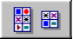 and type 5 in B Columns and 6 in B Rows. This image has been made, thinking specifically in this cell layout.
- Select the word Mercury from the list on the left and, on the right, click on the cell showing this planet (the one nearest the sun).
- Then click on Venus and the corresponding cell in the image on the left.
- Continue like this for the rest of the planets, always selecting from list A first and then clicking on the corresponding cell in B. As the image is compressed, there are some planets that cannot be seen very well. Pluto is a small stain at the top left of the image.
- Confirm the relationship assignment by clicking on OK. We then go back to the edit activity window.
We could check the aspect of the activity by clicking on OK again. It is not quite what we hoped for because the content of B is disordered and the graphic looses its meaning. We can go back to editing the activity by typing CTRL+E.
- Unmark the Delimit cells and Shuffle boxes for grid B. The ones in grid A can be left marked.
- Write a welcome message such as:
Find each planet in this diagram
- ... and a good bye message of congratulations.
- Test the activity.
Save the file as PLANET2.ASS

Creating an association with indirect references
In this exercise we will make an association between photographs of the planets and their names. The photographs are in some GIF files that you should find in the working directory if you followed the instructions that we gave at the beginning carefully.
We will not be able to use the select Image type option for grid B in this exercise as there are 9 photographs in 9 separate files rather than just one image and only one file can be selected from the drop list. We will have to use the indirect call technique, writing the file names in a text file.
- Go to the File - New... – Association menu. We will use the same working directory as before.
- Select the PLANETS.TXT file from the previous exercises for grid A.
- You will have to create a NEW TEXT for grid B. Click on the Edit contents button and, when Clic asks, call it IMGPLANE
- In the note pad write the following lines:
{mercury.gif}
{venus.gif}
{earth.gif}
{mars.gif}
{jupiter.gif}
{saturn.gif}
{uranus.gif}
{neptune.gif}
{pluto.gif}
It is important to write the file names between curved brackets "{" and "}" and not to confuse them with square brackets "[" and "]". It is also important not to leave any spaces at the beginning or the end of any of the lines.
By writing the file names between curved brackets in a text file, Clic will display their contents within the cells rather than the literal expression of each line.
- Save the file and close the note pad.
- Set the layout at 3 rows and 3 columns.
- In Welcome message write:
Match each planet with its photograph
- ...and in Good bye message:
Very good!
- Click OK and test the activity.
- Save it as PLANET3.ASS
It works... but some of the photographs are cut off. We could consider changing the cell distribution to improve this, by putting the list of names in a single column on the left and keeping the 3x3 grid for the photographs. Here are the steps to follow:
- Use CTRL+E to activate the edit window (the shortcut for the Edit - Edit activity menu).
- Change the Kind to Complex association. You need to make this change because it is not possible to have different cell layouts for the two grids in normal associations.
- Change the layout to 1 column and 9 rows. This should affect grid A.
- Click on the Relationship assignment button and change the setting to 3 for both B Rows and B Columns.
- Click on each of the lines in the list on the left to check if the relationship assignment is still correct. The same row on the right should be automatically selected. If this is not the case, mark it.
Click OK to return to edition and OK again to test it. Indeed, the layout has changed, but the cells in grid A are too big and the ones in grid B are too small.
Before modifying the cell dimensions, we shall do a few simple calculations:
The planet images have maximum dimensions of 100x100 pixels (you can check this with PaintShop Pro or another graphic editor). To leave a bit of a margin between the photographs, we could give the cells in grid B dimensions of 120x120. This will give a total of 360x360 for grid B.
There are now 9 rows in grid A, while B still has 3. For both grids to have the same height, the cells in grid A would have to be a third of those in B. A third of 120 is 40 pixels.
Here are the steps to modify the cell dimensions:
- Edit the activity (CTRL+E) and click the Options button.
- Change the width settings in both grids to 120 and the height settings to: 40 in A and 120 in B.
- Confirm everything and check how the activity looks. It should now have a more appropriate distribution.
Grid B would look better if the cells had a black background:
- Edit the activity (CTRL+E) and click the Fonts button.
- Mark the Grid B box (it is very important to always select the area before changing colours or fonts).
- Click on the Background button and select black.
- Click on Text and select white. Even though there is no text in grid B, it is always a good idea to avoid having the same text and background colour in case the activity is changed at a later date.
- Confirm everything and check how the activity looks now.
- To avoid the dividing lines appearing between the cells in grid B, edit the activity and unmark Delimit cells.
- Save the activity again with the same name, PLANET3.ASS

Creating an activity pack
We will now sequentially link the activities we have made so far to finish the guided practices.
- Activate File - New... - Activity pack menu.
We will use the same working directory as before: C:\Clic\Course\Module1\Practice
- If you have followed the proposed guided practices, there should be 5 files in the list on the left. Click on the one called EARTH1.PUZ so that it is selected and then use the >> Add >> button to add to the list on the right.
- Select the rest of the activities in the following order: PLANET1.PUZ, PLANET1.ASS, PLANET2.ASS and PLANET3.ASS.
- Confirm the pack creation, clicking on OK. Clic will ask if you want to save it, say yes and call it PLANETS.PAC
Test the pack. If you want to make any changes, use the Edit - Edit activity pack menu.

Exercises
Search for the photographs of four European writers and a map or a satellite photograph of Europe on the Internet. Copy them to the Practice folder of module 1.
You will have to work on the photographs with PaintShop Pro so that they are no larger than 100 x 100 pixels. They do not have to be exactly 100 x 100, they just need to fit in a rectangle of 100 x 100. The map or photograph of Europe should be no larger than 200 x 200.
Using this material you have to make:
- An association between the writers' names and four of the books they have written or wrote.
- An association between the writers' places of birth and their names.
- An association between the writers' photographs and names.
- An association between the writers' photographs and the area where they were born on the map of Europe.
- A puzzle with the map of Europe.
- A pack where all the activities that you have made are linked together.
When you have finished the activities compress them in ZIP format and send them to the course tutor.

Here are some clues to help you find the information on the Internet:
- On the Nobel Foundation web site, you will find biographies, bibliographies and photographs of all the authors that have who the literature prize:
http://www.nobel.se
Go to The Electronic Nobel Museum Project > Lists of laureates > Literature.
- In relation to maps and photographs, here are a few sites:
http://www.lib.utexas.edu/Libs/PCL/Map_collection/Map_collection.html
http://www.xtec.es/rtee/europa/mapa_eng.htm
http://www.nationalgeographic.com/maps/index.html
http://www.fourmilab.ch/earthview
To download a photograph or an image from the Internet, you should right-click on it and select Save image as... from the menu.

Module 2

More associations
In the last module we saw the two basic types of associations, normal and complex. Clic allows you to work with certain types of activities including a relationship assignment between the elements of two different groups.

Indicate
In this type of activity you only have to select the content for grid A and then go to the relationship assignment window and assign the expression Yes or No for each of the elements in A.
In the indicate activities it is very important to ask a question in the message box as the user's task is to click on the cells that answer the question in the affirmative. The correctly identified cells turn grey or, alternatively, show the content selected in the solved grid A field.

Explore mode
In this type of activity all the content of grid A and just one B cell is shown. The user can click on the cells in A and the programme will show the associated content in the B cell.
The user does not have to answer a question; they only have to look for the information hidden behind each cell in A.
Even though only one cell is shown in B, the programme virtually divides its content in rows and columns. The number of elements in B and their distribution is set in the relationship assignment window.

Written answer
These types of associations are similar in appearance to those in the explore mode. They show all of the content for grid A and only one cell in B, where the user has to write the appropriate text for the selected cell in A.
There has to be at least one answer for each of the cells in A and the answers have to be written in a text file assigned to grid B. The answers in these files have to be written in the same order as the questions in A.
The programme never shows the content for B; it is only used to check if the answers given by the user are correct.
If a cell allows more than one correct answer, all the possibilities have to be in the same line of text and separated by a vertical bar. For example, the line of text:
Bike|Bicycle
... will make the programme accept either of the answers. The vertical bar is obtained by the combination of ALTGR+1.
The programme does not differentiate between capitals and lower case when checking the answers but accents and punctuation marks must be written correctly.
Most written answer associations can also be set as Text activities, which we will see in module 3.

Information screen
This type of activity is not really an association, although it has been included in this group for practical reasons. They are used to show a certain piece of information that the user has to read, look at or listen to before continuing with the rest of the activities in a pack.
To create an information screen we only need to indicate the content for grid A the format in rows and columns that we want. If the content is a text, we can use it to insert active content in the cells. This is a technique that can be used to make "menus" that lead to certain activity packs. For example, suppose that we have prepared three activity packs about the human body called "digestiv.pac", "circula.pac" and "locomoto.pac" and we want to make a screen that lets the user select one. One way of doing this is by creating an information screen type association, then give it a format of 3 rows and 1 column and assign the following content to grid A:
Digestive system{digestiv.pac}
Circulatory system{circula.pac}
Locomotory system{locomoto.pac}
The result being that when the user clicks on the cells the programme will start up the corresponding activity pack.

Colours, fonts, background graphics and other options
The visual aspect of the screen where the activity is presented is basically controlled by two windows:
- Through the Fonts button that appears in activity edition (CTRL+E) the colours and fonts of the areas which show text or active contents can be changed.
- In Activity options (CTRL+O keys) other parameters are set, such as the background colour, the game window position, the buttons to appear, etc.
We shall now look in detail at how these two configuration boxes work:
The Fonts and colours window has a different appearance, according to the type of activity being designed:
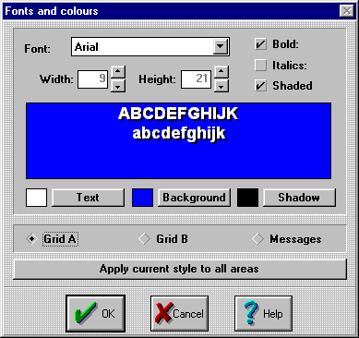 | 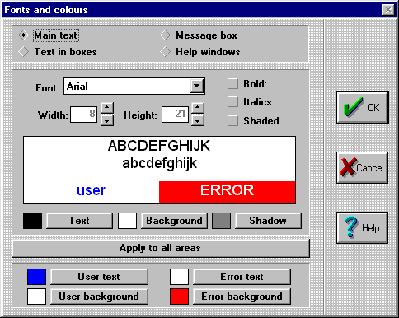
Appearance of the Fonts and colours window in puzzles, associations, word searches and crosswords. | Appearance of the Fonts and colours window in text activities.
To change the fonts and colours, you have to follow these steps:
- Select the area to be modified. The main areas are grid A, grid B and the message box. In text activities, which we will see further on, there are four areas: main text, text in boxes, help windows and message box.
- Select the font by dropping the Font list. It is recommended to use the basic Windows fonts, especially if you are planning to install you activities on various computers. If you specify other fonts, the users of your activities will need to have these fonts installed as well. The basic Windows fonts are Arial, TimesNewRoman, CourierNew and System.
- Adjust the letter width and height, as well as the Bold, Italics and Shade attributes.
- Change the colours. To choose a colour, click on the buttons that appear to the right of the example boxes.
- If we want all the areas to have the same appearance, we just have to click on the Apply to all areas button. Otherwise we will have to select the areas one by one and follow all the above steps.
You should to take into account that it will not always be possible to show the texts in sizes chosen. When Clic detects that text leaves the margins set for a cell, it automatically reduces the font size for the whole area of the cell in question. The cell and font size are two variables that are closely related.
The Shadow colour is also used to fill the space left in the cells that disappear while an activity is being solved. Try changing this colour for the puzzles in the Clic "demo" and you will see how the changes are shown.
The rest of the parameters that control appearance can be found in Activity options:
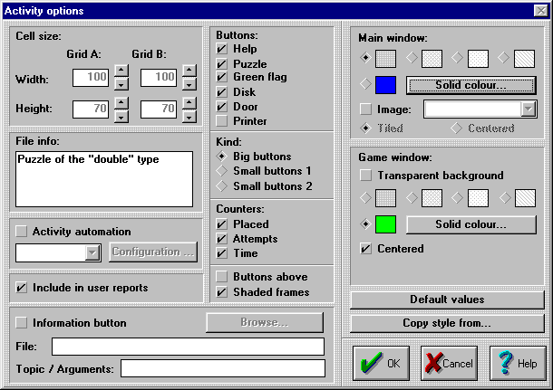
We have three options for the Main window (see the Areas of the screen section in module 1):
- Choose one of the four grey shades.
- Choose a colour. To do this, first you have select the diamond in front of the colour sample and then click on the Solid colour button to select it.
- Choose a background image. The graphic can be tiled (filling the whole window) or centered in the middle of the screen, filling the rest with the selected colour or shade. Some of the text activities in the Clic "demo" use background images: for example, TXA02.TXA (tiled), or TXA06.TXA (centred).
We also have three options for the Game window:
- Make it transparent. In this case the colours, shading or background images selected for the main window dominate.
- Select a shade.
- Select a solid colour.
The game window appears centred on the screen by default, but it is possible to place it elsewhere. This option is usually used together with a centred background image in the main window, which acts as a decoration for the activity.
Many other parameters that control the activity appearance are controlled by the activity options:
- The buttons and counters which have to appear.
- The design of the buttons. There are three possibilities:
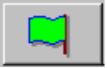 | 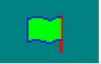 | 
Big buttons  Solid rectangles with shadows, with the same style as the classical Windows buttons. | Small buttons 1  The image is drawn in colour directly on the main screen background. | Small buttons 2  Single colour line drawings on the screen background.
The colour used to draw the small buttons 2 is the same as the one selected for the message box text in the Fonts window.
- The Button position: on the left or at the top of the screen.
- The showing or non-showing of a rectangle around the game window, the message box and the counters. This is controlled by the Shaded frames option.
- The width and height of the cells.
When dimensions are set that, with the current cell layout, exceed those permitted by the screen, Clic reduces them until they fit, keeping the indicated height/ width ratio. For example, suppose that we have made an activity with a grid that has a maximum space of 540 x 320 points on the screen (see the graphic of maximum dimensions in the previous module), and that there are 10 rows and 10 columns. If we set a cell size of 100 x 50 we will obviously exceed the available space (we would need an area of 1.000 x 500 points!). Faced with this Clic will end up setting the dimensions at 54 points for the width (540/10=54) and 27 points for the height as the sizes set (100x50) imply that the height should always be half the width (54/2=27). In fact there will be left over vertical space; the grid will take up 270 points (10x27) and there are 320 available, but Clic will always try to respect the ratio between width and height indicated.
When there are two grids the calculations are a little more complicated, but the same principle is followed, shrinking the cells as much as needed to fit them on the screen and keeping their proportions.
These considerations about cell size are only taken into account when the content is "text". With graphics, Clic automatically calculates the sizes and proportions from the real size of the image.
In text activities only the dimensions of grid A, which has one single cell, are considered.

Style automization
The Copy style from... button, which appears in the activity options window, can be used to homogenise the appearance of various activities that have to be gathered together in the same pack. Here is the process that would need to be followed:
- Create an activity and change the colours, fonts, background images, etc. until you get the desired appearance.
- Save the activity.
- Create a second activity and, before defining the content, go to Activity options (CTRL+O) and click on the Copy style from... button. Select the name of the "patron" activity that we created in the previous step and confirm. With this action we will give the new activity the same appearance as the previous one.
- Complete the creation of the second activity, altering the cell sizes and text size if necessary.
- Follow the same process for the remaining activities in the pack.
Cell sizes are usually a very specific characteristic to each activity. After importing an external style, it is important to always check them.

Word searches
The objective of a word search is to find hidden words in a grid full of characters. To show the programme that you have found a word you have to click on the first letter of the word, go to the last letter with the mouse and click again. If the word is correct it will appear marked in inverse video.
The words can be hidden in any direction: horizontal, vertical or diagonal, normally or back to front.
Optionally, Clic can be instructed to reveal the content in a second window as the words are found in the word search. The content of this alternative window can be a text, a graphic, or any kind of multimedia material.
Clic does not randomly set the positions of the words; it follows the distribution given and then fills the empty cells with random letters. To obtain different distributions of a group of words in a grid, you can use programmes such as WordSearch, which can be found in the "Clic Corner".
It is important to write the list of hidden words correctly, as Clic cannot detect which expressions are correct and which are not. If the activity has a second window, the words have to be written in the same order in that they should be shown in their cells.
Here are the steps to follow to make a word search:
- Sketch out the distribution of the words we want to appear on a sheet of paper (or use WordSearch to set the distribution).
- Create a new word search activity.
- Set the number of rows and columns that are needed to fit the word search in. The maximum is 10 rows and 21 columns.
- Write the hidden words in the grid, leaving the rest of the characters with the asterisks that Clic initially shows. You can move from one cell to another by using the arrow keys, and if an error is made it can be corrected by placing the cursor on the incorrect characters and pressing the SPACE BAR.
- Write the list of words that have been hidden in the grid in the Hidden words section.
- Optionally, mark the Right grid box and select a content type and the distribution of rows and columns for this second alternative window.
- To finish, write a welcome message and a good bye message, set the fonts and colours, etc.

Crosswords
Crosswords are created on a similar screen to word searches. They normally have to be designed beforehand on a piece of paper and then follow these steps:
- Set the number of rows and columns for the grid.
- Write the solution, leaving the asterisks in the cells that have to appear blacked out. It is recommended to use the arrow keys to move around the cells.
- Write the horizontal and vertical clues, separating them with a semi-colon when there is more than one word in a row or a column. The definitions can be text messages or references between curved brackets to graph, sound or digital video files.
In Toni Miquel Mollà's Noms d'Animals activity pack, which you will find in the "Clic Corner", an alternative way of making crosswords with complex associations with solved grid A is shown.

Calling multimedia contents from Clic
We have already seen that in any area of Clic where, in principal, text should appear (cells, hello and goodbye messages, crossword definitions, etc.) an image can be made to appear by writing the name of a BMP or a GIF file between curved brackets. This technique is also used to call other types of multimedia content, such as sound (WAV), MIDI (MID) or digital video (AVI) files, and also for special instructions such as: link to another activity or pack; record a fragment of sound with the microphone; reproduce a previously recorded fragment; activate a music CD, close Clic or start up external programmes.
For a detailed description of the syntax permitted in the calls between curved brackets, we recommend that you consult Import graphics, multimedia resources and other special commands which you will find in the Creating activities section of the help or the Clic manual.
More than one call between curved brackets can be set in the same area or cell, as long as the files are compatible. For example, a multimedia file and a text (or a graphic) can be combined by writing the two references in the same line, e.g.:
Bicycle{bike.wav}
{cow.bmp}{cow.wav}
{lion.gif}{lion.avi}
The human body{humanbod.pac}
In the first case the text Bicycle will be shown in the cell and when it is activated the bici.wav file will be heard. In the second the cow.bmp image will be seen, which will play the cow.wav file, and in the third case the lion.gif image will be shown until the lion.avi video is activated. The fourth example is the one normally used in information screens that act as menus to activate different activity packs.

Accessibility functions
Clic has some special functions thought out to facilitate use for students with sensory or motor difficulties. These are activated in the Options - Global options menu.
- The automatic cursor makes the mouse pointer skip from one cell to the next on its own. To click on a cell, you just have to press the space bar, the RETURN key or the mouse button when the cursor is on the cell.
- Big cursor makes Clic use a larger mouse pointer that is easier to see.
 | 
normal cursor | big cursor
- The Thread width parameter widens the lines that link a selected cell with the mouse pointer when an association or a exchange puzzle is being solved.
- Help in help has an effect that might seem anecdotal, but it is useful for younger students with motor difficulties. It stops them being able to accidentally activate Clic's reference document from the activity help windows.
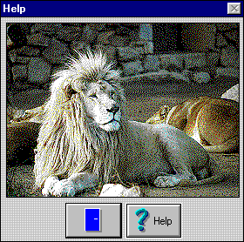 | 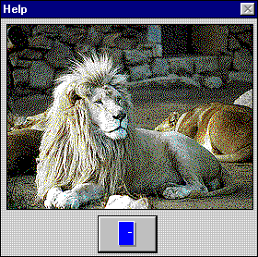
With "help in help" | Without "help in help"
- The menu bar can also be shown or hidden. This function only takes effect when Clic is called from an icon that directly activates an activity pack. The Clic 3.0 icon always activates the programme with menus.
These parameters are particular to the installation of Clic in each computer rather than characteristics of an activity or a pack. That means that an activity cannot be created with a big cursor, but rather you configure a computer where all the activities use it by default.
For more information on accessibility functions we recommend that you consult the Global options section in the help or the Clic manual.

Print functions
One of the new things in Clic 3.0 is the possibility of printing the content of the screen at any time. This could be useful for preparing exercises on paper.
To access the print functions you have to be in the desired activity and select the File -Print menu. You can also place a button on the main screen that directly activates printing, by marking the corresponding box in Activity options.
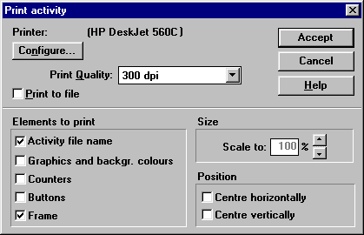
You can change various parameters in the screen that appears before printing such as which elements should appear and the position of the image on the sheet of paper. Clic always tries to occupy the maximum printable area of the paper in the printer, but this can be reduced with the Scale to option.

The information button
An extra button that opens a document or an auxiliary application can be placed in any activity:

The behaviour of this button is specified in the Activity options screen (CTRL+O) and can have various functions:
- Open a Windows help document, as in some Clic "demo" activities (e.g. PUZ05.PUZ). In this case you have to write the name of the HLP document in the File field and, optionally, the title of the page to be activated in the Topic/Arguments field.
The creation of Windows help documents is a bit complicated, but if you are interested, you can find some tools and documentation in the Resources section of The Clic corner.
- Open any document that can be activated by Windows. For example, a BMP image (which will be opened by the Paint utility), a Write (WRI) or a Word file (DOC), a web page (HTM), etc. The file must always have the corresponding format to its extension and be located in the working directory of the activity being edited.
This technique is used in Antoni Prim i Magda Argemí's Dites dels mesos de l'any activity pack, which you can download from the Click Corner, to open Paint with some black and white that the students can colour in and print.
- Start up any executable programme by writing its name in the File field. The programme can be located in the working directory or, if it is a Windows utility, in the C:\WINDOWS or C:\WINDOWS\SYSTEM folders. The Topic/Arguments field can be used to give additional instructions to the programme.

Guided practices
You will need to download the PRAC2.ZIP file to do the guided practices for this module. Decompress its contents in the C:\Clic\Course\Module2\Practice folder.
In this exercise some materials are used from the "Enciclopedia multimedia de los seres vivos" CD-ROM published by "Editorial Planeta", which came free with the Sunday editions of the "La Vanguardia" newspaper in 1997.

Creating an explore mode activity
In this exercise we will make an activity that allows the discovery of the names of four animals:
- Start up Clic and activate the File - New... - Association menu. The working directory will be the one corresponding to the guided practices in Module 2 (where you have just decompressed the ZIP file).
- Select explore mode in the area at the top of the edit window.
- We will use 4 animal photographs in this exercise. So you should set a layout of 2 rows and 2 columns.
- We will place the animal photographs in grid A. As they are in 4 separate files, we will have to do this with indirect calls from a text file. Select Text for the type, leave the entry NEW TEXT selected and click Edit contents.
- The programme will ask for a file name. Write PHOTOSAN and accept the operation.
- Write the following four lines in the Windows notepad:
{elephant.gif}
{leopard.gif}
{wolf.gif}
{dolphin.gif}
- Save the file and close the Windows notepad.
- We will also use a text file for grid B. Here we will write the names of the four animals. Leave the entry NEW TEXT selected and click on Edit contents. The file name will be NAMESANI.TXT (you only have to write NAMESANI), and the content will be the following:
Elephant
Leopard
Wolf
Dolphin
- Save the file and close the Windows notepad.
- There is no need to write a good bye message in explore mode activities. Write the following sentence in Welcome message:
Click on the photographs to know the names of these animals
- Confirm the creation of the activity by clicking OK.
- Save it as ANIMALS1.ASS.
It seems to work, but the photographs are cut off in the cells. Let's fix it:
- Edit the activity (CTRL+E keys) and change the placement of the grids to type A above B.
- Click on the Options button and change the dimensions of grid A so that they have a width of 220 and a height of 150 points. For grid B set the dimensions at 220 x 40.
- There is no need to solve anything in explore mode activities so unmark the Placed, Attempts and Time markers.
- Confirm everything and check the activity. It should now work much better!
The white background does not go very well with the photographs. We will make a few esthetical changes:
- Edit the activity again (CTRL+E) and click on the Fonts button.
- Mark the Messages box and click on the Apply to all areas button. This makes the grey background colour the same for the whole screen (we could have also changed it area by area but this way is quicker).
- Mark the Grid B box and select a font size of 12 x 30 and Bold style. Click on the Text button, select red and confirm.
- We are back in the edit activity window. unmark the boxes where it says Delimit cells for grid A and B.
- Click on the Options button and unmark the Shaded frames box.
- Confirm everything and test the activity again.
- Save it again with the same name: ANIMALS1.ASS

Integration of sound files
We will now make a variant of the previous activity that will let us hear the sound of each animal.
- Activate the File - New... - Association menu again. The working directory is the same as in the previous exercise.
- Mark the Explore mode kind and set a layout of 2 rows and 2 columns.
- Drop the list of files for grid A and select PHOTOSAN.TXT
- Click on the NEW TEXT button for grid B and call it SOUNDSAN. In the Windows notepad write:
{elephant.wav}
{leopard.wav}
{wolf.wav}
{dolfin.wav}
- Save the text file and close the notepad.
- Write the following text in Welcome message:
Listen to the sound of each animal
- Select an A above B type distribution.
- Confirm everything and test the activity.
As before, we find ourselves with cells that are too small. This time, instead of changing the parameters that control the appearance of the activity one by one, we will just copy them from the previous exercise:
- Go to Activity options (CTRL+O) and click on the Copy style from...button.
- In the window that appears click on the ANIMALS1.ASS file and accept.
- The graphical appearance is very similar to that of the first activity. We only have to unmark the Delimit cells option for grids A and B in the edit activity window (CTRL+E).
On clicking on the photo of each animal, its sound will be heard and a speaker icon is shown in grid B. Instead of this speaker, we could make each animal's name appear:
- Edit the activity (CTRL+E) and click on the EDIT CONTENTS button for grid B. You should open the Windows notepad with the SOUNDSAN.TXT file.
- Change this text file so that it ends up like this:
Elephant{elephant.wav}
Leopard{leopard.wav}
Wolf{wolf.wav}
Dolphin{dolfin.wav}
- Still in the Windows notepad, activate the Files - Name and save menu (or File - Save as...) and change the file name to NAMESOAN.TXT. Once that is done close the Windows notepad.
- In Clic's edit window, drop the list for grid B and select the file you have just created: NAMESOAN.TXT.
- Check the activity and save it as ANIMALS2.ASS

Creating a sound-image association
In this activity we will use the text files created in previous steps to make an association between animal sounds and their photographs. When the student guesses each pair, the animal's name will appear.
- Activate the File - New... - Association menu. The working directory will be the same as in the previous steps.
- Select a Complex association (even though it could be a normal association, we choose this type as it will allow us a different row and column distribution for grids A and B).
- Set 1 column and 4 rows.
- Select the SOUNDSAN.TXT file for grid A and PHOTOSAN.TXT for B.
- Mark the Solved grid A box and select the NAMESANI.TXT file.
- Write the following in Welcome message:
Link the sound of each animal to its photograph
- And in Good bye message:
Very good!
- Unmark the Delimit cells options for grids A and B.
Check the activity. Everything works well, but we find ourselves once again with the problem of the cell size for the photographs. Follow these steps to fix it:
- Edit the activity (CTRL-E) and click on the relationship assignment button (the one above the Fonts button).
- Set a distribution of 2 rows and 2 columns for grid B. Check that the settings between the elements in A and B are still correct, as we did in the previous module with the planets.
- Confirm the operation and click on the Options button.
- Change the cell sizes to 110 x 80 for grid A and 220 x 160 for grid B.
- Confirm the operation and check the activity.
Note that when you click the help button (the yellow question mark on the left of the game window), the list of WAV files between curved brackets that correspond to the initial content of grid A appear. In these cases, when the content of A is not a meaningful text, it is recommended to deactivate the help button. You can easily do this in Activity options.
It would also be useful to change grid B's background colour to grey. You can do this through the Fonts button in the edit activity window.
When you have made these changes, save the activity as ANIMALS3.ASS

Indicate activities
Indicate activities are based on a question asked in the message box. The student should only select the elements that fit the question asked:
- Create a new association and change the kind to Indicate.
- Set a distribution of 2 rows and 2 columns.
- Select the photosan.txt file for grid A and unmark the Delimit cells option.
- Write the following text in Welcome message:
Which of these animals are carnivorous?
- And in Good bye message:
Perfect! You found all of them!
- Click on the relationship assignment button and link each element from the list on the left to the "Yes" or "No" expressions on the right as appropriate.
- Go back to the edit activity window and click on the Options button. Change the cell sizes for grid A to 220 x 160. There is no grid B in indicate activities so there is no need to worry about it.
- Check the activity.
- Sound files can also be called from message boxes. Try adding the text {bravo.wav} after the good bye message and you will see what happens when the activity is completed.
- Save the activity as ANIMALS4.ASS

Integrating AVI files
AVI files contain digital video sequences that usually take up a lot of space and, therefore, are only recommendable for use in applications that will later be distributed on CD-ROM. The ones used in this exercise are very small to facilitate downloading from the Internet.
- Create a new association in the same working directory used so far.
- Set a distribution of 2 rows and 2 columns.
- You should create a NEW TEXT in grid A called AVIANI.TXT. Its content should be as follows:
{deer.avi}
{frog.avi}
{zebra.avi}
{bear.avi}
- Create a new text file called NAMESAN2.TXT for grid B (to distinguish it from NAMESANI that we have used previously) and write:
Deer
Frog
Zebra
Bear
- In Welcome message write:
Do you know these animals?
- And a message of congratulation in Good bye message.
- Click on the Options button and set the cell size at 120 x 88 for grids A and B. This is the size of the example videos which come with the ZIP file corresponding to this guided practice.
- Confirm everything and test the activity.
You will have noticed that on starting the activity there are film roll icons shown in the cells in grid A. This is the standard image that Clic uses when there is only an animation or a video in an area, the same way as a speaker is shown for WAV files. This initial appearance could be modified to include a message or an image in each cell while the AVI video is inactive.
Some GIF images representing the first still of each video are included in the practice materials. The objective of the following steps is to combine these GIF images with the AVI files to give the sensation of a board of images that start moving when clicked:
- Edit the activity (CTRL+E) and click on the Edit contents button for grid A.
- Change the AVIANI.TXT file so that it ends up as follows (The character at the end of the GIF files is a zero, not a capital "o"):
{deer0.gif}{deer.avi}
{frog0.gif}{frog.avi}
{zebra0.gif}{zebra.avi}
{bear0.gif}{bear.avi}
- Save the changes and check the activity.
- Deactivate the help button, as the text does not show any meaningful text.
- Save the activity as ANIMALS5.ASS

Creating a word search
In this exercise we will make a word search in which the names of four animals will be hidden. As a complement to the word search, we will make the AVI videos from the last exercise appear as the words are found.
- Activate the File - New... - Word search menu.
- Change the grid size to 10 columns and 6 rows.
- Hide the names of the four animals that we used in the last exercise. Here is a possible combination:
**DEER*B**
*******E*Z
**F****A*E
***R***R*B
****O****R
*****G***A
- Write the following in hidden words:
DEER
FROG
ZEBRA
BEAR
- Mark the Right Grid box and change the content to Text. Select the AVIANI.TXT file from the drop list and set 2 rows and 2 columns.
- Write a welcome message such as:
Let's see if you find the four animals hidden in this word search
- ... and a congratulatory good bye message.
- Click on the Options button and change the cell sizes to: 28 x 28 for grid A and 120 x 88 for B.
- Test the activity.
- Save it as ANIMALS1.SOP

Creating an activity pack
Just as we did in the previous guided practice, we will join the activities we have created in a pack:
- Activate the File - New... - Activity pack menu.
- Make the list of the pack's activities in this order: ANIMALS1.ASS, ANIMALS2.ASS, ANIMALS3.ASS, ANIMALS4.ASS, ANIMALS5.ASS and ANIMALS1.SOP.
- Mark the Requires 256 colours box, accept and save it as ANIMALS.PAC

Exercises
To do the practical exercises for this module, you will have to download the EXER2.ZIP file and decompress it in the C:\Clic\Course\Module2\Exercice folder
You will find four photographs of musical instruments and four WAV files with and example of their sound in the ZIP file. The photographs are 200 x 200 maximum, and the sound files have been compressed in MPEG-3 format to occupy the minimum possible space.
With this material you should make:
- An explore mode activity which lets you hear each instrument's sound when you click on its photograph.
- An association between the photographs and names of the instruments. As each pair is linked, make the instrument's sound be heard.
- An association between the sounds and the photographs.
- A word search with the names of the instruments, making each instrument's photograph appear and sound be heard when its name is found.
- A pack with all these activities.
To make better use of the space available, we recommend that you work with a configuration of 800x600 for the Windows screen.
When you have finished, compress the materials in a ZIP file and send it to the course tutor by e-mail.

Module 3

Text activities
These types of activity consist of completing, ordering, correcting or identifying parts of a text document presented in a single window. Before starting to study them, it is a good idea to clarify some of the terms that we shall use:
• The body of the text is the base of the activity, the material that the student will interact with. All the body of the text has the same size, font and style attributes.
• The line of text concept is relative. Clic distributes the lines automatically according to the length of the words and the width of the game window. A text that occupies a determined number of lines in the edit activity window could take up a lot more in the game window, according to the width given to grid A (in fact, there is only one grid in text activities) in activity options. If the text needs more lines than those allowed by the game window, a vertical scroll bar automatically appears which allows moving up and down the text.
• In contrast, the paragraph concept is very clear. Hard returns always separate one paragraph from another. Hard returns are represented by the ¶ symbol in the edit activity window to help distinguish between automatic line returns and changes of paragraph.
• Boxes can be inserted within the body of the text. Boxes are rectangles of various sizes where a text, an image or any type of multimedia resource can appear. As in all Clic activities, images and multimedia content are called up by writing their name within curved brackets.
• Targets are certain parts of the text that have been marked as special areas on which the student has to interact. A target can be a word, a sentence, a letter or a whole paragraph, according to the type of exercise than we want to create. All text activities should have at least one target. In the case of fill in blanks type activities, the targets can have many special attributes, as we will see later on.
• The correction of text activities can be done in two ways: correcting the user's answers as they are written (immediate evaluation), or waiting for the user to finish the exercise and click on a button at the bottom of the game window (deferred evaluation).
The characteristics of the Clic activities that we have seen so far (associations, puzzles, word searches...) can be controlled by one or two edition screens. The complexity of text activities makes it necessary to use various buttons to access the functions that define their behaviour, as shown in the image below:
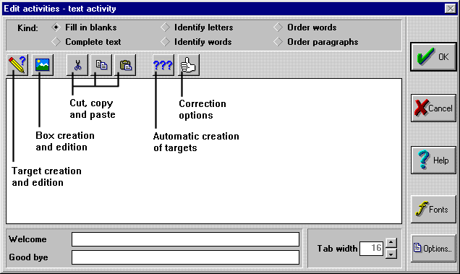
The best way to discover the workings of text activities is to open the Clic "demo" and examine the examples there. Note that there are 6 different types: Fill in blanks, complete text, identify letters or words an order words o paragraphs. In the following pages the characteristics of these variations and the function of each button in the edit window are explained.

Fill in blanks
The "fill in blanks" type of text activities offer the greatest versatility. The targets can be set out in three different ways:
- As a blank space which has to be filled. These spaces can be initially filled with a variable number of dashes, asterisks, blank spaces, or any other character.
- With an initial expression that the student has to correct.
- As a drop list of options from which one has to be chosen.
In this setting the targets can also have an associated floating help window which can contain a message, sound, image, animation, or any type of multimedia material. These help windows can be activated in three different moments:
- Automatically, on entering the space.
- When a wrong answer is written.
- By pressing F1.
A delay and a maximum time of appearance can also be set.
The evaluation of fill in blanks activities can be immediate or deferred, and in both cases Clic can be made to try to detect which letters or words are wrong and show them by a change in colour. There is also, however, the possibility of just saying whether the answer is correct or not without giving any clues as to where the error may be.
In this type of activity it is recommended to always press the return key (or the forward arrow) after writing the answer in each of the spaces. That way Clic knows you have finished writing and can go on to evaluate the answer.

Complete text
When a complete text activity is started, the blocks marked as targets disappear completely, showing the rest of the document in the game window. The student's task is to complete the text, filling in whatever is missing. The programme does not give any clues as to where missing text has to go or to how many targets have disappeared. As opposed to the previous type of activity, where the student can only write in certain areas (the spaces), here they can write wherever they want and as much as they want.
The evaluation of complete text activities always has to be deferred: the student writes what they think is missing, checks the exercise and, when they think everything is correct, clicks on the correct activity button at the bottom of the screen. Clic then evaluates the work done, highlights possible errors and, if necessary, informs of the number of targets that have not been solved.

Identify letters and words
These types of activities have to be solved with clicks of the mouse. The student has to mark the letters or words (according to the activity type chosen) that were defined as targets when the activity was designed.
The evaluation of this type of activity also has to be deferred. On clicking the correction button, the programme highlights the incorrectly selected letters or words and, if necessary, informs of the number of elements that still have not been found.

Order words and paragraphs
As in all the previous cases, to create this type of exercise you have to write a text and select certain words or paragraphs as targets. On starting the activity the targets are shuffled and the student's task is to put them back in order. The reordering is always done by exchanging the positions of a pair of elements, similar to the way that exchange type puzzles are solved.
Obviously, to create one of these exercises at least two targets have to be created; otherwise it would be impossible to disorder anything.
When creating order words type activities, it is possible to limit the initial disordering to paragraph level. In this case the words are only shuffled with their neighbours, making the exercise easier to solve.
The evaluation of order activities is also always deferred.

Creation process of text activities
The steps to follow to create a text activity are:
- Activate the File - New... - Text activity menu.
- Choose a kind of activity from the six possible options.
- Write the text for the activity, being careful to only press Return and the end of the paragraphs.
- If a box needs to be inserted, place the cursor where you want the box to appear and click on the button shown below:
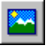
... and set its dimensions and content. If there is any need to modify the characteristics of a box, you just have to click on it.
The boxes behave as any character within the text: to delete them you can place the cursor in front of one and press the DEL key, or from behind with the Backspace key.
When a lot of changes are made to a box, the text format shown in the edit window may be lost. In this case click on the OK button and edit the activity again with CTRL+E.
The colours and fonts shown in a box are adjusted by using the Fonts button.
- Select the text that will be the first target. To select blocks of text you can use one of the following techniques:
- Place the cursor at the beginning of the block, press the shift key and, keeping the shift key held down, go forward with the arrow keys until the block is selected. If, apart from the shift key, you also keep the control key pressed down you will advance word by word.
- Click on the left button of the mouse and, without letting go, drag the pointer to the end.
- Once the block that will be the first target has been selected, click on the button below:
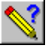
If it is a fill in blanks activity, a window will appear where you can specify the behaviour and correct answer for the target and also the possibility of showing a help window. In the other types of activity you will notice that the text colour changes, indicating that the block has already been converted into a target.
To check the behaviour of a target in a fill in blanks activity, place the cursor within the target (there is no need to select the entire target) and click on the same button that you used to create it. The target definition window will then reappear.
There are two ways to deselect a block as a target:
- In fill in blanks activities, delete the block and rewrite it.
- In the other activity types, place the cursor within the target and click on the button you used to create it.
The quickest way to delete all the targets in an exercise is to change the type (buttons at the top of the edit window) and accept the warning given by Clic.
- Continue selecting text and creating the necessary targets. If there are various targets in the activity that have some text in common, you can use the automatic creation of targets button:

This button allows the creation of a set of targets in a single action. For example, hide, in one go, all the words that have a certain letter or the appearances of a certain text expression. Consult the help or the Clic manual for more information on the automatic creation of targets.
- Adjust the fonts and colours through the Fonts button. Here you can make changes to four different areas:
- There are three combinations of colours for the main: the principal colour, the colour used for targets (user text and user background) and the colour Clic uses to highlight errors when the exercise is corrected.
- A font and a combination of colours can also be set for the boxes.
- In fill in blanks activities a specific style can be set for the help windows which can be optionally linked to the targets.
- As in all Clic activities, there is also a combination for the Message box.
- Check the activity and, if necessary, change the correction options through the button shown below:

There are four groups of parameters that can be changed in the correction options screen:
a) The tolerance of certain differences between the correct answer and what the user writes: capitals/small caps, accents and special characters, punctuation marks, repeated spaces, etc.
b) When the exercise is corrected: immediately after each answer, on finishing the activity, whether all the targets have to be solved before going on to the next activity, etc.
c) Decide if the programme should analyse the answers letter by letter highlighting possible errors, or just indicate whether each target has been answered correctly or not. In the first case even the parameters used to compare the user's answer with the correct answer can be adjusted.
d) Whether an initial screen should appear before starting to solve the activity and the amount of time this should be visible. The initial screen can show the solution to the exercise (for example, show the complete text before shuffling the paragraphs) or an explicatory document.
• Change, in activity options, the size of the text window (grid A), the background colours or graphics, the buttons and counters to be shown, etc.

Guided practices
You will need to download the PRAC3.ZIP file to do the guided practices for this module. Decompress its contents in the C:\Clic\Course\Module3\practice folder.
The materials used in the guided practices for this module come from the NGO Intermón web page (http://www.intermon.org)

Creating a fill in blanks activity
In this exercise we will make a reading comprehension activity: the student will be shown a text and will then be asked to complete the text with the missing words.
• Start up Clic and activate the File - New... - Text activity menu. The working directory will be the one corresponding to module 3: C:\Clic\Course\Module3\practice
• Write the following text in the edit window, remembering to only press the Return key at the end of each paragraph (the ¶ symbol will appear in Clic):
World education is in crisis. Apart from the millions of children that do not go to school, one in four adults are illiterate.
It is women who are in the worst situation; they make up 70% of the people who do not know how to read or write.
The situation is very serious. Education is a basic way overcoming poverty. Those with access to education have more possibilities of getting a decent wage, knowing and demanding their rights, building their own future. Without education, the children of today are the illiterates of tomorrow. They will have to survive with unstable wages and they will not be able to send their children to school.
The circle of poverty is perpetual.
• When you have finished writing the text, click OK and save the activity as EDUCA1.TXA.
• Go back to the edit window and place the cursor and the start of the document. Insert a return to leave an empty line. Go to the start of this empty line and click on the create boxes button:
• In the create boxes window write the following text:
{logo.gif}
Set the width at 500 the height at 90 (to reach 500 quickly, hold down the counter arrow with the mouse), deselect the With frame box and confirm. If everything goes well the "Education now" campaign logo should appear.
• Select the word "illiterate" in the first paragraph. To select a word you can use either of the two techniques explained earlier (click and drag, or move with the arrow keys while holding down the shift button). When you have selected the word click on the create and edit targets button:
In the window that appears the behaviour of the space that we have just selected is controlled. Initially, it will show 10 dashes, it will allow a maximum of 10 characters to be written and the correct answer will be "illiterate". Confirm these options by clicking on the OK button.
• Select the word "Women" that appears in the second paragraph and click again on the target creation button. In this case we will set the target as a drop list: click on the Present options in a list box and write:
Men
Women
Boys
Girls
When you have completed the list confirm the target creation.
• Select the word "poverty" and click again on the target creation button. In this case we will allow some synonyms of the original word. Go to the Correct answer box and write the following:
poverty|misery|indigence
The vertical bars that separate the words are obtained by the combination of the ALTGR+1 keys. No blank spaces should be written.
• As the word "indigence" has more than 7 characters we have to make Clic let the expression be written in the space. Change the Maximum amount of characters to 9.
• Create a new target for the word "wage", where the answer "salary" is also allowed.
• Select the word "survive" as a target as well, allowing the synonyms "subsist" and "live".
• To finish, convert the word "circle" into a target, presenting it in a drop list along with the options "square" and "triangle".
• In Welcome message write the following sentence:
Write the words that are missing in this text
• And add a goodbye message of congratulations.
Check the activity. Remember to press Return after writing each answer so that Clic can check them.
As this is a reading comprehension activity it would be useful to let the student read the original text thoroughly before starting to answer:
• Edit the activity (CTRL+E) and click on the correction options button:
- Mark the Display before starting box and keep the Display original text option. Set the maximum time counter to zero (this will give an undefined time, until the student clicks the mouse or presses a key) and write the following text in Welcome message:
Read this text carefully and when you finish, click on the mouse to start the exercise
Check the activity. Now it looks more like we wanted, but there is still a problem. As the text is quite long a vertical scroll bar appears that stops us from being able to read it in one go. There are two ways of fixing this: make the font size a bit smaller or increase the size of the game window. The second option would be the most appropriate if the activity only had to work on screens with a 800x600 resolution, but this will cause problems at 640x480 as the current window size is almost the maximum available in this resolution. We shall opt, so, for a smaller font size:
- Edit the activity (CTRL+E) and click on the Fonts button.
- Make sure that, at the top, the area marked is Main text and change the size of the Arial font to 7 x 18. Once that is done select the Help windows area and change the font size to7 x 18 as well and accept.
- Check the activity. If the vertical scroll bar is still there, this could be because you added a return to the end of the document: If this is the case, delete it.
- Save the activity again with the same name: EDUCA1.TXA

Add help windows to a text activity
In this exercise we will complete the previous activity by adding some help windows to help the student complete the text.
- Open the EDUCA1.TXA activity that you created in the previous exercise. To open an activity you have to go to the File - Open menu, click on the appropriate activity type button on the left (in this case, the text activities button, "aeiou"), look for the folder that where it is saved, select the file and accept.
- Edit the activity with CTRL+E.
- Place the cursor within the word "illiterate" and click on the create and edit targets button:
- Click on the Pop-up information window box and write:
Person that does not know how to read or write
- Change the size of the information window to 180 x 60, activate Centre text and click on the Pop up in errors option.
- Accept everything and check what happens when an incorrect answer is written in the first target.
To reinforce the apparition of the help window, we could include a warning sound to get the student's attention:
- Edit the activity again, place the cursor within "illiterate" and click on the targets button.
- Add the text "{error.wav}" to the end of the message. It should look like this:
- Person that does not know how to read or write{error.wav}
- Check what happens now when a wrong answer is written in this target.
- Edit the activity, place the cursor in the target "poverty" and activate a pop-up information window with the same size and behaviour as the last one. The text could be:
Lack of or great shortage of what is needed to live{error.wav}
- Do the same with the targets "wage" and "survive". The help texts could be:
Money received in exchange for work{error.wav}
Continue living{error.wav}
We could make a few changes to the activity's appearance to finish off:
- Edit the activity, click on the Fonts button, activate the Help Windows area and change the text colour to red.
- Go to Activity options and make the following changes:
- In the Game window area click on the Solid colour button and change it to white (this will reduce the grey flash visual effect when the help windows are activated).
- For the Main window click on Image, drop the list and select the bground.gif file.
- Unmark the Shaded frames box.
- Select Small buttons 2.
- Check the activity and save it through the File - Save menu.

Creating order words activities
In this activity we will present a text where some words are shuffled which have to be put back in place:
- Create a new text activity and select the Order words kind.
- Write the following text:
This girl is called Ramdwa Saidi. She is 11 years old and lives in Tanzania. She wants to go to school, but she cannot. Before, school was free and Ramdwa and her sister went to school.
Her country's government was forced to start charging fees and her mother, Mwange, does not have the money to pay them, nor can she afford the uniforms or all the material needed to go to school.
- The appearance of the activity will be similar to the one we created in the last exercise. Click on the Options button and on Copy style from. Select the educa1.txa file and accept. Before closing the options window, mark the Image box for the main window and select bground.gif.
- Insert a blank line at the start of the document.
- Insert a box in this line with a size of 90 x 130, without a frame and with the text {ramdwa.gif}
- Confirm the changes with the OK button to see the appearance of the activity.
- Save it as RAMDWA1.TXA and go back to the edit window (CTRL+E)*.
- Place the cursor just in front of the photograph, insert three spaces on the same line and click on the insert boxes button again. This time set the size to 300 x 60, unmark the Centre text and With frame boxes and write:
RAMDWA
- Confirm the creation of the box, click on the Fonts button, activate the Text in boxes area and select the Arial font at 12 x 30 in bold. Change the colour of the text orange (or any other that you like) and accept.
- Place the cursor in the word "girl" and click on the target creation button. Note that the whole word is highlighted with a different colour.
- Select the following words from the first paragraph as targets as well: "Tanzania", "school" and "sister".
- And these words from the second paragraph "government", "fees" and "money".
- Check the activity.
- Write a welcome message such as: "Put the shuffled words back in their place", and a congratulatory good bye message.
- Click on the correction options button () and change the text under the Correction button to:
Click here when you finish
- Check the activity.
- We could make one last change to improve the appearance of the activity. Go to the edit window (CTRL+E), click on the Fonts button, select the Main text area and click on the User background button. Change the colour from grey to white and confirm everything.
- Save the document again with the same name: RAMDWA1.TXA
Now we will make a second activity, which will be the continuation of this one. Instead of starting from zero we will save the activity that we have just made with another name and then make some changes:
- Go to the File - Save as... menu and change the name so that a copy is saved by the name of RAMDWA2.TXA
- Delete the whole text except for the first line (where the two boxes are with the heading and the photograph). If you accidentally delete either of the boxes, reopen the RAMDWA2.TXA file that we just saved in the last step.
- Write the following text:
If the Tanzanian government had more money, school would be free again. But Tanzania invests three times more in paying its foreign debt than it spends on education. Relief of foreign debt and an increase in international help for basic education would allow Ramdwa, her sister and all the children in the world to go to school.
- Set the following words as targets: "invests", "debt", "foreign", "help", "international" and "school".
- Check the activity.
It would be better if "foreign debt" and "international help" behaved as single blocks rather than two separate words. To fix this do the following:
- Place the cursor in front of "debt" and delete the space that separates it from "foreign".
- Type the space again. There is no apparent difference, but the two words have changed into a single block.
- Do the same with "international help".
- Check the activity and save it through the File - Save menu.

Creating an order paragraphs activity
In this activity, some of the paragraphs from the text will be shuffled and have to be put back in order.
- Activate the File - New... - Text activity menu.
- Change the kind to Order paragraphs.
- Go to Activity options and copy the style from RAMDWA2.TXT. Remember that the Image box for the main window has to be activated.
- Start by inserting a box of 400 x 50, without a frame or centred text and with the following text:
FAIR COMMERCE
- Insert a return after the box and write:
We live in a global world. Sugar can come from Brazil, coffee from Uganda, bananas from Ecuador and clothes from Taiwan or Morocco.
The communities in these countries that make the products we consume have very tough working conditions: long working hours, low wages, discrimination against women, exploitation of child labour, drainage of natural resources, prohibition of unions...
Changing this situation, helping to make decent working conditions in the South is our job as well. We are all implicated and our actions in the North will have repercussions for the communities in the South.
We have to spread and support fair commerce and buy responsibly, in favour of the people in the third world.
- Save the activity as FAIRCOM1.TXA.
- Go back to the edit window, place the cursor within the first paragraph of the text and click on the target creation button. The paragraph is selected and shown in inverse video.
- Do the same with the other three paragraphs.
- Write the following Welcome message:
Put the paragraphs in order
- Add a congratulatory Good bye message.
- Click on the correction options button and mark the Display before starting box. Leave maximum time at zero (the student can take as much time as he wants) and in Welcome message write:
Read this text and click on the screen to start the exercise
- Change the correction button text to:
Click here when you finish
- Confirm everything and check the activity.
- Save the activity again with the same name: FAIRCOM1.TXA.

Creating a dictation
This activity will be similar to TXA06.TXA in the Clic "demo". We will record a wav file with a spoken text and prepare a "fill in blanks" activity. The targets will be the phrases from the recorded document preceded by boxes that activate the corresponding sound fragment.
In the activities we have done so far, we have often called a wav file by writing its name between curved brackets. In this case we need to hear a particular fragment of sound for each phrase. We will do this by using "from" and "to" after the file name. These words have to be followed by a number that indicate a point, expressed in milliseconds, in the sound file. This technique is explained in detail on page 26 of the Clic manual.
Any specialised programme can be used to make the recording, such as CoolEdit 96 shareware (which can be downloaded from the resource section of the "Clic Corner).
- Start up the sound edition programme and prepare a new recording. In CoolEdit 96 this is done through the File - New menu. To get good enough quality without having too big a file, we recommend setting the recording properties to 11.025, mono and 16 bits.
- Adjust the microphone volume with the Windows mixer and record the following text:
The current Fair Commerce movement started in 1990 and involves more than 3,000 shops in Europe.
Its basic principal is to guarantee a fair return for their work to the producers in the South. To achieve this they buy the products directly from the farmers and craftspeople.
The items on sale respect social guarantees; they have been made without the use of slave labour or damaging the environment.
- Check that the recording level is at an appropriate level (with CoolEdit we recommend normalising it at 90% of the maximum volume through the Transform - Amplitude - Normalize menu), cut out any silences at the beginning and the end of the recording and save the file as DICTAT.WAV in the practice folder for module 3.
- Now you should jot down the time intervals for each phrase, in milliseconds, on a piece of paper. It is easy to see the values in CoolEdit 96. This is done as follows:
- Click where you think the start of the sentence is and drag the cursor to the end.
- Press the Spacebar to listen to the selected block. If necessary, adjust the beginning and/ or end of the block by dragging it with the right mouse button. When the selected block coincides with the phrase, note down the BEG and END values that appear at the bottom on the right:

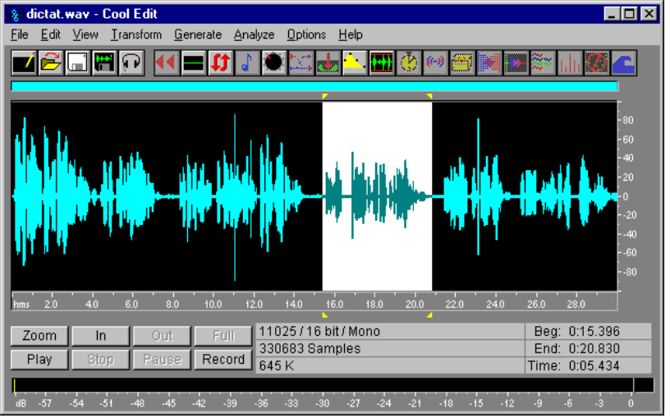
In this example, the fragment selected starts at 15,396 milliseconds and finishes at 20,830.

- Here are the phrases that you need to note down the intervals for:
Phrase | Start | Finish
The current Fair Commerce movement started in 1990 | 0 | 3942
and involves more than 3,000 shops in Europe | 3942 | 7458
Its basic principal is to guarantee a fair return for their work to the producers in the South | 8204 | 14544
To achieve this they buy the products directly from the farmers and craftspeople | 15396 | 20883
The items on sale respect social guarantees | 21256 | 24932
they have been made without the use of slave labour or damaging the environment | 25039 | 29940
NOTE: The values that appear in the table are only an example. They were obtained from a test recording and do not have to coincide with your values.

- Once you have noted down the fragment values, you can close the sound editor and open Clic.
- Create a new text activity in the practise exercise folder for module 3 set the kind to Fill in blanks.
- Click on the Options button and copy the style from FAIRCOM1.TXA. Before closing the options window, activate the Image box in the Main window area.
- Insert a box at the start of the document with a size of 400x50, without a Frame or Centred text and with the text:
FAIR COMMERCE
- Insert a return after the box and write the dictation text, as shown at the beginning of the exercise.
- Save the activity as FAIRCOM2.TXA.
- Place the cursor before the first "T" in the text and insert a box with a size of 60 x 40, without a frame and with the following text:
{dictat.wav from 0 to XXX}
...replacing "XXX" for the value you have for the end of the first phrase. The values must be written without commas for the thousands, "3,942" would be an incorrect expression and would have to be replaced with "3942".
- Confirm everything and test the box. You will see that Clic inserts a drawing of a speaker, this is the predetermined icon for boxes containing only a sound file:

This icon is a bit on the large side for text activities. We could use the smaller drawing below in its place, which can be found the speaksma.gif file (included in the ZIP file materials for this module):

- Edit the activity and click on the box containing the speaker. Change the size to 30 points width, 20 points height and change the text, adding the reference to the GIF file:
{speaksma.gif}{dictat.wav from 0 to XXX}
- Accept the change and see what the box looks like now.
- Edit the activity again and select the whole phrase from the first "T" to "1990", making sure that the box and the last comma are not included in the selected block. Click on the target creation box (pencil), increase the maximum amount of characters to 60 (this should be increased so as not to block the target if the user commits an error) and reduce the initial answer space to 1.
- Check what we have done so far and then go back to the edit window.
- Before creating the second target, we will make a change that will make our work easier. Click on the Options button and change the size of Grid B to 30 x 20. There are no "grid Bs" in text activities, but Clic uses this size as the default value when creating new boxes.
- Accept the changes and place the cursor in front of the "a" in "and". Create a new box, unmark frame and write the following text:
{speaksma.gif}{dictat.wav from XXX to YYY}
...replacing "XXX" and "YYY" for the start and end positions of the second phrase in the WAV file.
- Select the phrase from the "a" in "and" to "e" in "Europe", without including the full stop in the selected block. Create a new target increasing the maximum amount of characters and reducing the initial answer space to 1.
- Accept and continue creating boxes and targets for the rest of the phrases. Remember to leave out the punctuation signs from the target blocks; this will help the students contextualize each phrase.
- Write the following text in Welcome message:
Do this dictation. Click on the speakers to listen to the phrases.
... and add a Good bye message of congratulations.
- Check the activity. Note that Clic is able to detect most of the errors that might be made in the answers, showing the student where the mistakes are. This is due to the indicate mistakes letter by letter function in Correction options ("finger" button) being active.
To finish the practise exercise we could let the student read the whole text before starting the exercise:
- Edit the activity and go to correction options ("finger" button).
- Mark the Display before starting and Display original text boxes.
- Write the following in the Welcome message box:
Now we will do a dictation. Read the text and when you have finished, click on the mouse to start the exercise.
- Change the maximum time to zero and confirm everything.
- Check the activity and save it with the same name: FAIRCOM2.TXA
If you still have time and want to, here are some extra suggestions to improve the working of the activity:
In the second phrase we could also accept "3,000" written in letters "three thousand". To do this we need to edit the target and assign an alternative answer, separating it from the original answer with a vertical bar. The correct answer text would change to: "and involves more than 3,000 shops in Europe|and involves more than three thousand shops in Europe". Make sure that the maximum amount of characters for this target is large enough for the second answer.
We could make the sound fragments start up automatically on entering each target without having to click on the speaker boxes. To do this we need to edit the targets, activate the Pop-up information window box, write {dictat.wav from XXX to YYY} and mark the Only interpret box, which stops the window with the text from appearing.

Creating an activity pack
As in the previous guided practices, we will finish by creating a pack with the activities from this module:
- Activate the File - New... - Activity pack menu, and select the working directory for the practices in module 3.
- Put the activities in the pack in the following order: EDUCA1.TXA, RAMDWA1.TXA, RAMDWA2.TXA, FAIRCOM1.TXA and FAIRCOM2.TXA
- Mark the Requires 256 colours box and save it as INTERMON.PAC

Exercises
Look in a newspaper for six brief articles (or pieces of articles), of between 100 and 150 words. Make the following with the articles:
• A "fill in blanks" text activity with four missing words for the student to fill in. Use help windows for any words that are not easily identifiable from the context.
• Another "fill in blanks" activity, where four targets are set in form of a list of options.
• An "identify words" text activity where all nouns in a text have to be marked.
• An "order paragraphs" text activity. Here it is important that you use a text made up of a logical sequence of short paragraphs.
• An "order words" activity, where ten words in the text are shuffled.
• A pack that joins the six activities together.
All the activities and the pack should be saved in the practical exercises folder for module 3.
When you have finished, compress the materials in a ZIP file and send it to the course tutor.
To find the texts you could use a conventional newspaper or the electronic edition that most newspapers offer on the internet.
If you use the electronic edition, you can take advantage and use some of the images that accompany the articles and insert one in a box in the activities. Make sure that the images are quite small* so that enough space is left for the body of the activity.

Module 4

Automatic content generation
There is a file called ARITH2.DLL in the C:\Clic\Act\Demo folder. This is a special programme that acts as an external compliment to Clic, generating mental calculation operations at random based on certain criteria set when making an activity.
Open the Clic "demo" and go to the ASS07.ASS activity in the association examples. If you look at the edition window (CTRL+E), you will see something strange: the file ARITEXT.TXT is used as the content for both the A and B grids and if you click on Edit contents, you will see that there is no sign of any mathematical operation. How can the appearance of the activity be so different from what we seem to see in the content files?
The secret is in the Activity options window. Note that the Activity automation option is marked and that the file ARITH2.DLL has been selected in the list. In fact Clic does not use the ARITEXT.TXT file, it is only there because a content file is required for each grid in associations. It is the ARITH2 module that governs what appears on the screen.
The activity automation modules provide the activities with the contents to be displayed in the cells. At the moment there is only the ARITH2 mental calculation module, but the specifications are published in the Clic help and manual and any programmer that knows C++ and how to make a DLL file (which is not the aim of this course!) could create additional modules that randomly generate the content of other types of activities.
The Configuration button, which appears next to the module drop list, calls ARITH2 to show its control screen:

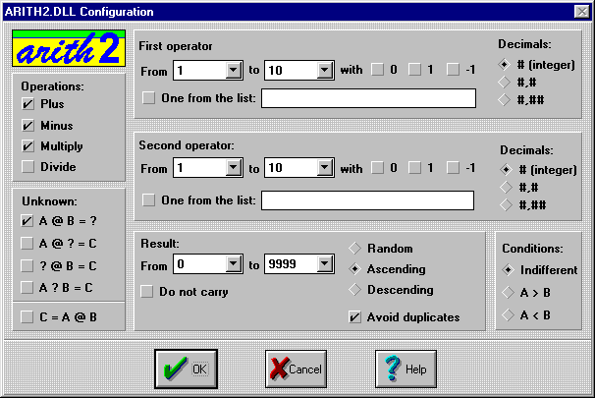
This is where we decide what kind of mental calculation operations can appear in the activity while it is being edited:
- Which of the four basic arithmetical operations should appear.
- Which of the four elements of an operation (first operator, operation, second operator and result) will be the target. The result is usually the target, e.g. "3 + 4 = ?", but the same operation could be set as: "3 + ? = 7", "? + 4 = 7" or "3 ? 4 = 7". Operations can also be written starting with the result: "7 = 3 + 4".
- The limits of both operators and the result.
- The number of decimals in the result (none, one or two).
- The possibility of setting "do not carry" additions and subtractions i.e. the operation applied digit by digit is never more than 9 or less than 0.
- The ordering of results is useful for setting puzzles such as PUZ05.PUZ in the Clic demo.
The Arith2 module tries to generate random operations based on the parameters set as long as they are reasonable. However if it finds non-solvable situations (e.g. a sum with operators between 10 and 20 that give a result less than 5) it finds itself forced to break one of the conditions.
To create activities that use the Arith2 module you have to copy the ARITH2.DLL file (which you will find with the Clic demo files) to the corresponding working directory.

Activity packs
The packs are basically a list of activities that Clic will present to the user one after the other. A pack is usually set up in the last step of creating a Click application once the component activities have been made and saved in the working directory.
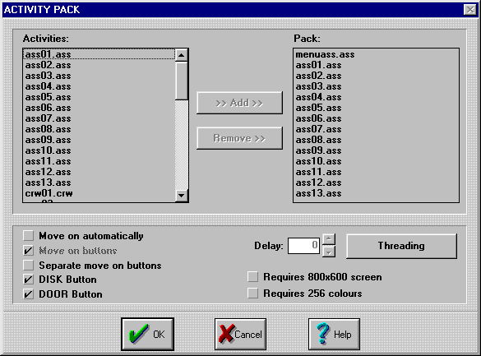
The working of an activity pack is controlled by four basic parameters:
- The list of activities to be presented to the user. This is made up of the activities in the working directory through the Add and Remove buttons.
- The mechanism used to move from one activity to another. The user normally has to click on the move on buttons (the arrows) go forward or back in the pack, but if the move on automatically box is marked the programme goes on to the next activity once the current one is finished, with the option of including a delay before changing activities. If the automatic move is activated and the Move on buttons box is unmarked a closed pack is created where the user has to solve all the activities to reach the end. This technique should only be used in very particular cases. It is usually preferable to use a combination of the buttons and automatic move to avoid giving the student the sensation of being in a blind alley when confronted with an activity that they cannot solve.
- The pack appearance: whether the move on buttons should be together or separated on the left and the right; whether the Disk and Door buttons should be shown; or whether the user should be warned that the pack requires a 800x600 screen or 256 colours in case they try to use it in lower conditions.
- The threading allows the definition of circuits that go back to an options menu or advance according to the level of correct answers. There are three types of pack threading:
- Default threading indicates the pack that will automatically start when the current one is finished.
- Low threading moves on to another pack (in principal easier than the current one) a minimum accuracy is not reached, or a set time is exceeded.
- High threading should move on to a more complicated pack when the student passes a certain threshold of points in a reasonable time.
The mechanism of point calculation used by Clic to decide on low and high threadings depends on the precision concept used in the reports, which is explained later.

The ClicPac utility
As we saw at the beginning of the course, Clic packs can be presented in one of two formats: normal packs (.PAC) and compact packs (.PCC). The basic difference between the two types of packs is in the information contained in the files. The PAC packs only contain references to the activities (we could say they are like a "shopping list"), while the PCC packs contain most of the necessary ingredients to make them work (following the same analogy, they would be the equivalent to a "shopping basket"). Multimedia files can never be put in the "basket" and have to stay as independent elements in the working directory.
When a compact Clic pack (PCC) is used all the activity edition functions are disabled. To check the "shopping list" and examine or change the contents you have to open the "basket" and spread the ingredients on the table.
The compact format (PCC) is ideal for distributing Clic applications once they are finished. It has two clear advantages over the normal format:
- It protects the materials from accidental changes or intentional changes by the students.
- It facilitates the transfer of materials from one computer to another as most of the components are gathered in one file.
The ClicPac utility, which is installed with Clic, can be used to pack normal packs or unpack compact Clic packs.
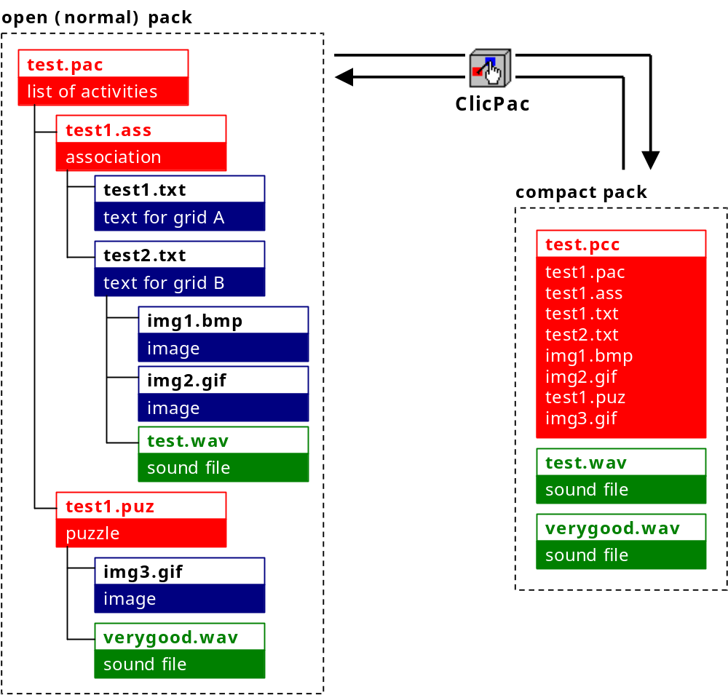

Compacting packs
These are the steps to compact a pack:
- Start up ClicPac. A screen like the one below will be shown:
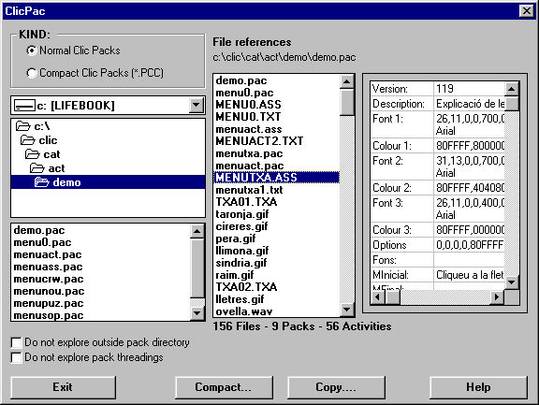
- At the top of the screen select Normal Clic packs (*.PAC)
- Search for the application that you want to compact in the directory list.
- Select the file for the main pack. The programme will analyse the dependencies between the application's components and will advise of any errors, e.g. a call to a non-existent file. If there are any errors, you will have to close ClicPac, check the activity with the error, fix it and start again.
- Click on the Compact button.
- The screen below shows all the files that will be in the compact Clic pack on the left and, on the right, the files that will be left out (WAV, MID, AVI, DLL files, etc.):
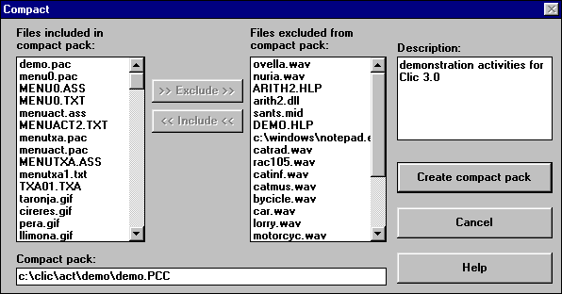
- Click on the Create compact pack button.
- When the PCC file is created, the programme will ask if you want to delete the component files. It is recommended to say yes to avoid wasting disk space with copies of files that are no longer used.

Separating packs
Here are the steps to separate a pack:
- Start up ClicPac.
- Select Compact Clic packs (*.PCC) on the top-left of the options window.
- Search for the application that you want to extract in the directory list.
- Select the appropriate PCC file.
- Click on the Separate button. A screen will appear with a list of the files in the PCC file. In principal, you should select all of them.
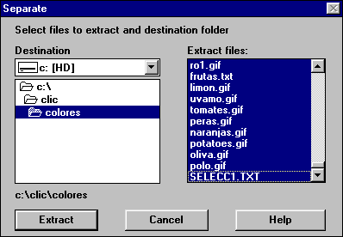
- Click on the Extract button. ClicPac will create the files as independent units in the working directory.
As a last step, we recommend that you delete the PCC file as there is no need to have it on the hard disk once the application has been converted into a PAC. You can delete the file with the Explorer in Windows.
Some comments on compacting and separating packs:
- If a pack is separated directly from a CD-ROM or a unit in a network with "Read only" rights, you will have to select an alternative destination on the hard disk where ClicPac can write without restrictions.
- The icons created by the installers of the Clic activities in the Windows "Start Menu " or "Program Administrator" usually point to a PCC file. If you delete the PCC file after separating it (as suggested in the instructions), the icon will stop working. If you want to keep on using the icon, you will have to change the short-cut properties so that they point directly to the PAC file. In W95, the short cuts are normally found in the C:\Windows\Start menu\Programs\Clic folder.
While creating activities it is normal to do tests and create different files that may not be used in the end. ClicPac offers the chance to "clean up" by copying all the contents of a normal pack to another folder. Here are the steps:
- Create a new folder and give it a different name to the folder used to create the activities.
- Copy the pack from the old working directory to the new one by using ClicPac.
- Delete the application's original folder.
From now on the "good" folder will be the new one, which will only contain the necessary components for the activity pack. On deleting the original working directory, all the files that were not being used will have been deleted.

Clic reporting system
Clic v3.0 allows a detailed assessment of the students' results in each of the activities they do.
The evaluated items are:
- Time used
- Number of attempts
- Number of correct answers
- Whether an activity has been solved or not
- Precision obtained. This value is calculated as follows:
- First of all, the minimum amount of attempts necessary to solve the activity is calculated, which we will call “n”.
- If the activity has been solved, “n” is divided by the number of attempts made by the user.
- If the activity has not been solved, the square of the correct answers is divided by the product between “n” and the attempts made.
In both cases the result is multiplied by 100 to express it in percentage form.
A list of the values of these five items for each activity done can be accessed through the Reports - Show current report menu. A summary of the session, with the totals and average precision obtained can be found at the bottom of the window.
Certain activities are never evaluated or taken into account for the totals and averages. These are the information screens, explore mode associations and, in general, any activity where the Include in user reports box in Activity options is not marked. It is important to unmark this box when creating activities that should not count in the global report, for example: an association used as a menu to select different packs (like the MENUACT.ASS file in the Clic demo); or a text activity that is only used to present information (e.g. the NOU02.TXA file in the demo).
The reports can be saved in a database. The system can work on a network so that the results accumulate in a common database for the whole classroom, independently of where the student sits in each session. You can find detailed instructions for configuring the reporting system on a network in the appendix of the Clic manual.
To register the reports in a database you have to go to Global options and mark the Register activity reports box. You also have to say where the information file is located, which is normally called CLICDB.MDB and found in the Clic folder or, if the computer is linked to a network, in a shared folder that can be written in.

The ClicDB programme
The ClicDB utility is used to manage and consult the Clic report database. The programme is considered for the exclusive use of teachers and should, therefore, only be saved on the network server.
The programme has three types of functions:
- Group and user maintenance: adding and deleting groups and users, modifying and cleaning up data. Groups and users are usually identified by their name, but it is also possible to assign them an image (a scanned photograph, an icon, a logo, etc.) that appears on the user selection buttons when Click is opened.
You can indicate the types of operations related to the creation of new users and groups that students are allowed to do in the Global options of Clic. It is probably best that the tutor adds students as users before they start work (through ClicDB) and that the students only have to select their name or photo on the indicate screen.
The database always has both a group called .Unknow and a user called .Unknow. These can be used as a joker to test the reporting system without saving the results.
- Data queries at three different levels:
- Group reports allow you to follow the evolution of a group's performance at a global level or with a particular activity pack.
- User reports are similar, but offer detailed information on all the work sessions, packs and activities done by a certain user. As in group reports, global data or data on a particular activity pack can be shown.
- Reports on packs and activities offer an inverse perspective, showing the users' performance with a particular activity pack. From the information obtained we can see various aspects such as: which users have worked on a particular pack; the global mark for a user or a group; how the results are distributed between the users (in bands of 20%); etc.
All the query screens show a graph with two variables: the evolution of precision (see the previous section) in green and the percentage of activities solved from the total of activities done.
The data can be observed globally or concentrated on a certain time period. To modify the observation period you have to click on the button that appears on the top-left of all the report screens. You have to write the full version for the years (1999, 2000, 2001,etc.) to avoid problems with the year 2000 effect.
It is also possible to print the results, either in graph format or as a detailed list.
- Every so often it is a good idea to compact the database to free up space on the hard disk and to improve its agility. It is especially important to do this after adding or deleting groups of students.
You will find more information on the database structure and how ClicDB works in the Clic manual.

Guided practices
You will need to download the PRAC4.ZIP file to do the guided practices for this module. Decompress its contents in the C:\Clic\Course\Module4\Practice folder.

Creating activities with ARITH2
The automatic generation of activities module ARITH2 is used in this guided practice to create some mental calculation activities.
First of all, copy the ARITH2.DLL file, which goes with the Clic "demo", to the working directory:
- Open Windows Explorer (Start - Programs - Explorer).
- Find the C:\CLIC\ACT\DEMO folder in the left panel and select it.
- Click on the ARITH2.DLL file, which should appear in the right hand panel, with the right mouse button. Select Copy from the menu.
- Find and select the practice folder for module 4 in the left-hand panel.
- Click on the right hand panel with the right mouse button and select paste from the menu.
You should now have a copy of ARITH2.DLL in the working directory.
- Start up Clic, go to the File - New... - Association menu and select the working directory for module 4.
- Set a layout of 1 column and 5 rows.
- Select Text for grid A, make sure that the NEW TEXT option is selected in the drop list and click on the Edit contents button. We will call the file EMPTY.TXT
In fact this text file will have a purely testimonial role. It will be used to create a skeleton of the activity and we will set up the actual content for the activity with ARITH2.
- When Notepad opens, insert a couple of returns and go directly to the File - Save and File - Exit options.
- Open the list for grid B and select the EMPTY.TXT file again.
- Mark the Solved grid A box and select EMPTY.TXT once more.
Accept the changes. We have a normal association between two empty grids. The next step is to use ARITH2 to fill the cells:
- Go to Activity options (CTRL+O) and mark the Activity automation* box.
- Select the ARITH2.DLL file from the drop list above this box and click on the Configuration button.
- Leave the predetermined values (values of between 0 and 10) in the Arith2 configuration window and accept everything.
Test the activity. Each time the green flag is clicked, the activity is reloaded with different operations.
- Edit the activity to write the following Welcome message:
Solve these calculations
... and add a congratulatory good bye message.
- Save the activity as ADD1.ASS.
Now we can make a few changes to improve the activity's appearance. We will use the technique of showing the game window on a decorative background as in the TXA06.TXA activity in the Clic "demo":
- Go to the Activity options (CTRL+O) and click on the Solid colour button for the main window. Select white.
- Select white as the background colour for the game window as well.
- Mark the Image box for the main window, open the list and select BGROUND.GIF
- Mark the Centred box and accept the changes.
Everything seems to be going well so far. A background image has appeared, but the game window is too large and does not appear in the frame in the background decoration. We will have to make a few more changes:
- Go back to the activity options and unmark the Centred box for the game window. Just below this box there are two numerical fields that set the co-ordinates of the game window in relation to the top left corner of the background image. Change them to X: 270 and Y: 10
- Change the cell sizes to 164 x 64 for both grid A and B.
- Unmark the Shaded frames box and accept everything.
The game window is now placed exactly where we wanted it and fits in the rectangle in the background image. We will make a few last changes to the appearance:
- Edit the activity (CTRL+E) and unmark the Delimit cells button for both grid A and B.
- Click on the Fonts button, select the Message box area and choose marine blue as the background colour and white for the text. Once that is done select the Grid B area and change the shadow colour to white (the "shadow" colour is also used to fill the cells once a pair has been solved).
- Save the activity again with the same name: ADD1.ASS

Now we will make use of this activity to make a few variants with more difficult calculations:
- Go to Activity options and click on the Configuration button in activity automation.
- Change the first operator to a range of 10 to 99, mark the Do not carry box and accept everything.
- Press the F12 key (which is the same as File - Save as...), change the name to ADD2.ASS and accept.
- Unmark the Do not carry box in the Arith2 configuration.
- Save the activity as ADD3.ASS with F12.
- Continue the process of making the calculations more difficult and saving the activities with F12. You should make the following activities:
ACTIVITY | ARITH2 CONFIGURATION
ADD4.ASS | Second operator between 10 and 99, "without carrying"
ADD5.ASS | The same as above, but "carrying"
SUB1.ASS | Operator: minus. Both operators between 1 and 10
SUB2.ASS | Operator: minus. First operator between 10 and 99
SUB3.ASS | Operator: plus. Unknown: A @ ? = C (only mark this option)

If you have followed all the steps, we will have a set of activities that we can use to make a series of threaded packs in the next exercise.

Creating threaded packs
Click allows the setting of "intelligent" threadings between activity packs, moving to one option or another according to the level of accuracy obtained by the student. In this exercise, we will create packs of increasing difficulty based on the activities made above and we will create links between them.
First of all we will prepare an information screen to show that the sequence of packs has finished:
- Go to the File - New... - Association menu. Select the practice folder for module 4.
- Change the kind of activity to Information screen.
- Click on the Edit contents button for grid A. Call the file FINAL.TXT
- Write the following in the Windows Notepad:
Congratulations!!!
You have reached the end of the addition and subtraction pack
{exit}
- Save the file and close Notepad.
- Unmark the delimit cells option and set a layout of 1 column and 3 rows.
- Click on the Options button and cell size for grid A to 400 x 60. Deactivate all the counters and buttons and shaded frames. Select BGROUND2.GIF as the image for the Main window and in mosaic. Set background transparent for the Game window.
- Confirm the options and click on the Fonts button. Select Arial at 10 x 25 in bold and red for Grid A.
- Accept everything and save the activity as FINAL.ASS
Note that the "{exit}" command at the end of the text has made the door icon appear, which will close the programme when the student clicks on it.
The next step is to create the activity packs:
- Go to the File - New... - Activity pack menu.
- Put the following activities in the pack ADD1.ASS and ADD2.ASS
- Accept and save it as CALCUL1.PAC
- Create a second pack with ADD3.ASS and ADD4.ASS, and call it CALCUL2.PAC
- Create CALCUL3.PAC, with ADD5.ASS and SUB1.ASS, and CALCUL4.PAC with SUB2.ASS and SUB3.ASS
- To finish, create a pack that only contains FINAL.ASS. Save it as FINAL.PAC
The next step is to link the five packs we have just created:
- Open CALCUL1.PAC and edit it with CTRL+P
- Click on the Threading button.
- Mark Default threading and select the same pack: CALCUL1.PAC. That will put the pack in a circular process, when it is finished it will start again.
- Mark High threading, select CALCUL2.PAC and increase the global assessment to 80%. That will make Clic go to pack 2 if at least 4 of the 5 operations in each activity are solved. If this level is not reached the pack will start again.
- In this case we will leave low threading unmarked as this is the first pack in the series and it is not possible to go to an easier pack. Nor will we set a minimum time to get maximum and minimum marks.
- Accept everything and accept the changes.
- Open CALCUL2.PAC, edit it with CTRL+P and set a default threading with itself, a high threading with CALCUL3.PAC if 80% is attained and a low threading with CALCUL1.PAC for scores lower than 40%.
- Do the same with CALCUL3.PAC and CALCUL4.PAC, linking them to their respective higher and lower levels. The higher level for CALCUL4.PAC will be FINAL.PAC.
When you have finished, open CALCUL1.PAC and try to reach the final screen by solving the operations that appear.

Adapting an existing pack
In this exercise we will download, install and separate an activity pack from the "Clic Corner". We will make some translations and other changes and then repack it.
- Look for the "Trencaclosques d'animals" activity package by Pilar Codina in the "Clic Corner". You can use the search facility in the "Corner" or go directly to Activities - Activities by topics - Miscellaneous.
- When you find the page for this pack, download the catalan version ANIMALS.EXE file and save it in the practice folder for module 4.
- Run the installer and, when asked, change the working directory proposed (C:\CLIC\ANIMALS) for another folder called ANIMALS but below the practice folder. The full path should be:

C:\Clic\Course\Module4\Practice\Animals
- When the programme asks where you want to put the icon in the program manager, change the proposed name ("Clic") to Course. That way we will not interfere with any other installation of this pack that there might be on the same computer.
- Try out the icon, which should appear in the Course group.
In this puzzle pack the messages appear in handwriting. Let’s assume that in our school we teach students how to read and write using block letters (instead of joined writing), and that we want to change the activities so that the students work with simple sentences in English.
To make things easier, rather than keeping the three packs (with 4, 6 and 12 pieces), we will just make one with 6 pieces.
The packs cannot be changed in their current format, PCC, which deactivates the edition menus. We will have to use ClicPac to separate it:
- Close Clic.
- Open ClicPac and select Compact Clic packs (*.PCC) in the top left part of the window.
- Find the folder that we have just installed the pack in and select ANIMALS.PCC from the list. ClicPac will analyse the file and show a list of its contents.
- Click on the Separate button and then on Extract. ClicPac will tell you that 76 new files have been created. Click on Ok and Exit.
At the moment we have two versions of the pack in the working directory: the compact version (ANIMALS.PCC) and the normal version (TRENCACL.PAC).
- Open Clic, go to File - Open and find TRENCACL.PAC. It is important to select the "PAC" version, as the PCC version will not let us make any changes.
The first activity is an information screen showing the name of the pack and the author. We will change it to reflect the changes we are going to make:
- Edit the activity (CTRL+E) and click on the Edit contents button. If everything goes well, PaintShop Pro will start up with the PORTADA.GIF image*.
- Change the pack name to PUZZLES WITH ANIMALS and, underneath the author's name, type "English version by " and your name. It should look more or less like this:
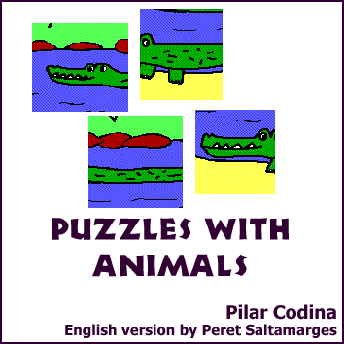
- Save the file and close PaintShop Pro.
- Change the welcome message to:
Go to next screen
- Click on the Fonts button, select the Messages area, change the font to Arial at 14 x 36 and click on the Apply to all areas button.
- Save the file with File - Save (or use the Shift+F12 shortcut).
- Edit the activity pack (CTRL+P) and delete the PORTADA.ASS file from the list on the right, leaving just the PORTADA1.ASS file. This will make sure that PORTADA.ASS does not appear in the menu of options in the adapted pack.
- Add the following activities to the pack: camel6.puz, cocodri6.puz, foca6.puz, mariet6.puz, misi6.puz, and tortug6.puz (we could add more, but we will keep to these six puzzles to make the exercise easier).
- Accept the changes made to the pack and save it as ANIPUZEN.PAC.
- Click on the forward arrow in the pack to go on to the first activity, CAMEL6.PUZ. Edit it with CTRL+E and change the welcome message to:
The camel lives in the desert
- ... and the good bye message to:
How hot it is!
- Click on the Options button and then Copy style from. Select PORTADA1.ASS and accept. This will give the same font type as the first activity.
- Save the activity with Shift+F12 and go on to the next one.
- Now it is a case of doing the same with the rest of the activities in the pack. Here are some suggestions for the translations:
Un cocodril està nedant! | The crocodile takes a bath!
Aquest animal és polar  Quin fred! Molt bé! | This animal lives near the pole  How cold it is! Good!
Quin bitxo és aquest?  Molt bé! És una marieta! | What kind of bug is it?  Good! It's a ladybird!
Aquest animal no té son | This animal is not sleepy
Això és una tortuga! | This is a turtle!

- When you have changed and saved the final activity, close Clic and open ClicPac.
- Find the ANIMALS folder within the practice folder for module 4.
- Select ANIPUZEN.PAC. ClicPac will look for all the elements connected to this pack.
- Click on the Compact button and then on Create compact Clic pack.
- There are now two copies of the independent files (activities, texts, images, etc.) in the PCC pack. In this case ClicPac asks us if we want to delete the extra copies from the hard disk. Say Yes to save some space.
Even though ClicPac has deleted those files, the files not used for TRENCACL.PCC are still in the folder. You need to use Explorer to delete them. Find the ANIMALS folder within the practice folder for module 4 and delete all the files there except ANIPUZEN.PCC.
To finish off, you should modify the icon created by the installer in the Windows Start Menu so that its command line points to ANIPUZEN.PCC.

Creating a menu of packs
In this last exercise we will make an activity pack that can be used as an access menu to all the packs made in the course. The menu will be saved in the course root directory and will open the packs from each of their folders.
- Go to File - New... - Association. In this case will use the root directory of the course modules as the working directory: C:\Clic\Course
- Change the type to Information screen.
- Make sure that Text is selected for grid A and click on Edit contents. The programme will ask for a name for the new text file, which could be MENU.TXT
- Write the following text in the Windows Notepad:
Planets{module1\practice\planetes.pac}
Animals{module2\practice\animals.pac}
Solidarity{module3\practice\intermon.pac}
Mental arithmetic{module4\practice\calcul1.pac}
Note that when the packs are in different folders, you also have to give their path or Clic would not be able to find them.
- Close Notepad and say Yes to save the changes.
- Set a layout of 1 column and 4 rows.
- Write the following in Welcome message:
Clic course practices
- Click on the Options button and set the size of grid A at 400x80. Unmark the three counters and the Shaded frames, select Small buttons 2 and change the main window and game window colour to blue.
- Accept the changes in Options and click on the Fonts button. Select Arial at 11 x 26, mark the Bold and Shadow buttons and change the following colours: Text to white, Background to blue and Shadow to black. When you have made all these changes click on the Apply to all areas button.
- Accept everything and, before clicking on any of the cells, save the activity as MENU.ASS.
- Go to the File - New... - Activity pack menu. The working directory stays as C:\Clic\Course
- Put the MENU.ASS activity as the single component, accept and save the pack as COURSE.PAC
Now we can link each pack to the menu so that the menu appears when a pack is finished with:
- Click on the first cell, where it says "Planets". If everything goes well, the pack we created in the first session should open.
- Activate the activity pack edition (CTRL+P) and click on the Threading button. Mark the Default threading box and, in the box below, write:
..\..\Course.pac
The expression "..\..\" tells Clic to go back by two folders to find "Course.pac". We have to do this as "planets.pac" is in the C:\Clic\Course\Module1\practice folder and the menu is in C:\Clic\Course.
- Accept everything and save the pack with the same name and in the same place.
- Go through the activities in the "Planets" pack. When you finish, the programme should go back to the main menu.
- Repeat the same steps with the "Animals" and "Solidarity" packs. The default threading in both cases will also be ..\..\Course.pac
The mental arithmetic pack is a little more complicated. As it already has its own links, we will have to find a way linking it without breaking its own links:
- Go to File - Open and find FINAL.PAC in the Modul4\practice folder.
- Edit the activity pack and give it a default threading to ..\..\Course.pac
- Save the pack, click on the forward button to reach the menu and see what happens. All the exercises have to be solved to leave the "Mental arithmetic" branch and go back to the menu, if not, the inferior threading is activated and will repeat the exercises.
To finish, create a Windows icon that opens the activity pack we have just made:
- Right click on the Start button in Windows.
- Select Explore from the menu. This will open Explorer.
- Look for the Clic folder in Program files and select it.
- Right click on a blank space in the right panel of Explorer.
- Select New... and Shortcut. The shortcut assistant will open.
- Write C:\Clic\Course\Course.pac on the command line and go to the next screen.
- Write Clic course practices in shortcut name.
- Accept everything, close Explorer and test the icon, which should appear in the Start - Program files - Clic menu.

Extra exercise
The English puzzle pack has not been included in the menu because it is in the compact format (PCC) and this stops us from making changes to the pack. To add it to the menu, we need to separate ANIPUZEN.PCC with ClicPac, change MENU.ASS to increase the number of rows to 4, add an extra line in MENU.TXT and set the return threading from ANIPUZEN.PAC to COURSE.PAC. Remember that this pack is one level deeper in the folder structure: C:\Clic\Course\Module4\practice\Animals. Therefore the return path should be "..\..\..\course.pac".

Exercises
Download the "Les Illes Balears" activity pack, created by Àngela Martín and Joan Saura from C.P. Montaura, Manacor de la Vall, from the "Clic Corner" and install it on your computer.
Look through the pack. You will that some activities have a general content (geographical location of the Islands, their silhouette on the map, Majorca's mountain ranges, etc.) and that others go into further detail that exceed the basic content that we would use with students here in Catalonia (location of all the towns on each of the islands, mountain peak names etc.).
The practical exercise we propose here is to separate the pack, copy it to the practice folder for session 4, choose the activities that we want to use with our students and create a new pack (that we could call balears2.pac) that only contains the selected activities.
If you wish, you can make the most of the process and make a few changes in some of the activities (fonts, colours, fix a puzzle that has two identical cells, etc.) and add some activity you feel appropriate.
When you have finished, compact the balears2.pac pack so as to obtain the compact version, balears2.pcc. Put it in a ZIP file along with verygood.wav and send it by email to your course tutor.

Final Project
To finish the course you have to make a Clic activity pack on a subject of your choice, with the following characteristics:
• It has to be all your own work and by no means an adaptation of an existing pack.
• It must have a specific didactic use in one of the areas of the primary or secondary curriculum.
• It must have at least one of each of the basic Clic activities: puzzles, associations, word searches and text activities. Optionally, it may also contain crosswords.
• The first activity must be an information screen with the name of the pack and author.
• Some type of multimedia resource must be used: digital sound, video or animations.
• The images can be your own, taken from the internet, from a CD-ROM or scanned, but if you wish to have the possibility of publishing your work in the "Clic Corner" or on the "Sinera" CD-ROM, the contents used must be of free circulation.
• To save space when sending files, all images must be in GIF format and sounds compressed in WAV-MP3 format*.
• The pack should be sent in compact PCC format.
It has to be accompanied by a Word document with:
• The author's name, the pack name, the educational area and level that it is aimed at.
• A brief description of the objectives that you hope to achieve through use of the material.
• A brief description of the pack's contents and structure.
• Α Bibliography and/or a list of the origin of the multimedia and graphical material used.
Before starting on the pack, send a message to the course tutor outlining the project you have in mind: subject, type of activities, etc. The tutor can give some advice on techniques to use when developing the activities and possible sources of multimedia materials.
Once you have finished, compress everything (PCC file, multimedia files and Word document) in a ZIP file and send it to the course tutor.

* When you insert or change a box it is always adviseable to confirm and go back to editing so that Clic can format the document with the size of the game window.
* Use PaintShop Pro to change the size of the images if they are too big and remember to save them in BMP or GIF format.
* If this box is not activated, it means that you have not copied the file to the correct folder. Repeat the first steps of the exercise, paying special attention to where you copy the file to.
* If a message appears in Clic saying that GIF files cannot be opened with Paintbrush, you will have to make the changes to the default configuration as explained at the beginng of Module 1 before continuing.
* To save a sound in WAV-MP3 format, open it with CoolEdit and go to the File - Save as menu. In the window that appears, select ACM Waveform (*.wav) type of file and click on Options. In the Format list, select MPEG Layer-3 and accept everything.

