**Team UwU’s Engineering Logbook**

**Email:** [**teamuwurobotics@gmail.com**](mailto:teamuwurobotics@gmail.com)

**Github:** [**https://github.com/Team-UwU-Robotics/Team-UwU**](https://github.com/Team-UwU-Robotics/Team-UwU)

**Mechanical Log**

9 May 2020

* We started designing the robot using autocad.

November 2020

* Our first prototype of the robot was designed

December 2020

* Our design of the second layer was improved to reduce weight

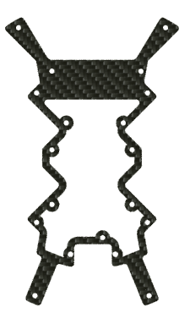

January 2021

* Finalised 3D design of our robot
* 3D printed the minor components(e.g. Infrared sensor guard, battery holder, omni-wheels, dribbler, kicker, etc)

February 2021

* PCBs was delivered to us and we started soldering the robot together

March 2021

* Dribbler was fully assembled
* The dribbler was too much to the back and could not touch much of the ball, to solve this problem, we moved the dribbler forwards by about 1cm
* Kicker was not strong enough had to make modifications

May 2021

* Finished assembling our first robot
* Robot was able to spin
* Started building and assembling our second robot

End of May 2021

* Robot 1 was able to complete the missions

**Electrical Log**

December 2020

* We began designing our PCBs

January 2021

* Design of PCBs were completed and we sent the design to be manufactured

February 2021

* Received our PCBs and started soldering the SMDs and pins

March 2021

* Completed soldering on layers 1 and 3 on our first robot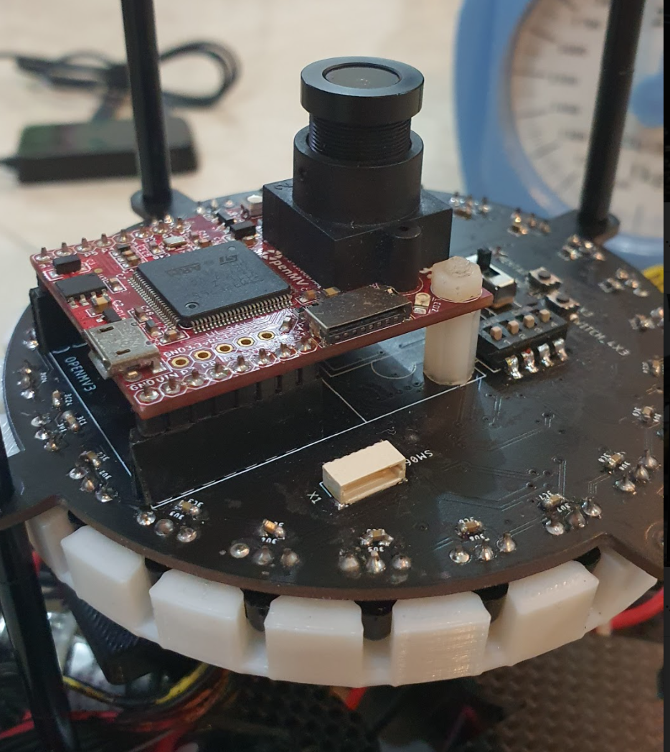

April 2021

* Soldering on layer 4 was completed and we tested all the circuits on our first robot
* 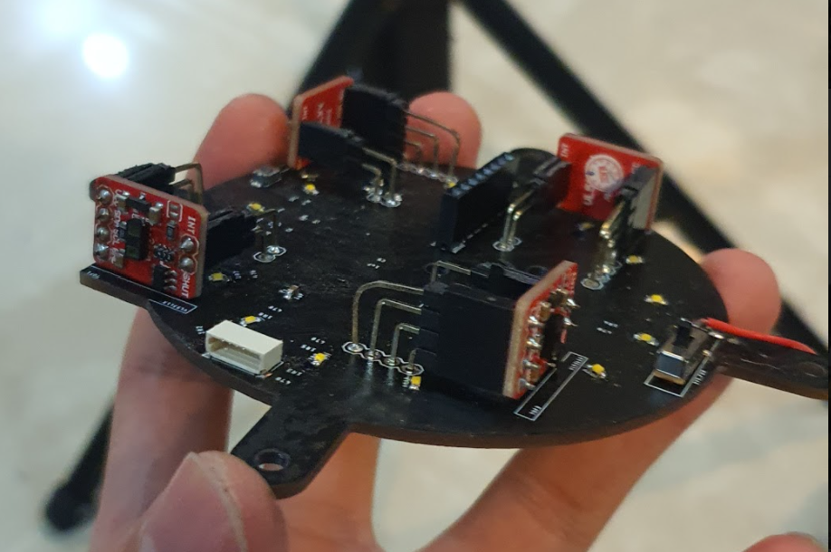

May 2021

* We began soldering on our second robot