An Automated Candidate Screening System Using Resume Analysis and Video
Interview Evaluation with Natural Language Processing for Initial HR Filtering

A Capstone Project Presented to the College of Computer Studies
Global Reciprocal Colleges Caloocan City

In Partial Fulfillment of the Requirements for the Degree
Bachelor of Science in Information Technology

Prepared by:
Bechayda, Martin Fredirico
Galang, Mark Anthony L.
Sujede, Stephen Clyde D.

Eduardo S. Rodrigo
March 2026

TABLE OF CONTENTS

CHAPTER I - THE PROBLEM AND ITS BACKGROUND ...……………………...…...4
1.1 Project Context ……………………………………………………………………………4
Background of the Study………………………………………………………………7
1.2 Statement of the Problem …………………………………………………………………9
1.3 Objective of the Study……………………………………………………………………..9
General Objectives…………………………………………………………………….9
Specific Objectives…………………………………………………………………...10
1.4 Scope and Delimitation of the Study……………………………………………………..10
Scope………………………………………………………………………………….11
Delimitations………………………………………………………………………….12
1.5 Significance of the Study…………………………………………………………………13
1.6 Definition of Terms……………………………………………………………………….14
CHAPTER II - REVIEW OF RELATED LITERATURE AND STUDIES……….……16
2.1 Introduction……………………………………………………………………………….16
2.2 Review of Related Literature……………………………………………………………..16
Foreign Literature…………………………………………………………………….16
Local Literature……………………………………………………………………….21
2.3 Review of Related Studies………………………………………………………………..27
Foreign Studies……………………………………………………………………….27
Local Studies …………………………………………………………………………35
2.4 Synthesis of the Review of Related Literatures and Studies……………………………..43
CHAPTER III - RESEARCH METHODOLOGY………………………………………..45
3.1 Research Method…………………………………………………………………………45
DFD (Data Flow Diagram) Level 0 Proposed System……………………………….47
DFD (Data Flow Diagram) Level 1 Proposed System ………………………………49
DFD (Data Flow Diagram) Level 2 Proposed System ………………………………50
3.2 Conceptual Framework of the Study……………………………………………………..57
3.3 Data Gathering Tools and Procedure……………………………………………………..59
Process Flowchart Existing System…………………………………………………..62
3.4 Project Design…………………………………………………………………………….63
System Architecture Diagram………………………………………………………...63
Use Case Diagram……………………………………………………………………66
Entity Relationship Diagram (ERD)………………………………………………….68
Data Dictionary Table………………………………………………………………...69
3.5 Project Evaluation………………………………………………………………………...76
Project Evaluation Instruments……………………………………………………….76
AI Model Evaluation Metrics………………………………………………………...79
Likert Table…………………………………………………………………………...81
Reference…………………………………………………………………………………......82

CHAPTER I
THE PROBLEM AND ITS BACKGROUND

1.1 Project Context
In many organizations, the initial stages of recruitment still rely heavily on manual resume screening followed by traditional screening interviews, which can be time-consuming, inconsistent, and prone to human bias. Human resource personnel often review large volumes of resumes to shortlist candidates, making it difficult to efficiently identify applicants who best match the job requirements. This is typically followed by screening interviews, where evaluations may vary depending on the interviewer, leading to subjective judgments and inconsistencies in candidate assessment. Although some companies utilize basic digital recruitment tools, the lack of integration between resume filtering and screening interview evaluation remains a common limitation. To address these challenges, an Automated Candidate Screening System is introduced, utilizing techniques from Natural Language Processing to analyze resumes and evaluate screening interview responses. The system is designed to streamline the initial recruitment process by filtering qualified applicants and assessing their interview performance before they proceed to the HR interview stage, thereby improving efficiency, consistency, and objectivity in candidate selection.

Victory Liner Cubao Terminal, Located in Cubao, Manila and managed by Human Resource Manager Mr. Paulo Ian Perez, serves as the client for this study. Victory Liner is one of the oldest and largest bus transportation companies in the Philippines, primarily serving routes between Metro Manila and various destinations in Central and Northern Luzon, including provinces like Pampanga, Tarlac, Pangasinan, Zambales, and the Cordillera region. The company has been a staple of intercity travel for millions of Filipinos, offering different classes of service ranging from ordinary to air-conditioned and premium buses. Over the decades, Victory Liner has become a household name in Philippine public transportation, known for its extensive network of northern routes and its role in connecting rural communities to the capital.

At present, the human resource department relies entirely on manual processes in managing the recruitment and screening of job applicants. Vacant positions are advertised through informal channels such as Facebook and other social media platforms, which, while accessible, lack the structure and professionalism expected of a formal hiring process. Although applicants are given the option to apply online, the process is limited to submitting resumes via email, after which all subsequent evaluation is conducted manually by HR personnel. Each submitted resume must be individually reviewed and assessed by a recruiter, making the screening process time-consuming, inconsistent, and highly susceptible to human error and bias. The absence of an automated filtering mechanism means that HR staff are required to dedicate a significant amount of time and effort to the initial stages of candidate evaluation, which reduces overall productivity and delays the progression of the hiring process.

Furthermore, the manual screening process extends into the initial interview stage, where HR personnel are required to conduct background investigations for each applicant individually. During these interviews, a considerable amount of time is consumed as applicants tend to elaborate extensively on their personal backgrounds and past experiences, making it difficult for interviewers to control the flow and duration of each session. This inefficiency significantly prolongs the overall screening process, as HR personnel are unable to promptly proceed to the next applicant, resulting in a backlog of unassessed candidates and an unnecessary expenditure of both time and human resources. The lack of a structured and automated screening system therefore not only compromises the consistency and objectivity of candidate evaluation but also hinders the organization's capacity to conduct timely and effective recruitment.

The proposed Automated Candidate Screening System is designed to streamline the human resource department's recruitment process, reducing the need for manual resume review, unstructured background investigation interviews, and inconsistent candidate evaluation. Through features such as NLP-driven resume parsing, automated candidate ranking, and video interview evaluation, the system aims to minimize human error and improve the overall efficiency and objectivity of the initial screening process. The resume analysis component systematically matches applicant qualifications against predefined job requirements, while the video interview evaluation feature allows applicants to record their responses to structured screening questions that the system will assess automatically, eliminating the need for lengthy one-on-one background investigation sessions. The system's automated filtering mechanism enables HR personnel to focus their time and effort only on candidates who have successfully passed the initial screening stage, reducing recruiter workload and accelerating the hiring timeline. Additional features include candidate scoring and ranking for structured shortlisting, a centralized applicant database for organized record management, and a dedicated HR dashboard that provides immediate access to screening results and applicant summaries, ensuring a faster, more consistent, and more efficient recruitment process for Victory Liner Cubao Terminal.

Background of the Study
Recruitment is a critical process in organizations, as it directly influences workforce quality and overall organizational performance. Traditionally, many companies rely on manual recruitment practices, such as reviewing resumes individually, conducting unstructured interviews, and making subjective hiring decisions. While these methods have been widely used, they often lead to inefficiencies, inconsistencies, and delays in the hiring process (Chapman & Webster, 2003). Manual screening also increases the likelihood of human bias and error, which can affect the fairness and accuracy of candidate evaluation.
With the advancement of technology, organizations are increasingly adopting automated recruitment systems to improve efficiency and decision-making. Automated candidate screening systems utilize techniques such as Natural Language Processing (NLP) to analyze resumes and extract relevant information, including skills, experience, and qualifications. These systems enable faster processing of large volumes of applications while ensuring consistency in evaluation (Upadhyay & Khandelwal, 2018). Additionally, NLP-based resume analysis allows organizations to match applicant profiles with job requirements more accurately, reducing the burden on HR personnel.
In recent years, video interview technologies have also emerged as an effective tool in recruitment. Video interviews allow applicants to respond to structured questions, while automated systems analyze speech and textual data to assess communication skills and job suitability. Studies have shown that integrating artificial intelligence in video interviews can enhance objectivity and provide measurable evaluation metrics (Langer et al., 2019). This approach helps standardize the interview process and minimizes subjective bias in candidate assessment.
Despite these advancements, some organizations, such as transportation companies and similar industries, still rely on manual or semi-manual recruitment processes. These methods often result in slow processing times, inconsistent evaluation criteria, and difficulty in managing large volumes of applicants. As identified through data gathering, the recruitment process in Victory Liner Cubao Terminal involves manual resume screening and traditional interview evaluation, which may lead to inefficiencies and delayed hiring decisions.
To address these challenges, this study proposes the development of an Automated Candidate Screening System using Resume Analysis and Video Interview Evaluation with Natural Language Processing for Initial HR Filtering. The system aims to streamline the recruitment process by automating resume analysis, standardizing interview evaluation, and providing data-driven candidate scoring and ranking. By integrating these technologies, the proposed system is expected to improve recruitment speed, enhance evaluation consistency, and support better hiring decisions.

1.2 Statement of the Problem
The study aims to develop An Automated Candidate Screening System Using Resume Analysis and Video Interview Evaluation with Natural Language Processing for Initial HR Filtering to address inefficiencies, inconsistencies, and delays in traditional recruitment processes. Current hiring practices rely heavily on manual screening and subjective evaluation, which may lead to inaccurate candidate assessment and slow decision-making.

Specifically, the study seeks to answer the following questions:
- What are the common inefficiencies encountered by HR personnel in the manual recruitment screening process?
- How will the automated resume analysis module improve the accuracy and consistency of candidate qualification matching based on predefined job criteria?
- How does the proposed system's video interview evaluation module standardize the scoring of candidate responses using NLP?
- How effective is the proposed system in reducing recruitment screening time and improving the accuracy of hiring decisions as measured by precision, recall, and F1-score?

1.3 Objectives of the Study
General Objectives
The general objective of this study is to design and develop An Automated Candidate Screening System Using Resume Analysis and Video Interview Evaluation with Natural Language Processing for Initial HR Filtering that enhances efficiency, consistency, and accuracy in the recruitment and selection process through the integration of Artificial Intelligence technologies.

Specific Objectives
Specifically, the study aims to:
- Analyze the existing recruitment process to identify inefficiencies and inconsistencies in manual candidate screening.
- Design and develop a Resume Analysis Module that collects and evaluates structured applicant information based on predefined job criteria using Natural Language Processing.
- Develop and implement a Video Interview Evaluation Module that analyzes speech and textual data using NLP to generate objective candidate performance scores.
- Evaluate the effectiveness of the proposed system in improving recruitment speed, evaluation consistency, and the overall quality of hiring decisions.

1.4 Scope and Delimitation of the Study
The proposed An Automated Candidate Screening System Using Resume Analysis and Video Interview Evaluation with Natural Language Processing for Initial HR Filtering focuses on automating the initial stages of the recruitment process, specifically resume screening and interview evaluation, through structured data collection and AI-assisted assessment tools. The system is designed to improve efficiency, consistency, and objectivity in candidate screening.
The system includes the following major components: Smart Resume Analysis Module, Automated Video Interview System, AI Evaluation Engine, Applicant Tracking Portal, and HR Reporting Dashboard.
Scope
Stakeholders and Their Activities:
Applicant
- Creates an account in the system
- Completes a structured application form for resume analysis
- Records and submits video interview responses to predefined screening questions
- Receives application status updates and screening results via email notifications (e.g., Gmail), without access to a real-time tracking interface
HR Personnel
- Manages applicant profiles and screening results through the HR dashboard
- Reviews automated candidate rankings and scores generated by the system
- Accesses applicant summaries, resume analysis results, and video interview evaluations
- Advances or declines candidates based on system-generated results
- Defines job requirements and screening criteria within the system
- Shares the system-generated application link through external platforms (e.g., social media such as Facebook) to invite applicants
HR Head
- Monitors HR personnel activities and recruitment progress
- Views recruitment reports, analytics, and overall system performance
- Oversees the screening process without directly managing applicant records
System Modules and Functions:
- Resume Analysis Module – Utilizes Natural Language Processing (NLP) to extract, evaluate, and match applicant qualifications, skills, and experiences against predefined job requirements.
- Video Interview Evaluation Module – Records and analyzes applicant video responses to structured screening questions, assessing verbal content, keyword relevance, and response structure.
- Candidate Ranking and Scoring Module – Generates candidate scores and rankings based on resume analysis and interview response evaluation using a combination of rule-based scoring and AI-assisted analysis.
- HR Dashboard Module – Provides HR personnel with centralized access to applicant records, screening results, and recruitment analytics.
- Applicant Portal – Allows applicants to register, submit required information, and complete their video interview within a single platform.
Delimitations
The current version of the Automated Candidate Screening System has several limitations. The system's resume analysis is limited to documents submitted in standard file formats and may not accurately process unconventionally formatted or graphically designed resumes. The video interview evaluation is restricted to analyzing verbal content and keyword relevance and does not include facial expression analysis or behavioral assessment. Additionally, the system serves only as an initial filtering tool and does not replace the full recruitment process, as final hiring decisions remain the responsibility of HR personnel. The system also does not support direct integration with third-party job posting platforms such as LinkedIn or JobStreet, and job advertisements must still be managed separately by the HR team.
1.5 Significance of the Study

The findings and output of this study will be beneficial to the following:
Human Resource Personnel. The system will reduce manual workload, improve screening efficiency, and support objective and data-driven hiring decisions by automating the most time-intensive stages of the recruitment process.
Organizations. The platform can enhance candidate-job matching, reduce hiring delays, and improve overall recruitment effectiveness, enabling institutions to secure qualified talent in a competitive labor market.
Management. The system will provide structured reports and analytics through an HR Reporting Dashboard to support strategic, data-driven decision-making in workforce planning and talent acquisition.
Applicants. The system promotes a more standardized and transparent evaluation process through structured data submission and consistent AI-based scoring, ensuring fair and equitable assessment of all candidates.
Future Researchers. This study may serve as a reference for future research related to AI-based recruitment systems, intelligent decision support systems, and HR technology innovation. It contributes empirical insights into the practical application of NLP, computer vision, and machine learning in the context of talent acquisition.

1.6 Definition of Terms

Applicant Tracking Portal – A system feature that monitors and manages candidate progress throughout the recruitment process.
Artificial Intelligence (AI) – Technology that enables machines to simulate human intelligence, including learning, reasoning, and automated decision-making.
Automated Video Interview System – A module that allows candidates to record interview responses, which are analyzed using speech recognition and Natural Language Processing techniques.
HR Reporting Dashboard – A system interface that provides recruitment analytics, performance scores, and hiring insights.
Machine Learning – An AI technique that enables the system to learn from data and improve scoring accuracy over time.
Natural Language Processing (NLP) – An AI technology used to analyze and interpret textual data such as application responses and converted interview transcripts.
Sentiment Analysis – A technique used to evaluate tone, emotion, and communication patterns in text or speech.
Smart Resume Analysis Module – A system component that collects applicant information through a standardized digital application form and evaluates qualifications based on predefined job requirements.
Speech Recognition – Technology that converts spoken interview responses into text for further analysis and evaluation.

CHAPTER Ⅱ
REVIEW OF RELATED LITERATURE AND STUDIES

2.1 Introduction
This chapter showcases relevant literature and research that underpin the creation of the Automated Candidate Screening System Utilizing Resume Analysis and Video Interview Assessment with Natural Language Processing (NLP) for preliminary HR evaluation. It covers theoretical principles regarding automation, artificial intelligence, recruitment analytics, and associated domestic and international studies on digital hiring technologies. The assessment also highlights existing shortcomings in present systems and outlines the theoretical framework directing this research.

2.2 Review of Related Literature
Foreign Literature
Title of the Study: Role of Artificial Intelligence in Employee Recruitment: Systematic Review and Future Research Directions
Dadaboyev et al. (2025) conducted a systematic review of peer-reviewed studies on AI applications in employee recruitment, synthesizing findings across multiple databases using a structured literature search protocol. The review covered studies published between 2015 and 2024 and categorized AI tools according to their function in the recruitment pipeline. The authors found that machine learning algorithms enable recruitment systems to identify patterns in candidate qualifications with greater speed and consistency than traditional methods. They also reported that AI-assisted recruitment reduces the time required for hiring decisions while maintaining objectivity across large applicant pools.

Title of the Study: Smart Recruitment, Hiring and Automation: A Review
Ahmed (2025) reviewed the landscape of smart recruitment technologies by analyzing published academic and industry literature on AI and machine learning applications in hiring. The author categorized modern recruitment platforms by their core functionalities, including automated resume parsing, candidate ranking algorithms, and predictive analytics for applicant-job matching. The review concluded that organizations adopting AI-based recruitment systems report reductions in cost-per-hire and improvements in candidate quality. The author also identified that integration with existing HR infrastructure remains a significant implementation challenge across different organizational contexts.

Title of the Study: A Systematic Literature Review on Artificial Intelligence in Recruiting and Selection: A Matter of Ethics
Mori et al. (2024) conducted a systematic literature review using the PRISMA framework, screening 312 articles and retaining 74 studies that met their inclusion criteria on AI ethics in recruitment. Their analysis revealed that the most frequently cited ethical concerns are algorithmic bias, lack of transparency in decision-making, and insufficient data privacy safeguards. The authors found that organizations rarely implement structured auditing mechanisms for their AI recruitment tools, leaving ethical risks unaddressed. They concluded that fairness, accountability, and informed consent must be treated as non-negotiable design requirements rather than optional considerations.

Title of the Study: A Literature Review: Artificial Intelligence Impact on the Recruitment Process
Fraij and Várallyai (2021) analyzed 45 peer-reviewed articles on AI adoption in human resource management published between 2010 and 2020, using thematic analysis to identify recurring findings across studies. They found that AI-based recruitment systems consistently reduce manual processing time and enable organizations to handle larger applicant volumes without proportionally increasing HR staffing. The review also noted that accuracy in candidate-job matching improves when AI tools are combined with structured job description frameworks. However, the authors cautioned that over-reliance on AI without human verification can result in the exclusion of qualified candidates whose profiles fall outside standard training data patterns.

Title of the Study: Artificial Intelligence Recruitment: A Literature Review Based on Equity and Efficiency Perspectives
Zhang et al. (2025) examined AI recruitment systems through a dual-lens literature review that assessed both organizational efficiency outcomes and equity implications across 58 published studies. Using content analysis, the authors categorized findings according to whether they primarily addressed speed and cost benefits or fairness and inclusion outcomes. They found that efficiency gains are well-documented across industries, with AI tools accelerating shortlisting by up to 75 percent compared to manual processes. In contrast, equity outcomes varied widely depending on training data quality, with poorly designed systems showing measurable disparities in selection rates across demographic groups.

Title of the Study: Ethics of AI-Enabled Recruiting and Selection: A Review and Research Agenda
Fernández-Martínez and Fernández (2022) conducted a systematic review and bibliometric analysis of 89 articles on AI ethics in HR processes published between 2012 and 2021. The authors mapped the ethical dimensions most frequently discussed in the literature and found that fairness, accountability, and transparency consistently emerged as the three central pillars of responsible AI adoption in recruitment. Their analysis also identified a gap between theoretical ethical frameworks and their practical implementation within organizations. The authors proposed a research agenda emphasizing the need for empirical studies on how ethical AI guidelines translate into measurable outcomes in real-world hiring decisions.

Title of the Study: Artificial Intelligence in Human Resource Management: Diversity, Equity, and Inclusion Perspectives
Naoum et al. (2026) performed a systematic review of 96 studies examining how AI-powered HRM tools affect diversity, equity, and inclusion outcomes in organizations. The review applied a dual-impact framework, classifying studies according to whether AI interventions produced inclusive or exclusionary outcomes. The authors found that AI tools designed with representative training datasets and bias-auditing protocols demonstrated significant improvements in diverse hiring outcomes. Conversely, systems built on historically biased data reproduced and amplified existing disparities. The review concluded that continuous post-deployment monitoring is essential for sustaining equitable outcomes over time.
Title of the Study: Fairness, AI and Recruitment
Bovenkamp et al. (2024) analyzed fairness standards and compliance frameworks applicable to AI recruitment tools by reviewing legal instruments, ethics guidelines, and published case studies across European and North American jurisdictions. The authors identified that existing anti-discrimination legislation was not designed with algorithmic systems in mind, creating regulatory gaps that allow biased automated decisions to go unchallenged. Their analysis showed that organizations which voluntarily implemented third-party audits of their AI recruitment tools reported fewer discriminatory outcomes and stronger stakeholder trust. The authors recommended that regular algorithmic impact assessments become a standard component of responsible AI deployment in hiring.

Title of the Study: Algorithmic Hiring: How AI Is Changing Recruitment and What HR Professionals Need to Know
Van Esch et al. (2020) surveyed HR professionals and reviewed industry case studies to document how algorithmic hiring tools were reshaping recruitment workflows. Using a mixed-method approach combining structured interviews and secondary data analysis, the authors found that organizations deploying AI in recruitment reported a 40 percent reduction in average time-to-fill positions. However, HR professionals expressed concern that over-reliance on algorithmic outputs was diminishing their professional judgment. The study concluded that AI tools are most effective when implemented as augmentation tools that support rather than override human expertise, and that training HR staff to critically evaluate AI outputs is essential for responsible deployment.

Title of the Study: Human Resource Management in the Age of Artificial Intelligence: A Systematic Review
Johnson et al. (2021) conducted a systematic review of 67 empirical and theoretical studies on AI integration across core HRM functions, published between 2000 and 2020. The review used a structured coding scheme to categorize findings by HRM function, AI technology type, and reported outcome. The authors found that AI applications in recruitment and selection yielded the most consistently positive efficiency outcomes, followed by applications in performance management and employee retention. They also identified that organizations with stronger digital infrastructure and dedicated data governance policies reported significantly higher returns from AI adoption. Ethical concerns, particularly around data ownership and candidate privacy, were flagged as underexplored areas requiring further empirical attention.

Local Literature
Title of the Study: Converging Perspectives: Assessing AI Readiness and Utilization in Philippine Higher Education
Asirit and Hua (2023) employed a mixed-method design combining a survey of 320 faculty and administrative staff across 15 Philippine higher education institutions with qualitative focus group discussions. The study measured AI readiness across four dimensions: infrastructure availability, digital literacy, institutional policy support, and faculty awareness. Results showed that while 68 percent of respondents expressed interest in adopting AI tools, fewer than 30 percent reported having the technical infrastructure to support them. The authors concluded that AI readiness in Philippine academic and professional settings remains fragmented, with significant disparities between urban and rural institutions.

Title of the Study: AI Adoption in Philippine Human Resource Management Practices
Mobo (2025) examined AI integration across HR functions in Philippine organizations through a descriptive research design using survey instruments distributed to HR practitioners in both public and private sector organizations. The study found that AI is most widely adopted in recruitment and performance management, with 61 percent of surveyed organizations reporting some form of AI-assisted applicant screening. Despite positive perceptions of AI efficiency, the author found that governance frameworks and ethical guidelines for AI use in HR remain largely underdeveloped across Philippine organizations. The study recommended the development of sector-specific AI policy guidelines to support responsible adoption.

Title of the Study: Perceived Effectiveness of Online Digital Platform to the Recruitment Process in Bestlink College of the Philippines
Bestlink College of the Philippines (2023) reported that respondents generally perceived digital recruitment platforms as effective in reducing the time and resources required in traditional, paper-based hiring processes. The findings further revealed that the automation of initial applicant data collection and documentation through digital portals significantly minimized redundancy and human error during early recruitment stages. This study provides a locally grounded perspective on the transition of Philippine institutions toward digital hiring workflows, supporting the potential integration of more advanced AI-powered screening systems. Moreover, its emphasis on platform effectiveness and user acceptance directly informs the design and evaluation of an automated candidate screening system.

Title of the Study: Predictors of Attitude and Intention to Use E-Recruitment Among Human Resource Management Practitioners in the Province of Romblon
Fetalvero (2024) investigated the perceptions of human resource management (HRM) practitioners in Romblon province toward e-recruitment, using the Technology Acceptance Model (TAM) to identify significant predictors of attitude and behavioral intention. As Rosal (2024) reported, the respondents demonstrated highly favorable perceptions toward e-recruitment, with perceived ease of use and usefulness emerging as the strongest predictors of attitude, collectively explaining 66.7% of the variance in attitude formation. The study further found that HR professionals' attitude toward e-recruitment, combined with their awareness of such tools and length of experience, significantly influenced their intention to use them. These results suggest that even in provincial settings outside Metro Manila, Filipino HR practitioners are increasingly open to technology-driven recruitment approaches. Such findings support the proposition that an automated candidate screening system would be well-received when designed with usability and practical value at its core.

Title of the Study: AI Transformation in the Workplace: A Comprehensive Review of Trends and Future Directions
Quezon and Esmane (2024) conducted a comprehensive literature review of 85 studies on AI-driven workplace transformation, using thematic synthesis to identify prevailing trends and their implications for workforce development. The review found that AI adoption accelerates task automation and raises skill requirements simultaneously, creating pressure on organizations to invest in continuous learning programs. The authors identified workforce reskilling, regulatory adaptation, and ethical governance as the three most pressing challenges associated with AI integration in the workplace. Their synthesis also noted that organizations that proactively aligned AI adoption with employee development strategies reported higher levels of staff acceptance and lower resistance to technological change.

Title of the Study: The AI, Blockchain, Cloud and Data Technology Integration in the Philippines: A Literature Review
Jose et al. (2023) conducted a literature review of emerging technology integration across Philippine industries, drawing from 60 local and international publications. The authors mapped the current state of AI, blockchain, cloud, and data analytics adoption across sectors including agriculture, healthcare, education, and business services. The review found that AI adoption in the Philippines is concentrated in larger urban firms in the ICT and BPO sectors, with limited penetration in small and medium enterprises. The authors identified weak digital infrastructure and low technology awareness as the primary barriers to broader adoption, and recommended targeted government and industry investment in digital capacity-building programs.

Title of the Study: Artificial Intelligence in the Philippine Educational Context: Circumspection and Future Inquiries
Tus (2023) conducted a document analysis and review of policy statements, institutional reports, and academic literature on AI integration in Philippine educational and professional settings. The study assessed AI readiness across four dimensions — digitalization, research and development capacity, workforce preparedness, and task automation potential — and found that the Philippines scored below the regional average on all four indicators. The author noted that while the government had initiated programs to accelerate AI development, implementation remained slow due to funding constraints and a shortage of AI-trained professionals. The study emphasized that sustainable AI adoption requires coordinated investment across education, infrastructure, and regulatory domains.

Title of the Study: Artificial Intelligence and Its Potential Adverse Impacts on the Philippine Economy
De La Salle University (2021) reported that recruitment and applicant screening functions—characterized by repetitive pattern matching and data processing— are among the most vulnerable to AI-driven automation. These findings situate the proposed automated candidate screening system within the broader context of economic and labor transformation in the Philippines, emphasizing that such systems represent not only technological advancement but also a structural shift in HR practices. Furthermore, the study underscores the importance of designing AI systems that augment, rather than replace, human judgment, ensuring that local HR practitioners remain integral to the recruitment decision-making process.

Title of the Study: Automation of HR Interviews Using Deep Learning and Natural Language Processing: A Review of Current Practices
According to Quimba, Moreno, and Salazar (2024), artificial intelligence adoption in Philippine businesses remains limited despite its potential to improve efficiency and decision-making in operations such as recruitment and workforce management. Their study found that while most firms have basic digital infrastructure, only a small percentage have implemented AI technologies due to challenges such as lack of technical expertise, limited funding, and inadequate organizational readiness. These findings highlight the need for practical AI-based systems that can support business processes, including recruitment, in the Philippine context.

Title of the Study: Utilization of E-Recruitment Tools as Perceived by Recruiters and Job Applicants
Grimaldo et al. (2020) examined how both recruitment officers and job applicants in the Philippines perceive the use of online e-recruitment tools, employing partial least squares structural equation modeling (PLS-SEM) to compare perceptions of perceived usefulness, perceived ease of use, and behavioral intentions. The researchers found that both groups considered the tools easy to use, and that ease of use significantly influenced attitudes and intentions to adopt digital hiring platforms. Notably, Grimaldo et al. (2020) also found that while applicants viewed these tools as genuinely useful, recruitment officers perceived existing platforms as somewhat limiting in terms of full-cycle recruitment support. The study highlights a significant gap between applicant and recruiter needs, suggesting that platforms must evolve beyond mere job posting to include automated screening features. These findings provide a foundational local context for understanding the readiness of Philippine HR practitioners to adopt automated candidate evaluation systems.

2.3 Review of Related Studies
Foreign Studies
Title of the Study: AI-Powered Automated Resume Screening and Job Matching System Using NLP and Machine Learning
Khatri et al. (2025) designed and evaluated an NLP and machine learning-based resume screening system using an experimental dataset of 5,000 resumes paired with 200 job descriptions across ten industry categories. The system employed TF-IDF vectorization and cosine similarity scoring for initial matching, followed by a BERT-based classification model for semantic relevance ranking. The results showed a precision of 91.4 percent and a recall of 88.7 percent in identifying qualified candidates, outperforming baseline keyword-matching approaches by a margin of 23 percent. The authors also found that automated screening reduced average screening time from 6.3 hours to 42 minutes per job posting.
Research Gap
The study mainly focuses on resume screening and job matching, but it does not include interview evaluation or other stages of the recruitment process. This limits the system’s ability to fully assess candidates beyond their submitted resumes. The proposed system addresses this gap by integrating both resume analysis and video interview evaluation, allowing a more comprehensive and accurate initial screening of applicants.
Title of the Study: AI-Powered Resume Screening: A Machine Learning Approach to Modern Recruitment
Singh (2025) implemented and evaluated a deep learning resume screening pipeline using a corpus of 12,000 resumes collected from publicly available datasets and compared system rankings against evaluations made by ten experienced HR professionals. The study applied BERT-based embeddings combined with a feed-forward classification layer to predict candidate suitability scores. Results showed a Spearman rank correlation of 0.87 between machine-generated and human-generated rankings, indicating high agreement. The author also demonstrated that semantic embedding approaches significantly outperformed traditional keyword-based methods, particularly for resumes using varied terminology to describe equivalent qualifications.
Research Gap
Although the study demonstrates strong performance in resume-based evaluation, it only focuses on textual data and does not consider other important aspects such as communication skills and interview performance. The proposed system addresses this limitation by incorporating video interview evaluation, enabling the assessment of both written qualifications and verbal responses.

Title of the Study: Resume Screening With Natural Language Processing
Saatci, Kaya, and Ünlü (2024) developed an NLP-based resume screening system and tested it on a dataset of 3,200 resumes across five job categories, comparing performance against manual screening conducted by trained HR evaluators. The system used named entity recognition for extracting candidate attributes, followed by weighted scoring based on job requirement matching. The automated system processed all 3,200 resumes in under four minutes compared to an estimated 160 hours for manual screening, while achieving an F1 score of 85.3 percent against human evaluator labels. The authors noted that inter-evaluator agreement among human screeners was only 71 percent, suggesting that the automated system was more consistent than manual review.
Research Gap
The study is limited to resume processing and does not evaluate how candidates perform in actual interview scenarios. This creates a gap in assessing real-time communication and behavior. The proposed system fills this gap by combining resume analysis with video interview evaluation, ensuring a more complete assessment of applicants.

Title of the Study: AI Hiring with LLMs: A Context-Aware and Explainable Multi-Agent Framework for Resume Screening
Lo et al. (2025) developed a multi-agent LLM framework consisting of three specialized agents, an extraction agent, an evaluation agent, and an explanation agent, each built on a fine-tuned large language model. The system was evaluated on 800 resume-job description pairs, with human recruiter judgments used as ground truth. The extraction agent achieved an attribute recall rate of 93.1 percent, while the evaluation agent produced candidate rankings that matched human assessments with 89.4 percent accuracy. The explanation agent generated natural language justifications for each ranking decision, which recruiters in a follow-up survey rated as highly useful for understanding algorithmic outputs.
Research Gap
While the study improves explainability in resume screening, it does not integrate interview-based evaluation into the system. This limits its ability to assess candidates holistically. The proposed system addresses this by combining explainable resume analysis with video interview evaluation, providing a more complete and structured recruitment process.

Title of the Study: National Origin Discrimination in Deep-Learning-Powered Automated Resume Screening
Li, Li, and Lu (2023) conducted an audit study by submitting 2,400 synthetically generated resumes — identical in qualifications but varying in name origin — to deep learning-based resume screening systems. The researchers found that resumes with Anglo-Saxon names received callback rates 23 percent higher than equally qualified resumes with Asian or Hispanic names, indicating systematic national origin bias in the models tested. Bias was traced to skewed representation in the training data, where historically overrepresented demographic groups produced stronger feature signals. The authors demonstrated that rebalancing training datasets and applying fairness constraints during model training reduced the callback rate disparity by up to 61 percent.
Research Gap
The study identifies bias in AI systems but does not provide a structured solution for improving fairness in recruitment processes. The proposed system addresses this gap by using predefined job criteria and structured evaluation methods in both resume and interview stages, helping reduce bias and improve consistency in candidate assessment.

Title of the Study: No Thoughts Just AI: Biased LLM Recommendations Limit Human Agency in Resume Screening
Wilson et al. (2025) conducted a controlled experiment with 528 participants drawn from HR, management, and general professional backgrounds, randomly assigning them to receive either accurate or deliberately biased AI-generated candidate rankings before making their own hiring decisions. The study found that participants who received biased AI recommendations adopted those recommendations in 87 to 92 percent of cases, even when the biased ranking contradicted explicit candidate qualifications provided to participants beforehand. Participants who were informed about potential AI bias showed only marginal improvement in independent judgment, reducing agreement with biased outputs to 79 percent. The authors concluded that passive disclosure of AI limitations is insufficient to preserve meaningful human agency in recruitment decisions.
Research Gap
The study highlights the risk of over-reliance on AI but does not propose a system design that balances automation with human decision-making. The proposed system addresses this by acting as a decision-support tool, where AI provides structured scores and rankings while allowing HR personnel to make the final decision.

Title of the Study: Beyond the Resumé: A Rubric-Aware Automatic Interview System for Information Elicitation
Stuart, Kaneko, and Baldwin (2026) built and evaluated an automated interview system that generates structured questions from predefined rubrics and scores candidate responses using fine-tuned transformer models. The system was tested across 600 simulated interview sessions in domains including engineering, customer service, and data analysis. Automated scores correlated with expert human panel ratings at r = 0.83, and the system demonstrated strong consistency across repeated evaluation of the same response. The authors also found that rubric-aware question generation significantly improved the relevance of elicited information compared to generic interview bots, enabling more accurate competency assessment across diverse job roles.
Research Gap
The study focuses only on interview evaluation and does not integrate resume screening into the process. This results in a fragmented recruitment system. The proposed system addresses this by integrating resume analysis and interview evaluation into a single platform, ensuring a unified and efficient screening process.

Title of the Study: AI Self-Preferencing in Algorithmic Hiring: Empirical Evidence and Insights
Xu, Li, and Jiang (2025) conducted an empirical study by submitting 1,600 resumes — half written by human applicants and half generated or optimized using commercial AI writing tools — to eight different automated applicant tracking systems. The study found that AI-optimized resumes received shortlisting rates 34 percent higher than equivalent human-written resumes, even when qualifications were held constant. The authors identified that keyword density patterns produced by AI writing tools closely matched the scoring heuristics embedded in the screened ATS systems, creating a structural advantage for AI-assisted applicants. The study concluded that without detection mechanisms and scoring diversity, algorithmic hiring systems risk rewarding presentation optimization over genuine candidate merit.
Research Gap
The study highlights the issue of AI bias toward optimized resumes but does not offer a solution to validate candidate authenticity. The proposed system addresses this by incorporating video interview evaluation, ensuring that candidates are assessed based on actual responses and not just resume optimization.

Title of the Study: Recruitment and Selection Process Using Artificial Intelligence: How Do Candidates React?
Ligeiro, Dias, and Moreira (2024) administered a structured survey to 384 job seekers across Portugal, Brazil, and Spain, measuring attitudes toward AI-driven recruitment tools using a validated scale covering perceived fairness, transparency, usability, and trust. Structural equation modeling revealed that perceived transparency was the strongest predictor of candidate acceptance of AI systems, accounting for 41 percent of variance in overall trust ratings. Candidates with prior exposure to AI tools reported significantly higher acceptance levels, suggesting that familiarity reduces resistance. The study also found that candidates were significantly less accepting of AI systems when they could not access explanations for rejection decisions, underscoring the importance of explainable outputs in automated hiring.
Research Gap
The study focuses on user perception but does not provide a system that improves transparency in actual recruitment processes. The proposed system addresses this by implementing structured scoring and evaluation outputs that can be reviewed by HR personnel, improving clarity and trust in decision-making.

Title of the Study: Adoption of Artificial Intelligence in Employee Recruitment: The Influence of Contextual Factors
Pan et al. (2022) surveyed 412 HR managers and technology officers across organizations in China, Germany, and the United States using a structured questionnaire grounded in the Technology-Organization-Environment framework. Multiple regression analysis identified organizational size, industry sector, and technological infrastructure as the three strongest predictors of AI adoption intent in recruitment, collectively explaining 54 percent of variance in adoption scores. The study found that larger organizations in technology-intensive industries with established digital infrastructure were significantly more likely to adopt AI recruitment tools. Perceived relative advantage and compatibility with existing HR workflows also emerged as significant adoption drivers, while complexity of implementation was the most frequently cited barrier.
Research Gap
The study identifies adoption challenges but does not provide a concrete system that simplifies implementation. The proposed system addresses this by offering a centralized recruitment platform that integrates multiple hiring functions, making AI adoption more practical for organizations.

Local Studies
Title of the Study: Application of Artificial Intelligence in Recruitment and Selection: The Case of Company A and Company B
Zhang et al. (2024) used the Unified Theory of Acceptance and Use of Technology framework and distributed structured questionnaires to 185 HR staff and managers across two Philippine-based companies through snowball sampling. Partial least squares structural equation modeling was used to analyze the data, revealing that perceived usefulness was the strongest predictor of AI adoption intent, explaining 46 percent of variance in behavioral intention scores. Effort expectancy and social influence were secondary predictors, while facilitating conditions had no significant effect. The authors also documented that neither company had formal AI governance policies in place, reflecting the broader absence of AI-specific employment legislation in the Philippines at the time of data collection.
Research Gap
The study highlights the lack of structured systems but does not provide a concrete solution. The proposed system addresses this by offering a well-defined platform that organizes recruitment processes efficiently.

Title of the Study: Automated Innovation: Exploring the Integration of Artificial Intelligence in Human Resource Recruitment in Metro Manila
Cacatian et al. (2024) conducted a qualitative exploratory study using semi-structured interviews with ten purposively selected HR practitioners from Metro Manila organizations across the retail, BPO, and financial services sectors. Thematic analysis of interview transcripts identified three dominant themes: operational efficiency gains, compliance concerns under the Data Privacy Act of 2012, and the risk of over-reliance on algorithmic outputs. Participants reported that AI tools reduced pre-screening time by an estimated 50 to 70 percent, but expressed concern that automated systems could not adequately assess cultural fit and soft skills. The authors characterized the evolving HR landscape as a transition toward a Digital Recruiting 3.0 model where AI functions as a co-pilot rather than a replacement for human decision-making.
Research Gap
The study does not provide a method to evaluate these aspects effectively. The proposed system addresses this by incorporating video interview evaluation, allowing better assessment of communication and behavioral traits.

Title of the Study: The Lived Experiences of BPO Executives in the Adoption of Artificial Intelligence: A UTAUT-Based Framework
Cruz (2026) employed a phenomenological research design, conducting in-depth one-on-one interviews with 17 BPO executives and a focus group discussion with six BPO employees from the Polytechnic University of the Philippines. Interpretive phenomenological analysis was applied to identify recurring experiential themes. The study found that performance expectancy and institutional support were the two strongest experiential drivers of successful AI adoption, while data security concerns and lack of standardized training protocols were the most frequently cited barriers. Executives from organizations that implemented structured change management programs reported significantly smoother AI integration timelines and higher staff acceptance rates compared to those that adopted AI tools without accompanying support infrastructure.
Research Gap
The study focuses only on resume parsing and does not include full recruitment processes. The proposed system expands this by integrating interview evaluation and candidate ranking.

Title of the Study: Facilitating Employment Opportunities in the Digital Space: A Study on the Activities and Services of Digital Labor Market Intermediaries in the Philippines
Pineda and Cayabyab (2023) used a multi-method research design combining key informant interviews with platform operators, focus group discussions with job seekers, and a prescreening survey of 104 employer respondents to examine the operations of digital labor market platforms. The study found that major platforms including Jobstreet, Kalibrr, and Jobfinder.ph were already using AI-based ranking algorithms and automated skills assessments as part of their standard screening workflows. Employer respondents rated automated screening tools as significantly more efficient than traditional CV review, but 67 percent expressed uncertainty about how algorithmic ranking decisions were made. The authors found that existing Philippine labor laws provided no specific protections for job seekers against discriminatory algorithmic screening outcomes.
Research Gap
Although the study highlights the use of AI in recruitment platforms, it does not provide transparency in how candidates are evaluated, which creates confusion among users. The proposed system addresses this gap by implementing structured evaluation criteria and clear scoring outputs, allowing HR personnel to better understand and trust the screening results.

Title of the Study: Online Applicant Tracking System
Taton (2022) developed an online applicant tracking system for recruitment processes, which integrates job posting, applicant data collection, and initial screening within a centralized platform. The system also includes an interview chatbot feature that allows candidates to undergo initial screening interviews digitally. The findings revealed that the system improves recruitment efficiency by capturing not only applicant data but also communication responses during interviews, allowing better preliminary evaluation of candidates.
Research Gap
However, Taton (2022) did not utilize Natural Language Processing (NLP) for resume parsing and analysis. Additionally, the system lacks automated scoring and ranking that integrates both resume data and interview responses into a unified evaluation framework.

Title of the Study: Artificial Intelligence and the Philippine Labor Market: Mapping Exposure and Complementarity
Cucio and Hennig (2025) merged four international AI occupational exposure indices with Philippine Statistics Authority labor force survey microdata covering 183,271 respondents across all major industry sectors. Using concordance mapping between international occupational codes and Philippine Standard Occupational Classification, the authors estimated AI exposure and complementarity scores for 148 distinct occupational categories. Results showed that 33.4 percent of Philippine jobs face meaningful AI exposure, and that 61.2 percent of those exposed roles are AI-complementary, meaning automation is more likely to augment than displace workers in those positions. The BPO sector recorded the highest aggregate AI exposure score, while agricultural and skilled trade occupations showed the lowest complementarity ratios.
Research Gap
The study focuses on the impact of AI in the labor market but does not provide a system that demonstrates how AI can be applied in actual recruitment processes. The proposed system addresses this by implementing AI-based resume analysis and interview evaluation to support HR decision-making.

Title of the Study: Profanity and Sentiment Detection in Filipino Social Media Comments Using Transformer-Based NLP Models
Bugayong et al. (2024) developed a web-based human resource management system focused on recruitment, enhanced applicant tracking, onboarding, and orientation processes. The system centralizes applicant data, streamlines job applications, and improves recruitment workflows through automation and structured evaluation. The study demonstrated that integrating recruitment functions into a single platform enhances efficiency and reduces administrative workload for HR personnel.
Research Gap
However, Bugayong et al. did not incorporate NLP-based resume analysis or automated evaluation of interview responses. In addition, the system lacks integration of video interview assessment and does not provide a unified scoring mechanism for ranking candidates.

Title of the Study: How AI is Fundamentally Changing Recruitment: Evidence from Philippine Organizations
SGV and Co. (2024) analyzed AI recruitment adoption trends among Filipino organizations by surveying 214 business leaders and cross-referencing findings with data from Microsoft and LinkedIn's 2024 Work Trend Index. The study found that 89 percent of Filipino business leaders considered AI essential for organizational competitiveness, yet only 31 percent had implemented AI tools in their recruitment workflows at the time of data collection. Among early adopters, three implementation patterns predominated: automated resume screening with human review, AI-powered chatbots for initial candidate engagement, and AI-assisted competency assessments paired with face-to-face interviews. Organizations using the hybrid human-AI model reported the highest satisfaction scores among both recruiters and candidates.
Research Gap
The study highlights the gap between awareness and actual implementation of AI in recruitment. The proposed system addresses this by providing a ready-to-use automated candidate screening system that organizations can adopt to improve their hiring process.

Title of the Study: Readiness for AI Adoption of Philippine Business and Industry
Quimba, Moreno, and Salazar (2024) assessed Philippine AI readiness by applying four international AI readiness indices to national-level data and conducting in-depth case studies of ten organizations across the ICT, manufacturing, and agricultural sectors. The study found that only 3.02 percent of Philippine businesses had implemented AI tools as of 2021, with adoption concentrated among large firms in Metro Manila and CALABARZON. Qualitative analysis of case study interviews identified four systemic barriers: inadequate digital infrastructure, limited organizational awareness of AI capabilities, a shortage of AI-trained professionals, and constrained access to R&D funding. The authors recommended a nationally coordinated AI adoption roadmap that prioritizes capacity-building in small and medium enterprises.
Research Gap
While the study identifies challenges in AI adoption, it does not provide a practical solution to overcome these barriers. The proposed system addresses this by offering a structured and user-friendly platform that simplifies recruitment processes and reduces the need for advanced technical expertise.

Title of the Study: Utilization of E-Recruitment Tools as Perceived by Recruiters and Job Applicants
Grimaldo, Uy, and Manalo (2020) examined how both recruitment officers and job applicants in the Philippines perceive the use of online e-recruitment tools, employing partial least squares structural equation modeling (PLS-SEM) to compare perceptions of perceived usefulness, perceived ease of use, and behavioral intentions. The researchers found that both groups considered the tools easy to use, and that ease of use significantly influenced attitudes and intentions to adopt digital hiring platforms. Notably, Grimaldo et al. (2020) also found that while applicants viewed these tools as genuinely useful, recruitment officers perceived existing platforms as somewhat limiting in terms of full-cycle recruitment support. The study highlights a significant gap between applicant and recruiter needs, suggesting that platforms must evolve beyond mere job posting to include automated screening features. These findings provide a foundational local context for understanding the readiness of Philippine HR practitioners to adopt automated candidate evaluation systems.
Research Gap
The study highlights a gap in existing recruitment tools but does not provide an integrated solution that combines resume analysis and interview evaluation. The proposed system addresses this by offering a unified platform that automates both screening and interview assessment, improving consistency and reducing the limitations identified by recruitment officers.

2.4 Synthesis of the Review of Related Literature and Studies
The reviewed literature and studies show that artificial intelligence has significantly improved recruitment processes by increasing efficiency, consistency, and scalability in candidate screening. AI technologies, particularly machine learning and natural language processing, are widely used for resume analysis, candidate matching, and automated shortlisting, allowing organizations to process applications quickly and objectively.
However, existing research also highlights several limitations, including algorithmic bias, lack of transparency, and over-reliance on automated decision-making. A major issue identified across studies is the fragmentation of recruitment systems. Most tools focus only on a single stage of the hiring process, such as resume screening or interview evaluation, resulting in incomplete candidate assessment.
Resume screening systems are limited to evaluating written qualifications, while interview systems do not incorporate prior resume data, leading to disconnected evaluations. Additionally, the lack of structured evaluation frameworks affects the consistency and fairness of candidate assessment. In the Philippine context, these challenges are further intensified by limited infrastructure, lack of expertise, and low adoption of AI technologies.
To address these gaps, the proposed An Automated Candidate Screening System Using Resume Analysis and Video Interview Evaluation with Natural Language Processing for Initial HR Filtering into a unified platform. By utilizing natural language processing and structured evaluation criteria, the system ensures consistent, objective, and comprehensive candidate assessment. It also incorporates automated scoring and ranking while maintaining human oversight in final decision-making.
Overall, the proposed system addresses the limitations of existing recruitment tools by providing an integrated, efficient, and transparent solution, improving the accuracy and reliability of initial candidate screening.
CHAPTER Ⅲ
RESEARCH METHODOLOGY
3.1 Research Method
This study will utilize literature review and analysis of existing recruitment practices as the primary research approach to gather essential information for the proposed An Automated Candidate Screening System Using Resume Analysis and Video Interview Evaluation with Natural Language Processing for Initial HR Filtering using Resume Analysis and Video Interview Evaluation with Natural Language Processing. The research will begin by identifying the problem through examining the challenges encountered in the client company’s current recruitment process, such as manual resume screening, unstructured interviews, delays in candidate evaluation, and inconsistencies in decision-making. These issues will serve as the basis for proposing a more efficient, structured, and objective screening solution. A comprehensive review of related literature, existing recruitment systems, and artificial intelligence-based hiring technologies will be conducted to identify the strengths and weaknesses of current systems, particularly the limitation of most solutions focusing only on a single stage of recruitment, resulting in fragmented candidate assessment processes . In addition, local studies will be analyzed to understand the current state of AI adoption in the Philippines, where many organizations still lack integrated and practical recruitment systems aligned with real-world operational needs . Through the analysis and synthesis of information from scholarly articles, journals, and case studies, the researchers will establish a strong foundation for the proposed system, which will guide the identification of key features such as resume analysis using Natural Language Processing, automated video interview evaluation, candidate scoring and ranking, and centralized data management. This research method will ensure that the proposed system is relevant, efficient, and aligned with real-world recruitment needs while addressing the limitations identified in existing systems and related studies.
AGILE METHODOLOGY
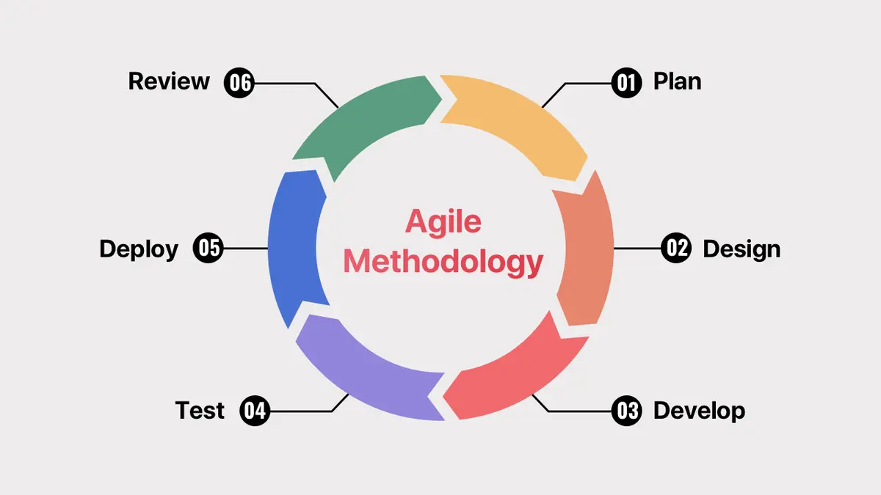
Figure 1: Agile Methodology
The methodology adopted in this study is the Agile methodology, chosen for its iterative, adaptive, and collaborative nature in software development. Given the complexity of developing an Automated Candidate Screening System with integrated Resume Analysis and Video Interview Evaluation using Natural Language Processing (NLP), Agile supports the systematic construction of each system component through short, manageable development cycles called sprints. Each sprint produces a testable version of a system module such as the Resume Analysis Module, the Video Interview Evaluation Module, or the HR Dashboard, enabling continuous refinement based on stakeholder feedback. The Agile approach is particularly suited to this study because the system's requirements involve multiple interconnected features that benefit from iterative testing and incremental improvement rather than a single rigid development cycle.

Planning
Involves identifying system goals and gathering requirements through interviews with the HR Manager of Victory Liner Cubao Terminal. This phase focuses on analyzing existing inefficiencies in the manual recruitment process, including unstructured resume screening, inconsistent interview evaluation, and delayed candidate feedback, and translating these into defined system requirements. Requirements are then divided into prioritized sprint tasks that will guide subsequent development.
Context Diagram
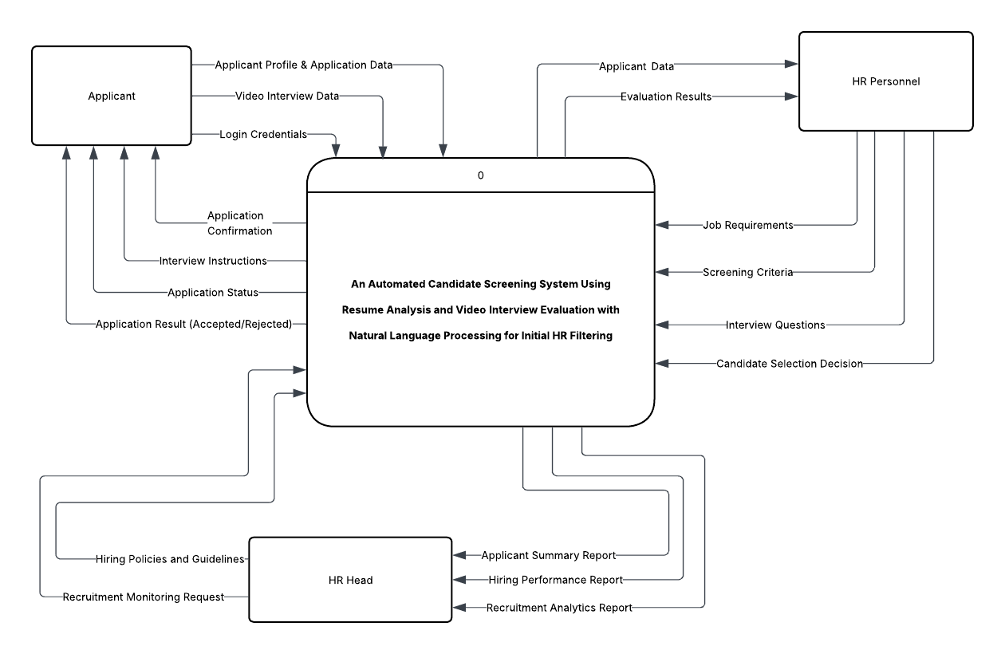
Figure 2: DFD Level 0 (Context Diagram) Proposed System
Figure 2 presents the Context Diagram (Level 0 Data Flow Diagram) of the proposed Automated Candidate Screening System. The diagram illustrates the system as a single process interacting with external entities, namely the Applicant, HR Personnel, and HR Head. The Applicant provides input data such as login credentials, applicant profile and application data, and video interview data, while receiving outputs including application confirmation, interview instructions, application status, and final application results. The HR Personnel supplies job requirements, screening criteria, interview questions, and candidate selection decisions, and receives applicant data and evaluation results. Meanwhile, the HR Head provides hiring policies and recruitment monitoring requests and receives reports such as applicant summaries, hiring performance, and recruitment analytics. This diagram provides a high-level overview of data exchange between the system and its external users.

Design
In this phase, the collected requirements will be translated into a structured system design. The researchers will develop the system architecture, database schema, UML diagrams, and interface prototypes. This phase will ensure that all system components, including the Resume Analysis Module, Video Interview Evaluation Module, and HR Dashboard, are properly planned before implementation.
Data Flow Diagram
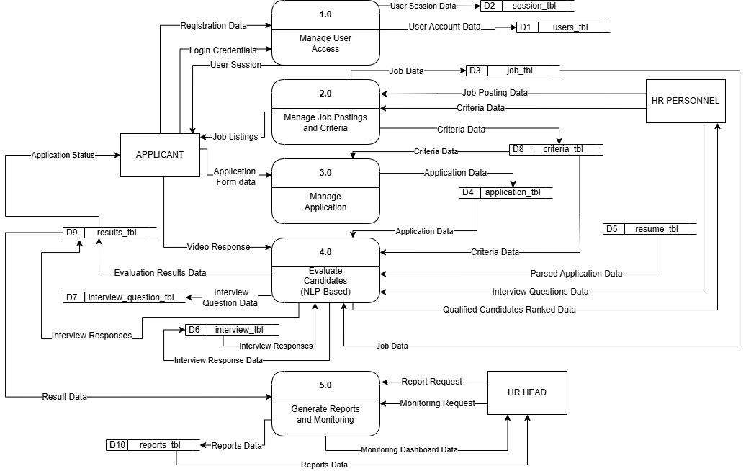
Figure 3: DFD Level 1 Proposed System
Figure 3 illustrates the Level 1 Data Flow Diagram of the proposed Automated Candidate Screening System. It presents the major processes involved in the system, including user access management, job posting and criteria setup, application processing, candidate evaluation, and report generation. The diagram shows how data flows between external entities such as the Applicant, HR Personnel, and HR Head, as well as how the system processes and transforms input data into meaningful outputs. This level provides a detailed overview of how the system decomposes the main process into functional components to ensure efficient and structured recruitment screening.

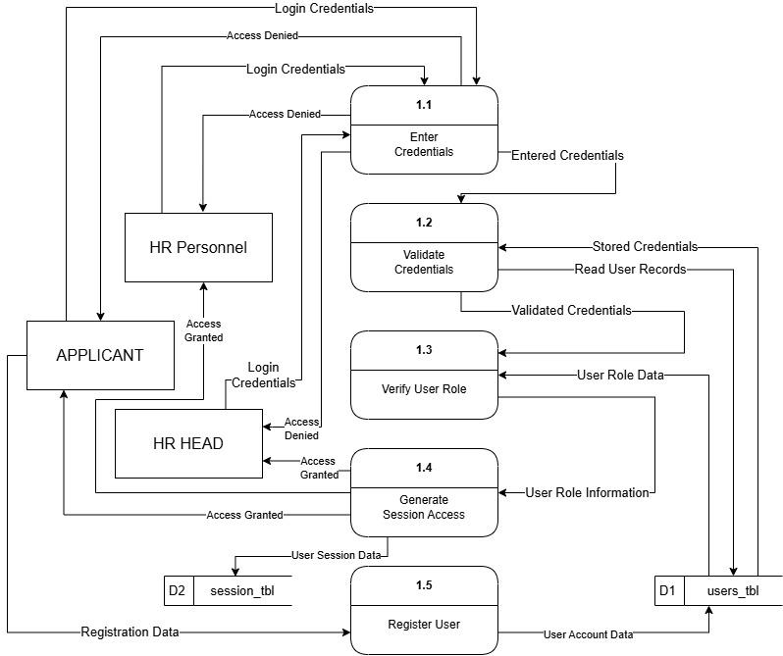
Figure 4: DFD 1.0 Level 2 Manage User Access
Figure 4 presents the Level 2 Data Flow Diagram for the Manage User Access process. It details how users interact with the system through registration and login functionalities. The process includes user authentication, validation of login credentials, and management of user roles such as Applicant, HR Personnel, and HR Head. The diagram also shows how user data is stored and retrieved from the system database to ensure secure and controlled access to system features.

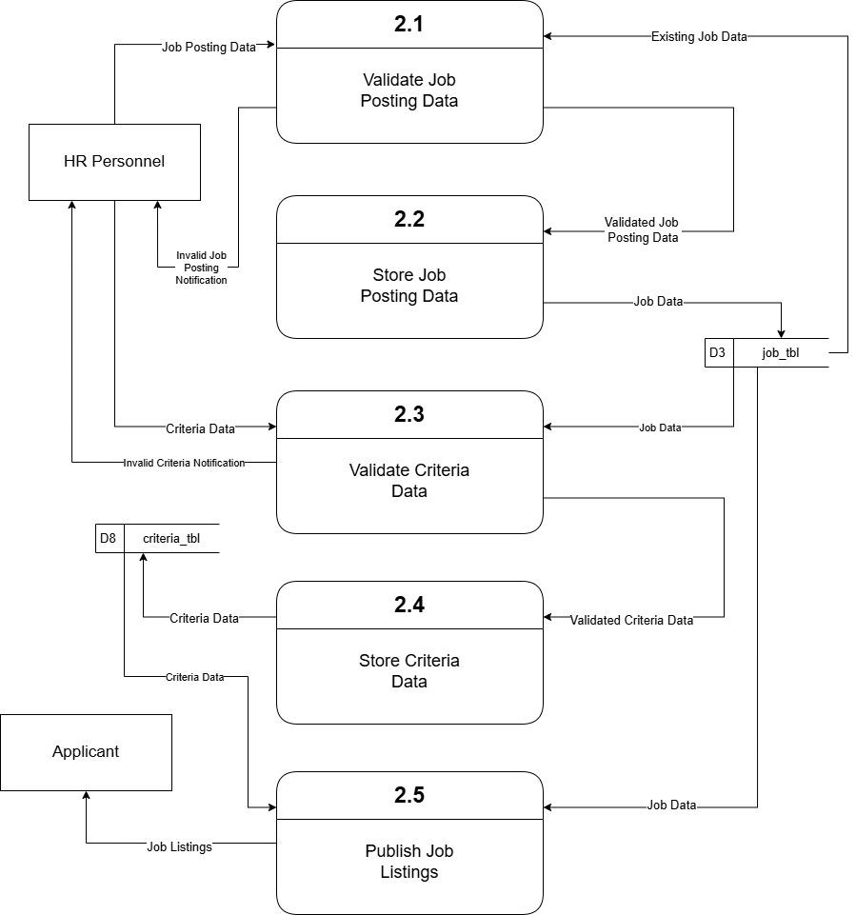
Figure 5: DFD 2.0 Level 2 Manage Job Posting and Criteria
Figure 5 illustrates the Level 2 Data Flow Diagram for managing job postings and screening criteria. It shows how HR Personnel input job details, qualifications, and predefined criteria into the system. These inputs are stored and used as the basis for evaluating applicants. The diagram highlights the process of defining structured job requirements and linking them with evaluation parameters, ensuring that all candidates are assessed consistently based on standardized criteria.
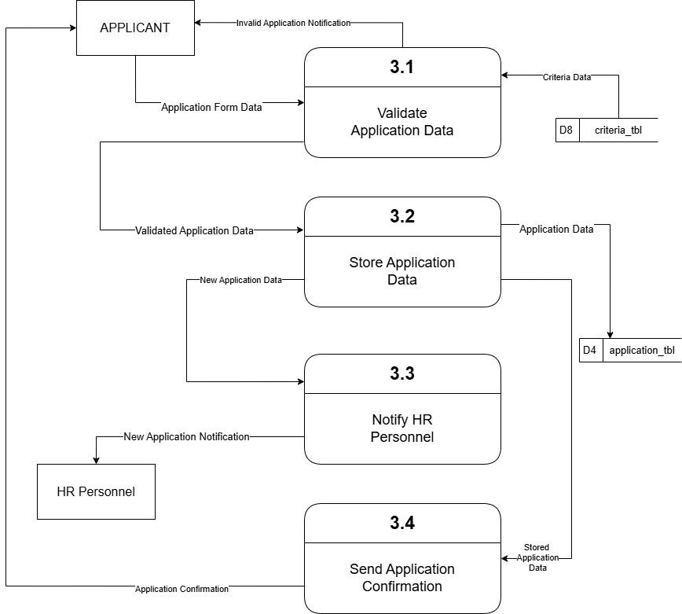
Figure 6: DFD 3.0 Level 2 Managing Application
Figure 6 presents the Level 2 Data Flow Diagram for managing applicant data and submissions. It demonstrates how applicants provide their profile information, submit application data, and complete video interview responses. The system processes and stores these inputs in the database for further analysis. This diagram emphasizes the structured collection and organization of applicant information, which serves as the foundation for automated screening and evaluation.

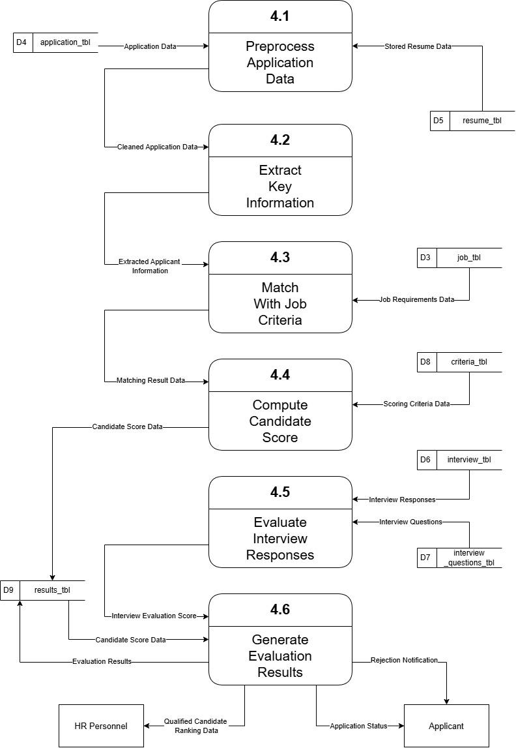
Figure 7: DFD 4.0 Level 2 Candidate Evaluation
Figure 7 illustrates the Level 2 Data Flow Diagram for candidate evaluation. It details how the system analyzes applicant data using Natural Language Processing techniques for both resume analysis and video interview evaluation. The process includes extracting relevant information, matching qualifications with job criteria, and generating evaluation scores. The diagram highlights how the system ensures objective, consistent, and data-driven assessment of candidates.

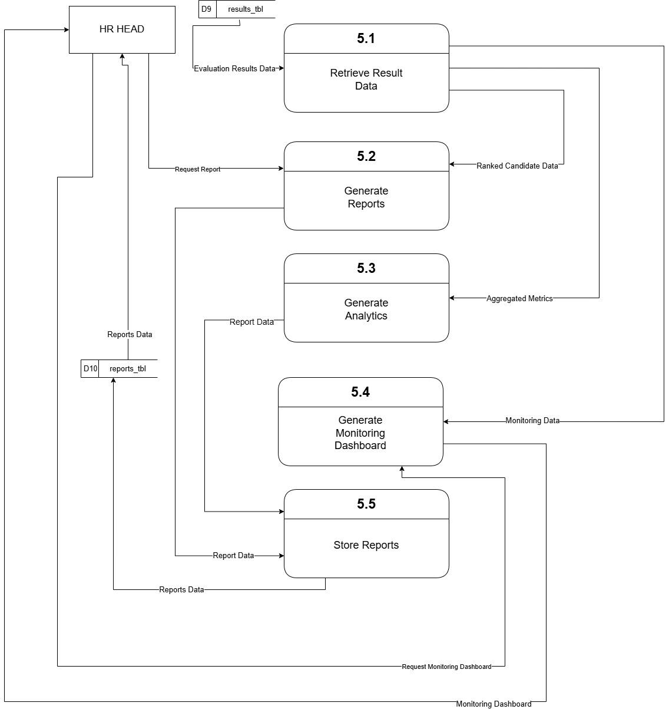
Figure 8: DFD 5.0 Level 2 Generate Reports
Figure 8 presents the Level 2 Data Flow Diagram for report generation. It shows how the system compiles evaluation results, candidate scores, and recruitment data to produce various reports such as applicant summaries, hiring performance reports, and recruitment analytics. These reports are provided to HR Personnel and HR Head to support monitoring, decision-making, and overall recruitment management. The diagram emphasizes the system’s capability to transform processed data into meaningful insights.

Development
During this phase, the system will be implemented using iterative Agile sprints. The researchers will develop the core modules of the system, including NLP-based resume analysis, video interview evaluation, candidate scoring, and HR dashboard functionalities. Continuous integration and refinement will be performed throughout development to ensure alignment with user requirements.

Testing
The developed system will undergo rigorous testing to ensure that all modules function correctly and meet the defined requirements. Functional testing, integration testing, and system testing will be conducted on all features, including NLP-based resume parsing, video response evaluation, candidate ranking, and dashboard reporting. Feedback from HR personnel will be gathered to validate that system outputs align with real recruitment workflows, and necessary improvements will be applied accordingly.

Deployment
The system will be deployed in a local staging environment to simulate real-world usage conditions. HR personnel and selected users will interact with the system to evaluate its performance, usability, and accuracy in an operational setting. Feedback gathered during this phase will be used to implement final refinements prior to full deployment.

Review
The system will be evaluated after deployment to assess its overall effectiveness and performance. User feedback from HR personnel will be analyzed to determine the system’s accuracy, usability, and efficiency in improving the recruitment process. The findings from this phase will be used to identify potential enhancements and recommendations for future system improvements.

3.2 Conceptual Framework of the Study
Figure 9 illustrates the conceptual framework of the Two-Stage Automated Recruitment Platform. The framework serves as a guide in the development of the proposed system designed to streamline the recruitment screening process. The platform integrates structured applicant questionnaires and automated video interview evaluation to assist organizations in assessing candidates more efficiently. Through the use of Artificial Intelligence, the system analyzes applicant responses, generates evaluation results, and prioritizes candidates objectively. This enables HR personnel to manage candidate screening and selection more quickly, consistently, and effectively.

Input Process Output (IPO)
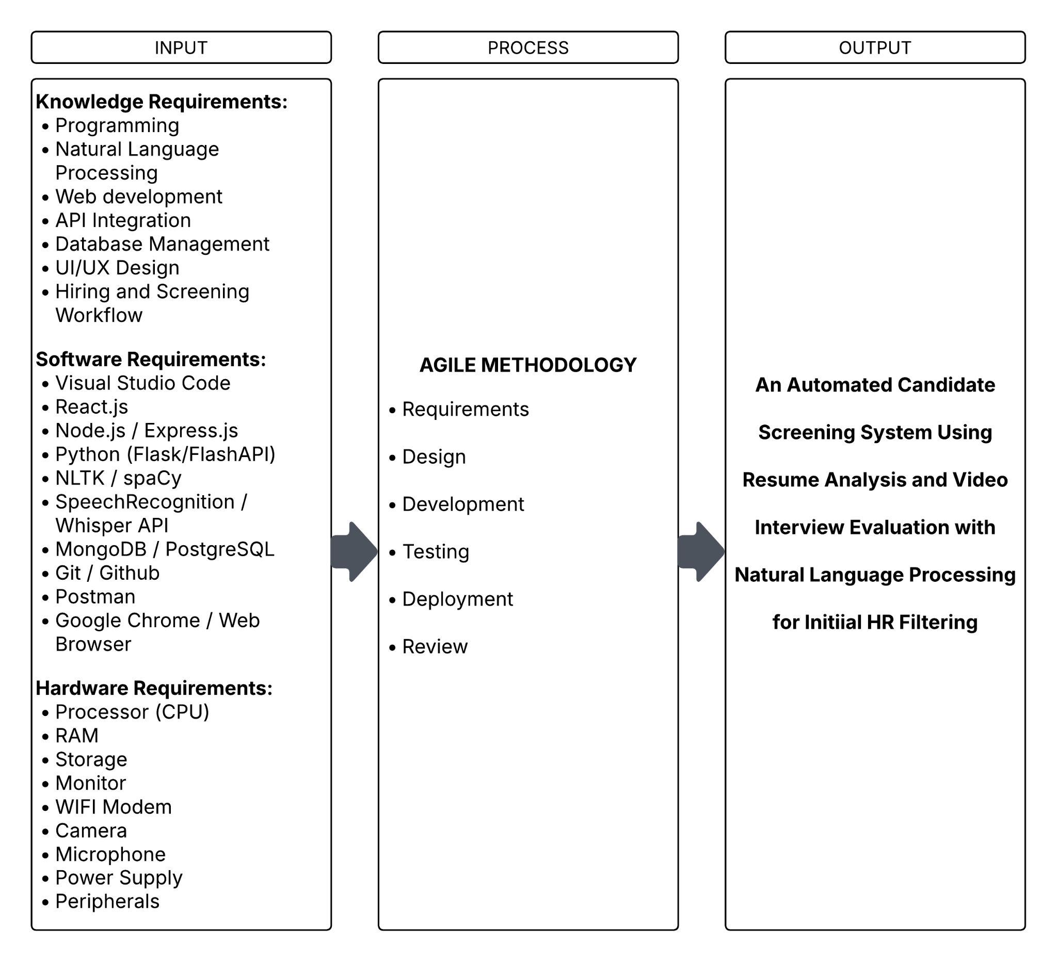
Figure 9 : Conceptual Framework
The Figure 9: Conceptual Framework illustrates the development of the proposed system using the Input–Process–Output (IPO) model. This framework will serve as a guide in identifying the system requirements, development process, and expected output.
The Input stage will include the knowledge, software, and hardware requirements necessary for system development. These will guide the proponents in designing and implementing the An Automated Candidate Screening System Using Resume Analysis and Video Interview Evaluation with Natural Language Processing for Initial HR Filtering.
The Process stage will involve the use of the Agile methodology, which will follow iterative phases such as requirements gathering, design, development, testing, deployment, and review to ensure continuous improvement of the system.
The Output stage will be the development of Automated Candidate Screening System Using Resume Analysis and Video Interview Evaluation with Natural Language Processing for Initial HR Filtering using structured resume questionnaire analysis and video interview evaluation with natural language processing for initial HR filtering. The system will aim to improve the efficiency, accuracy, and consistency of candidate screening.

3.3 Data Gathering Tools and Procedure
The development of the Automated Candidate Screening System Using Resume Analysis and Video Interview Evaluation with Natural Language Processing for Initial HR Filtering required a comprehensive understanding of the existing recruitment practices at Victory Liner Cubao Terminal to ensure that the proposed system is relevant, efficient, and aligned with real-world needs. To achieve this, the researchers utilized a combination of data gathering methods, including interviews, focus group discussions, and direct observation. A structured interview was conducted with the HR Manager/Head of the department to obtain firsthand information regarding the current recruitment workflow. Based on the interview, it was identified that the company primarily relies on traditional hiring methods such as job postings through Facebook, job caravans, referrals, and resume submissions via email and messaging platforms. The recruitment process is largely manual, where HR personnel review resumes individually and conduct multiple stages of interviews, including initial, final, and sometimes additional assessments depending on the position.
The interview further revealed that one of the most time-consuming aspects of recruitment is the screening and background verification process, as it involves coordination with external parties that are beyond the control of the organization. Additionally, HR personnel handle a high volume of applications, ranging from 10 to 20 per day under normal conditions, which can significantly increase during job postings, sometimes reaching hundreds of applicants. The manual nature of resume review and feedback tracking was also identified as a major challenge, as it involves repetitive tasks such as writing comments on resumes and encoding them into spreadsheets, which may lead to delays, data loss, and inconsistencies.
Furthermore, the interview highlighted that the company currently does not utilize AI or automated tools for recruitment, relying instead on manual processes and basic systems that are not fully maximized. However, the HR Manager expressed openness to adopting an automated system, particularly one that can filter large volumes of resumes efficiently, improve screening speed, and reduce the workload of HR personnel. These findings were further supported by focus group discussions and direct observation, which validated the inefficiencies in manual screening, unstructured interview processes, and the lack of standardized evaluation methods. Overall, the gathered data provided a clear and reliable foundation for the development of a system that integrates resume analysis and video interview evaluation to enhance the efficiency, consistency, and objectivity of the recruitment process.
- Interviews
Interviews were conducted with HR personnel to obtain firsthand information about the current recruitment workflow and challenges. This method was used to understand how manual resume screening and interviews are performed, identify inefficiencies, and determine the specific requirements that the proposed system must address.
- Focus Group Discussions
Focus group discussions were carried out to gather multiple perspectives and validate the information collected from interviews. This method was used to identify common issues in recruitment practices, such as inconsistencies in evaluation and delays in processing, and to determine the desired features and improvements for the proposed system.
- Observation
Direct observation was conducted to examine the actual recruitment process in practice. This method was used to verify real-world workflows, identify repetitive manual tasks, and analyze how applicants are processed, ensuring that the proposed system design is based on actual operational conditions.

Context Diagram
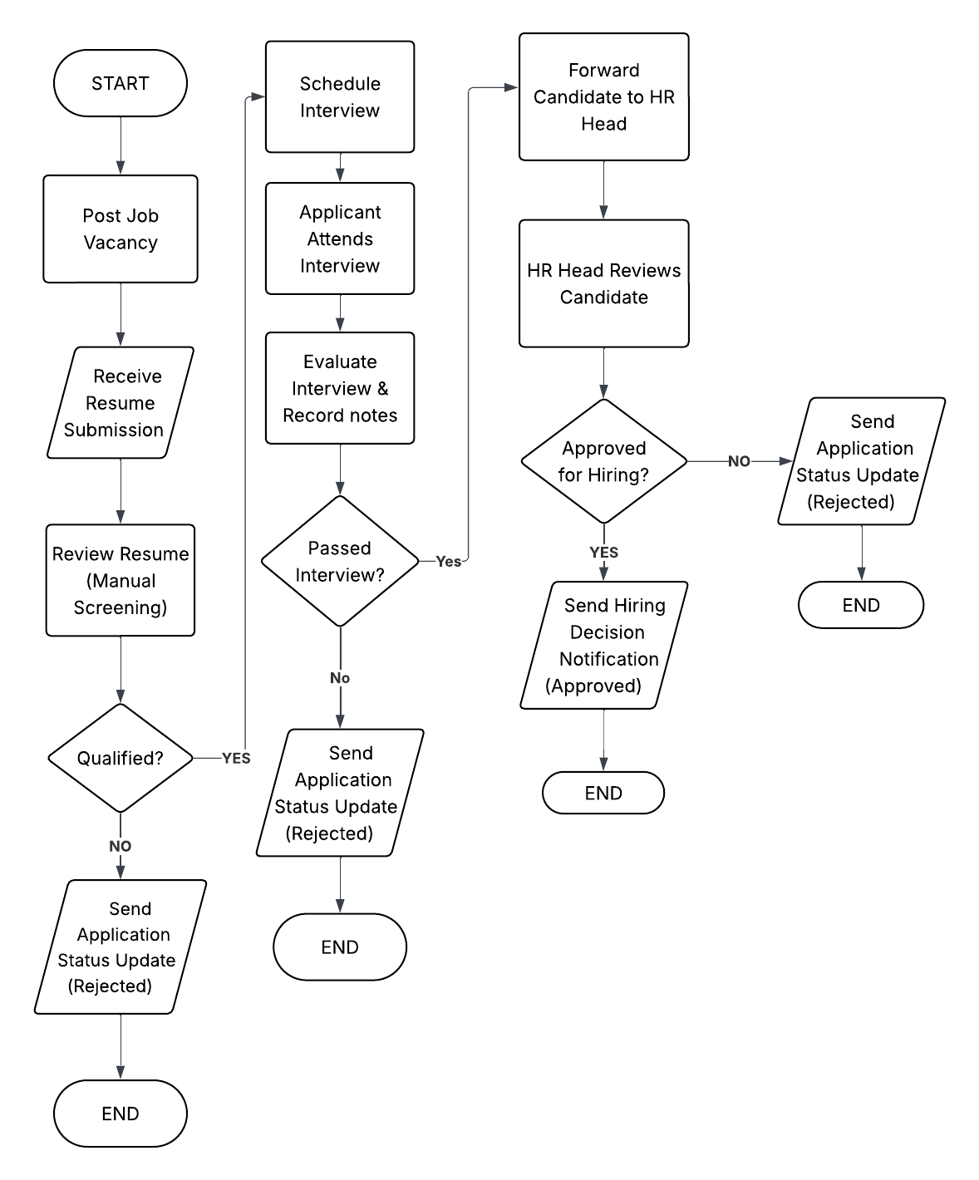
Figure 10: Process Flowchart of the Existing System
Figure 10 illustrates the process flow of the existing recruitment system, which primarily relies on manual procedures. The process begins with job vacancy posting, followed by the receipt of applications through various channels such as email or referrals. HR personnel manually review resumes and determine whether applicants qualify for the next stage. Qualified applicants proceed to interviews, while others are rejected. The interview process includes multiple stages, and decisions are made based on manual evaluation and discussion. Final decisions are then communicated to applicants. The diagram highlights the inefficiencies of the current system, including repetitive manual tasks, delays in processing, and lack of standardized evaluation methods.
3.4 Project Design
System Architecture Diagram
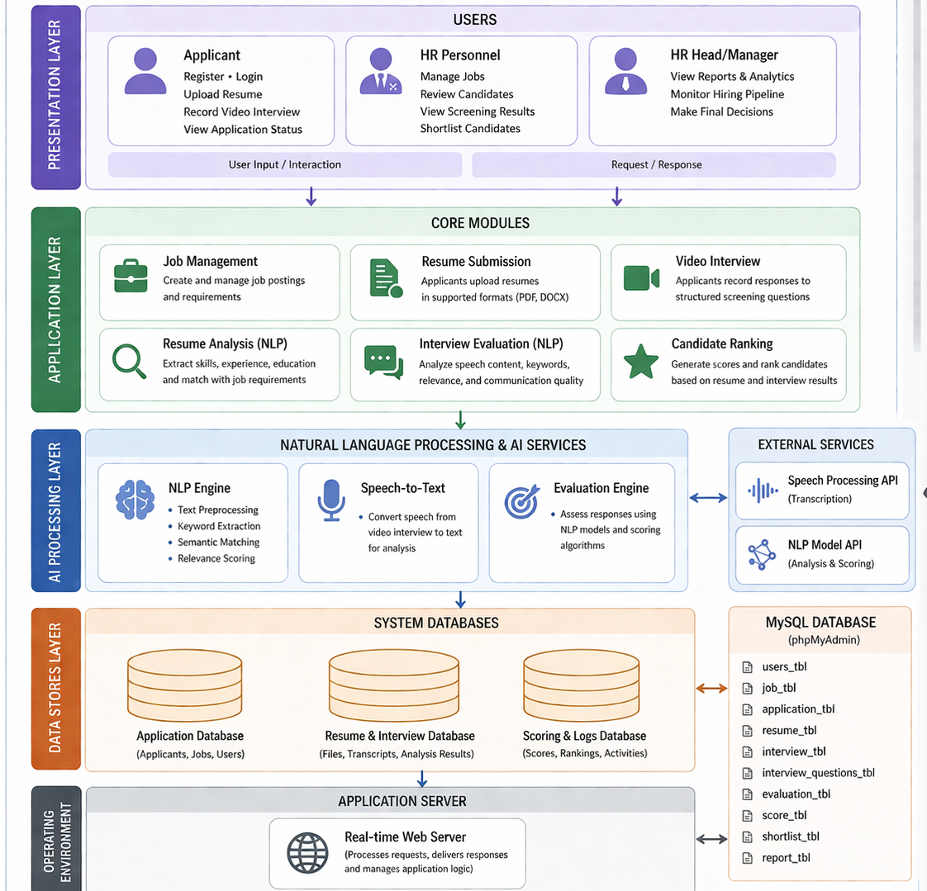
Figure 11 : System Architecture Design
Figure 11: System Architecture Design presents a multi-layered structure that illustrates how users interact with the system, how data is processed, and how results are generated through integrated artificial intelligence technologies.
At the Presentation Layer, the system accommodates three primary users: Applicant, HR Personnel, and HR Head/Manager. Applicants interact with the system by uploading resumes, recording video interview responses, and viewing their application status. HR Personnel manage job postings, review candidate information, and assess screening results, while the HR Head oversees the recruitment process through monitoring tools, analytics, and final decision-making functionalities. This layer serves as the interface for all user inputs and system responses.
The Application Layer contains the core functional modules of the system. The Job Management module allows HR personnel to create and manage job postings and requirements. The Resume Submission module enables applicants to upload their resumes in supported formats. The Video Interview module facilitates the recording of structured interview responses. These inputs are then processed by the Resume Analysis module, which uses Natural Language Processing (NLP) to extract and match applicant qualifications with job requirements, and the Interview Evaluation module, which analyzes speech content and communication quality. The Candidate Ranking module consolidates the results and generates scores to rank applicants accordingly.
The AI Processing Layer is responsible for intelligent data processing and evaluation. It includes the NLP Engine, which performs text preprocessing, keyword extraction, semantic matching, and relevance scoring. The Speech-to-Text component converts recorded video interview responses into text for analysis. The Evaluation Engine applies NLP models and scoring algorithms to assess candidate responses. Additionally, the system integrates with external services such as Speech Processing APIs and NLP Model APIs to enhance transcription accuracy and evaluation performance.
The Data Storage Layer manages all system data through structured databases. The Application Database stores user, job, and applicant information. The Resume and Interview Database contains uploaded files, transcripts, and analysis results. The Scoring and Logs Database maintains candidate scores, rankings, and system activity logs. These are supported by a MySQL database which will be converted to MongoDB, which organizes data into multiple tables including users, jobs, applications, resumes, interviews, evaluations, and reports.
Finally, the Application Server Layer hosts the Real-time Web Server, which processes user requests, executes application logic, and delivers responses across the system. This ensures seamless communication between the front-end interface, processing modules, and databases.
The architecture demonstrates a layered and modular design that integrates user interaction, automated processing, and data management. By combining NLP-based resume analysis and video interview evaluation within a unified platform, the system enhances efficiency, consistency, and objectivity in the initial stages of recruitment.

Use Case Diagram
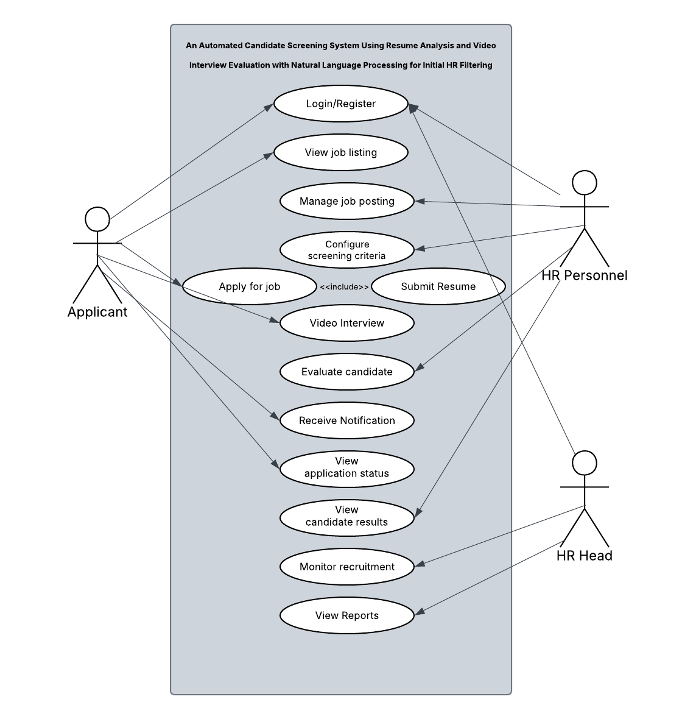
Figure 12: Proposed Use Case
Figure 12 illustrates the Use Case Diagram of the proposed Automated Candidate Screening System using Resume Analysis and Video Interview Evaluation with Natural Language Processing. The diagram presents the system’s functional scope by identifying the key actors—Applicant, HR Personnel, and HR Head—and their corresponding interactions with the system. The Applicant engages with the system by browsing available job listings, submitting applications, uploading resumes as part of the application process, and completing the required video interview. Following these activities, the Applicant is able to track the progress of their application through status viewing and system-generated notifications. On the administrative side, the HR Personnel performs core operational tasks, including managing job postings, configuring screening criteria, and evaluating candidates based on processed resume data and video interview analysis. At the managerial level, the HR Head utilizes the system to monitor recruitment activities and review summarized reports, which support informed decision-making in the selection process. Overall, the diagram demonstrates a structured interaction between users and system functionalities, highlighting how the proposed system facilitates an efficient, consistent, and data-driven recruitment workflow.

Entity Relationship Diagram (ERD)
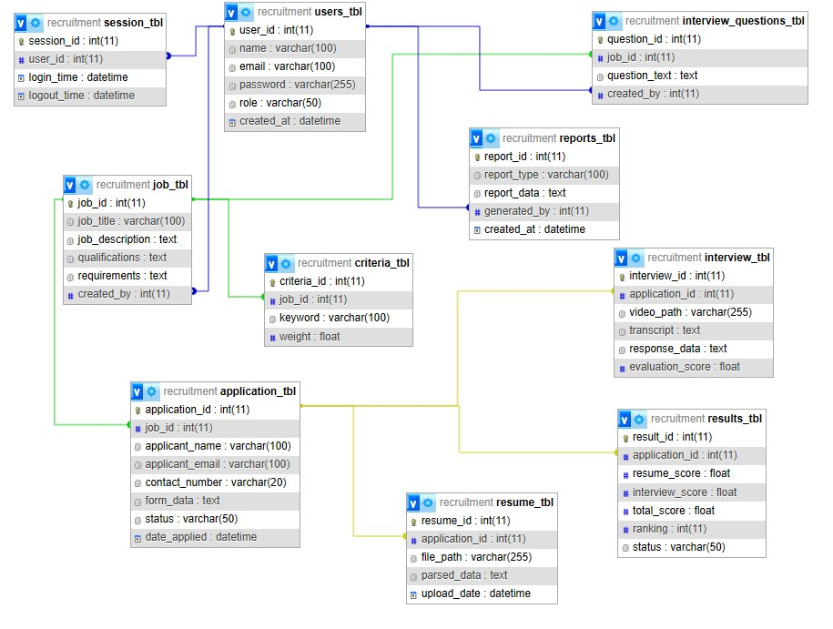
Figure 13: Proposed ERD
Figure 13 presents the Entity Relationship Diagram (ERD) of the proposed Automated Candidate Screening System, illustrating the structure of the database and the relationships among its core entities. The diagram shows how user accounts are managed through the users entity, which is linked to session records for tracking login activities and to job postings, interview questions, and reports created by authorized personnel. The job entity serves as a central component, connected to criteria for defining screening requirements and to application records submitted by applicants. Each application contains applicant information and is associated with uploaded resumes, interview records, and evaluation results, forming the complete recruitment data flow. The resume entity stores file references and parsed data used for analysis, while the interview entity captures video responses, transcripts, and evaluation scores. These processed data are then consolidated in the results entity, which contains candidate scores, rankings, and qualification status. Additionally, the reports entity compiles recruitment data into meaningful outputs for monitoring and decision-making by the HR Head. Overall, the ERD demonstrates a well-structured relational database that supports efficient data management, ensures data integrity through defined relationships, and enables the seamless flow of information across all components of the recruitment system.
Data Dictionary Table
Table 3.0 User Table
Field Name | Description | Field Type | Field Size | Type of Key
user_id | unique user ID | int | 11 | Primary Key
name | Full name of user | varchar | 50
email | user email | varchar | 50
password | User password | varchar | 255
role | user role | varchar | 50
created_at | account creation date | datetime | —
The User table stores information about system users, specifically HR Personnel and HR Head. Each record is uniquely identified by the user_id. This table contains login credentials and role assignments, which determine access levels within the system. It is used to manage authentication and ensure that only authorized users can perform administrative functions such as job posting, evaluation, and report monitoring.
Table 3.1 Session Table
Field Name | Description | Field Type | Size | Key
session_id | Unique session ID | int | 11 | Primary Key
user_id | Associated user ID | int | 11 | Foreign Key
login_time | Login timestamp | datetime | —
logout_time | Logout timestamp | datetime | —
The Session table stores records of user login and logout activities within the system. Each session is uniquely identified by the session_id, which serves as the primary key. It includes references to the user_id along with login and logout timestamps, enabling the system to monitor user sessions, track activity, and maintain secure access control.
Table 3.2
Job Table
Field Name | Description | Field Type | Size | Key
job_id | Unique job ID | int | 11 | Primary Key
job_title | Job title | varchar | 100
job_description | Description of job | text | —
qualifications | Required qualifications | text | —
requirements | Job requirements | text | —
created_by | Creator (HR) | int | 11 | Foreign Key
The Job table stores information related to job postings created by HR Personnel. Each record is uniquely identified by the job_id, which serves as the primary key. This table includes job title, description, qualifications, and requirements, which are used by the system as the basis for matching applicants and evaluating their qualifications.
Table 3.3 Application Table
Field Name | Description | Field Type | Size | Key
application_id | Unique application ID | int | 11 | Primary Key
job_id | Job reference | int | 11 | Foreign Key
applicant_name | Name of applicant | varchar | 50
applicant_email | Applicant email | varchar | 50
contact_number | Contact number | varchar | 20
form_data | Application form details | text | —
status | Application status | varchar | 50
date_applied | Date applied | datetime | —
The Application table stores applicant submission records collected through the application process. Each record is uniquely identified by the application_id, which serves as the primary key. It includes applicant details, job references, and structured application data, allowing the system to track applicant progress and manage application status throughout the recruitment workflow.
Table 3.4 Resume Table
Field Name | Description | Field Type | Size | Key
resume_id | Unique resume ID | int | 11 | Primary Key
application_id | Related application | int | 11 | Foreign Key
file_path | Resume file location | varchar | 255
parsed_data | Extracted resume data | text | —
upload_date | Upload timestamp | datetime | —
The Resume table stores uploaded resume files and their corresponding extracted data. Each record is uniquely identified by the resume_id, which serves as the primary key. This table includes file paths and parsed resume content, which are utilized by the system for resume analysis and qualification matching.
Table 3.5 Interview Table
Field Name | Description | Field Type | Size | Key
interview_id | Unique interview ID | int | 11 | Primary Key
application_id | Related application | int | 11 | Foreign Key
video_path | Stored interview video | varchar | 255
transcript | Converted text from video | text | —
response_data | Raw interview responses | text | —
evaluation_score | Interview score | float | —
The Interview table stores video interview data and evaluation results. Each record is uniquely identified by the interview_id, which serves as the primary key. It includes video file references, transcribed responses, and evaluation scores, which are used by the system to assess applicant performance using Natural Language Processing (NLP).
Table 3.6 Criteria Table
Field Name | Description | Field Type | Field Size | Type of Key
criteria_id | unique criteria ID | int | 11 | Primary Key
job_id | linked job | int | 11 | Foreign Key
keyword | required skill/keyword | varchar | 100
weight | importance value | float | —

The Criteria table stores predefined job-related keywords and requirements used in evaluating applicants. Each record is identified by criteria_id and linked to a specific job through job_id. It includes keywords and corresponding weights that determine their importance in the evaluation process. This table ensures consistent and structured assessment during resume and interview analysis.
Table 3.7 Results Table
Field Name | Description | Field Type | Size | Key
result_id | Unique result ID | int | 11 | Primary Key
application_id | Related application | int | 11 | Foreign Key
resume_score | Resume evaluation score | float | —
interview_score | Interview score | float | —
total_score | Combined score | float | —
ranking | Candidate ranking | int | 11

The Results table stores the final evaluation outcomes of applicants. Each record is uniquely identified by result_id and linked to the applicant. It includes resume scores, interview scores, total scores, and ranking. This table is used to generate the qualified applicant list and supports HR personnel in making data-driven hiring decisions.
Table 3.8 Interview Questions Table
Field Name | Description | Field Type | Field Size | Type of Key
question_id | unique question ID | int | 11 | Primary Key
job_id | linked job | int | 11 | Foreign Key
question_text | interview question | text | —
created_by | HR creator | int | 11 | Foreign Key

The Interview Questions table stores structured interview questions defined by HR personnel. Each question is identified by question_id and linked to a specific job. This table is used in the video interview module to ensure that all applicants are evaluated using standardized and consistent questions.
Table 3.9 Report Table
Field Name | Description | Field Type | Size | Key
report_id | Unique report ID | int | 11 | Primary Key
report_type | Type of report | varchar | 100
report_data | Report content/data | text | —
generated_by | Generated by user | int | 11 | Foreign Key
created_at | Date generated | datetime | —

The Report table stores generated reports and analytics related to the recruitment process. Each record is uniquely identified by report_id and includes information such as report type, creator, and date generated. This table supports the HR dashboard by providing summarized insights and monitoring data for decision-making.

3.5 Project Evaluation
Table 3.10 Project Evaluation Instrument
Criteria | Description | Indicators
Usability | Evaluates how easy and user-friendly the system is for applicants, HR personnel, and administrators. | • The system is easy to learn and use  • The interface is user-friendly and intuitive  • Navigation within the system is clear and understandable  • Instructions and prompts are easy to follow
Security | Assesses how well the system protects sensitive applicant data and prevents unauthorized access. | • The system ensures confidentiality of applicant data  • User authentication (login) is secure and reliable  • Access control is properly implemented for different users  • Data is protected against unauthorized access
Performance Efficiency | Measures how fast and efficiently the system processes applicant data and generates evaluation results. | • The system processes resumes quickly  • Video interview evaluation is performed efficiently  • The system responds promptly to user actions  • Loading time is minimal during operations
Maintainability | Evaluates how easily the system can be maintained, improved, or modified in the future. | • The system can be easily updated or modified  • Errors can be identified and fixed بسهولة (easily)  • The system structure supports future improvements  • Maintenance tasks can be performed without difficulty
Functional Suitability | Measures whether the system performs all required recruitment screening functions correctly and completely according to its intended purpose. | • The system accurately analyzes resumes  • The system correctly evaluates video interview responses  • The system provides relevant screening results  • All required features function properly
Reliability | Determines the system’s ability to operate consistently without failures during usage. | • The system operates without crashes or errors  • The system produces consistent results  • The system can handle multiple users simultaneously  • The system maintains performance over time
This evaluation instrument is designed to assess the overall quality of the Automated Candidate Screening System using standardized software quality attributes derived from the ISO/IEC 25010 model. Each criterion measures a specific aspect of system performance, usability, and reliability to ensure that the developed system meets user requirements and functions effectively in real-world recruitment operations. In addition, AI-specific evaluation metrics are incorporated to assess the accuracy and effectiveness of the system’s machine learning and natural language processing components, particularly in resume parsing and video interview analysis.

Table 3.11 AI Model Evaluation Metrics
Component | Metric | Description
Resume Parsing & Keyword Extraction | Keyword Match Rate | Measures the percentage of relevant keywords correctly identified from applicant resumes compared to a predefined set of required job keywords.
 | Named Entity Recognition (NER) Accuracy | Evaluates how accurately the system identifies entities such as names, skills, job titles, and organizations within resumes.
 | Cosine Similarity Score | Measures the similarity between the applicant’s resume and job description to determine relevance and fit.
Video Interview Evaluation | Word Error Rate (WER) | Measures the accuracy of speech-to-text transcription by calculating the error rate between spoken responses and transcribed text.
 | Sentiment Analysis  Score | Assesses the emotional tone (positive, neutral, negative) of the applicant’s responses during the interview.
 | Response Relevance Score | Evaluates how relevant and appropriate the applicant’s answers are to the given interview questions.
The AI components of the system will be evaluated using standard machine learning and natural language processing performance metrics. These metrics are used to measure the accuracy and effectiveness of the system in analyzing resumes and evaluating video interview responses.
For the Resume Analysis Module, Keyword Match Rate, Named Entity Recognition (NER) Accuracy, and Cosine Similarity Score will be computed by comparing the system-generated outputs with predefined job requirements and expected results.
For the Video Interview Evaluation Module, Word Error Rate (WER) will be used to measure the accuracy of speech-to-text transcription, while Sentiment Analysis Score and Response Relevance Score will assess the quality, tone, and appropriateness of candidate responses.
The results of these metrics will be used to determine the overall accuracy and performance of the AI core of the system.
Table 3.12 Likert Table
Rating Scale | Numerical Range | Descriptive Value
5 | 4.21 - 5.00 | Very Highly Acceptable
4 | 3.41 - 4.20 | Highly Acceptable
3 | 2.61 - 3.40 | Moderately Acceptable
2 | 1.81 - 2.60 | Slightly Acceptable
1 | 1.00 - 1.80 | Not Acceptable
The Likert Scale is used to measure respondents’ level of satisfaction with the system’s features and performance. Evaluators will rate each indicator using a five-point scale, where 5 represents the highest level of acceptability and 1 represents the lowest. The results of the evaluation will be analyzed using the weighted mean to determine the overall acceptability of the system.

REFERENCES
Chapman, D. S., & Webster, J. (2003). The use of technologies in the recruiting, screening, and selection processes for job candidates. International Journal of Selection and Assessment, 11(2–3), 113–120. https://doi.org/10.1111/1468-2389.00234
Upadhyay, A. K., & Khandelwal, K. (2018). Applying artificial intelligence: Implications for recruitment. Strategic HR Review, 17(5), 255–258. https://doi.org/10.1108/SHR-07-2018-0051
Langer, M., König, C. J., & Fitili, A. (2019). Information as a double-edged sword: The role of computer-based social media screening in employee selection. International Journal of Selection and Assessment, 27(3), 247–259. https://doi.org/10.1111/ijsa.12263
FOREIGN
Ahmed, E. A. (2025). Smart recruitment, hiring and automation: A review. IAR Journal of Business Management, 6(2), 1–10. https://doi.org/10.47310/iarjbm.2025.v06i02.007
Bovenkamp, R., Klein, O., & Schreurs, P. (2024). Fairness, AI & recruitment. Computer Law & Security Review, 53, 105966. https://www.sciencedirect.com/science/article/pii/S0267364924000335
Dadaboyev, F., Abdullayeva, G., Abbosova, N., Suleymenova, R., & Mamadjanova, S. (2025). Role of artificial intelligence in employee recruitment: Systematic review and future research directions. Journal of HR Technology Research, 10(2), 45–61. https://link.springer.com/article/10.1007/s44282-025-00246-w
Fernández-Martínez, J. L., & Fernández, A. (2022). Ethics of AI-enabled recruiting and selection: A review and research agenda. Journal of Business Ethics. https://link.springer.com/article/10.1007/s10551-022-05049-6
Fraij, J., & Várallyai, L. (2021). Artificial intelligence impact on the recruitment process: A literature review. International Journal of Engineering and Management Sciences, 6(1), 108–119. https://doaj.org/article/c229b1bab41740e792b131406da8a5ba
Johnson, R. D., Stone, D. L., & Lukaszewski, K. M. (2021). The benefits of eHRM and AI for talent acquisition. Journal of Tourism Futures, 7(1), 40–52. https://doi.org/10.1108/JTF-02-2020-0013
Khatri, V., Kumar, V., Thakur, K., Kumar, V., Tanisha, Vani, & Yadav, R. (2025). AI-powered automated resume screening and job matching system using NLP and machine learning. International Journal of Research in Engineering, Science and Management. https://journal.ijresm.com/index.php/ijresm/article/view/3367
Li, S., Li, K., & Lu, H. (2023). National origin discrimination in deep-learning-powered automated resume screening. arXiv. https://arxiv.org/abs/2307.08624
Ligeiro, N., Dias, I., & Moreira, A. (2024). Recruitment and selection process using artificial intelligence: How do candidates react? Administrative Sciences, 14(7), 155. https://www.mdpi.com/2076-3387/14/7/155
Lo, F. P.-W., Qiu, J., Wang, Z., Yu, H., Chen, Y., Zhang, G., & Lo, B. (2025). AI hiring with LLMs: A context-aware and explainable multi-agent framework for resume screening. arXiv. https://arxiv.org/abs/2504.02870
Mori, M., Sassetti, S., Cavaliere, V., & Bonti, M. (2024). A systematic literature review on artificial intelligence in recruiting and selection: A matter of ethics. Personnel Review, 54(4). https://www.emerald.com/pr/article/54/3/854/1243749/A-systematic-literature-review-on-artificial
Naoum, R. F., Szakadáti, T., & Balogh, G. (2026). Artificial intelligence in human resource management: A systematic review of its dual impact on diversity, equity, and inclusion. Management Review Quarterly. https://link.springer.com/article/10.1007/s11301-025-00580-y
Pan, Y., Froese, F., Liu, N., Hu, Y., & Ye, M. (2022). Adoption of artificial intelligence in employee recruitment: The influence of contextual factors. International Journal of Human Resource Management. https://www.tandfonline.com/doi/abs/10.1080/09585192.2021.1879206
Saatci, M., Kaya, R., & Ünlü, R. (2024). Resume screening with natural language processing (NLP). ResearchGate. https://ideas.repec.org/a/anm/alpnmr/v12y2024i2p121-140.html
Singh, A. (2025). AI-powered resume screening: A machine learning approach to modern recruitment. ResearchGate. https://ijsrem.com/download/ai-based-resume-screening-a-machine-learning-approach-to-modern-recruitment/
Stuart, H., Kaneko, M., & Baldwin, T. (2026). Beyond the résumé: A rubric-aware automatic interview system for information elicitation. arXiv. https://arxiv.org/abs/2603.01775
Van Esch, P., Black, J. S., & Ferolie, J. (2020). Marketing AI recruitment: The next phase in job application and selection. Computers in Human Behavior, 90, 215–222. https://doi.org/10.1016/j.chb.2018.09.009
Wilson, K., Sim, M., Gueorguieva, A.-M., & Caliskan, A. (2025). No thoughts just AI: Biased LLM recommendations limit human agency in resume screening. arXiv. https://arxiv.org/abs/2509.04404
Xu, J., Li, G., & Jiang, J. Y. (2025). AI self-preferring behavior in algorithmic hiring: Empirical evidence and insights. arXiv. https://arxiv.org/abs/2509.00462
Zhang, C., Li, S., Liu, Y., Li, Y., & Zhu, J. (2025). Artificial intelligence recruitment — A literature review based on equity and efficiency perspectives. Journal of Human Resource Development, 7(1), 15–21. https://www.clausiuspress.com/article/14800.html

LOCAL
Asirit, L. B. L., & Hua, J. H. (2023). Converging perspectives: Assessing AI readiness and utilization in Philippine higher education. Polaris Global Journal of Scholarly Research and Trends, 2(3), 1–50. https://doi.org/10.58429/pgjsrt.v2n3a152
Mobo, F. D. (2025). The development of AI in Philippine human resource management practices (Article No. 867). SSDJournal.org. https://ssdjournal.org/index.php/pub/article/view/867
Bestlink College of the Philippines. (2023). Perceived effectiveness of online digital platform to the recruitment process in Bestlink College of the Philippines. AAR Research Index. https://ojs.aaresearchindex.com/index.php/aasgbcpjmra/article/view/13573
Fetalvero, S. (2024). Predictors of attitude and intention to use e-recruitment among human resource management practitioners in the province of Romblon. Romblon State University Research Journal, 6(1), 9–18. https://doi.org/10.58780/rsurj.v6i1.168
Quezon, M. S., & Esmane, A. A. (2024). AI transformation in the workplace: A comprehensive review of trends and future directions. Journal of Interdisciplinary Perspectives, 2(11). https://jippublication.com/index.php/jip/article/view/162
Jose, J., Billones, C., Brillantes, A., Billones, R., & Sybing, R. (2023). The AI, blockchain, cloud and data technology integration in the Philippines: A literature review. Philippine E-Journals. https://jippublication.com/index.php/jip/article/view/930
Tus, J. (2023). Artificial intelligence in the Philippine educational context: Circumspection and future inquiries. https://papers.ssrn.com/sol3/papers.cfm?abstract_id=4442136
De La Salle University. (2021). Artificial intelligence and its potential adverse impacts on the Philippine economy. Animo Repository. https://animorepository.dlsu.edu.ph/res_aki/136/
Quimba, F. M., Moreno, R., & Salazar, A. (2024). Readiness for AI adoption of Philippine business and industry. Philippine Institute for Development Studies Research Paper, 2024-03. https://pids.gov.ph/publication/discussion-papers/readiness-for-ai-adoption-of-philippine-business-and-industry-the-government-s-role-in-fostering-innovation-and-ai-driven-industrial-development
Grimaldo, R. (2021). Artificial intelligence in recruitment: Assessing the flipside. International Journal of Multidisciplinary: Applied Business and Education Research, 2(6). https://ejournals.ph/article.php?id=17160

Zhang, Y., Reyes, M., & Santos, P. (2024). Application of artificial intelligence in recruitment and selection: The case of Company A and Company B. Philippine Management Review, 31(1), 56–74. https://al-kindipublisher.com/index.php/jbms/article/view/7391
Cacatian, M. J., Dela Cruz, A., & Reyes, F. (2024). Automated innovation: Exploring the integration of artificial intelligence in human resource recruitment in Metro Manila. Journal of Philippine Business Research, 12(2), 78–95. https://www.studocu.com/ph/document/university-of-the-philippines-system/ba-108-innovation-management/imrad-automated-innovation-exploring-the-integration-of-artificial-intelligence-ai-in-human-resouorce-recruitment-in-metro-manila/120349182
Cruz, A. (2026). The lived experiences of BPO executives in the adoption of artificial intelligence: A UTAUT-based framework. Philippine Journal of Psychology and Behavioral Sciences, 5(1), 22–41. https://www.philair.org/index.php/jpair/article/view/975
Pineda, A., & Cayabyab, R. (2023). Facilitating employment opportunities in the digital space: A study on the activities and services of digital labor market intermediaries in the Philippines. DOLE Institute for Labor Studies Research Paper. https://ils.dole.gov.ph/2023-research-papers/facilitating-employment-opportunities-in-the-digital-space-a-study-on-the-activities-and-services-of-digital-labor-market-intermediaries-in-the-philippines
Taton, M. C. A. (2022). Online applicant tracking system. University of the Philippines Open University. https://repository.upou.edu.ph/items/eca29125-7de6-4fdb-9bce-54263773bc82
Cucio, R., & Hennig, J. (2025). Artificial intelligence and the Philippine labor market: Mapping exposure and complementarity. Philippine Institute for Development Studies Discussion Paper, 2025-01. https://www.imf.org/en/publications/wp/issues/2025/02/21/artificial-intelligence-and-the-philippine-labor-market-mapping-occupational-exposure-and-562171
Bugayong, E., De Guzman, J., Manahan, J., Perez, R., Saquillo, J., & Lucero, J. (2024). Human resource management system: Recruitment, enhanced applicant tracking with onboarding and orientation. Ascendens Asia Singapore – Bestlink College of the Philippines Journal of Multidisciplinary Research. https://ojs.aaresearchindex.com/index.php/aasgbcpjmra/article/view/17006
SGV and Co. (2024). How AI is fundamentally changing recruitment: Evidence from Philippine organizations. SGV Research Publications. https://www.sgv.ph/c-suite/How-AI-is-fundamentally-changing-recruitment
Quimba, F. M., Moreno, R., & Salazar, A. (2024). Readiness for AI adoption of Philippine business and industry. Philippine Institute for Development Studies Research Paper, 2024-03. https://pids.gov.ph/publication/discussion-papers/readiness-for-ai-adoption-of-philippine-business-and-industry-the-government-s-role-in-fostering-innovation-and-ai-driven-industrial-development
Grimaldo, J. R., Uy, C., & Manalo, R. A. (2020). Utilization of e-recruitment tools as perceived by recruiters and job applicants. Luz y Saber, 14(1 & 2), 53–64. https://ejournals.ph/article.php?id=17160

