Performance in Video Games Between Genders and Stress

Joseph Ra, Diego Portugal, Jeremy Velasco

California State University Northidge

Abstract

There is a higher prevalence and performance rate amongst males than females in video game consumption. In this study, we focused on whether gender and stress related to video game performance. It is expected that males participants would outperform females participants in both stressed and non-stressed environments. It is also expected that participants in the non-stressed environment would outperform participants in the stressed environment. We expected an interaction with video game performance between gender and stress. We recruited 90 CSUN students at random to participate in our study and to play three rounds of Crossy Road in a between-groups design. A significant main effect was found with gender indicating that males perform better than females in video games regardless of environment. Participants tested in the stressed environment also scored significantly higher than participants tested in non-stressed environment. There was no significant interaction between video game performance with gender and stress.The lack of interaction may be due to weak internal validity. Socioeconomic status, age, platform, testing effects, and physiology were not properly taken into consideration during this study. As a relatively new topic of research and the exponentially evolving growth of technology, it is important to avoid design confounds.

*Keywords*: gender, video games, stress, social facilitation, performance

Differences of Video Game Performance Between Gender and Stress

The mindset of many individuals carry a lot of weight when they are faced with the challenge of producing satisfying results. The outcomes of their results are dependent on the environment and how it affects the individual, a common predicament that many can relate to. The variables that can affect an individual’s performance include gender, social facilitation, pressure or choking, time allocation, task difficulty, and payoff rate. While all these variables may not affect everyone, they are critical factors that influence performance and are worth considering. The topic of performance results and variables that affect it is important to how findings can correlate to practical topics outside of just entertainment.

The goal of this literature review is to compare the variables that correlate to different levels of task-reward based performances with their results. The literature will focus mainly on game performance, gender, and stress. The first part will compare how gender affects game performance, followed by how stress affects video game performance. Comparing each level of variables will help enlighten how each affect one another. After reviewing the literature, I will present my research question and hypotheses on these topics.

**Gender and its Effect on Video Game Performance**

In 2017, Hopp and Fisher suggests that the enjoyment of First Person Shooter (FPS) games is based off of game performances. The results show that the enjoyment of FPS games are not influenced by game performance for males, suggesting that FPS games are fun regardless of how well they perform. However, the enjoyment of FPS games are influenced by game performance for females, suggesting that females enjoy FPS games if they are proficient at it, as well as why there is a massive difference in the male-to-female ratio (99% of the respondents being male) who play FPS video games (Hopp & Fisher, 2017). This suggests that the level of enjoyment of an activity can correlate with the motivation to learn and improve in that activity.

Males perform better than females in competitive games, but if both genders are given relatively the same amount of gameplay time, games with linear progression and grinding, such as Massively Multiplayer Online Role Playing Game (MMORPG) titles, show no significant differences between males and females in regards to character progression (Shen et al., 2016). This study argues that there is no gender performance gap, but fails to address the fact that the demand in skills is fairly low when it comes to MMORPGs as it demands time over skill.

When it comes to making time to play video games, female students in universities have less time to put aside for leisure, let alone in smaller amounts at a time, compared to males students in universities (Winn & Heeter, 2009). This shows that males on average are able to allocate more time to hone their skills in video games, which shows in their performance and suggests that there is a positive association between time allocated to competitive video games and performance in video games.

**Stress and its Effect on Video Game Performance**

Video game players, especially those in the professional scene, underperform or choke the closer they get to achieving a higher payoff. Players’ performance is affected by reward-based tasks in direct correlation to how high or low the reward is (Mobbs et al., 2009). There is consistency in participants choking under pressure in numerous scenarios, with wrong actions being more present with high-rewards (21.8%) than low-rewards (14.3%). There is also a positive association between financial motivation and midbrain activation for higher payoffs. In contrast to the findings by Hopps and Fisher, the choking seems to occur because of how much a player can lose or gain, be it tangible objects like money or abstract concepts like pride and ego.

Underperformance under pressure can subconsciously provoke players to disengage the situation the simplest and quickest way possible. This causes players wanting to end the task quickly to escape the emotional stress caused by social facilitation, which can be seen in past clips of soccer players during the World Cup series kicking off penalty shots in succession or failure (Jordet et al., 2009).

Based on a study in 2013, performance in games with the presence of a physical audience is highly dictated by whether or not the game was a high-challenge game or a low-challenge game (Bowman et al., 2013). There is a significant difference between the measures of performance between someone playing a game of low challenge and a high challenge game in front of a physical audience. The level of challenge in a game is a predictor of an individual’s game performance with social facilitation, as low-challenge games have a positive correlation with performance and high-challenge games have a negative correlation.

**Present Study**

The previously mentioned literature focuses on task performance in video games and its correlations between gender and stressful environments. In our research study, we observed the interactions of video game performance between gender and stress to see if there are any possible correlations stemming from one another. We aim to discover whether or not there is a significant difference in video game performance between gender and stress. This study will contribute to pre existing studies pertaining to claims of video game performance gaps between genders, as well as strengthening the theory of how stress and social facilitation can influence performance, both positively and negatively.

By using a population sample within a specific age group, we were able to focus on specific groups that are relative to the study and provided a more accurate representation of who our study could generalize towards. Our study hypothesizes that 1) the male participants will outperform the female participants overall and that 2) participants will score significantly higher in a non-stressed environment and scoring significantly lower in a stressed environment. Our last hypothesis is that 3) males will perform significantly higher than females in both the stressed and non-stressed environments.

**Method**

**Participants**

The target samples were made up of 45 males and 38 females. Both gender groups were split into a stressful and non-stressful environment for testing. 23 males and 20 females were placed in non-stressed environments and 22 males and 18 females were placed in stressed environments.The target age range was between 18 and 25 years old due to the location of samples.The participants were recruited on the CSU Northridge campus and locations where there were high concentrations of college students/ people within the desired age range.

**Materials**

Our group primarily used smartphones to allow the participants to play the Crossy Road game app. The smartphones had Apple or Android operating systems. The operating system is negligible as Crossy Road can be played on either. The Crossy Road app was used as a material. The game essentially plays like a Frogger clone where the player controls an avatar that can move forwards, backwards, and sideways in increments of one unit of space. Each successful advancement forward will award the player with one point, whereas going backwards or sideways will not. The player will need to avoid obstacles and traverse through different environments that challenge the player to time their jumps between each move. If the player stands idle for too long, the player will die.

**Design and Analysis**

We will be using the 2 x 2 Factorial design with one dependent variable and two independent variables with two levels. The first independent variable was gender/sex between males and females. The second independent variable was stress between environments emulating stress and non-stress.

**Variable Operationalization**

The independent variables between stressful and non-stressful environments were operationalized by emulating social facilitation by having participants aware of the testers’ presence and their observation of the participants’ progress. Participants in the on-stress groups were given three feet of space to play the games at their own leisure.

**Procedure**

Three testers confronted students passing by on random locations of the CSUN campus and said, “Hi! Do you have five minutes to participate in my research study regarding video game performance between gender and stress?” If they agreed, we would ask them to sign a consent form on Google Forms on our phones.We then asked 23 males and 20 females to play three rounds of Crossy Road for one minute or until they die under a no-stress environment. The other 22 males and 18 females played the game three times under a stressful environment for one minute or until they die. After collecting and recording all three scores from each participant, we calculated the average from the three recorded scores.

**Results**

A two-way ANOVA was conducted to examine how gender and stress relate to video game performance. There was a significant difference in video game performance for participants in the unstressed condition (*M =* 20.79, *SD* = 11.06) compared to participants in the stressed condition (*M* = 29.65, *SD* = 16.38), *F*(1,83) = 8.11, *p* < .05. There was a significant difference between the main effect of gender and video game performance, F(1,83) = 4.19, *p* < .05. There was no statistically significant interaction between the effects of gender with stress on video game performance, *F*(1,83) = .589, *p* > .05. The effect size for both gender and stress are both small effect sizes.

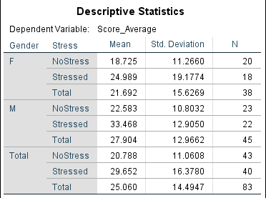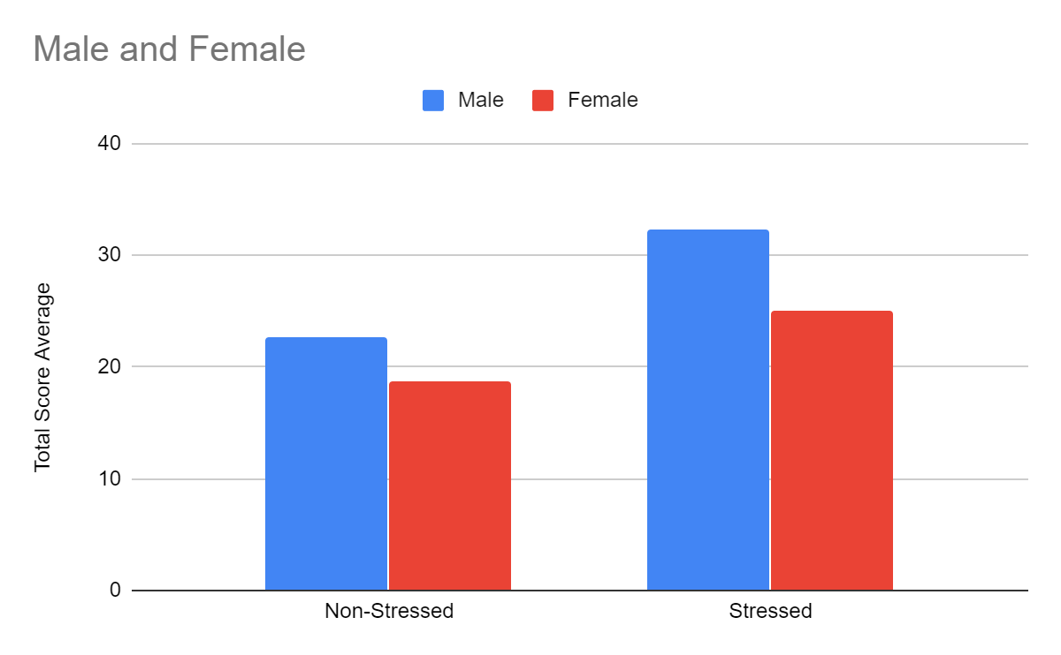

**Discussion**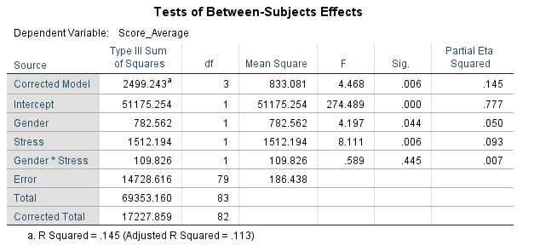

Our study supports two out of the three hypotheses. Our results showed male participants scoring significantly higher than the female participants in both settings and in total, which indicates that gender is associated with game performance. Participants scoring significantly higher in stressed environments than participants in non-stressed environments suggests that there is an association between video game performance and stress. However, there is no significant interaction overall between gender with stress and video game performance, which indicates that gender, stress, and game performance may have no association with each other. Previous studies showed similar results to our own where both genders scored higher when placed in stressed environments as opposed to non-stressed environments, but lacked statistical significance (Mobbs et al., 2009). In previous studies, they found that those who risk losing higher rewards are more likely to be affected by social facilitation and performance overall. In another previous study, it found no skill gap between males and females based on measuring the total progression of the participants’ in-game characters within an MMORPG. However, our research findings contradict those findings by seeing significant differences in performance results between males and females (Shen et al., 2016). A previous study done on stress and performance showed contradicting results to ours of World Cup soccer players underperforming under pressure due to social facilitation, missing the majority of their penalty kicks whenever the spotlight was on them (Jordet et al., 2009). The common theory is that the players have a subconscious mindset of wanting to “get it over with” as soon as possible without mentally preparing themselves before each penalty shot. Our findings, however, show that those under stress are able to perform better than they would when not under stress. This may be due to the sample method and age demographic we chose for our research study since ego and pride plays a role in reward-based performance decrements (Mobbs et al., 2009). Our study sampled students between the ages of 18-25, but World Cup soccer players vary widely in terms of age groups, as well as the size of ego or pride being affected by age. There was also no reward at risk when our participants played our game, so their cortisol and adrenaline levels were nowhere near as high as the participants in the previous studies.

**Limitations**

The limitations for our study were definitely relative to sample size and method. Our sample size only had 83 participants and our randomized sampling only included college campus students. This sample size would not have provided a good representation of the population and had little external validity. The threats and confound variables present in our study heavily reduced the study design’s internal validity. A potential confound is the game and platform we used being prone to testing threats and practice effects. Some participants may have had an advantage over others through past experiences with the game.

**Future Direction**

The future direction for research in gender, stress and game performance could focus on strengthening the manipulated variables due to how low the differences were between levels. The obscuring effects between the Independent Variables are too weak and should be redesigned to consider internal validity threats. Independent variables like stress should be operationalized better and designed to emulate social facilitation as accurately as possible. The game genres chosen to measure performance should not measure character progression and time like MMORPGs, as those measure the wrong conditions. Instead, competitive games that require intuition, reaction time and intelligence should be used while also avoiding floor/ ceiling effects. Lastly, the sample size and population representation must be broader or closer to what should be generalizing the population. External and internal validity is weak within this study and should be strengthened for future studies.

**Conclusion**

Overall, there seems to be a consistency in our findings where the skill gap between genders favor males with previous studies. However, the findings from our study and previous ones seem to have little consistency with the stress variable where some studies have participants performing better under stress and vice-versa. There is a divide between supporting and contradicting results, which means more studies are required on the subject of game performance and the factors associated with it.

References

Byrne, K. A., & Worthy, D. A. (2016). Toward a mechanistic account of gender differences in reward-based decision-making. *Journal of Neuroscience, Psychology, and Economics*, *9*(3–4),157–168. https://doi-org.libproxy.csun.edu/10.1037/npe0000059

Shen, C., Ratan, R., Cai, Y. D., & Leavitt, A. (2016). Do men advance faster than women? Debunking the gender performance gap in two massively multiplayer online games. *Journal of Computer-Mediated Communication*, *21*(4), 312–329. https://doi-org.libproxy.csun.edu/10.1111/jcc4.12159

Winn, J., & Heeter, C. (2009). Gaming, gender, and time: Who makes time to play? *Sex Roles: A Journal of Research*, *61*(1–2), 1–13. https://doi-org.libproxy.csun.edu/10.1007/s11199-00 9-9595-7

Jordet, G., Hartman, E., & Sigmundstad, E. (2009). Temporal links to performing under pressure in international soccer penalty shootouts. *Psychology of Sport and Exercise*, *10*(6), 621–627. https://doi-org.libproxy.csun.edu/10.1016/j.psychsport.2009.03.004

Mobbs, D., Hassabis, D., Seymour, B., Marchant, J. L., Weiskopf, N., Dolan, R. J., & Frith, C. D. (2009). Choking on the money: Reward-based performance decrements are associated with midbrain activity. *Psychological Science*, *20*(8), 955–962. <https://doi-org.libproxy.csun.edu/10.1111/j.1467-9280.2009.02399.x>

Bowman, N. D., Weber, R., Tamborini, R., & Sherry, J. (2013). Facilitating game play: How others affect performance at and enjoyment of video games. *Media Psychology*, *16*(1), 39–64. https://doi-org.libproxy.csun.edu/10.1080/15213269.2012.742360

Appendix A

Consent Form

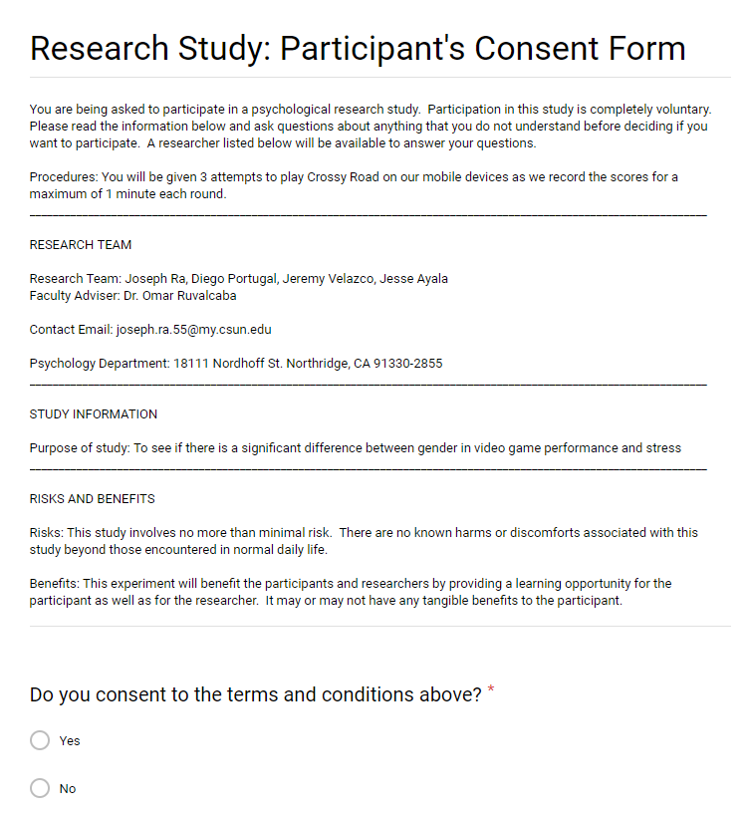

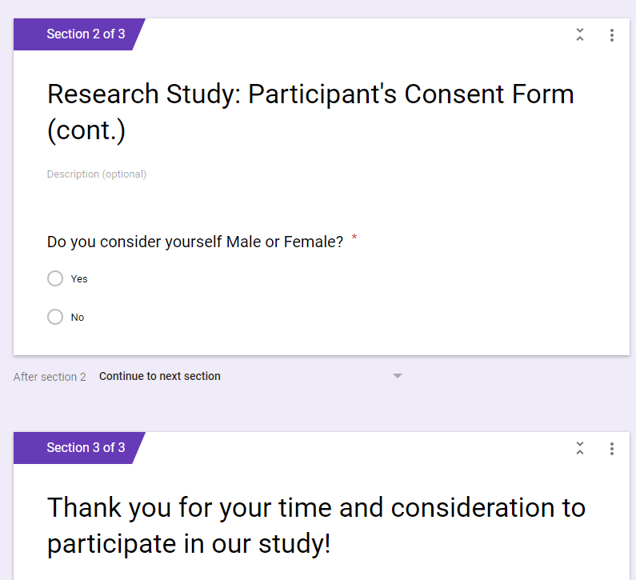

Appendix B

Demographic Survey

