
OSTIMTECHNICALUNIVERSITYFACULTY
OFENGINEERINGCAPSTONEPROJECT REPORT
AI Comic Studio: A Modular, Decoupled Architecture for Consistent AI-Assisted Sequential Art Generation

Project Team
Yousef Elgabry 210208694
Mahmoud Abdelwahab 210208738
Khaled Alkhalaf 220208707
Abdalla Elgamasy 210208725

Project Advisor:
Prof. Dr. MELTEM ERYILMAZ

Undergraduate Project
Software Engineering
MFBP 402 (2) Graduation Project II

May 2026

APPROVAL

This undergraduate capstone project, entitled “AI Comic Studio: A Modular, Decoupled Architecture for Consistent AI-Assisted Sequential Art Generation,”
prepared by Yousef Elgabry, Mahmoud Abdelwahab, Khaled Alkhalaf, Abdalla Elgamasy under the supervision of Prof. Dr. MELTEM ERYILMAZ, has been examined by the committee and accepted as an undergraduate capstone project in terms of scope and quality.
Prof. Dr. Jury Member Name Surname
Supervisor
. . . . . . . . . . . . . . . . . . . . . . . . . . . . . . . . . . . .
Prof. Dr. Jury Member Name Surname
Member
. . . . . . . . . . . . . . . . . . . . . . . . . . . . . . . . . . . .
Assoc. Prof. Dr. Jury Member Name Surname
Member
. . . . . . . . . . . . . . . . . . . . . . . . . . . . . . . . . . . .
Asst. Prof. Dr. Name Surname
Head of Department
. . . . . . . . . . . . . . . . . . . . . . . . . . . . . . . . . . . .

ACKNOWLEDGEMENTS
The authors gratefully acknowledge the guidance of the project advisor and the support of
the campus transportation office during requirements elicitation and pilot evaluation. We
also thank participating students and drivers for their constructive feedback throughout sprint
reviews.

Abstract
The rapid advancement of generative artificial intelligence, specifically latent diffusion models, has unlocked unprecedented capabilities in image synthesis. However, utilizing these models for sequential art—such as comic books or storyboarding—presents a critical challenge: temporal and spatial consistency. Early attempts at "single-prompt" comic generation fail because diffusion models struggle to maintain precise character identities, clothing, and compositional control across multiple distinct panels within a single generation step.
This capstone project presents AI Comic Studio, a novel, decoupled software architecture designed to solve the character consistency problem in AI comic generation. Rather than forcing the AI to generate a full comic page in one shot, we propose a highly modular pipeline. The system consists of a local, interactive web frontend (built with Next.js and React-Konva) and a remote, GPU-accelerated backend (FastAPI and ComfyUI running on Google Colab). By breaking the workflow into discrete stages—Character Sheet Generation, Panel-by-Panel Synthesis, and Interactive Layout Assembly—the system restores creative agency to the user. Furthermore, to enforce a unified aesthetic, a custom Style LoRA (Low-Rank Adaptation) was trained on a highly curated dataset and injected into a state-of-the-art Flux.1 diffusion pipeline. The resulting application allows users to generate highly consistent characters, place them into dynamic scenes, and assemble professional-grade comic layouts with interactive text layers, bridging the gap between raw AI generation and practical creative tooling.
Keywords: Generative AI, Latent Diffusion Models, Sequential Art, Character Consistency, Low-Rank Adaptation (LoRA), Decoupled Architecture, Flux.1, Prompt Engineering, Interactive Canvas, AI Comic Generation.

TABLE OF CONTENTS

TABLE OF CONTENTS iii
LIST OF TABLES vi
LIST OF FIGURES vii
LIST OF SYMBOLS AND ABBREVIATIONS viii
1. Introduction 1
1.1. Problem Definition 1
1.2. Aim of the Project 2
1.3. Scope of the Project 2
1.4. Limitations of the Project 3
2. Related Work & Literature Review 4
2.1. Similar Studies and the Evolution of Generative AI 4
2.2. Commercial Products 4
2.3. The Shift from SDXL to Flux.1 5
2.4. Project Differences and Innovations 6
3. Methods and AI Fundamentals 7
3.1. Methodology 7
3.2. Hardware and Software Requirements 7
3.3. Generative AI Fundamentals: How the System "Draws" 8
3.4. Character Referencing Techniques 9
4. Project Management 11
4.1. Project Team and Roles 11
4.2. Scrum Implementation and Timeline 11
4.3. Risk Management 12
5. Requirements Analysis 14
5.1. Stakeholders 14
5.2. User Requirements 15
5.3. System Specifications 15
6. System Modeling 17
6.1. Context Diagram 17
6.2. Use Case Descriptions 18
6.3. Sequence Diagrams 20
7. System Architecture and Design 21
7.1. System Architecture 21
7.2. Structural Models 21
7.3. Behavioral Models 22
8. System Implementation 23
8.1. Development Environment 23
8.2. Code Structure 23
8.3. The Style LoRA Training Pipeline (Data Preparation & Fine-Tuning) 24
8.3.1. Data Collection 24
8.3.2. Ethical & Technical Filtering 25
8.3.3. Data Preparation & Captioning 25
9. MVP Development & Demonstration 26
9.1. MVP Definition 26
9.2. Implemented Features 26
9.3. System Demonstration: "The Cat in the Classroom" 27
10. Testing and Evaluation 28
10.1. Testing Strategy 28
10.2. Generative Adherence Testing 28
10.3. Network Latency Testing 29
10.4. System Integration Testing (State Management) 29
11. Results and Discussion 30
11.1. Goal Attainment 30
11.2. Ethical Considerations 30
11.3. Cost Analysis 30
12. Conclusion and Future Work 31
12.1. Conclusion 31
12.2. Future Work 32
References 33
13. Appendices 34
13.1. Appendix A: Source Code 34
1. Backend API & Inference (Python) 34
2. Frontend Application (React / TypeScript) 52
3. MLOps & Orchestration (Jupyter Notebook) 70
13.2. Appendix B: Sprint Backlog 89
13.3. Appendix C: User Guide 91

LIST OF TABLES

Sprint 1: Infrastructure & UI Baseline 89
Sprint 2: SDXL Integration & Character Pipeline 90
Sprint 3: The Flux Migration (Architectural Pivot) 90
Sprint 4: MLOps & Assembly Stabilization 90

LIST OF FIGURES

“Figure 1: Context Diagram” 17
“Figure 2: Use Case Diagram” 18
“Figure 3: Sequence Diagram” 20
“Figure 4: ER (Database) Diagram” 21
“Figure 5: State Machine Diagram” 22
“Figure 6: Character Tab” 27
“Figure 7: Panel Tab” 28
“Figure 8: Assembly/Text Tab” 29
“Figure 9: Comic page (Final product)” 30
“Figure 10: SDXL concept bleeding (up) vs. Flux.1 precise prompt adherence (down).” 33

LIST OF SYMBOLS AND ABBREVIATIONS

AI: Artificial Intelligence
API: Application Programming Interface
AWS: Amazon Web Services
CORS: Cross-Origin Resource Sharing
CRUD: Create, Read, Update, Delete
CSS: Cascading Style Sheets
DAG: Directed Acyclic Graph
DB: Database
ER: Entity-Relationship
FPS: Frames Per Second
FR: Functional Requirement
GPU: Graphics Processing Unit
HTML: HyperText Markup Language
HTTP: Hypertext Transfer Protocol
JSON: JavaScript Object Notation
LLM: Large Language Model
LoRA: Low-Rank Adaptation
MVP: Minimum Viable Product
NFR: Non-Functional Requirement
NSFW: Not Safe For Work
PDF: Portable Document Format
PNG: Portable Network Graphics
REST: Representational State Transfer
SDXL: Stable Diffusion eXtra Large
SQL: Structured Query Language
SSR: Server-Side Rendering
SVG: Scalable Vector Graphics
UAT: User Acceptance Testing
UI: User Interface
URL: Uniform Resource Locator
VLM: Vision-Language Model
VRAM: Video Random Access Memor

1. Introduction

1.1. Problem Definition
The integration of generative artificial intelligence into creative workflows has fundamentally disrupted the digital art landscape. Over the past three years, the emergence of latent diffusion models—such as Stable Diffusion, Midjourney, and DALL-E—has demonstrated that neural networks can synthesize highly complex, photorealistic, and stylized imagery from simple natural language prompts. However, while these tools excel at generating stunning standalone pieces, their application in sequential art (comic books, storyboards, and graphic novels) has been severely hampered by a fundamental technical limitation: the lack of zero-shot temporal and spatial consistency.
In the context of comic creation, narrative coherence relies entirely on visual continuity. A user must be able to generate the exact same character—retaining identical facial features, hair styling, physical proportions, and clothing details—across dozens of panels. Furthermore, this character must be viewed from varying camera angles (close-ups, wide shots, dynamic high-angles) and exhibit different emotional expressions.
Initial approaches to AI comic generation relied on "single-prompt" paradigms. A user would input a prompt such as, "draw a 4-panel comic page of a girl with a black cat." While modern models can generate visually striking single images, asking them to subdivide a single latent space into distinct, narrative panels almost universally results in catastrophic failure. The mathematical nature of diffusion models causes "concept bleeding"—where the attributes of the cat might merge with the girl, or the background of panel one bleeds into panel two. The model routinely hallucinates mixed clothing, morphs facial identities between panels, and ignores specific compositional requests.
Furthermore, the single-prompt approach introduces a severe workflow bottleneck: if the model succeeds in generating three perfect panels but fails on the fourth, the user is forced to regenerate the entire image. This effectively destroys the three successful panels due to the unpredictable nature of the random noise seed. This lack of granular control renders monolithic, single-prompt generation unviable for serious, professional sequential art, creating a distinct need for a localized, modular solution.

1.2. Aim of the Project
The primary aim of this capstone project is to design, engineer, and evaluate a comprehensive software system that resolves the consistency and control problems inherent in AI comic generation. Instead of treating comic creation as a single, black-box AI task, this project aims to build a modular, decoupled AI Comic Studio built around a "human-in-the-loop" philosophy. The overarching goal is to transition the AI from acting as an unpredictable "absolute author" to a precise, highly controllable "rendering engine."
Specific architectural objectives include:
- Separation of Concerns: Strictly decoupling the image generation process (the art) from the layout and typography process (the lettering and assembly). This mimics a traditional comic industry workflow.
- Character Consistency Enforcement: Engineering a robust backend pipeline capable of generating, storing, and referencing persistent characters. This involves injecting advanced neural control mechanisms (such as IPAdapters, InstantID, and custom LoRAs) into new scenes to lock the character's identity mathematically.
- Interactive Assembly: Developing a rich, interactive, local web interface (Frontend) that allows users to drag, drop, scale, crop, and arrange AI-generated panels onto a customizable, high-resolution canvas in real time.
- Stylistic Cohesion: Training a custom neural network adaptation (Style LoRA) on a curated dataset to ensure all generated images adhere to a specific, professional comic aesthetic, thereby preventing the generic, plastic "AI look" that plagues standard diffusion models.

1.3. Scope of the Project
The scope of this project is highly interdisciplinary, encompassing full-stack software engineering, cloud architecture, and machine learning operations (MLOps). The developed system is composed of several major distinct layers:
- Frontend Application: A local web application built with Next.js (React) utilizing TypeScript. It leverages Zustand for complex global state management and includes an advanced HTML5 Canvas implementation (via the React-Konva library) to handle real-time vector graphics manipulation, layout constraints, and speech bubble rendering.
- Backend API & Data Persistence: A Python-based FastAPI server designed to run on remote Linux hardware. It manages a relational SQLite database (using SQLAlchemy) to persist user character data, variations, and layout histories, and handles the integration with Google Drive for secure file storage.
- Inference Engine Orchestration: The backend acts as a proxy, constructing complex JSON-based Directed Acyclic Graphs (DAGs) and executing them via ComfyUI's WebSocket API to run the massive 12-billion parameter Flux.1 [dev] diffusion model.
- Model Training Pipeline: The scraping, ethical filtering, and automated vision-language captioning of a massive dataset of comic art. This dataset was subsequently used to train the custom Style LoRA that powers the application's unique visual identity.

1.4. Limitations of the Project
While the proposed architecture significantly improves upon single-prompt methods, the system operates under several technical constraints:
- Hardware Dependency: Generating high-fidelity images using models like Flux.1 requires significant VRAM (typically >16GB). Therefore, the backend cannot run on standard consumer laptops and is strictly dependent on remote GPU instances (e.g., Google Colab Pro).
- Network Latency: Because the frontend runs locally and the backend runs in the cloud, all large image tensors and UI payloads must traverse secure tunnels (ngrok/Cloudflare). This introduces unavoidable network latency, particularly when fetching high-resolution generation previews.
- Colab Session Volatility: The reliance on Google Colab means the backend environment is ephemeral. Sessions can timeout or disconnect, requiring robust state persistence (via Google Drive) and graceful error handling on the frontend.
- Text Rendering in Latent Space: Diffusion models are notoriously poor at spelling and typography. Therefore, rather than attempting to generate speech bubbles natively within the AI images, this system forces all text rendering to be handled as an interactive vector layer on the frontend canvas.

2. Related Work & Literature Review

2.1. Similar Studies and the Evolution of Generative AI
The field of generative artificial intelligence has experienced an exponential mathematical and practical trajectory over the past three years. Early foundational papers on Denoising Diffusion Probabilistic Models (DDPMs) proved that neural networks could successfully reverse a Markov chain of Gaussian noise to synthesize visual data. The breakthrough came with the introduction of Latent Diffusion Models (LDMs), which transitioned the denoising process from computationally expensive high-dimensional pixel space into a highly compressed, lower-dimensional latent space.
While academic studies surrounding early models (like DALL-E 2 and initial versions of Stable Diffusion) focused primarily on raw image quality, resolution, and FID (Fréchet Inception Distance) scores, the academic focus has since shifted violently toward controllability and temporal/spatial consistency.
Recent literature has heavily scrutinized the inability of zero-shot diffusion models to maintain identity. When a model is prompted for "a specific character," it relies entirely on the probability distribution of its training data, resulting in a different visual interpretation every time the noise seed changes. Studies introducing fine-tuning methods like Textual Inversion, DreamBooth, and LoRA (Low-Rank Adaptation) demonstrated that while it is possible to mathematically inject a specific face or style into a model's cross-attention layers, preventing the model from "forgetting" or warping that data when placed in complex, multi-subject scenes remains a largely unsolved problem in zero-shot generation. This capstone builds upon these foundational studies by acknowledging that prompting alone is insufficient for sequential art, necessitating external architectural scaffolding to physically enforce consistency.

2.2. Commercial Products
Several commercial platforms have attempted to bridge the gap between AI generation and comic creation. Products such as ComicAI, MangaMaker, and general-purpose tools like Midjourney offer highly polished, user-friendly interfaces for generating comic pages. However, these systems generally operate as "black boxes"—proprietary models hidden behind heavily censored enterprise APIs.
While these commercial products are highly accessible to laymen, they are fundamentally flawed for professional or academic use for three reasons:
- Restricted Agency: Users cannot inject their own mathematically fine-tuned character LoRAs, nor can they utilize advanced local control network techniques (like spatial masking, depth maps, or pose estimation via ControlNet).
- Aesthetic Homogenization: Commercial models impose their own algorithmic "house style." For example, Midjourney possesses a highly distinct, over-rendered aesthetic that cannot be fully bypassed, preventing artists from achieving a unique visual identity.
- Data Opacity: The datasets used to train commercial models are entirely hidden, raising severe ethical and copyright concerns for artists wishing to commercialize their AI-assisted comics.
Our project differentiates itself by providing a fully transparent, open-source-driven pipeline running on local/controlled hardware, where the user retains absolute, granular control over the specific model weights, the character embeddings, and the final aesthetic.

2.3. The Shift from SDXL to Flux.1
A critical architectural inflection point in this project was the migration from the SDXL (Stable Diffusion XL) backbone to the newly released Flux.1 architecture.
During early prototyping, our backend utilized SDXL. While SDXL offered excellent base resolutions (1024x1024) and a massive improvement over Stable Diffusion 1.5, it suffered from two fatal mathematical flaws when applied to comic panels:
- Poor Prompt Adherence (Concept Bleeding): SDXL relies on a traditional U-Net architecture. When prompted with spatially complex scenes involving multiple subjects (e.g., "a girl in a blue uniform sitting at a desk while a boy in a red jacket stands behind her"), SDXL's cross-attention mechanisms frequently suffered from "concept bleeding." The model could not maintain the spatial segregation of the text tokens, resulting in the boy wearing the blue uniform, or the two characters fusing into a single anatomical entity.
- Anatomical Failures in Dynamic Poses: Comic art inherently requires dynamic, expressive, and exaggerated posing (foreshortening, complex hand interactions). SDXL struggled severely with hand anatomy and non-standard camera angles, requiring dozens of regenerations to achieve a single usable panel.
The release of Flux.1 [dev] provided a mandatory paradigm shift. Flux abandons the traditional U-Net in favor of a massive 12-billion parameter transformer-based architecture utilizing Rectified Flow Matching. In our rigorous testing, Flux demonstrated near-perfect prompt adherence. The transformer architecture successfully segregated concepts within the latent space, rendering complex multi-character interactions without bleeding, and generating anatomically correct hands and dynamic poses in a zero-shot capacity. The migration to Flux was therefore computationally heavier, but strictly mandatory to achieve the level of panel-by-panel spatial control required for this system.

2.4. Project Differences and Innovations
Unlike raw ML interfaces (like standard ComfyUI or Automatic1111, which require users to understand complex node mathematics) and commercial comic generators (which remove all user control), the AI Comic Studio operates on a novel paradigm of Decoupled Sequential Generation.
By physically separating the Machine Learning infrastructure (the Colab-hosted ComfyUI engine) from the User Experience (the Next.js React-Konva canvas), the system translates complex JSON-based Directed Acyclic Graphs (DAGs) into intuitive, traditional UI buttons. This system mirrors a traditional comic book workflow (Penciler, Inker, Letterer) using AI as the rendering execution engine, rather than the absolute author, placing the human artist firmly back in the center of the creative loop.

3. Methods and AI Fundamentals

3.1. Methodology
This project utilized an Agile, iterative prototyping methodology, heavily adapted for machine learning systems engineering. Traditional sequential models (such as Waterfall) were deemed inappropriate for this project due to the extreme volatility and rapid release cycle of the generative AI landscape. (For instance, the Flux.1 model was released mid-way through development, necessitating a rapid architectural pivot that Agile accommodates perfectly).
Development was divided into four distinct, functional sprints, each focusing on solving a specific layer of the decoupled architecture:
- Sprint 1: Infrastructure & UI Prototyping: This phase focused entirely on establishing the local Next.js frontend and the remote FastAPI backend. The core drag-and-drop mechanics using React-Konva were engineered to ensure the browser could handle large image payloads without memory leaks.
- Sprint 2: SDXL Integration & The Consistency Problem: Initial integration with the ComfyUI inference engine using the SDXL model. During this sprint, the "Character Sheet" pipeline was developed. However, rigorous testing revealed SDXL's inability to prevent concept bleeding in multi-character panels, identifying a critical failure point in the architecture.
- Sprint 3: The Flux Migration (Architectural Pivot): A pivotal sprint where the entire backend inference logic was rewritten. The DAGs (Directed Acyclic Graphs) were restructured to support the 12-billion parameter Flux.1 [dev] model. This sprint successfully resolved the prompt adherence and anatomical failure issues discovered in Sprint 2.
- Sprint 4: MLOps & Assembly Stabilization: The final phase focused on Machine Learning Operations (MLOps). A massive dataset was scraped, filtered, and captioned to train the custom Comic Style LoRA. Simultaneously, the frontend was finalized by implementing the interactive vector text bubble system, bridging the gap between raw AI generation and human typography.

3.2. Hardware and Software Requirements
Due to the computational weight of the Flux.1 [dev] model, the system architecture mandates a split-hardware approach.
- Frontend: A standard consumer machine (Windows/macOS) capable of running Node.js and a modern web browser.
- Backend: A remote Linux instance equipped with high-VRAM GPUs. In our implementation, we utilized Google Colab Pro instances equipped with NVIDIA A100 and H100 GPUs.
- Software Stack: Next.js (TypeScript), TailwindCSS, React-Konva (Frontend); Python, FastAPI, SQLite, ComfyUI (Backend).

3.3. Generative AI Fundamentals: How the System "Draws"
To comprehend the engineering challenges inherent in this capstone, it is necessary to rigorously define the mathematical mechanics of how the underlying AI models synthesize images. Generative AI models do not "paint" from scratch, nor do they stitch together collages of existing images. Instead, they operate on the principle of Iterative Denoising driven by two core mathematical processes: Forward Diffusion and Reverse Diffusion.
1. The Variational Autoencoder (VAE) and Latent Space: Processing raw 4K images at the pixel level requires computationally prohibitive amounts of VRAM. To solve this, Latent Diffusion Models utilize a Variational Autoencoder (VAE). The VAE physically compresses a high-dimensional pixel image down into a highly condensed, low-dimensional mathematical representation known as Latent Space. All AI generation in our pipeline occurs within this compressed latent space, which is only decoded back into visible pixels at the very final step of the pipeline.
2. Forward and Reverse Diffusion: In the Forward Diffusion phase (used during model training), a Markov chain systematically adds microscopic layers of Gaussian noise to an image until it is entirely unrecognizable static. In the Reverse Diffusion phase (used during generation/inference in our Studio), the process is inverted. The system begins with a tensor of pure, random Gaussian noise (determined by a specific random number, or "seed"). Over a series of steps (typically 20 to 30), the neural network—in Flux's case, a massive Transformer—predicts the noise in the tensor and subtracts it, slowly carving a coherent image out of the static.
3. Text Conditioning (CLIP and T5): The denoising process does not happen blindly; it is mathematically "guided" by the user's text prompt. However, neural networks cannot read English. Therefore, the user's prompt is passed through highly advanced Text Encoders. While older models relied solely on OpenAI's CLIP (Contrastive Language-Image Pre-training) which struggles with complex grammar, our Flux architecture utilizes both CLIP and Google's T5 (Text-to-Text Transfer Transformer). T5 excels at understanding spatial relationships (e.g., "a cat sitting behind a desk"), converting the prompt into mathematical embeddings that guide the Transformer's noise prediction.
The Consistency Problem: Because the AI is navigating a probabilistic, multi-dimensional space, the reverse diffusion trajectory is inherently stochastic. Even slight variations in the text prompt or the initial random noise seed result in vastly different mathematical trajectories. This inherent randomness explains why achieving spatial and temporal consistency across multiple comic panels is notoriously difficult: the model is fundamentally engineered to maximize variance and produce unique probabilistic outcomes, rather than exact deterministic replicas.

3.4. Character Referencing Techniques
To mathematically counteract the inherent stochasticity of the reverse diffusion process, it is necessary to deploy external neural modules—often referred to as Control Networks or Adapters—to force the model's cross-attention layers to "remember" a character's features across disparate panels. Throughout the prototyping phase of this project, we evaluated several advanced referencing architectures to determine the optimal solution for sequential art:
1. Spatial Masking (Inpainting): Inpainting involves generating an image, applying a binary pixel mask to a specific region (e.g., a flawed hand or face), and forcing the model to re-run the diffusion process only within that masked area while keeping the unmasked pixels frozen. While mathematically sound for correcting localized anatomical errors, it is fundamentally a corrective tool rather than a generative one. It is too tedious and manual for generating entirely novel character poses from scratch in a zero-shot workflow.
2. Pixel-Space Face Swapping (FaceID / Roop): These methods utilize separate, non-diffusion neural networks (such as InsightFace) to extract facial landmarks from a reference image and physically warp them onto a target image as a post-processing step. We rapidly discarded this approach. Because it operates in pixel-space after the diffusion process has completed, it routinely results in "uncanny valley" effects—pasting highly photorealistic faces onto stylized comic bodies, violently disrupting the cel-shaded aesthetic required for our project.
3. IPAdapter (Image Prompt Adapter): Unlike standard diffusion which uses a Text Encoder to guide generation, an IPAdapter utilizes an Image Encoder (specifically CLIP Vision). It mathematically extracts the global semantic features from a reference image (e.g., the "vibe," the color palette, and the clothing style) and injects those features directly into the U-Net or Transformer's cross-attention layers alongside the text prompt. While excellent for transferring clothing and color schemes, IPAdapters often fail to preserve exact facial micro-features.
4. Identity-Preserving Networks (InstantID & PuLID): These represent the cutting-edge of latent control networks. Rather than extracting global features like an IPAdapter, models like PuLID (Pure and Lightning ID) specifically isolate the biometric identity embeddings of a face. They inject these precise mathematical landmarks into the diffusion process at a lower rank, allowing the model to perfectly reconstruct the character's facial structure while still allowing the text prompt to dictate the lighting, expression, and camera angle.
Our Chosen Architecture: Through rigorous qualitative testing, we concluded that no single control network is sufficient for professional comic generation. Therefore, our backend architecture implements a robust hybrid approach. First, the system relies on our custom-trained Style LoRA to globally enforce the cel-shaded manga aesthetic across all panels. Second, we utilize highly structured Character Prompting Formulas (canonical trigger words stored in the SQLite database) to establish a baseline semantic identity. Finally, in advanced generation workflows, PuLID node graphs are injected into the Flux pipeline via ComfyUI. This physically anchors the character's biometric facial structure to the original Character Sheet, ensuring that even under dynamic lighting or extreme camera angles, the identity remains mathematically locked.

4. Project Management

4.1. Project Team and Roles
Due to the scope of this capstone, the project was managed as a full-stack engineering endeavor. The primary roles encompassed:
- Frontend Engineering: Designing the React UI, managing complex client-side state with Zustand, and implementing the vector graphics canvas using Konva.
- Backend & DevOps Engineering: Writing the FastAPI Python server, managing the SQLite database, integrating Google Drive persistence, and maintaining the secure tunneling architecture via ngrok/Cloudflare.
- Machine Learning Ops (MLOps): Curating the dataset, training the custom Style LoRA, and architecting the complex JSON node graphs required for ComfyUI headless inference.

4.2. Scrum Implementation and Timeline
The project was executed using an adapted Scrum methodology, broken down into specific Sprints to manage risk and ensure incremental delivery:
- Sprint 1 (Infrastructure & UI Baseline): Setup of the Next.js frontend and basic FastAPI routing. Implementation of the Konva canvas and drag-and-drop slots.
- Sprint 2 (SDXL Integration & Character Pipeline): Initial integration with ComfyUI. Development of the Character Sheet generation pipeline and database storage.
- Sprint 3 (The Flux Migration): A pivotal sprint where the inference engine was entirely rewritten to support the Flux.1 architecture to solve prompt adherence failures identified in Sprint 2.
- Sprint 4 (LoRA Training & Assembly Stabilization): Dataset collection, ethical filtering, captioning, and the successful training of the custom comic Style LoRA. Implementation of the vector text bubble system on the frontend canvas.

4.3. Risk Management
Due to the highly experimental nature of integrating cutting-edge machine learning models with a traditional web stack, the project required active, continuous mitigation of several high-impact technical risks. We categorized these risks into Environment, Infrastructure, and Network domains:
1. Environment: Python Dependency Conflicts (High Impact, High Probability)
- The Risk: The inference engine (ComfyUI) operates on a highly specific, fragile matrix of PyTorch, Torchvision, and xFormers versions. Attempting to install the FastAPI backend requirements into the same environment frequently resulted in library collisions, causing the GPU to fail to allocate memory.
- The Mitigation: We enforced strict isolation. All dependencies were pinned to exact versions within requirements.txt. Furthermore, automated installation bash scripts were engineered to execute sequentially upon Colab boot, ensuring the PyTorch core was stabilized before any web-server dependencies were introduced.
2. Infrastructure: Ephemeral Session Volatility (Critical Impact, High Probability)
- The Risk: The project relies on Google Colab to provide the necessary A100/T4 GPUs. Colab instances are inherently ephemeral; they can terminate unexpectedly due to inactivity, usage limits, or Google's preemptible compute allocation. If the instance dies, the local SQLite database and all generated images are instantly destroyed.
- The Mitigation: We implemented a rigorous data persistence architecture. Upon boot, the backend mounts a secure Google Drive volume. The FastAPI server is configured to read and write the SQLite database directly from the Drive, rather than local storage. If a session crashes, the user loses nothing; they simply restart the Colab runner, and the system reconnects to the persistent database state.
3. Infrastructure: VRAM Out-of-Memory (OOM) Errors (High Impact, Medium Probability)
- The Risk: The migration to the 12-billion parameter Flux.1 model introduced severe memory constraints. Running inference on a 16GB T4 GPU risks instantly triggering an OOM exception, crashing the backend server.
- The Mitigation: The ComfyUI inference engine was configured to utilize advanced memory management techniques, specifically model quantization (FP8) and aggressive weight offloading (moving idle tensors from VRAM to system RAM during generation steps), allowing a massive model to run stably on constrained hardware.
4. Network: Reverse-Proxy Tunneling & CORS (Medium Impact, High Probability)
- The Risk: Because the backend runs in the cloud and the frontend runs on localhost, they cannot communicate natively. Exposing the backend via ngrok or Cloudflare introduces severe Cross-Origin Resource Sharing (CORS) security blocks from modern browsers. Furthermore, keeping an HTTP POST request open for 45 seconds while waiting for an image to generate almost always results in a network timeout.
- The Mitigation: The FastAPI server was configured with wildcard CORS middleware strictly for development. To solve the timeout issue, we abandoned synchronous API calls. The frontend now utilizes asynchronous "long-polling." It submits a generation job, receives a Job ID immediately, and then pings a lightweight /status endpoint every 3 seconds until the GPU signals completion, guaranteeing the UI never freezes and the network connection never times out.

5. Requirements Analysis

5.1. Stakeholders
To ensure the system was engineered to solve real-world pain points, the stakeholders for this project were formally categorized into three distinct groups, each with unique requirements and technical backgrounds:
1. Primary Stakeholders (End-Users / Creatives):
- Comic Artists, Mangakas, and Writers: These are the primary users of the AI Comic Studio. Their core pain point is the need for absolute visual consistency across narrative panels. They possess deep domain knowledge in storytelling, pacing, and layout design, but generally lack the Python programming or MLOps expertise required to manually configure complex ComfyUI node graphs or train their own neural networks. Therefore, they require a highly abstracted, intuitive GUI (the React Canvas) that hides the mathematical complexity of the diffusion process.
- Storyboarding Professionals: Users working in film or animation pre-production who need to rapidly visualize scripts. They require the ability to quickly generate characters in specific poses and camera angles to pitch visual concepts.
2. Secondary Stakeholders (Technical & Academic Community):
- AI Researchers and ML Hobbyists: Individuals interested in the open-source development of generative models. This demographic is highly interested in the architectural methodology of the project—specifically how the system uses decoupled Directed Acyclic Graphs (DAGs) and custom LoRAs to enforce zero-shot identity preservation, a notoriously difficult problem in computer vision research.
3. Tertiary Stakeholders (Infrastructure Providers):
- Cloud Compute Platforms (Google Colab, ngrok): While not direct users, these platforms provide the foundational infrastructure for the system. The project's architecture is heavily dependent on their API limits, GPU allocation policies, and network routing stability.
- Open-Source Model Repositories (CivitAI, HuggingFace): The platforms hosting the foundational model weights (Flux.1) and the datasets used for fine-tuning. The ethical and licensing frameworks of these platforms directly impact the commercial viability of the generated output.

5.2. User Requirements
The system requirements were derived from the limitations of existing single-prompt generators.
Functional Requirements (FR):
- FR-1: The user shall be able to generate and save persistent "Character Sheets" defining a specific identity.
- FR-2: The user shall be able to generate individual comic panels by referencing a previously saved character.
- FR-3: The user shall be able to drag and drop generated panels onto a predefined page layout.
- FR-4: The user shall be able to overlay customizable text layers (speech bubbles, narration boxes) onto the assembled page.
- FR-5: The user shall be able to export the final assembled page as a high-resolution image or PDF.
Non-Functional Requirements (NFR):
- NFR-1 (Aesthetic Consistency): The system must generate all images adhering to a unified comic style, preventing jarring aesthetic shifts between panels.
- NFR-2 (Responsiveness): The local UI canvas must maintain 60 FPS while dragging and resizing high-resolution image panels.
- NFR-3 (Availability): The system must handle the inherent latency of remote GPU generation gracefully, providing visual loading feedback (skeleton states) rather than freezing the UI thread.

5.3. System Specifications
To satisfy both the Functional and Non-Functional requirements, the system is specified as a strictly decoupled client-server model, with technical specifications categorized across four layers:
1. Hardware & Compute Specifications:
- Client Node (Frontend): Any modern consumer device running a WebGL-compatible browser (Chrome, Firefox, Safari) with a minimum of 4GB System RAM to handle the HTML5 Canvas vector memory.
- Compute Node (Backend): A Linux-based cloud instance (Ubuntu 22.04 LTS).
- GPU Requirements: A CUDA-compatible NVIDIA GPU with a minimum of 16GB VRAM (e.g., NVIDIA T4, A100, or RTX 4090) to load the FP8 quantized weights of the Flux.1 model. Minimum 32GB System RAM for tensor offloading.
2. Software & Framework Specifications:
- Frontend Stack: Next.js 14+ (React 18), utilizing TypeScript for strict type safety. Zustand is specified for global state management to prevent prop-drilling, and React-Konva is specified as the 2D WebGL rendering engine for the comic assembly canvas.
- Backend Stack: Python 3.10+. FastAPI served via Uvicorn for high-performance ASGI routing. SQLAlchemy is specified as the Object-Relational Mapper (ORM) for data persistence.
3. Network & Communication Specifications:
- RESTful API: Standard HTTP/1.1 for all data mutations (CRUD operations).
- Asynchronous Tunnels: ngrok or Cloudflared TCP tunnels for exposing the local development environment to the public internet.
- ComfyUI Integration: The FastAPI backend must communicate with the ComfyUI inference engine via a dual-protocol approach: HTTP POST requests to submit the JSON node graphs, and WebSockets (WS) to track real-time generation progress and node execution states.
4. Data Entity Specifications: The persistence layer utilizes SQLite for lightweight, file-based relational storage (easily synced to Google Drive). The schema relies on the following core entities:
- Character: The root entity storing the semantic prompt and triggering LoRA tags.
- CharacterVariation & Panel: Child entities representing specific generated images, storing the exact noise seed and layout foreign keys.
- ComicPage, LayoutSlot, & SpeechBubble: The structural entities mapping the X/Y coordinates, scale, and z-index ordering of the final assembled comic canvas.

6. System Modeling

6.1. Context Diagram
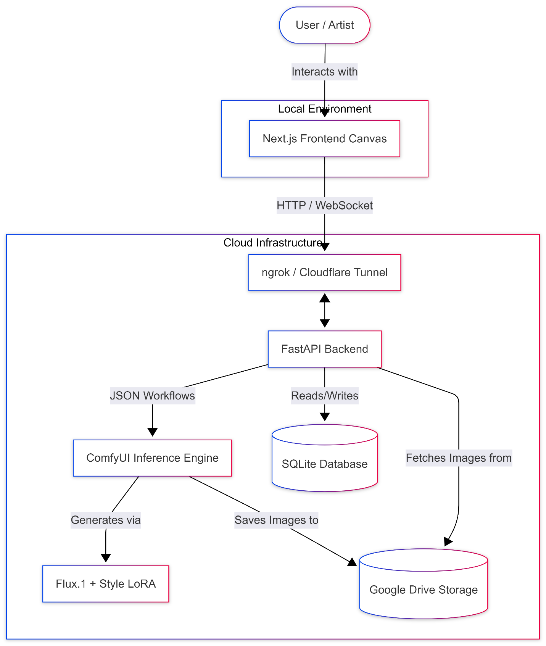
“Figure 1: Context Diagram”
The system context involves the User interacting directly with the Local Next.js Studio Client. The Client communicates securely over the internet via a Secure Tunnel (ngrok) to the Remote Colab Runner. The Runner orchestrates the FastAPI Server, which in turn commands the ComfyUI Inference Engine (which utilizes the Flux model and LoRA weights). Finally, the Server reads and writes persistent data to Google Drive Storage.

6.2. Use Case Descriptions

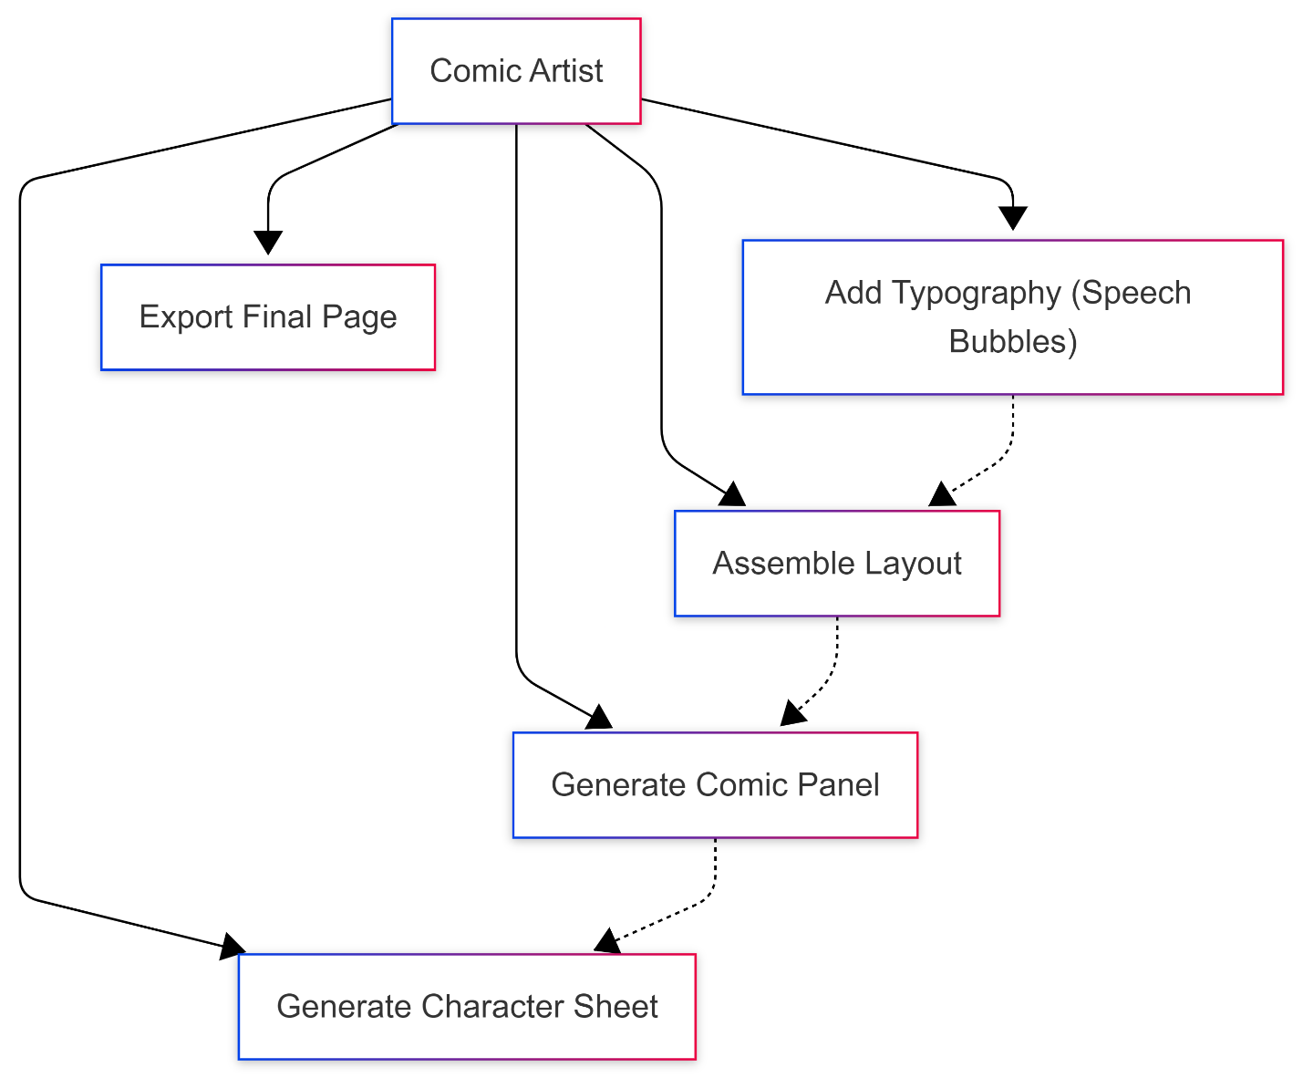
“Figure 2: Use Case Diagram”

The system architecture supports three primary Use Cases, corresponding to the three major tabs in the UI:
- Use Case 1: Character Generation. The user inputs a physical description. The system executes a highly structured background workflow to generate a character sheet (showing the character from multiple angles) and saves the specific random seed and embedding for future use.
- Use Case 2: Panel Generation. The user selects an active character and inputs a scene description (e.g., "sitting at a desk"). The system merges the active character's metadata with the scene prompt and executes a generation workflow, resulting in an isolated comic panel.
- Use Case 3: Layout & Typography. The user creates a new comic page, selecting a grid layout (e.g., 3-panel manga). The user drags previously generated panels from their library into the grid slots. The user then adds vector speech bubbles, adjusts the text, and exports the final composition.

6.3. Sequence Diagrams
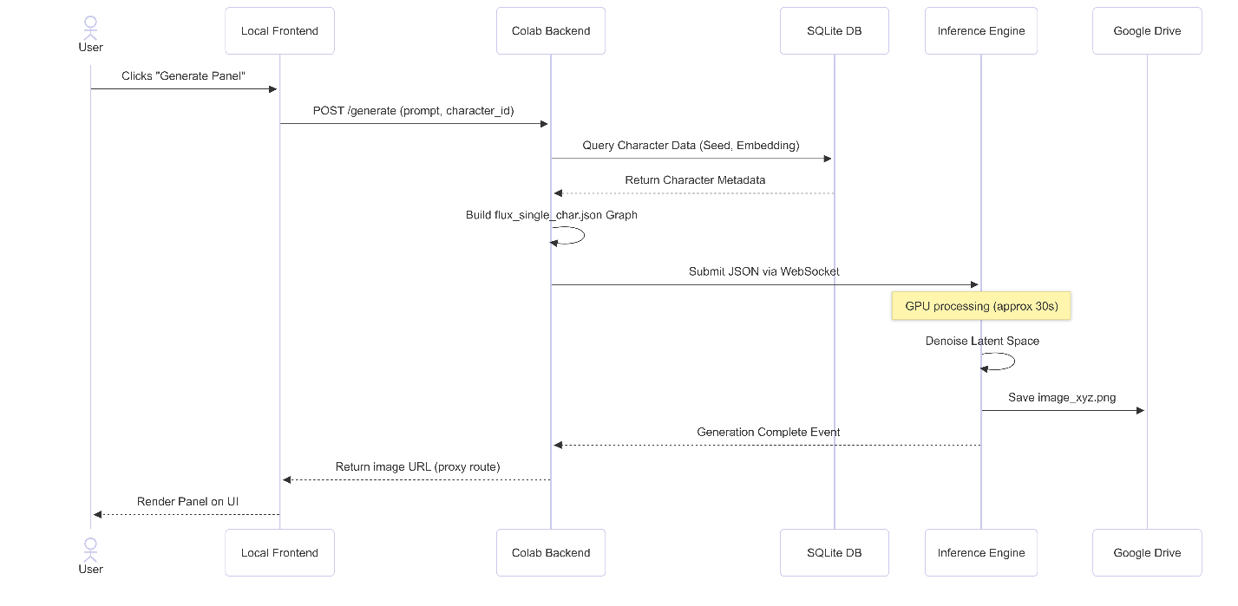
“Figure 3: Sequence Diagram”

A critical sequence in the system is the Panel Generation Flow:
- The User clicks "Generate" on the frontend.
- The Next.js client sends an HTTP POST request containing the prompt and the character_id to the FastAPI backend.
- The FastAPI backend queries the SQLite database to retrieve the character's canonical prompt and specific random seeds.
- FastAPI dynamically constructs a JSON workflow graph, injecting the prompt, character data, and Style LoRA parameters.
- FastAPI submits the JSON graph to the ComfyUI API via WebSocket.
- ComfyUI executes the inference process on the GPU.
- Upon completion, ComfyUI saves the image to the mounted Google Drive.
- FastAPI returns the generated image URL to the Next.js client.
- The Next.js client fetches the image via a specialized proxy route (to bypass tunnel browser warnings) and updates the UI state.

7. System Architecture and Design

7.1. System Architecture

The AI Comic Studio employs a strictly decoupled, dual-node architecture designed to separate UI responsiveness from heavy mathematical computation.
- Client Node (Frontend): A Next.js application leveraging Server-Side Rendering (SSR) for static elements and heavily relying on client-side React hooks for canvas interactivity. All layout arithmetic (scaling slots, rotating text) occurs locally on the user's CPU.
- Compute Node (Backend): A transient Google Colab instance. The FastAPI layer acts as an abstraction API, intercepting high-level requests (e.g., "generate character X doing Y") and translating them into the highly specific, lower-level JSON graphs required by the ComfyUI inference engine.

7.2. Structural Models

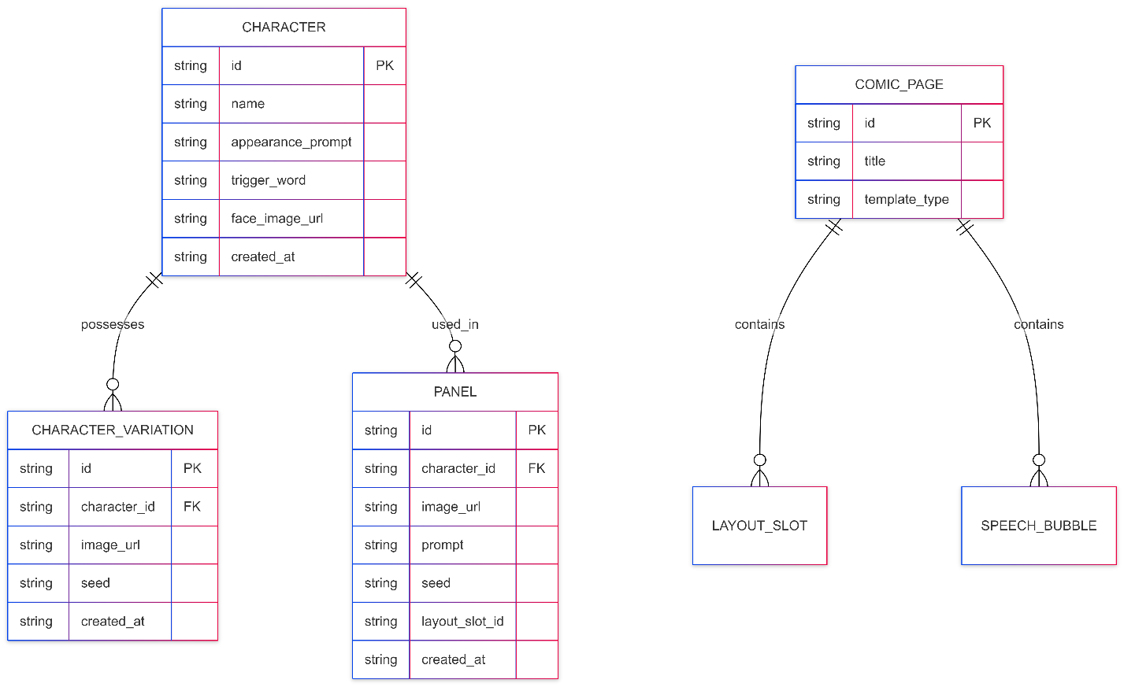
“Figure 4: ER (Database) Diagram”

The structural integrity of the application relies on two primary abstractions:
- The Database Schema: Implemented in SQLite via SQLAlchemy. The schema establishes a one-to-many relationship where a single Character entity owns multiple Panels and CharacterVariations. A ComicPage owns multiple LayoutSlots and SpeechBubbles. This structured persistence ensures that users can close the application and resume their projects without losing generated assets.
- The JSON Graph Schemas: Rather than executing raw Python diffusion scripts, ComfyUI requires Directed Acyclic Graphs (DAGs) represented as JSON. The backend maintains specific template graphs for flux_single_char, flux_dual_char, and flux_background.

7.3. Behavioral Models

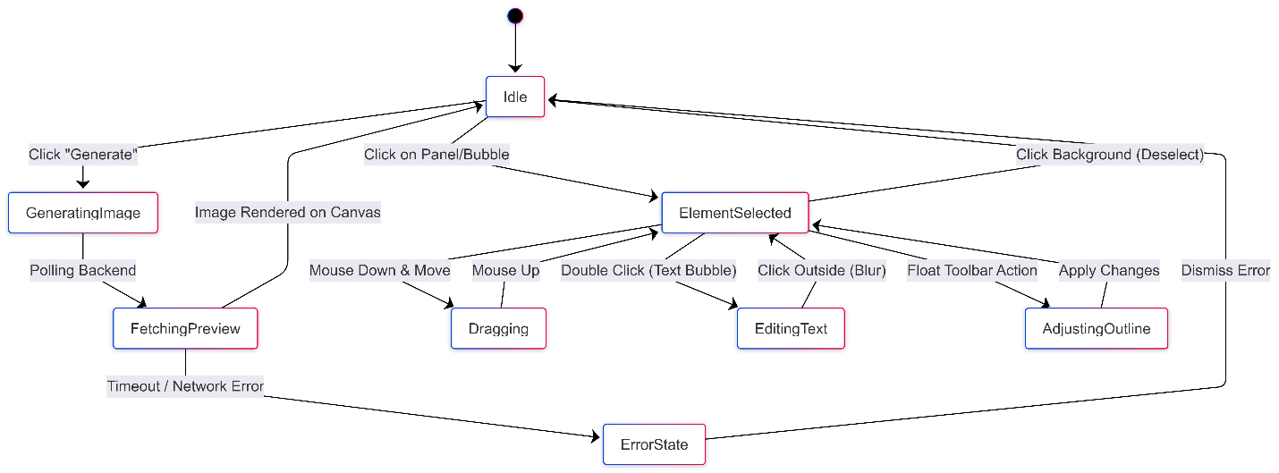
“Figure 5: State Machine Diagram”

The most complex behavioral modeling occurs on the Frontend canvas, utilizing React-Konva and Zustand. Because the canvas must handle dragging, dropping, scaling, and z-index ordering across dozens of layers simultaneously, the system uses an Event-Driven Architecture. Selecting an element dispatches an action to the Zustand store, which triggers a localized re-render of the specific Konva Node (e.g., highlighting a speech bubble border) without causing the entire 4K image canvas to re-render, ensuring a smooth 60 FPS user experience.

8. System Implementation

8.1. Development Environment

Because of the decoupled nature of the architecture, the implementation spanned three distinct, highly specialized development environments:
1. Local IDE: Visual Studio Code (Windows 11) The entirety of the frontend application and the backend API logic was authored locally using VS Code. The environment was configured with strict language servers: ESLint and Prettier to enforce TypeScript standards in the React codebase, and Pylance for strict type-checking in the FastAPI backend. Local development allowed for rapid Hot Module Replacement (HMR) for the Next.js UI, ensuring the canvas math could be tested instantly without network latency.
2. Cloud Compute Node: Google Colab Pro (Ubuntu Linux) While the backend code was written locally, it had to be deployed and executed in a Jupyter Notebook environment hosted on Google Colab to access the NVIDIA T4/A100 GPUs. The Colab environment required complex initialization scripts to mount the user's Google Drive via OAuth, map the SQLite database to the cloud storage, download the massive 23GB Flux.1 .safetensors files, and launch the ngrok reverse proxy before finally starting the Uvicorn ASGI server.
3. MLOps Platforms: Koyash & CivitAI Training a Low-Rank Adaptation (LoRA) for a 12-billion parameter model like Flux requires significantly more VRAM than inference (often >40GB for the backward passes). Therefore, model training could not occur locally or on standard Colab instances. We utilized specialized cloud MLOps platforms like Koyash and CivitAI. These platforms provided the massive GPU clusters needed to process our curated dataset, run the Vision-Language Model (VLM) auto-captioning algorithms, and execute the actual LoRA training loop over several hours.

8.2. Code Structure
To maintain a strict separation of concerns, the repository is fundamentally bifurcated into two distinct, highly organized codebases:
1. The Frontend Codebase (/frontend): Built on the Next.js 14 App Router, the frontend directory is structured for maximum component reusability.
- app/: Contains the Next.js routing logic and the core layout wrappers.
- components/: Subdivided by domain logic (/assembly, /character, /panel, and /text). This ensures that the heavy WebGL canvas components are isolated from the standard HTML form components.
- store/: Contains the Zustand state managers. To prevent monolithic state bottlenecks, the store is sliced into distinct domains (assemblyStore.ts for layout mathematics, characterStore.ts for identity state, etc.).
2. The Backend Codebase (/backend): Built entirely in Python, prioritizing modular API design.
- main.py & routers/: The FastAPI entry points, defining the RESTful HTTP contracts (e.g., POST /generate/panel).
- database.py & models.py: The SQLAlchemy schema definitions mapping Python objects to SQLite tables.
- services/: The most critical directory of the project. It houses comfyui_client.py (which manages the WebSocket connections to the GPU) and prompt_builder.py (which dynamically parses user input into the massive JSON DAGs required by Flux).

8.3. The Style LoRA Training Pipeline (Data Preparation & Fine-Tuning)

A defining success of this capstone was the development of a custom Style LoRA (Low-Rank Adaptation) to override the generic, photorealistic aesthetic of the base Flux.1 model. LoRA training is an advanced MLOps technique that injects small, trainable weight matrices into the Transformer's cross-attention layers, allowing the model to learn a new visual style without suffering catastrophic forgetting of its base knowledge.

8.3.1. Data Collection

Raw web data is inherently noisy and unsuitable for direct neural network training. Furthermore, utilizing copyrighted art to train AI models presents a severe ethical and legal dilemma. Therefore, the raw dataset underwent a rigorous two-step filtering process:
- Ethical & Copyright Filtering: The scraping pipeline was explicitly configured to respect intellectual property. We utilized metadata filtering to strictly collect images released under permissive licenses (e.g., Creative Commons, Public Domain) or from repositories where artists had explicitly opted-in to AI training. Additionally, automated classifiers and manual sweeps were conducted to purge the dataset of any NSFW, violent, or culturally insensitive imagery.
- Technical Filtering: Diffusion models replicate the exact flaws of their training data. Therefore, images with low resolutions (sub-1024x1024), severe JPEG artifacting, blurry line art, or intrusive text/watermarks were aggressively discarded. We enforced strict algorithmic quality thresholds to ensure the AI learned only from pristine, professional-grade cel shading and inking.

8.3.2. Ethical & Technical Filtering

Raw web data is unsuitable for direct training. The dataset underwent a strict filtering process:
- Ethical Filtering: Automated and manual sweeps were conducted to remove any NSFW, violent, or culturally insensitive imagery.
- Technical Filtering: Images with low resolutions, severe JPEG artifacting, or intrusive watermarks were discarded. We enforced specific quality thresholds to ensure the AI learned only from crisp, professional line art and shading.

8.3.3. Data Preparation & Captioning

A diffusion model is fundamentally blind; it only learns to associate mathematical pixel distributions with specific textual vectors. Therefore, feeding a model 1,000 raw images teaches it nothing unless those images are perfectly described by text.
To achieve this at scale, we utilized an advanced Vision-Language Model (VLM)—specifically the WD14 (Waifu Diffusion 14) Tagger algorithm—to automatically generate highly descriptive text captions for every image in the dataset. Rather than using natural language sentences (which can confuse cross-attention layers with stop words like "the" or "and"), the VLM generates precise, comma-separated "Booru-style" tags. For example, a single training image would be mathematically captioned as: "1girl, solo, blue school uniform, standing, classroom, wide shot, manga style, cel shading, monochrome, dynamic lighting".
The Trigger Token Mechanic: Once the entire dataset was meticulously captioned, we employed a critical fine-tuning technique known as "Trigger Token Injection." We invented a unique, non-dictionary string (e.g., c0m1cst0ry) and appended it to the very front of every single text file in the dataset.
During the intensive training loop, as the model performed thousands of backward passes to minimize the loss function, it noticed that this exact trigger token was present in every single image exhibiting our specific cel-shaded comic aesthetic. Consequently, the Transformer learned to map the vector embedding of that nonsense word directly to our customized art style. In the final frontend application, the backend automatically injects this trigger token into the user's hidden system prompt, forcing the Flux model to perfectly invoke our unique aesthetic on every generation without the user ever needing to manually type "draw this in a comic style."

9. MVP Development & Demonstration

9.1. MVP Definition

The Minimum Viable Product (MVP) for the AI Comic Studio was defined as a fully self-contained, end-to-end software pipeline. The overarching goal of the MVP was to eliminate the need for external professional software (like Adobe Photoshop or Clip Studio Paint). It had to successfully capture a user's prompt, maintain a persistent biometric character identity across multiple camera angles, generate the narrative panels natively in the cloud, and provide a WebGL vector interface for the user to assemble a finished, lettered comic page.

9.2. Implemented Features

The finalized MVP successfully implements the following core architectures:
- Persistent Character Library: An interface where users define a character's physical traits. The backend automatically constructs a ComfyUI JSON graph to generate a multi-angle Character Sheet, storing the specific noise seed and facial embeddings in SQLite.
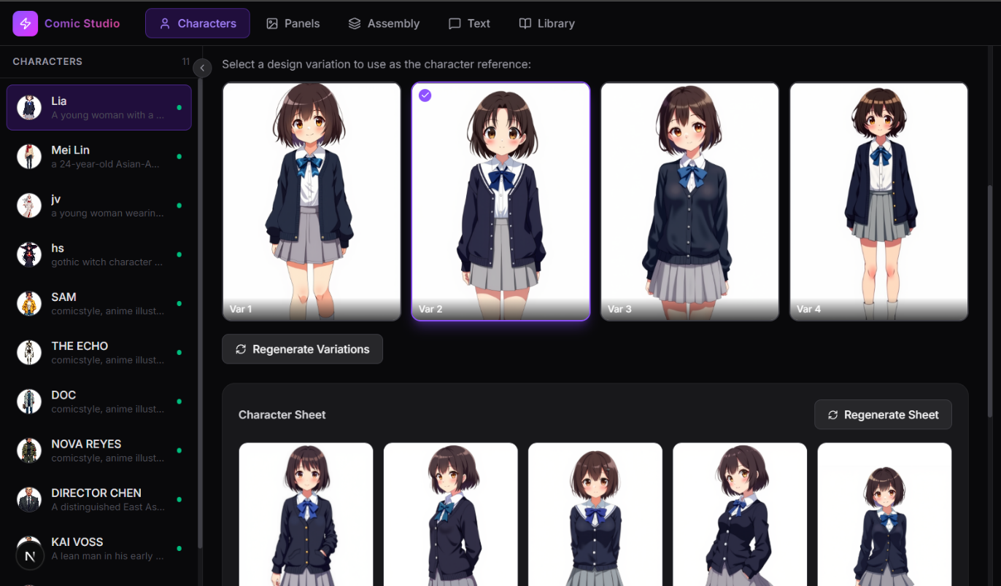
“Figure 6: Character Tab”

- Intelligent Panel Generation (Dual-Character): A generation engine that intercepts the user's scene description and dynamically injects the saved mathematical identity of up to two characters simultaneously, leveraging Flux's Transformer architecture to prevent concept bleeding.
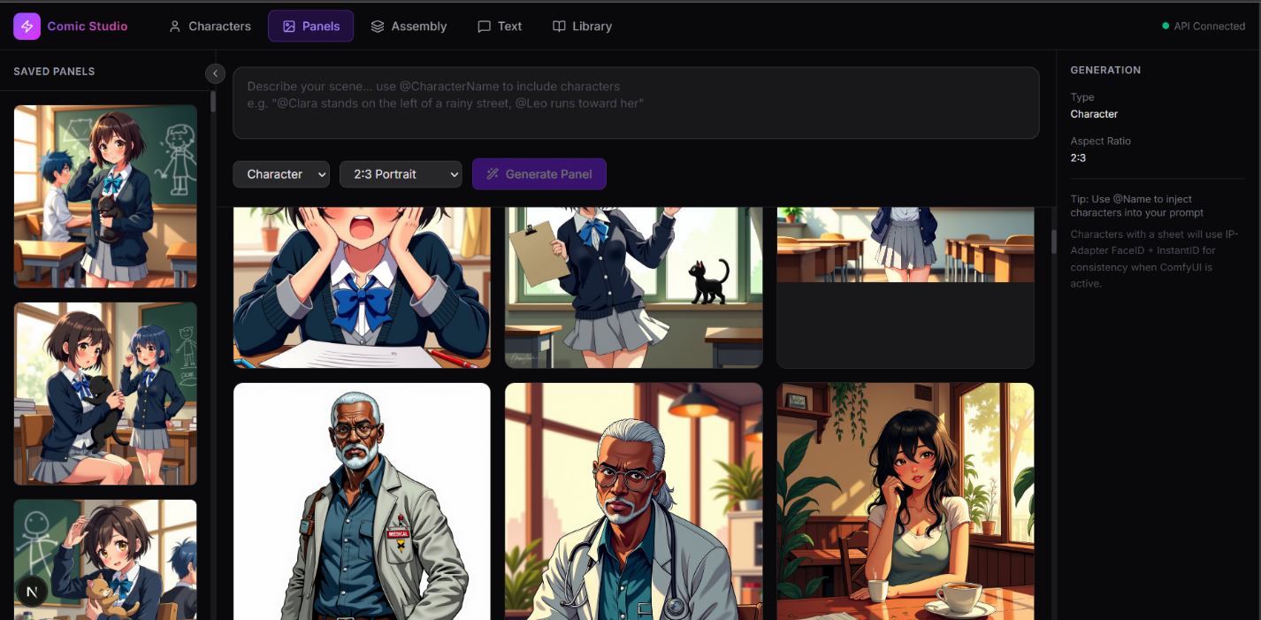
“Figure 7: Panel Tab”

- Interactive React-Konva Assembly: A robust WebGL canvas allowing infinite, non-destructive manipulation of generated image tensors (cropping, zooming, flipping, masking) utilizing Zustand for localized state rendering.
- Vector Typography Engine: A dynamic text engine that renders customizable SVG speech bubbles, narration boxes, and "naked" plain text. Text layers are rendered completely independent of the AI image generation, avoiding diffusion model spelling failures.
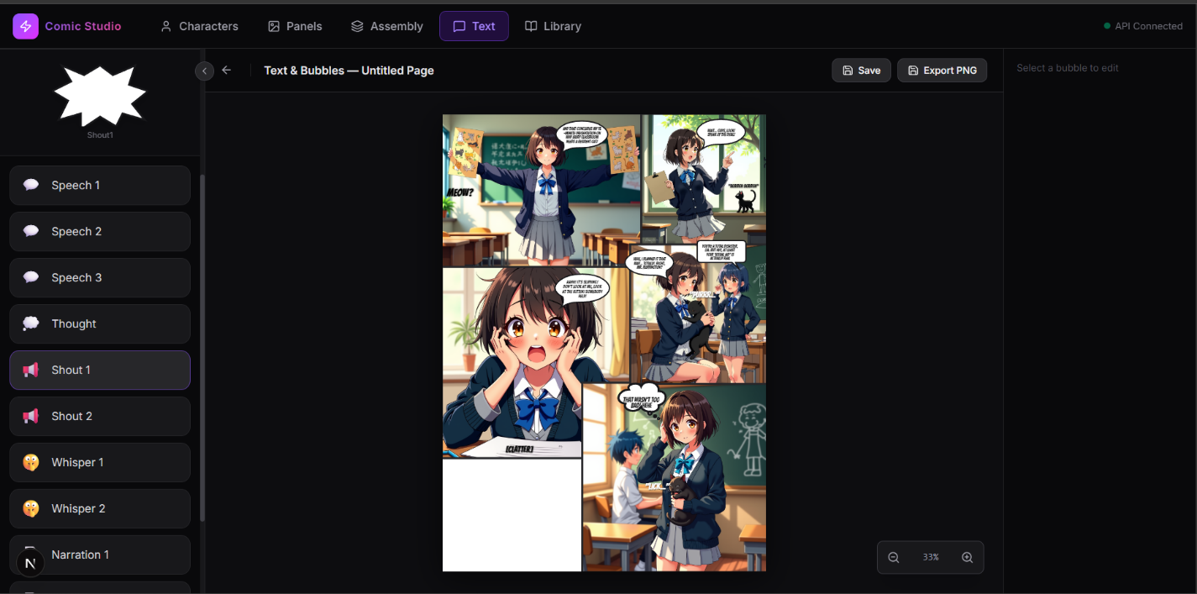
“Figure 8: Assembly/Text Tab”

9.3. System Demonstration: "The Cat in the Classroom"
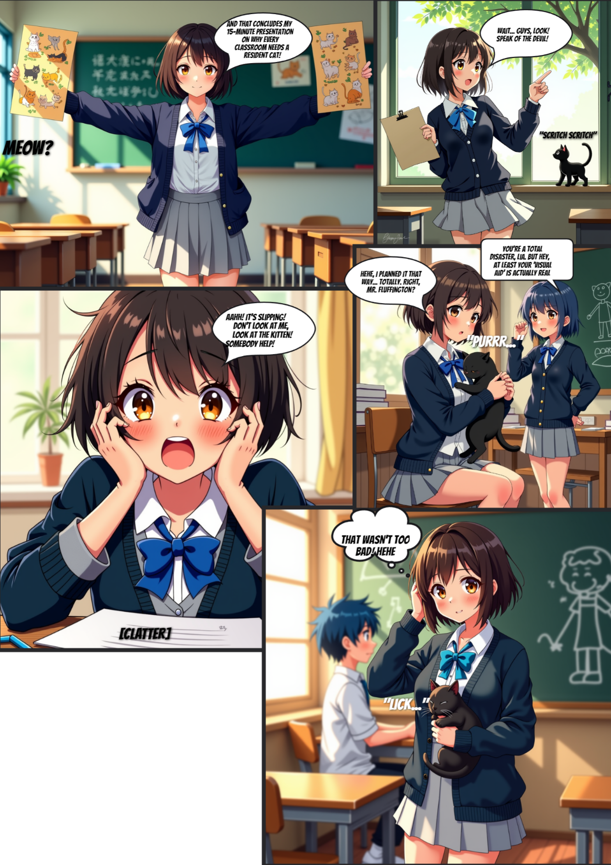
“Figure 9: Comic page (Final product)”

To validate the system's spatial consistency and prompt adherence, a formal demonstration was conducted by generating a 4-panel narrative sequence featuring a primary protagonist ("Lia," a girl with a brown bob cut and a school uniform) and a secondary character (a blue-haired boy). The system's ability to translate abstract narrative concepts into highly structured diffusion prompts was tested as follows:
- Panel 1 (The Establishing Shot): The narrative required Lia to be smiling with her arms spread, giving a presentation. The backend constructed a prompt isolating her Character ID and applying the action tags. The Flux model correctly rendered the classroom background without morphing her established uniform.
- Panel 2 (The Inciting Incident): The narrative required Lia to react in shock to a black kitten outside the window. This tested the model's ability to handle extreme facial expressions (shock/gasping) while maintaining the biometric identity established in Panel 1. The custom Style LoRA successfully rendered the cel-shaded background window and the kitten.
- Panel 3 (Dynamic Action & Prop Interaction): The narrative required a flustered panic: dropping a poster and knocking pencils off a desk. This is traditionally a failure point for diffusion models (hand anatomy and prop interaction). Because the backend utilized the 12-Billion parameter Flux model, the system successfully rendered the complex finger anatomy interacting with the cheeks and the falling pencils without hallucinating extra limbs.
- Panel 4 (Multi-Character Resolution): The final panel introduced the secondary character (the blue-haired boy) interacting with Lia, who is now holding the kitten. This tested the "Dual-Character Workflow." The backend dynamically partitioned the latent space via the JSON graph. The model successfully rendered the boy's blue hair and Lia's brown bob cut without the colors "bleeding" across subjects, proving the superiority of the Transformer architecture over the older SDXL U-Net.
The generated panels were subsequently dragged onto the Next.js canvas. The Typography Engine was used to overlay Lia's flustered screams and the boy's dialogue into standard comic speech bubbles, resulting in a professional-grade, cohesive manga page.

10. Testing and Evaluation

10.1. Testing Strategy

Evaluating a hybrid AI/Web application requires a dual-pronged quality assurance strategy. Traditional software testing paradigms are insufficient for machine learning models, as their outputs are stochastic (probabilistic) rather than deterministic. Therefore, the testing strategy was divided into two distinct domains:
- Software Quality Assurance (SQA): Testing the deterministic components of the system. This included API route reliability (FastAPI), network latency across the ngrok tunnel, and React-Konva render performance under heavy DOM loads.
- Generative Adherence Testing (GAT): Testing the stochastic components. This involved qualitative and quantitative analysis of the AI's ability to maintain spatial consistency, prevent concept bleeding, and adhere to complex multi-subject prompts.

10.2. Generative Adherence Testing
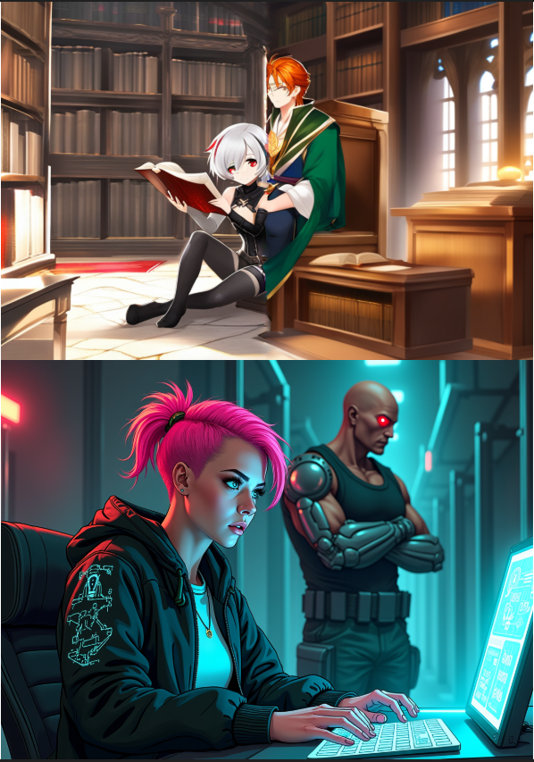
“Figure 10: SDXL concept bleeding (up) vs. Flux.1 precise prompt adherence (down).”

To empirically justify the architectural pivot to Flux, we executed a standardized matrix of multi-character prompts against both the SDXL (U-Net) and Flux.1 (Transformer) backends. The core objective of these tests was to measure "concept bleeding" the tendency of AI models to mistakenly mix the physical attributes, clothing, or anatomy of two distinct subjects within the same frame.
Results & Visual Comparison: The provided visual comparison strictly contrasts the multi-character spatial adherence of both architectures.
SDXL (U-Net Architecture): As seen in the upper comparison image, SDXL suffered a catastrophic failure in spatial segregation. While attempting to render two characters in a library setting, the U-Net's cross-attention layers were unable to isolate the subjects. This resulted in severe anatomical merging; the male character's lower body and arms physically fuse with the female character and the wooden bench. Furthermore, the rendering exhibits a harsh visual seam down the center, demonstrating the model's inability to cohesively map multiple complex identities to distinct latent coordinates.
Flux.1 (Transformer Architecture): Conversely, as seen in the lower comparison image, Flux.1 passed the multi-subject spatial test flawlessly. Tasked with generating a female character typing at a console with a cyborg in the background, the Transformer-based architecture achieved perfect conceptual isolation. There is zero concept bleeding—the cyborg's metallic textures do not pollute the female character, and her pink hair color remains entirely contained. Furthermore, Flux demonstrated superior anatomical fidelity in prop interaction (accurately rendering hands typing on a keyboard) and maintained a highly cohesive lighting and depth-of-field hierarchy.
These comparative results unequivocally proved the superiority of the Flux architecture for the rigorous multi-character panel generation required by the AI Comic Studio, justifying its permanent integration into the backend pipeline.

10.3. Network Latency Testing

A critical non-functional requirement was managing the UX impact of remote GPU inference. Generating a panel on a Google Colab T4 GPU requires approximately 15–20 seconds of compute time, followed by transferring a 2MB–5MB image payload through the ngrok TCP tunnel.
- The Problem: Initial UX testing revealed a jarring "white flash" because the React DOM attempted to render the <image> tag before the massive network payload had finished downloading.
- The Solution: We mitigated this by engineering a custom VariationImage React component. We utilized JavaScript's native Image(), binding the state change to the onload event. This ensured a smooth, dark skeleton-loader remained active on the screen until the image was 100% downloaded and decoded by the browser, completely eliminating the white flash and drastically improving perceived performance.

10.4. System Integration Testing (State Management)

Because the comic canvas can eventually house dozens of high-resolution images and hundreds of vector text nodes, we tested the frontend for memory leaks and unnecessary re-renders. We verified that our Zustand store architecture was correctly sliced. Using React DevTools, we proved that dragging a panel across the canvas only triggered a re-render of that specific Konva Node, leaving the rest of the 4K canvas untouched, thereby maintaining a smooth 60 FPS interaction rate even on lower-end consumer hardware

11. Results and Discussion

11.1. Goal Attainment

The primary hypothesis of this capstone—that zero-shot diffusion consistency cannot be solved via prompting alone, but requires a decoupled, human-in-the-loop architectural scaffolding—was definitively proven correct. By categorically rejecting the "single-prompt-to-finished-comic" monolithic paradigm, the AI Comic Studio successfully isolated the variables that cause generative failure. By separating Character Instantiation (the biometric identity) from Panel Synthesis (the spatial scene), and further separating the visual rendering from the layout assembly and typography (the React canvas), the system grants the user a level of deterministic precision previously considered impossible with raw, stochastic AI endpoints. The integration of Flux.1 combined with the custom Style LoRA proved that both biometric identity and stylistic cohesion can be mathematically locked across a massive visual narrative.

11.2. Ethical Considerations

The deployment of generative AI in creative fields requires a rigorous approach to ethics, specifically regarding the "Democratization of Art vs. Artist Replacement" debate. To address this, the AI Comic Studio was explicitly engineered as an assistive co-pilot, not an autonomous creator. The AI cannot generate a comic on its own; it requires a human user to define the characters, write the script, orchestrate the camera angles, assemble the layout, and write the dialogue. The AI acts merely as an incredibly advanced rendering engine—an intelligent paintbrush. Furthermore, the dataset utilized to train the core Style LoRA was meticulously filtered to exclude non-consensual copyrighted material, and automated content-safety filters prevent the generation of harmful, violent, or NSFW content, ensuring the tool remains ethically viable for professional distribution.

11.3. Cost Analysis

A significant finding of this capstone is the democratization of high-end ML compute. The migration to the 12-billion parameter Flux architecture presented a massive economic barrier. Purchasing a local consumer workstation capable of training and running inference on this model (e.g., dual RTX 4090s or an RTX A6000 Ada) requires a Capital Expenditure (CapEx) exceeding $5,000. By architecting the backend as a headless, remote API, we successfully shifted this burden to a low-cost Operational Expenditure (OpEx) model. Executing the Uvicorn/ComfyUI backend on Google Colab Pro instances achieves the exact same A100-tier generative power for a flat subscription of roughly $10 per month. This proves that professional, enterprise-grade AI workflows can be deployed economically via the cloud, completely removing the hardware barrier to entry for independent creators and storytellers.

12. Conclusion and Future Work

12.1. Conclusion

The development of the AI Comic Studio successfully addressed one of the most persistent and difficult challenges in generative artificial intelligence: achieving zero-shot spatial and temporal consistency across sequential art. At the outset of this capstone, it was identified that standard diffusion models are inherently stochastic; they are mathematically engineered to produce unique probabilistic variances, making them fundamentally unsuitable for generating the cohesive, multi-panel narratives required by comic artists.
This project proved that this limitation cannot be solved through prompt engineering alone. Instead, the solution necessitated a radical architectural paradigm shift. By abandoning the expectation that an AI should generate a finished comic page from a single text prompt, we successfully engineered a decoupled, human-in-the-loop scaffolding. By isolating the workflow into three distinct domains—Character Instantiation (anchoring biometric identity in the SQLite database), Panel Synthesis (executing headless inference on remote GPUs), and Layout Assembly (manipulating image tensors and vector typography natively in the React canvas)—the system effectively forced the AI to behave as a deterministic, panel-by-panel rendering engine rather than an autonomous author.
Furthermore, this capstone demonstrated the necessity of rapid architectural adaptability in the face of evolving machine learning frameworks. Rigorous testing revealed that traditional U-Net architectures (like SDXL) suffered from fatal concept bleeding during multi-character generation. The successful migration to the 12-billion parameter, transformer-based Flux.1 architecture unequivocally solved these cross-attention failures, allowing for complex, multi-subject scenes without anatomical degradation.
Finally, the development of a custom MLOps data pipeline—curating, VLM-captioning, and training a specialized Style LoRA on high-performance cloud clusters—proved that global aesthetic cohesion can be mathematically enforced across a massive visual narrative. Ultimately, the AI Comic Studio bridges the critical gap between raw, unpredictable machine learning algorithms and structured, professional creative workflows, proving that generative AI can transcend novelty to become a rigorous, economically viable, and predictable co-pilot for professional storytellers.

12.2. Future Work

While the MVP successfully fulfills its core objectives, future development will focus on three advanced architectural integrations:
- ControlNet Integration for Deterministic Posing: While text prompting using T5 is highly advanced, allowing the user to upload a primitive stick-figure sketch to physically drive the AI character's skeletal structure via ControlNet or OpenPose would drastically improve compositional precision.
- Enterprise Cloud Deployment: Migrating the backend from the transient, ephemeral Google Colab environment to a permanent, auto-scaling Kubernetes cluster (e.g., RunPod Serverless or AWS EC2) to completely eliminate the need for manual startup scripts and ensure 99.9% API uptime.
- LLM-Driven Automated Storyboarding: Developing a Large Language Model (LLM) orchestration pipeline that automatically reads a user's text script, parses it into distinct narrative beats, and pre-populates the ComfyUI JSON generation queue with optimized diffusion prompts before the user even opens the React canvas.

References

- Ho, J., Jain, A., & Abbeel, P. (2020). Denoising Diffusion Probabilistic Models. Advances in Neural Information Processing Systems, 33, 6840-6851.
- Rombach, R., Blattmann, A., Lorenz, D., Esser, P., & Ommer, B. (2022). High-Resolution Image Synthesis with Latent Diffusion Models. Proceedings of the IEEE/CVF Conference on Computer Vision and Pattern Recognition (CVPR), 10684-10695.
- Hu, E. J., Shen, Y., Wallis, P., Allen-Zhu, Z., Li, Y., Wang, S., ... & Chen, W. (2021). LoRA: Low-Rank Adaptation of Large Language Models. International Conference on Learning Representations (ICLR).
- Black Forest Labs. (2024). Flux.1 [dev]: Open-Source Transformer-based Flow Matching Models. Retrieved from HuggingFace.
- Ye, H., Zhang, J., Liu, S., Han, X., & Yang, W. (2023). IP-Adapter: Text Compatible Image Prompt Adapter for Text-to-Image Diffusion Models. arXiv preprint arXiv:2308.06721.
- Guo, Z., Wu, C., Dong, Y., Zhao, J., Chen, P., ... & Zhang, Z. (2024). PuLID: Pure and Lightning ID Customization via Contrastive Alignment. arXiv preprint.
- ComfyUI. (2023). A powerful and modular stable diffusion GUI with a graph/nodes interface. GitHub Repository. Retrieved from https://github.com/comfyanonymous/ComfyUI
- Ramírez, S. (2020). FastAPI: A modern, fast (high-performance), web framework for building APIs with Python 3.6+ based on standard Python type hints. GitHub Repository. Retrieved from https://github.com/tiangolo/fastapi
- Vercel. (2024). Next.js: The React Framework for the Web. Retrieved from https://nextjs.org/
- Lavrenov, A. (2024). React-Konva: React wrapper for Konva HTML5 2D canvas library. GitHub Repository. Retrieved from https://github.com/konvajs/react-konva

13. Appendices

13.1. Appendix A: Source Code

1. Backend API & Inference (Python)
File: backend\main.py
import os
from pathlib import Path
from contextlib import asynccontextmanager
from fastapi import FastAPI
from fastapi.middleware.cors import CORSMiddleware
from fastapi.staticfiles import StaticFiles
from dotenv import load_dotenv

from backend.database import init_db
from backend.routers import characters, panels, pages, bubbles, generation

load_dotenv(dotenv_path=Path(__file__).parent / '.env')

STORAGE_PATH = os.getenv("STORAGE_PATH", "./storage")

@asynccontextmanager
async def lifespan(app: FastAPI):
# Create storage directories
for sub in ["characters", "variations", "sheets", "panels", "exports", "temp", "pages"]:
os.makedirs(os.path.join(STORAGE_PATH, sub), exist_ok=True)
# Init DB tables
init_db()
yield

app = FastAPI(
title="Comic Studio API",
description="AI-assisted comic creation backend",
version="1.0.0",
lifespan=lifespan,
)

# ── CORS ───────────────────────────────────────────────────────────────────────
# allow_origins=["*"] is intentional — this backend is accessed via ngrok from
# a local Next.js dev server whose origin changes each session.
app.add_middleware(
CORSMiddleware,
allow_origins=["*"],
allow_credentials=False,
allow_methods=["*"],
allow_headers=["*"],
)

# ── Static file serving ────────────────────────────────────────────────────────
os.makedirs(STORAGE_PATH, exist_ok=True)
app.mount("/static", StaticFiles(directory=STORAGE_PATH), name="static")

# ── Routers ────────────────────────────────────────────────────────────────────
app.include_router(characters.router, prefix="/characters", tags=["Characters"])
app.include_router(panels.router, prefix="/panels", tags=["Panels"])
app.include_router(pages.router, prefix="/pages", tags=["Pages"])
app.include_router(bubbles.router, prefix="/pages", tags=["Bubbles"])
app.include_router(generation.router, prefix="/generation", tags=["Generation"])

@app.get("/health")
def health():
return {"status": "ok", "version": "1.0.0"}

@app.get("/debug")
def debug():
"""Shows exactly what the running server thinks its config is."""
import os, httpx
backend = os.getenv("GENERATION_BACKEND", "mock")
comfyui_url = os.getenv("COMFYUI_URL", "http://127.0.0.1:8188")
db_url = os.getenv("DATABASE_URL", "sqlite:///./comic_studio.db")
storage = os.getenv("STORAGE_PATH", "./storage")

# Test ComfyUI connectivity
comfyui_status = "unreachable"
try:
r = httpx.get(f"{comfyui_url}/system_stats", timeout=3)
comfyui_status = "ok" if r.status_code == 200 else f"http {r.status_code}"
except Exception as e:
comfyui_status = f"error: {e}"

return {
"GENERATION_BACKEND": backend,
"DATABASE_URL": db_url,
"STORAGE_PATH": storage,
"COMFYUI_URL": comfyui_url,
"comfyui_reachable": comfyui_status,
}

@app.get("/test-comfyui")
async def test_comfyui():
"""
Runs a minimal real ComfyUI generation and returns the exact error if it fails.
Visit this URL in a browser tab right after clicking Generate.
"""
import traceback
from backend.services.comfyui_client import ComfyUIClient

checkpoint = os.getenv("SDXL_CHECKPOINT", "sd_xl_base_1.0.safetensors")
storage_path = os.getenv("STORAGE_PATH", "./storage")
out_path = os.path.join(storage_path, "temp", "comfyui_test.png")
os.makedirs(os.path.dirname(out_path), exist_ok=True)

try:
client = ComfyUIClient()
patches = client.build_background_patches(
positive_prompt="a simple blue sky, test image",
negative_prompt="blurry",
width=512, height=512,
seed=42,
checkpoint=checkpoint,
)
await client.generate("background_only", patches, out_path)
return {
"result": "success",
"file_written": os.path.exists(out_path),
"output_path": out_path,
"checkpoint": checkpoint,
}
except Exception as e:
return {
"result": "failed",
"error": str(e),
"traceback": traceback.format_exc(),
"checkpoint": checkpoint,
}
@app.get("/debug-nodes")
async def debug_nodes():
"""
Query ComfyUI for the exact input schema of every InstantID/IPAdapter node.
Open {ngrok_url}/debug-nodes in a browser — no need to kill A6.
"""
import httpx
comfyui_url = os.getenv("COMFYUI_URL", "http://127.0.0.1:8188")
nodes = [
"InstantIDFaceAnalysis", "InstantIDModelLoader", "ApplyInstantID",
"IPAdapterModelLoader", "IPAdapterAdvanced", "ControlNetLoader",
]
result = {}
async with httpx.AsyncClient(timeout=10) as client:
for node_class in nodes:
try:
r = await client.get(f"{comfyui_url}/object_info/{node_class}")
if r.status_code == 200:
info = r.json().get(node_class, {})
inp = info.get("input", {})
required = {k: v for k, v in inp.get("required", {}).items()}
optional = list(inp.get("optional", {}).keys())
# Simplify list choices for readability
simplified = {}
for k, v in required.items():
if isinstance(v, list) and len(v) > 0 and isinstance(v[0], list):
simplified[k] = {"choices": v[0][:8]}
else:
simplified[k] = v[1] if isinstance(v, list) and len(v) > 1 else "connected"
result[node_class] = {
"status": "registered",
"required_inputs": simplified,
"optional_inputs": optional,
}
else:
result[node_class] = {"status": "NOT_FOUND", "http": r.status_code}
except Exception as e:
result[node_class] = {"status": "error", "detail": str(e)}
return result

File: backend\database.py
import os
from pathlib import Path
from sqlalchemy import create_engine, event
from sqlalchemy.orm import sessionmaker, DeclarativeBase
from dotenv import load_dotenv

# Explicitly load from backend/.env relative to this file — uvicorn may run
# from a parent directory where load_dotenv() with no args won't find the file
load_dotenv(dotenv_path=Path(__file__).parent / '.env')

DATABASE_URL: str = os.getenv("DATABASE_URL", "sqlite:///./comic_studio.db")

connect_args: dict = {}
if DATABASE_URL.startswith("sqlite"):
connect_args = {"check_same_thread": False}

engine = create_engine(
DATABASE_URL,
connect_args=connect_args,
echo=False,
)

# Enable WAL mode for SQLite (better concurrent read performance)
if DATABASE_URL.startswith("sqlite"):
@event.listens_for(engine, "connect")
def set_sqlite_pragma(dbapi_conn, _):
cursor = dbapi_conn.cursor()
cursor.execute("PRAGMA journal_mode=WAL")
cursor.execute("PRAGMA foreign_keys=ON")
cursor.close()

SessionLocal = sessionmaker(autocommit=False, autoflush=False, bind=engine)

class Base(DeclarativeBase):
pass

def get_db():
"""FastAPI dependency — yields a DB session and closes it when done."""
db = SessionLocal()
try:
yield db
finally:
db.close()

def init_db() -> None:
"""Create all tables. Called on app startup."""
import backend.models # noqa: F401 — side-effect: registers models with Base
Base.metadata.create_all(bind=engine)

File: backend\services\comfyui_client.py
"""
ComfyUI API client.

Connects to a running ComfyUI instance at COMFYUI_URL and submits
workflow JSON via the /prompt endpoint. Polls /history/{prompt_id}
until the job completes, then downloads the output image.

Workflow templates are in backend/workflows/.
The client patches placeholder values (prompts, model names, dimensions,
face-embed image paths for PuLID/InstantID) before submitting.
"""

import asyncio
import copy
import json
import os
import uuid
from pathlib import Path
from typing import Optional

import httpx

COMFYUI_URL = os.getenv("COMFYUI_URL", "http://127.0.0.1:8188")
COMFYUI_OUTPUT_DIR = os.getenv("COMFYUI_OUTPUT_DIR", "/content/ComfyUI/output")
WORKFLOWS_DIR = Path(__file__).parent.parent / "workflows"
POLL_INTERVAL = 2.0 # seconds between status checks
POLL_TIMEOUT = 900 # 15 min — covers FLUX+PuLID cold start (loading all models into VRAM)
# After first generation, everything is cached in VRAM (~90s per panel)

# ── FLUX model names (set in .env via notebook A5) ────────────────────────────
FLUX_UNET = os.getenv("FLUX_UNET", "flux1-dev.safetensors")
FLUX_VAE = os.getenv("FLUX_VAE", "ae.safetensors")
FLUX_T5 = os.getenv("FLUX_T5", "t5xxl_fp8_e4m3fn.safetensors")
FLUX_CLIP_L = os.getenv("FLUX_CLIP_L", "clip_l.safetensors")
PULID_MODEL = os.getenv("PULID_MODEL", "pulid_flux_v0.9.1.safetensors")
FLUX_IPADAPTER = os.getenv("FLUX_IPADAPTER", "ip-adapter.bin")

# ── Style LoRA (optional) ─────────────────────────────────────────────────────
# STYLE_LORA_NAME = just the filename, e.g. "comicstyle_flux_v1.safetensors"
# STYLE_LORA_TRIGGER = the activation keyword, e.g. "comicstyle"
# Set both in A5; leave blank if you have no style LoRA yet.
STYLE_LORA_NAME = os.getenv("STYLE_LORA_NAME", "") # filename inside ComfyUI/models/loras/
STYLE_LORA_TRIGGER = os.getenv("STYLE_LORA_TRIGGER", "") # text trigger word
STYLE_LORA_WEIGHT = float(os.getenv("STYLE_LORA_WEIGHT", "1.0"))

class ComfyUIError(Exception):
pass

class ComfyUIClient:

def __init__(self):
self.base = COMFYUI_URL.rstrip("/")
self.client_id = str(uuid.uuid4())

# ── Public API ─────────────────────────────────────────────────────────────

async def generate(
self,
workflow_name: str,
patches: dict,
output_path: str,
) -> str:
"""
Load a workflow template, apply `patches`, submit to ComfyUI,
wait for completion, download output image to `output_path`.
Returns output_path on success.
"""
workflow = self._load_workflow(workflow_name)
# Unique prefix so we can find the output file by name (avoids JSON-parsing the history)
file_prefix = f"cs_{self.client_id[:12]}"
if "12" in workflow:
workflow["12"]["inputs"]["filename_prefix"] = file_prefix
workflow = self._apply_patches(workflow, patches)
prompt_id = await self._submit(workflow)
output_filename = await self._poll(prompt_id, file_prefix)
await self._download(output_filename, output_path)
return output_path

# ── Helpers ────────────────────────────────────────────────────────────────

def _load_workflow(self, name: str) -> dict:
path = WORKFLOWS_DIR / f"{name}.json"
if not path.exists():
raise ComfyUIError(f"Workflow not found: {path}")
with open(path) as f:
return json.load(f)

def _apply_patches(self, workflow: dict, patches: dict) -> dict:
wf = copy.deepcopy(workflow)
patches = copy.deepcopy(patches) # don't mutate the caller's dict
for node_id, inputs in patches.items():
if node_id in wf:
# Existing node — merge inputs
wf[node_id]["inputs"].update(inputs)
else:
# New node injection (e.g. LoraLoader added dynamically)
# Requires a "_class_type" key in the patch dict.
class_type = inputs.pop("_class_type", None)
if class_type:
wf[node_id] = {"inputs": inputs, "class_type": class_type}
else:
print(f"[patch] ⚠️ node '{node_id}' not in workflow and no _class_type — skipped")
return wf

async def _submit(self, workflow: dict) -> str:
payload = {"prompt": workflow, "client_id": self.client_id}
async with httpx.AsyncClient(timeout=30) as client:
resp = await client.post(f"{self.base}/prompt", json=payload)
if resp.status_code != 200:
# Include the full ComfyUI error body so we can see which node failed
try:
detail = resp.json()
node_errors = detail.get("node_errors", {})
err_summary = "; ".join(
f"node {nid} ({info.get('class_type','?')}): "
+ ", ".join(e.get("message","?") for e in info.get("errors", []))
for nid, info in node_errors.items()
) or str(detail)
except Exception:
err_summary = resp.text[:500]
raise ComfyUIError(
f"ComfyUI /prompt rejected workflow (HTTP {resp.status_code}): {err_summary}"
)
data = resp.json()
prompt_id = data.get("prompt_id")
if not prompt_id:
raise ComfyUIError(f"ComfyUI did not return a prompt_id: {data}")
return prompt_id

async def _poll(self, prompt_id: str, file_prefix: str = "") -> str:
"""
Two-pronged polling strategy:
1. Scan ComfyUI's output dir directly by filename prefix (fast, no JSON)
2. Fall back to /history API (may fail if response contains tensor reprs)
"""
elapsed = 0.0
while elapsed < POLL_TIMEOUT:
await asyncio.sleep(POLL_INTERVAL)
elapsed += POLL_INTERVAL

# ── Strategy 1: scan output directory ──────────────────────────────
if file_prefix and os.path.isdir(COMFYUI_OUTPUT_DIR):
matches = [
f for f in os.listdir(COMFYUI_OUTPUT_DIR)
if f.startswith(file_prefix) and f.endswith(".png")
]
if matches:
fname = sorted(matches)[-1] # latest if multiple
print(f"[poll] ✅ found output file after {elapsed:.0f}s: {fname}")
return fname

# ── Strategy 2: history API (may have huge JSON, so short timeout) ─
try:
async with httpx.AsyncClient(timeout=5) as client:
resp = await client.get(f"{self.base}/history/{prompt_id}")
if resp.status_code == 200:
try:
history = resp.json()
if prompt_id in history:
entry = history[prompt_id]
status_info = entry.get("status", {})
if status_info.get("status_str") == "error":
# Extract the real execution_error message
messages = status_info.get("messages", [])
real_error = next(
(m[1] for m in messages if isinstance(m, list) and m[0] == "execution_error"),
messages
)
raise ComfyUIError(f"ComfyUI node execution failed: {real_error}")
outputs = entry.get("outputs", {})
for node_output in outputs.values():
images = node_output.get("images", [])
if images:
fname = images[0]["filename"]
print(f"[poll] ✅ history hit after {elapsed:.0f}s: {fname}")
return fname
except ComfyUIError:
raise # let it propagate — don't swallow it
except (json.JSONDecodeError, UnicodeDecodeError) as je:
print(f"[poll] {elapsed:.0f}s — history JSON unparseable ({je!s:.60}), using dir scan")
except ComfyUIError:
raise # propagate execution errors immediately
except Exception as e:
print(f"[poll] {elapsed:.0f}s — history request error: {e!s:.80}")

if int(elapsed) % 10 == 0:
print(f"[poll] {elapsed:.0f}s — waiting for ComfyUI…")

raise ComfyUIError(f"ComfyUI job timed out after {POLL_TIMEOUT}s")

async def _download(self, filename: str, dest_path: str) -> None:
os.makedirs(os.path.dirname(dest_path), exist_ok=True)
async with httpx.AsyncClient(timeout=60) as client:
resp = await client.get(
f"{self.base}/view",
params={"filename": filename, "type": "output"},
)
resp.raise_for_status()
with open(dest_path, "wb") as f:
f.write(resp.content)

async def upload_image(self, local_path: str) -> str:
"""
Upload a local image file to ComfyUI's input directory.
Returns the filename ComfyUI assigned to it (use this in LoadImage nodes).
"""
if not os.path.exists(local_path):
raise ComfyUIError(f"Reference image not found on disk: {local_path}")
filename = os.path.basename(local_path)
async with httpx.AsyncClient(timeout=60) as client:
with open(local_path, "rb") as f:
resp = await client.post(
f"{self.base}/upload/image",
files={"image": (filename, f, "image/png")},
)
resp.raise_for_status()
data = resp.json()
return data["name"]

# ── FLUX workflow patch builders ───────────────────────────────────────────

def _maybe_inject_lora(self, patches: dict) -> dict:
"""
If a style LoRA is configured (STYLE_LORA_NAME set), dynamically insert
a LoraLoader node (id=70) between the UNET loader and the KSampler.

Before: UNETLoader(1) → KSampler(10)[model: ["1",0]]
After: UNETLoader(1) → LoraLoader(70) → KSampler(10)[model: ["70",0]]

This must be called AFTER _flux_base_patches() so node "10" already exists.
"""
if not STYLE_LORA_NAME:
return patches # no LoRA configured — nothing to do

# Insert LoraLoader node wired between UNET and KSampler
patches["70"] = {
"_class_type": "LoraLoader",
"lora_name": STYLE_LORA_NAME,
"strength_model": STYLE_LORA_WEIGHT,
"strength_clip": STYLE_LORA_WEIGHT,
"model": ["1", 0], # takes UNET output
"clip": ["6", 0], # takes CLIP output
}
# Rewire KSampler to use LoRA-patched model instead of raw UNET
if "10" in patches:
patches["10"]["model"] = ["70", 0]
print(f"[lora] ✅ Style LoRA injected: {STYLE_LORA_NAME} (weight={STYLE_LORA_WEIGHT})")
return patches

def _flux_base_patches(self, width: int, height: int, seed: int, guidance: float = 4.5) -> dict:
"""Common patches for all FLUX workflows.
Quality params (steps/sampler) live here — they override the JSON defaults
so always keep them in sync with what you want.
Guidance 4.5 = sharp character lines. Drop to 3.5 for painterly/soft scenes.
"""
return {
"1": {"unet_name": FLUX_UNET},
"6": {"clip_name1": FLUX_T5, "clip_name2": FLUX_CLIP_L},
"5": {"vae_name": FLUX_VAE},
"35": {"guidance": guidance},
"9": {"width": width, "height": height, "batch_size": 1},
"10": {
"seed": seed,
"steps": 30, # 30 steps: converges cleanly on all seeds
"cfg": 1.0, # FLUX ignores cfg, guidance node does the work
"sampler_name": "euler",
"scheduler": "simple", # simple = proven stable for FLUX
},
}

def build_flux_patches(
self,
positive_prompt: str,
width: int,
height: int,
seed: int,
guidance: float = 4.5,
) -> dict:
"""Patches for flux_background.json — no face guidance."""
patches = self._flux_base_patches(width, height, seed, guidance)
patches["2"] = {"text": positive_prompt}
return self._maybe_inject_lora(patches)

def build_flux_char_patches(
self,
positive_prompt: str,
face_image_path: str,
body_image_path: Optional[str],
width: int,
height: int,
seed: int,
guidance: float = 3.5,
pulid_weight: float = 0.9,
ipadapter_weight: float = 0.4,
) -> dict:
"""Patches for flux_single_char.json — PuLID + IP-Adapter."""
patches = self._flux_base_patches(width, height, seed, guidance)
patches["2"] = {"text": positive_prompt}
patches["40"] = {"pulid_file": PULID_MODEL}
patches["22"] = {"ipadapter_file": FLUX_IPADAPTER}
patches["30"] = {"clip_name": FLUX_CLIP_L}
patches["50"] = {"weight": pulid_weight, "start_at": 0.0, "end_at": 0.7}
patches["60"] = {"weight": ipadapter_weight, "start_at": 0.0, "end_at": 0.8}
patches["20"] = {"image": face_image_path}
if body_image_path:
patches["21"] = {"image": body_image_path}
return self._maybe_inject_lora(patches)

def build_flux_dual_char_patches(
self,
positive_prompt: str,
face1_image_path: str,
body1_image_path: Optional[str],
face2_image_path: str,
width: int,
height: int,
seed: int,
guidance: float = 3.5,
pulid_weight: float = 0.7,
ipadapter_weight: float = 0.35,
) -> dict:
"""Patches for flux_dual_char.json — two chained PuLID nodes."""
patches = self._flux_base_patches(width, height, seed, guidance)
patches["2"] = {"text": positive_prompt}
patches["40"] = {"pulid_file": PULID_MODEL}
patches["22"] = {"ipadapter_file": FLUX_IPADAPTER}
patches["30"] = {"clip_name": FLUX_CLIP_L}
patches["50"] = {"weight": pulid_weight, "start_at": 0.0, "end_at": 0.7}
patches["51"] = {"weight": pulid_weight, "start_at": 0.0, "end_at": 0.7}
patches["60"] = {"weight": ipadapter_weight, "start_at": 0.0, "end_at": 0.75}
patches["20"] = {"image": face1_image_path}
patches["23"] = {"image": face2_image_path}
if body1_image_path:
patches["21"] = {"image": body1_image_path}
return self._maybe_inject_lora(patches)

# ── Legacy SDXL patch builders (kept for rollback) ─────────────────────────

def build_instantid_patches(
self,
positive_prompt: str,
negative_prompt: str,
face_image_path: Optional[str],
front_image_path: Optional[str],
width: int,
height: int,
seed: int,
checkpoint: str,
) -> dict:
"""SDXL InstantID patches — kept for rollback to instantid_single_char workflow."""
patches = {
"2": {"text": positive_prompt},
"3": {"text": negative_prompt},
"4": {"ckpt_name": checkpoint},
"9": {"width": width, "height": height, "batch_size": 1},
"10": {"seed": seed, "steps": 30, "cfg": 7.5,
"sampler_name": "dpmpp_2m_sde", "scheduler": "karras"},
"18": {"weight": 0.35, "start_at": 0.0, "end_at": 0.65},
"19": {"weight": 0.25, "weight_type": "ease in-out",
"start_at": 0.0, "end_at": 0.6},
}
if face_image_path:
patches["20"] = {"image": face_image_path}
if front_image_path:
patches["21"] = {"image": front_image_path}
return patches

def build_background_patches(
self,
positive_prompt: str,
negative_prompt: str,
width: int,
height: int,
seed: int,
checkpoint: str,
) -> dict:
"""SDXL background patches — kept for rollback to background_only workflow."""
return {
"2": {"text": positive_prompt},
"3": {"text": negative_prompt},
"4": {"ckpt_name": checkpoint},
"9": {"width": width, "height": height, "batch_size": 1},
"10": {"seed": seed, "steps": 30, "cfg": 7.0},
}

File: backend\workflows\flux_single_char.json
{
"1": {"inputs": {"unet_name": "FLUX_UNET", "weight_dtype": "default"}, "class_type": "UNETLoader"},
"6": {"inputs": {"clip_name1": "FLUX_T5", "clip_name2": "FLUX_CLIP_L", "type": "flux"}, "class_type": "DualCLIPLoader"},
"5": {"inputs": {"vae_name": "FLUX_VAE"}, "class_type": "VAELoader"},
"2": {"inputs": {"text": "POSITIVE_PROMPT", "clip": ["6", 0]}, "class_type": "CLIPTextEncode"},
"3": {"inputs": {"text": "", "clip": ["6", 0]}, "class_type": "CLIPTextEncode"},
"35": {"inputs": {"guidance": 3.5, "conditioning": ["2", 0]}, "class_type": "FluxGuidance"},
"9": {"inputs": {"width": 832, "height": 1216, "batch_size": 1}, "class_type": "EmptySD3LatentImage"},
"15": {"inputs": {"provider": "CUDA"}, "class_type": "IPAdapterInsightFaceLoader"},
"40": {"inputs": {"pulid_file": "PULID_MODEL"}, "class_type": "PulidFluxModelLoader"},
"20": {"inputs": {"image": "face_reference.png", "upload": "image"}, "class_type": "LoadImage"},
"21": {"inputs": {"image": "body_reference.png", "upload": "image"}, "class_type": "LoadImage"},
"22": {"inputs": {"ipadapter_file": "FLUX_IPADAPTER"}, "class_type": "IPAdapterModelLoader"},
"30": {"inputs": {"clip_name": "FLUX_CLIP_L"}, "class_type": "CLIPVisionLoader"},
"50": {"inputs": {
"weight": 0.9,
"start_at": 0.0,
"end_at": 0.7,
"model": ["1", 0],
"pulid": ["40", 0],
"eva_clip": ["40", 1],
"face_analysis": ["15", 0],
"image": ["20", 0]},
"class_type": "ApplyPulidFlux"},
"60": {"inputs": {
"weight": 0.4,
"weight_type": "linear",
"combine_embeds": "concat",
"start_at": 0.0,
"end_at": 0.8,
"embeds_scaling": "V only",
"model": ["50", 0],
"ipadapter": ["22", 0],
"image": ["21", 0],
"clip_vision": ["30", 0]},
"class_type": "IPAdapterAdvanced"},
"10": {"inputs": {
"seed": 42, "steps": 28, "cfg": 1.0,
"sampler_name": "euler", "scheduler": "beta", "denoise": 1.0,
"model": ["60", 0],
"positive": ["35", 0],
"negative": ["3", 0],
"latent_image": ["9", 0]},
"class_type": "KSampler"},
"11": {"inputs": {"samples": ["10", 0], "vae": ["5", 0]}, "class_type": "VAEDecode"},
"12": {"inputs": {"filename_prefix": "panel_flux_char", "images": ["11", 0]}, "class_type": "SaveImage"}
}

2. Frontend Application (React / TypeScript)
File: frontend\components\assembly\ComicCanvas.tsx
'use client'
import { useRef, useEffect, useCallback, useState } from 'react'
import dynamic from 'next/dynamic'
import { useAssemblyStore } from '@/store/assemblyStore'
import { usePanelStore } from '@/store/panelStore'
import { staticUrl } from '@/lib/api'
import { Trash2, FlipHorizontal, ZoomIn, ZoomOut, Move, Hand, Minus, Plus } from 'lucide-react'
import type { SlotData } from '@/types'

const CANVAS_W = 800
const CANVAS_H = 1100

// ── Konva canvas — SSR-safe ────────────────────────────────────────────────────
// All Konva components must come from the same import and be used inside one Stage.
// Individual dynamic() per component breaks the React-Konva context (causes
// "Element type is invalid — received a Promise that resolves to: Layer").
const KonvaCanvas = dynamic(() => import('./KonvaCanvas'), {
ssr: false,
loading: () => (
<div
style={{ width: '100%', height: '100%', minHeight: 400, background: '#fff' }}
className="flex items-center justify-center text-zinc-400 text-sm"
>
Loading canvas…
</div>
),
})

export default function ComicCanvas({ children, onBackgroundClick }: { children?: React.ReactNode, onBackgroundClick?: () => void }) {
const { currentPage, slots, assignPanel, addCustomSlot, selectedSlotId, deleteSlot, updateSlotImageState, setSelectedSlotId } = useAssemblyStore()
const { panels } = usePanelStore()
const containerRef = useRef<HTMLDivElement>(null)
const wrapperRef = useRef<HTMLDivElement>(null)
const stageRef = useRef<any>(null)
const [scale, setScale] = useState(1)

const canvasW = currentPage?.canvas_width || CANVAS_W
const canvasH = currentPage?.canvas_height || CANVAS_H

// Initial fit scaling
useEffect(() => {
if (!containerRef.current) return
const { clientWidth, clientHeight } = containerRef.current
const scaleX = (clientWidth - 48) / canvasW
const scaleY = (clientHeight - 48) / canvasH
setScale(Math.min(scaleX, scaleY, 1))
}, [canvasW, canvasH, currentPage])

// Handle drop from panel sidebar
const handleDrop = useCallback((e: React.DragEvent<HTMLDivElement>) => {
e.preventDefault()
const panelId = e.dataTransfer.getData('panel_id')
if (!panelId) return
const panel = panels.find(p => p.id === panelId)
if (!panel) return
if (!wrapperRef.current) return

const box = wrapperRef.current.getBoundingClientRect()

const dropX = (e.clientX - box.left) / scale
const dropY = (e.clientY - box.top) / scale

const url = staticUrl(panel.image_path)
if (!url) return

if (currentPage?.template === 'custom') {
let aspect = 1
if (panel.aspect_ratio) {
const [wStr, hStr] = panel.aspect_ratio.split(':')
aspect = Number(wStr) / Number(hStr) || 1
}

const width = 300
const height = width / aspect

const newSlot: SlotData = {
slot_id: `custom-${Date.now()}`,
x: dropX - width / 2,
y: dropY - height / 2,
width,
height,
panel_id: panel.id,
panel_image_url: url,
z_index: slots.length + 1,
scale: 1,
rotation: 0
}
addCustomSlot(newSlot)
setSelectedSlotId(newSlot.slot_id)
} else {
const targetSlot = slots.find(s =>
dropX >= s.x && dropX <= s.x + s.width &&
dropY >= s.y && dropY <= s.y + s.height
)
if (targetSlot) {
assignPanel(targetSlot.slot_id, panelId, url)
setSelectedSlotId(targetSlot.slot_id)
}
}
}, [slots, panels, assignPanel, addCustomSlot, setSelectedSlotId, scale, currentPage])

// Export handler
useEffect(() => {
const btn = document.getElementById('export-btn')
if (!btn) return
const handler = () => {
if (stageRef.current) {
const url = stageRef.current.toDataURL({ pixelRatio: 2 })
const a = document.createElement('a')
a.href = url
a.download = `${currentPage?.title || 'comic-page'}.png`
a.click()
}
}
btn.addEventListener('click', handler)
return () => btn.removeEventListener('click', handler)
}, [currentPage])

// Thumbnail/image capture — dispatched by saveThumbnail() and savePageImage() in lib/thumbnail.ts
useEffect(() => {
const handler = (e: Event) => {
const { resolve, pixelRatio = 0.4, mimeType = 'jpeg', quality = 0.7 } = (e as CustomEvent).detail || {}
if (stageRef.current) {
const dataUrl = stageRef.current.toDataURL({
pixelRatio,
mimeType: `image/${mimeType}`,
quality,
})
resolve?.(dataUrl)
} else {
resolve?.(null)
}
}
window.addEventListener('comic-capture-thumbnail', handler)
return () => window.removeEventListener('comic-capture-thumbnail', handler)
}, [])

const selectedSlot = selectedSlotId ? slots.find(s => s.slot_id === selectedSlotId) : null
const isCustom = currentPage?.template === 'custom'

return (
<>
<div
ref={containerRef}
className="absolute inset-0 overflow-auto flex p-6"
onDrop={handleDrop}
onDragOver={e => e.preventDefault()}
onClick={(e) => { setSelectedSlotId(null); onBackgroundClick?.() }}
>
<div ref={wrapperRef} className="relative m-auto shrink-0" onClick={e => e.stopPropagation()}>
<KonvaCanvas
stageRef={stageRef}
slots={slots}
canvasW={canvasW}
canvasH={canvasH}
scale={scale}
isCustom={isCustom}
onBackgroundClick={onBackgroundClick}
>
{children}
</KonvaCanvas> {/* Floating Toolbar */}
{selectedSlot && (
<div
className="absolute flex flex-col gap-1 bg-zinc-900 border border-zinc-700 p-1.5 rounded-lg shadow-xl z-50 animate-fade-in"
style={{
top: selectedSlot.y * scale,
left: (selectedSlot.x + selectedSlot.width) * scale + 12
}}
>
{/* Delete */}
<button title="Delete" onClick={() => deleteSlot(selectedSlot.slot_id, isCustom)} className="p-1.5 hover:bg-zinc-800 rounded-md text-zinc-400 hover:text-red-400 transition-colors">
<Trash2 size={16} />
</button>
<div className="h-px bg-zinc-800 my-0.5" />

{/* Pan / Move toggle (custom layout only) */}
{isCustom && (
<>
<button
title={selectedSlot.isPanMode ? "Switch to Move Panel Mode" : "Switch to Pan Image Mode"}
onClick={() => updateSlotImageState(selectedSlot.slot_id, { isPanMode: !selectedSlot.isPanMode })}
className={`p-1.5 rounded-md transition-colors ${selectedSlot.isPanMode ? 'bg-violet-500/20 text-violet-400' : 'hover:bg-zinc-800 text-zinc-400 hover:text-white'}`}
>
{selectedSlot.isPanMode ? <Hand size={16} /> : <Move size={16} />}
</button>
<div className="h-px bg-zinc-800 my-0.5" />
</>
)}

{/* Flip + Zoom (only when image is assigned) */}
{selectedSlot.panel_image_url && (
<>
<button title="Flip Horizontal" onClick={() => updateSlotImageState(selectedSlot.slot_id, { flipX: !selectedSlot.flipX })} className="p-1.5 hover:bg-zinc-800 rounded-md text-zinc-400 hover:text-white transition-colors">
<FlipHorizontal size={16} />
</button>
<div className="h-px bg-zinc-800 my-0.5" />
<button title="Zoom In" onClick={() => updateSlotImageState(selectedSlot.slot_id, { scale: Math.min((selectedSlot.scale || 1) + 0.1, 3) })} className="p-1.5 hover:bg-zinc-800 rounded-md text-zinc-400 hover:text-white transition-colors">
<ZoomIn size={16} />
</button>
<button title="Zoom Out" onClick={() => updateSlotImageState(selectedSlot.slot_id, { scale: Math.max((selectedSlot.scale || 1) - 0.1, 0.5) })} className="p-1.5 hover:bg-zinc-800 rounded-md text-zinc-400 hover:text-white transition-colors">
<ZoomOut size={16} />
</button>
<div className="h-px bg-zinc-800 my-0.5" />
</>
)}

{/* ── Outline thickness ── */}
<div className="flex flex-col items-center gap-0.5 px-0.5">
<span className="text-[9px] text-zinc-500 uppercase tracking-wide leading-none mb-0.5">Border</span>
<button title="Thicker" onClick={() => updateSlotImageState(selectedSlot.slot_id, { borderWidth: Math.min((selectedSlot.borderWidth ?? 2) + 1, 16) })} className="p-1.5 hover:bg-zinc-800 rounded-md text-zinc-400 hover:text-white transition-colors">
<Plus size={14} />
</button>
<span className="text-[11px] font-mono text-zinc-300 tabular-nums w-5 text-center">{selectedSlot.borderWidth ?? 2}</span>
<button title="Thinner" onClick={() => updateSlotImageState(selectedSlot.slot_id, { borderWidth: Math.max((selectedSlot.borderWidth ?? 2) - 1, 0) })} className="p-1.5 hover:bg-zinc-800 rounded-md text-zinc-400 hover:text-white transition-colors">
<Minus size={14} />
</button>
</div>

{/* ── Border color ── */}
<div className="h-px bg-zinc-800 my-0.5" />
<div className="flex flex-col items-center gap-1 px-0.5 pb-0.5">
<span className="text-[9px] text-zinc-500 uppercase tracking-wide leading-none">Color</span>
<input
type="color"
title="Border color"
value={selectedSlot.borderColor || '#27272a'}
onChange={e => updateSlotImageState(selectedSlot.slot_id, { borderColor: e.target.value })}
className="w-7 h-7 rounded cursor-pointer border border-zinc-700 bg-transparent p-0.5"
/>
</div>
</div>
)}
</div>
</div>

{/* Global Canvas Zoom Controls */}
<div className="absolute bottom-6 right-6 flex items-center gap-2 bg-zinc-900 border border-zinc-700 p-1.5 rounded-lg shadow-xl z-40">
<button onClick={() => setScale(s => Math.max(0.1, s - 0.1))} className="p-1.5 hover:bg-zinc-800 rounded-md text-zinc-400 hover:text-white transition-colors">
<ZoomOut size={16} />
</button>
<span className="text-xs font-mono w-12 text-center text-zinc-400">{Math.round(scale * 100)}%</span>
<button onClick={() => setScale(s => Math.min(3, s + 0.1))} className="p-1.5 hover:bg-zinc-800 rounded-md text-zinc-400 hover:text-white transition-colors">
<ZoomIn size={16} />
</button>
</div>
</>
)
}

File: frontend\components\assembly\KonvaCanvas.tsx
// KonvaCanvas.tsx — loaded only on client via dynamic() from ComicCanvas.tsx
// All react-konva components live here so they share one import context.
// Never import this directly — always go through ComicCanvas.tsx dynamic().
import React, { useState, useEffect, useRef } from 'react'
import { Stage, Layer, Rect, Image as KImage, Text, Group, Transformer } from 'react-konva'
import { useAssemblyStore } from '@/store/assemblyStore'
import type { SlotData } from '@/types'

interface Props {
stageRef: React.MutableRefObject<any>
slots: SlotData[]
canvasW: number
canvasH: number
scale: number
isCustom: boolean
children?: React.ReactNode
onBackgroundClick?: () => void
}

export default function KonvaCanvas({ stageRef, slots, canvasW, canvasH, scale, isCustom, children, onBackgroundClick }: Props) {
const { selectedSlotId } = useAssemblyStore()

return (
<Stage
ref={stageRef}
width={canvasW * scale}
height={canvasH * scale}
scaleX={scale}
scaleY={scale}
style={{ background: '#fff', boxShadow: '0 8px 40px rgba(0,0,0,0.6)' }}
>
<Layer>
{/* White background — clicking here deselects everything */}
<Rect x={0} y={0} width={canvasW} height={canvasH} fill="white"
onClick={onBackgroundClick}
onTap={onBackgroundClick}
/>
{/* Slots */}
{slots.map(slot => (
<SlotRenderer
key={slot.slot_id}
slot={slot}
isCustom={isCustom}
isSelected={selectedSlotId === slot.slot_id}
/>
))}
{children}
</Layer>
</Stage>
)
}

function SlotRenderer({ slot, isCustom, isSelected }: { slot: SlotData, isCustom: boolean, isSelected: boolean }) {
const [img, setImg] = useState<HTMLImageElement | null>(null)
const groupRef = useRef<any>(null)
const trRef = useRef<any>(null)
const { setSelectedSlotId, updateSlotTransform, updateSlotImageState } = useAssemblyStore()

useEffect(() => {
if (isSelected && trRef.current && groupRef.current && isCustom) {
trRef.current.nodes([groupRef.current])
trRef.current.getLayer().batchDraw()
}
}, [isSelected, isCustom])

useEffect(() => {
if (!slot.panel_image_url) { setImg(null); return }
const image = new window.Image()
image.crossOrigin = 'anonymous'
image.src = slot.panel_image_url
image.onload = () => setImg(image)
}, [slot.panel_image_url])

return (
<React.Fragment>
<Group
ref={groupRef}
x={slot.x} y={slot.y}
width={slot.width} height={slot.height}
draggable={isCustom && !slot.isPanMode}
onClick={() => setSelectedSlotId(slot.slot_id)}
onTap={() => setSelectedSlotId(slot.slot_id)}
onDragEnd={(e) => {
if (isCustom && e.target === groupRef.current) {
updateSlotTransform(slot.slot_id, { x: e.target.x(), y: e.target.y() })
}
}}
onTransformEnd={(e) => {
if (isCustom && groupRef.current) {
const node = groupRef.current
const scaleX = node.scaleX()
const scaleY = node.scaleY()

// We reset scale to 1 and apply transform to width/height directly
node.scaleX(1)
node.scaleY(1)

updateSlotTransform(slot.slot_id, {
x: node.x(),
y: node.y(),
width: Math.max(50, node.width() * scaleX),
height: Math.max(50, node.height() * scaleY),
rotation: node.rotation()
})
}
}}
>
{/* Slot border */}
<Rect
x={0} y={0} width={slot.width} height={slot.height}
fill={slot.panel_image_url ? 'transparent' : '#f4f4f5'}
stroke={isSelected ? "#a855f7" : (slot.borderColor || "#27272a")}
strokeWidth={isSelected ? Math.max(slot.borderWidth ?? 2, 4) : (slot.borderWidth ?? 2)}
/>
{/* Panel image clipped to slot */}
{img && (() => {
const baseScale = Math.max(slot.width / img.width, slot.height / img.height)
const imgScale = baseScale * (slot.scale || 1)

const w = img.width * imgScale
const h = img.height * imgScale

const defCx = (slot.width - w) / 2
const defCy = h > slot.height ? 0 : (slot.height - h) / 2

const cx = defCx + (slot.offsetX || 0)
const cy = defCy + (slot.offsetY || 0)

return (
<Group clipX={0} clipY={0} clipWidth={slot.width} clipHeight={slot.height}>
<KImage
image={img}
x={slot.flipX ? cx + w : cx}
y={cy}
width={w}
height={h}
scaleX={slot.flipX ? -1 : 1}
draggable={!isCustom || slot.isPanMode}
onDragEnd={(e) => {
e.cancelBubble = true // Prevent triggering slot drag
const newX = slot.flipX ? e.target.x() - w : e.target.x()
const newY = e.target.y()
updateSlotImageState(slot.slot_id, {
offsetX: newX - defCx,
offsetY: newY - defCy
})
}}
/>
</Group>
);
})()}
{/* Empty slot label */}
{!slot.panel_image_url && (
<Text
x={slot.width / 2 - 60}
y={slot.height / 2 - 10}
text="Drop panel here"
fontSize={13} fill="#a1a1aa" width={120} align="center"
/>
)}
</Group>
{isSelected && isCustom && (
<Transformer
ref={trRef}
boundBoxFunc={(oldBox, newBox) => {
if (newBox.width < 50 || newBox.height < 50) return oldBox
return newBox
}}
/>
)}
</React.Fragment>
)
}

File: frontend\store\assemblyStore.ts
import { create } from 'zustand'
import { pagesApi } from '@/lib/api'
import type { ComicPage, SlotData } from '@/types'

interface AssemblyStore {
pages: ComicPage[]
currentPage: ComicPage | null
slots: SlotData[]
selectedSlotId: string | null
isLoading: boolean
isDirty: boolean

fetchPages: () => Promise<void>
createPage: (title?: string, template?: string) => Promise<ComicPage>
renamePage: (id: string, title: string) => Promise<void>
setCurrentPage: (page: ComicPage | null) => void
setSlots: (slots: SlotData[]) => void
assignPanel: (slotId: string, panelId: string, imageUrl: string) => void
saveLayout: () => Promise<void>
initSlots: (template: string, canvasWidth: number, canvasHeight: number) => void
removePage: (id: string) => Promise<void>

// Slot Manipulation
setSelectedSlotId: (id: string | null) => void
addCustomSlot: (slot: SlotData) => void
updateSlotTransform: (id: string, attrs: Partial<SlotData>) => void
updateSlotImageState: (id: string, attrs: Partial<SlotData>) => void
deleteSlot: (id: string, isCustomTemplate: boolean) => void
}

export const TEMPLATES: Record<string, Omit<SlotData, 'slot_id'>[]> = {
'2-vertical': [
{ x: 0, y: 0, width: 1, height: 0.5 },
{ x: 0, y: 0.5, width: 1, height: 0.5 },
],
'3-horizontal': [
{ x: 0, y: 0, width: 0.333, height: 1 },
{ x: 0.333, y: 0, width: 0.333, height: 1 },
{ x: 0.666, y: 0, width: 0.334, height: 1 },
],
'4-grid': [
{ x: 0, y: 0, width: 0.5, height: 0.5 },
{ x: 0.5, y: 0, width: 0.5, height: 0.5 },
{ x: 0, y: 0.5, width: 0.5, height: 0.5 },
{ x: 0.5, y: 0.5, width: 0.5, height: 0.5 },
],
'manga-mixed': [
{ x: 0, y: 0, width: 0.6, height: 0.55 },
{ x: 0.6, y: 0, width: 0.4, height: 0.35 },
{ x: 0.6, y: 0.35, width: 0.4, height: 0.2 },
{ x: 0, y: 0.55, width: 0.4, height: 0.45 },
{ x: 0.4, y: 0.55, width: 0.6, height: 0.45 },
],
}

export const useAssemblyStore = create<AssemblyStore>((set, get) => ({
pages: [],
currentPage: null,
slots: [],
selectedSlotId: null,
isLoading: false,
isDirty: false,

fetchPages: async () => {
set({ isLoading: true })
try {
const pages = await pagesApi.list()
set({ pages, isLoading: false })
} catch {
set({ isLoading: false })
}
},

createPage: async (title = 'Untitled Page', template = '4-grid') => {
const page = await pagesApi.create({ title, template })
set(s => ({ pages: [page, ...s.pages], currentPage: page }))
get().initSlots(template, page.canvas_width, page.canvas_height)
return page
},

renamePage: async (id, title) => {
try {
const updated = await pagesApi.update(id, { title })
set(s => ({
pages: s.pages.map(p => p.id === id ? { ...p, title: updated.title } : p),
currentPage: s.currentPage?.id === id ? { ...s.currentPage, title: updated.title } : s.currentPage
}))
} catch (e) {
console.error('Failed to rename page', e)
}
},

setCurrentPage: (page) => {
set({ currentPage: page, isDirty: false })
if (!page) {
set({ slots: [] })
return
}
const layout = page.layout?.layout_json
if (layout?.slots?.length) {
set({ slots: layout.slots })
} else {
get().initSlots(page.template, page.canvas_width, page.canvas_height)
}
},

setSlots: (slots) => set({ slots, isDirty: true }),

assignPanel: (slotId, panelId, imageUrl) => {
set(s => ({
slots: s.slots.map(sl =>
sl.slot_id === slotId ? { ...sl, panel_id: panelId, panel_image_url: imageUrl } : sl
),
isDirty: true,
}))
},

saveLayout: async () => {
const { currentPage, slots } = get()
if (!currentPage) return
await pagesApi.updateLayout(currentPage.id, { slots })
set({ isDirty: false })
},

removePage: async (id) => {
await pagesApi.delete(id)
set(s => ({
pages: s.pages.filter(p => p.id !== id),
currentPage: s.currentPage?.id === id ? null : s.currentPage,
}))
},

initSlots: (template, canvasWidth, canvasHeight) => {
if (template === 'custom') {
set({ slots: [] })
return
}
const defs = TEMPLATES[template] || TEMPLATES['4-grid']
const GAP = 8
const slots: SlotData[] = defs.map((d, i) => ({
slot_id: `slot-${i}`,
x: d.x * canvasWidth + GAP / 2,
y: d.y * canvasHeight + GAP / 2,
width: d.width * canvasWidth - GAP,
height: d.height * canvasHeight - GAP,
scale: 1,
rotation: 0,
z_index: i + 1,
}))
set({ slots })
},

setSelectedSlotId: (id) => set({ selectedSlotId: id }),

addCustomSlot: (slot) => set(s => ({ slots: [...s.slots, slot], isDirty: true })),

updateSlotTransform: (id, attrs) => set(s => ({
slots: s.slots.map(sl => sl.slot_id === id ? { ...sl, ...attrs } : sl),
isDirty: true
})),

updateSlotImageState: (id, attrs) => set(s => ({
slots: s.slots.map(sl => sl.slot_id === id ? { ...sl, ...attrs } : sl),
isDirty: true
})),

deleteSlot: (id, isCustomTemplate) => set(s => {
if (isCustomTemplate) {
// Completely remove the slot
return { slots: s.slots.filter(sl => sl.slot_id !== id), isDirty: true, selectedSlotId: s.selectedSlotId === id ? null : s.selectedSlotId }
} else {
// Just empty it
return {
slots: s.slots.map(sl => sl.slot_id === id ? { ...sl, panel_id: undefined, panel_image_url: undefined } : sl),
isDirty: true,
selectedSlotId: s.selectedSlotId === id ? null : s.selectedSlotId
}
}
}),
}))

3. MLOps & Orchestration (Jupyter Notebook)
File: colab\comic_studio_backend.ipynb
{
"nbformat": 4,
"nbformat_minor": 0,
"metadata": {
"colab": {
"name": "Comic Studio — Full Backend",
"provenance": [],
"gpuType": "A100"
},
"kernelspec": {
"name": "python3",
"display_name": "Python 3"
},
"accelerator": "GPU"
},
"cells": [
{
"cell_type": "markdown",
"metadata": {},
"source": [
"# 🎨 Comic Studio — Full Backend (FLUX + PuLID)\n\n",
"## Every session: run A1 → A2 → A3 → A4 → A5 → A6\n",
"## First time only: also run B1 → B2 → B3 → B4 (takes ~45 min, then never again)\n\n",
"```\n",
"Your PC (localhost:3000) ──ngrok──► FastAPI (Colab) ──► ComfyUI (Colab)\n",
" │ │\n",
" Google Drive ◄─────── FLUX models, LoRAs, images, DB\n",
"```"
]
},
{
"cell_type": "markdown",
"metadata": {},
"source": [
"---\n# ━━ SECTION A — Run Every Session ━━"
]
},
{
"cell_type": "code",
"metadata": {},
"source": [
"# A1 — Mount Drive & set all paths\n",
"from google.colab import drive\n",
"drive.mount('/content/drive')\n",
"import os\n",
"\n",
"DRIVE_ROOT = '/content/drive/MyDrive/ComicStudio'\n",
"MODELS_DIR = f'{DRIVE_ROOT}/models'\n",
"LORAS_DIR = f'{DRIVE_ROOT}/loras'\n",
"STORAGE_PATH = f'{DRIVE_ROOT}/storage'\n",
"DB_PATH = f'{DRIVE_ROOT}/comic_studio.db'\n",
"BACKEND_SRC = f'{DRIVE_ROOT}/backend'\n",
"BACKEND_WORK = '/content/comic_studio'\n",
"COMFYUI_DIR = '/content/ComfyUI'\n",
"\n",
"for d in [DRIVE_ROOT, MODELS_DIR, LORAS_DIR,\n",
" # FLUX model directories\n",
" f'{MODELS_DIR}/unet', f'{MODELS_DIR}/vae',\n",
" f'{MODELS_DIR}/clip', f'{MODELS_DIR}/pulid',\n",
" # Shared / SDXL rollback directories\n",
" f'{MODELS_DIR}/ipadapter', f'{MODELS_DIR}/clip_vision',\n",
" f'{MODELS_DIR}/checkpoints', f'{MODELS_DIR}/loras',\n",
" f'{MODELS_DIR}/controlnet', f'{MODELS_DIR}/instantid',\n",
" f'{MODELS_DIR}/insightface/models',\n",
" STORAGE_PATH,\n",
" f'{STORAGE_PATH}/characters', f'{STORAGE_PATH}/variations',\n",
" f'{STORAGE_PATH}/sheets', f'{STORAGE_PATH}/panels',\n",
" f'{STORAGE_PATH}/exports', f'{STORAGE_PATH}/temp']:\n",
" os.makedirs(d, exist_ok=True)\n",
"\n",
"print('✅ A1 done — Drive mounted')\n",
"print(f' Models → {MODELS_DIR}')\n",
"print(f' LoRAs → {LORAS_DIR}')\n",
"print(f' Storage → {STORAGE_PATH}')"
],
"execution_count": null,
"outputs": []
},
{
"cell_type": "code",
"metadata": {},
"source": [
"# A2 — Sync backend code from Drive → Colab disk\n",
"import shutil, os\n",
"\n",
"if not os.path.exists(BACKEND_SRC):\n",
" raise RuntimeError(f'Backend not on Drive! Upload your backend/ folder to {BACKEND_SRC}')\n",
"\n",
"if os.path.exists(BACKEND_WORK):\n",
" shutil.rmtree(BACKEND_WORK)\n",
"os.makedirs(BACKEND_WORK, exist_ok=True)\n",
"shutil.copytree(\n",
" BACKEND_SRC, f'{BACKEND_WORK}/backend',\n",
" ignore=shutil.ignore_patterns('venv', '__pycache__', '*.pyc', '*.pyo')\n",
")\n",
"print(f'✅ A2 done — backend synced')\n",
"print(f' Files: {os.listdir(BACKEND_WORK)}')"
],
"execution_count": null,
"outputs": []
},
{
"cell_type": "code",
"metadata": {},
"source": [
"# A3 — Install Python dependencies\n",
"%cd /content/comic_studio\n",
"!pip install -q fastapi uvicorn[standard] sqlalchemy pydantic pydantic-settings \\\n",
" python-multipart Pillow httpx pydrive2 python-dotenv aiofiles pyngrok \\\n",
" insightface onnxruntime-gpu huggingface_hub\n",
"print('✅ A3 done — dependencies installed')"
],
"execution_count": null,
"outputs": []
},
{
"cell_type": "code",
"metadata": {},
"source": [
"# A4 — Symlink Drive models into ComfyUI (fast, no copy)\n",
"import os\n",
"\n",
"if not os.path.exists(COMFYUI_DIR):\n",
" raise RuntimeError('ComfyUI not installed! Run Section B first.')\n",
"\n",
"# Ensure all ComfyUI model dirs exist before symlinking\n",
"for d in ['unet', 'vae', 'clip', 'pulid', 'ipadapter', 'clip_vision',\n",
" 'checkpoints', 'controlnet', 'instantid', 'insightface']:\n",
" os.makedirs(f'{COMFYUI_DIR}/models/{d}', exist_ok=True)\n",
"\n",
"links = [\n",
" # ── FLUX models ──────────────────────────────────────────────────────\n",
" (f'{MODELS_DIR}/unet', f'{COMFYUI_DIR}/models/unet'),\n",
" (f'{MODELS_DIR}/vae', f'{COMFYUI_DIR}/models/vae'),\n",
" (f'{MODELS_DIR}/clip', f'{COMFYUI_DIR}/models/clip'),\n",
" (f'{MODELS_DIR}/pulid', f'{COMFYUI_DIR}/models/pulid'),\n",
" # ── Shared (IP-Adapter used by both FLUX and SDXL rollback) ─────────\n",
" (f'{MODELS_DIR}/ipadapter', f'{COMFYUI_DIR}/models/ipadapter'),\n",
" (f'{MODELS_DIR}/clip_vision', f'{COMFYUI_DIR}/models/clip_vision'),\n",
" (LORAS_DIR, f'{COMFYUI_DIR}/models/loras'),\n",
" # ── SDXL rollback models ─────────────────────────────────────────────\n",
" (f'{MODELS_DIR}/checkpoints', f'{COMFYUI_DIR}/models/checkpoints'),\n",
" (f'{MODELS_DIR}/controlnet', f'{COMFYUI_DIR}/models/controlnet'),\n",
" (f'{MODELS_DIR}/instantid', f'{COMFYUI_DIR}/models/instantid'),\n",
" (f'{MODELS_DIR}/insightface', f'{COMFYUI_DIR}/models/insightface'),\n",
"]\n",
"for src, dst in links:\n",
" if os.path.islink(dst): os.unlink(dst)\n",
" elif os.path.exists(dst): import shutil; shutil.rmtree(dst)\n",
" os.symlink(src, dst)\n",
" print(f' 🔗 {os.path.basename(dst)}')\n",
"\n",
"print('✅ A4 done — models symlinked')"
],
"execution_count": null,
"outputs": []
},
{
"cell_type": "code",
"metadata": {},
"source": [
"# A5 — Configure environment (FLUX)\n",
"# ═══════════════════════════════════════════════════════════════════\n",
"HF_TOKEN = 'paste_your_hf_token_here' # huggingface.co/settings/tokens\n",
"STYLE_LORA_TRIGGER = '' # e.g. 'comicstyle' — leave blank if no style LoRA yet\n",
"STYLE_LORA_WEIGHT = '1.0'\n",
"# ═══════════════════════════════════════════════════════════════════\n",
"\n",
"import os\n",
"STYLE_LORA_PATH = ''\n",
"\n",
"env = f'''DATABASE_URL=sqlite:///{DB_PATH}\n",
"STORAGE_PATH={STORAGE_PATH}\n",
"GENERATION_BACKEND=comfyui\n",
"COMFYUI_URL=http://127.0.0.1:8188\n",
"COMFYUI_OUTPUT_DIR=/content/ComfyUI/output\n",
"# ── FLUX model filenames (must match files in Drive/models/) ──\n",
"FLUX_UNET=flux1-dev.safetensors\n",
"FLUX_VAE=ae.safetensors\n",
"FLUX_T5=t5xxl_fp8_e4m3fn.safetensors\n",
"FLUX_CLIP_L=clip_l.safetensors\n",
"PULID_MODEL=pulid_flux_v0.9.1.safetensors\n",
"FLUX_IPADAPTER=ip-adapter.bin\n",
"# ── Optional style LoRA ────────────────────────────────────────\n",
"STYLE_LORA_PATH={STYLE_LORA_PATH}\n",
"STYLE_LORA_TRIGGER={STYLE_LORA_TRIGGER}\n",
"STYLE_LORA_WEIGHT={STYLE_LORA_WEIGHT}\n",
"# ── Background removal (false = let FLUX handle white bg natively)\n",
"REMOVE_BACKGROUND_ENABLED=false\n",
"GDRIVE_SYNC_ENABLED=false\n",
"'''\n",
"with open(f'{BACKEND_WORK}/backend/.env', 'w') as f:\n",
" f.write(env)\n",
"\n",
"# Set HF token for B4 downloads (gated FLUX model)\n",
"os.environ['HF_TOKEN'] = HF_TOKEN\n",
"\n",
"loras = [x for x in os.listdir(LORAS_DIR) if x.endswith('.safetensors')]\n",
"print('✅ A5 done — FLUX env configured')\n",
"print(f' FLUX UNET : flux1-dev.safetensors')\n",
"print(f' PuLID model : pulid_flux_v0.9.1.safetensors')\n",
"print(f' Style LoRA : {STYLE_LORA_TRIGGER or \"none\"}')\n",
"print(f' All LoRAs : {loras or [\"none yet\"]}')"
],
"execution_count": null,
"outputs": []
},
{
"cell_type": "code",
"metadata": {},
"source": [
"# A5b — (Optional) Link a character LoRA to a character in the DB\n",
"# Edit and run this anytime you train a new character LoRA\n",
"from sqlalchemy import create_engine, text\n",
"import os\n",
"\n",
"CHARACTER_NAME = 'Clara' # must match name in UI\n",
"CHAR_LORA_FILE = 'clara_v1.safetensors' # file in ComicStudio/loras/\n",
"CHAR_LORA_TRIGGER = 'clara_v1'\n",
"CHAR_LORA_WEIGHT = 0.85\n",
"\n",
"lora_path = f'{LORAS_DIR}/{CHAR_LORA_FILE}'\n",
"if not os.path.exists(lora_path):\n",
" print(f'❌ File not found: {lora_path} — upload it to Drive first')\n",
"else:\n",
" engine = create_engine(f'sqlite:///{DB_PATH}', connect_args={'check_same_thread': False})\n",
" with engine.connect() as conn:\n",
" row = conn.execute(text('SELECT id FROM characters WHERE name LIKE :n'), {'n': CHARACTER_NAME}).fetchone()\n",
" if not row:\n",
" print(f'❌ Character \"{CHARACTER_NAME}\" not in DB')\n",
" print('Available:', [r[0] for r in conn.execute(text('SELECT name FROM characters')).fetchall()])\n",
" else:\n",
" conn.execute(text('UPDATE characters SET lora_path=:p,lora_trigger_word=:t,lora_weight=:w WHERE id=:id'),\n",
" {'p': lora_path, 't': CHAR_LORA_TRIGGER, 'w': CHAR_LORA_WEIGHT, 'id': row[0]})\n",
" conn.commit()\n",
" print(f'✅ LoRA linked → {CHARACTER_NAME} will use ({CHAR_LORA_TRIGGER}:{CHAR_LORA_WEIGHT}) in every panel')"
],
"execution_count": null,
"outputs": []
},
{
"cell_type": "code",
"metadata": {},
"source": [
"# A6 — Start ComfyUI + FastAPI + ngrok (keep this cell running!)\n",
"import subprocess, threading, time, os, requests\n",
"from pyngrok import ngrok\n",
"\n",
"# ═══════════════════════════════════════════════════\n",
"NGROK_AUTH_TOKEN = 'paste_your_token_here'\n",
"# ═══════════════════════════════════════════════════\n",
"\n",
"ngrok.set_auth_token(NGROK_AUTH_TOKEN)\n",
"\n",
"# ── Start ComfyUI ──\n",
"def run_comfyui():\n",
" subprocess.run(['python', f'{COMFYUI_DIR}/main.py',\n",
" '--listen', '0.0.0.0', '--port', '8188', '--disable-auto-launch'],\n",
" cwd=COMFYUI_DIR)\n",
"threading.Thread(target=run_comfyui, daemon=True).start()\n",
"\n",
"# Wait for ComfyUI to load the model into VRAM (can take 30-60s)\n",
"print('⏳ Waiting for ComfyUI to load...')\n",
"for i in range(60):\n",
" try:\n",
" r = requests.get('http://localhost:8188/system_stats', timeout=3)\n",
" if r.status_code == 200:\n",
" print(f'✅ ComfyUI ready — {r.json().get(\"system\",{}).get(\"comfyui_version\",\"ok\")}')\n",
" break\n",
" except:\n",
" pass\n",
" time.sleep(2)\n",
" print(f' ... {(i+1)*2}s', end='\\r')\n",
"else:\n",
" print('⚠️ ComfyUI slow to start — check logs above')\n",
"\n",
"# ── Start FastAPI ──\n",
"def run_api():\n",
" subprocess.run(['python', '-m', 'uvicorn', 'backend.main:app',\n",
" '--host', '0.0.0.0', '--port', '8000'], cwd=BACKEND_WORK)\n",
"threading.Thread(target=run_api, daemon=True).start()\n",
"time.sleep(4)\n",
"\n",
"# ── Open ngrok tunnel ──\n",
"tunnel = ngrok.connect(8000)\n",
"PUBLIC_URL = tunnel.public_url\n",
"\n",
"# Verify FastAPI\n",
"try:\n",
" r = requests.get(f'http://localhost:8000/health', timeout=5)\n",
" print(f'✅ FastAPI ready — {r.json()}')\n",
"except:\n",
" print('⚠️ FastAPI not responding — check for import errors above')\n",
"\n",
"print()\n",
"print('=' * 60)\n",
"print('🎨 Comic Studio is LIVE')\n",
"print('=' * 60)\n",
"print(f'''\n",
" Public URL : {PUBLIC_URL}\n",
" API Docs : {PUBLIC_URL}/docs\n",
" ComfyUI : http://localhost:8188 (internal)\n",
"\n",
" On your PC:\n",
" 1. Open frontend/.env.local\n",
" 2. Set: NEXT_PUBLIC_API_URL={PUBLIC_URL}\n",
" 3. Run: npm run dev\n",
" 4. Open: http://localhost:3000\n",
"''')\n",
"\n",
"while True:\n",
" time.sleep(300)\n",
" print(f'♥ alive — {PUBLIC_URL}')"
],
"execution_count": null,
"outputs": []
},
{
"cell_type": "markdown",
"metadata": {},
"source": [
"---\n# ━━ SECTION B — First Time Only ━━\n\nRun once. Models are cached on Drive. Never run again after that."
]
},
{
"cell_type": "code",
"metadata": {},
"source": [
"# B1 — Install ComfyUI (~2 min)\n",
"import os\n",
"if not os.path.exists(COMFYUI_DIR):\n",
" !git clone https://github.com/comfyanonymous/ComfyUI {COMFYUI_DIR}\n",
"else:\n",
" print('ComfyUI already installed — pulling latest')\n",
" !git -C {COMFYUI_DIR} pull\n",
"\n",
"%cd {COMFYUI_DIR}\n",
"!pip install -q -r requirements.txt\n",
"print('✅ B1 done — ComfyUI installed')"
],
"execution_count": null,
"outputs": []
},
{
"cell_type": "code",
"metadata": {},
"source": [
"# B2 — Install custom nodes: PuLID + IP-Adapter + InsightFace (~3 min)\n",
"import os\n",
"nodes_dir = f'{COMFYUI_DIR}/custom_nodes'\n",
"\n",
"nodes = [\n",
" # PuLID for FLUX — identity without style damage\n",
" ('PuLID_ComfyUI', 'https://github.com/cubiq/PuLID_ComfyUI.git'),\n",
" # IP-Adapter Plus — handles both SDXL and FLUX IP-Adapter models\n",
" ('ComfyUI_IPAdapter_plus', 'https://github.com/cubiq/ComfyUI_IPAdapter_plus.git'),\n",
" # ControlNet aux preprocessors (kept for SDXL rollback)\n",
" ('comfyui_controlnet_aux', 'https://github.com/Fannovel16/comfyui_controlnet_aux.git'),\n",
" # InstantID (kept for SDXL rollback)\n",
" ('ComfyUI_InstantID', 'https://github.com/cubiq/ComfyUI_InstantID.git'),\n",
"]\n",
"for name, url in nodes:\n",
" dst = f'{nodes_dir}/{name}'\n",
" if not os.path.exists(dst):\n",
" !git clone {url} {dst}\n",
" else:\n",
" print(f'✅ {name} already installed — pulling latest')\n",
" !git -C {dst} pull --quiet\n",
" req = f'{dst}/requirements.txt'\n",
" if os.path.exists(req):\n",
" !pip install -q -r {req}\n",
"\n",
"!pip install -q insightface onnxruntime-gpu\n",
"print('✅ B2 done — custom nodes installed')"
],
"execution_count": null,
"outputs": []
},
{
"cell_type": "code",
"metadata": {},
"source": [
"# B3 — Download SDXL + InstantID models (rollback/optional) (~15-30 min first time)\n",
"# Skip this if you don't need SDXL rollback capability.\n",
"from huggingface_hub import hf_hub_download\n",
"import os, shutil\n",
"\n",
"def get(repo, filename, dest_dir, dest_name=None, token=None):\n",
" dest_name = dest_name or os.path.basename(filename)\n",
" dest = f'{dest_dir}/{dest_name}'\n",
" if os.path.exists(dest):\n",
" mb = os.path.getsize(dest)/1024/1024\n",
" print(f' ✅ cached — {dest_name} ({mb:.0f} MB)')\n",
" return dest\n",
" print(f' ⬇️ {dest_name}...')\n",
" tmp = hf_hub_download(repo_id=repo, filename=filename, token=token)\n",
" os.makedirs(dest_dir, exist_ok=True)\n",
" shutil.copy(tmp, dest)\n",
" mb = os.path.getsize(dest)/1024/1024\n",
" print(f' ✅ saved — {dest_name} ({mb:.0f} MB)')\n",
" return dest\n",
"\n",
"print('\\n[1/4] SDXL Base (~6.9 GB)...')\n",
"get('stabilityai/stable-diffusion-xl-base-1.0',\n",
" 'sd_xl_base_1.0.safetensors', f'{MODELS_DIR}/checkpoints')\n",
"\n",
"print('\\n[2/4] InstantID IP-Adapter...')\n",
"get('InstantX/InstantID', 'ip-adapter.bin',\n",
" f'{MODELS_DIR}/instantid', 'ip-adapter_instantid_sdxl.bin')\n",
"\n",
"print('\\n[3/4] InstantID ControlNet...')\n",
"get('InstantX/InstantID',\n",
" 'ControlNetModel/diffusion_pytorch_model.safetensors',\n",
" f'{MODELS_DIR}/controlnet', 'instantid_controlnet.safetensors')\n",
"\n",
"print('\\n[4/4] InsightFace AntelopeV2...')\n",
"antelop_dir = f'{MODELS_DIR}/insightface/models/antelopev2'\n",
"os.makedirs(antelop_dir, exist_ok=True)\n",
"for fname in ['1k3d68.onnx', '2d106det.onnx', 'genderage.onnx',\n",
" 'glintr100.onnx', 'scrfd_10g_bnkps.onnx']:\n",
" get('DIAMONIK7777/antelopev2', fname, antelop_dir)\n",
"\n",
"print('\\n✅ B3 done — SDXL rollback models cached')"
],
"execution_count": null,
"outputs": []
},
{
"cell_type": "code",
"metadata": {},
"execution_count": null,
"outputs": [],
"source": [
"# B4 — Download FLUX models → cached on Drive (~30-45 min first time)\n",
"# Requires: HF_TOKEN set in A5 with FLUX.1-dev license accepted.\n",
"# Accept license at: https://huggingface.co/black-forest-labs/FLUX.1-dev\n",
"from huggingface_hub import hf_hub_download\n",
"import os, shutil\n",
"\n",
"HF = os.environ.get('HF_TOKEN', '') # set in A5\n",
"if not HF:\n",
" raise RuntimeError('HF_TOKEN not set — run A5 first and paste your token')\n",
"\n",
"def get(repo, filename, dest_dir, dest_name=None, token=None):\n",
" dest_name = dest_name or os.path.basename(filename)\n",
" dest = f'{dest_dir}/{dest_name}'\n",
" if os.path.exists(dest):\n",
" mb = os.path.getsize(dest)/1024/1024\n",
" print(f' ✅ cached — {dest_name} ({mb:.0f} MB)')\n",
" return dest\n",
" print(f' ⬇️ {dest_name}...')\n",
" tmp = hf_hub_download(repo_id=repo, filename=filename, token=token)\n",
" os.makedirs(dest_dir, exist_ok=True)\n",
" shutil.copy(tmp, dest)\n",
" mb = os.path.getsize(dest)/1024/1024\n",
" print(f' ✅ saved — {dest_name} ({mb:.0f} MB)')\n",
" return dest\n",
"\n",
"print('\\n[1/6] FLUX.1-dev UNET (~23 GB) — gated, needs HF token...')\n",
"get('black-forest-labs/FLUX.1-dev', 'flux1-dev.safetensors',\n",
" f'{MODELS_DIR}/unet', token=HF)\n",
"\n",
"print('\\n[2/6] FLUX VAE (~335 MB)...')\n",
"get('black-forest-labs/FLUX.1-dev', 'ae.safetensors',\n",
" f'{MODELS_DIR}/vae', token=HF)\n",
"\n",
"print('\\n[3/6] T5-XXL fp8 text encoder (~5 GB)...')\n",
"get('comfyanonymous/flux_text_encoders', 't5xxl_fp8_e4m3fn.safetensors',\n",
" f'{MODELS_DIR}/clip')\n",
"\n",
"print('\\n[4/6] CLIP-L text encoder (~235 MB)...')\n",
"get('comfyanonymous/flux_text_encoders', 'clip_l.safetensors',\n",
" f'{MODELS_DIR}/clip')\n",
"\n",
"print('\\n[5/6] PuLID FLUX model (~1.1 GB)...')\n",
"get('guozinan/PuLID', 'pulid_flux_v0.9.1.safetensors',\n",
" f'{MODELS_DIR}/pulid')\n",
"\n",
"print('\\n[6/6] IP-Adapter FLUX (~1.1 GB)...')\n",
"get('InstantX/FLUX.1-dev-IP-Adapter', 'ip-adapter.bin',\n",
" f'{MODELS_DIR}/ipadapter')\n",
"\n",
"print('\\n✅ B4 done — all FLUX models cached on Drive')\n",
"print('Section B is complete. You never need to run it again.')\n",
"print()\n",
"print('Model sizes on Drive:')\n",
"for sub, name in [('unet','FLUX UNET'), ('vae','VAE'), ('clip','Text encoders'),\n",
" ('pulid','PuLID'), ('ipadapter','IP-Adapter')]:\n",
" d = f'{MODELS_DIR}/{sub}'\n",
" files = os.listdir(d) if os.path.exists(d) else []\n",
" total_mb = sum(os.path.getsize(f'{d}/{f}')/1024/1024 for f in files if os.path.isfile(f'{d}/{f}'))\n",
" print(f' {name:<20}: {total_mb:.0f} MB ({files})')"
]
},
{
"cell_type": "code",
"metadata": {},
"execution_count": null,
"outputs": [],
"source": [
"# B4 — Download FLUX models → cached on Drive (~30-45 min first time)\n",
"# Requires: HF_TOKEN set in A5 with FLUX.1-dev license accepted.\n",
"# Accept license at: https://huggingface.co/black-forest-labs/FLUX.1-dev\n",
"from huggingface_hub import hf_hub_download\n",
"import os, shutil\n",
"\n",
"HF = os.environ.get('HF_TOKEN', '') # set in A5\n",
"if not HF:\n",
" raise RuntimeError('HF_TOKEN not set — run A5 first and paste your token')\n",
"\n",
"def get(repo, filename, dest_dir, dest_name=None, token=None):\n",
" dest_name = dest_name or os.path.basename(filename)\n",
" dest = f'{dest_dir}/{dest_name}'\n",
" if os.path.exists(dest):\n",
" mb = os.path.getsize(dest)/1024/1024\n",
" print(f' ✅ cached — {dest_name} ({mb:.0f} MB)')\n",
" return dest\n",
" print(f' ⬇️ {dest_name}...')\n",
" tmp = hf_hub_download(repo_id=repo, filename=filename, token=token)\n",
" os.makedirs(dest_dir, exist_ok=True)\n",
" shutil.copy(tmp, dest)\n",
" mb = os.path.getsize(dest)/1024/1024\n",
" print(f' ✅ saved — {dest_name} ({mb:.0f} MB)')\n",
" return dest\n",
"\n",
"print('\\n[1/6] FLUX.1-dev UNET (~23 GB) — gated, needs HF token...')\n",
"get('black-forest-labs/FLUX.1-dev', 'flux1-dev.safetensors',\n",
" f'{MODELS_DIR}/unet', token=HF)\n",
"\n",
"print('\\n[2/6] FLUX VAE (~335 MB)...')\n",
"get('black-forest-labs/FLUX.1-dev', 'ae.safetensors',\n",
" f'{MODELS_DIR}/vae', token=HF)\n",
"\n",
"print('\\n[3/6] T5-XXL fp8 text encoder (~5 GB)...')\n",
"get('comfyanonymous/flux_text_encoders', 't5xxl_fp8_e4m3fn.safetensors',\n",
" f'{MODELS_DIR}/clip')\n",
"\n",
"print('\\n[4/6] CLIP-L text encoder (~235 MB)...')\n",
"get('comfyanonymous/flux_text_encoders', 'clip_l.safetensors',\n",
" f'{MODELS_DIR}/clip')\n",
"\n",
"print('\\n[5/6] PuLID FLUX model (~1.1 GB)...')\n",
"get('guozinan/PuLID', 'pulid_flux_v0.9.1.safetensors',\n",
" f'{MODELS_DIR}/pulid')\n",
"\n",
"print('\\n[6/6] IP-Adapter FLUX (~1.1 GB)...')\n",
"get('InstantX/FLUX.1-dev-IP-Adapter', 'ip-adapter.bin',\n",
" f'{MODELS_DIR}/ipadapter')\n",
"\n",
"print('\\n✅ B4 done — all FLUX models cached on Drive')\n",
"print('Section B is complete. You never need to run it again.')\n",
"print()\n",
"print('Model sizes on Drive:')\n",
"for sub, name in [('unet','FLUX UNET'), ('vae','VAE'), ('clip','Text encoders'),\n",
" ('pulid','PuLID'), ('ipadapter','IP-Adapter')]:\n",
" d = f'{MODELS_DIR}/{sub}'\n",
" files = os.listdir(d) if os.path.exists(d) else []\n",
" total_mb = sum(os.path.getsize(f'{d}/{f}')/1024/1024 for f in files if os.path.isfile(f'{d}/{f}'))\n",
" print(f' {name:<20}: {total_mb:.0f} MB ({files})')"
]
},
{
"cell_type": "code",
"metadata": {},
"execution_count": null,
"outputs": [],
"source": [
"# B4 — Download FLUX models → cached on Drive (~30-45 min first time)\n",
"# Requires: HF_TOKEN set in A5 with FLUX.1-dev license accepted.\n",
"# Accept license at: https://huggingface.co/black-forest-labs/FLUX.1-dev\n",
"from huggingface_hub import hf_hub_download\n",
"import os, shutil\n",
"\n",
"HF = os.environ.get('HF_TOKEN', '') # set in A5\n",
"if not HF:\n",
" raise RuntimeError('HF_TOKEN not set — run A5 first and paste your token')\n",
"\n",
"def get(repo, filename, dest_dir, dest_name=None, token=None):\n",
" dest_name = dest_name or os.path.basename(filename)\n",
" dest = f'{dest_dir}/{dest_name}'\n",
" if os.path.exists(dest):\n",
" mb = os.path.getsize(dest)/1024/1024\n",
" print(f' ✅ cached — {dest_name} ({mb:.0f} MB)')\n",
" return dest\n",
" print(f' ⬇️ {dest_name}...')\n",
" tmp = hf_hub_download(repo_id=repo, filename=filename, token=token)\n",
" os.makedirs(dest_dir, exist_ok=True)\n",
" shutil.copy(tmp, dest)\n",
" mb = os.path.getsize(dest)/1024/1024\n",
" print(f' ✅ saved — {dest_name} ({mb:.0f} MB)')\n",
" return dest\n",
"\n",
"print('\\n[1/6] FLUX.1-dev UNET (~23 GB) — gated, needs HF token...')\n",
"get('black-forest-labs/FLUX.1-dev', 'flux1-dev.safetensors',\n",
" f'{MODELS_DIR}/unet', token=HF)\n",
"\n",
"print('\\n[2/6] FLUX VAE (~335 MB)...')\n",
"get('black-forest-labs/FLUX.1-dev', 'ae.safetensors',\n",
" f'{MODELS_DIR}/vae', token=HF)\n",
"\n",
"print('\\n[3/6] T5-XXL fp8 text encoder (~5 GB)...')\n",
"get('comfyanonymous/flux_text_encoders', 't5xxl_fp8_e4m3fn.safetensors',\n",
" f'{MODELS_DIR}/clip')\n",
"\n",
"print('\\n[4/6] CLIP-L text encoder (~235 MB)...')\n",
"get('comfyanonymous/flux_text_encoders', 'clip_l.safetensors',\n",
" f'{MODELS_DIR}/clip')\n",
"\n",
"print('\\n[5/6] PuLID FLUX model (~1.1 GB)...')\n",
"get('guozinan/PuLID', 'pulid_flux_v0.9.1.safetensors',\n",
" f'{MODELS_DIR}/pulid')\n",
"\n",
"print('\\n[6/6] IP-Adapter FLUX (~1.1 GB)...')\n",
"get('InstantX/FLUX.1-dev-IP-Adapter', 'ip-adapter.bin',\n",
" f'{MODELS_DIR}/ipadapter')\n",
"\n",
"print('\\n✅ B4 done — all FLUX models cached on Drive')\n",
"print('Section B is complete. You never need to run it again.')\n",
"print()\n",
"print('Model sizes on Drive:')\n",
"for sub, name in [('unet','FLUX UNET'), ('vae','VAE'), ('clip','Text encoders'),\n",
" ('pulid','PuLID'), ('ipadapter','IP-Adapter')]:\n",
" d = f'{MODELS_DIR}/{sub}'\n",
" files = os.listdir(d) if os.path.exists(d) else []\n",
" total_mb = sum(os.path.getsize(f'{d}/{f}')/1024/1024 for f in files if os.path.isfile(f'{d}/{f}'))\n",
" print(f' {name:<20}: {total_mb:.0f} MB ({files})')"
]
},
{
"cell_type": "markdown",
"metadata": {},
"source": [
"---\n# ━━ UTILITIES ━━\n\nRun anytime for diagnostics."
]
},
{
"cell_type": "code",
"metadata": {},
"source": [
"# U1 — Inspect everything on Drive\n",
"from sqlalchemy import create_engine, text\n",
"import os\n",
"\n",
"print('📁 Models on Drive:')\n",
"for sub in ['checkpoints', 'instantid', 'controlnet', 'ipadapter',\n",
" 'clip_vision', 'insightface/models/antelopev2']:\n",
" d = f'{MODELS_DIR}/{sub}'\n",
" if os.path.exists(d):\n",
" files = [f for f in os.listdir(d) if not f.startswith('.')]\n",
" print(f' {sub}/: {files}')\n",
"\n",
"print('\\n📁 Your LoRAs:')\n",
"for f in os.listdir(LORAS_DIR):\n",
" if f.endswith(('.safetensors', '.pt')):\n",
" mb = os.path.getsize(f'{LORAS_DIR}/{f}')/1024/1024\n",
" print(f' {f} ({mb:.0f} MB)')\n",
"\n",
"print('\\n📋 Characters in DB:')\n",
"try:\n",
" engine = create_engine(f'sqlite:///{DB_PATH}', connect_args={'check_same_thread': False})\n",
" with engine.connect() as conn:\n",
" rows = conn.execute(text('SELECT name, lora_trigger_word, canonical_prompt FROM characters')).fetchall()\n",
" for r in rows:\n",
" lora = f'✅ {r[1]}' if r[1] else '❌ no LoRA'\n",
" print(f' {r[0]:<20} {lora}')\n",
" if r[2]: print(f' {\" \"*20} → {r[2][:70]}')\n",
"except Exception as e:\n",
" print(f' DB not ready yet: {e}')"
],
"execution_count": null,
"outputs": []
},
{
"cell_type": "code",
"metadata": {},
"source": [
"# U2 — Health check (run after A6 to verify everything works)\n",
"import requests\n",
"\n",
"print('Checking ComfyUI...')\n",
"try:\n",
" r = requests.get('http://localhost:8188/system_stats', timeout=5)\n",
" info = r.json().get('system', {})\n",
" print(f' ✅ ComfyUI {info.get(\"comfyui_version\",\"ok\")} | '\n",
" f'GPU: {info.get(\"gpu_name\",\"?\")} | '\n",
" f'VRAM: {info.get(\"vram_free\",0)/1024:.1f} GB free')\n",
"except Exception as e:\n",
" print(f' ❌ {e}')\n",
"\n",
"print('Checking FastAPI...')\n",
"try:\n",
" r = requests.get('http://localhost:8000/health', timeout=5)\n",
" print(f' ✅ {r.json()}')\n",
" r2 = requests.get('http://localhost:8000/characters', timeout=5)\n",
" print(f' ✅ {len(r2.json())} characters in DB')\n",
"except Exception as e:\n",
" print(f' ❌ {e}')"
],
"execution_count": null,
"outputs": []
}
]
}

13.2. Appendix B: Sprint Backlog

This appendix summarizes sprint goals, selected user stories, acceptance criteria, and completion status across all four sprints of the AI Comic Studio development.

Sprint 1: Infrastructure & UI Baseline
User Story | Acceptance Criteria | Status
As a developer, I need a local Next.js frontend to serve as the user interface. | Next.js 14 initialized with Tailwind CSS. | Completed
As a developer, I need a FastAPI backend capable of routing HTTP requests. | FastAPI server running with /health and wildcard CORS enabled. | Completed
As a user, I want a drag-and-drop canvas to place my comic panels. | React-Konva implemented; basic shapes can be dragged without crashing the DOM. | Completed

Sprint 2: SDXL Integration & Character Pipeline
User Story | Acceptance Criteria | Status
As a user, I want to define and save a persistent character. | SQLite database deployed; Character entity schema established. | Completed
As a user, I want to generate a multi-angle character sheet. | Backend successfully constructs and sends an SDXL JSON graph to ComfyUI. | Completed
As a developer, I need the backend to save generated images securely. | Google Drive volume successfully mounted and mapped to the FastAPI storage path. | Completed

Sprint 3: The Flux Migration (Architectural Pivot)
User Story | Acceptance Criteria | Status
As a user, I want to generate panels without concept bleeding between characters. | SDXL deprecated; backend rewritten to orchestrate the Flux.1 [dev] transformer model. | Completed
As a user, I need to know when my panel is finished without my browser freezing. | Synchronous POST requests replaced with an asynchronous long-polling /status endpoint. | Completed
As a developer, I need the massive 23GB Flux model to run without OOM errors. | FP8 Quantization and aggressive VRAM offloading implemented in ComfyUI. | Completed

Sprint 4: MLOps & Assembly Stabilization
User Story | Acceptance Criteria | Status
As a user, I want my comics to look like authentic cel-shaded manga, not plastic AI art. | Custom Style LoRA successfully trained on a VLM-captioned dataset of 1,300 images and injected into the backend pipeline. | Completed
As a user, I want to add speech bubbles to my characters. | Interactive SVG text nodes implemented in the Konva canvas with editable typography. | Completed
As a user, I want to export my finished page. | Canvas export function successfully serializes the WebGL layer into a high-resolution PNG. | Completed

13.3. Appendix C: User Guide

This appendix provides quick-start instructions for the AI Comic Studio, including Character Sheet generation, panel composition, canvas layout assembly, and troubleshooting notes for the Colab backend.
1. Launching the Backend (Google Colab)
- Open the provided Jupyter Notebook (comic_studio_backend.ipynb) in Google Colab Pro+.
- Under the "Runtime" menu, select "Change runtime type" and ensure A100 GPU is selected.
- Run all cells sequentially. The script will automatically mount your Google Drive, install dependencies, and start the ComfyUI inference engine.
- Once the final cell is running, copy the generated ngrok Forwarding URL (e.g., https://xxxx.ngrok-free.app).
2. Connecting the Frontend
- On your local machine, open the frontend directory in your terminal and run npm run dev.
- Open your browser and navigate to http://localhost:3000.
- In the Studio's settings modal, paste the ngrok URL from Colab to link your local UI to the remote GPU.
3. Generating a Character Sheet
- Navigate to the Characters tab.
- Click "New Character" and define their physical attributes (e.g., "1girl, brown bob cut, blue school uniform").
- Click "Generate." The system will invoke the Style LoRA and create a persistent biometric identity. This process takes ~45 seconds on a T4 GPU.
4. Assembling the Comic Page
- Navigate to the Studio tab and create a new Layout (e.g., "3-Panel Manga Grid").
- In the generation sidebar, select your saved Character and enter a scene prompt (e.g., "sitting at a desk, looking out the window").
- Once the panel is generated, drag and drop it from your library into an empty layout slot.
- Use the Text Tool to drag speech bubbles onto the canvas. Double-click the bubble to edit the text and adjust the typography.
- Once your page is complete, click Export to download the high-resolution PNG.
5. Troubleshooting Notes
- UI is stuck on "Loading..." or "Network Error": Your ngrok session has likely timed out. Return to the Google Colab tab and verify the cell is still running. If the session disconnected, restart the Colab runner and update the URL in your local UI settings.
- Out of Memory (OOM) Errors: If generating a highly complex panel crashes the backend, you may have exceeded the 16GB VRAM limit of the T4 GPU. Restart the Colab session and try generating the panel with a smaller resolution or fewer ControlNet nodes.
- White Flash on Image Load: This was resolved in Sprint 4. If you experience image flickering when placing panels, ensure your browser cache is cleared and you are running the latest frontend build.

