**Sipna College of Engineering & Technology, Amravati**

**Department of Computer Science And Engineering**

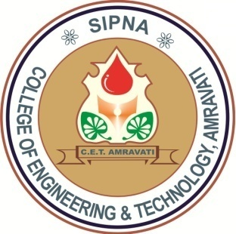

**CERTIFICATE**

*This is to certify that the dissertation titled*

***“Intrusion Detection System For Network Data Security”***

*has been successfully completed in session 2018-19 by*

***Bhushan H. Talan***

*in recognition to the partial fulfillment for the degree of*

***Master of Engineering***

*(Computer Science and Engineering),*

*Sant Gadge Baba Amravati University, Amravati.*

Prof. H. R. Vyawahare Dr. S. S. Dhande

Guide Head of Department

Principal

Sipna CoET, Amravati