Oxima Tabel

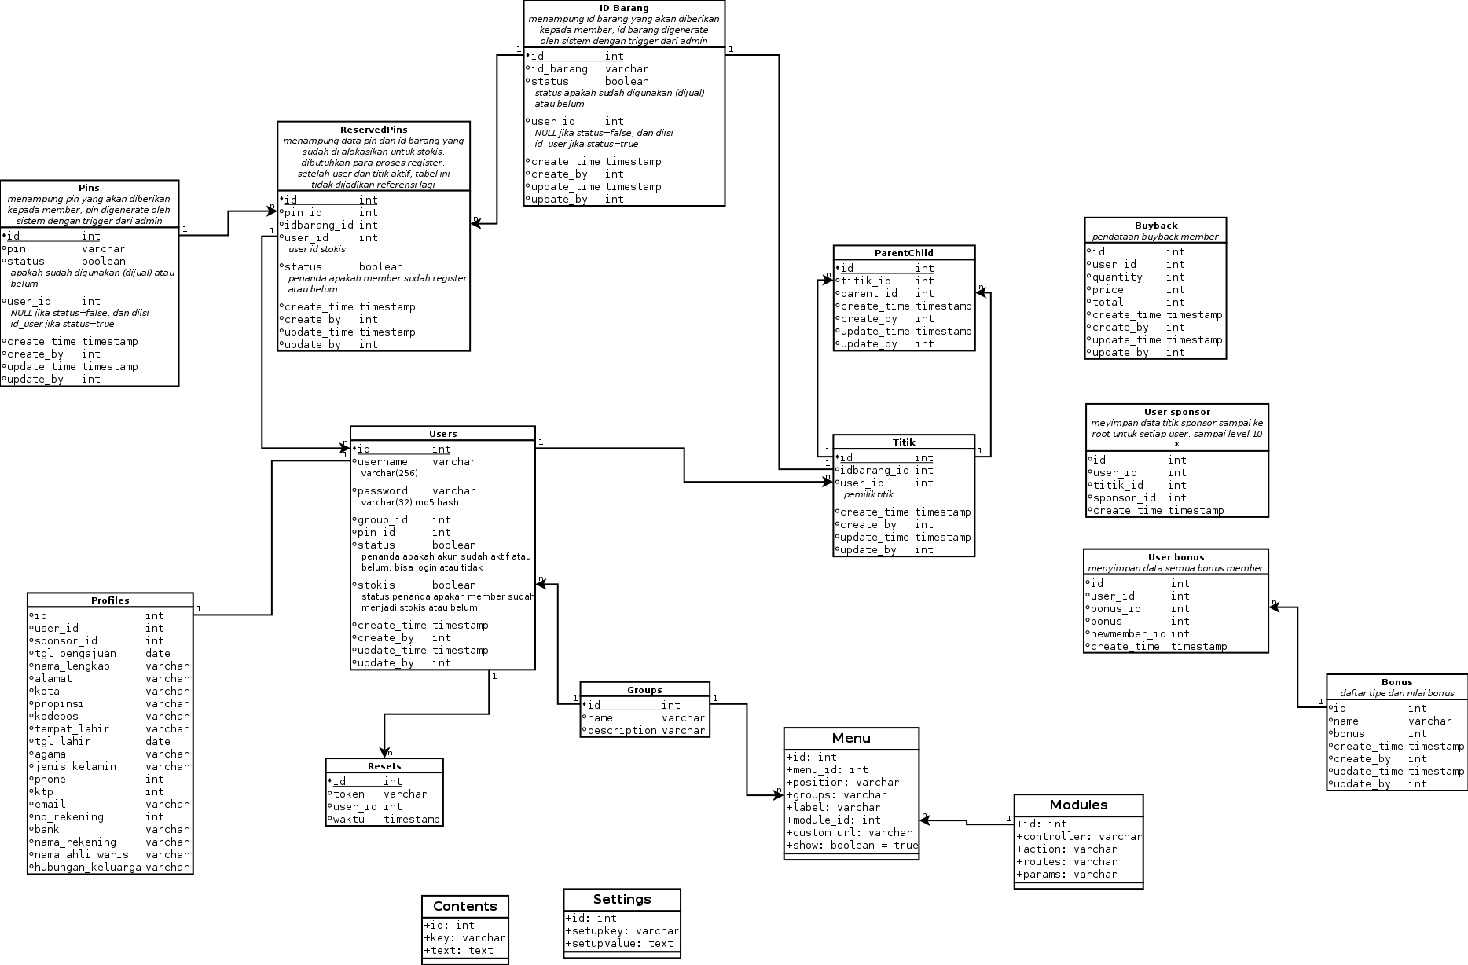

Oxima design

User | Fitur
* | - Register  - Login  - Forget password
Administrator | - Update profile  - Change password  - Websettings  - Create account  - Generate pin & idbarang  - Reserved pins  - Network graph  - Manage users  - Detail member  - Withdraw list  - Report list  - Set/approve buy back  - Manage bonus  - Change sponsor
Operator | - Update profile  - Change password  - Reserved pins  - Network graph  - Manage member  - Detail member  - Withdraw list  - Report list  - Set/approve buy back
Member - Stokis | - Update profile  - Change password  - Reserved pins  - Network graph  - Bonus list  - Bonus withdraw  - Buy back  - Set/approve buy back  - Report person

Register
Proses khusus untuk calon member, prosesnya :
- Pada halaman register disediakan dua input text, input pertama untuk pin yang kedua untuk idbarang.

Login

Forget password

Update profile

Change password

Websettings

Create account
Proses pembuatan akun baik administrator, operator, dan member.

Generate pin & idbarang
Menampilkan daftar pin dan idbarang, juga statusnya. Proses pembuatan pin dan idbarang (jika diperlukan).

Reserved pins
Proses pemasangan pin dengan idbarang

Network graph
Lihat graph jaringan user bersangkutan

Manage users

Detail member

Withdraw list

Report list

Set/approve buy back

Manage member

Bonus list

Bonus withdraw

Buy back

Report person

Manage bonus

Change sponsor

