Cartoon Video Pipeline — How It Works
A plain-language guide for the team — no technical background needed.

What This System Does
This is an automated system that turns a simple idea into a finished, ready-to-post cartoon video — with a person always checking it before it goes live. You give it a title, it makes the video, you approve it, and it posts itself to Instagram.

The Daily Flow — What Actually Happens
Walked through step by step, matching exactly what you'd see on screen at each stage:

Step 1 — An idea goes into the Control Panel

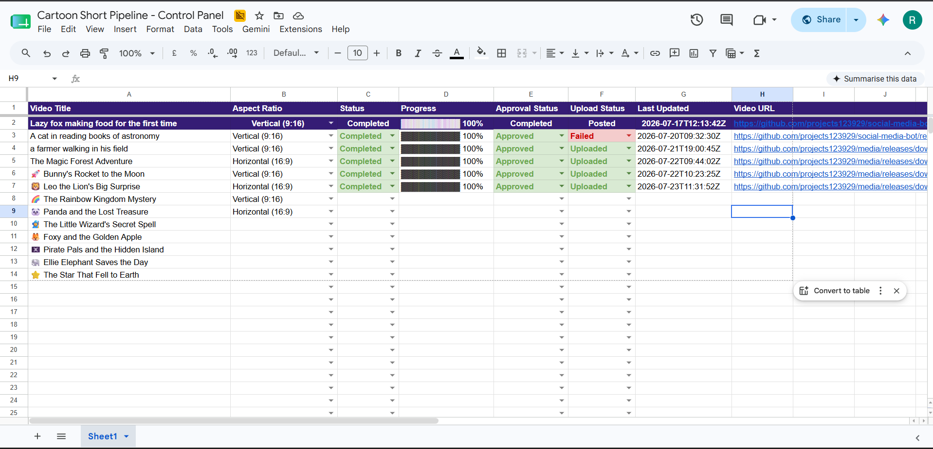
Someone adds a row to the shared Google Sheet, called the "Cartoon Short Pipeline - Control Panel": just a video title (e.g. "a farmer walking in his field") and whether it should be Vertical (9:16, like a phone screen) or Horizontal (16:9). Everything else in that row fills itself in automatically as the video moves through the pipeline — Status, Progress, Approval Status, Upload Status, and a link to the finished video.

Step 2 — A timer checks in every hour

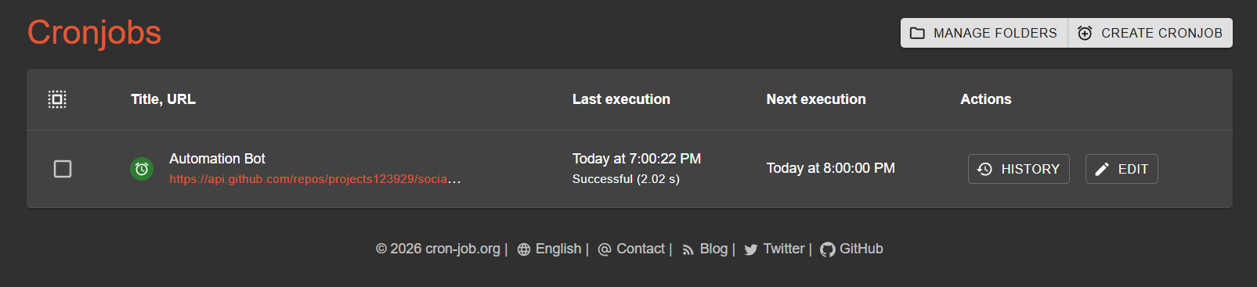
A free scheduling service called cron-job.org acts as the system's alarm clock. Once every hour, it pings the system and asks "is there anything to do?" — checking both for new video ideas waiting in the sheet, and for any approval-email replies that have come in since the last check.

Step 3 — The video gets made (takes about 12-15 minutes)

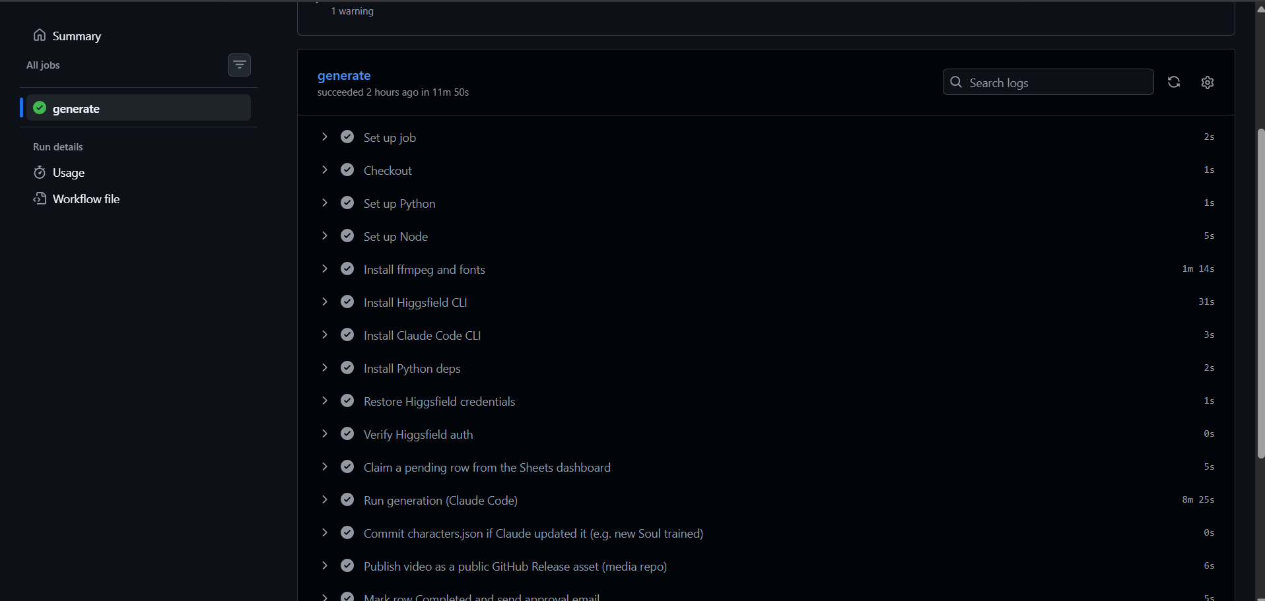
If there's a new idea to work on, the system builds the whole video from scratch: it writes its own mini-script, designs characters, generates the animated scenes, adds captions, and stitches it all together. This whole process takes roughly 12 to 15 minutes per video, start to finish — a real one, timed, took just under 12 minutes end-to-end (about 8 minutes of that was the animation-generation step itself). Only one video is made per day, and not before 11:00 AM.

Step 4 — A review email arrives

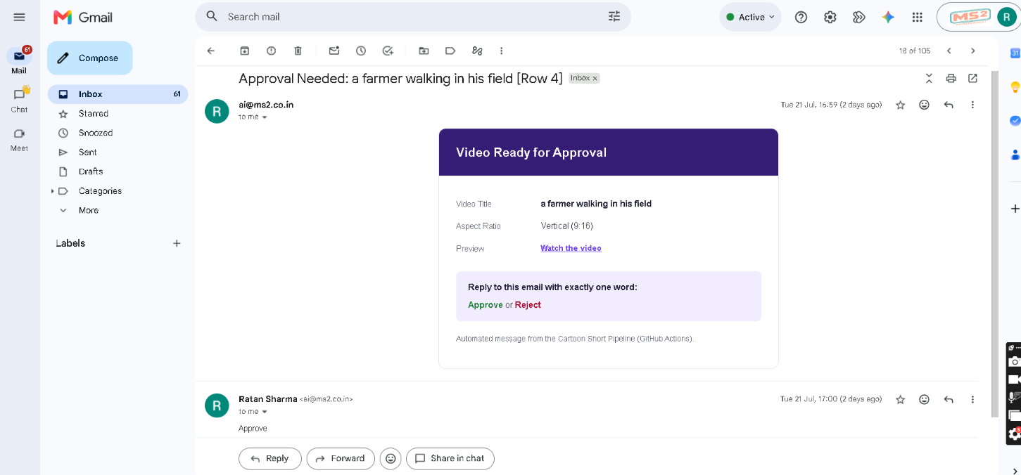
Once the video is ready, an email lands in the ai@ms2.co.in inbox titled something like "Approval Needed: a farmer walking in his field [Row 4]". It shows the video title, the aspect ratio, and a "Watch the video" link to preview it before deciding.

Step 5 — Reply Approve or Reject
Whoever is reviewing simply replies to that email with one word: Approve or Reject. No app, no login, no dashboard — just a normal email reply. The next time the hourly check runs, it reads that reply and acts on it.

Step 6 — It posts itself to Instagram

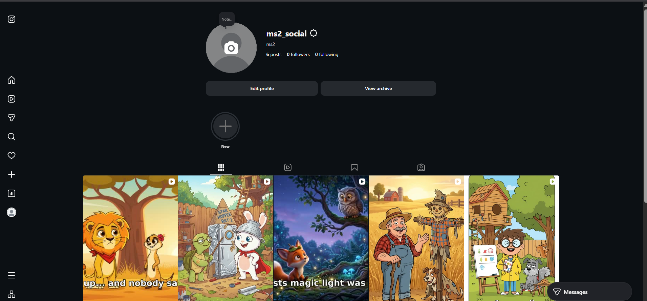
If approved, the video is automatically published to the Instagram account (ms2_social) as a Reel — no further action needed. The Sheet's Upload Status column updates to "Uploaded" once it's live. Several real videos have already gone through this exact process and are live on the account today.

What You Need To Do
- Add new video ideas to the Google Sheet — that's the only "input" step.
- Reply Approve or Reject when the review email arrives.
- That's it. Everything else — writing the script, generating the animation, checking in every hour, posting it — happens without anyone touching anything.

Current Status
Piece | Status
Video generation | Working — ~12-15 minutes per video
Hourly scheduling (cron-job.org) | Working
Email review step | Working
Posting to Instagram | Working — several real videos live on ms2_social
Posting to YouTube | Not built yet
Videos per day | One per day, by design

Things Worth Knowing
Checks happen once an hour, not instantly
The system doesn't watch continuously — it checks in once every hour (via cron-job.org). That means after replying Approve, the actual Instagram post can take up to an hour to appear, not seconds. This was a deliberate choice to keep the system's running costs low.

One video a day, on purpose
Even if several ideas are waiting in the sheet, the system only makes one video per day, and not before 11:00 AM. This is intentional — it keeps costs and review load manageable, not a bug.

The theme/style isn't locked in yet
Right now the system invents a generic, safe idea each time because the team hasn't decided on a specific niche or content style. Once that's decided, it'll start making videos that actually match a real content strategy instead of placeholder ideas.

Occasional manual restart needed
One part of the system (the video-generation service, Higgsfield) needs someone to log back in every few days when its access expires — usually a five-minute fix. If a day goes by with no video and no email, this is the most likely reason.

How to refresh the Higgsfield login (when needed)
1. Open a terminal on the machine that has the Higgsfield CLI installed and run: higgsfield auth login. This opens a browser window to log back in.
2. Once logged in, find the refreshed credentials file at C:\Users\aryan\.config\higgsfield\credentials.json and copy its full contents.
3. Go to the GitHub repository's Settings, then Secrets and variables, then Actions, and update the secret named HIGGSFIELD_CREDENTIALS by pasting in that copied content.
4. That's it — the next scheduled run will pick up the refreshed login automatically.

If Something Looks Stuck
- Check the Google Sheet — the Status and Progress columns will show where a row is stuck, if anywhere.
- If a row has been "In Progress" for a long time with no email, or nothing has updated in over a day, let the technical owner know — it's most likely the access-expiry issue mentioned above, not something wrong with the idea itself.
- No video will ever post without someone replying "Approve" first — there's no way for this system to publish something nobody reviewed.

Where to Find Things
The Google Sheet (add ideas here)
Approval emails arrive at the ai@ms2.co.in inbox.

