Suraksha

Digital Transformation to Indian Police Services

Meghana S1, Pooja C2 , Hemashri R M3

123Department of Computer Science

123Jyothy Institute of Technology

[1meg261995@gmail.com](mailto:1meg261995@gmail.com), [2poojachandrashekar4@gmail.com](mailto:2poojachandrashekar4@gmail.com), [3rmhemashree@gmail.com](mailto:3rmhemashree@gmail.com)

***Abstract*** *-* **With the vision of Digital India programme to transform India into a digitally empowered society with safety of every individual is of highest priority in modern India. This project proposal will be contributing to the information and Communication Technology(ICT) which focuses on enabling effective communication between the citizen ant the police. To increase transparency of Indian Police Services and to boost the public confidence rating, a mobile app that has all-in-one solution to enable secure real-time operational system will be developed as a part of the project proposal. This project proposal enables common man of India to get connected with the police system anytime, anywhere in India with various modules which includes Criminal booking module, Case management module, Forensic module, Investigation module and Traffic monitoring module with accident rescue operations.**

***Keywords –*** *Suraksha, IPS, Mobile APP, Digital Transformation, Police, User/Citizen*

1. **INTRODUCTION**

Digital Transformation is the buzzword today and forever in future making huge impact on the way we live in the society. With the vision of Digital India Programme [1] [2] to transform India into a digitally empowered society with safety of each individual is of highest priority in modern India. To increase transparency in Indian Police Services and to boost the public confidence rating, a mobile app based all-in-one solution to enable secure real-time operational system will be developed as a part of this proposal. This project proposal enables every common man of India to get connected with the police system anytime, anywhere in India. The Indian Police Services has various operational modules which includes Criminal booking, Case management, Forensic, Investigation, Traffic monitoring module and also accident rescue operations. All of these modules of Indian police services are bound in such a way that, it is bonded with common man of the society we are living in. To empower the concept of E-Governance and to transform India into digital India, a mobile application will be developed to make every individual of the country to keep in touch with the police services. The user will be enabled with a login to the mobile app using aadhar number as login ID. On every user registration or login to the app, the details of the user will be recorded in the centralized police system database. User profiles including basic information and a photo has to be uploaded at the very first login. The user will be mapped to the nearest police station automatically from his/her current location through Google map API’s. There will be an explicit option to change the user to police station mapping if required. However the user will get a faster response if he/she gets connected to the police station which is in the area where the user is present. The user will be given with list of options to lodge complaints against, lost mobile phone/sim card, physical assault, exploitation, robbery, fire accidents and also traffic related issues. The moment user requests for any of the services, a tracking ID will be generated to get in touch with the status or response from the police department end. As an instance, a person can lodge a complaint for lost mobile phone with all the details to get the ACK in PDF which can be used to get a duplicate sim card. Also, Police patrolling vehicles can be mapped to any of the complaints based on the severity and user can check for the actions taken by police immediately. Thus, every user will be enabled to keep in touch directly with the police system to use the various police services at finger tips.

1. **EXISTING SYSTEM**

The methodology in which the police system currently uses to solve several issues involves a very tedious process which is very time consuming. The present service basically works as follows, requires a manual method of lodging a complaint [3] [4]. Though there have been many social forums to reach out to police none of them have been very efficient. The service provided by this methodology seems to lose its scope due to several reasons. Some of which are listed below

* Some minor incidents which require manual tracking are ignored.
* Time consuming due to manual documentation.
* Requires long procedures to solve major issues.

1. **NEED FOR DIGITAL TRANSFORMATION IN IPS**

The Indian police service has been serving the country in many ways till now. The IPS consists of police force nominated to protect the welfare of the country. To protect the nation from crime, theft and many other activities these cops bury their sweat off. In every city of each state in India there are innumerable amount of police officers to serve this purpose. They are the only way on which the citizens of the country can rely upon in case of any negative event. The efficiency of the Indian Police Service sometimes lags due to some limitations. The procedure adapted to serve the mankind seems to be a very tedious process when it comes to crime related activities. The problems associated along with this process are time management, miscommunication, lack of knowledge about the event and many more. The main factor is time management. Also, after a person has booked a complaint he/she has to regularly follow the advancement physically which is a tedious process. Hence, here comes the need for digital transformation. Digital transformation in IPS is the use of internet to interact with the police at the time of an event. Since India is a developing country, digital transformation would take the pride of this country to a higher level. Digital transformation ensures safety and security at finger tips. The tedious procedures can be minimized through digitalizing the IPS. As it is known Digital India is all about seeking government services through the internet electronically. Digitalizing the IPS contributes a part to Digital India. A glimpse of this technique would be filing an FIR by the police through internet which reduces time consumption, also the task of the victim to physically appear at the police station regularly. A tracking device will be a part of the digitalizing process as a result any severe case can ensure immediate action. Any accident that has taken place can be reported immediately and the police can arrive at the location through Google map APIs. As citizens of the developing country, it is our responsibility to contribute and cooperate for this purpose. As a result of digitalizing of the IPS, every individual who suspects a crime happening will be free to lodge complaint immediately. Hence digitalization of the Indian Police Service contributes a major part of India acquiring the tag of a “Developed country”.

1. **PROPOSED SOLUTION & IMPLEMENTATION METHODOLOGY**

The proposed solution is in the form of a mobile application (App) which can be used by every citizen of India to get connected to police system from anywhere and anytime. The app user will have login id as AADHAR number with a password. The user has to register for the very first time by uploading all the basic information such as a Name, Date of Birth, a Photo, Permanent residential address and other details.

Soon after the successful registration, the user data will be stored safely in a centralized data base of Indian Police system and these data can only be accessed by police officials.

It is proposed to have a centralized police system throughout the country to which the user can get connected directly and whenever a user logins to the app, user will be automatically mapped from current location to the nearest police station. There will be multiple channels for users to get connected to the police station and the modern police control room for all the requests raised by every individual who is in need for any types of police services.

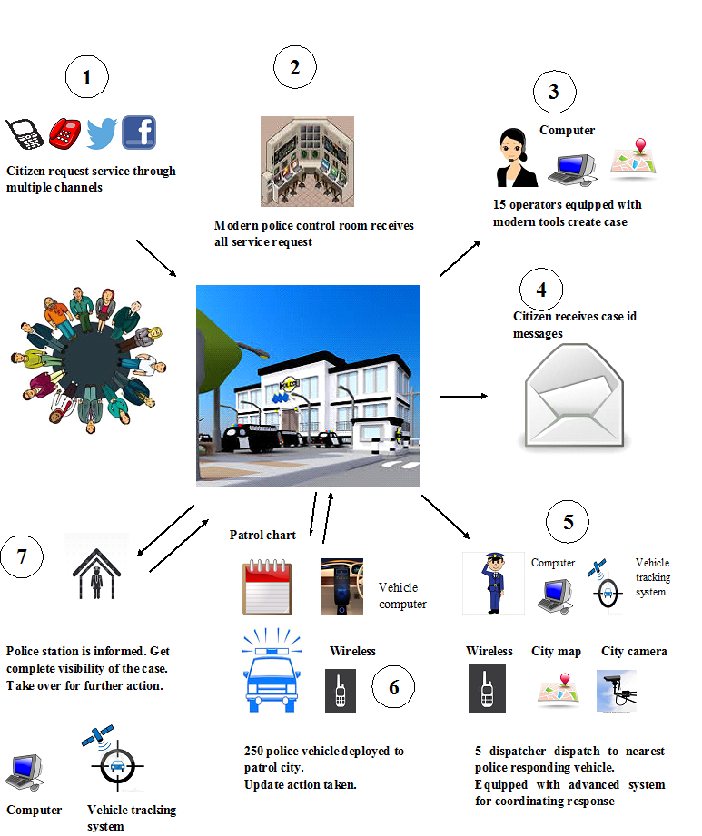

**Figure 1:** Architecture of Centralized Police System

Figure 1 shows the proposed architecture of centralized Police system. The user will have list of options for using the different types of services provided from the police department. At the initial stages of this project implementation, there will be options for registering complaints for lost sim card, theft of vehicles or any belongings, Physical threat or assault, robbery, road side vehicle accidents, fire accidents. Every type of services are given with the priorities and resolved accordingly. The user will be issued with a tracking ID on submission of request for any sort of services and all the requests made by the user will be made reflected in the police systems to take up the case and resolve.

The citizens receive a tracking ID in the app which can be used to track the current status, action taken from police to get the complete solution. The tracking ID’s will be given with a lifespan and police system has to respond to the user request within a particular period of time.

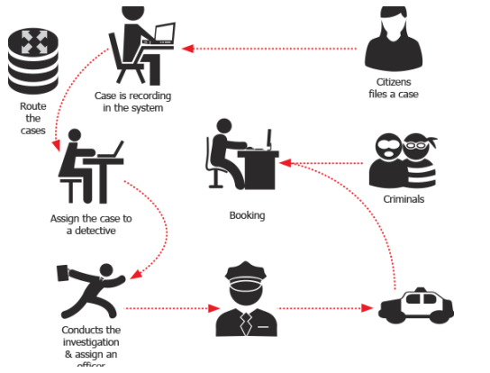

**Figure 2:** Entities of Proposed Digital Police System

If there is no response from any of the officials within the tracking ID expires, the same request or complaint will be made reflected in the higher officials system and hence the severity levels keep increasing as the request moves up in hierarchy or levels of police system. With this plan, the station will be informed completely about particular case of a user for taking the further actions. Based on the severity level of the request or complaint made by user, police system will generate a patrol chart and will assign a patrolling team to take actions and resolve the problem dynamically. The user can use the tracking id to check the current position of the corresponding patrolling team and also track the patrolling vehicle location using the Google map APIs to boost the confidence level and bring the sense of safety. The police system can also deploy CCTV’s across the city and monitor the activities and the videos can be stored in the centralized database and used throughout the county for investigation purpose.

The proposed mobile app will have user friendly interfaces for accessing the services at any point of time and will give complete localization in terms of the languages used by the users, i.e., a user can change the language from English to any local language to access the application easily and effectively.

1. **POSSIBLE OUTCOME**

Due to digital transformation, it has become easier for the public to use the services provided by the Indian Police. It mainly helps to solve the problem of overlapping between the responsibilities held by many police officers, legacy problem, many dysfunctional and communication problems. It also controls the rate of corruption in the society. The user interaction becomes more feasible due to the automatic response from the police department side. As a result of this a quick remedy can be obtained for any problem within a short amount of time. This is not only useful for the public but it also reduces the burden on the police officers. The major outcome is that it provides safety and security to the public in any situation. It also plays a major role to make India a developed country. The different modules that are included solve different type of problems which can be very useful to reduce the crime rate in the society. It gives highest priority to boost the confidence of the public due to the transparency. This increases the responsibility of every individual to make the country digitally improve in all the ways to achieve safety of every individual. Thus a digital transformation is a basic need for our country. Many police officers from rural areas can serve the public as they can improve their knowledge. This brings a revolutionary change in socio-economic activities in the patents of Indian society, the modern age of economic activities and political awakening; the police have to perform arduous task of law and caution. Hence it increases public cooperation and support. The sense of social responsibility is a major

change that we can bring to our country. The creation of awareness among people which makes them protect their surroundings is also a good sign to the society. The task of the police officers becomes easy if the city is free of corruption and that can be achieved by digital transformation. The healthy use of technology can make a common man of India to improve in all aspects and as a result improving the whole country. The drastic changes that can be brought due to digitalization make India a highly developed country that directly affects the country to increase its economy. Thus digitalization is a major requirement to our country.

1. **CONCLUSION**

Emphasizing on the details again, SURAKSHA is designed on android platform for making Indian society digitally empowered with the aid of recent improvements in mobile technology. This application helps tracking the location of the victims through Google map APIs which helps the law enforcement authorities to rescue the person in need as quickly as possible. As stated above, bringing digitalization to Indian Police Services in the Indian society is something that is very much necessary. Digitalization basically enables very efficient and faster methods of communication between the citizens and the police system. As most of the citizens today carry smart phones to wherever they go, with only a few prerequisites this application can be really helpful for personal safety. Suraksha means safety; henceforth enabling safety of every individual of our country at their figure tips is the main aim of this proposal.

**REFERENCES**

[1] <http://www.digitalindia.gov.in/>, The digital India program launched by government of India.

[2] Documentation on transforming India digitally <http://www.digitalindia.gov.in/content/icegov-2017>

[3] Understanding Law enforcement in india <https://en.wikipedia.org/wiki/Law_enforcement_in_India>

[4] Understanding Indian Police Services <https://en.wikipedia.org/wiki/Indian_Police_Service>