**Chapter 1**

**INTRODUCTION**

This chapter gives overview of the project, the problem statement, the proposed solution, the

objective of project and about the organization of report.

* 1. **Overview**

The advancements and developments happening in the field of science and technology has brought a tremendous change in day-to-day life of human being where everything is made smart and anything can be accessed at the finger tips using smart phones via apps. In this aspect, the services provided by the Indian Police Service can also be made smart through digitalization.

In this project, a mobile app will be developed which can be used by the citizens of the country at the time of any unusual event. This app will connect individuals to the police anytime anywhere in the country. The app will have various cases like lost sim card, criminal booking, robbery; location based tracking, physical assault and so on. Any of these can be used by the user to lodge a complaint. As soon as the user logs in the app, he/she will be mapped to the nearest police station according to the location.

There will be two versions of the project, a web view (website) and a mobile view (app). Both user and police information will be stored in a database (Mysql). Apache server will be used to have interaction with the user app developed in android environment.

* 1. **Problem Statement** **and Existing System**

Traditional way of providing service involves literally documenting each and every case manually. Minor cases will be ignored many a times. A citizen has to physically go to the station to track the improvement in the case. All these process are tedious to follow and in this century, digitalization is the go to which is a direct contribution to the Digital India Programme.

* 1. **Proposed Solution**

The proposed solution is in the form of a mobile application (App) which can be used by every citizen of India to get connected to police system from anywhere and anytime. The app user will have login id as AADHAR number with a password. The user has to register for the very first time by uploading all the basic information such as a Name, Date of Birth, a Photo, Permanent residential address and other details.

Soon after the successful registration, the user data will be stored safely in a centralized data base of Indian Police system and these data can only be accessed by police officials.

It is proposed to have a centralized police system throughout the country to which the user can get connected directly and whenever a user logins to the app, user will be automatically mapped from current location to the nearest police station. There will be multiple channels for users to get connected to the police station and the modern police control room for all the requests raised by every individual who is in need for any types of police services.

**1.4 Objective of the project**

The main objective of this project is to bring digital transformation to Indian Police Services in order to provide safety to the citizens at their finger tips. Digitalization will straight away remove the burden of all the manual procedures that are followed today. The developed mobile App will be very helpful to both citizens by providing safety and the police by improving the quality of their service.

**Chapter 2**

**LITERATURE SURVEY**

The purpose of this literature survey is to provide background information on the issues to be

considered in this thesis and to emphasize the relevance of the present study. This Chapter

gives the survey of associated technologies and summary of related work done in the past.

A brief study and survey has been carried out so far to understand various issues related to

the project SURAKSHA which involves, identifying and solving the problems of the citizens throughout the country to realize the frequency and ease the access for people. A detailed study is made on the process of case handling and solving techniques to understand the drawbacks in the already existing police case solving techniques. A survey is made About the police services in India and also on the various online portals that can be used to reach to the police during emergencies .

The detailed study on the police services reveals the Effectiveness of their application or website and likewise, it also depicts the drawbacks of the same.A brief study on the working of Andriod SDK tool is carried out and successfully installed the all prerequisites ( MYSQL, APACHE) required by the tool.

A study on Android App development is made to learn the app development life cycle.

SDK and ADT bundle software’s were successfully installed on windows and a test app in

the name of SURAKSHA is developed. The solution is in the form of a mobile application (App) which can be used by every citizen of India to get connected to police system from anywhere and anytime. The app user will have login id as AADHAR number with a password. The user has to register for the very first time by uploading all the basic information details. After the successful registration, the user data will be stored safely in a centralized data base of Indian Police system and these data can only be accessed by police officials.Whenever a user logins to the app, user will be automatically mapped from current location to the nearest police station. There will be multiple channels for users to get connected to the police station.

**INDIAN POLICE SERVICE OF NATION** :

Police in India is the first agency of the Government to respond to any need of the people. Be it terrorist or insurgent attacks, normal crimes, law and order situations, natural and man-made disasters or provision of emergency humanitarian assistance, the Police is always at the forefront. Police forces around the country thus, provide the most fundamental duty of a government towards its citizens, that of providing a peaceful environment to enable all members of society to live meaningful lives.In meeting these challenges, police officers lay down their lives and perforce neglect the demands of their own families. In the last decade, an average of almost 700 police personnel laid down their lives every year in the line of duty. Since Independence, over 33,000 police men and women have sacrificed their lives, more than any other department of the Government. This website is an attempt to make accessible to the people the work that police forces around the country do to maintain harmony in society. Especially highlighted here are those who have made the supreme sacrifice and the circumstances in which these sacrifices were made.This website is maintained by the DGPs/IGPs Conference Secretariat, Ministry of Home Affairs, Government of India with materials provided by police organisations in every State/Union Territory and at the Centre. A link to the website maintained by each police force is also available here for easy access

**Key Features:**

* The citizens can get an easy access to police of all the states and this access is made available by a scroll bar which consists of police contact details to all the citizens of india for any kind of emergency
* Once the citizen selects the state ,The User is directed to another page which solely consists of the details of the police of that particular state.

**INDIAN POLICE AT YOUR CALL:**

Prime Minister Narendra Modi recently had launched the ‘Indian Police at Your Call’ mobile app at a national police conference held in Hyderabad. It was organised by the Intelligence Bureau (IB). The app is a GIS Map based interface for the citizens to locate police stations near to their current location so that they can easily reach the police station in case of emergency.  
**Key Features:**

* The app was developed by Nation Information Centre (NIC). It has been developed on Android and iOS platforms
* . It was launched as part of the Digital India initiative aimed at the safety and security of the citizen anytime anywhere.
* The app provides the names of the police stations, distance from the place where you are and how much time it will take to reach police station one wants to go to.
* It provides the police station number, number of control room and also the SP office number. However, no mobile phones numbers are provided. It also promotes facility to “Tap to Call” any of these police stations and know the route and road distance to reach there.

**Bangalore City Police(BCP):**

Bangalore City Police (BCP) is another online police help center maintained by the police of bangalore. The BCP website consists of various helplines to name a few, Lost Report, Offenders ,Lost Vehicles, Find your police station, Women's helpline and child helpline .

This particular website solely focuses on the native bangalore people and helps the individuals living here to safe and connected to the police.

**WORKING OF IPS:**

**Indian Police: The Context**

The term police has been derived from the latin word politia which means the condition of a Polis or State. According to Oxford dictionary, the term police means a system of regulation for the preservation of order and enforcement of law; the internal government of State (Kalia, 1995). The term broadly refers to purposeful maintenance of public order and protection of persons and property, from the hazards of public accidents and the commission of unlawful acts. It refers to civil functionaries charged with maintaining public order and safety and enforcing the law including the prevention and detection of crime (Ghosh & Rustamji, 1993). India is multi-cultural, multi-ethnic and vast country. It is the second most populated country of the world. Maintaining law and order in world’s largest democratic country is an arduous task. The police personnel provide for the security of people and enforcement of laws of the country. It determines the manner in which democratic decisions are implemented in the country. In view of the growing violence, social conflicts and serious threats of terrorist activities, the role of police is becoming even more important. The assurance of equality and dignity to the weaker sections of the society is also dependent upon the performance of the police. Clearly, police has a crucial role in the existence and development of India.

**Indian Police Services(IPS):**

IPS is short for Indian Police Service. It is one of the three all-India services of the government of India; the other two being the Indian Administrative Service (IAS) and the Indian Forest Service (IFS). It is a general pool from which police officers are drawn and sent out to serve in senior posts all over the country.

IPS officers in India work as senior police officers. IPS officers maintain public peace and order, prevent crime, investigate, collect intelligence, provide security to VIPs, and tackle terrorism and a range of other crimes. Paramilitary forces like the Central Reserve Police Force (CRPF), the Border Security Force (BSF), the Assam Rifles, the Indo-Tibetan Border Police (ITBP) and the National Security Guard (NSG) are armed policing organisations established for special duties by the central government. They are structured along the lines of the army and thus called paramilitary. They help the police in counterinsurgency or anti-terrorist activities and in moments of civil unrest.  
As an IPS officer, you can go on to work in and even lead the Indian intelligence agencies such as Research and Analysis Wing, Intelligence Bureau, Central Bureau of Investigation, Crime Investigation

**Law enforcement in India** is performed by numerous Law enforcement agencies. Like many nations, the nature of the Constitution of India mandates law and order as a subject of the state, therefore the bulk of the policing lies with the respective of state and union territories of India.At the federal level, the many police forces  are part of the Services, and support the states in their duties. Larger cities also operate Metropolitan forces, under respective state governments. All senior

IPS officers in India work as senior police officers. IPS officers maintain public peace and order, prevent crime, investigate, collect intelligence, provide security to VIPs, and tackle terrorism and a range of other crimes. Paramilitary forces like the Central Reserve Police Force (CRPF), the Border Security Force (BSF), the Assam Rifles, the Indo-Tibetan Border Police (ITBP) and the National Security Guard (NSG) are armed policing organisations established for special duties by the central government. They are structured along the lines of the army and thus called paramilitary. They help the police in counterinsurgency or anti-terrorist activities and in moments of civil unrest.  
As an IPS officer, you can go on to work in and even lead the Indian intelligence agencies such as Research and Analysis Wing, Intelligence Bureau, Central Bureau of Investigation, Crime Investigation.The police have all sorts of different powers, all of which are given by law and they must use them only according to the procedure laid down in the law. So they can make arrests, carry out search and seizures, investigate offences, question witnesses, interrogate suspects, disperse unruly crowds and maintain order in society, but they have to do it strictly in the way the law lays down and not any other way. They cannot act just as they wish or want to. Any abuse of power or negligence of duty will amount to a breach of discipline, civil wrong or a crime and the police officer is liable to be punished.Each state has its own police force under the control of the government of that state. So there are many police forces in the country. Police that work in parts of India that are directly under the control of the central government like the capital Delhi, Chandigarh, Puducherry, Daman and Diu, Lakshwadeep Islands, Dadra and Nagar Haveli and Andaman and Nicobar Islands come under the control of the central government.

IPS is short for Indian Police Service. It is one of the three all-India services of the government of India; the other two being the Indian Administrative Service (IAS) and the Indian Forest Service (IFS). It is a general pool from which police officers are drawn and sent out to serve in senior posts all over the country.

2.3 Present Organizational Structure of Police According to article 246 of the Indian Constitution and section 3 of the IPA, the police force is a state subject and not dealt with at central level. Each state government has the responsibility to draw guidelines, rules and regulations for its police force. These regulations are found in the state police manuals (Commonwealth Human Right Initiative Report, 2005). The organizational structure of police forces in India is fairly uniform in all the states throughout the country. The broad set up of police organization in a state is shown in the figure 2.1. State police works under the overall control of State Government (CHRI, 2005). The head of the police force in a state is the Director General of Police DGP). DGP is responsible to the state government for the administration of the police force in the state and for advising the government on police matters. The state is further divided into several zones, ranges and districts (Martensson, 2006). An officer of the rank of Superintendent of Police (SP) heads the district police force. *' A group of districts form a range, which is looked after by an officer of the rank of Deputy Inspector General of Police (DIGP). DIGP guides, advices and assists the SP through regular visits and inspections. Some states have zones comprising two or more ranges. Zones are the areas which are under the charge of an officer of the rank of an Inspector General of Police (IGP) (CHRI, 2005). The districts are again divided into sub-divisions, circles and police stations (Martensson, 2006). A sub-division is under the charge of an officer of the rank of Additional or Deputy Superintendent of police (ASP/ Dy. SP). Every sub-division is further divided into a number of police stations, depending on its area, population and prevalence of crime. The police station is headed by the station in charge of the rank of Inspector/Sub-Inspector. Each police station is further divided into a number of beats assigned for patrolling, surveillance and collection of intelligence. District police is divided into two major branches of police force i.e. the armed police and the civil police. The primary function of the civil force is to control crime, while the primary function of armed police is to deal with law and order situation. Armed police is the reserve police of the district. The force is kept reserved to meet any emergency situation. Armed police and civil police supply material and officers to the other branches. Therefore, these two branches constitute the most visible part of the force .In addition to civil and armed forces there are departments like detective police, traffic police revenue police, mounted police, fire police, and technical branches like prosecution branch, radio branch and intelligence police.

Police and Public Order are state subjects, but this does not minimize the role of Central Government in Police administration. Constitution of India empowers the Central Government to intervene in some situations or perform special function in police matters. For example, Article 355 specifies that it is the duty of the Centre to protect the states against internal disturbances and to ensure that the governance of every state is carried on in accordance with the provisions of the Constitution.

An important power with Central Government is the appointment of IPS (Indian Police Services) officers. Section 3 of the All India Services Act, 1951 empowers the central government, after consultation with the state governments, to make rules for the regulation of recruitment and the conditions of service of persons appointed to an all India service including IPS. The senior duty posts are called cadres and generally the cadre posts are filled with IPS officers. The central government periodically reexamines the strength and compositions of each cadre in consultation with state government and makes such alteration therein as it deems fit.

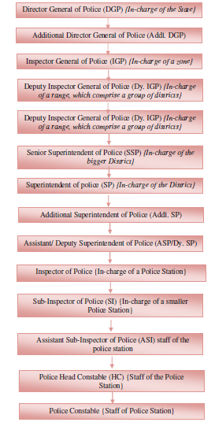

The duty of an IPS officer is mainly related with law and order, detection of crime and prevention, Control of traffic, Management, and prevention of accident etc.IB, RAW, CBI etc are also the job which IPS officer will get a chance to act.

Objective With the passage of time Indian Police Service's objectives were updated and redefined, the current rules and functions of an Indian Police Service Officer are as follows: • To fulfill duties based on border responsibilities, in the areas of maintenance of public peace and order, crime prevention, investigation, and detection, collection of intelligence, VIP security, counter-terrorism, border policing, railway policing, tackling smuggling, drug trafficking, economic offences, corruption in public life, disaster management, enforcement of socio-economic legislation, bio-diversity and protection of environmental laws etc. Leading and commanding the Indian Intelligence Agencies like Research and Analysis Wing (R&AW), Intelligence Bureau (IB), Central Bureau of Investigations (CBI), Criminal Investigation Department (CID) etc., Indian Federal Law Enforcement Agencies, Civil and Armed Police Forces in all the states and union territories. Leading and commanding the Central Armed Police Forces (CAPF) which include the Central Police Organisations (CPO) and Central Paramilitary Forces (CPF) such as Border Security Force (BSF), Central Reserve Police Force (CRPF), Indo-Tibetan Border Police (ITBP), National Security Guard (NSG), Central Industrial Security Force (CISF), Vigilance Organisations, Indian Federal Law Enforcement Agencies. Serve as head of the departments in policy making in the Ministries and Departments of Central and State Governments and public sector undertakings both at centre and states, Government of India. To interact and coordinate closely with the members of other All India Services and also with the Indian Armed Forces primarily with the Indian Army. Last but not the least, to lead and command the force with courage, uprightness, dedication and a strong sense of service to the people. Endeavour to inculcate in the police forces under their command such values and norms as would help them serve the people better. Inculcate integrity of the highest order, sensitivity to aspirations of people in a fast-changing social and economic milieu, respect for human rights, broad liberal perspective of law and justice and high standard of professionalism.

**Developing Android Application**

There are many platforms available for mobile devices. Every platform has its own pros and

cons, Having said that the below listed are a few main platforms for development of an application.

* Windows phone
* iPhone iOS
* Blackberry OS
* Android

**Why Android?**

* Freely available Software Development Kit.
* Supports too many hot technologies.
* Free and open source.
* Familiar language, familiar development environments.
* Android is supported by dozens of hardware manufacturers.
* Familiar and inexpensive development tools.

**2.5.1 Setting up the Android Development Environment**

Step 1: Setup Java Development Kit (JDK)

Step 2: Configure Android SDK

Step 3: Setup Andriod studios IDE

Step 4: Setup Android Development Tools (ADT) Plugin

Step 5: Create Android Virtual Device

**2.5.2 Testing**

Testing is as important as developing the app. SDK tools can also help set up and test

applications. SDK will help you test different aspects of your app no matter if you are

planning on running your tests within an emulator or any Android device.

ADT is comparatively easier than the other tools. ADT is used to create a test project and link

it to the application under test.

**Chapter 3**

**SOFTWARE REQUIREMENT SPECIFICATION**

Software Requirement Specification document describes the intended purpose and the environment for the application to be developed as a part of the project and this document specifies how a system has to perform without any unexpected outcomes.

The SURAKSHA application which would be developed will focus to bring Digital Transformation to Indian Police Services by making the services available electronically where the user will be able to login to the application using Adhaar number as login credential.

The project includes the following sections such as

1. **Development Phase**
2. **Deployment Phase**
3. **Maintenance Phase**
4. **Development Phase**

* Development Phase describes the programming tools used to create the application. The developer would be connected to the computer system during the process of developing the application SURAKSHA.
* The below section explains the functional requirements and non-functional requirements that are taken into consideration for developing the application.

**1.1 Functional Requirements**

This module includes the following stages of development:

* **Login Page**
* **Sign up Page**
* **Home Page**

**Login Page:**

Login page comprises of an Adhaar Number as the user login and it is followed by a user unique password.

It can be used only if the citizen has already registered for the application usage.

**Sign up Page:**

Sign up page enables the user to register for the usage of SURAKSHA application. The provisos for the registration process are:

* **Name**
* **DOB**
* **Gender**
* **Permanent residential address**
* **Adhaar number**
* **Photo**

All these details must be submitted during the registration.

**Home Page:**

The home page consists of various modules that the user would want to use based on their emergency. The modules that are enlisted in the application at the preliminary stages are lost sim, robbery, physical assault, accident and location based tracking.

**Lost Sim Card Case**

Every module consists of two sides,

* **User side**
* **Police side**

The features of user and police side for lost sim card case will be as explained below:

**• User side**: The user is required to fill details such as Name, Service provider, Sim card number, lost location. Once the user has submitted all the details, the police end receives the request as a pop up box.

**• Police side**: As soon as the police side receives the request, based on the severity the action would be taken. A unique case ID and tracking ID is generated for each case. Google map API’s are used to track down the emergency location.

**Hardware specifications**

* The system which is used to develop the application is compelled to have the following hardware requirements

**System** : Laptop or Personal Computer

**Processor** : Dual core i3 with 1.70 Gigahertz speed

**RAM** : 4 Gigabytes

**Storage** : 50 Gigabytes

**Software specifications**

* The developer will work on the following set of software tools listed below:

**Operating** **System** : Windows 7 and above

**Software** : Android studio version 2.1.2

**Package** : Java Development Toolkit

**Languages** : Java, XML

**1.2 Non Functional Requirements**

* The Non Functional requirements for the application that will be developed will have the following factors:

**Compatibility**: It is the property where software runs on multiple platforms without any conflicts. The developed application is intended to support multiple Operating Systems like Windows, Linux and Mac Operating System.

**Availability**: It is the degree to which the identified system will be in an operable and committable state. SURAKSHA will be available at any time round the clock.

1. **Deployment Phase**

* The Deployment Phase in this project is the mobile device, where the developed SURAKSHA application will be made live and the system which runs the application will have the following requirement specifications.

**2.1 Functional requirements**

**Hardware specifications**

**System** : Smart phones

**Processor** : Dual core with 1.20 Gigahertz speed

**RAM** : 1 Gigabyte

**Storage**  : 4 Gigabytes to 8 Gigabytes

**Software specifications**

**Operating** **System** : Lollipop and above versions

**Software** : SURAKSHA

**2.2 Non functional requirements**

* **Availability**: Availability of any software gives the meaning that the software runs most of the time. The application SURAKSHA will be available at any random point of time.
* **Reliability**: It is the ability in which a developed tool produces stable and consistent results. The application will be bound to its reliable nature.
* **Portability**: It is task of doing any work necessary to make the computer program run in a new environment. The application will work on Android/Mac/Windows phones.
* **Usability**: It is the ease of use and learnability of software developed. SURAKSHA will have a simple user interface.

1. **Maintenance Phase**

* Maintenance Phase is the third part of this project which briefs about the interaction between user and the system which gets reflected on the police system server.
* The specifications required for the server to react as per the application’s need are given in the following section.

**3.1 Functional Requirements**

**Hardware specifications**

**System** : Laptop or Personal Computer

**Processor** : Dual core i3 with 1.70 Gigahertz speed

**RAM** : 4 Gigabytes

**Storage** : 1 Terabyte

**Software specifications**

**Operating** **System** : Windows 7 and above

**Server** : Apache 2.4

**Database** **Management** **System** : Mysql

**Integrated** **Development** **Environment**: Netbeans 8.1

**Languages** : JavaScript, Perl, PHP, SQL

**3.2 Non Functional Requirements**

**Maintenance**: It is the process of preserving a state of condition. In the developed application, the details of the user and the police are maintained in a centralized database.

**Security**: It is the attribute which specifies how safe the system is. SURAKSHA will have a password to login for both user and the police as the security credential.

**Chapter 4**

**DESIGN**

In this chapter, the architectural design is presented first and then the functional architecture overview, followed by a detailed description of module diagrams, sequence diagrams and use case diagrams.

**4.1 Architecture**

The below illustrates an overview of the User interactions with the Police sytems Using the SURAKSHA app. The various programmable modules are deployed in different parts of the mobile app. All these Modules are built for various emergencies and the user can select the appropriate service based on the requirement. The system along with Programmable modules in the application has all these modules available in the Official Website of the Application. The data which is recieved by all these modules will be extracted and stored in MySQL database. This is done using apache server, where php code is used to store values on server and html is used to display values on the web page. The processed data is stored in MySQL database and retrieved through an android app. These stored data will be retrieved by php from the database using an android app which displays both on the user side and police side respectively and indicates the status of the case lodged. Thus, acts as Good interface between the user and the police enabling the user to monitor a few emergency situations at his fingertips via suraksha.

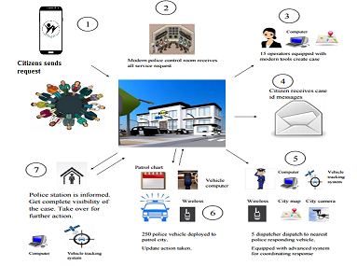

1. **Block Diagram**
   * Block diagram is a diagram of a system in which the principle parts are represented by blocks connected by lines that show the relationships of the block.
   * They are typically used for higher level, less detailed descriptions that are intended to clarify over all concepts without concern for the details of implementation.
   * The below figure shows the block diagram of Suraksha.

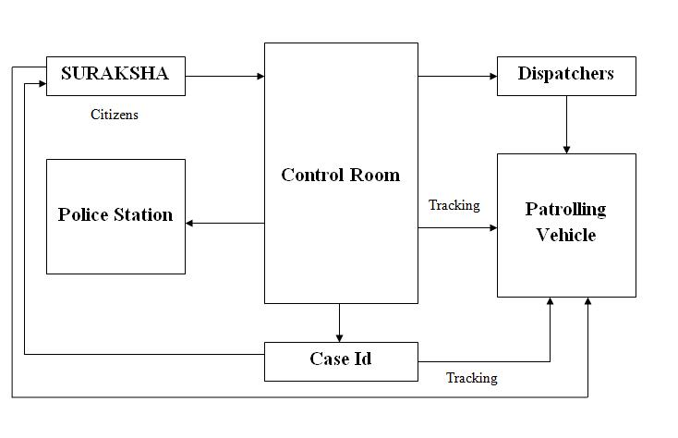

**Suraksha:** A citizen who becomes a victim to any the negative events, shall login to theapplication and ask for services.

**Control Room:** There will be certain officials/operators in the police control room who willreceive all these requests. The requests will be listed in order of their severity. The operators will assign a particular case to a group of dispatchers. For every case, a case-id will be generated.

**Dispatchers:** As soon as they are assigned to a case, they dispatch in their patrolling vehicleto the location where the incident has taken place.

**Patrolling Vehicles:** Each patrolling vehicle will have GPS installed; its location can betracked by the operators in the control room and by the victim on the application.

**Case ID:** For every case, the operators create a case-id, which will be given to the dispatchersin the patrolling vehicle and to the victim on the application. Each case-id will have a lifespan. If the case is not solved within that lifespan, it will be automatically passed on to the higher officials.

**Police Station:** Once the case is solved, the operators in the control room inform in the policestation about it. The police in the police station will have complete visibility of the case. In case any further action is needed, it will be taken.

1. **Dataflow Diagram**
   * It is a traditional representation of how information flows within a system.
   * It helps us to know about the good amount of system requirements graphically.

**2.1 Level 0**

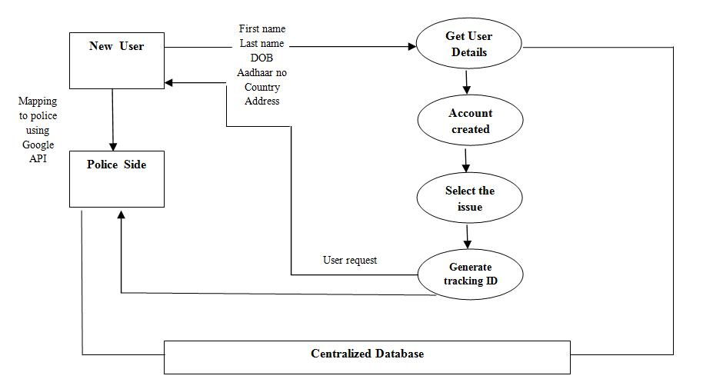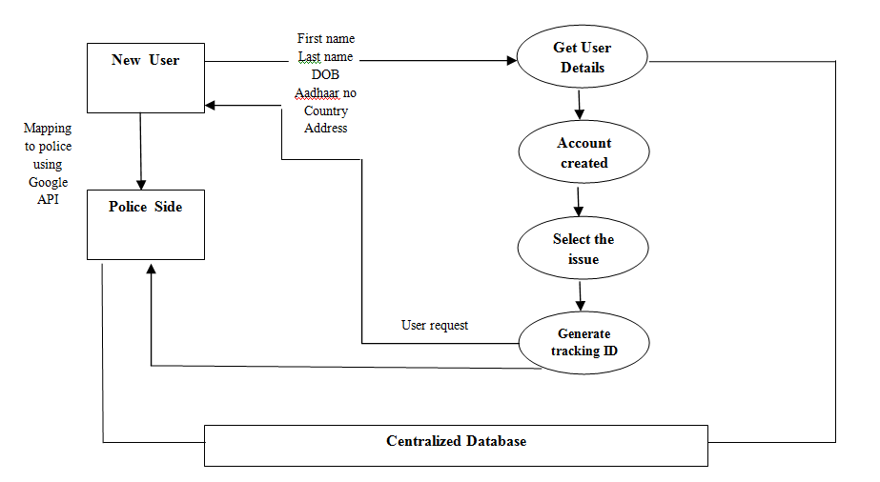

**Figure 2:** User and Police registration

* The level 0 of a dataflow diagram is a simple representation of the whole system.
* When a user creates an account with his basic details and once the account is created he can select the type of issue or the incident that has taken place.
* The user is connected to nearest police station using Google Map API’s and a tracking  ID is generated for each user.
* Every user record is reflected on the police system which will be recorded in the Centralized Database.

**2.2 Level 1**

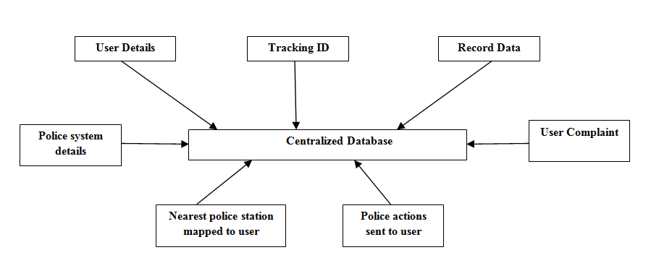

**Figure 3:** Connection to centralized DB

Level 1 contains the lower level functions decomposed from major functions.

**2.3 Level 2**

Each process in level 1 diagram is investigated in more detail to give a greater understanding of the activities and data flow. Normally processes are decomposed where:

* There are more than six data flows around the process.

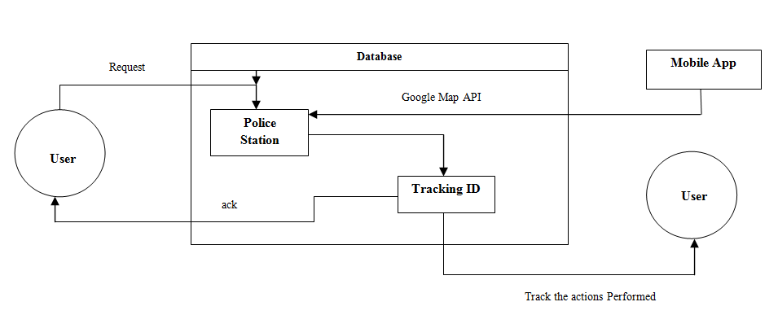

**Figure 4:** Solving the case

* + - The process name is complex or very general which indicates that it incorporates a number of activities.

1. **Sequence Diagram**
   * A sequence diagram shows the interaction between the objects. It also shows in what order the operation is performed.

The sequence diagram for Suraksha is as follows

* When the user logs in, he/she requests service through the app.
* The app is connected to the server through which the requests are monitored by the police control room.
* For each request, a case id is generated which is sent to the user and the patrolling vehicles at the same time.
* If the time span of the case id expires, it is forwarded to the higher officials.
* If not, the user and the control room can track the patrolling vehicle through this case id.
* These vehicles reach the destination and monitor the case further
* Once the case is closed, a finished report is send to the app.
* The user logs out.

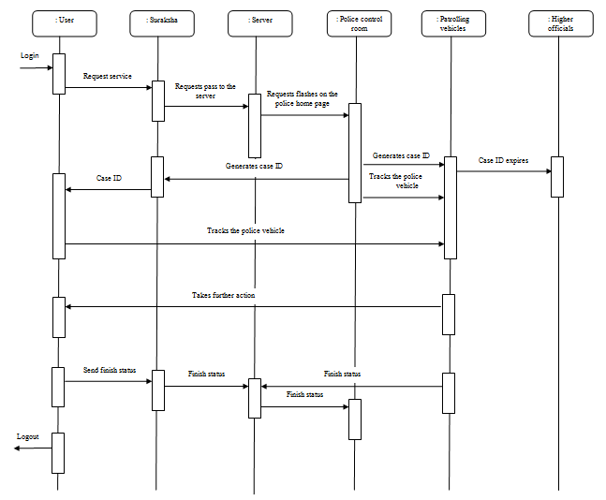 **Figure 5:** Sequence diagram for Suraksha

1. **Use Case Diagram**

Use case is a list of actions that defines the interaction between a role and a system.

Below figure shows different use case diagrams.

**Level 0**

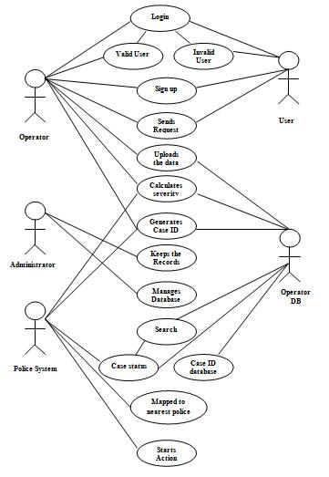

**Level 1**

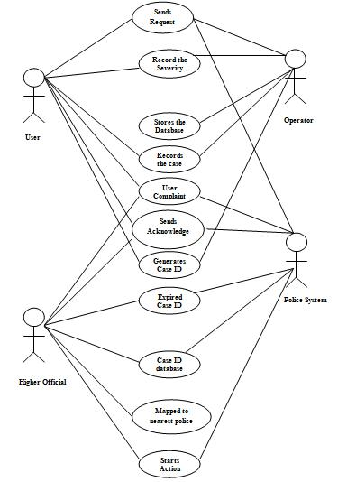

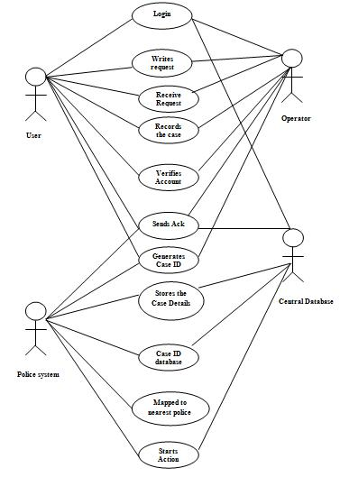

* Use Case: Registration and login through Suraksha Application
* Actors: User, Operator, Operator Database, Administrator, Police system.
* Description: The user sends a request through the Suraksha App for any kind of emergency situation. The operator receives the request and verifies if the user is valid or invalid.
* If valid, lets the user login or else the user has to register themselves. Once the service request is received the system admin classifies the case based on the severity. A unique case id is generated for each case and further actions are taken based on the case requirements. If the case Id expires then the case is transferred to higher officials. The user is able to track the police vehicle using the Google map API.
* Cancelled: If the user cancels the request by using the cancel option and in this case the app resets itself.
* Insufficient Information: If the user provides insufficient information then app does not let the user proceed any further.