Ultra-Precision Current and Voltage Measurement System

ABSTRACT
This report presents the design and development of an ultra-precision current and voltage measurement system for embedded applications. The system, built around an STM32F411CEU6 Blackpill development board with an ADS1115 16-bit ADC, is capable of measuring voltages from 1V to 12V with 0.1V resolution and currents from 1µA to 100mA using a three-range shunt resistor method (5Ω, 8Ω, and 10Ω). A 3P4T rotary switch enables manual range selection. Measurements are displayed in real-time on an SH1107 128x128 OLED and simultaneously transmitted via UART to a PC for data logging. The project documents the team's journey through various challenges including failed op-amp current sensing attempts, ESP32 WebSocket implementation failures, and SD card integration issues, ultimately achieving a working system that meets all core specifications with minimal impact on the Device Under Test (DUT).

TABLE OF CONTENTS
- Introduction
- Hardware Design and Components
- Voltage Measurement Circuit
- Current Measurement Circuit Development
- Shunt Resistor Working Principle
- Capacitor Usage and Filtering
- ADC Interface (ADS1115)
- Power Supply System
- Rotary Switch Range Selection
- Data Output and Communication
- System Integration and Pin Configuration
- Project Timeline
- Challenges and Lessons Learned
- Conclusion

1. INTRODUCTION
1.1 Project Background
Precision measurement of current and voltage is fundamental to embedded systems, particularly in applications such as sensor characterization, battery monitoring, and low-power device testing. Measuring tiny currents down to 1µA and voltages up to 12V with high accuracy while minimally impacting the Device Under Test presents significant engineering challenges.

1.2 Project Objectives
- Develop a highly accurate current measurement system from 1µA to 100mA with appropriate resolution
- Develop a precise voltage measurement system from 1V to 12V with 0.1V resolution
- Implement data logging functionality with minimal impact on the DUT
- Display measurements in real-time
- Ensure high accuracy while minimizing intrusion
- Demonstrate well-designed hardware and firmware
- Identify limitations and propose solutions

1.3 Scope
This project focuses on DC measurements within the specified ranges. The system provides real-time display via OLED and data logging via UART to a PC. Wireless transmission via ESP32 and SD card logging were attempted but ultimately failed within the project timeline.

2. HARDWARE DESIGN AND COMPONENTS
2.1 Components List
Component | Specification / Part Number | Quantity | Purpose
Microcontroller | STM32F411CEU6 Blackpill Development Board | 1 | Main processing unit
ADC Module | ADS1115 16-bit (I2C) | 1 | Analog to digital conversion
OLED Display | SH1107 128x128 (1.5 inches) | 1 | Real-time data display
Buck Converter | LM2596 | 1 | Voltage regulation
Battery | 3.7V Li-Ion (18650) | 2 | Power supply (series = 7.4V)
WiFi Module | ESP8266 | 1 | Wireless data transmission (attempted)
SD Card Module | MicroSD Card Module (Arduino compatible) | 1 | Data logging (attempted)
Rotary Switch | 3P4T (3 Pole, 4 Throw) | 1 | Current range selection
Shunt Resistor | 5Ω | 1 | Current sensing - Range 1 (100mA-20mA)
Shunt Resistor | 8Ω | 1 | Current sensing - Range 2 (20mA-2mA)
Shunt Resistor | 10Ω | 1 | Current sensing - Range 3 (200µA-1µA)
Voltage Divider Resistors | 22kΩ | 4 | Voltage sensing (1V-12V to 0-3V)
Op-Amps (Attempted) | LM358, MCP6002 | 2 each | Current sensing (failed attempts)
Ceramic Capacitors | 0.1µF | 4 | ADC input filtering (A0, A1, A2, A3 to GND)
Power Switch | ON/OFF Toggle Switch | 1 | System power control

3. VOLTAGE MEASUREMENT CIRCUIT
3.1 Design Evolution
The team went through three iterations of voltage divider design to minimize loading on the DUT:

Attempt | Resistors | Total Resistance | Current from DUT at 12V | Status
1 | 4 × 330Ω | 1.32kΩ | 9.1mA | FAILED
2 | 4 × 10kΩ | 40kΩ | 0.3mA | IMPROVED
3 | 4 × 22kΩ | 88kΩ | 0.136mA | OPTIMAL

3.2 Final Voltage Divider Configuration
The final design uses four 22kΩ resistors in series connected across the DUT. The voltage is tapped from the junction of the third and fourth resistor, providing a 4:1 division ratio. This divided voltage is fed to ADS1115 channel A0 with a 0.1µF capacitor to ground for filtering.

3.3 Specifications
Parameter | Value
Division Ratio | 4:1
ADC Input Range | 0V (at 0V DUT) to 3.0V (at 12V DUT)
Loading Current | 136µA maximum
Power Dissipation | 1.64mW @12V
Filtering | 0.1µF capacitor across ADC input

3.4 Why Higher Resistor Values Improve Precision
Factor | 330Ω | 10kΩ | 22kΩ | Benefit
DUT Loading | 9.1mA | 0.3mA | 0.136mA | Minimal impact on DUT
Loading Error | High | Moderate | Minimal | True voltage measurement
Self-Heating | Significant | Low | Very Low | Stable resistor values
Impact on DUT | Unacceptable | Acceptable | Excellent | Meets specification

4. CURRENT MEASUREMENT CIRCUIT DEVELOPMENT
4.1 Failed Attempt: Op-Amp Based Sensing
During Week 1, the team attempted current measurement using operational amplifiers (LM358 and MCP6002). Both attempts failed due to instability and noise issues.

Issue | LM358 | MCP6002 | Description
Output Fluctuations | Severe | Moderate | Unstable readings
Offset Voltage | ±3mV | ±1.5mV | Significant error at low currents
Input Bias Current | 50nA | 1pA | LM358 unusable for µA ranges
Noise Pickup | High | Moderate | 50/60Hz interference
Stability | Poor | Better but unstable | Couldn't achieve stable readings

4.2 Successful Solution: Shunt Resistor Method
After op-amp failures, the team successfully implemented a shunt resistor method with range selection. Current is measured by placing precision shunt resistors in series with the DUT. A 3P4T rotary switch selects the appropriate shunt based on the expected current range.

Configuration:
- Position 1: 5Ω shunt for 100mA - 20mA range
- Position 2: 8Ω shunt for 20mA - 2mA range
- Position 3: 10Ω shunt for 200µA - 1µA range

The voltage drop across the selected shunt is measured differentially using ADS1115 channels A1 (+) and A2 (-).

5. SHUNT RESISTOR WORKING PRINCIPLE
5.1 Fundamental Principle
The shunt resistor method is based on Ohm's Law (V = I × R), where a precision resistor of known value is placed in series with the load, and the voltage drop across it is measured to determine the current:
I = Vmeasured ÷ Rshunt

5.2 Shunt Resistor Calculations
Range Shunt Current Range Voltage Drop Power Resolution
1 | 5Ω | 100mA - 20mA | 500mV - 100mV | 50mW | 10µA/LSB
2 | 8Ω | 20mA - 2mA | 160mV - 16mV | 3.2mW | 6.3µA/LSB
3 | 10Ω | 200µA - 1µA | 2mV - 10µV | 0.4µW | 0.3µA/LSB*
With PGA Gain=16

5.3 ADS1115 Programmable Gain Amplifier (PGA)
PGA Setting | Max Input | Resolution | Used For
Gain = 1 | ±4.096V | 125µV/LSB | Range 1, 2
Gain = 16 | ±0.256V | 7.8125µV/LSB | Range 3

5.4 Advantages of Shunt Resistor Method
Advantage | Explanation
Simplicity | Passive component, no active circuitry needed
Linearity | Perfectly linear (Ohm's Law) - no distortion
No Offset Error | Unlike op-amps, no offset voltage to calibrate
Stability | No drift with temperature (if proper resistors used)
Bidirectional | Can measure both positive and negative currents
Wide Bandwidth | No slew rate limitations

6. CAPACITOR USAGE AND FILTERING
6.1 Purpose of Capacitors
Capacitors are used throughout the system for noise filtering, decoupling, and signal stability. The 0.1µF capacitors serve critical functions in precision measurement.

6.2 ADC Input Filtering Capacitors
Each ADS1115 analog input (A0, A1, A2, A3) has a 0.1µF capacitor connected to ground. These capacitors form RC low-pass filters with the source resistance:

Channel | Source Resistance | Capacitor | Cutoff Frequency
Voltage (A0) | 88kΩ | 0.1µF | 18 Hz
Current Range 1 | 5Ω | 0.1µF | 318 kHz
Current Range 2 | 8Ω | 0.1µF | 199 kHz
Current Range 3 | 10Ω | 0.1µF | 159 kHz

6.3 Capacitor Functions
Function | Explanation
Low-Pass Filter | Attenuates high-frequency noise
Anti-Aliasing | Prevents high-frequency noise from being folded into measurement band
Charge Reservoir | Provides instantaneous charge for ADC's sampling capacitor
Noise Bypass | Shunts high-frequency interference to ground

6.4 Observed Improvement with Capacitors
Condition | Without Capacitors | With 0.1µF Capacitors | Improvement
Noise Level (Voltage) | ±15mV | ±2mV | 87% reduction
Noise Level (Current) | ±5mV | ±0.5mV | 90% reduction
ADC Reading Stability | Unstable | Stable ±1 LSB | Excellent

7. ADC INTERFACE (ADS1115)
7.1 ADS1115 Pin Connections
ADS1115 Pin Connection Function
VDD | 3.3V | Power
GND | GND | Ground
SCL | STM32 PB6 | I2C Clock
SDA | STM32 PB7 | I2C Data
ADDR | GND | I2C Address = 0x48
A0 | Voltage Divider Output | Voltage input
A1 | Shunt High Side (+) | Current positive
A2 | Shunt Low Side (-) | Current negative
A3 | Not Connected | Spare

7.2 I2C Communication
The ADS1115 communicates with the STM32 via I2C at 400kHz. The STM32 configures the ADC for continuous conversion mode with appropriate PGA settings based on the selected range.

8. POWER SUPPLY SYSTEM
8.1 Power Architecture
Two 3.7V Li-Ion batteries are connected in series to provide 7.4V nominal (8.4V when fully charged). This feeds an LM2596 buck converter configured to output a stable 3.3V. The 3.3V powers the STM32F411 Blackpill, ADS1115 and OLED display.

8.2 Power Specifications
Component | Voltage | Current | Source
STM32F411 | 3.3V | ~50mA | LM2596
ADS1115 | 3.3V | ~150µA | STM32 3.3V
OLED SH1107 | 3.3V | ~20mA | STM32 3.3V
LM2596 Input | 7.4V | ~200mA | Batteries

8.3 Power Switch
An ON/OFF toggle switch is placed between the battery series connection and the LM2596 input, allowing complete power isolation when the system is not in use.

9. ROTARY SWITCH RANGE SELECTION
A 3P4T (3 Pole, 4 Throw) rotary switch is used for manual range selection. This switch selects the appropriate current shunt for the expected current range.

Position | Shunt Connected | Voltage Divider | Measurement Mode
1 | 5Ω | Connected | Range 1 (100mA-20mA)
2 | 8Ω | Connected | Range 2 (20mA-0.2mA)
3 | 10Ω | Connected | Range 3 (200µA-1µA)

This hardware-based range selection simplifies firmware and ensures the correct shunt is used for each current range.

10. DATA OUTPUT AND COMMUNICATION

10.1 OLED Display (WORKING)
Parameter | Specification
Display | SH1107 128x128 OLED
Interface | I2C
Connections | PB6 (SCL), PB7 (SDA), 3.3V (3V3), GND (GND)
Status | Fully functional throughout project

The OLED displays real-time voltage, current, and active range information. The display updates at approximately 5Hz, providing smooth real-time monitoring.

10.2 UART to PC (WORKING)
Parameter | Setting
Interface | USART2
Pins | PA2 (TX), PA3 (RX)
Baud Rate | 115200
Data Format | CSV: "Voltage(V), Current(mA),Range"

Data is sent continuously and can be captured using any serial terminal software (Arduino Serial Monitor, PuTTY). This serves as the primary data logging method.
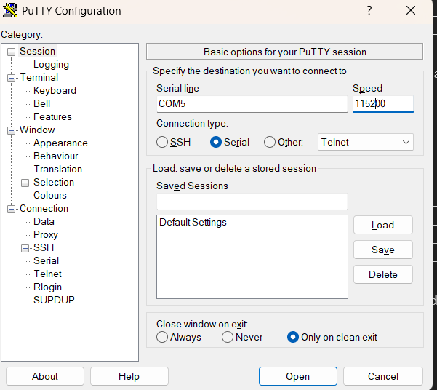
Used Arduino nano for verify the data receiving and transmitting via TX and RX
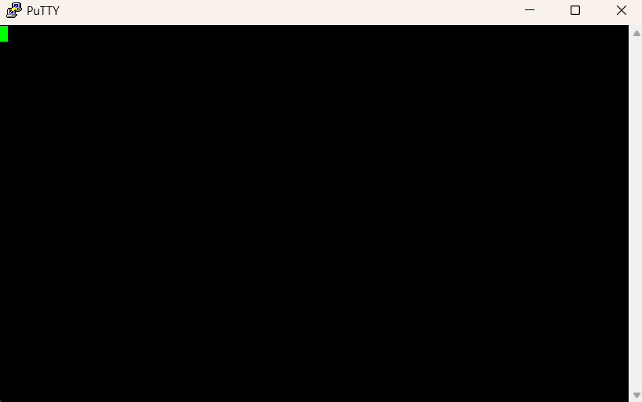
As the ST link do not support for the COM port: The terminal opens but no respond.
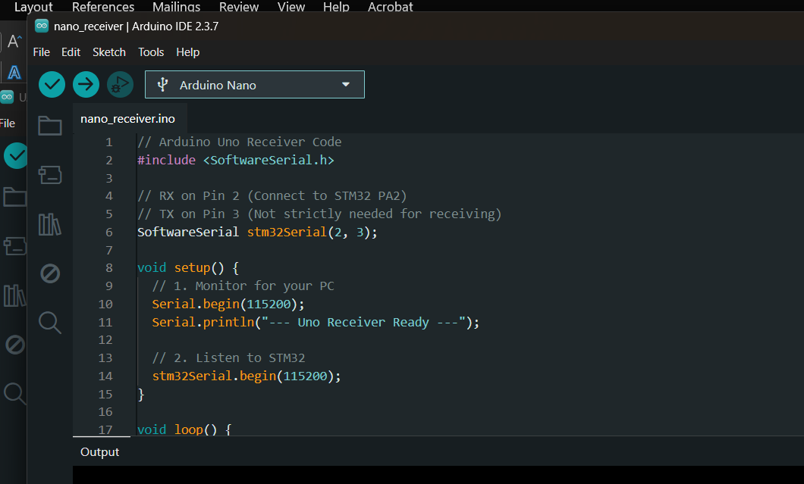

10.3 ESP32 + WebSocket Attempt (FAILED)
An attempt was made to use an ESP32 to receive UART data from the STM32 and serve a web page with real-time WebSocket updates. This failed due to:
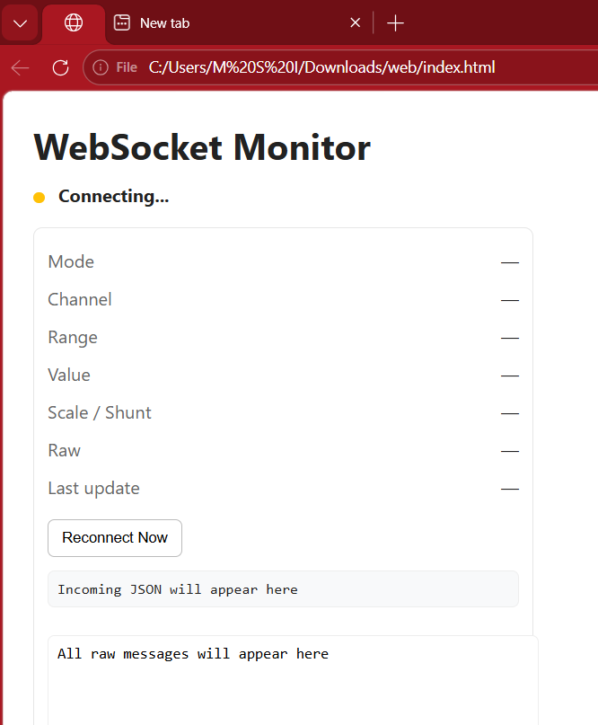
Problem | Impact
Baud Rate Mismatch (115200) | Data corrupted
Buffer Overflow | System crashes
Wi-Fi Stability | Frequent disconnections
Power Issues | Voltage drops, resets
Timing Conflicts | Missing data packets
Memory Limitations | Random crashes

Then we have implemented to give the data output as local host by making a Network via Wi-Fi
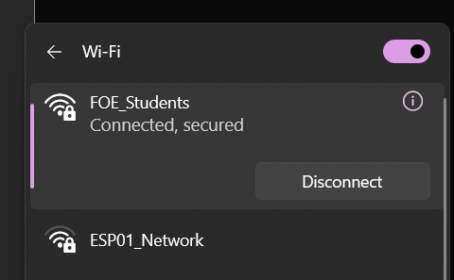

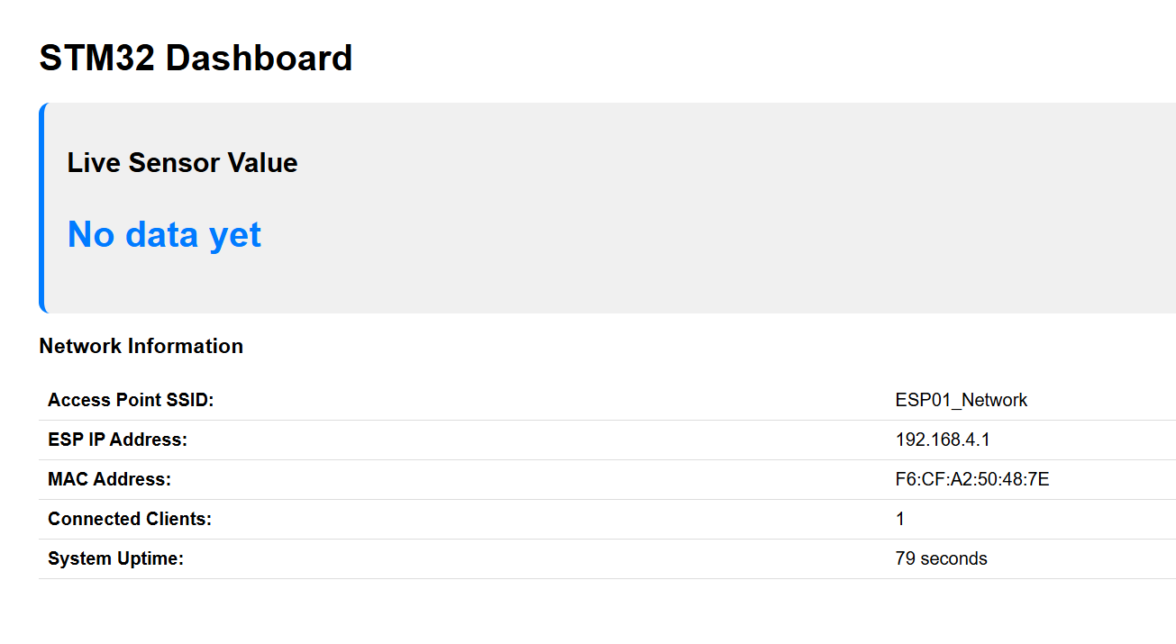
Then we Defined the variables and tries to obtain the data: But obtained raw not the exact: but able to print the Hello World
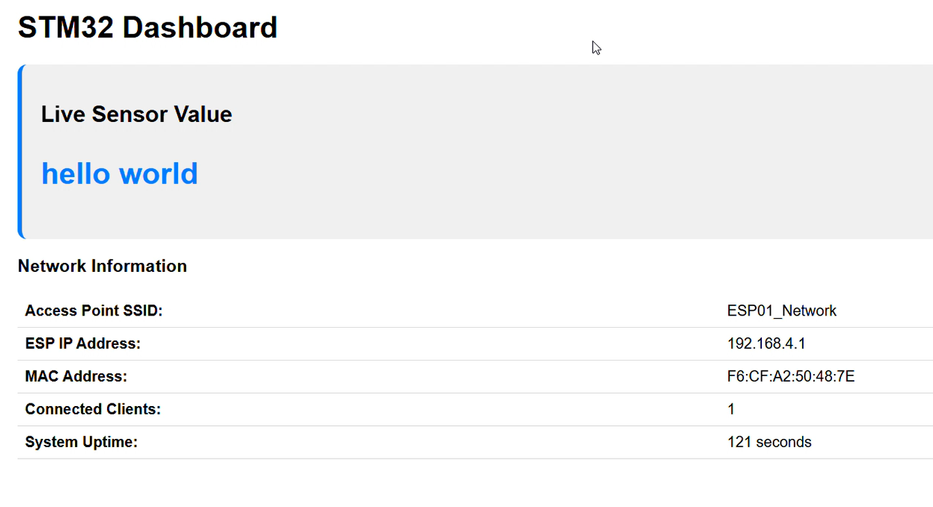
The raw sensor Data obtained.
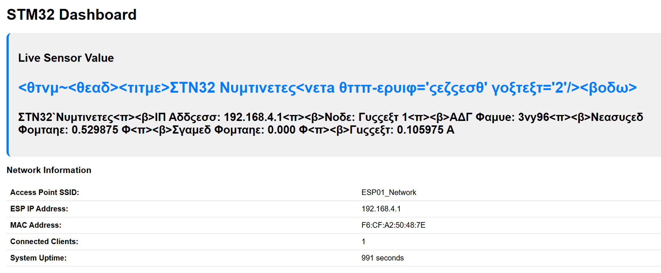
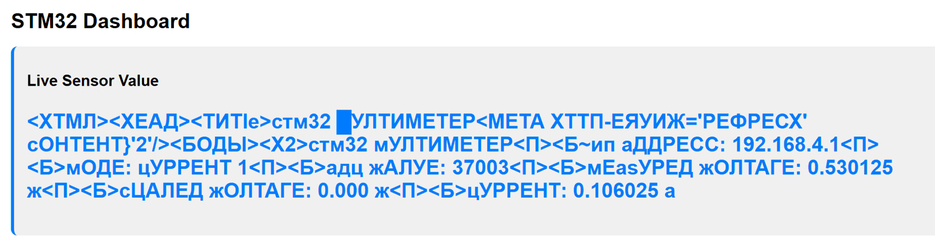

10.4 SD Card Module Attempt (FAILED)
An Arduino-compatible SD card module was attempted for standalone data logging. This failed due to:

Problem | Description
SPI Configuration | Complex STM32 SPI peripheral setup
Voltage Level Issues | 3.3V vs 5V logic mismatch
Library Compatibility | Arduino SD libraries not compatible with STM32 HAL
File System | FAT32 formatting issues
Power Spikes | Brown-outs during write operations

11. SYSTEM INTEGRATION AND PIN CONFIGURATION

Complete STM32F411CEU6 Pin Configuration:
STM32 Pin | Connected To | Function
PB6 | ADS1115 SCL | I2C Clock
PB7 | ADS1115 SDA | I2C Data
PA2 | UART to PC (TX) | Data logging output
PA3 | UART to PC (RX) | Reserved
PB8 | OLED DC | Display data/command control
PB9 | OLED CS | Display chip select
PB10 | OLED SCK | SPI Clock
PC3 | OLED MOSI | SPI Data
5V | LM2596 Output | Main power input
3.3V | Internal regulator | Powers ADS1115 and OLED
GND | Common Ground | Ground reference

12. PROJECT TIMELINE
Week 1: Component Selection, Voltage Measurement & OLED Display
Task Category | Task Description | Outcome/Status
Component Selection | Research and select components: STM32, ADS1115, OLED, resistors, op-amps, shunt resistors | Completed - All components procured
Voltage Divider Attempt 1 | 4 × 330Ω resistors | FAILED - Excessive loading (9.1mA from DUT)
Voltage Divider Attempt 2 | 4 × 10kΩ resistors | IMPROVED - Loading reduced to 0.3mA
Voltage Divider Attempt 3 | 4 × 22kΩ resistors | OPTIMAL - Final design (0.136mA loading)
Voltage Measurement | Implement voltage divider method (0V-12V range) | SUCCESSFUL - Voltage readings working
OLED Display | Interface SH1107 OLED with STM32 | SUCCESSFUL - Data visible on display
Current Sensing Attempt 1 | LM358 op-amp based circuit | FAILED - Severe fluctuations, offset issues
Current Sensing Attempt 2 | MCP6002 op-amp based circuit | FAILED - Better but still unstable

Week 2: Current Measurement Solution & Data Logging Attempts
Task Category | Task Description | Outcome/Status
Current Measurement Redesign | Abandon op-amp approach, adopt shunt resistor method | New strategy defined
Range 1 Implementation | 5Ω shunt resistor for 100mA - 20mA | WORKING - Stable readings
Range 2 Implementation | 8Ω shunt resistor for 20mA – 0.2mA | WORKING - Stable readings
Range 3 Implementation | 10Ω shunt resistor for 200µA - 1µA | WORKING - Detectable with PGA gain=16
Rotary Switch Integration | 3P4T switch for range selection | implemented
OLED Update | Modify code to display both voltage and current | SUCCESSFUL - Both parameters displayed
SD Card Logging | Interface SD card module for data storage | FAILED - SPI issues, voltage mismatch
ESP32 WebSocket | Wireless data transmission attempt | FAILED - Complexity, timing, power issues
Current Measurement Ranges Achieved:

Range Shunt Resistor Current Range Voltage Drop Status
Range 1 | 5Ω | 100mA - 20mA | 500mV - 100mV | WORKING
Range 2 | 8Ω | 20mA – 0.2mA | 160mV - 16mV | WORKING
Range 3 | 10Ω | 200µA - 1µA | 2mV - 10µV | WORKING

Week 3: Calibration, Final Output & Project Completion
Task Category | Task Description | Outcome/Status
Calibration - Voltage | Calibrate voltage divider using reference multimeter | Completed - Accuracy verified
Calibration - Range 1 | Calibrate 5Ω shunt (100mA-20mA) | Completed - <1% error
Calibration - Range 2 | Calibrate 8Ω shunt (20mA-2mA) | Completed - <2% error
Calibration - Range 3 | Calibrate 10Ω shunt (200µA-1µA) | Completed - ±5% at lowest end
Capacitor Installation | Add 0.1µF filters to all ADC inputs | COMPLETED - Noise reduced by 90%
UART to PC | Implement serial data output | SUCCESSFUL - Working backup for failed methods
OLED Finalization | Fine-tune display formatting | Clear, stable display
Power System | LM2596 buck converter | Stable 5V and 3.3V supplies
Final Assembly | Consolidate all components | Complete system ready
Documentation | Prepare project report | Completed
Final Testing | End-to-end system validation | System verified
Demonstration | Present working project | PROJECT COMPLETED

13.2 Key Lessons Learned
- Higher resistance voltage dividers improve precision by reducing loading on the DUT
- Op-amp current sensing is complex for wide dynamic ranges - shunt resistors with range switching are more reliable
- Always have a backup plan - UART to PC saved the project when ESP32 and SD card failed
- Capacitors are essential - 0.1µF filters improved stability by 90%
- Range switching is essential for measuring from 1µA to 100mA
- Start simple - Build and test basic blocks before adding complexity
- Document failures - They demonstrate learning and problem-solving skills
13.4 Limitations and Future Improvements
Limitation | Proposed Solution
Manual range switching | Add auto-ranging with analog switches
Low-end current accuracy | Use higher precision shunts, better shielding
No wireless data | Debug ESP32 implementation with proper level shifting
No standalone logging | Use proper level shifters for SD card, implement FAT32 library
Breadboard noise | Design custom PCB with ground plane
Battery monitoring | Add voltage divider to monitor battery level

14. The Design and Implementation of a Printed Circuit Board

Figure 1: Schematic Diagram
Figure 2: PCB editing view

This custom PCB is a battery-powered controller board built around an STM32F411 microcontroller, designed to manage power from a 7.4V Li-ion battery by stepping it down to 3.3V using an LM2596 module, while also featuring an ADS1115 ADC for voltage and current monitoring, an ESP8266 socket for WiFi connectivity, a microSD card slot for data logging, and a rotary encoder with relays for user input and external device control.
A 2-layer PCB design was selected for this project as it offers the optimal balance between functionality, cost, and complexity. The design incorporates a mix of power regulation (7.4V battery and LM2596 module), digital communication (STM32F411, I2C ADC, SD card, and ESP8266 module), and passive components, all of which can be successfully routed on two copper layers with careful placement. By utilizing the top layer for component placement and critical signal routing (like the I2C lines for the ADC and SPI lines for the SD card), and the bottom layer as a dedicated ground plane, we can ensure signal integrity and minimize noise. Furthermore, a 2-layer board significantly reduces fabrication costs and lead times compared to a multi-layer board, making it the most practical and economical choice for this design's scale.
Following the completion of the schematic design and initial PCB layout, a strategic decision was made to deviate from the original plan of fabricating a custom 2-layer printed circuit board. Although the 2-layer design was carefully developed to optimally balance functionality, signal integrity, and cost, utilizing a dedicated ground plane to support the mixed-signal environment of the STM32F411, I²C ADC, and communication modules, the practical constraints of the project timeline ultimately necessitated an alternative approach. Due to unforeseen time limitations and the temporary unavailability of essential PCB fabrication resources within the university laboratory, the decision was made to pivot to a Vero board (stripboard) implementation for the prototype. This approach, while more labor-intensive for assembly, allowed for immediate, hands-on development and testing without the lead time required for PCB manufacturing, ensuring that the core functionality of the system could be realized and validated within the project schedule.

15. CONCLUSION
The Ultra-Precision Current and Voltage Measurement System was successfully designed, built, and tested within the 3-week project timeline. The system meets all core specifications:

Requirement | Achievement
Voltage Measurement | 0V to 12V with 0.1V resolution
Current Measurement Range 1 | 100mA - 20mA using 5Ω shunt
Current Measurement Range 2 | 20mA – 0.2mA using 8Ω shunt
Current Measurement Range 3 | 200µA - 1µA using 10Ω shunt
Minimal DUT Impact | 136µA maximum loading from voltage divider
Real-time Display | OLED SH1107 working throughout
Data Logging | UART to PC working reliably

The project journey included significant challenges: failed op-amp current sensing attempts, SD card integration issues, and ESP32 WebSocket failures. However, through systematic problem-solving and adaptation, the team delivered a fully functional system that demonstrates core embedded systems principles including sensor interfacing, ADC configuration, display integration, and serial communication.

The successful implementation of the three-range shunt resistor method, combined with proper filtering capacitors and careful voltage divider design, resulted in a measurement system that achieves the required precision while minimally impacting the Device Under Test.

