AQDesk
Answer Question Community, Learning and Knowledge Platform

PROTOTYPE PHASE DOCUMENTATION
CS619 — Final Year Project
Field | Detail
Project title | AQDesk — Answer Question Community, Learning and Knowledge Platform
Project domain | Web Application
Submitted by | Titania Melody
Student ID | BC220203981
Course | CS619 — Final Year Project
Phase | Prototype Phase
Supervisor | Mr. Abdullah Qamar · abdullah.qamar@vu.edu.pk
Institution | Virtual University of Pakistan
Technology stack | Laravel 12 · PHP 8.2 · Blade · Bootstrap 5 · MySQL 8
Document version | 1.0

Table of Contents

(In Word: right-click the table above and choose "Update Field" to populate page numbers.)

1. Introduction

1.1 Purpose of this document
This document accompanies the Prototype Phase submission for the AQDesk final year project. It states what the prototype implements, what it deliberately does not implement, how the system is put together, and how to install and evaluate it.
Every scope decision recorded here is traced back to one of the two source documents supplied by the supervisor: the Main Requirement File (referred to below as the Requirement File) and the Prototype Assignment.

1.2 Project background
AQDesk (Answer Question Desk) is a digital community and knowledge-sharing platform designed to support learning, collaboration, professional development and awareness of emerging technologies. It provides a single environment in which students, instructors, researchers, technology professionals, experts and organisations can interact.
The Requirement File specifies seven functional areas: user management, a community Q&A system, project collaboration, events and podcasts, a jobs and opportunities board, consulting management, and newsletters and announcements. The Prototype Assignment narrows this to six mandatory modules for the current phase.

1.3 Objectives of the prototype
- Demonstrate a correct understanding of the project requirements before final development begins.
- Implement the six mandatory modules as working, database-backed functionality rather than static mock-ups.
- Establish a modular architecture that the four remaining modules can be added to without rework.
- Show competence in the chosen technology stack and be able to explain every part of it.
- Lay the groundwork for the accessibility and usability validation required at final submission.

2. Scope of the Prototype
The Prototype Assignment names six mandatory modules. The table below maps each one to its origin in the Requirement File and records its implementation status.

2.1 Modules implemented
# | Module | Requirement source | Status
1 | User Authentication | FR1 — Requirement File | Fully implemented
2 | Role-Based Access | FR1 — Requirement File | Fully implemented
3 | Dashboard | Prototype Assignment only | Fully implemented
4 | User Profile | FR1 — Requirement File | Fully implemented
5 | Community Q&A | FR2 — Requirement File | Fully implemented
6 | Jobs / Opportunities | FR5 — Requirement File | Fully implemented
Note that "Dashboard" appears only in the Prototype Assignment. It has no corresponding functional requirement in the Requirement File, so its content was designed by the project team and is described in section 4.3.

2.2 Modules deferred to the final project
The four remaining functional requirements are represented in the prototype by dedicated placeholder pages. Each page is reachable from the main navigation, is clearly marked "Planned for Phase 2", lists the features the Requirement File specifies, and cites its FR number. They are included deliberately: they make the full scope of AQDesk visible to an evaluator and demonstrate that the architecture anticipates them.
Module | FR | Features specified in the Requirement File
Project Collaboration | FR3 | Create project spaces · Invite collaborators · Share files · Provide feedback
Events & Podcasts | FR4 | Event creation · Event registration · Webinar integration · Podcast publishing
Consulting Management | FR6 | Client management · Consultation booking · Proposal tracking
Newsletter & Announcements | FR7 | Newsletter subscription · Email campaign management · Community updates
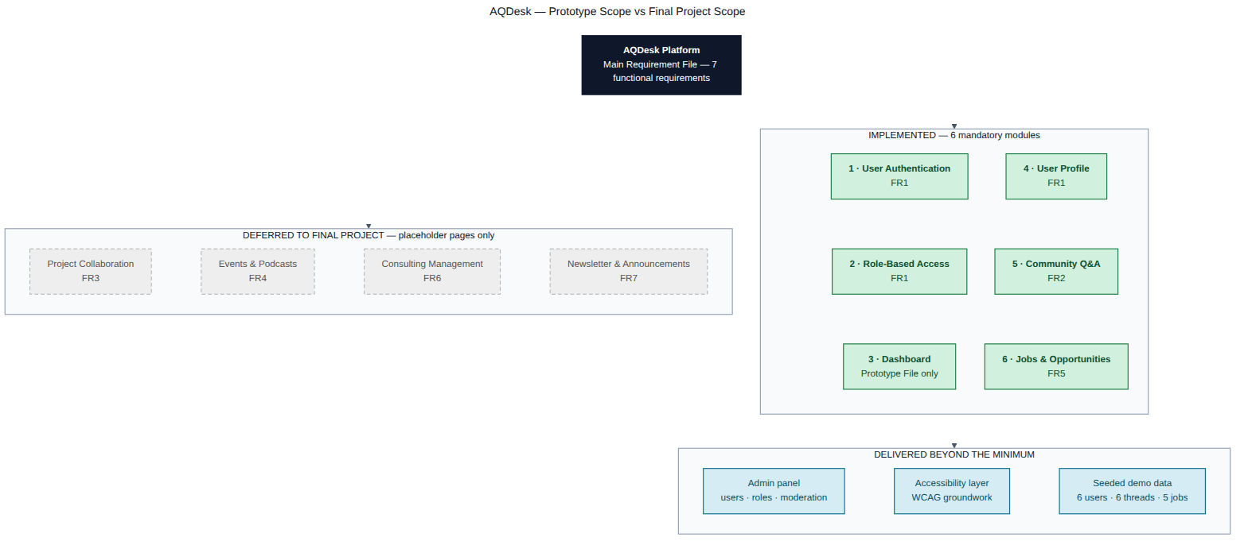
Figure 1 — Prototype scope against the full AQDesk scope.

2.3 Meeting the stated quality requirement
The Prototype Assignment asks for a 70–80% functional frontend, basic backend integration, database connectivity and a clear system architecture. The table below records how each is satisfied.
Requirement | How the prototype satisfies it
70–80% functional frontend | All six mandatory modules work end to end against the database. Only the four deferred modules are static pages.
Basic backend integration | Full create/read/update/delete across eleven application tables, session authentication, validated file uploads.
Database connectivity | MySQL 8 accessed through the Eloquent ORM over PDO. Migrations and seeders are included.
Clear system architecture | Three-tier MVC structure documented in section 3, with routes grouped by module.

3. System Architecture

3.1 Architectural overview
AQDesk follows a conventional three-tier architecture implemented through Laravel's MVC structure. Keeping the tiers distinct is what allows the four deferred modules to be added later as self-contained units: each new module needs its own migrations, models, controllers and views, and touches nothing that already exists.
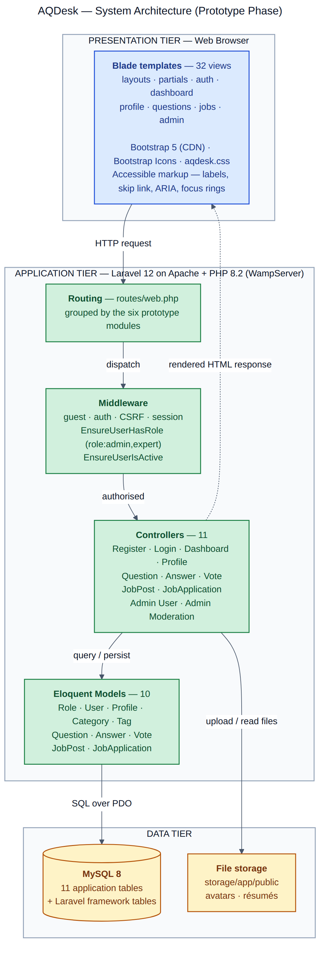
Figure 2 — Three-tier system architecture.

3.2 Request lifecycle
A request travels through the system in a fixed order, which makes both debugging and authorisation reasoning straightforward:
- The browser issues an HTTP request to a route declared in routes/web.php.
- Global middleware verifies the session and the CSRF token, and EnsureUserIsActive signs out any account an administrator has deactivated.
- Route middleware applies coarse access control — guest, auth, or EnsureUserHasRole for role-restricted areas.
- The controller validates the incoming data and performs any fine-grained ownership check.
- Eloquent models read from or write to MySQL over PDO; uploaded files go to the public storage disk.
- A Blade template renders the response, or the controller issues a redirect carrying a flash message.

3.3 Technology stack and justification
Layer | Technology | Justification
Backend framework | Laravel 12 (PHP 8.2+) | Named as the preferred backend in the Requirement File. Its MVC structure maps naturally onto the six modules.
Templating | Blade | Server-side rendering keeps the prototype simple and removes a build step.
UI framework | Bootstrap 5 + Bootstrap Icons | Named in the Requirement File. Responsive and accessible out of the box.
Database | MySQL 8 (MariaDB compatible) | Named in the Requirement File. Relational model suits the data.
ORM | Eloquent | Bundled with Laravel; relationships express the domain model directly.
Local environment | WampServer (Apache, PHP, MySQL) | Standard Windows development stack; matches the evaluation environment.
Version control | Git / GitHub (private repository) | Required deliverable.

3.4 Two engineering decisions worth recording

No Node.js or npm dependency
Bootstrap 5 and Bootstrap Icons are loaded from a CDN, and the project's own styles live in a single plain CSS file at public/css/aqdesk.css. The alternative — a Vite asset pipeline — is more production-like but adds Node.js, an npm install and a build step to the setup instructions.
For a deliverable that an evaluator must run on an unfamiliar machine, removing an entire toolchain removes an entire class of setup failure. The project installs with composer install and nothing else. A compiled asset pipeline is planned for production deployment in the final project.

The opportunities table is named job_posts
Laravel reserves the jobs table for its queue worker, and the default framework migration creates it. Naming the opportunities table jobs would have collided with the framework, so the table and its model are named job_posts and JobPost.

4. Implemented Modules

4.1 Module 1 — User Authentication (FR1)
- Registration with server-side validation; the applicant chooses to join as a Member or an Expert. Administrator accounts can only be granted by an existing administrator.
- Email and password sign-in, with passwords hashed using bcrypt through Laravel's hashed attribute cast — no plain-text password is ever stored or logged.
- Session-based authentication with an optional "keep me signed in" token.
- CSRF protection on every state-changing form.
- Sign-out invalidates the session and regenerates the CSRF token.
- A profile record is created inside the same database transaction as the user, so no account can exist without one.
- Deactivated accounts are signed out on their next request by the EnsureUserIsActive middleware.
Social login is specified in FR1 but is not implemented in the prototype: the Prototype Assignment asks only for "User Authentication". It is listed in the future work in section 9.

4.2 Module 2 — Role-Based Access (FR1)
Neither source document names the roles the system should have. The three below were derived from the user types listed in the Requirement File's introduction — students, instructors, researchers, technology professionals, experts and policy experts — and should be confirmed with the supervisor.
Role | Slug | Permissions
Administrator | admin | All member and expert permissions, plus: manage users, assign roles, activate and deactivate accounts, moderate any question or opportunity.
Expert / Professional | expert | All member permissions, plus: publish jobs and internships, review applicants, change application status.
Member | member | Ask and answer questions, vote, edit and delete own content, maintain a profile, apply to opportunities.
Roles are stored in a normalised roles table with a foreign key on users, rather than as a string column. This means a role can be renamed or given a description without a data migration, and the schema documents the available roles.

Three levels of enforcement
- Route middleware — EnsureUserHasRole guards entire route groups. The administration area is declared with role:admin and the opportunity-publishing routes with role:admin,expert.
- Ownership checks in controllers — a question or answer may only be edited or deleted by its author or an administrator. This is a per-record decision that middleware cannot make.
- Conditional interface — Blade templates render only the actions the current role can actually perform, so the interface never offers something that would be refused.

4.3 Module 3 — Dashboard
This module is mandatory under the Prototype Assignment but has no corresponding functional requirement in the Requirement File, so its content was designed by the project team. It was made role-aware, which turns it into the clearest single demonstration of role-based access in the whole prototype: three users signing in one after another see three visibly different pages.
Role | Statistics shown | Quick actions
Administrator | Total users · Questions · Answers · Open opportunities | Ask a question · Post an opportunity · Admin panel
Expert | My answers · My questions · Jobs I posted · Applicants received | Ask a question · Post an opportunity
Member | My questions · My answers · My applications · Open jobs | Ask a question
Every role additionally sees recent community questions, the latest opportunities, their own recent contributions, and the Phase 2 module roadmap.

4.4 Module 4 — User Profile (FR1)
- Public profile page showing avatar, headline, biography, skills, organisation, location and social links, together with question and answer counts and the user's recent questions.
- Edit form covering all profile fields, with an avatar upload restricted to JPG, PNG or WebP up to 2 MB. Replacing an avatar deletes the previous file so uploads do not accumulate.
- A separate password-change form that verifies the current password before accepting a new one.
- Users without an avatar are given a generated initials placeholder, so no layout ever renders a broken image.
- Extended profile fields live in a separate profiles table, keeping the authentication table lean.

4.5 Module 5 — Community Q&A (FR2)
The Requirement File specifies four features for this module — ask questions, post answers, upvote answers, tag topics — and four categories. All are implemented.
Feature | Implementation
Ask questions | Title, category, body and up to five comma-separated tags. Slugs are generated automatically and de-duplicated.
Post answers | Any signed-in user may answer any open question.
Upvote answers | Upvote and downvote on both questions and answers. Clicking the same arrow again removes the vote; switching arrows changes it. A user cannot vote on their own content.
Tag topics | Tags are created on demand and shared across questions through a pivot table, so tag pages aggregate correctly.
Categories | The four named in FR2: EdTech, Artificial Intelligence, Web Development, Internet Governance.
Browse and search | Pagination, keyword search across title and body, category filter, tag filter, and three sort modes: newest, most viewed, unanswered only.
Accept an answer | The question author or an administrator marks one answer as accepted; it is pinned to the top with distinct styling. Beyond the stated requirements.
Moderation | An administrator can close a question to new answers, re-open it, or delete it. Beyond the stated requirements.

Design note — the polymorphic votes table
Voting applies to both questions and answers. Rather than two vote tables with duplicated logic, a single votes table carries votable_type and votable_id, so one relation, one controller and one set of rules serve both. When a future module needs voting, it inherits the mechanism at no cost.

4.6 Module 6 — Jobs and Opportunities (FR5)
FR5 specifies job postings, internship listings and application submission. All three are implemented, together with the employer-side workflow that makes applications meaningful.
Feature | Implementation
Job postings | Title, company, description, requirements, salary range, work mode, location and deadline.
Internship listings | Handled as a distinct type on the same model, filterable separately as FR5 requires.
Application submission | Cover letter plus an optional résumé (PDF, DOC or DOCX, up to 4 MB). A unique database constraint prevents a user applying twice to the same opportunity.
Publishing rights | Restricted to Administrators and Experts through role middleware.
My applications | The applicant tracks status and may withdraw an application, which also deletes the stored résumé.
Applicant management | The employer reads cover letters, downloads résumés, and moves each application through pending, reviewed, shortlisted, rejected and accepted.
Browsing | Card grid with keyword search and filters for type and work mode. Expired and unpublished opportunities are handled explicitly.

5. Database Design
The prototype uses eleven application tables plus Laravel's framework tables for sessions, cache and queues. The schema is created by migrations; the equivalent MySQL DDL is supplied as the required schema deliverable at /schema/aqdesk_schema.sql.
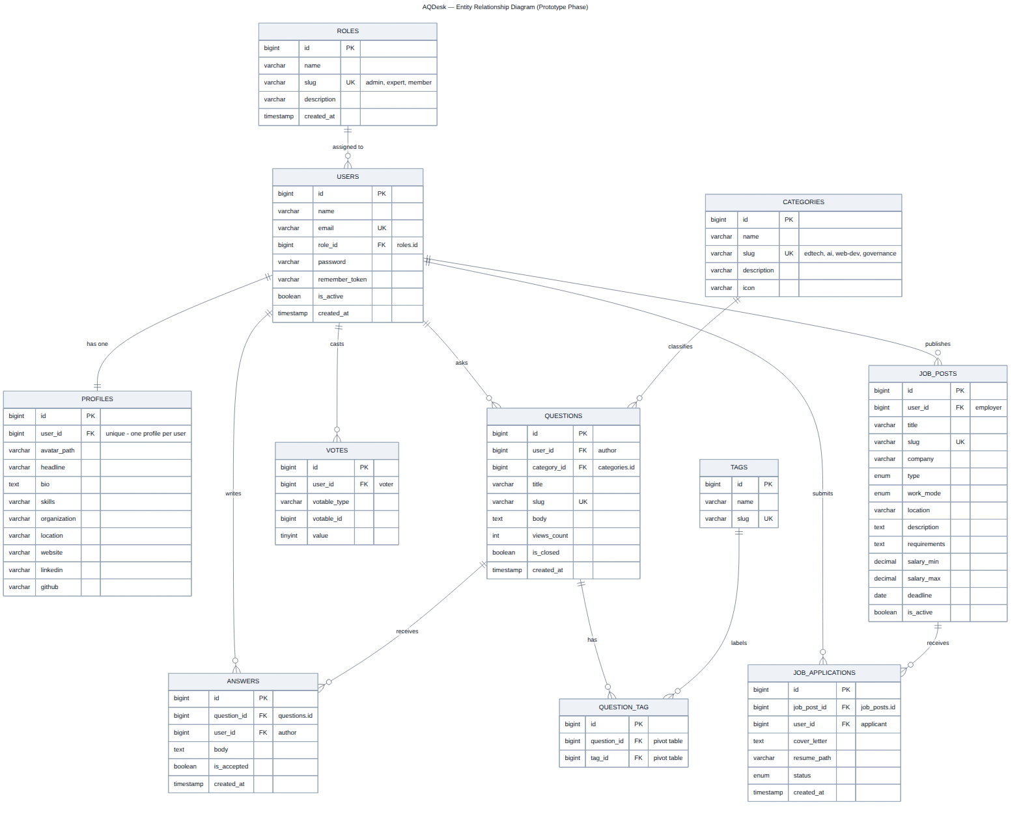
Figure 3 — Entity relationship diagram.

5.1 Tables
Table | Purpose | Key relationships
roles | The three access roles | One role has many users
users | Accounts and credentials | Belongs to a role; has one profile
profiles | Extended profile data | One-to-one with users
categories | The four FR2 topic areas | One category has many questions
tags | Free-form topic labels | Many-to-many with questions
questions | Community questions | Belongs to a user and a category
question_tag | Pivot table | Links questions and tags
answers | Answers to questions | Belongs to a question and a user
votes | Polymorphic up/down votes | Belongs to a user; targets a question or an answer
job_posts | Jobs and internships | Belongs to the publishing user
job_applications | Submitted applications | Belongs to a job post and an applicant

5.2 Integrity constraints
- Foreign keys cascade on delete, so removing a question removes its answers, its tag links and its votes — no orphaned rows.
- users.role_id is nullable and set to null on delete, so removing a role never destroys accounts.
- A unique index on (user_id, votable_id, votable_type) enforces one vote per user per item at the database level, not only in application code.
- A unique index on (job_post_id, user_id) prevents duplicate applications.
- Slugs are unique on questions and job_posts, giving readable and stable URLs.
- Indexes on questions.created_at and on (job_posts.type, is_active) support the default listing queries.

6. Use Cases and User Flows

6.1 Use case diagram
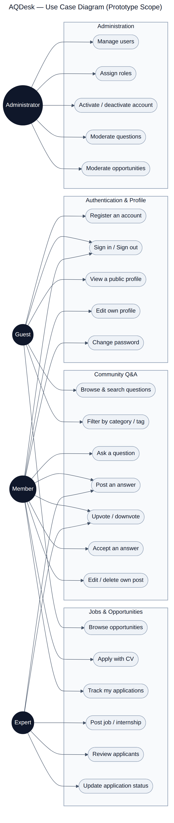
Figure 4 — Use cases within the prototype scope, by actor.

6.2 Primary user flow
The path below is the recommended demonstration route: it exercises all six modules and every role in a single pass.
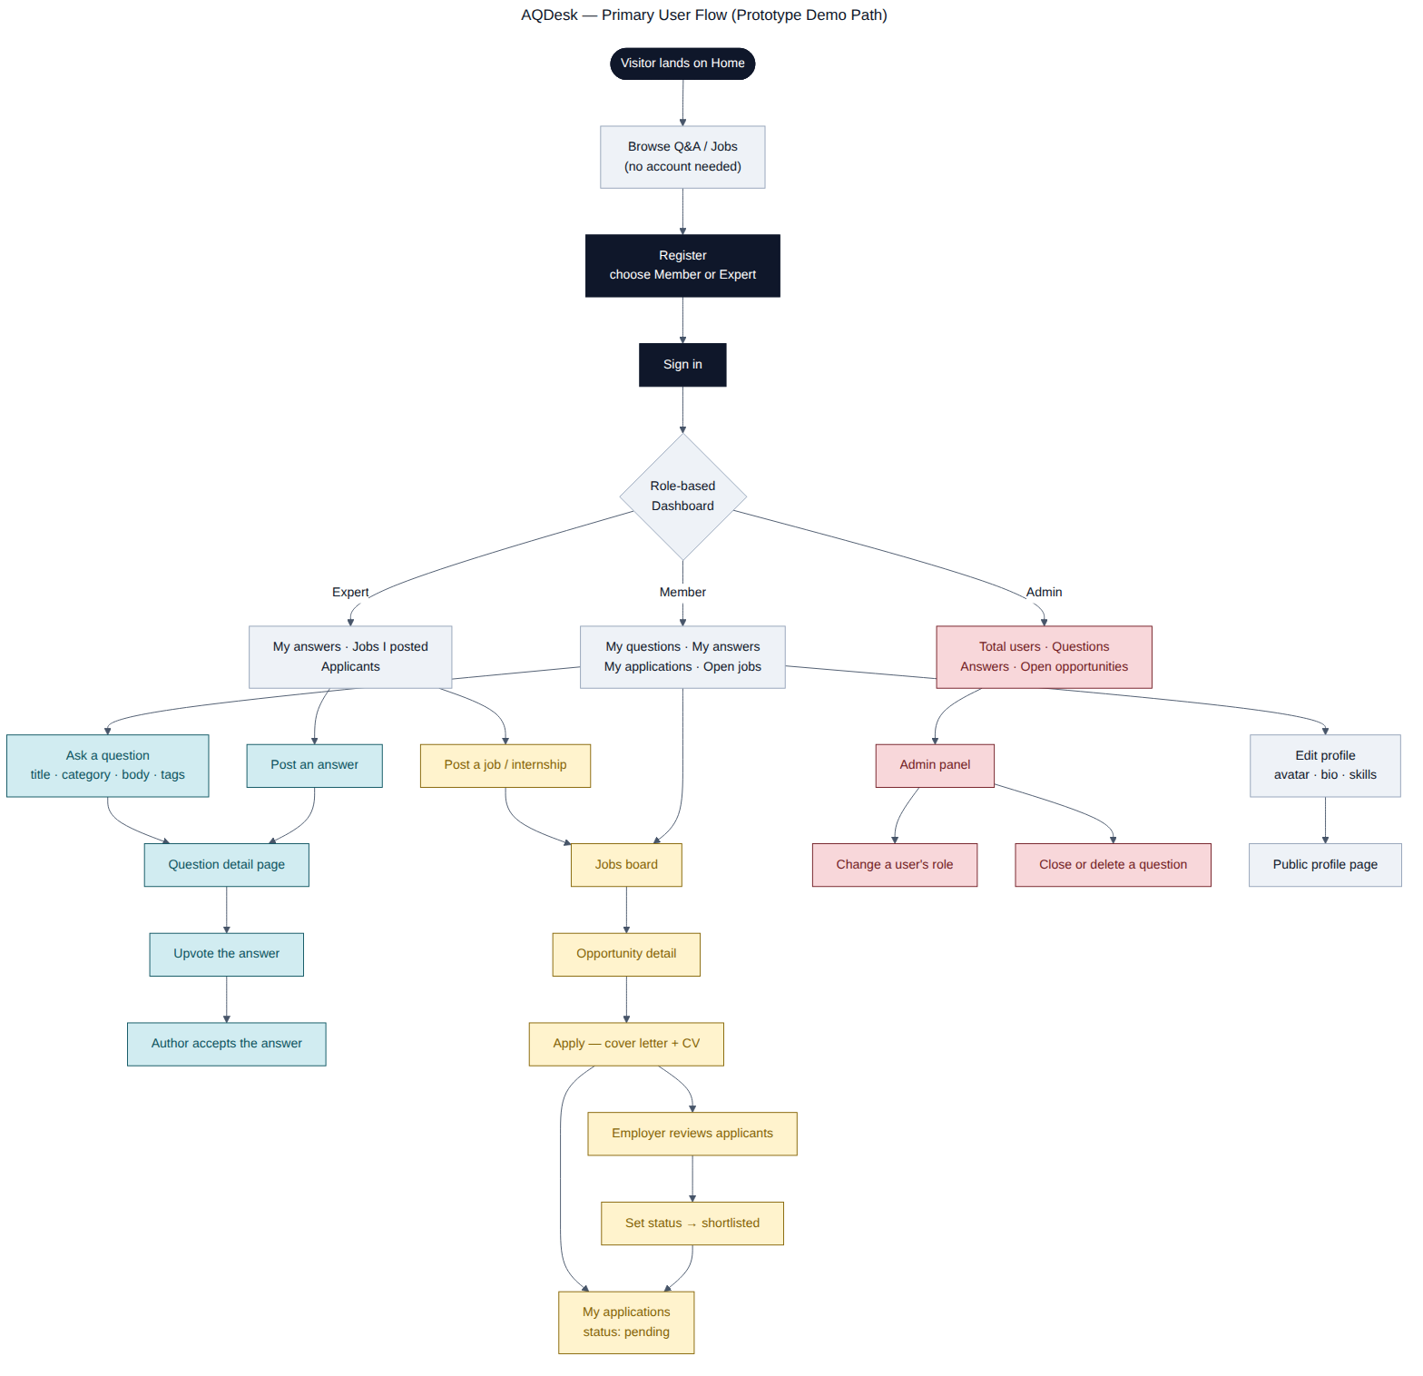
Figure 5 — Primary user flow through the prototype.

6.3 Sequence — applying to an opportunity
The diagram below traces a single request end to end, showing where validation, authorisation, file storage and persistence each occur.
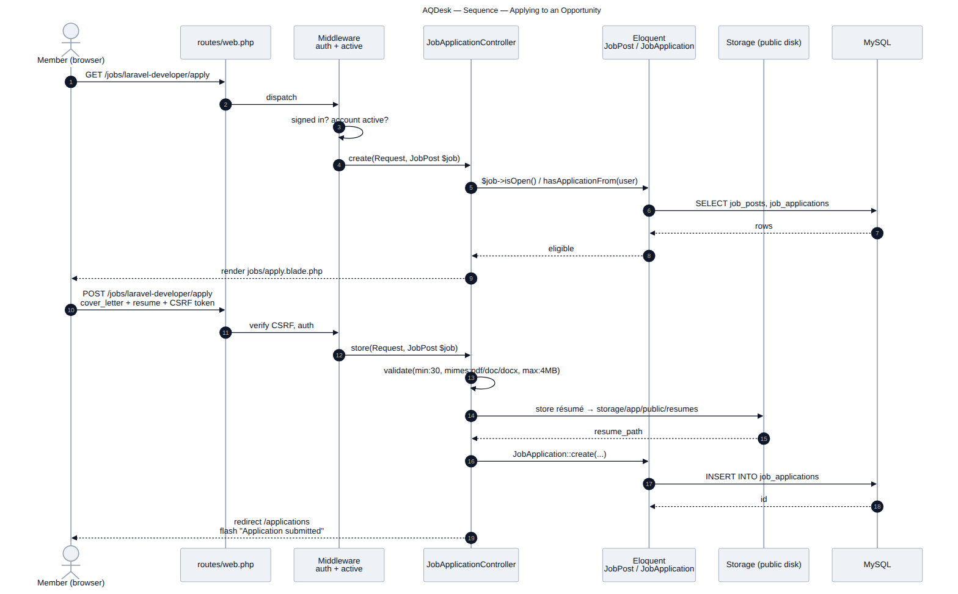
Figure 6 — Sequence diagram for submitting a job application.

7. Interface Inventory
The prototype comprises the following screens, rendered from 32 Blade templates.
Area | Screens | Access
Public | Landing page · Register · Sign in | Guest
Community Q&A | Question list with filters · Question detail with answers and voting · Ask a question · Edit a question | Browsing is public; posting requires an account
Jobs | Opportunity grid with filters · Opportunity detail · Post an opportunity · Edit an opportunity · Application form · My applications · Applicant list | Browsing is public; applying requires an account; posting requires Expert or Administrator
Account | Role-based dashboard · Public profile · Edit profile and password | Authenticated
Administration | Manage users and roles · Moderate questions · Moderate opportunities | Administrator only
Phase 2 | Project Collaboration · Events & Podcasts · Consulting · Newsletter | Public placeholder pages

7.1 Accessibility measures
Accessibility is named as a focus area in the Prototype Assignment and as the overall focus of the Requirement File, whose deliverables include WCAG compliance checks at final submission. The following measures were built in as the templates were written:
- Semantic landmarks — header, nav, main, footer and section elements with accessible names.
- A visible-on-focus skip-to-content link as the first focusable element on every page.
- An explicit label bound to every form control; placeholder text is never used as a substitute.
- Help text linked to its input with aria-describedby, and inline validation messages tied to the field that failed.
- Vote buttons expose aria-pressed and carry descriptive aria-labels.
- Decorative icons are marked aria-hidden so screen readers do not announce them.
- Data tables carry captions and use row and column header scopes.
- A 3px visible focus ring on every interactive element, and a prefers-reduced-motion rule that disables animation.
A formal WCAG 2.1 AA audit with automated tooling and screen-reader testing is scheduled for the final project.

8. Installation and Evaluation

8.1 Prerequisites
Requirement | Notes
WampServer (or XAMPP / Laragon) | Provides Apache, PHP 8.2 or newer, and MySQL
Composer 2.x | getcomposer.org — point the installer at the WAMP PHP executable
Git | For cloning the repository
No Node.js or npm is required.

8.2 Installation steps
git clone <repository-url> aqdesk
cd aqdesk
composer install
copy .env.example .env
php artisan key:generate
Start WampServer, open http://localhost/phpmyadmin and create an empty database named aqdesk with collation utf8mb4_general_ci. The credentials already in .env match WampServer's defaults (user root, no password).
php artisan migrate --seed
php artisan storage:link
php artisan serve
Open http://localhost:8000. To reset the database at any point, run php artisan migrate:fresh --seed.

8.3 Demo accounts
All demo accounts use the password "password".
Role | Email | Demonstrates
Administrator | admin@aqdesk.test | User management, role assignment, moderation
Expert | expert@aqdesk.test | Answering, posting internships, reviewing applicants
Expert (employer) | hr@aqdesk.test | Posting jobs, application status tracking
Member | member@aqdesk.test | Asking, voting, applying
Member | sara@aqdesk.test | Second account for demonstrating voting
Member | faisal@aqdesk.test | Third account

8.4 Suggested evaluation path
- Sign in as member@aqdesk.test. Note the Member dashboard.
- Open Community Q&A, filter by a category, and open a question. Upvote an answer.
- Ask a new question with tags, then confirm it appears in the list and on your profile.
- Open Jobs, filter to internships, open one and apply with a cover letter. Check My Applications.
- Sign out and sign in as expert@aqdesk.test. Note the different dashboard, and that "Post an opportunity" is now available.
- Open the applicant list for a posting and change an application status.
- Sign out and sign in as admin@aqdesk.test. Note the Admin menu, change a user's role, and close a question.
- Attempt to reach /admin/users while signed in as a Member — the request is refused with HTTP 403.
- Open any Phase 2 module from the navigation to see the deferred scope.

9. Requirement Observations
Reading the two source documents closely raised several points that affected design decisions. They are recorded here because they should be confirmed with the supervisor before final development begins.
Observation | Where it appears | How the prototype handled it
Functional requirements are numbered inconsistently — FR4 is also labelled 5, FR5 also 6, FR6 also 7, FR7 also 8, suggesting a requirement was merged or removed. | Requirement File | Treated as seven functional requirements. To be confirmed.
The technology stack is named as a preference in one document and left to the students in the other. | Requirement File vs Prototype Assignment | Built on Laravel, Bootstrap and MySQL, which satisfies both documents.
Role-based access is required but the roles themselves are never named. | Both documents | Three roles derived from the listed user types. To be confirmed.
"Dashboard" is a mandatory module with no corresponding functional requirement and no specified content. | Prototype Assignment | Designed as a role-aware summary page. Described in section 4.3.
One bullet under FR3 Project Collaboration is blank in the source document. | Requirement File | No impact — FR3 is deferred.
The User Manual deliverable is described as instructions "for form creators and respondents", which does not correspond to any AQDesk feature. | Requirement File | Read as residual text from another specification. To be confirmed.
Social login is required by FR1 but the Prototype Assignment lists only "User Authentication". | Requirement File vs Prototype Assignment | Email authentication implemented; social login deferred.

10. Future Work

10.1 The four deferred modules
Module | Planned implementation
Project Collaboration (FR3) | Project spaces with membership, collaborator invitations, file sharing with version history, threaded feedback.
Events & Podcasts (FR4) | Event CRUD, registration with capacity limits, webinar integration through the Zoom or Google Meet API, podcast upload with an audio player and RSS feed.
Consulting Management (FR6) | Client records, consultant availability calendar, consultation booking, proposal creation and status tracking.
Newsletter & Announcements (FR7) | Subscription management, campaign composer, queued delivery through a real mail service, community announcement feed.

10.2 Enhancements to existing modules
- Social login through Google and GitHub OAuth, completing FR1.
- Email verification and password reset by email.
- Rich text editing with sanitisation for question and answer bodies.
- Notifications when a question is answered or an application status changes.
- Reputation points derived from accepted answers and vote totals.
- Duplicate-question detection at ask time.
- Full-text search indexing in place of LIKE queries as content volume grows.

10.3 Quality, testing and deployment
- A formal WCAG 2.1 AA audit with automated tooling and screen-reader testing, producing the Testing Report the Requirement File specifies.
- A PHPUnit feature test suite covering authentication, role enforcement, the Q&A flow and the application flow.
- Usability testing with student participants.
- Cloud deployment to DigitalOcean or cPanel with a compiled asset pipeline, HTTPS and scheduled database backups.
- Rate limiting, an administrator audit log, and a documented retention policy for uploaded résumés.

11. Conclusion
The prototype implements all six mandatory modules named in the Prototype Assignment as working, database-backed functionality, and represents the four deferred modules as labelled placeholder pages so that the full scope of AQDesk and the modularity of its architecture remain visible.
The quality bar set by the Prototype Assignment is met: the frontend is functional across every mandatory module, the backend performs full create-read-update-delete operations against eleven MySQL tables, and the architecture is documented and deliberately structured to accommodate what comes next. The remaining work is set out in section 10 and can be built on this foundation without rework.

