My Home Haven
  - Technical Design Document - v2.4.0
Development Team
29 March 2026
Table of Contents

Project | My Home Haven - Household Inventory PWA
Current Version | 2.4.0
Document Status | Living Document - updated with every release
Last Updated | 29 March 2026
Author | Development Team

1 Executive Summary
My Home Haven is a production-ready Progressive Web App (PWA) for household inventory management. It enables multi-user, real-time tracking of pantry items, household supplies, and recurring chores across devices. The system is built on React 18 with a Supabase backend, deployed to Vercel, and enhanced with AI-powered item identification via the Anthropic Claude API.
The application supports two user roles — Admin (full inventory control) and Helper (task-only access) — and delivers a mobile-first experience installable to the home screen on both iOS and Android.

2 1. Background and Context

2.1 1.1 Problem Statement
Households struggle to maintain consistent awareness of what they have in stock, what needs restocking, what is expiring soon, and who is responsible for recurring tasks. Existing solutions are too complex, require manual syncing, or lack real-time collaboration between household members.

2.2 1.2 Target Users
User | Role | Primary Need
Primary household manager | Admin | Track inventory, shopping, and manage the household
Family member / helper | Helper | View and complete assigned chores
Guest / visitor | Public via share link | View shopping list without an account

2.3 1.3 Project Constraints
- No dedicated backend server — BaaS-only (Supabase)
- Must be installable as a PWA on iOS and Android
- Must work across mobile and desktop browsers
- Cost target: free tier infrastructure

3 2. Goals and Non-Goals

3.1 2.1 In Scope
- Inventory CRUD with categories, locations, and custom fields
- Real-time multi-device synchronization
- Expiry date tracking with visual alerts
- Smart shopping list auto-populated from low-stock items
- Recurring household task management with photo completion proof
- Barcode scanning and AI-powered item identification
- CSV bulk import and export
- Read-only shareable shopping list links
- Browser push notifications for low-stock alerts
- Dark mode

3.2 2.2 Out of Scope
Feature | Reason Excluded
Recipe management | Out of product scope
E-commerce / ordering integration | Complexity, cost
Voice commands | Future consideration
Offline-first with service worker cache | Not required for current scale
Multi-household / multi-tenant | Requires architecture change
Nutrition tracking | Out of product scope

3.3 2.3 Assumptions
- Users have a modern browser (Chrome 90+, Safari 14+, Firefox 88+)
- Supabase free tier capacity is sufficient for household scale
- No more than approximately 5 concurrent users per household

4 3. System Architecture

4.1 3.1 High-Level Architecture Diagram
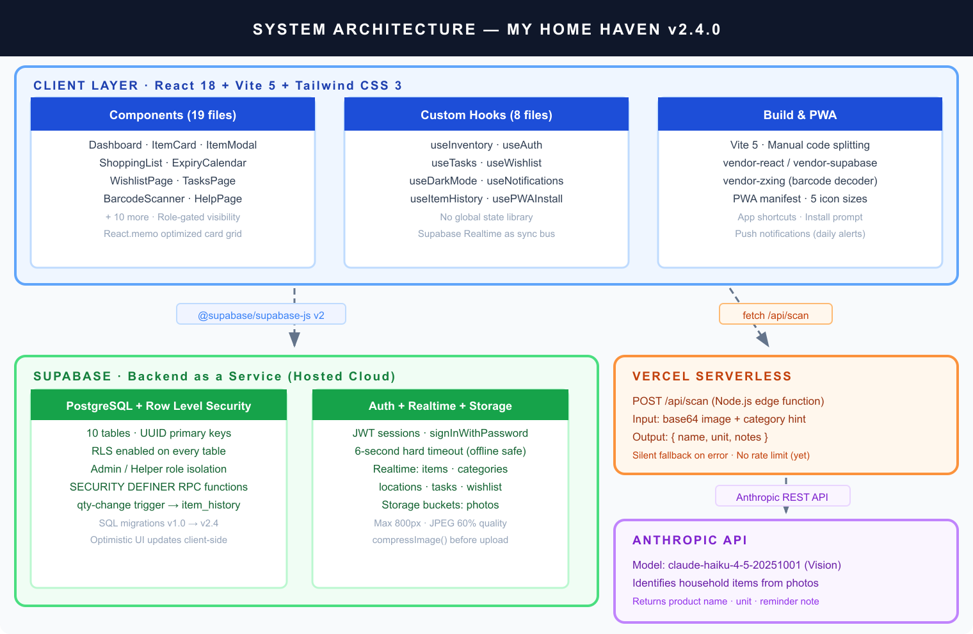
System Architecture Overview

4.2 3.2 Architecture Decisions and Rationale
Decision | Chosen Approach | Alternatives Considered | Rationale
Backend | Supabase (BaaS) | Firebase, custom Express API | Free tier PostgreSQL + Auth + Realtime in one; RLS for security
Frontend framework | React 18 | Vue 3, SvelteKit | Team familiarity; vast ecosystem; React.memo for list optimization
State management | useState + custom hooks | Redux, Zustand, Jotai | Sufficient for scale; no cross-cutting global state needed
Real-time sync | Supabase Realtime | Polling, manual WebSockets | Built-in; no extra infrastructure
Styling | Tailwind CSS | CSS Modules, Styled Components | Utility-first; rapid iteration; dark mode via class strategy
Build tool | Vite 5 | CRA, Next.js | Fast HMR; excellent code splitting; no SSR needed
Deployment | Vercel | Netlify, Cloudflare Pages | Native serverless functions; zero config
AI scanning | Claude Haiku Vision | GPT-4o, Gemini Flash | Best vision accuracy-to-cost ratio for household items

4.3 3.3 Technology Stack
Layer | Technology | Version
UI Framework | React | 18.2.0
Build Tool | Vite | 5.1.4
CSS Framework | Tailwind CSS | 3.4.1
Backend as a Service | Supabase | ^2.100.1
AI Vision API | Anthropic SDK | ^0.39.0
Barcode Decoding | @zxing/browser | ^0.1.5
Image Processing | sharp | ^0.34.5
Deployment | Vercel | —
Runtime | Node.js | 24.x

5 4. Application Design

5.1 4.1 Entry Logic and Navigation
The application uses conditional rendering in src/App.jsx with no router library. Navigation is controlled by a view state string passed as props.
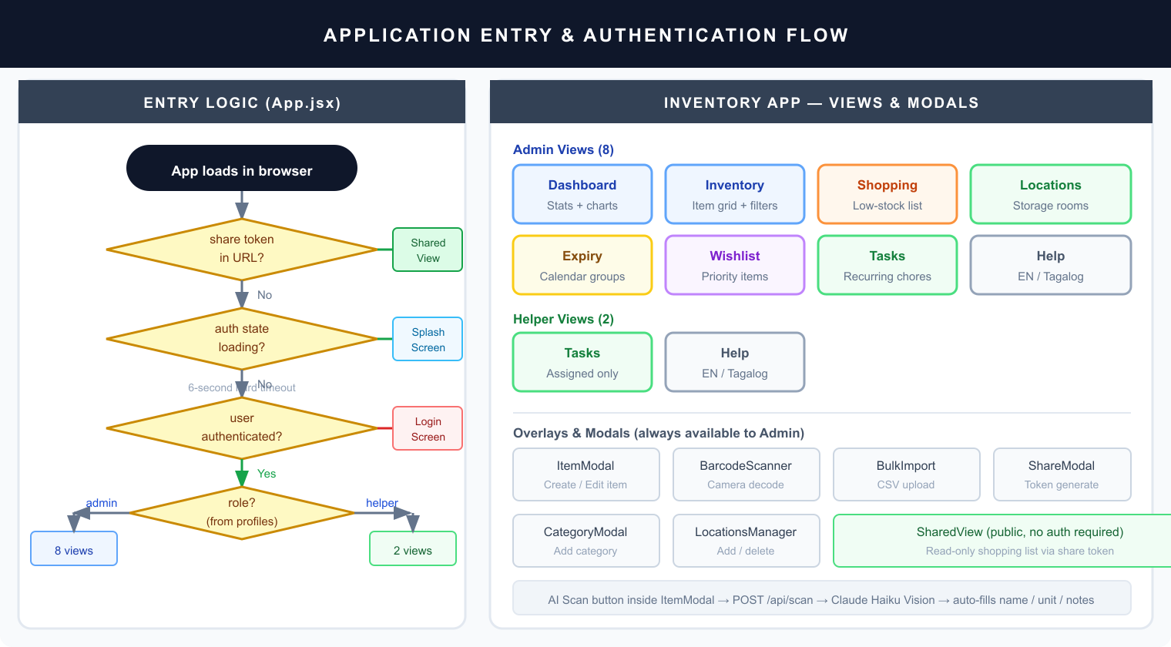
Application Entry Flow and Views

5.2 4.2 Component Reference
Component | Category | Description
Header.jsx | Layout | Sticky mobile header with dark mode toggle and user avatar
CategoryBar.jsx | Layout | Horizontal scrollable category filter chips with emoji
ItemCard.jsx | Display | Memo-optimized card: qty, expiry badge, location chip, actions
EmptyState.jsx | Display | Placeholder when inventory is empty
Dashboard.jsx | View | Stat cards, category bar chart, recently updated list
LocationsPage.jsx | View | Location cards with item count badge; click-to-filter inventory
ExpiryCalendar.jsx | View | Items grouped: Expired / This Week / This Month / Later
ShoppingList.jsx | View | Low-stock items; running price total; group-by-store toggle
WishlistPage.jsx | View | Priority items with estimated price; promote-to-inventory
TasksPage.jsx | View | Recurring chores with templates and photo completion proof
HelpPage.jsx | View | Bilingual step-by-step guide (English and Tagalog)
ItemModal.jsx | Modal | Full create/edit form; AI scan button; barcode; item history
BarcodeScanner.jsx | Modal | Camera-based QR/barcode reader via @zxing/browser
BulkImport.jsx | Modal | CSV upload with row preview and progress bar
LocationsManager.jsx | Modal | Add/delete locations with back-camera photo capture
ShareModal.jsx | Modal | Generate and revoke read-only share tokens
SharedView.jsx | Public | Token-authenticated read-only shopping list (no login required)
LoginScreen.jsx | Auth | User selection and password sign-in
CategoryModal.jsx | Modal | Add category with emoji picker and color selector

5.3 4.3 Custom Hooks
Hook | Responsibility
useInventory.js | Core CRUD for items, categories, locations; Realtime listeners; computed lists (lowStockItems, expiringItems, overdueRecurItems)
useAuth.js | Session management; profile fetch; 6-second hard timeout; admin/helper role
useTasks.js | Task template and task CRUD; role-scoped Realtime subscriptions
useWishlist.js | Wishlist CRUD; promote-to-inventory action
useDarkMode.js | Toggle .dark class on html element; persist to localStorage
useNotifications.js | Browser Notification API; daily low-stock alert at user-configured hour
useItemHistory.js | Fetch last 10 quantity changes from item_history table
usePWAInstall.js | Capture beforeinstallprompt event; expose install trigger

5.4 4.4 State Management
No global state library is used. State flows from custom hooks into InventoryApp, then down to view components via props. Supabase Realtime acts as the synchronization bus — changes made on one device propagate to all other connected clients automatically.
Key state in InventoryApp:
State | Type | Purpose
view | string | Active page key
selectedCategory | uuid or all | Category filter
locationFilter | uuid or null | Set by clicking a location card
activeFilters | Set | Quick toggles: low, expiring
searchQuery | string | Text search across name, notes, location, store
sortBy | string | low-stock, a-z, recent, or expiry
editingItem | object or null | Item currently open in ItemModal

5.5 4.5 Design System
Color Palette
Name | Light | Mid | Dark | Usage
blush | #fce7f3 | #f9a8d4 | #be185d | Primary actions, active sidebar highlight
lavender | #ede9fe | #c4b5fd | #7c3aed | Dashboard, help page
mint | #dcfce7 | #86efac | #16a34a | Locations, tasks
peach | #ffedd5 | #fdba74 | #ea6c00 | Shopping list
rose | #ffe4e6 | #fda4af | #f43f5e | Expiry warnings, destructive actions
Typography: Pacifico (brand/title display) and Plus Jakarta Sans (body, weights 400–700), both loaded from Google Fonts.
Responsive Breakpoints:
Breakpoint | Width | Layout
Mobile (default) | under 480px | Header at top + bottom tab bar (5 tabs)
Desktop (sm:) | 480px and above | Fixed 220px left sidebar, no tab bar
Animations: bounce-soft (2s infinite), fade-in (0.2s), slide-up (0.25s cubic-bezier), scale-in (0.2s).

6 5. Data Architecture

6.1 5.1 Entity Relationship Diagram
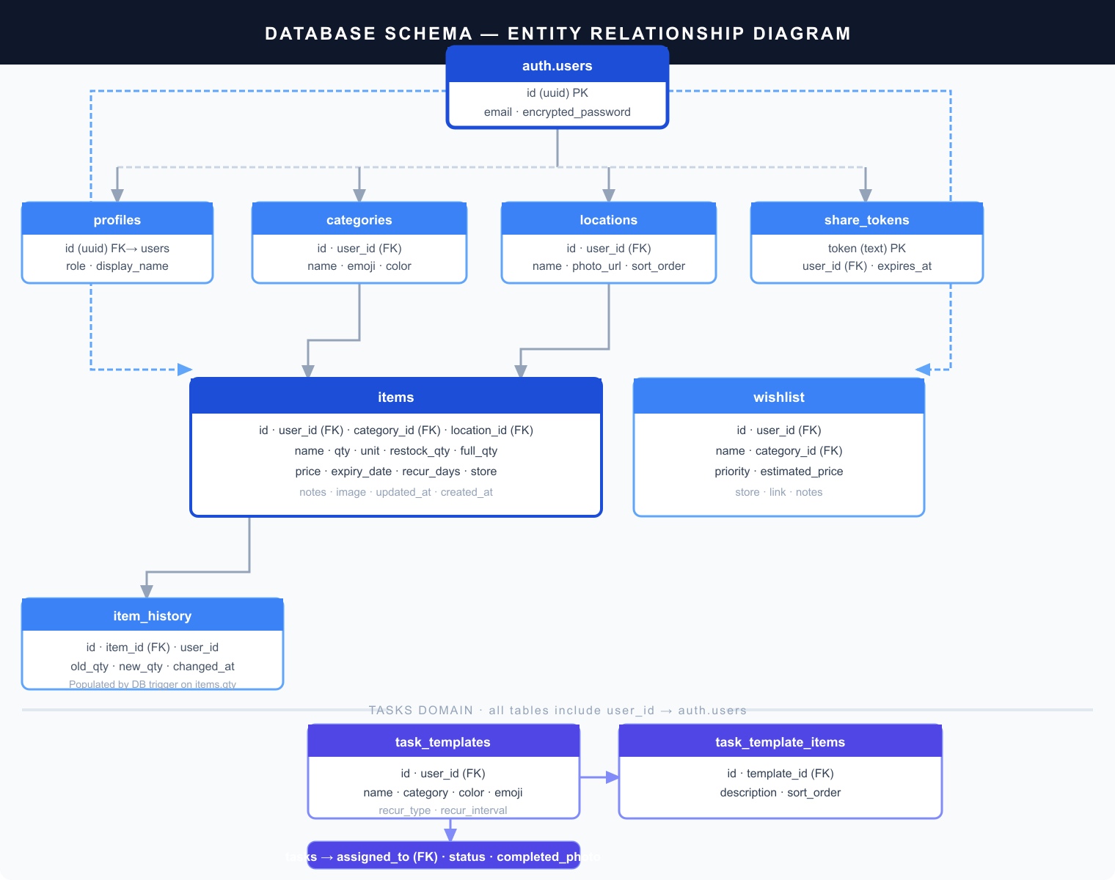
Database Entity Relationship Diagram

6.2 5.2 Table Definitions
items — Core inventory table
Column | Type | Notes
id | uuid PK | gen_random_uuid()
user_id | uuid FK | NOT NULL, references auth.users
category_id | uuid FK | References categories, ON DELETE SET NULL
location_id | uuid FK | References locations, ON DELETE SET NULL
name | text | NOT NULL
qty | numeric | Current quantity
unit | text | pcs, bottles, boxes, bags, rolls, cans, etc.
restock_qty | numeric | Low-stock threshold
full_qty | numeric | Full/target quantity
price | numeric(10,2) | Price per unit
expiry_date | date
recur_days | int | Recurring restock reminder interval in days
store | text | Where to purchase
notes | text | Free-form notes
image | text | Base64 or Supabase Storage URL
updated_at | timestamptz | Updated by trigger on change
categories — Item groupings with visual identity (name, emoji, hex color per user)
locations — Physical storage locations (name, photo_url, sort_order per user)
wishlist — Future purchase list (name, category_id, priority high/medium/low, estimated_price, store, link)
item_history — Automatic quantity change audit log. Columns: id, item_id (FK ON DELETE CASCADE), user_id, old_qty, new_qty, changed_at. Populated by the log_qty_change database trigger.
share_tokens — Public shopping list links (token PK, user_id, expires_at — not yet enforced server-side)
task_templates + task_template_items + tasks — Recurring chore system. Templates define reusable blueprints with checklist items. Tasks are dated instances assigned to a user with pending/completed status and optional photo completion proof.
profiles — User role extension of auth.users (id FK, role admin or helper, display_name)

6.3 5.3 Row Level Security
All 10 tables have RLS enabled, scoped to auth.uid() = user_id.
Table | Admin | Helper | Public
items | Full CRUD | Read + update qty | —
categories | Full CRUD | Read | —
locations | Full CRUD | Read | —
wishlist | Full CRUD | — | —
item_history | Read | — | —
share_tokens | Full CRUD | — | —
task_templates | Full CRUD | Read | —
tasks | Full CRUD | Read assigned + update own status | —
profiles | Read own | Read own | —
Public access is granted exclusively via the get_shared_items SECURITY DEFINER RPC function.

6.4 5.4 Database Functions and Triggers
Object | Type | Purpose
log_qty_change() | Trigger — AFTER UPDATE on items | Inserts a row into item_history whenever qty changes
get_shared_items(p_token text) | SECURITY DEFINER RPC | Returns low-stock items for the token owner without requiring authentication

7 6. API Design

7.1 6.1 Serverless Endpoint — POST /api/scan
AI-powered item identification from a camera image. Implemented as a Vercel serverless Node.js function in api/scan.js.
Property | Value
Model | claude-haiku-4-5-20251001 (Vision)
Input | base64 encoded image + optional category name hint
Output | JSON object with name, unit, and notes fields
Authentication | None — relies on Vercel deployment isolation
Rate limiting | None — tracked as open issue
Error behavior | Silent fallback — returns empty defaults on any Claude API error
Supported image types | JPEG, PNG, GIF, WebP (defaults to JPEG if type unknown)

7.2 6.2 Supabase RPC Functions
Function | Authentication | Returns
get_shared_items(p_token text) | Public (SECURITY DEFINER) | All low-stock items belonging to the token owner

7.3 6.3 External APIs Used by Client
API | Used For | Fallback Behavior
Open Food Facts | Barcode product lookup | Falls back to UPC Item DB
UPC Item DB | Barcode product lookup (secondary) | Falls back to manual entry

8 7. Authentication and Authorization

8.1 7.1 Authentication Flow
- App loads in browser
- useAuth calls supabase.auth.getSession() with a 6-second hard timeout
- No valid session within timeout → show LoginScreen
- User selects profile and enters password → supabase.auth.signInWithPassword()
- On success → fetch row from profiles table → set user and role in React state
- onAuthStateChange listener keeps session state reactive across tab focus changes

8.2 7.2 Role Model
Capability | Admin | Helper
View inventory grid | Yes | No
Add, edit, and delete items | Yes | No
Update item quantity only | Yes | Yes
Manage categories and locations | Yes | No
View shopping list, expiry calendar, wishlist | Yes | No
View and complete tasks | Yes | Yes (assigned tasks only)
Create and manage task templates | Yes | No
Generate and revoke share links | Yes | No

8.3 7.3 Session Handling
Sessions are Supabase JWT tokens persisted automatically in localStorage by the Supabase client SDK. The 6-second hard timeout in useAuth prevents an infinite loading spinner when the device is offline or Supabase is unreachable. Token refresh is handled transparently by the SDK.

9 8. Security Architecture

9.1 8.1 Security Controls
Control | Implementation | Assessment
Database access control | Row Level Security on all 10 tables | Strong
Authentication | Supabase JWT via signInWithPassword | Strong
Supabase anon key in client bundle | Expected behavior; RLS is the enforcement layer | Acceptable
Clickjacking / MIME sniffing | X-Frame-Options: DENY and X-Content-Type-Options: nosniff headers | Strong
Camera permission scope | Permissions-Policy: camera=(self), microphone=() | Strong
Transport security | HTTPS enforced by Vercel on all routes | Strong
SQL injection | Supabase JS client uses parameterized queries exclusively | Strong
Cross-site scripting | React escapes all rendered output by default | Strong

9.2 8.2 Known Risks and Mitigations
Risk | Severity | Current Status | Recommended Action
Personal Access Token committed in scripts/migrate-tasks.js | High | Open | Move to environment variable before sharing repository
No rate limiting on POST /api/scan | Medium | Open | Add Upstash Redis rate limiter or Vercel Edge Middleware
share_tokens.expires_at not enforced server-side | Low | Open | Add WHERE expires_at > now() to get_shared_items RPC
Base64 images stored directly in database rows | Low | Accepted | No size or content-type validation on server

10 9. Non-Functional Requirements

10.1 9.1 Performance Targets
Target | Implementation
Initial JavaScript bundle under 600 KB | Manual chunk splitting: vendor-react, vendor-supabase, vendor-zxing
Smooth item list rendering on mobile | React.memo on ItemCard prevents unnecessary re-renders
Uploaded images under 150 KB | compressImage() helper resizes to max 800px and encodes at JPEG 60% quality
AI scan response under 3 seconds | Claude Haiku chosen specifically for low latency

10.2 9.2 Availability
Supabase free tier provides 99.9% database uptime. Vercel provides 99.99% edge network uptime. The application degrades gracefully when offline — the last-rendered state remains visible and any write mutations fail silently with user-facing toast error messages.

10.3 9.3 Scalability Ceiling
The current single-household architecture supports up to approximately 10 users and 5,000 inventory items before RLS query costs become noticeable. Multi-household support requires adding a household_id tenant column to all tables and updating all RLS policies.

10.4 9.4 Accessibility
- Minimum 16px font size on iOS form inputs prevents unwanted auto-zoom (implemented via @supports CSS)
- aria-label attributes on all icon-only action buttons
- Custom scrollbar styled with sufficient contrast (blush #fda4bc)
- Transparent tap highlight color for smooth mobile touch feedback

11 10. Build and Deployment

11.1 10.1 Vite Build Configuration
Setting | Value | Purpose
Plugin | @vitejs/plugin-react | React Fast Refresh during development
Injected globals | APP_VERSION, BUILD_DATE | Runtime version display
Chunk size warning threshold | 600 KB | Alert on oversized bundles
Manual chunks | vendor-react, vendor-supabase, vendor-zxing | Browser cache optimization via stable hashes
reportCompressedSize | false | Faster build output

11.2 10.2 Vercel Deployment
Setting | Value
Framework | vite
Build command | npm run build
Output directory | dist
SPA catch-all rewrite | All paths except /api/* route to /index.html
Static asset caching | Cache-Control: public, max-age=31536000, immutable
Security headers | X-Frame-Options, X-Content-Type-Options, X-XSS-Protection, Referrer-Policy, Permissions-Policy

11.3 10.3 Environment Variables
Variable | Runtime | Purpose
VITE_SUPABASE_URL | Client (build-time injection) | Supabase project REST endpoint
VITE_SUPABASE_ANON_KEY | Client (build-time injection) | Supabase public anonymous key
VITE_WIFE_EMAIL | Client (build-time injection) | Admin user email shown on login screen
VITE_LEA_EMAIL | Client (build-time injection) | Helper user email shown on login screen
ANTHROPIC_API_KEY | Server (Vercel secret, never exposed) | Anthropic API key for /api/scan function

12 11. Progressive Web App

12.1 11.1 Web App Manifest
Property | Value
Name | My Home Haven
Short name | Home Haven
Description | Keep your household stocked — track pantry, supplies, and shopping lists
Display mode | standalone
Orientation | portrait-primary
Theme color | #fb7185 (rose-pink)
Background color | #fdf2f8 (blush light)
Start URL | /
Categories | lifestyle, utilities
App shortcuts registered in the manifest:
Shortcut | URL
Shopping List | /?view=shopping
Add Item | /?add=1

12.2 11.2 Icon Set
All icons are generated from public/icon.svg by running node scripts/gen-icons.js, which uses sharp for rasterization. Maskable icons are centered within the 80% safe zone required by Android adaptive icons.
File | Dimensions | Purpose
icon-192.png | 192 x 192 | Standard Android launcher
icon-512.png | 512 x 512 | Splash screen and large display
icon-maskable-192.png | 192 x 192 | Android adaptive icon (standard)
icon-maskable-512.png | 512 x 512 | Android adaptive icon (large)
apple-touch-icon.png | 180 x 180 | iOS home screen bookmark

13 12. Open Issues and Future Work
ID | Item | Priority | Notes
1 | Rate limit POST /api/scan | High | Prevent unexpected Anthropic API spend if endpoint is discovered
2 | Remove PAT from scripts/migrate-tasks.js | High | Security risk if repository is ever made public
3 | Enforce share_tokens.expires_at server-side | Medium | Add WHERE clause to get_shared_items RPC
4 | Offline-first with service worker caching | Medium | Required for true PWA offline capability
5 | End-to-end test suite | Medium | No automated tests currently exist
6 | Multi-household and tenant support | Low | Requires household_id column across all tables
7 | Server-side image content validation | Low | Currently accepts any base64 string without validation

14 Appendix A: SQL Migration Log
v1.0.0 — Initial Schema Core tables items, categories, and profiles created with basic Row Level Security.
v2.1.0 Added expiry_date, price, and recur_days columns to items. Created item_history table and the log_qty_change AFTER UPDATE trigger. Created share_tokens table and the get_shared_items SECURITY DEFINER RPC function.
v2.2.0 Created the locations table. Added location_id foreign key column to items.
v2.3.0 Added the store text column to items. Created the wishlist table with RLS policies.
v2.4.0 Created task_templates, task_template_items, and tasks tables with role-scoped RLS (admin full CRUD; helper read assigned tasks and update own status). Enabled Supabase Realtime publication on task_templates and tasks tables.

15 Appendix B: Feature Reference Matrix
Feature | Primary Component | Hook | Access
Inventory CRUD | ItemModal | useInventory | Admin
Item quantity update | ItemCard | useInventory | Both
Category management | CategoryModal | useInventory | Admin
Location management | LocationsManager | useInventory | Admin
Barcode scanning | BarcodeScanner | — | Admin
AI item identification from photo | ItemModal + api/scan.js | — | Admin
Dark mode toggle | — | useDarkMode | Both
CSV bulk import | BulkImport | useInventory | Admin
CSV export of full inventory | App.jsx inline | — | Admin
Shopping list with running total | ShoppingList | useInventory | Admin
Shareable read-only shopping list | ShareModal + SharedView | — | Admin + Public
Expiry calendar grouped by urgency | ExpiryCalendar | useInventory | Admin
Wishlist with priority levels | WishlistPage | useWishlist | Admin
Recurring tasks with photo proof | TasksPage | useTasks | Both
Dashboard with stat cards | Dashboard | useInventory | Admin
Daily low-stock push notifications | — | useNotifications | Both
Item quantity change history | ItemModal | useItemHistory | Admin
Real-time cross-device sync | — | useInventory + useTasks + useWishlist | Both
PWA install to home screen | — | usePWAInstall | Both
Bilingual help guide | HelpPage | — | Both

16 Document History
Version | Date | Summary
2.4.0 | 2026-03-29 | Complete TDD rewrite with professional industry-standard formatting. Added 3 embedded architecture diagrams: system overview, database ERD, and application entry flow. Introduced Word export pipeline via pandoc and sharp.
2.3.0 | 2026-03-29 | Wishlist tab with priority levels and promote-to-inventory. Expiry Calendar view. Shopping List running total and group-by-store. Dashboard estimated shopping cost card. Store field on items. Barcode UPC Item DB fallback. Quick filter chips. Location cards click-to-filter.
2.2.0 | 2026-03-28 | Dedicated Locations page with sidebar and mobile tab. Location cards with item count badge and photo. Inline add form with back-camera capture. 6-second auth spinner timeout.
2.1.0 | 2026-03-27 | Dark mode. Barcode scanner. Expiry date tracking with badges. Price field and inventory value. Recurring restock reminders. Item history log via DB trigger. Duplicate item. Bulk CSV import. Share links. Shopping mode. Dashboard. Push notifications.
2.0.0 | 2026-03-26 | Migrated to React 18 + Vite 5 + Tailwind 3. Custom color palette. Plus Jakarta Sans and Pacifico fonts. PWA manifest. Mobile-first layout with desktop sidebar.
1.0.0 | — | Initial release: item CRUD, categories, quantity tracking with restock threshold, Supabase PostgreSQL backend with Row Level Security, admin and viewer roles.

