Name :

Age :

Gender :

Do you feel you have a normal sense of sight ? If not , if you have spectacles , please mention the power of your sight .

On a scale of one to ten , how creative do you think you are ?

Do you think creativity is an important factor in a person’s life ?

Have you had any problems with hearing ?

Have you ever been diagnosed for any neurological or psychological illnesses ?

**PART A**

4. What you have to do in this activity is simple . A picture has been given to you below . Extend the picture in whatever manner you feel is creative. You can transform these lines into a drawing of your choice . Feel free to get as creative as possible !

6. In this exercise , you will be given a random set of words . What you have to do is this :

1. Select ONE word of your choice .
2. Think of as many associations as you can . For example , if the word “phone” is given , this is how your thought process might work – Okay so we can CALL from a phone . We can do this because it has a SIM. Hmm , what does a sim card have in it ? ALUMINIUM ? is that SILVER in color ? Silver reminds me , is that what JEWELLERY is made of ? My mom bought hers at JOY ALLUKAS ... so on and so forth . Think and write about as much as you can in the time limit .

**4.Drug**

**5.Water**

**6.Lemon**

**7.Engineer**

**8.Boy**

**9.Paper**

**1.Cup**

**2.Girl**

**3.Wind**

7. As you have noticed , I have mentioned a group of words . The idea here is to form a paragraph with these given set of words . Try to use as many of the words as you can to form a paragraph \ story that is meaningful !

**fly,arrest,scan,bus,loan,bullet,island,bal,lphoto,feel,romance , seven,village,listen,wheel,simple,win,steel,man , biology,peace,paper, exercising.**

8. Look at this picture for a minute or two . During this time ,concentrate on the picture . At the same time , try to focus on the number of times you are blinking your eyes .

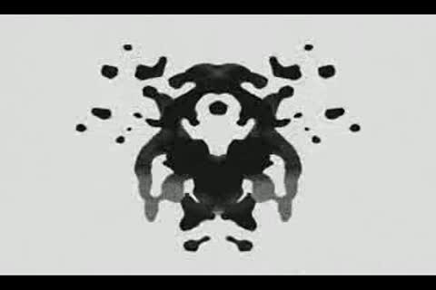

On an average , how many times did you think you were blinking your eyes per minute ?

**PART B**

4. What you have to do in this activity is simple . A picture has been given to you below . Extend the picture in whatever manner you feel is creative. You can transform these lines into a drawing of your choice . Feel free to get as creative as possible !

6. In this exercise , you will be given a random set of words . What you have to do is this :

1. Select ONE word of your choice .
2. Think of as many associations as you can . For example , if the word “phone” is given , this is how your thought process might work – Okay so we can CALL from a phone . We can do this because it has a SIM. Hmm , what does a sim card have in it ? ALUMINIUM ? is that SILVER in color ? Silver reminds me , is that what JEWELLERY is made of ? My mom bought hers at JOY ALLUKAS ... so on and so forth . Think and write about as much as you can in the time limit .

**4.Drug**

**5.Water**

**6.Lemon**

**7.Engineer**

**8.Boy**

**9.Paper**

**1.Cup**

**2.Girl**

**3.Wind**

7. As you have noticed , I have mentioned a group of words . The idea here is to form a paragraph with these given set of words . Try to use as many of the words as you can to form a paragraph \ story that is meaningful !

**fly,arrest,scan,bus,loan,bullet,island,bal,lphoto,feel,romance , seven,village,listen,wheel,simple,win,steel,man , biology,peace,paper, exercising.**

8. Look at this picture for a minute or two . During this time ,concentrate on the picture . At the same time , try to focus on the number of times you are blinking your eyes .



On an average , how many times did you think you were blinking your eyes per minute ?

Could you feel the process of surveying could have been improved in any manner ? If so , please mention below . I’d love to hear from you !

That is all ! Thank you for participating in this questionnaire . I hope this way fun for you guys ! Before you go , if you agree that the answers you gave can be used by me for my paper , please sign below !

( Your signature here ) ( Date here )