First things first , this idea is still baking. Open to suggestions / improvements . Basically looking for feedback and understand if this is something worth pursuing .

**Problem and idea behind it**

TLDR; No paths from one building to another. No mention of shortcuts one can use to get from one place to another.

I’m a second sem grad student. When I first got to Mason , I used the maps on the Mason Mobile app , but found one detail missing : You can’t plot paths from one location to another. It just gives you your location and the location of your destination , but no path that you can follow to get there .

Additionally , over a month , I figured that you can take routes that are not on the map as such ( through the grass , for instance ) . The best example of this would be the path near Subway with the “Do not walk on grass sign” ( when you’re trying to get from aquia creek lane to ox road) . Now , I know it does say do not walk on the grass , but I’ve seen a ton of people do it , and I figure it’s a much shorter way to get through campus .

**Solution**

Okay , I’m not entirely sure if this is the right approach , but here’s what I came up with.

Create a list of (lat,long) values for each point on the campus. Since lat,long can get really close , we could go really specific ( for instance , consider each entrance/exit in the Johnson center to be a point ) .

Now , each point can only be connected to it’s adjacent points , and will have a length to it . ( For example , a set of adjacent points can be the Johnson center entrance opposite Robinson hall B and the entrance for David King hall ….a set of non adjacent points can be David king hall and the aquatic center as you’d have to traverse through a bunch of other points to get there ) . Think of this as a collection of points through which people can walk . Why do this ? Because I’m sometimes late for class and it’d be good to know the shortest possible route I could take .

I think this image illustrates what I’m trying to say :

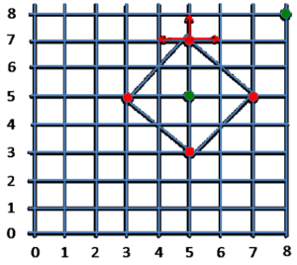

# sidenote : can include both designated paths for walking as well as shortcuts ( which cut through the do not walk through grass signs , for instance ) .

**How would we figure out the shortest path ?**

We consider an nxn matrix ( with all the points on the x and y axis ) , and traverse the shortest possible path from one point to another . This illustrates what I mean perfectly :

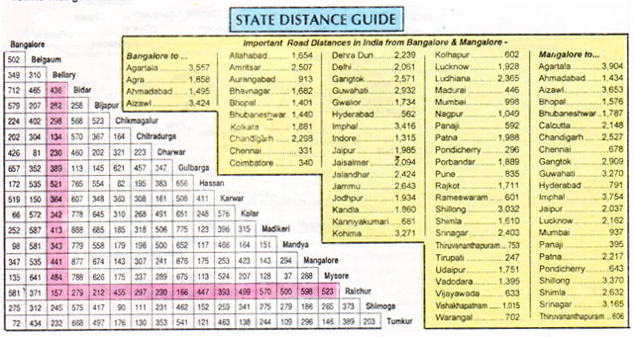

( bad quality , sorry ) .

**What next ?**

Once we have data regarding the shortest route from one point to another , the next step would be to allow users to query for the same. I’m not sure how I would incorporate a live location into this yet. I’m hoping #maps has some ideas.

Feedback ? Ideas ? Suggestions ? Interested in collaboration ? Shoot a message on slack 😊

Mail : [sdonthin@gmu.edu](mailto:sdonthin@gmu.edu)

PS : I’m calling this LazyMason for now. Yeah. That.