**Abstract**   
Microblogging today has become a very popular tool for communication and voicing opinions among Internet users, where millions of users share opinions on varied topics. Microblogging platforms like Twitter allow users to share views within a 140 character limit, leading to a high rate of information compression. Users also have the option of adding images, links and videos among other things, which makes the type and variety of content very diverse. Here processing the tweet involves extraction of metadata of tweet, geocoding the physical address in a tweet, analysing the sentiment of content in the tweet text and extracting the significant and key phrases from a text. This project mainly focuses on performing three tasks. First is to collect the tweets from Twitter, having a chosen keyword, save them on a database and clean them up to have only necessary information. This is achieved using the Twitter Application Program Interface (API) along with Python language. Secondly, classify the tweets based on Sentiment Analysis, which determines the judgment or evaluation of a user with respect to the chosen topic. This is performed using Python language. Third is to represent the locations and frequencies of the tweets geographically. The details of the users of the corresponding tweets are collected using REST and Streaming APIs provided by Twitter and the geographic representation is acheived using the packages of R language.

**Contents**

**Chapter1  
Introduction**The growth of the computer age has brought along with it a very large amount of information that is available for use . This has gained a lot of traction especially in the past few years, with scientists and the general public alike looking for better ways to utilize and make sense of the existing data. The existing patterns of communicating data, which mostly include listing out the data might not always be the best method to ensure that the information behind the data is conveyed efficiently. One of the better methods used in this regard is the process of visualization.

Visualization is gone for human comprehension in preparing the data proficiently and successfully. The quickened development of 'informal communities' (Example,Twitter) makes conceivable, to exchange and share data to numerous client's quick with less cost. The potential result of interpersonal interaction encourages a client to reach and cooperate a great many different clients. Organizations are building Third gathering applications, which are exploratory in conveying apparatuses to advantage client. It examines the conclusions, client sees, new thoughts, open hobbies, and their engaged exercises of a huge number of client round the globe. Showcasing firms additionally get included in dissecting client inputs and practicing over open supposition, and the brake out of most recent patterns in the masses in overhauling the items and administrations. The crude material in building the outsider application is mass volumes of information that needs to procedure to get data. The extraction of data from crude information put additional weight on applications that impedes viable usage of accessible information. Content examination might likewise allude as content digging for content investigation, to enhance quality perseverance and adds sense to the importance of information. The work proposed visualizes a structure that not only reduces the amount of existing noise that usually comes along with the corpus, but also looks at methods that can ensure that the amount of noise be reduced to a great extent.   
  
This paper expects to assess the accessible API's to get access information from Twitter, and execution of suitable methodology to fabricate database of interpersonal organization information (twitter). To make it helpful for perception of twitter information, it is imperative to comprehend which is proficient and compelling in usage and support. Additionally inspected and thought about existing gazetteers and Entity extraction libraries. For an undertaking of actualizing NER (Names Entity Recognition) to concentrate annotation particular to the characterized examples and organizations after legitimate investigation of information. Assumption examination have knowledge to distinguish the positive and negative sense in the content, the assessment concentrates for the most part on the conduct viewpoints and words or expressions that implies the human feelings.

* 1. **Literature review**Present data world conveys reporting through robotization, minimizes human push to investigate the content. Continuous examination encourages easy to use strategies in executing frameworks, to concentrate data from the textural content. In the present connection of breaking down the content and concentrate data concerning application necessities is vital. Representation needs a handled sensible or factual information to speak to in visual configuration makes a difference clients to comprehend huge volume of information easily. Current work centered to dissect the writings of huge volume sources like twitter (long range interpersonal communication database), it tosses parcel more questions in actualizing the framework, essential of advancement is to examine relative works and existing exploration or prior proposed frameworks. Variables which are huge in survey of effectively dedicated works like dependability, ease of use, adaptability and many-sided quality. Particular of current work proposition requires a legitimate study on different angles that impact proposed execution.
     1. **Accessing tweets from Twitter**The Twitter API has several methods, such as GET statuses / user_timeline, GET statuses / home_timeline and GET search / tweets, which return a timeline of Tweet data. Such timelines can grow very large, so there are limits to how much of a timeline a client application may fetch in a single request. Applications must therefore iterate through timeline results in order to build a more complete list. Because of Twitter’s realtime nature and the volume of data which is constantly being added to timelines, standard paging approaches are not always effective. The goal of this page is to demonstrate the issues Twitter developers may face when paging through result sets and to give best practices for processing a timeline.  
        Twitter API (dev twitter 2011) offers reaction to asks for in "JSON", "XML" and "Molecule" arrangements, parsing the yield need particular to the system you are utilizing to extricate. In twitter reaction, out put some field are not ensured to give back the worth may it contain invalid, if estimation of the comparing field worth is not accessible to return? The http reaction codes may be seen in the yield, by determining the status of the client demand.   
        Twitter4j (twitteer4j, 2011) gives a usage of java libraries to parse the GET reactions like JSON, XML and so forth. Metadata of the tweet likewise embedded accordingly of a pursuit question, it's essential in comprehension the data expressed in the tweet. (dev twitter 2011) have prove and broke down that each tweet is not geo-labeled (geographic coordinate's scope and longitude), however a few tweets are solely geo-labeled in reactions through Search API.It's simply discretionary to the client in expressing the geo-area, on account of client point of view and security to incapable the debilitate this geo-labeling highlight while tweeting through twitter.
     2. **Annotations Extraction**The component of indentifying the annotation depends on the coordinating of the prepared document content with textural expressions of separate annotation kind of comparing documents. Outside preparing records with information on annotation and inner system to say the gazetteer file with the rundowns are the two techniques that are normally utilized. Isolation substances must be taken into distinctive records or documents while setting up the training.In concern straightforward Text annotation with different control information, confounds the method of characterizing the preparation information. As talked about before there is each need to stroll through the code for customisation, separated from the models in the talk. In the event that custom execution requests more annotation separated from models, there are elective alternatives to go for custom models . One component that impacts the execution is the preparation source, be mindful about the measure of the preparation documents. Principle surmising is the engineer must be. Wary over the no element sort records in a preparation document, on the grounds that postpone time in extricating annotation is corresponding to the preparation information size. Question execution time pivotal in planning the databases, proficient utilization of memory assembles application productivity along these lines, to be specific in surrounding the annotation sorts on need premise.
     3. **Geo Coding of a location**Geo-coding assumes an imperative part in representation of physical location on visual energized maps. Earth surface is isolated in even and vertical points, the level lines speak to scope and vertical lines speak to longitude. For scope the equator is taken a reference point as 0 Degree and towards posts end 90 Degrees, the Greenwich (prime meridian) and aggregate 360 Degrees compass of vertically into equivalent parts of 180 Degrees of east furthermore, 180 Degrees of west. Geo-coding directions are decimal estimations of scope and longitude. As the goal of this work it requests for geo-coding (changing over area or address into scope and longitude organizes) the contemporary instrument is to make utilization of the API's having usefulness and gigantic information relating to the geographic organizes. In this connection it's important to investigate the accessible assets, assess the relative usefulness, ease of use and adaptability in customization of the asset. In which way the accessible exploration fulfills the client suspicion in building another framework, by redesigning necessities of particular situation in the accessible framework. The location need to examined dealt with giving data like road name, postal code or the territory name, case province, locale . Which should be cognizant over giving estimated location string in any event in, discovering the geo-facilitates of an address.The mainstream geo-coding API accessible being used is "Google geo-coding" (Mono imprints, 2010) furthermore, "hurray place discoverer" (yippee 1.0 2010) both are giving web-administrations to discover the geocoordinates of the client question. Mono imprints (2010) and yippee 1.0 (2010) have gives administrations which require authorisation and both have comparability in http solicitation to the particular URI and reaction arrangements of JSON and XML. As the administration is on business premise and to control heap of boundless solicitation from clients, they put limitation over the availability by restricting the client demands. Mono imprints (2010) is intended to have customer side reason by restricting the 2500 solicitations/day for every IP address, though Yahoo1.0 (2010) was worried for server-side restricted 50,000 solicitations/day for the client application. Mono imprints (2010) arrangement rules expresses that utilizing geo-coding results without plotting on Google map is restrictive. In correlation Mono imprints (2010) and Yahoo 1.0 (2010) both are effective also, exact yet Mono imprints gives best results.
     4. **Sentiment analysis**Sentiment analysis gets to be noteworthy in today's reality to dissect the corpus or mass writings. It is clear the time requirement, high recurrence of information and reports, quick client criticisms forcing additional weight on adjusting bodies (blogging gatherings, market investigators, stock sheets, gateways). Aside from the supervision it needs a computerized instrument to assess the feeling in a content. There is extent of study by utilizing opinion investigation instrument as a part of progressing theory in open life, client sentiment investigation, following the audits of an item and to examine the mass slant over distinctive issues or viewpoints. Present it's been organized in exploration and improvement of specific apparatuses to accomplish a superior examination over mass information in developing economies. A content or archive can be broke down and bifurcated into positive and negatives slant, and keeping in mind the end goal to that they have outlined a methodology to assess the info information corpus, essential undertaking is grammatical form labeling to every expression of information content with predefined coding. Rahman, mukras and nirmalie (2007) have characterized an optional undertaking of word/expression recurrence location in given content, and extricating "bi-Gram" (estimation rich expressions/words) and allot a score which is predefined for assumption or feeling words (in view of the power of the word). At long last by conglomeration of positive and negative arrangements of score, the prescient score of the assumption in the content get unearthed; another methodology utilizing particular classifier a two levels smaller scale level and large scale level, and averaging the assumption at both levels will be utilized as a part of this case.
  2. **Problem definition**Microblogging today has turned into an extremely mainstream instrument for correspondence and voicing feelings among Internet clients, where a large number of clients offer assessments on shifted themes. Microblogging stages like Twitter permit clients to share sees inside of a 140 character limit, prompting a high rate of data pressure. Clients additionally have the choice of including pictures, connections and recordings in addition to other things, which makes the sort and assortment of substance extremely different. The major problem that is being solved here is the fact that there is no coherent study that considers the sentiment analysis regarding a particular area or topic of interest and then correlates it with a geo coded data set. The main intention behind this is to ensure that there is a sample corpus and study based on which the research can be applied to similar areas of interest.
  3. **Organization of project report**

Table of Contents

1.0 ABSTRACT

2.0 Introduction

3.0 Literature Review

3.1 Accessing tweets from Twitter

3.2 Annotations Extraction

3.3 Geo-Coding of a location

3.4 Sentiment analysis

4.0 Project Requirement Specifications

4.1 Requirements

4.1.1 Problem Definition and Project scope

4.1.2 Software Requirements

4.1.3 Functional Requirements

4.1.4 Non-Functional Requirements

4.2 Use cases

5.0 Analysis and Design

5.1 System Design

5.2 Overview of the proposed system design

5.3 Security concerns

6. Implementation and Testing

6.1 Implementation

6.1.1 Planning or approach for implementation

6.1.2 Design patterns

6.1.3 TweetCollector

6.1.4 TextAnalysisComponents

6.1.5 GeoCode

6.2 Testing

7.0 Project Evaluation

7.1 Requirement specification evaluation

7.2 Performance testing results

7.3 Performance evaluation

7.4 Project Demonstration

8.0 Critical Evaluation of project and self reflections

9.0 Conclusion

Future work

10.0 References

Appendices

**Chap 2   
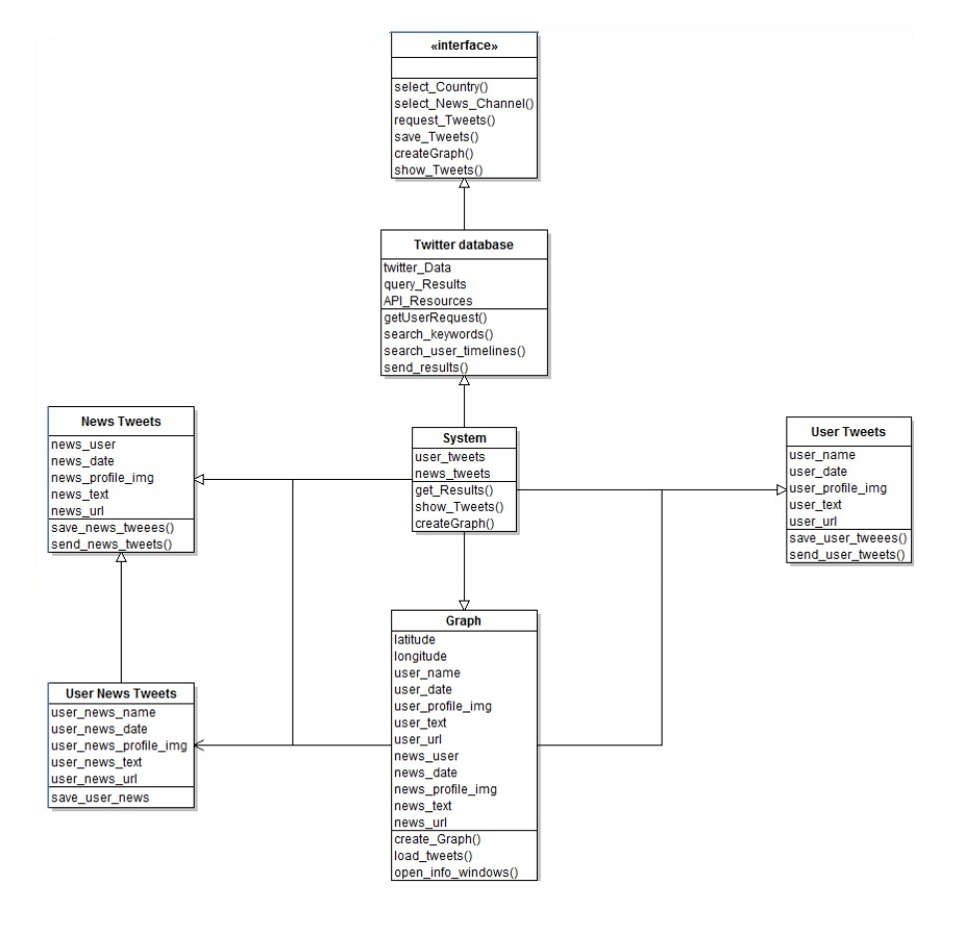  
Geo class diagram   
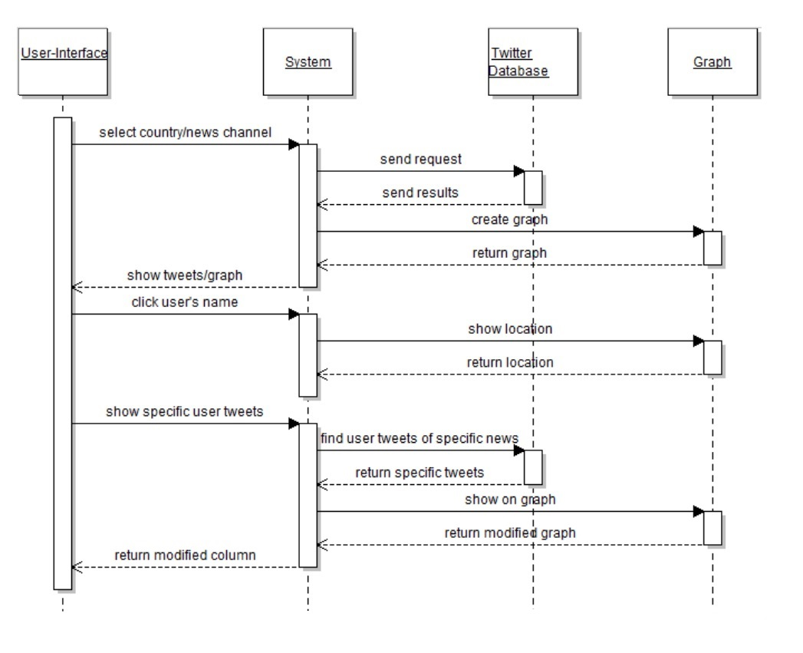  
Geo sequence diagram   
  
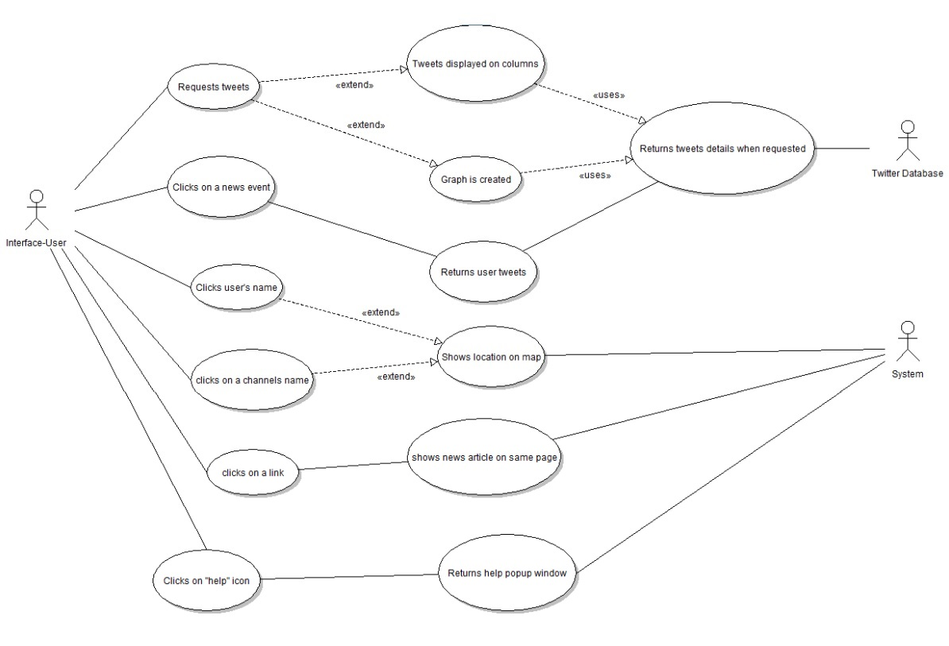  
Geo Use case diagram**

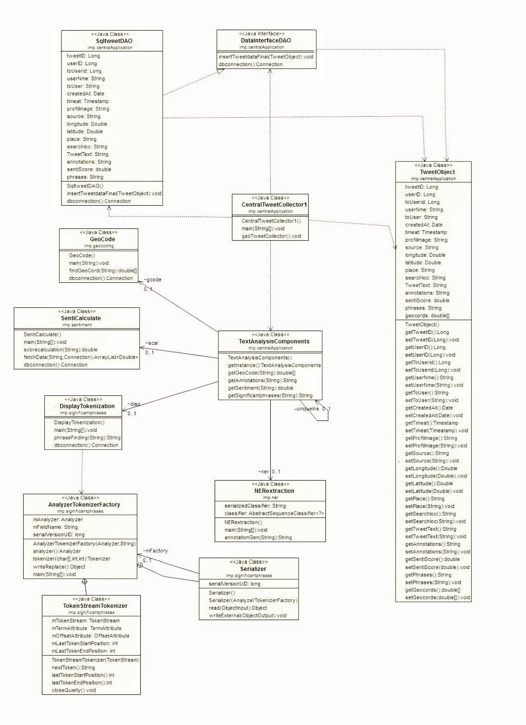   
Geo ewkjfb **Sentiment Analysis class diagram   
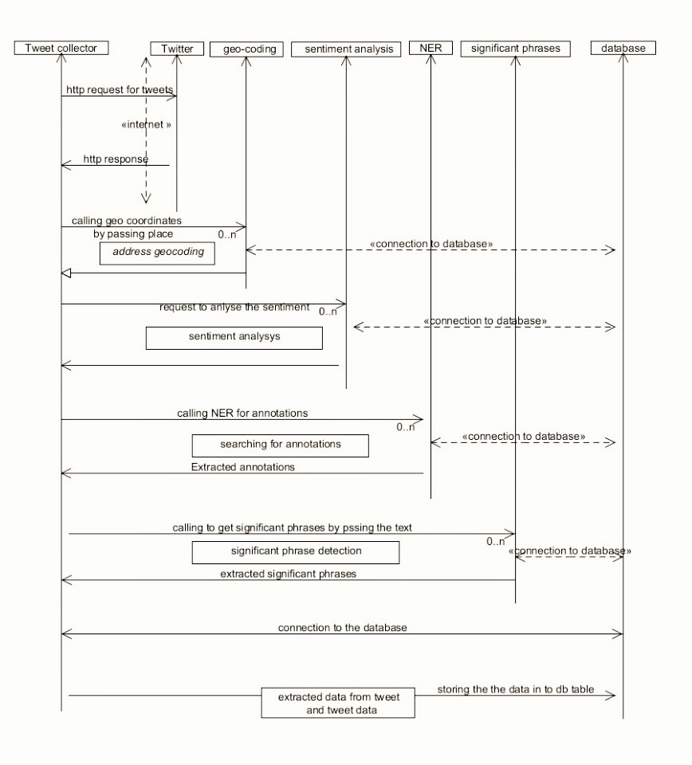  
Sentiment Analysis sequence diagram   
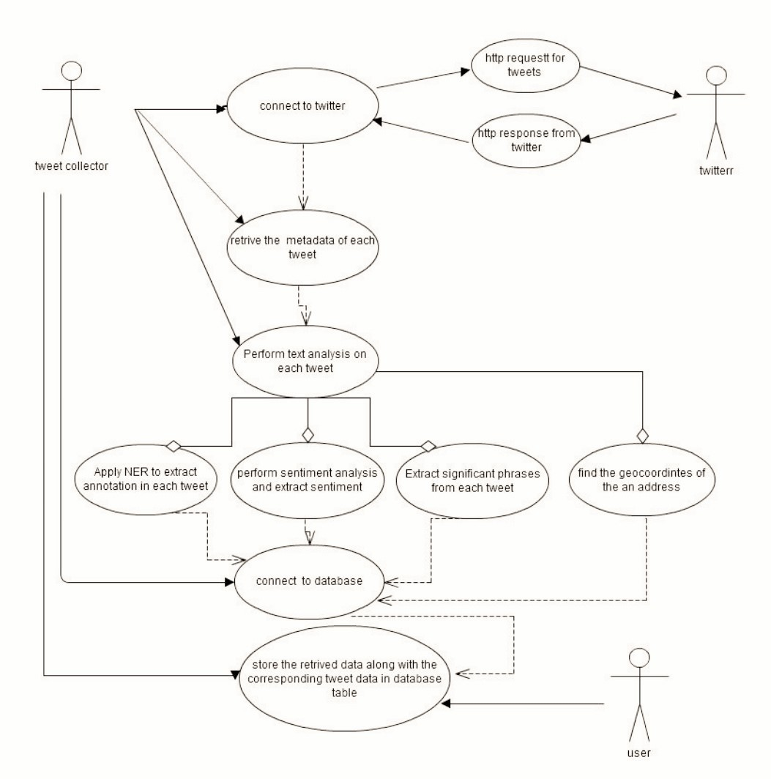  
Sentiment Analysis Use Case diagram**

**9 uml diagrams**

**System model**

**Conclusion**

**Basepaper ( reference )**

**Bibliography**