**Assignment 2 Report**

**Setup**

I used Python 3 and the graphic library PyQt6.

**OpenCV Implementation**

For calculating the PID, I followed the formulas and suggestions in the lectures. Instead of integrating the error term, I approximated by calculating the area average of error height and previous error height times the time elapsed. Instead of differentiating, I just divided the error velocity by the time elapsed.

For tweaking the PID, I didn’t have to, because the initial values given to me Kp=6000, Ki=5000, and Kd=500 were good enough. I did have to set bias to 1380, because there was a systematic error that was causing the detected ball height to always be lower than the target height by the same time.

There is an issue if the target is set above 1m. What happens is that the ball can no longer be detected, so the program stops updating the detected ball position. So in the black graph, it still thinks the detected height is 1m. In that case, the calculated CTE doesn’t reflect the actual CTE, leading to the divergence shown in the white graph (Ignore the green line below, that seems to be a bug from PyQt6.):

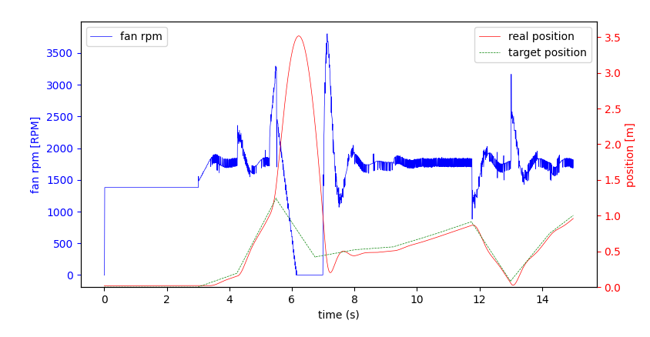

Kalman Filter Implementation