**Project 2**

**Relational Model**

Categories(name, priority)­­

People(hinsurnum, name, phone, city, streetaddr, postalcode, dateofbirth, gender, regdate, cname)

* cname references Categories

Locations(name, streetaddr, city, postalcode)

Hospitals(name)

* name references Locations

Nurses(licenseno, name, hospname)

* hospname references Hospitals

WorkingDays(locname, date)

* locname references Locations

Vaccines(name, numdoses, waitingperiod)

Batches(name, batchnum, manufacdate, expirydate, numvials, locname)

* name references Vaccines
* locname references Locations

Vials(name, batchnum, num)

* name, batchnum references Batches

Slots(locname, date, time, tentnum, hinsurnum, allocdate, licenseno, vname, batchnum, num)

* locname, date references WorkingDays
* hinsurnum references People
* licenseno references Nurses
* vname, batchnum, num references Vials

NurseDay(licenseno, locname, date)

* licenseno references Nurses
* locname, date references WorkingDays

**Pending Constraints**

* The UsedIn relationship can’t be merged into both Slots and Vials (Slots was chosen). So the model doesn’t stop a vial from being in multiple slots. It also doesn’t enforce that every vial has to be in a slot (i.e. there can be non-administered vials stored in the database).
* For non-participation key constraints that involve multiple foreign keys, it is not possible to enforce that those keys are either all null or all not null. For example, Slots has the foreign key (vname, batchnum, num), but the model cannot force them all to be set or not set.

**SQL Queries**

4a)

SELECT locname, date, time, tentnum, hinsurnum, allocdate, licenseno, vname, batchnum, num

FROM Slots

WHERE locname = 'Jewish General'

AND date = '3/20/2021'

AND hinsurnum is NULL

AND allocdate is NULL

;

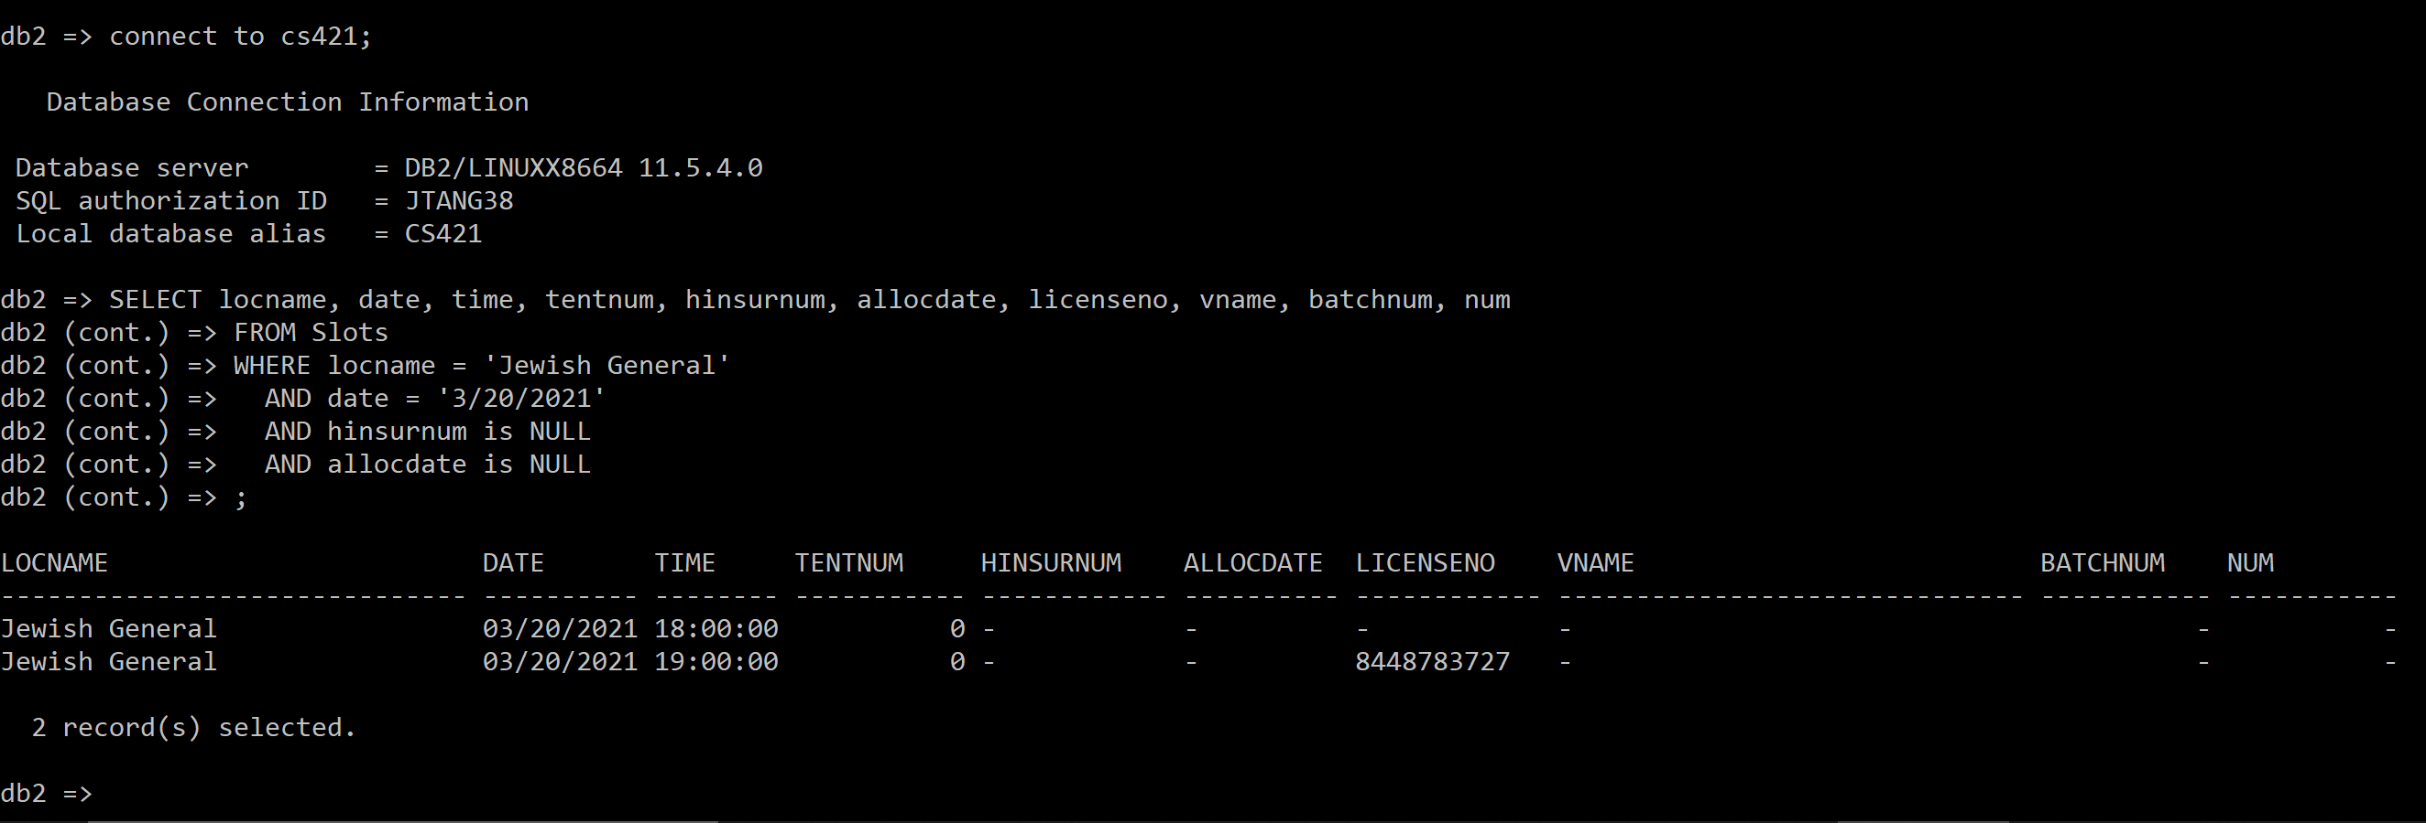

4b)

SELECT Batches.expirydate

FROM People, Slots, Vials, Batches

WHERE People.name = 'Jane Doe'

AND Slots.date = '2/6/2021'

-- People, Slots

AND People.hinsurnum = Slots.hinsurnum

-- Slots, Vials

AND Slots.vname = Vials.name

AND Slots.batchnum = Vials.batchnum

AND Slots.num = Vials.num

-- Vials, Batches

AND Vials.name = Batches.name

AND Vials.batchnum = Batches.batchnum

;

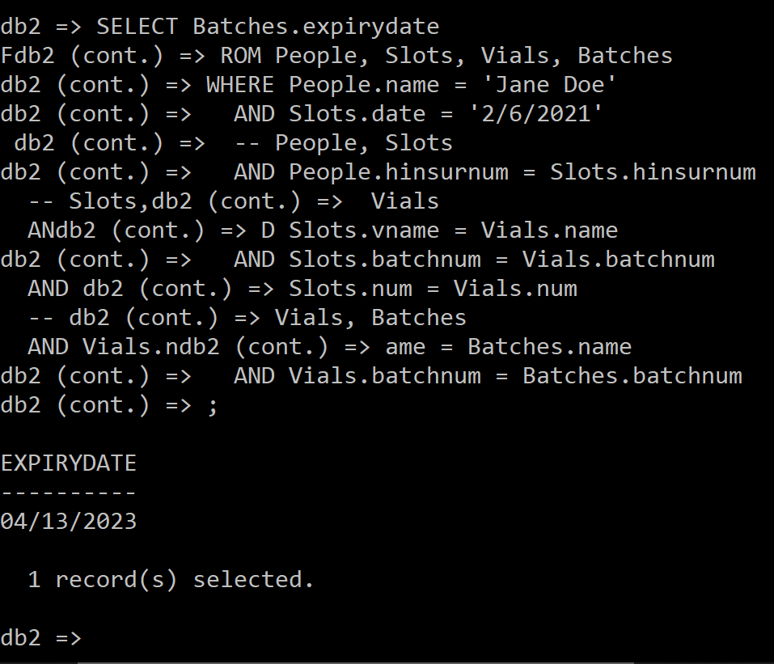

4c)

SELECT count(hinsurnum) as total

FROM Slots, WorkingDays, Locations

WHERE Slots.date = '2/6/2021'

AND Locations.city = 'Montreal'

--- Slots, WorkingDays

AND Slots.locname = WorkingDays.locname

AND Slots.date = WorkingDays.date

--- WorkingDays, Locations

AND WorkingDays.locname = Locations.name

;

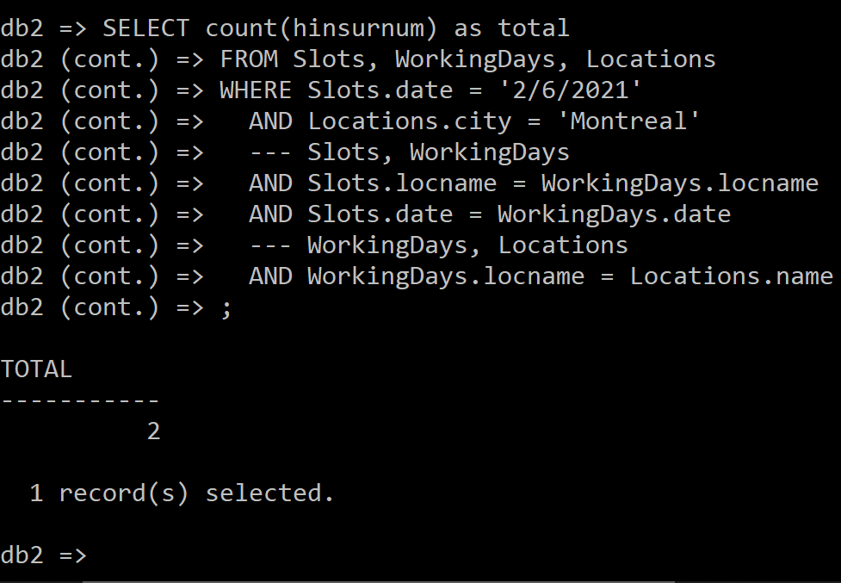

4d)

SELECT name, phone, hinsurnum

FROM People

WHERE hinsurnum in (

SELECT hinsurnum

FROM Slots

WHERE Slots.vname = 'Pfizer-BioNTech' AND Slots.date < '2/1/2021'

GROUP BY hinsurnum

HAVING count(hinsurnum) = 1

);

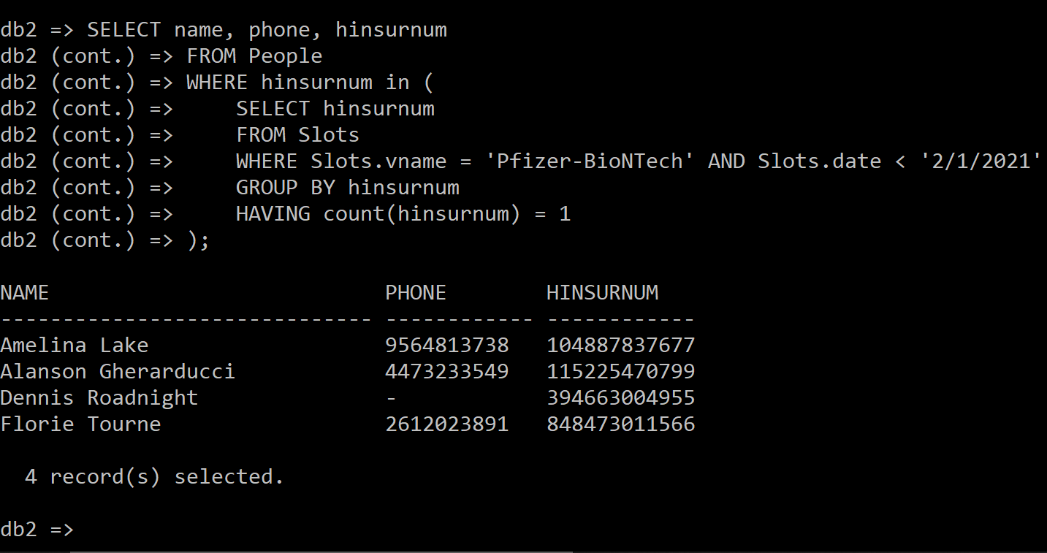

4e)

SELECT cname, count(DISTINCT People.hinsurnum) as Ppl

FROM People, Slots

WHERE People.hinsurnum = Slots.hinsurnum

GROUP BY cname

UNION (

SELECT DISTINCT cname, 0 as Ppl

FROM Categories, People

WHERE Categories.name = People.cname

EXCEPT

SELECT cname, 0 as Ppl

FROM People, Slots

WHERE People.hinsurnum = Slots.hinsurnum

GROUP BY cname

);

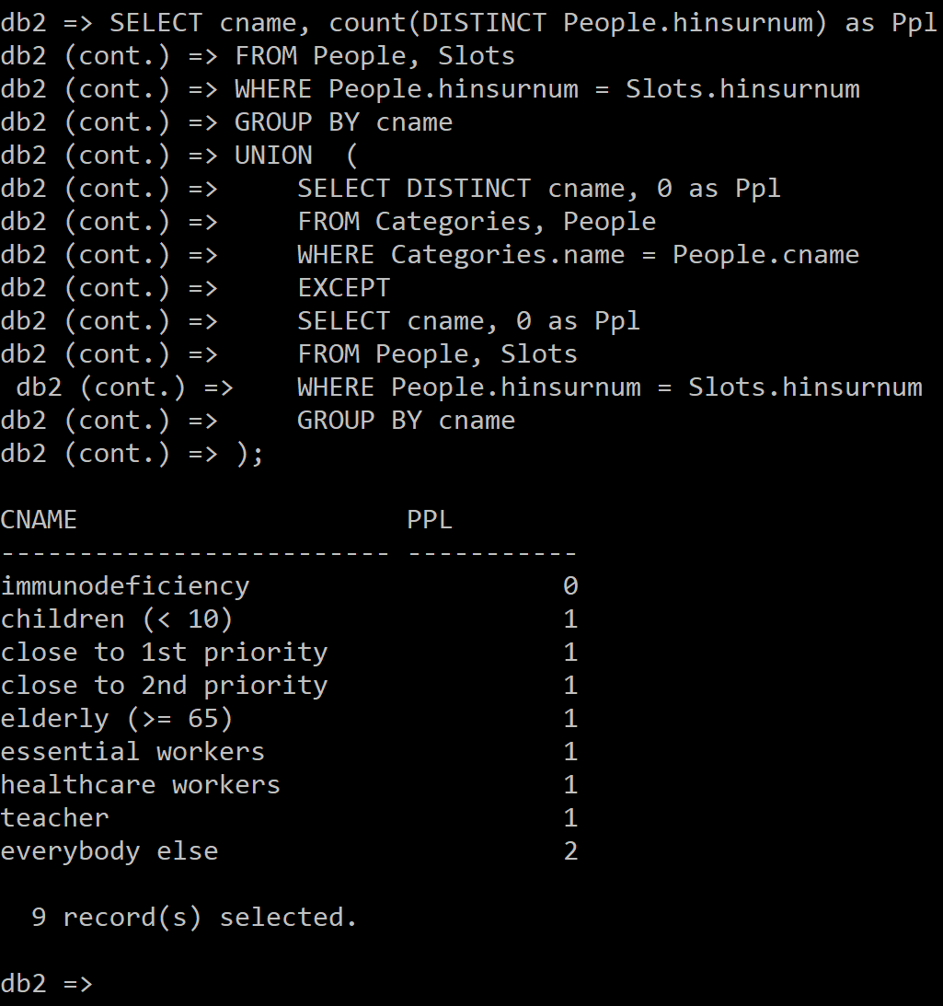

**Montreal Nurses**

CREATE VIEW mtlnurses(licenseno, name, hospname, postalcode, streetaddr)

AS SELECT licenseno, Nurses.name, Nurses.hospname, postalcode, streetaddr

FROM Nurses, Locations

WHERE Nurses.hospname = Locations.name AND city = 'Montreal'

;

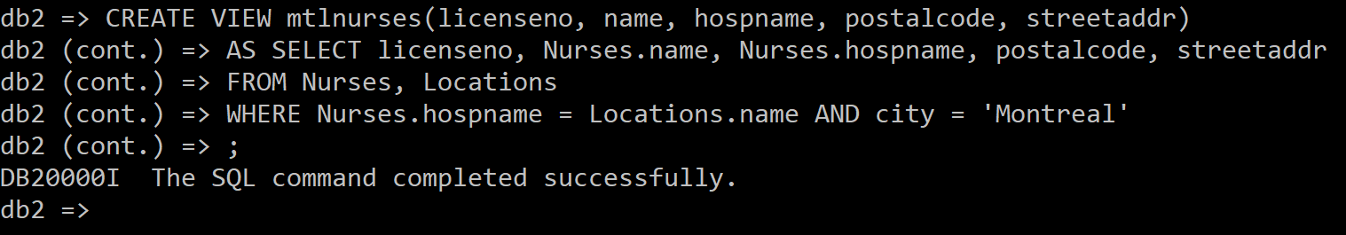

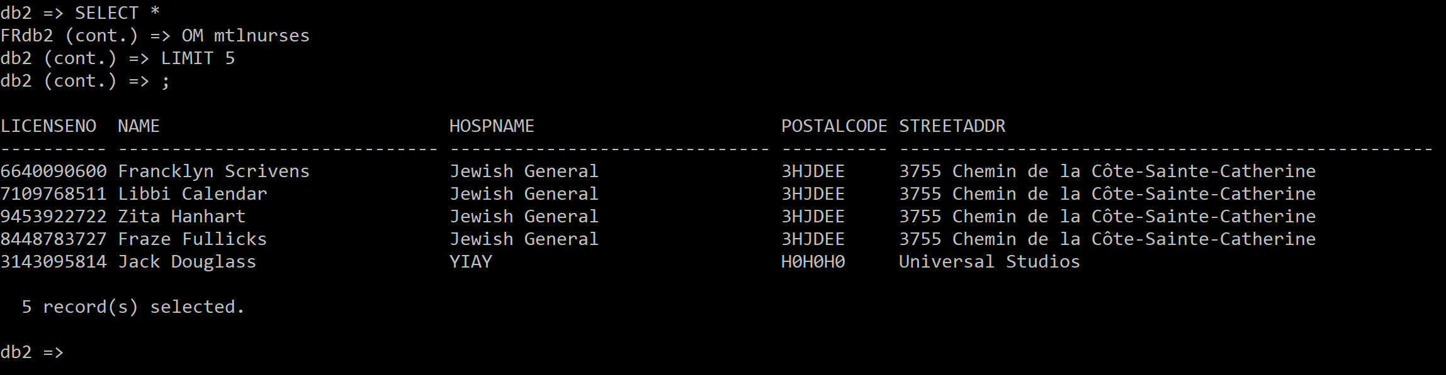

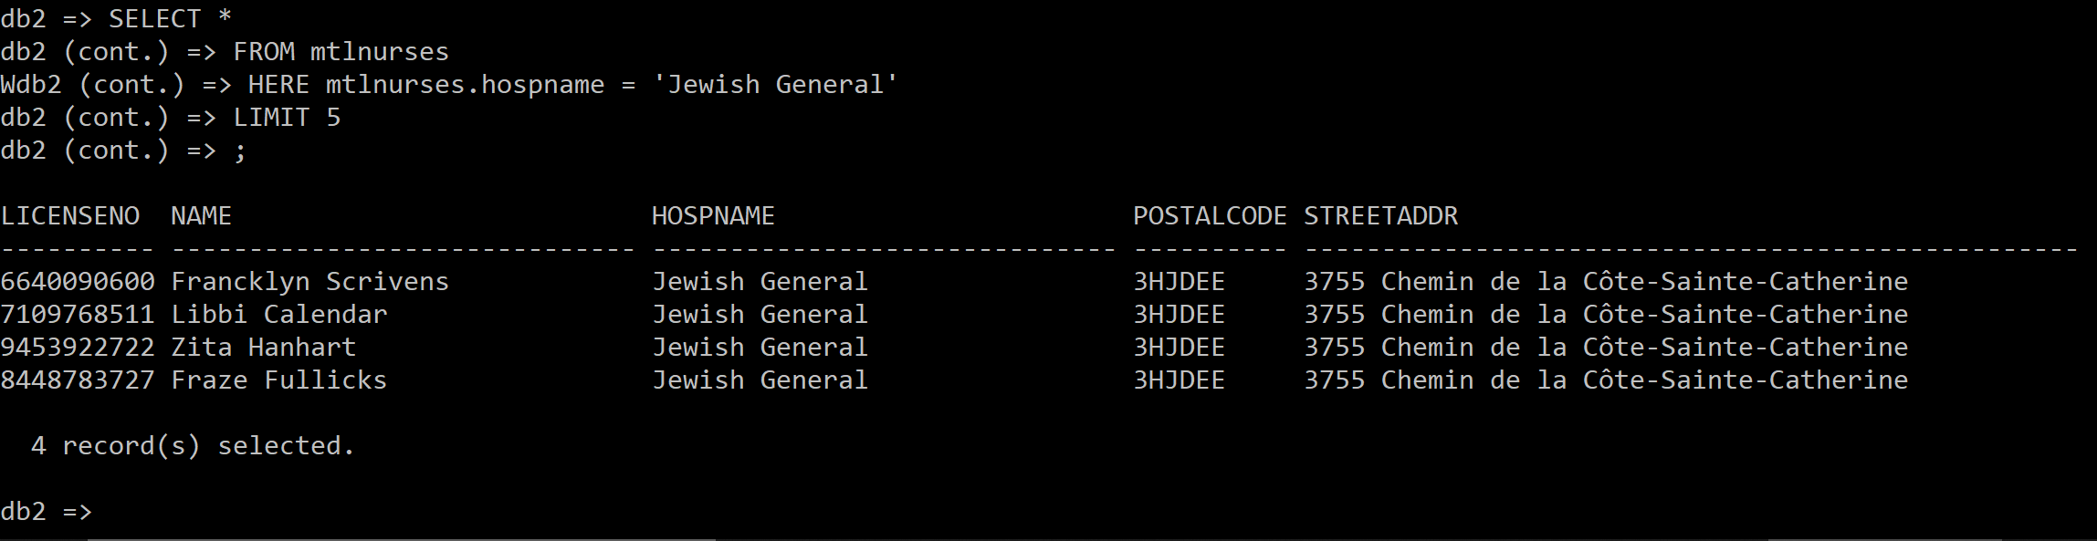

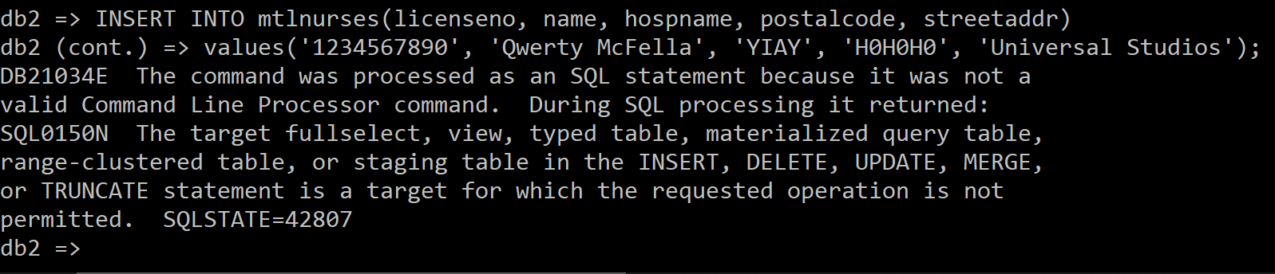

Explanation: You can’t add a new nurse to an existing hospital but then also have to specify things like postalcode and streetaddr, which are already defined for that existing hospital. This works though (I don’t need to use the command line since the photo below is not required):

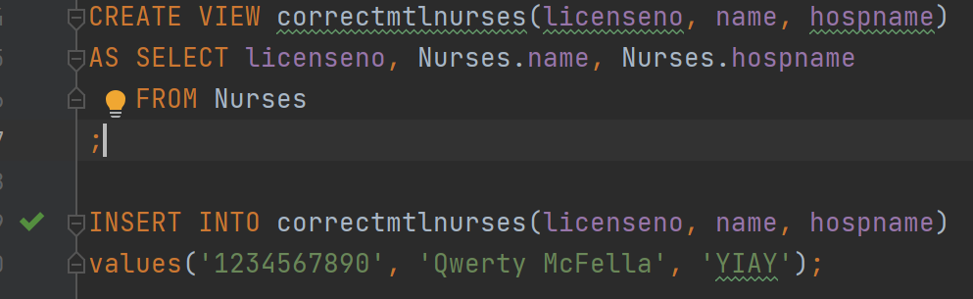

**Check Constraints**

Inserting is allowed before applying constraint:

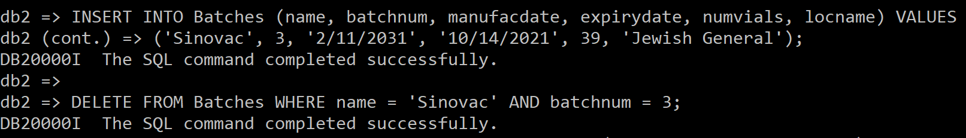

Now it is not:

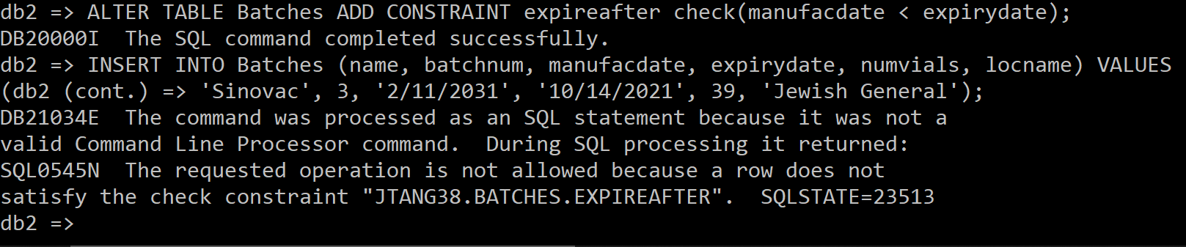

**ER Model**

I know this is not needed, but if it helps, it helps:

