**Project 3**

**1. Relational Model**

Categories(name, priority)­­

People(hinsurnum, name, phone, city, streetaddr, postalcode, dateofbirth, gender, regdate, cname)

* cname references Categories

Locations(name, streetaddr, city, postalcode)

Hospitals(name)

* name references Locations

Nurses(licenseno, name, hospname)

* hospname references Hospitals

WorkingDays(locname, date)

* locname references Locations

Vaccines(name, numdoses, waitingperiod)

Batches(name, batchnum, manufacdate, expirydate, numvials, locname)

* name references Vaccines
* locname references Locations

Vials(name, batchnum, num)

* name, batchnum references Batches

Slots(locname, date, time, tentnum, hinsurnum, allocdate, licenseno, vname, batchnum, num)

* locname, date references WorkingDays
* hinsurnum references People
* licenseno references Nurses
* vname, batchnum, num references Vials

NurseDay(licenseno, locname, date)

* licenseno references Nurses
* locname, date references WorkingDays

**2. Application Interaction**

For reference:

* P1/H1/P2: 111111111111
* P3: 611568426700
* P4: 998497091433
* P5: 511568426700
* P6: 006147016388
* S1: Pharmaprix, 2021-03-20, 19:00, 0
* S2: Jewish General, 2021-03-20, 18:00, 0
* S3: Jewish General, 2021-03-20, 18:00, 0
* S4: McGill Neurological Institute, 2021-04-06, 14:00, 3 (I made this up for part d)
* N1: 0744604915
* N2: 8617596554
* V1/W1: Pfizer-BioNTech, 3, 1
* V1/W3: Pfizer-BioNTech, 7, 5 (the already taken shot in ei)
* V2/W2: Moderna, 1, 5

ai)

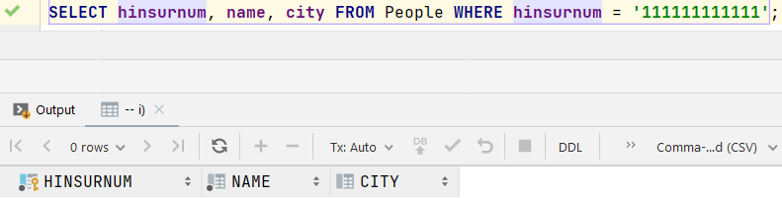

aii)

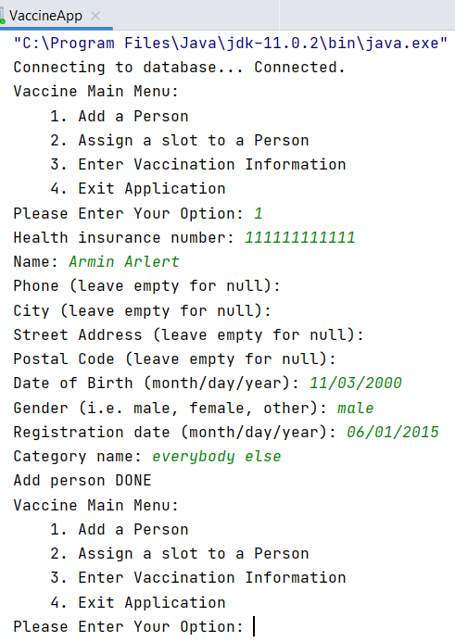

aiii)

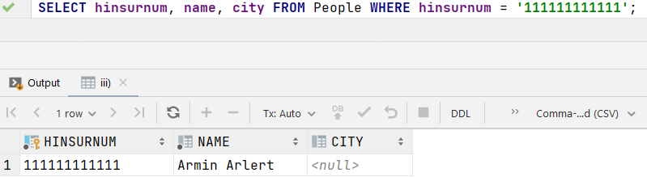

aiv) P2 is basically P1 but city is different

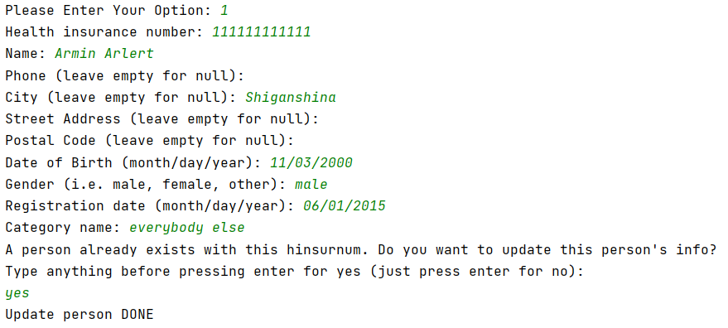

av)

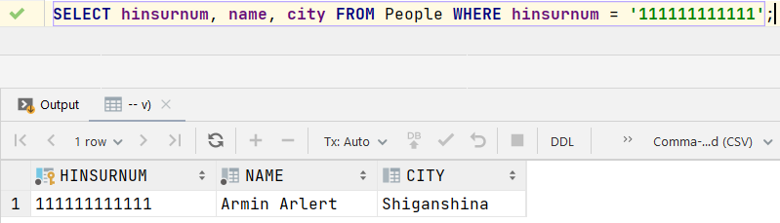

bi)

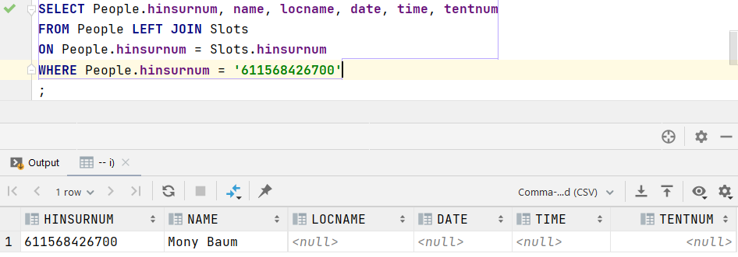

bii)

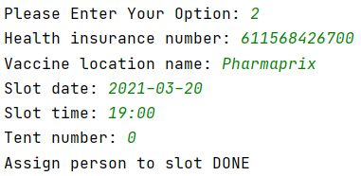

biii)

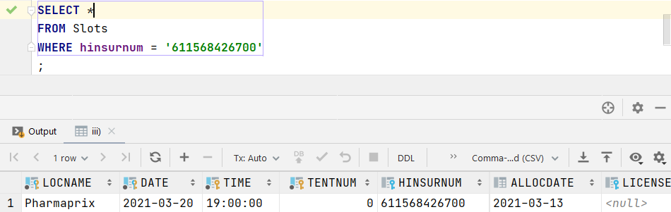

biv)

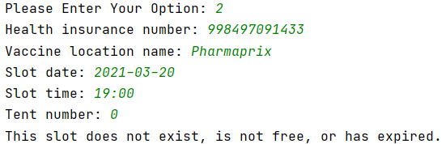

bv)

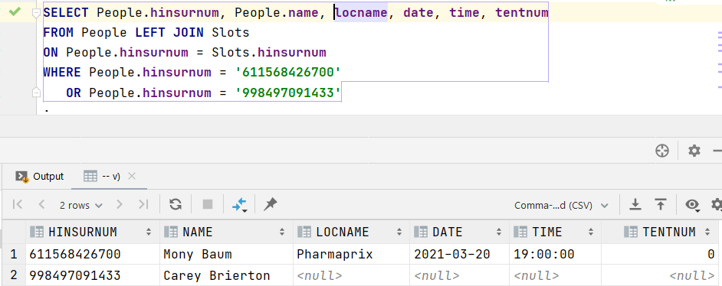

ci)

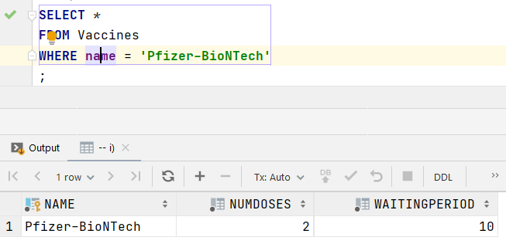

cii)

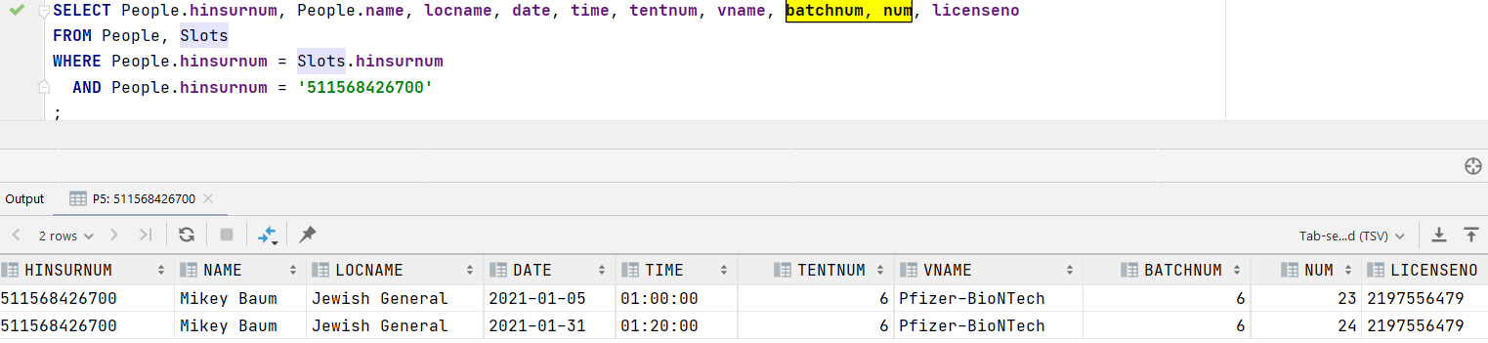

ciii) If you have taken the required number of shots, you cannot be assigned more slots. My assumption here is I should also take into consideration shots that are scheduled to be taken but haven’t yet. So If I need 2 shots, and I’ve taken 1 and reserved 1, then I cannot be assigned more slots.

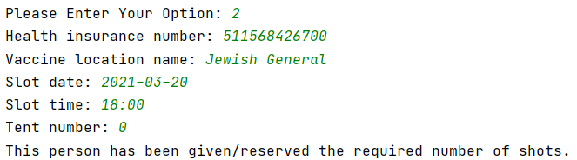

civ)

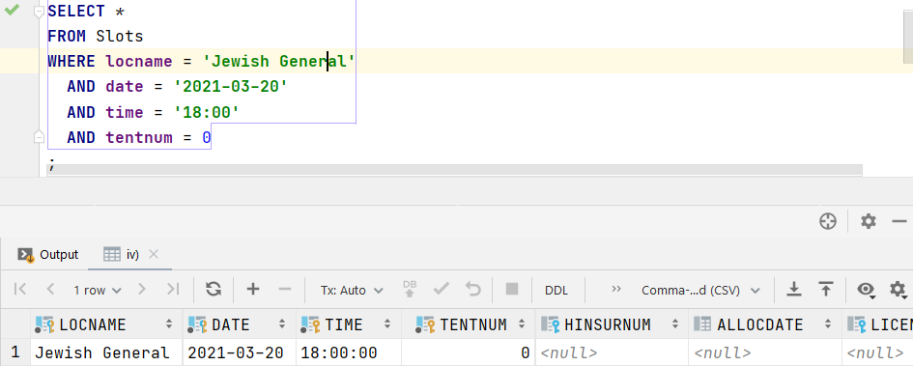

di)

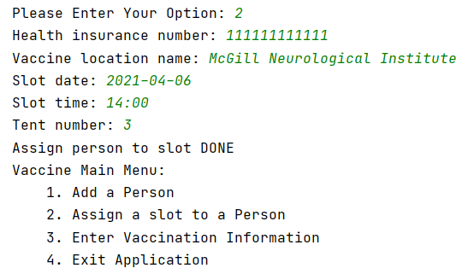

For option 3:

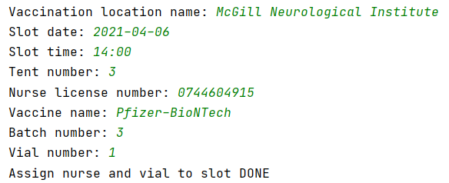

dii)

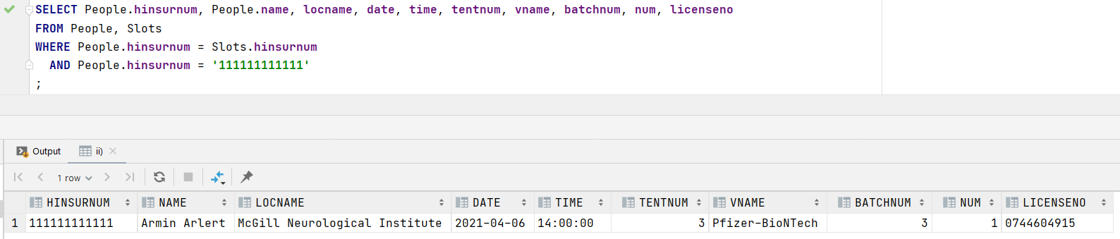

ei)

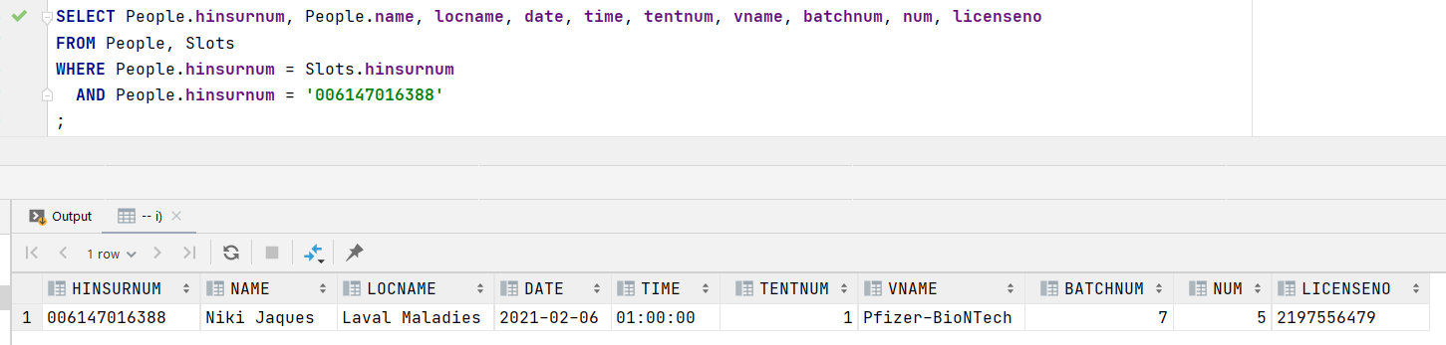

eii)

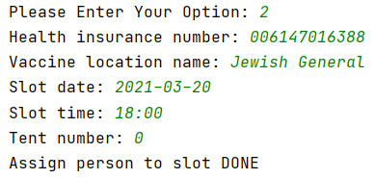

eiii)

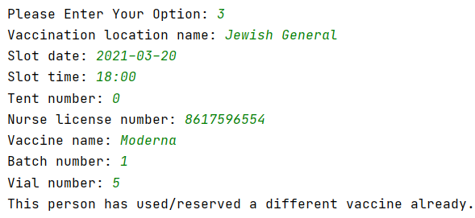

**3. Index**

I’m considering the case where phone number is a non-null unique column, because then I can include streetaddr as an additional attribute (DB2 documentation, “The INCLUDE clause, applicable only on unique indexes, specifies additional columns to be appended to the set of index key columns”):

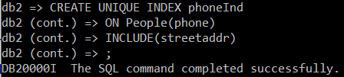

They both serve different purposes. If we want to query a specific or a range of hinsurnum, obviously a hinsurnum index would be faster. Likewise for the phoneInd to search the addresses of specific phone numbers.

As for which of these searches are faster, that depends on whether the hinsurnum clustered index is allowed to have additional attributes, and whether it’s a point or range query.

|  |  |  |
| --- | --- | --- |
| **Hinsurnum additional attributes** | **Query Type** | **Verdict** |
| Yes | Point | No difference |
| Yes | Range | Hinsurnum index is faster, it doesn’t have to access as many leaf pages, since the entries in the leaf pages are sorted by hinsurnum itself. |
| No | Point | The phoneInd is faster, because it can directly access address, saving a trip to a data page. |
| No | Range | Hard to say. Hinsurnum index accesses data pages, while phoneInd accesses more leaf pages. phoneInd edges out a bit I think, since it just has leaf costs while hinsurnum has data page costs and a bit of leaf costs. |

If I made phone not unique so that its index doesn’t have an additional attribute, then it should be simpler: without additional attributes, hinsurnum is faster in range queries due to accessing less leaf and data pages, point queries are still the same.

**4. Query and Chart**

I included a date range in my query, because out of that range, there are days with less than 5 shots:

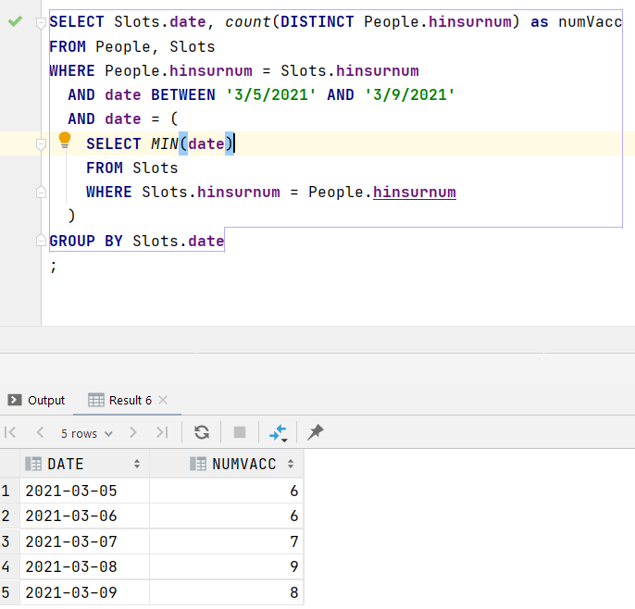

You can find this chart in numvaccs.xlsx:

**0. ER Model**

I know this is not needed, but if it helps, it helps:

