TASK 1

Here is Setup page for ChildrenParty4U. Here included create databases with tables and data. This index file in setup-project directory folder.

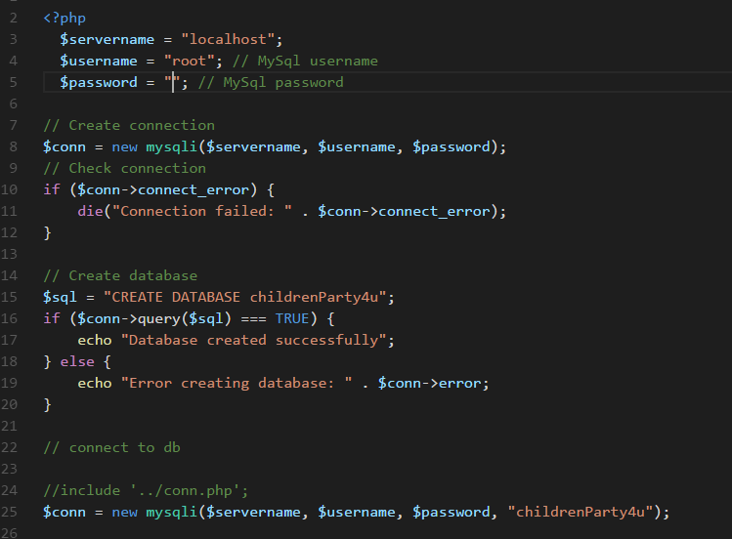

TASK 2

This is login and registration System for ChildrenParty4U. This registration system checks the username and email uniqueness. And login system take Username for login credential. After login in a $_SESSION variable store a User ID, that It can be accessible from any file in project.

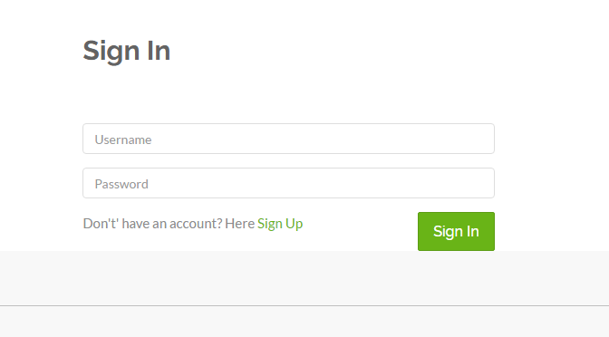

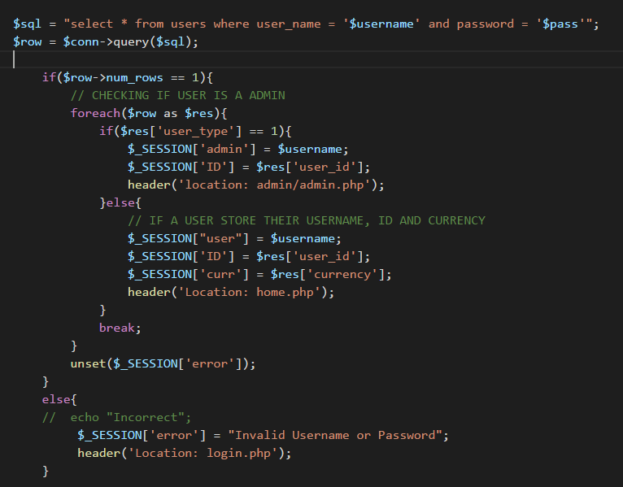

Here is code for Sign up

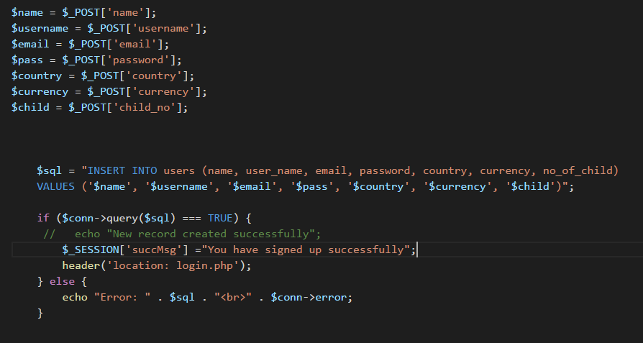

TASK 3

This task is about add new party to the databases. Also with a edit option for admin. Its enabled uploading a image with party description. In this page, there included a admin restriction checking. Checking is it admin or a user.

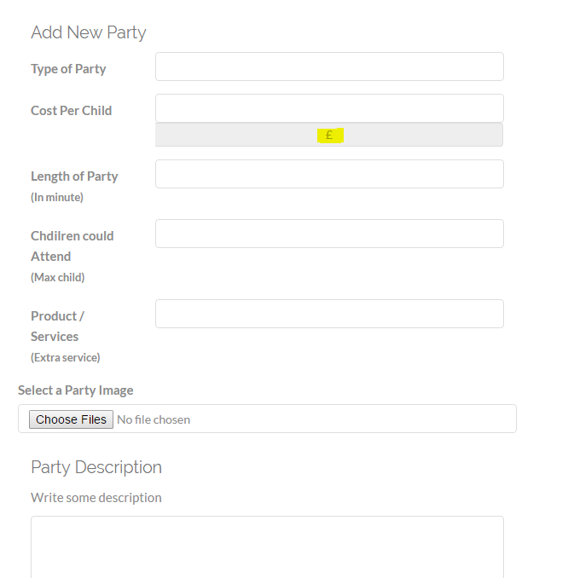

This is code for insert party into databases. Also included update query in it.

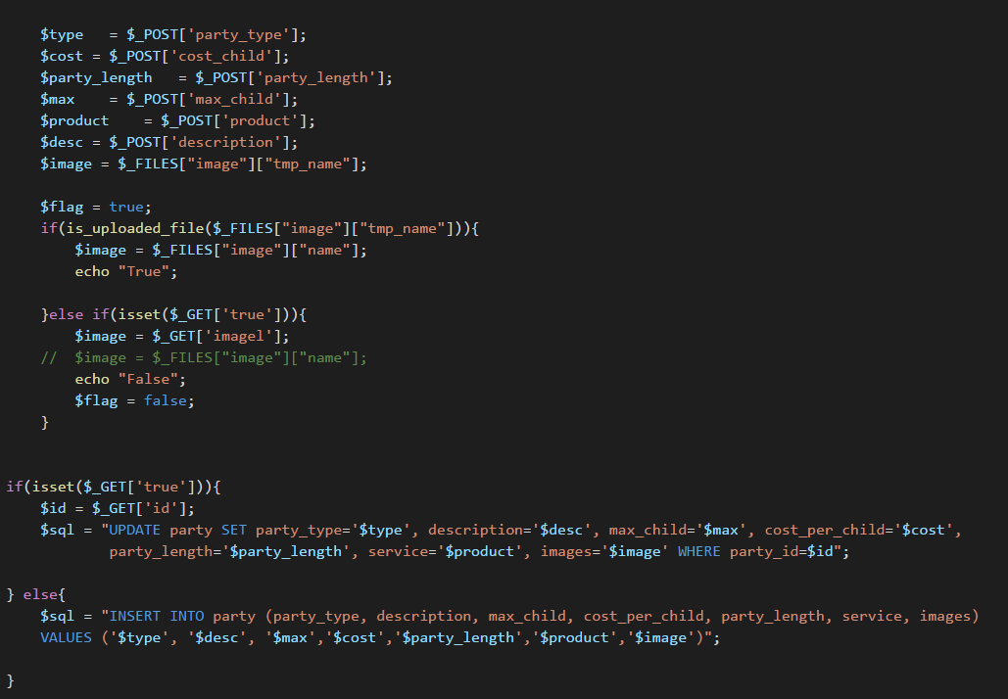

TASK 4

This task is about booking, to show booked and available dates with a Calendar. I have installed a jQuery plugin for Calendar. In this calendar it shows “Available” and “Unavailable” date in blur and active dates.

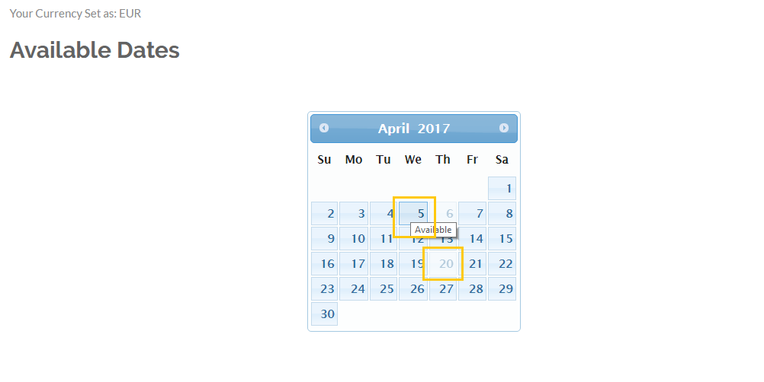

TASK 5

Here Rajinda can Edit a existing party and delete them without confirmation. After edit button it takes to a edit form that Rajinda can edit them anything.

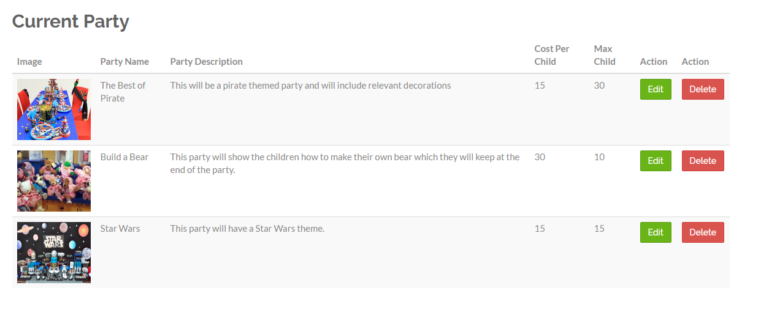

After click on Edit this form will appear to edit a party.

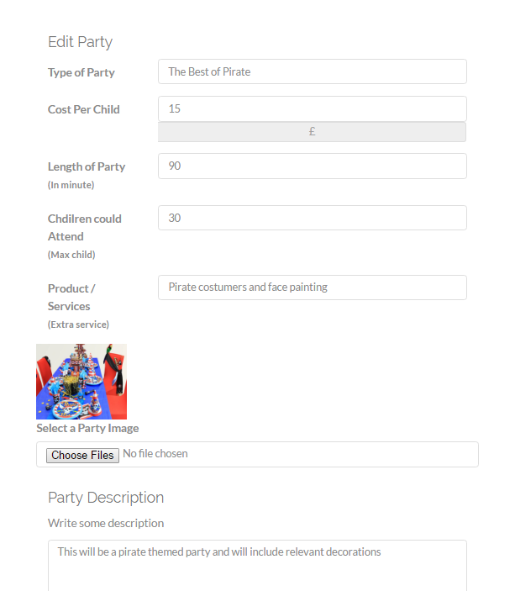

This is code for Edit a party into databases.



TASK 6

Here free dates are visible to client. S/He can view available and unavailable dates in online calendar with I integrated. Also after admi approval a Confirmation mail send to client email, that party booked or not.

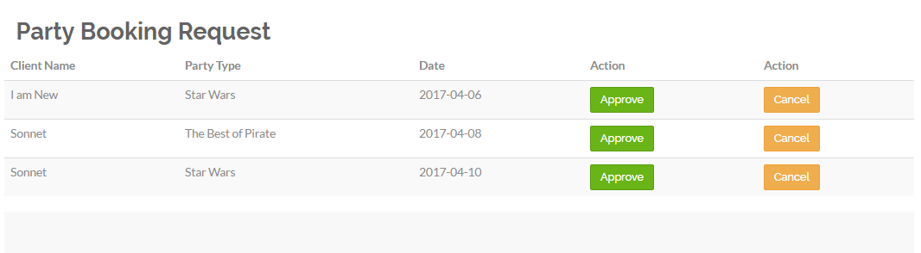

Here PHPMailer used to send email to clients.

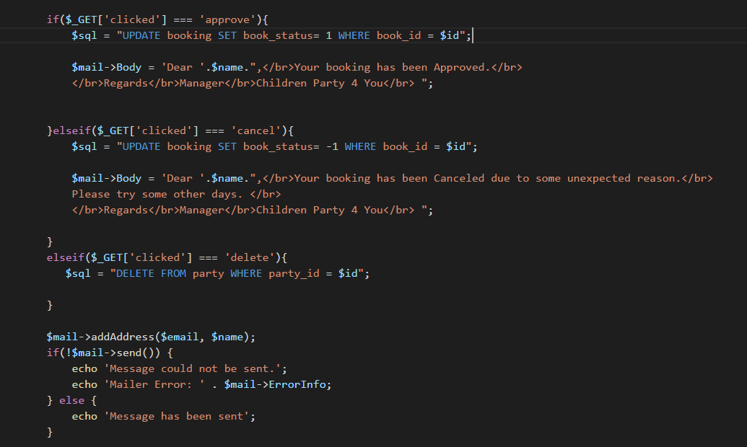

TASK 7

In the booking time, it is visible to client how cost per child in their local currency. Also after submit it shows total cost with multiple of child number they entered.

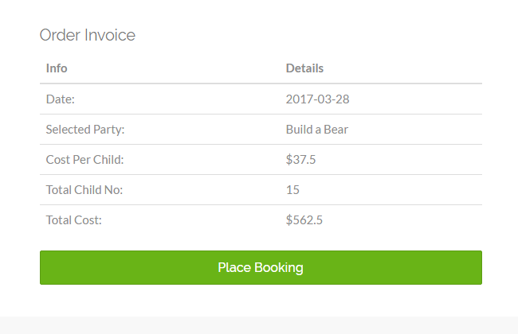

TASK 8

There are lots of payment gateways. For online payment there are like PayPal, Stirpe UK, Worldpay, Sage Pay and so on. By all of these payment gateways this party booking payment can be paid. By setting up online payment gateway business will be more enrich to service customer properly. Customer could be booked and give their payment from their home without any problem. For this facility business will grow in rapidly.

To integrate payment gateway with website, we must use to PHP code with html. Such as stripe gate way, we must have a stripe API key to use stripe payment system. After getting stripe API key, that key will use in PHP code. In this process a payment gateway could be installed. After pasting specific gateway service code to website, that payment system will be enable to Childrenparty4U website.

TASK 9

I have learnt a lot. Starting from PHP, MySql query, retrieving data from databases, inset data into databases, update data and delete from databases. I learnt handle user and admin login in Web system with USER_TYPE. Make a restriction in access with $_SESSION.

I have learnt how to design a website with bootstrap framework. Bootstrap is much friendly and easy to use. For a website what needed, everything included in bootstrap.

In PHP make sign up and login system with $_POST method alongside with $_GET method. A way to get data and insert into databases. Check uniqueness and give warning. For checking username and email availability in databases I learnt Ajax. Ajax used for response instantly in page without loading a page.

This project there included some important features like mail sending, admin panel handling mostly a booking system. Sending mail using PHPMailer. Setting configuration with protocol and ports and authenticity. For this booking system, I learnt PHP and MySql code writing methodologies. Also Javascript for online calendar to show available and unavailable dates.

This system could be improved in UX with payment system. For security purposes a confirmation SMS could be used in booking, that is it a user or robot. Also include a party offer system in admin panel. That admin can make an offer in specific season. Occasional offer will increase party booking. There should also include a admin verification method. After adding admin, that admin should verify him/her.

In this system the calendar implementation part was most difficult for me. How get data from databases, make unavailable to client also admin. For calendar implementation JavaScript knowledge is required highly. It was hard to retrieve data from booking table and set available and unavailable to calendar. In my code requires Json to connect PHP with JavaScript. Json used here a middle connector.