PROKON CRM · CONFIDENTIAL — FOR CLIENT REVIEW  API Integration & Tally Export  How e-Invoicing (IRN + E-Way Bill) and Tally accounting will run automatically from inside the CRM — and a five-day plan to set it up. | Prepared for: Prokon  Scope: 3 branches · 1 Tally company  Delivery: 5 working days  Version: 1.0

01 Two automations, one source of truth
A · COMPLIANCE  GSP API — E-Invoice (IRN) & E-Way Bill  The CRM itself fetches the legally valid IRN, acknowledgement number, signed QR code and E-Way Bill number from the Government portal, through our GSP partner. No separate portal login, no copy-paste.  ₹29,500 / year · 4,000 API calls |  | B · ACCOUNTING  Tally Export — books stay in TallyPrime  Every CRM invoice is converted into TallyPrime vouchers with matching ledgers, GST rate buckets and invoice references. One file, imported in one go — Sales, GST and party ledgers update together.  ₹0 — Tally's import gateway is built in
The rule both follow: the CRM is the only place a bill is created. Nothing is re-typed in the Government portal or in Tally — so the same figures reach the tax department and your books.
02 The process, end to end
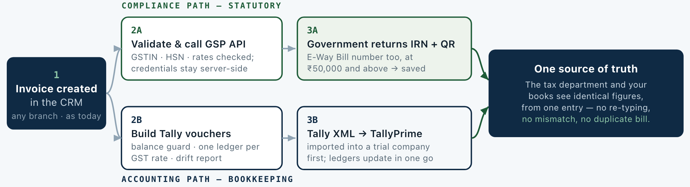
1 | Invoice created in the CRM — any of the three branches, exactly as today.
2A | Validation, then a secure server-to-server call to the GSP API. Credentials never reach the browser.
3A | Government returns IRN, acknowledgement number, signed QR and E-Way Bill number; the invoice is marked Complete.
2B | Export engine converts the invoice into Tally vouchers and checks every figure first.
3B | One XML file imported into a Tally trial company first, then into your live company.
★ | Both paths start from the same stored invoice — that is what keeps taxes and books in agreement.
03 What changes for your team
TASK | TODAY — MANUAL | AFTER INTEGRATION — AUTOMATIC
IRN / e-Invoice | Download JSON → upload to GST portal → copy the response → paste it back into the CRM | One click in the CRM. IRN, acknowledgement number and QR return and save themselves.
E-Way Bill | A second manual round trip on a separate portal | Raised immediately after the IRN, with transport details prefilled and validity date stored.
Tally entry | Accounts re-types every invoice into TallyPrime by hand | Pick a date range and branch, export one XML file, import it — all vouchers post at once.
Errors & audit | Mistakes surface late, usually at GST filing time | Balance and GST-rate checks block a bad voucher; every API call is logged and traceable.
Reference integrity | A wrong or invented bill number cannot be detected | The system refuses to save or export a statutory reference that was not genuinely issued.

PROKON CRM · DELIVERY PLAN  Five-day setup plan  Day by day: what gets built, and the single test that proves each day is finished. | Working days: 5  Blocking inputs: from you, Day 0  Go-live: end of Day 5  Hypercare: 1 week after

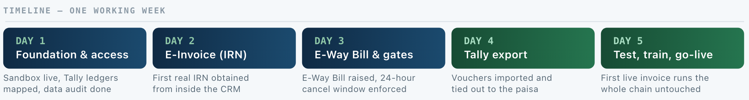
Why this order: access first — nothing can be tested without it. Then the statutory path (Days 2–3), because an invoice has no legal validity without its IRN. Then the books (Day 4). Training and go-live last, so nobody is trained on something still moving.
04 Day by day
DAY 1 Foundation & access |  | DAY 2 GSP integration — E-Invoice (IRN)
- Sandbox test credentials from the GSP partner configured and verified end to end.  - Your Tally chart of accounts collected; every ledger name mapped to the export.  - Existing invoice records audited for compliance data; a cleanup list prepared.  DONE WHEN — the CRM talks to the sandbox, and the ledger map matches your Tally company exactly. |  | - Secure server-side connection built; credentials are never exposed to the browser.  - IRN generation, cancellation and details lookup implemented and tested against sandbox.  - Manual download-paste replaced by one button; kept as a fallback if the API is down.  DONE WHEN — a test invoice receives a real IRN from the sandbox and is marked Complete in the CRM.
DAY 3 E-Way Bill & compliance gates |  | DAY 4 Tally export
- E-Way Bill raised automatically after the IRN, with transport and dispatch details prefilled.  - 24-hour cancellation window enforced in the interface; validity date stored on the invoice.  - Clear error messages, automatic retries, and a log of every API call.  DONE WHEN — a test E-Way Bill is generated with a valid till date, and cancellation after 24 hours is blocked. |  | - Export wired in: choose a date range and branch, download the Tally XML.  - Balance guard, one ledger per GST rate, and a drift report comparing CRM and Tally figures.  - Imported into a Tally trial company; voucher count verified.  DONE WHEN — the Tally Sales register and Trial Balance tie back to the CRM invoice register, to the paisa.
DAY 5 End-to-end test, training & go-live |  | DAY 0 What we need from you first
- Full run on real branch data: invoice → IRN → E-Way Bill → Tally.  - Production credentials swapped in and re-verified after the sandbox passes.  - Owner and accounts team trained; a one-page SOP handed over.  DONE WHEN — the first real invoice completes the whole chain with zero manual data entry. |  | - Ledger names from your TallyPrime company — Chart of Accounts → Ledgers.  - GSP sandbox credentials and sign-off on the API proposal (4,000 calls/year tier).  - Accountant's call on the one-paisa CGST/SGST rounding note.  Note — these three items are the only things that can delay Day 1. Everything else is on our side.
05 Assumptions, exclusions and cost
- The CRM stays the only billing source — Tally consumes data; no two-way sync to maintain.  - One Tally company on one Windows PC; all three branches are supported from day one.  - Import starts file-based (no always-on gateway); the live gateway can be added later.  - Not in these five days: purchase and credit-note vouchers, payment allocation splitting, bulk backfill of old invoices. |  | Cost — nothing new to buy for Tally  An invoice that needs an E-Way Bill uses two calls (one IRN, one E-Way Bill), so the 4,000-call tier covers roughly 2,000 despatches a year.
  GSP APIs — e-Invoice + E-Way Bill + GSTIN, 4,000 calls/year | ₹29,500 / yr
  On-boarding & support | Free (FOC)
  TallyPrime XML import gateway | ₹0 — built in
  Hosting | Existing — no change
  Effective cost per e-invoiced despatch | ≈ ₹14.75

