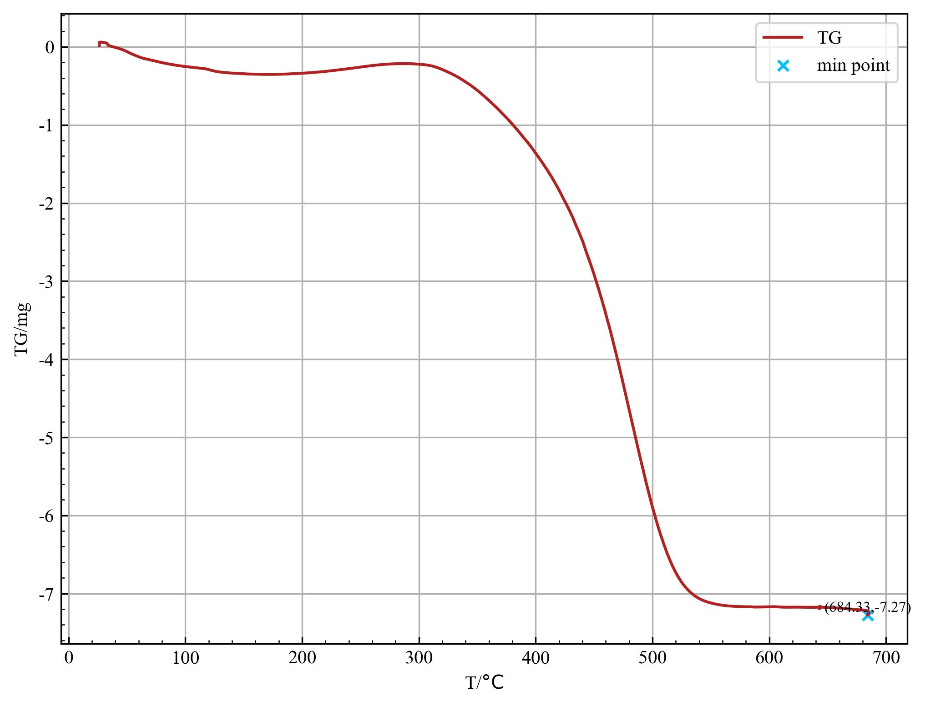

|  |  |
| --- | --- |
| TG_min | [684.33, -7.27] |

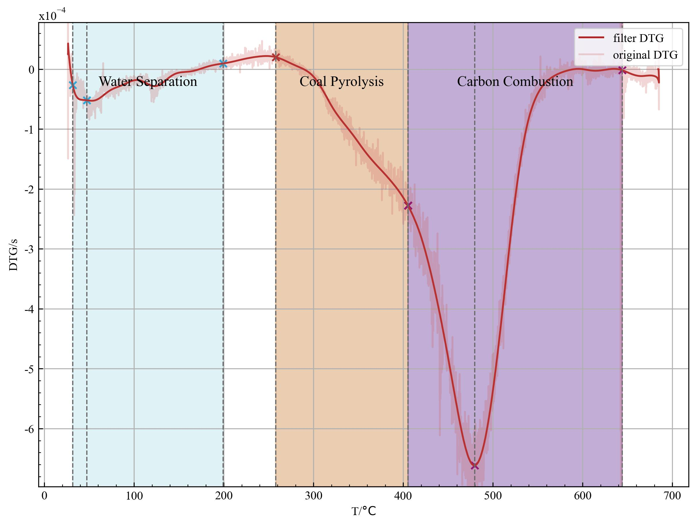

|  |  |
| --- | --- |
| water_separation | 31.73~199.17 |
| coal_pyrolysis | 258.0~405.36 |
| carbon_combustion | 405.36~644.26 |

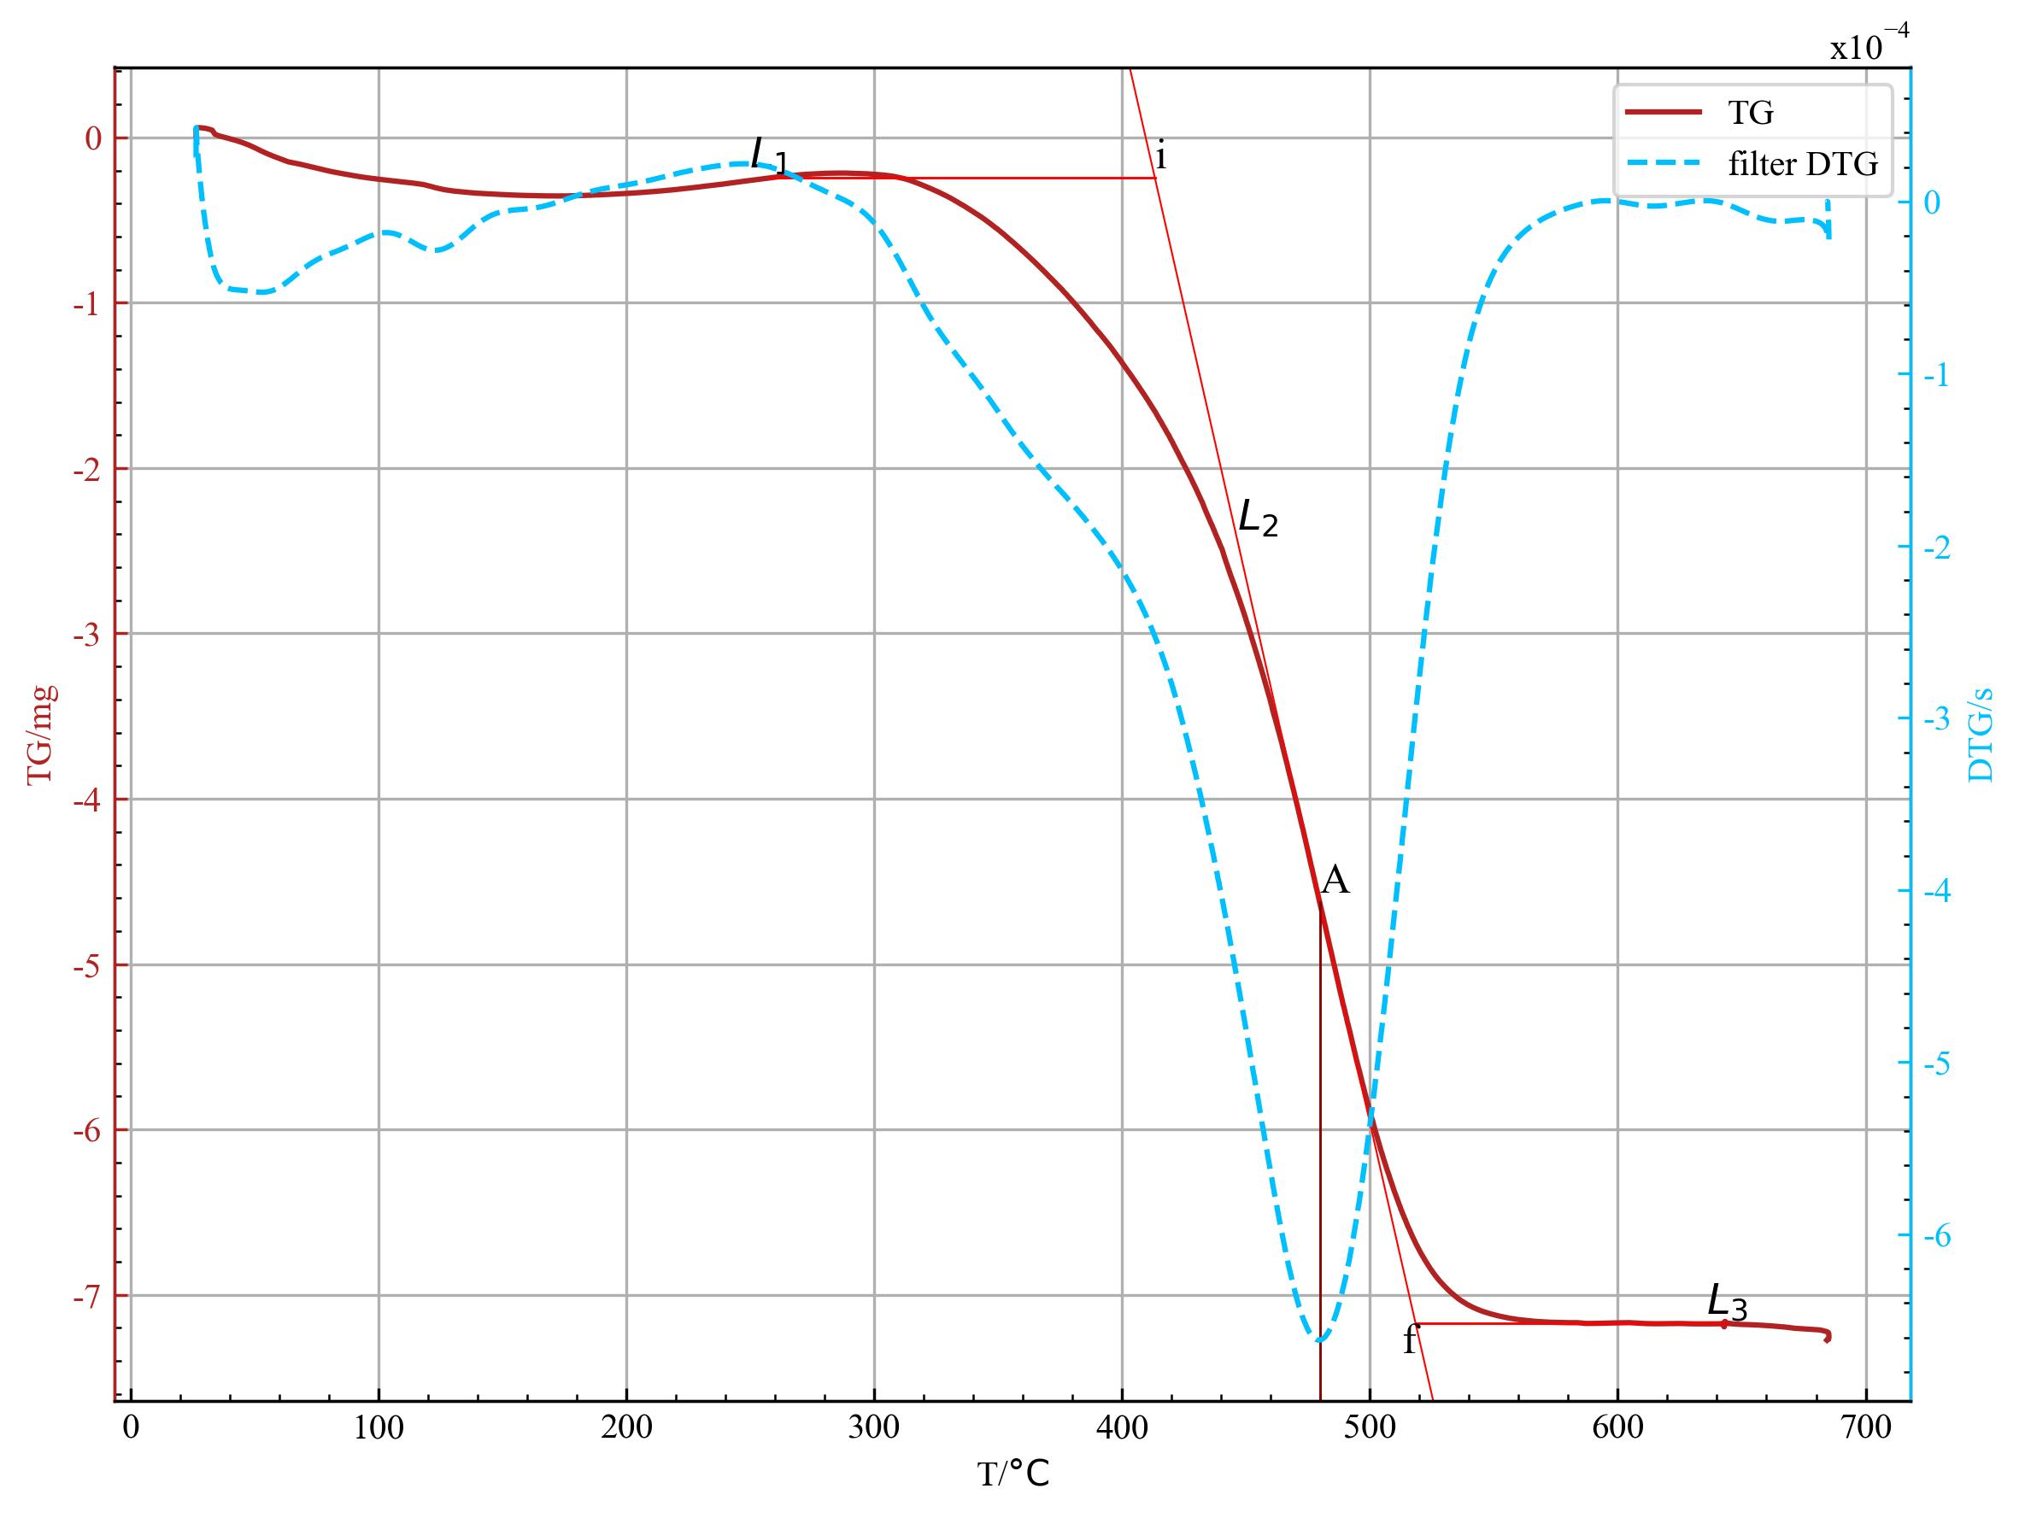

|  |  |
| --- | --- |
| T_i | 413.24 |
| T_f | 518.40 |
| T_p | 479.75 |
| v_p | 6.616e-04 |
| v_mean | 3.62 |

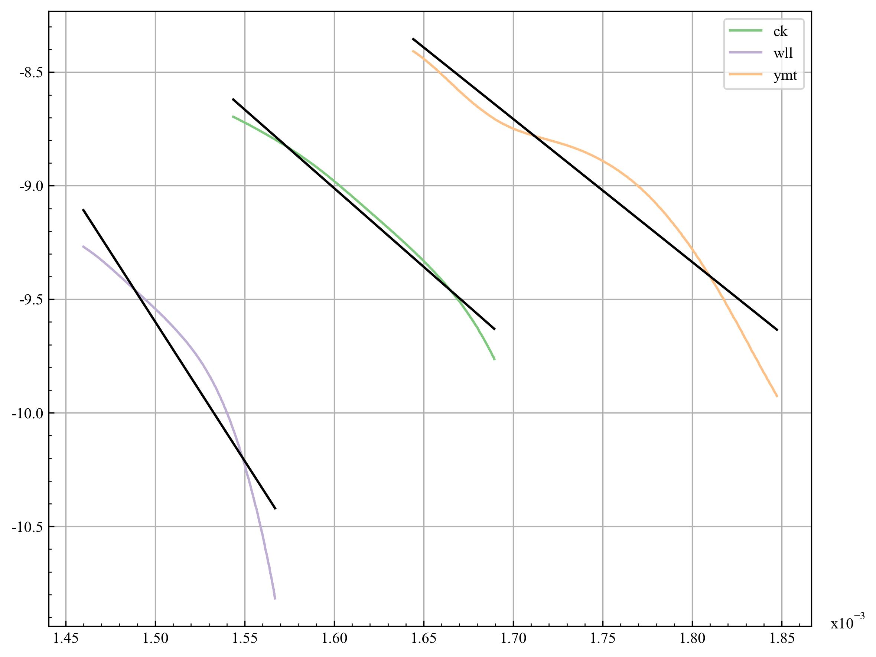

|  |  |
| --- | --- |
| T_min | 591.92 |
| T_max | 647.83 |
| A | -6923.17 |
| b | 2.07 |
| R_square | 0.982 |
| E | 57559.25 |
| k0 | 7.89 |

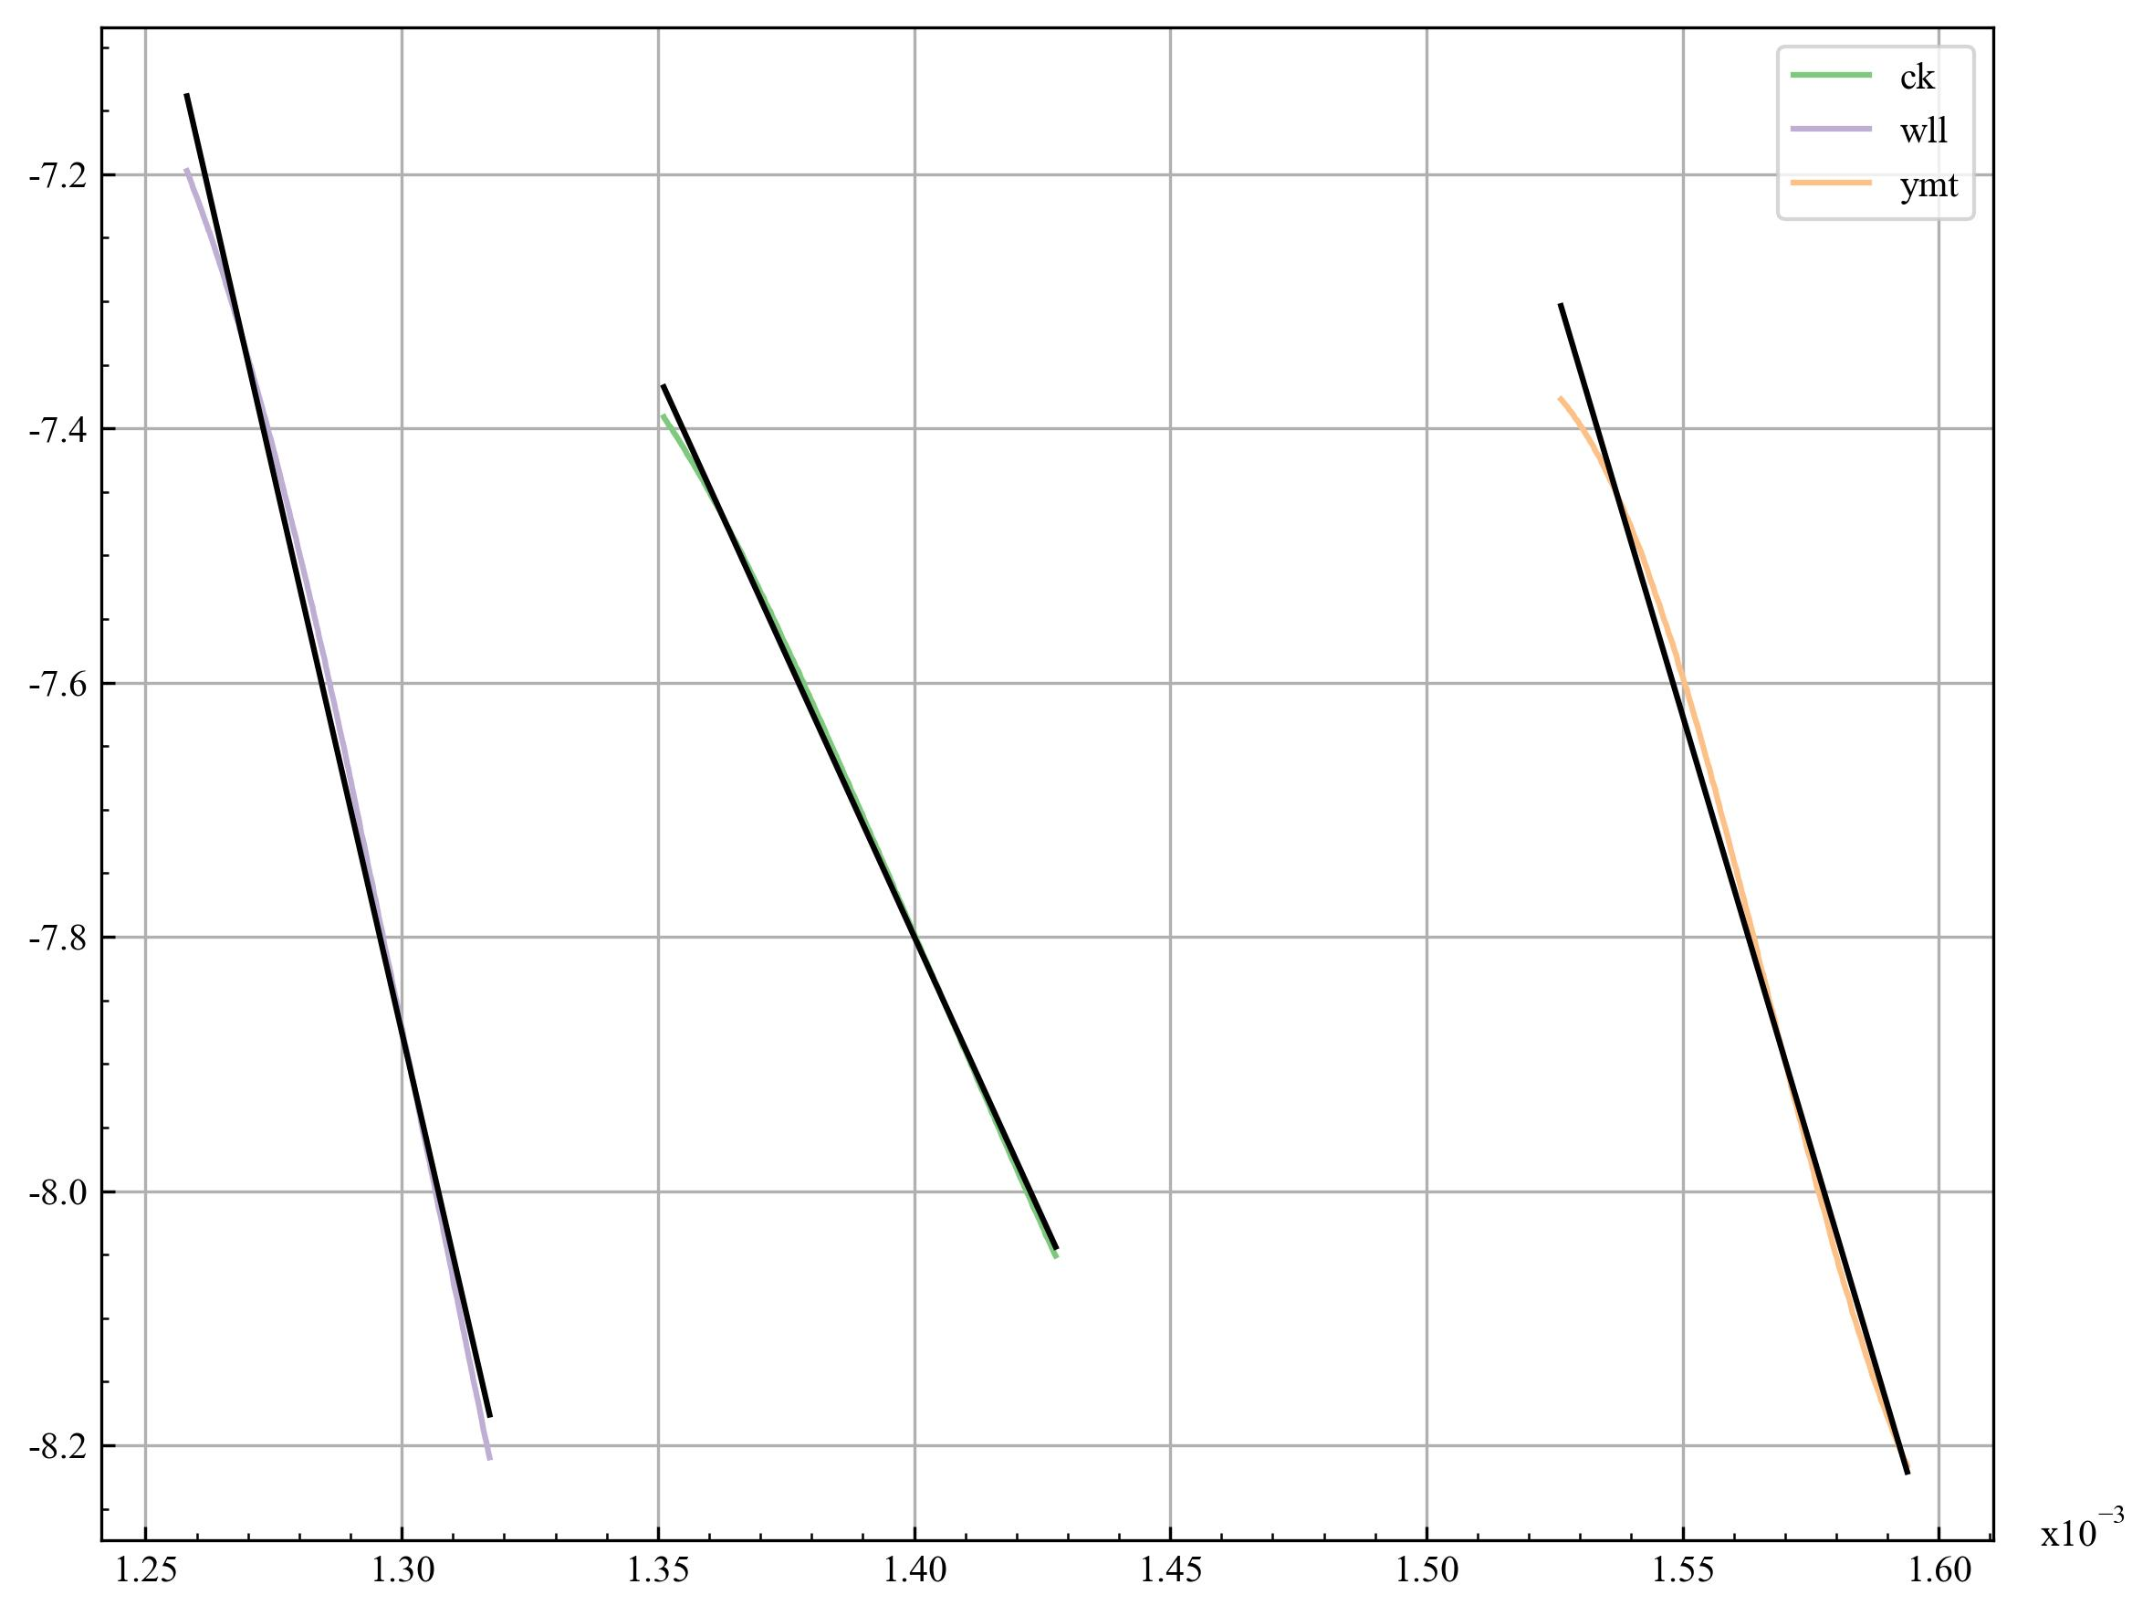

|  |  |
| --- | --- |
| T_min | 700.46 |
| T_max | 740.11 |
| A | -8844.87 |
| b | 4.58 |
| R_square | 0.999 |
| E | 73536.24 |
| k0 | 97.84 |