OO PROGRAMMING - CONTINUOUS ASSESSMENT

UNIVERSITY SOUVENIR STORE APPLICATION

SE23 #2FT TEAM

TANUJ KHATOR (A0134643J)
M.CHARAN TEJA (A0134630R)
XU MINSHENG (A0134434M)
AVISHEK KAR DEB BARMAN (A0135865W)
LIU XINZHUO (A0136010A)
XIE JIABAO (A0109328E)
ACHYUT SURESH RAO (A0134598R)

- Domain Class Diagram

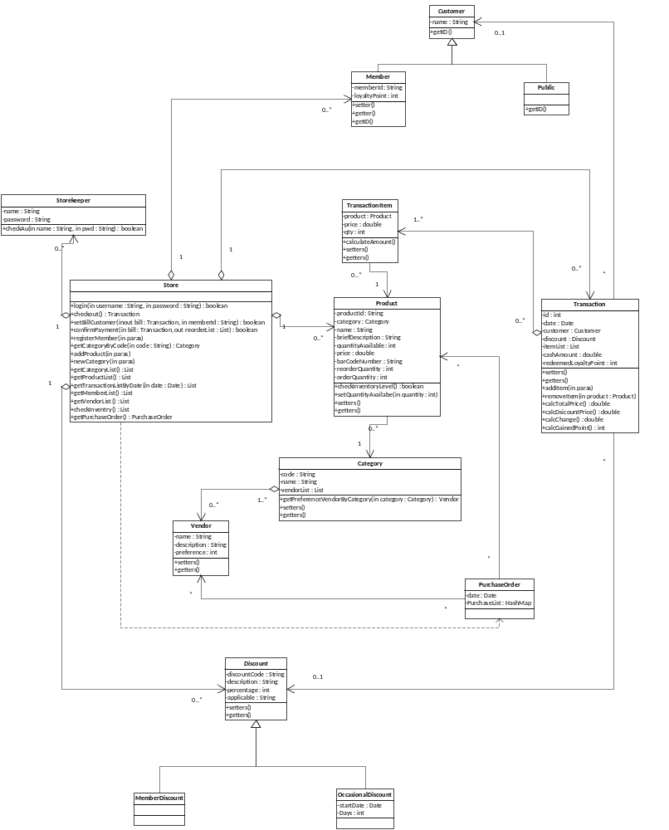

- Assumptions
- Save a snapshot of relevant product's price in [transaction.dat] file.
- Load data upon application initiation and save it upon application termination as approved by the lecturer.
- Every record has a unique primary key as identity, like for Product the primary key is [productId] which is not allowed to be modified.
- When an object is associate with other objects, for instance, a product appears in some transaction, it should not be deleted or modified its primary key
- The VendorsXXX.dat file (XXX=> product Category) file contains vendor details and each vendor supplies all the products under that particular product category. Currently as per the requirement, vendor is associated with product Category and not with the product. In case the highest preference vendor is not supplying the current product under threshold in the respective category, the preference needs to be changed using the GUI before generating the purchase order.
- Few of the Junit Tests were written considering the current size (number of entries) of the .dat files. Any local changes made to the .dat files manually or by adding/editing/deleting entries using the GUI might impact the Pass/Fail of the current Test Cases.
- In case of a bar code scanner, if the scanner is not working there should be a way to enter the member Id and bar code manually.
- User Manual for Checkout Window
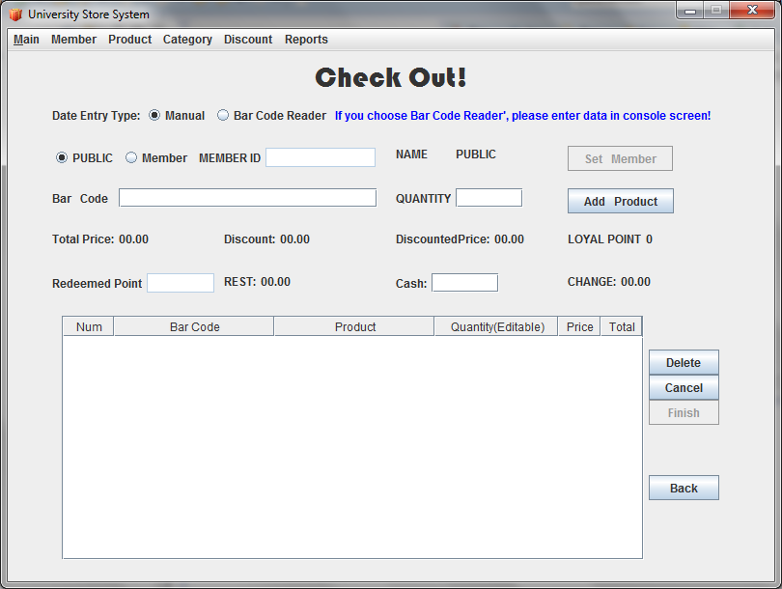

Data Entry Type Options
Manual
- It implies that the user wishes to enter member ID and Bar Code (product bar code) manually due to malfunction of bar code reader or any other reasons.
Bar Code Reader
- It implies that the user wishes to scan the member Id and the Bar Code (product bar code) using the bar code reader.
- In the application, as per the requirements the place holder classes represent the bar code reader and the user shall be prompted to enter the member id/product bar code on the console in the following scenarios:
  - “Bar Code Reader” option is selected and user selects “Member” radio button.
  - “Member” radio button option is selected and user selects “Bar Code Reader” option.
  - In either of the above mentioned scenarios, if an invalid member id is entered on the console and “Set Member” button is clicked.
  - “Bar Code Reader” option is selected and user presses the “Add Product” button.
NOTE: After entering the Member Id, “Set Member” button must be clicked.

