Introduction to BIM

Module 01 Modeling Building Elements

This module serves as a good introduction to the concepts of host elements such as walls and wall hosted elements such as doors and windows. With these key underpinnings you should feel confident in developing your own BIM models applying these concepts.

Steps to take

Exercise 1 Modeling Exterior and Interior Walls

Exercise 2 Adding Doors and Windows

Exercise 3 Creating Floors and Roofs

Exercise requirements

To use Autodesk Revit you will need an Autodesk ID. As a Student or Educator, you can obtain an Autodesk ID for free at [www.autodesk.com/education](http://www.autodesk.com/education) .

* Download the Autodesk Revit software for free at [www.autodesk.com/education](http://www.autodesk.com/education) and install it.

Exercise 1 — Modeling Exterior and Interior Walls

In this exercise, you will complete the development of both exterior and interior walls using a DWG underlay as a guide.

Objectives:

* Create walls by picking their location line and sketching them in a plan view.
* Change the orientation of walls that have been placed.

Create exterior walls

1. Navigate to the folder containing the downloaded resources for Module 1.

Module01_Resources

1. Open Revit file: Module01Ex01_Modeling Exterior and Interior Walls_Imperial_Start.rvt
2. Open the Ground Floor plan view.
3. On the Architecture tab, click Wall.

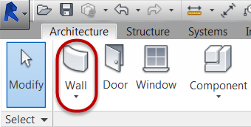

1. In Properties Palette, select Generic 8" (.20 m) wall type. Place the walls by setting the location line to Finish Face:Exterior and tracing the outer edge of the walls shown in the underlay drawing.

*Note: Placement of walls is direction dependent relative to the location line used. If wall footprint falls outside of the intended location, use the space bar key to flip the orientation of the wall while drawing.*

1. Completion of exterior walls highlighted in blue.

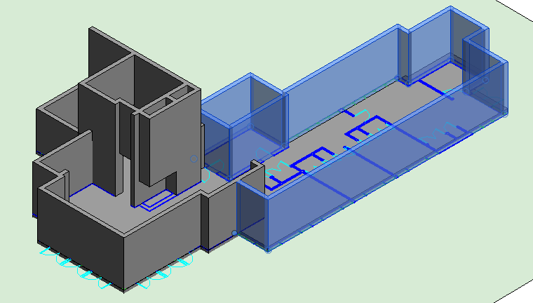

Create interior walls

1. Continue adding interior walls to the building model shown in the video tutorial, using the underlay drawing as a guide to determine their location.
2. Add new interior walls using the Generic 3" (.08 m) wall type. Place the walls

by setting the location line to either the Finish Face:Exterior or Finish

Face:Interior and tracing the corresponding edge of the walls shown in the underlay drawing.

*Note: Placement of walls is direction dependent relative to the location line used. If wall footprint falls outside of the intended location, use the space bar key to flip the orientation of the wall while drawing.*

1. Completion of interior walls highlighted in blue.

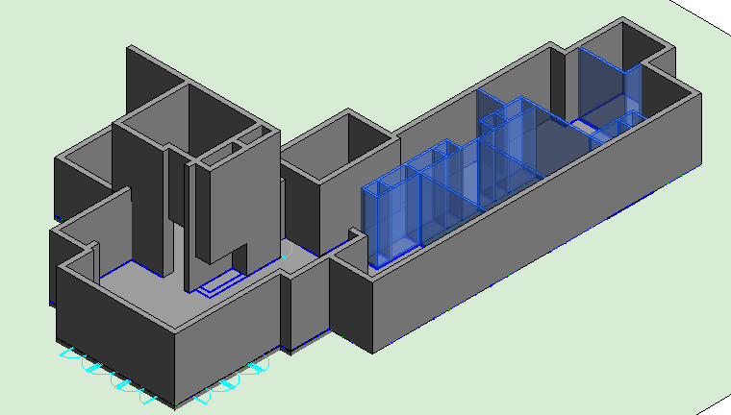

1. Save the Revit file as: Module01Ex01_Modeling Exterior and Interior Walls_Imperial_Finished.rvt

This concludes Exercise 1.

Exercise 2 — Adding Doors and Windows

In this exercise, you will add doors and window openings to the same house in the previous exercise using Autodesk Revit.

Objectives:

* Add doors and windows to a building model by choosing their type and placing

components in host walls.

* Change door and window placement.
* Change door and window height properties.

Place exterior doors

1. Navigate to the folder containing the downloaded resources for Module 1.

Module01_Resources

1. Open Revit file: Module01Ex02_Adding Doors and Windows_Imperial_Start.rvt
2. Open the Ground Floor plan view.
3. On the Architecture tab, click Door.

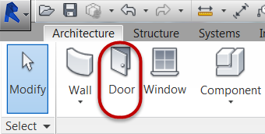

1. In Properties Palette, select Double-Glass 48” x 102” door type.

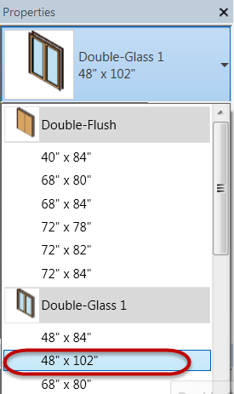

1. Place Double-Glass 48” x 102” door type at each location where Type B is identified in the Ground Floor plan view.

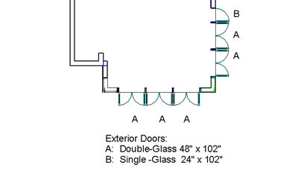

* 1. Hover cursor over Revit wall and use CAD underlay as a reference guide for handing and swing direction
  2. Left click to place door

*Note: Doors are hosted elements, you must hover over the edge of a Revit wall in order to preview the door to be placed.*

*To change the handing of single doors prior to placement use the space bar key.*

1. In Properties Palette, select Single-Glass 24” x 102” door type and place at each location where Type B is identified in the Ground Floor plan view.



*Note: To change the handing of single doors prior to placement use the space bar key.*

Place interior doors

1. On the Architecture tab, click Door.
2. In Properties Palette, select Single-Flush 20” x 84” door type and place at each location where Type A is identified in the Ground Floor plan view.

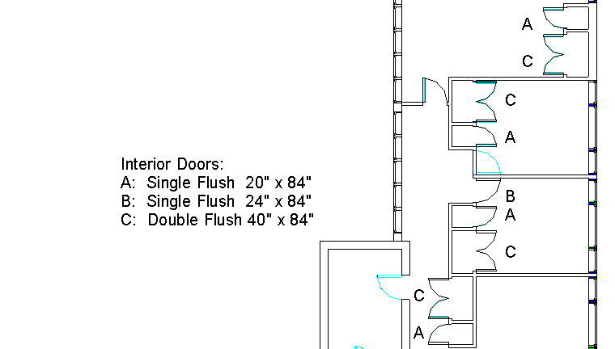

* 1. Hover cursor over Revit wall and use CAD underlay as a reference guide for handing and swing direction

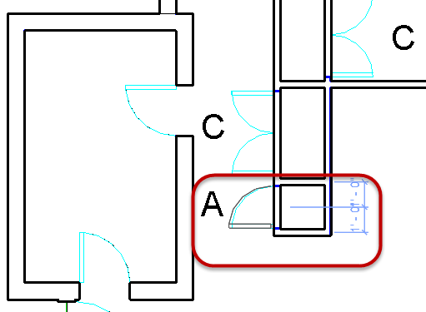

* 1. Left click to place door

*Note: Doors are hosted elements, you must hover over the edge of a Revit wall in order to preview the door to be placed.*

*To change the handing of single doors prior to placement use the space bar key.*

1. In Properties Palette, select Single-Flush 24” x 84” door type and place at each location where Type B is identified in the Ground Floor plan view.



1. In Properties Palette, select Double-Flush 40” x 84” door type and place at each location where Type C is identified in the Ground Floor plan view.



Place exterior windows

1. On the Architecture tab, click Window.

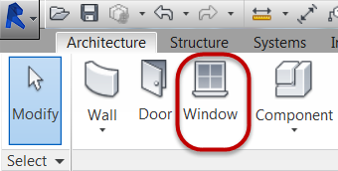

1. In Properties Palette, select Casement with Trim 24” x 24” window type.
2. Place Casement with Trim 24” x 24”window type at each location where Type A is identified in the Ground Floor plan view.

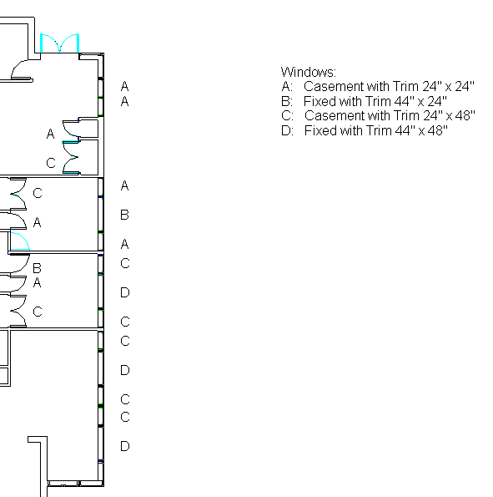

* 1. Hover cursor over the exterior face of the Revit wall and use CAD underlay as a reference guide
  2. Left click to place window

*Note: Windows are hosted elements, you must hover over the edge of a Revit wall in order to preview the window to be placed.*

*Hovering the cursor over the outside face of the Revit wall ensures the correct orientation of the Revit window.*

1. In Properties Palette, select Fixed with Trim 44” x 24” window type and place at each location where Type B is identified in the Ground Floor plan view.

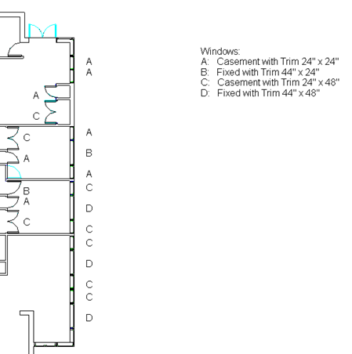

1. In Properties Palette, select Casement with Trim 24” x 48” window type and place at each location where Type C is identified in the Ground Floor plan view.



1. In Properties Palette, select Fixed with Trim 44” x 48” window type and place at each location where Type D is identified in the Ground Floor plan view.



1. Hit ESC key twice to end the window command

Change window head height

1. Open the {3D} 3D view.
2. Orbit the model to see the model of the exterior windows just placed.

*Note: Use the ViewCube or hold down Shift key + hold down middle mouse button and drag the mouse in direction desired.*

1. Focus on the Type A windows in the upper right corner of the plan view.

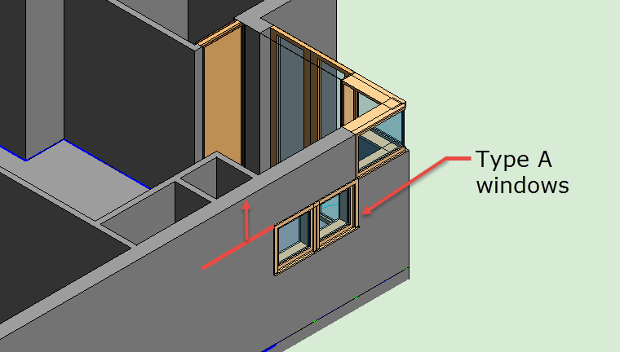

1. Place both Type A windows in a common selection set. Holding down the CTRL key, left click on each window to place them in a common selection set.
2. In Properties palette, change the Head Height value to: **7’-0” (2.123m)**

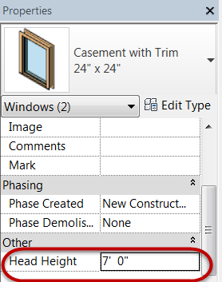

* 1. Click APPLY to accept and apply changes to the model elements.

1. Repeat steps 3 through 5 for window types: Type B, Type C, and Type D separately.

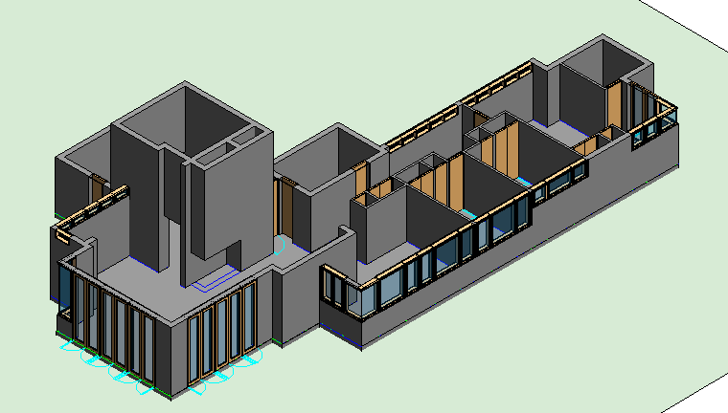

This concludes Exercise 2.

Exercise 3 — Creating Floors and Roofs

In this exercise, you will create flat roofs and pitched roofs for the house used in the previous exercise using Autodesk Revit.

Objectives:

* Create roofs based on the building footprint.
* Sketch a roof boundary and selecting the slope-defining edges.
* Set the roof level and slope instance properties.

Create a flat roof

1. Navigate to the folder containing the downloaded resources for Module 1.

Module01_Resources

1. Open Revit file: Module01Ex03_Creating Roofs_Imperial_Start.rvt
2. Open the Workspace Roof plan view.

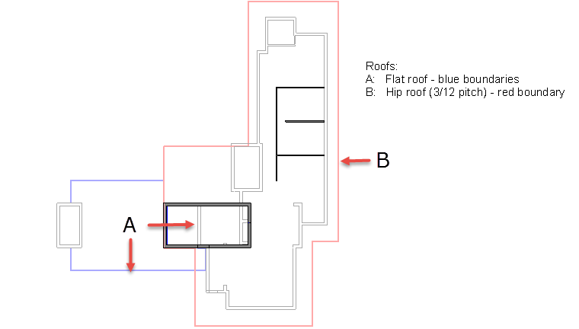

1. On the Architecture tab, click Roof by Footprint.

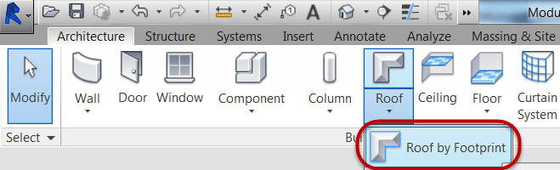

1. In Properties Palette, select Basic Roof Generic - 12” roof type and set Base Offset from Level = **0’-0” (0m)**.

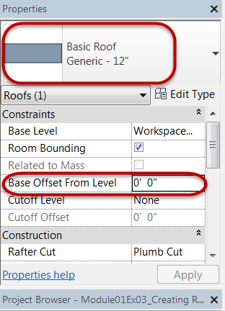

1. In Modify | Create Roof Footprint tab, confirm Boundary Line and Line mode is selected.

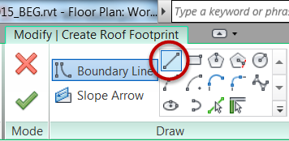

* 1. Unmark Defines slope check box.

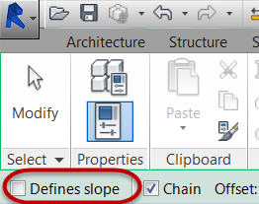

1. Create a closed boundary as indicated by the (4) sketch lines numbered below. The sketch lines should be placed on the inside face of walls.

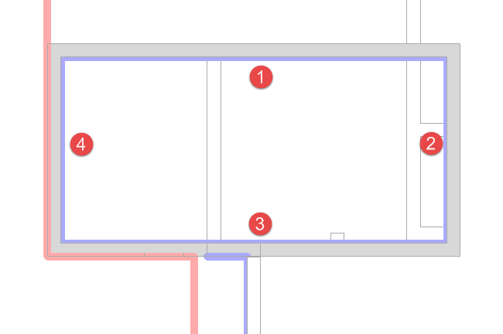

* 1. Click Modify command to end sketching.

*Note: Linework must be contiguous.*

1. Click Finish Edit Mode to create the 3D roof element.

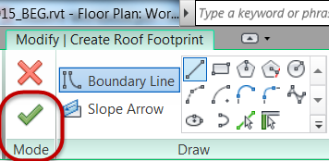

*Note: If you receive error messages, confirm that none of the linework overlaps itself. Then try Finish Edit mode again.*

1. Open the Carport Roof plan view.
2. Create the other flat roof using the same technique in steps 4 through 8.

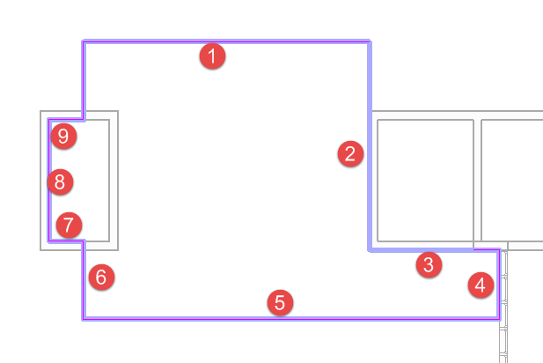

1. Hit Modify to end creating roofs.
2. Select highlighted wall shown below.
   1. Click Attach Top / Base

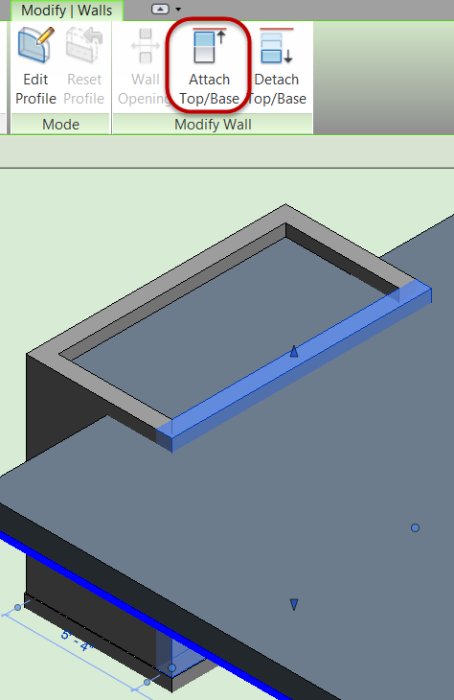

* 1. Click edge of Flat roof just created

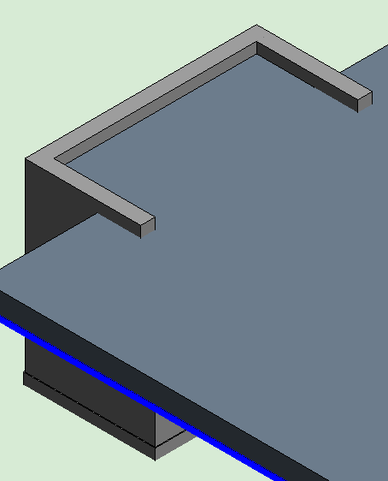

Create a pitched roof

1. Open the Living Area Roof plan view.
2. On the Architecture tab, click Roof by Footprint.



1. In Properties Palette, select Basic Roof Generic - 12” roof type and set Base Offset from Level = **0’-0” (0m)**.

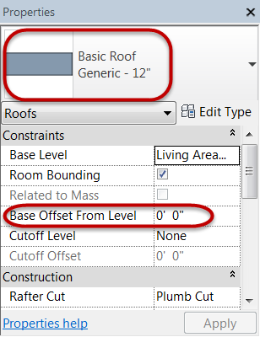

1. In Modify | Create Roof Footprint tab, confirm Boundary Line and Line mode is selected.



* 1. Mark Defines slope check box.

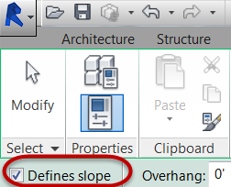

1. Create a closed boundary as indicated by the (10) sketch lines numbered below. Trace over the red linework in the view.

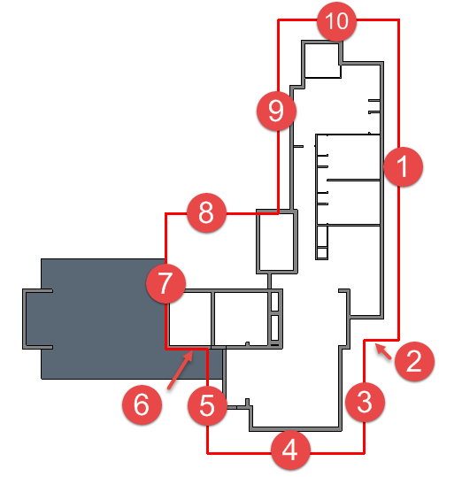

* 1. Click Modify command to end sketching.

*Note: Linework must be contiguous.*

1. Set the roof pitch for the sloped linework.
   1. Window select all of the sketch linework for the roof sketch.

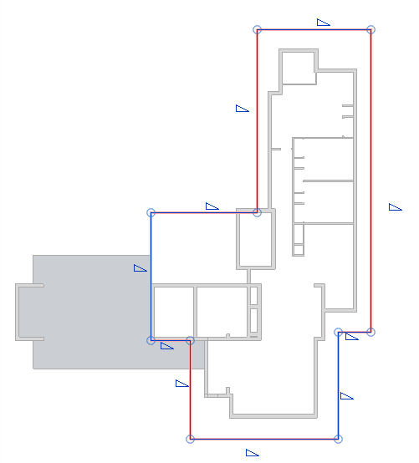

* 1. In Properties palette, set pitch to **3” (0.0762m)**.

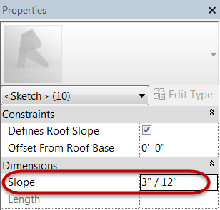

1. Click Finish Edit Mode to create the 3D roof element.



*Note: If you receive error messages, confirm that none of the linework overlaps itself. Then try Finish Edit mode again.*

* 1. Attach highlighted walls to roof? Click Yes.

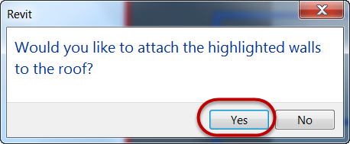

1. Finished roof exercise below

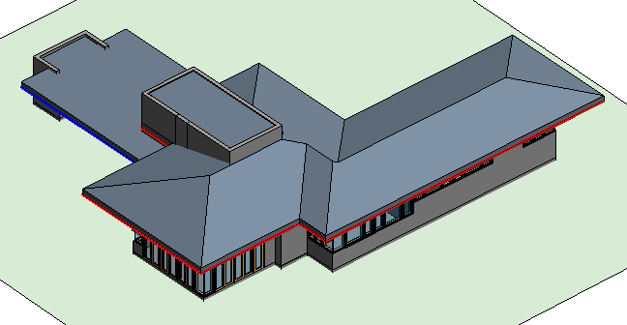

This concludes Exercise 3.