Introduction to BIM

Module 06 Views and Visualization

In this module, you explore the tools available in the Autodesk® Revit® software to create several types of common project views and specify the information that appears in them.

You will be able to:

* Create 2D views of their building model, such as plans, elevations, and sections—creating new views from scratch and duplicating existing views.
* Create 3D views by duplicating and editing the default 3D orthographic view.
* Customize the information presented in those views.

Steps to take

Exercise 1 Creating Plan Views

Exercise 2 Creating Elevation and Section Views

Exercise 3 Creating 3D Views

Exercise 4 Adjusting the Appearance of Elements in a View

Exercise requirements

To use Autodesk Revit you will need an Autodesk ID. As a Student or Educator, you can obtain an Autodesk ID for free at [www.autodesk.com/education](http://www.autodesk.com/education) .

* Download the Autodesk Revit software for free at [www.autodesk.com/education](http://www.autodesk.com/education) and install it.

Exercise 1 — Creating Plan Views

In this exercise, you will learn how to duplicate existing views and repurpose them to create dedicated views for specific disciplines or functions.

Objectives:

* Create new plan views by using the Plan View tool or duplicating existing plan

views.

* Select which types of elements appear in a plan view by setting visibility

graphics overrides.

* Turn on cropping and resize the crop region for a plan view.
* Adjust the view range (the height of the cutting plane and the view depth) for

plan views and plan regions.

* Select another level to underlay in a view.
* Change the scale of a plan view and adjust the level of detail shown.

Create a Level 1 Structural plan view

This plan view will focus on emphasizing structural elements in a specific color.

1. Navigate to the folder containing the downloaded resources for Module 6.

Module06_Resources

1. Open Revit file: Module06Ex01_Creating Plan Views part_Imperial_Start.rvt
2. Open the First Floor plan view.
3. Duplicate the First Floor plan view.
   1. In Project Browser, select First Floor plan view name.
   2. Right click the named view and select Duplicate View > Duplicate.

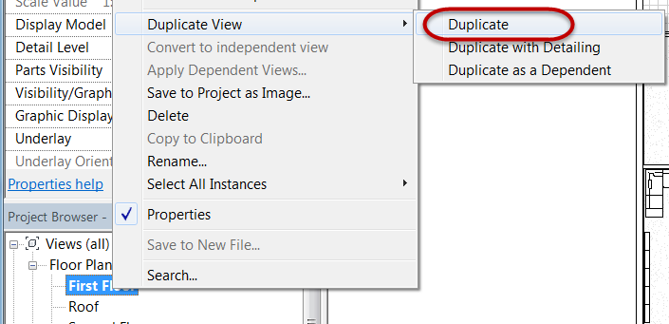

* 1. Rename the copied version of the view in Project Browser by right clicking the name and select Rename.
  2. Rename view to: Level 1 – Structural.
  3. Click OK to continue.

1. Turn off the visibility of specific element categories.
   1. On the View tab, Graphics panel, click Visibility / Graphics tool.
   2. Unmark the following categories on the Model Categories tab.

Furniture

Furniture systems

Specialty equipment

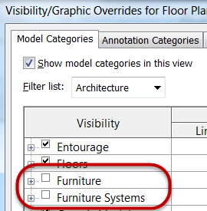

*Note: Specialty equipment category not shown.*

* 1. Click OK.

1. Override graphic properties of structural columns to be a heavier lineweight and change the color to red.
   1. Open Visibility / Graphics Overrides dialog box, type shortcut: **VG.**
   2. Scroll down and expand the Structural Column category.
   3. Override the Cut line property (Mark 1) for Stick Symbols sub-category and assign a lineweight of 8 (Mark 2) the color red (Mark 3).

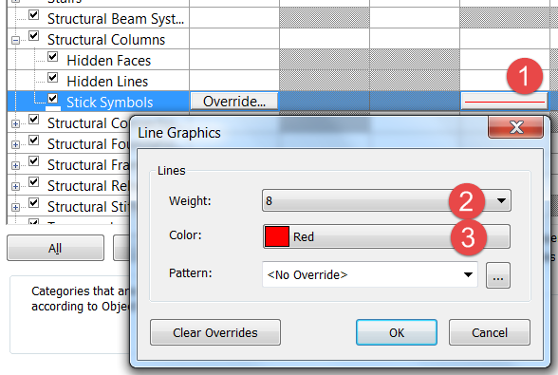

* 1. Click OK to continue.
  2. Click OK to exit the Visibility / Graphics Overrides dialog box.

1. Finished override results below.

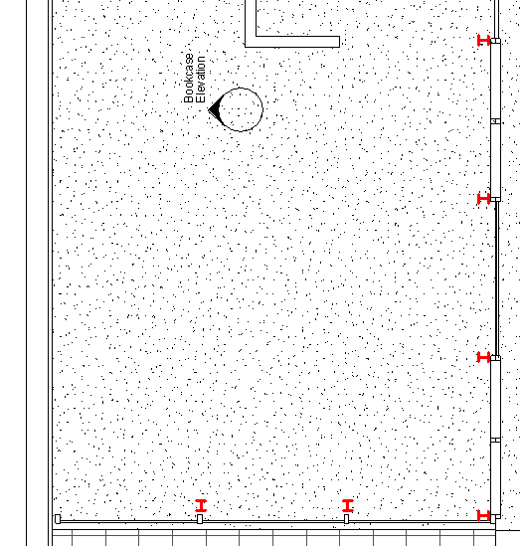

Create a Level 1 Furniture plan view

This plan view will focus on emphasizing furniture elements in a specific color.

1. Open the First Floor plan view.
2. Duplicate the First Floor plan view.
   1. In Project Browser, select First Floor plan view name.
   2. Right click the named view and select Duplicate View > Duplicate.
   3. Rename the copied version of the view in Project Browser by right clicking the name and select Rename.
   4. Rename view to: Level 1 – Furniture.
   5. Click OK to continue.
3. Override graphic properties of non-furniture categories to halftone effect.
   1. Open Visibility / Graphics Overrides dialog box, type shortcut: **VG.**
   2. On the Model Categories tab, Scroll down and place the following categories in a selection set:

Furniture

Furniture systems

Specialty Equipment

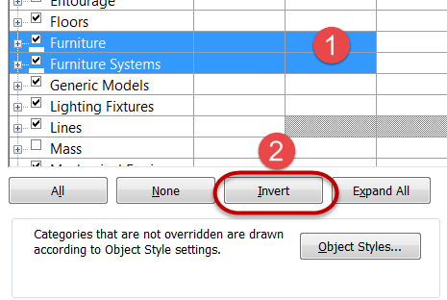

*Note: Use CTRL + Left click with mouse to build a selection set.*

* 1. Click Invert to invert the selected model categories.
  2. Mark the Halftone property (Mark 1) for any of the selected categories and it will apply that property to all selected categories.

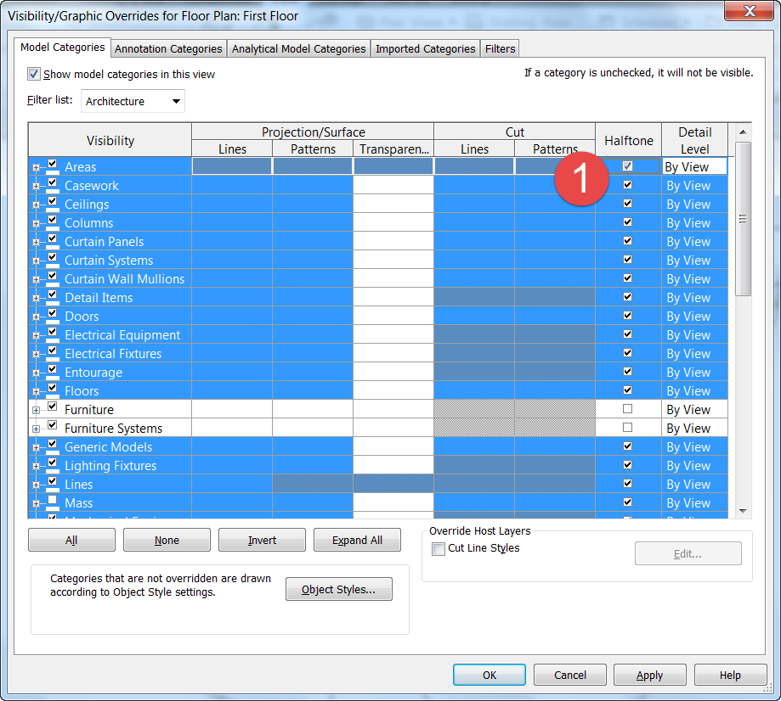

* 1. Click OK to continue.

1. Progress override results below.

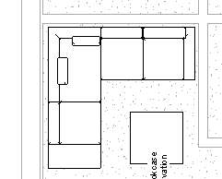

1. Override graphic properties of furniture categories to be of a different color.
   1. Open Visibility / Graphics Overrides dialog box, type shortcut: **VG.**
   2. Scroll down and select both furniture categories.
   3. Override the Projection / Surface line property (Mark 1) for Lines and assign it a lineweight of 6 (Mark 2) and the color orange (Mark 3).

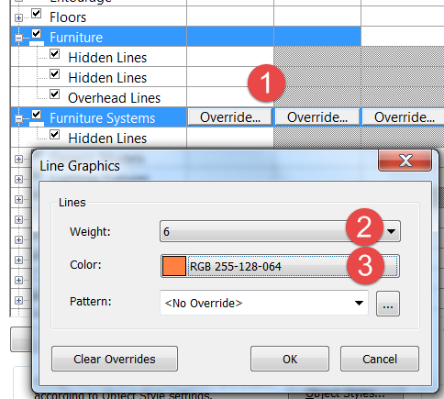

* 1. Click OK to continue.
  2. Click OK to exit the Visibility / Graphics Overrides dialog box.

1. Finished override results below.

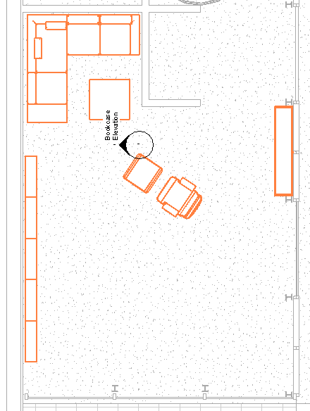

*Note: Partial floor plan shown.*

Create a Level 1 Residence only plan view

This plan view will focus on just the Residence area of the house.

1. Open the First Floor plan view.
2. Duplicate the First Floor plan view.
3. Rename copied view to:

First Floor – Residence.

1. Turn on crop window for the view and resize it.
   1. Click Show Crop Region tool (Mark 1) in the View Control toolbar.



* 1. Select the crop region in the canvas window and use the blue drag handles (Mark 2) to resize the window to appear just around the Residence area indicate by Mark 3.

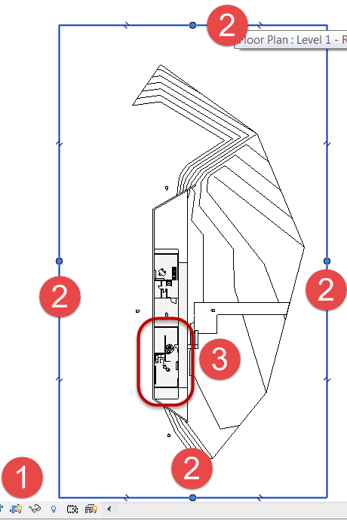

1. Hide the Crop Region Window when done.



1. Finished crop region resizing results below.

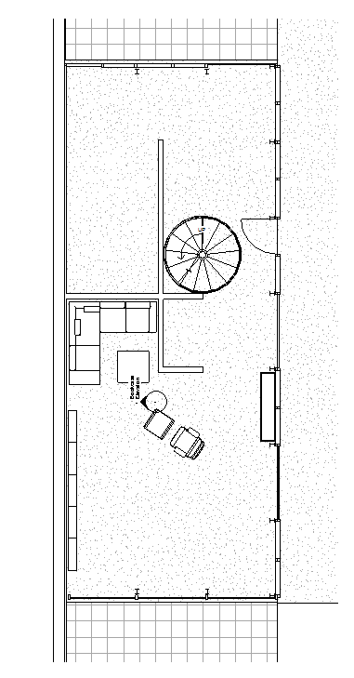

Create a Level 2 Residence only plan view

This plan view will focus on just the Residence area of the house.

1. Repeat the steps shown for creating the previous plan view for the Second Floor plan view.
2. Rename Second Floor view to:

Level 2 – Residence.

1. Crop the view region to just the Residence plan only similar to Level 1- Residence plan view.
2. Change the View Range parameters to see the first floor below.
   1. In Properties palette, scroll down to Extents category and click Edit button for View Range.

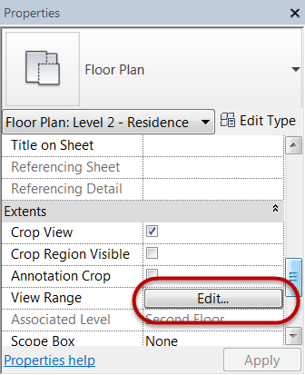

1. In View Range dialog box, set View Depth to: Level Below. (Mark 1) and click Apply (Mark 2) to see the results in the canvas window.

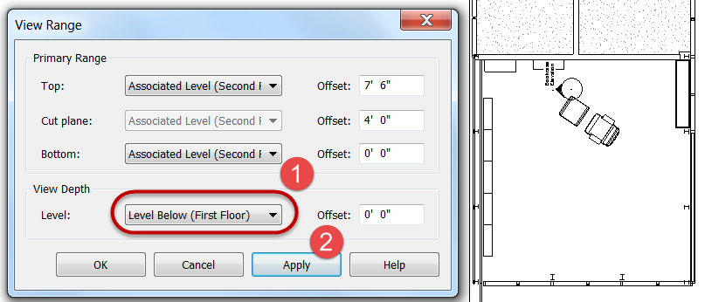

1. Click OK to dismiss dialog box.
2. Save the Revit file as: Module06Ex01_Creating Plan Views part_Imperial_Finish.rvt

This concludes Exercise 1

Exercise 2 — Creating Elevation and Section Views

In this exercise, you will learn create elevation views and modify its view properties.

Objectives:

* Place elevation tags to create new elevation views.
* Draw section lines to create new section views.
* Modify view properties to adjust the crop region, level of detail, and scale of

elevations and sections.

* Set visibility graphics overrides to choose which types of objects appear in the

views.

Create interior elevation views of the living area of the Residence building

1. Navigate to the folder containing the downloaded resources for Module 6.

Module06_Resources

1. Open Revit file:

Module06Ex02_Creating Elevation and Section Views_Imperial_Start.rvt

1. Open First Floor plan view.
2. Zoom into the Residence Living Room area.
3. On the Views tab, Create panel, click the Elevation pulldown menu and select Elevation.
4. In Properties palette, click Interior Elevation tag.

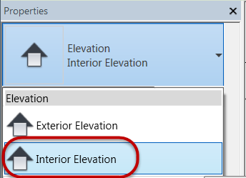

1. Place Interior Elevation tag at the location shown.

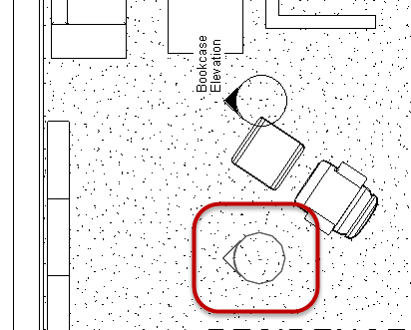

1. Hit ESC key twice to end the command.
2. Turn on all elevation views for the Interior Elevation tag.
   1. Select the interior elevation tag.
   2. Mark the Show Arrow boxes for all elevations by left clicking with mouse.

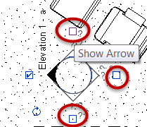

1. Hit Modify command to unselect tag.
2. Name each of the elevation views.
   1. In Project Browser, scroll down and expand the Elevations (Interior Elevations) folder (Mark 1) and then rename the view Elevation 1-a via right click menu to: Living Room Interior - West. (Mark 2) and click OK.

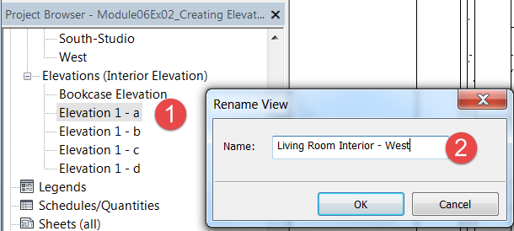

* 1. Repeat and name the remaining elevations:

Living Room Interior – North

Living Room Interior – East

Living Room Interior – South

1. Change interior elevation view scale.
   1. Open Living Room Interior - West elevation view (Mark 1) in Project Browser, then set view scale property to: **½” = 1’-0” (1:25)** (Mark 2).
   2. Set Detail Level: Fine. (Mark 3).
   3. Click Apply (Mark 4).

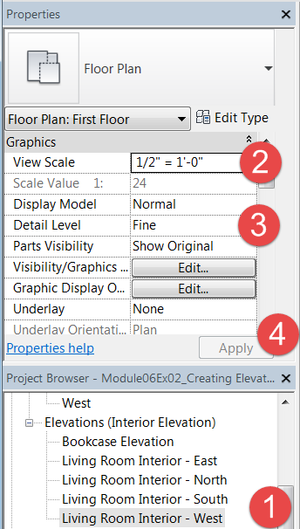

1. Create a view template from Living Room Interior – West view.
   1. Open Living Room Interior – West elevation view.
   2. Right click interior elevation view.
   3. Select Create View Template from View.

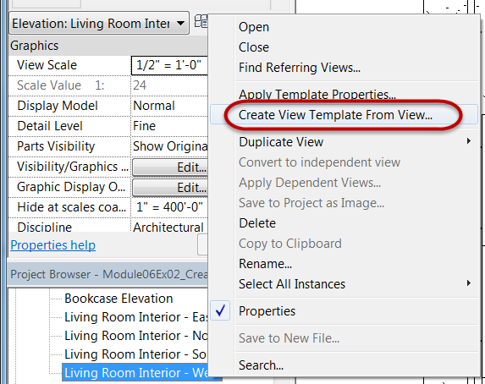

* 1. Name view template: Interior Elevation
  2. Click OK.
  3. Confirm settings for Interior Elevation view template is correct in the dialog box.
  4. Click OK to exit dialog box.

1. Apply view template to the remaining interior elevations created previously.
   1. Open Living Room Interior – North elevation view.
   2. Right click elevation view in Project Browser and select Interior Elevation and click OK.
   3. Repeat for remaining elevations.
2. Change depth of field for interior elevation.
   1. Open Living Room Interior – North elevation view.

Note: The spiral stair is partially displayed. We will correct this in the following steps.

* 1. Open First Floor plan view.
  2. Select the arrow on the tag for the north elevation to reveal the crop extents (Mark 1) and drag the drag handle for the elevation extents (Mark 2) beyond the spiral stair.

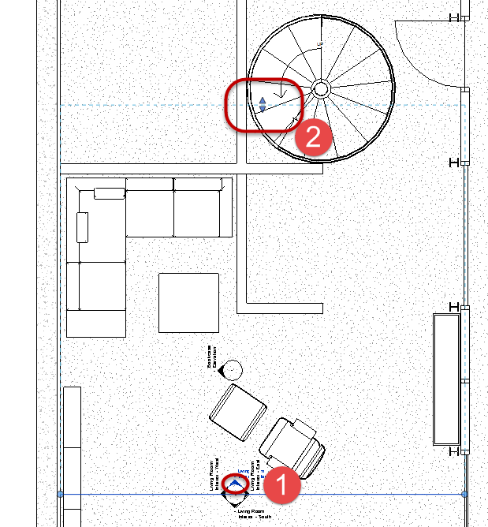

* 1. Click Modify command to exit editing tag.

1. Open Living Room Interior – North elevation view.

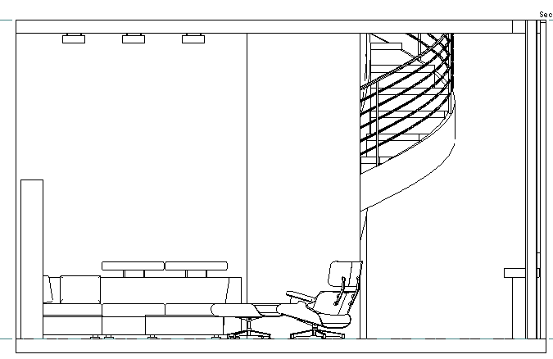

1. Save the Revit file as: Module06Ex02_Creating Elevation and Section Views_Imperial_Finished.rvt

This concludes Exercise 2.

Exercise 3 — Creating 3D Views

In this exercise, you will move beyond 2D orthographic views to create expressive 3D views for rich visualization.

Objectives:

* Duplicate the Default 3D View to create additional orthogonal views.
* Use the Autodesk® ViewCube® widget and the Autodesk® SteeringWheels®

widget to change the view settings.

* Use the section box to create 3D plans and section views.
* Use the Camera tool to create new perspective views.
* Adjust the crop region, far clip offset, and camera and target positions for

perspective views.

Create a perspective view of the Residence Living Room using the Camera tool

1. Navigate to the folder containing the downloaded resources for Module 6.

Module06_Resources

1. Open Revit file: Module06Ex03_Creating 3D Views_Imperial_Start.rvt
2. Open the First Floor plan view and zoom into the Residence Living Room space.
3. Place a camera view in the room.
   1. On the View tab, Create panel, click the pulldown menu for 3D View and select Camera.

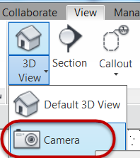

* 1. Place the Camera at the south end of the living room (Mark 1) and left click to set that as the origin point and then drag the cursor beyond the extents of the living room space to Mark 2 and left click.

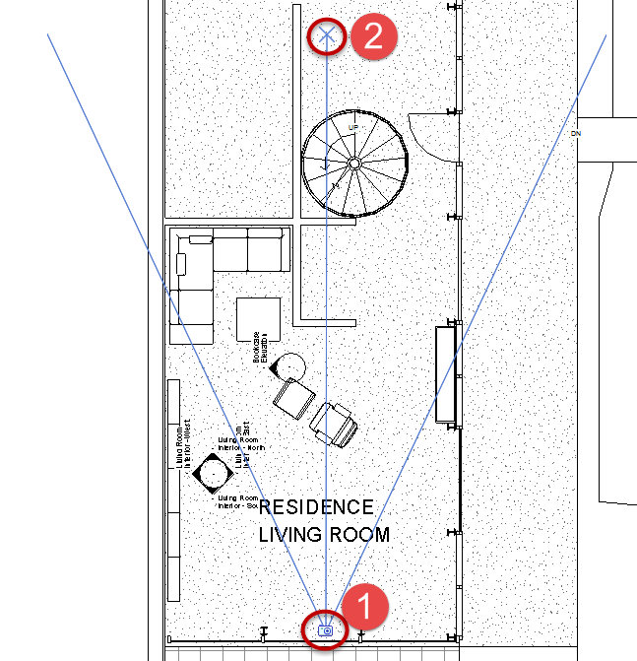

* 1. In Project Browser, view 3D View 1 3D view was automatically created and opened for you.

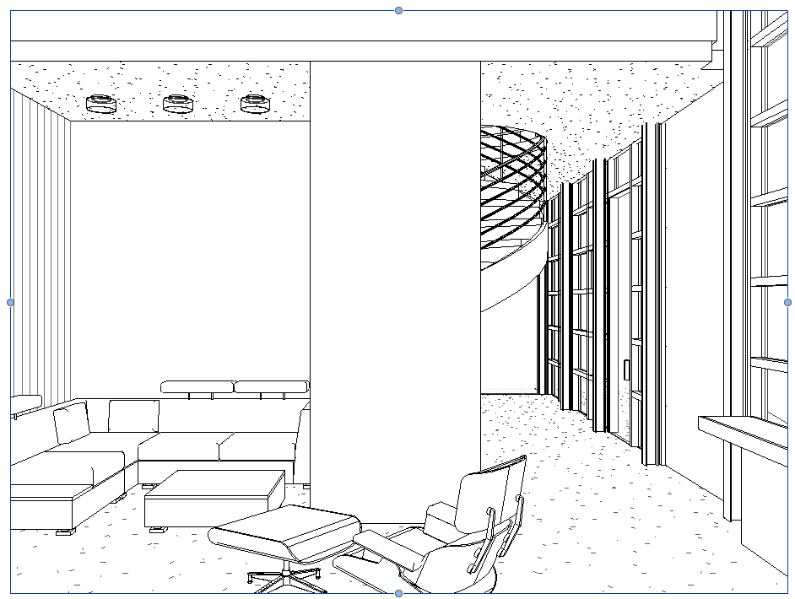

1. Change crop region proportion to 16:9 format.
   1. Select the 3D view crop region window.
   2. Click Size Crop from Crop panel.
   3. Set width = **16” (0.40m)**
   4. Set height = **9” (0.22m)**

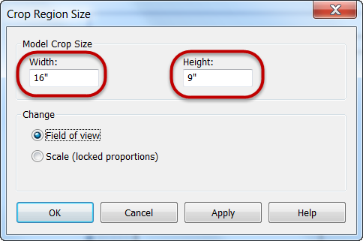

* 1. Click OK.

1. Zoom to Fit view (ZF).

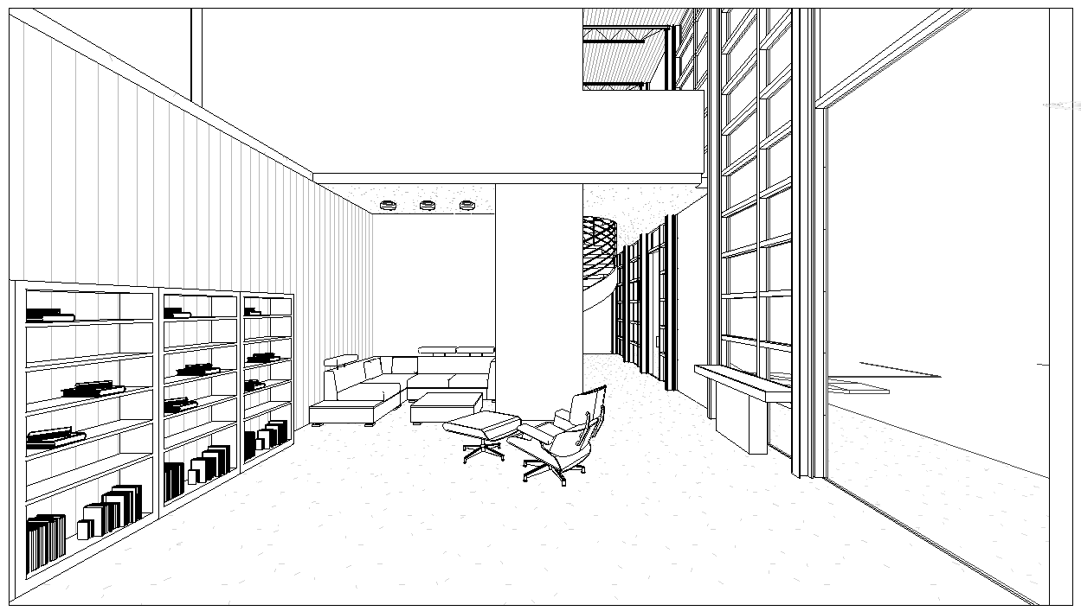

1. Rename the 3D view to:

Living Room Interior.

1. If you need to make camera adjustments for the view use the Navigation Wheel.
   1. Open Navigation Wheel by left clicking over it.

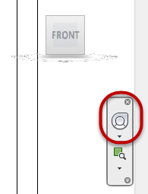

* 1. Use any of the following functions to compose the scene as desired

(Walk= Mark 1, Up/Down= Mark 2, and / or Look = Mark 3)

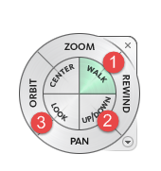

* 1. To close Navigation Wheel, click the X in the upper right corner of Navigation Wheel.

Create a 3D section cutaway view of the Residence building

1. Open First Floor - Residence plan view.
2. On the View tab, Create panel, click the Section command.

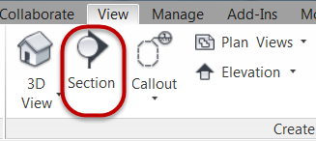

1. Place the section head outside of the Residence building at Mark 1 and left click to set and then drag cursor straight up and left click at Mark 2 to set the cutplane extents of the section view. Mark 3 represents the back extents of the section view.

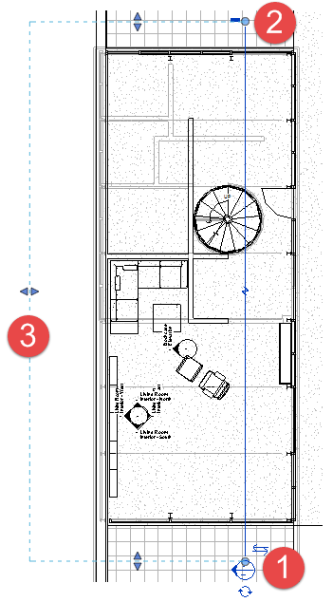

1. Click Modify to end section tool.
2. Open Section 1 section view.

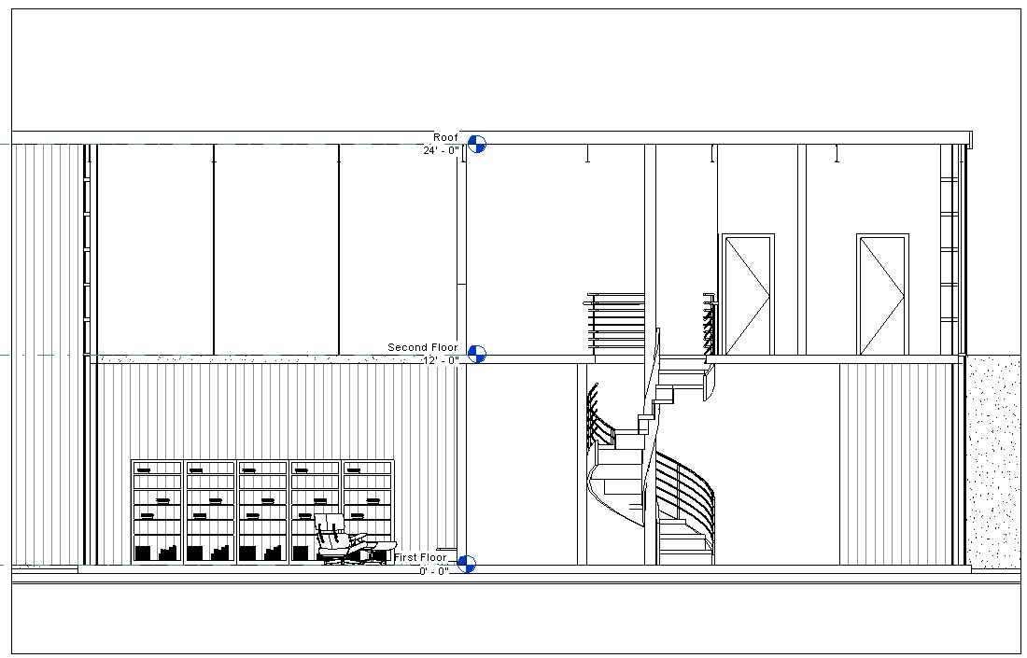

1. Select the crop region window and drag the left drag grip to the left to show the entire roof canopy.

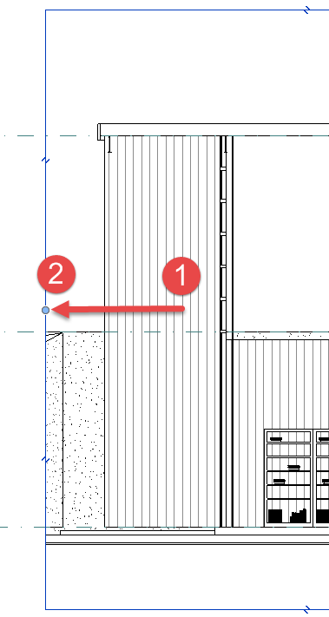

1. Duplicate the {3D} 3D view and rename to: Residence building.
2. Open Residence building 3D view.
3. Right click over the View Cube to reveal the right click menu and select Orient to View (Mark 1) and select Sections>Section:Section 1 view (Mark 2).

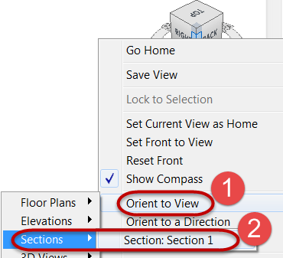

Note: You should now see a 2D orthographic representation of the Residence building in a 3D View.

1. Orient the 3D view to an axonometric representation.
   1. Left click on the upper right corner of the View Cube to tilt the view into a 3D orientation.

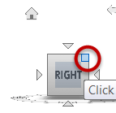

1. Finished orientation of 3D view shown below.

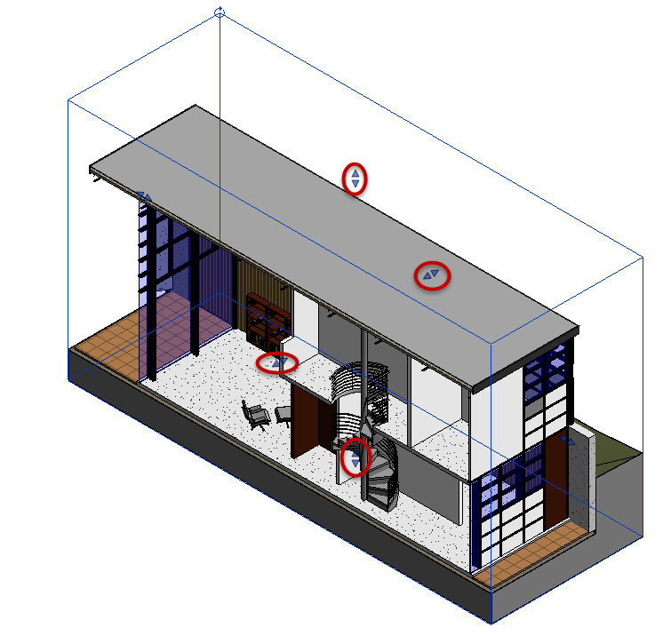

Note: You can select the Section box and drag the handles to crop the view even more in a non-destructive way.

1. Save the Revit file as: Module06Ex03_Creating 3D Views_Imperial_Finished.rvt

This concludes Exercise 3.

Exercise 4 — Adjusting the Appearance of Elements in a View

In this exercise, you will create an exterior perspective view and duplicate the view to apply different visual styles for presentation. In addition you will be introduced to some of the properties in Graphic Display Options.

Objectives:

* Use the View Control bar to quickly change a views display properties―for

example, the level of detail and the visual style.

* Display shadows and specifying the location of the lighting source.
* Set a project’s location and orientation to cast accurate shadows in a solar

study.

* Use Graphic Display Options to enhance the silhouettes of elements and add

gradient backgrounds to 3D views..

Create an exterior perspective view using the Camera tool

1. Navigate to the folder containing the downloaded resources for Module 6.

Module06_Resources

1. Open Revit file: Module06Ex04_Adjusting the Appearance of Elements in a View_Imperial_Start.rvt
2. Open the Site Plan plan view.

1. On the View tab, Create panel, click the 3D View pulldown menu and select Camera.
2. Place the camera at Mark 1 and set the far clip offset plane at Mark 2 as shown below.

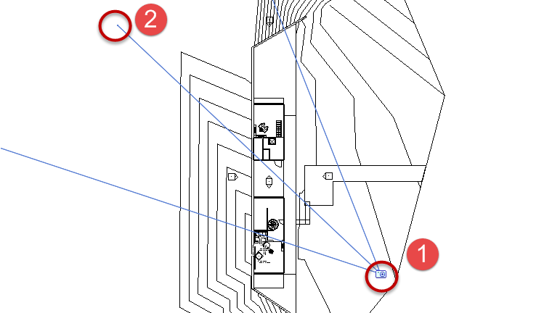

1. Change the frame ratio to 16:9.
   1. In the 3D View 1 3D view, select the crop region window.
   2. Click Size Crop from Crop panel and set frame size to: **16” (0.40m)** wide by **9” (0.22m)** high.
   3. Zoom to Fit view
2. Adjust camera using the Navigation Wheel until your composition looks similar to the view below.

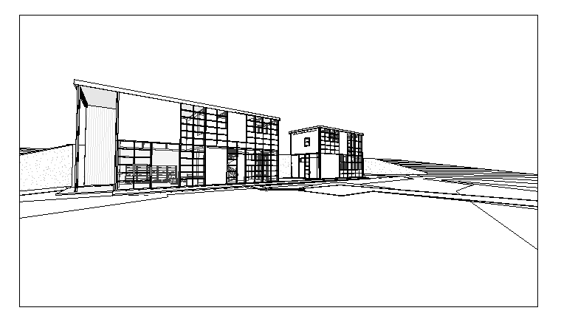

1. Rename 3D View 1 to: Exterior Perspective.

Review visual styles for Exterior Perspective view

1. On the View Control toolbar, select Visual Styles icon and apply each of the following styles to the current Exterior Perspective view to get a sense of what they do.

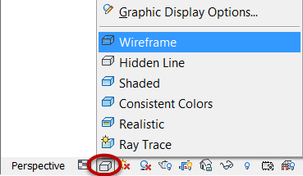

* 1. Apply Wireframe style or (**WF**) keyboard shortcut.
  2. Apply Hidden Line style (**HL**).
  3. Apply Shaded style (**SD**).
  4. Apply Consistent Colors style.
  5. Apply Realistic style.

1. Apply Hidden Line style (**HL**).

*Note: Visual style is a view property and is permanent to the view when the project is saved.*

Duplicate perspective view and apply different visual styles

Realistic style

1. Right-click on the Exterior Perspective 3D view name in Project Browser and Duplicate the view.
2. Right-click on the copied view in Project Browser and rename view to: Exterior Perspective – Realistic.
   1. Apply Realistic style.

Shadow style

1. Right-click on the Exterior Perspective 3D view name in Project Browser and Duplicate the view.
2. Right-click on the copied view in Project Browser and rename view to: Exterior Perspective with Shadows.
   1. Apply Shaded style (**SD**).
3. Adjust Graphic Display Options.
   1. On View Control toolbar, select Visual Style, then Graphic Display Options…

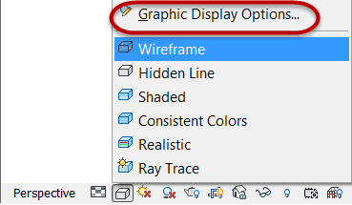

* 1. Enable Shadows. Mark the checkboxes shown below.

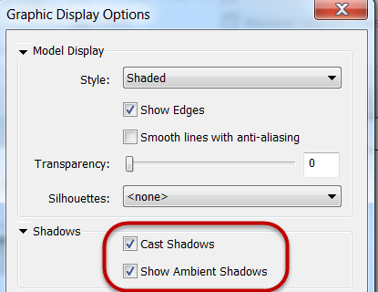

* 1. Set Sun Setting parameters for view.

Mark 1 = Click In-session lighting button.

Mark 2 = Click Still radio button.

Mark 3 = Click Calendar button and

click Year field.

Mark 4 = Set Year = 2015.

Mark 5 = Set Month = June.

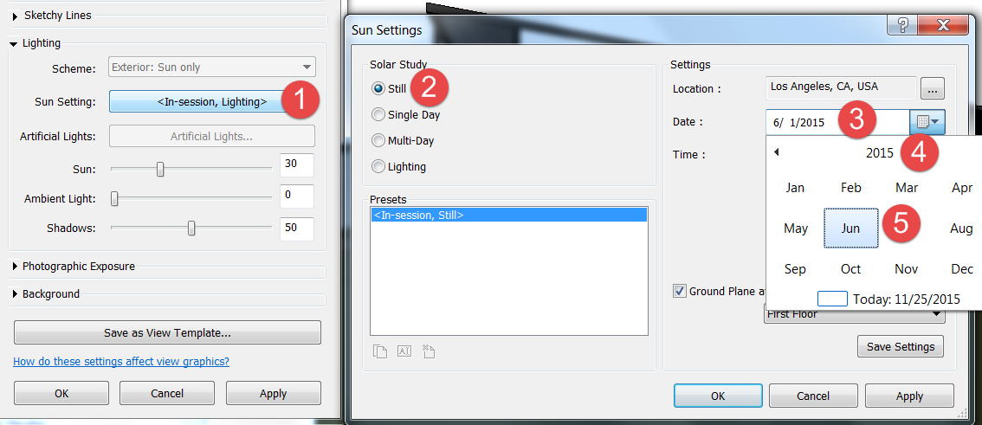

* 1. Set Background property.

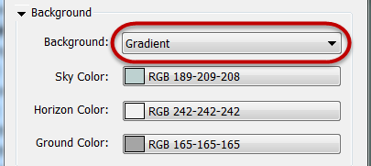

*Note: Accept default values.*

* 1. Click OK to accept all Graphic Display Option settings.

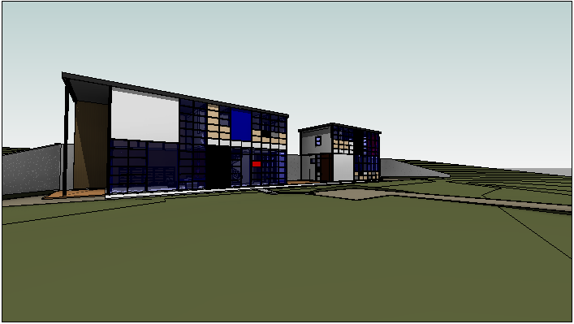

1. Save the Revit file as: Module06Ex04_Adjusting the Appearance of Elements in a View_Imperial_Finished.rvt

This concludes Exercise 4.