**PWD-**

To know the **Present Working Directory**.

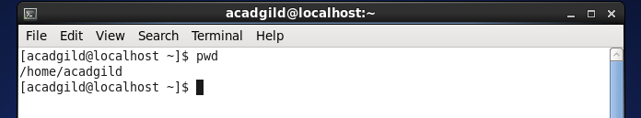

**Mkdir-**

To Make/Create new directory.

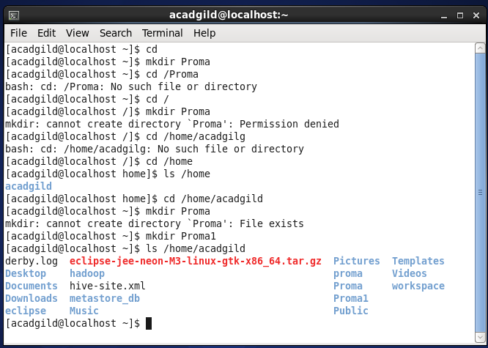

**Date-**

To know the system Date & Time.

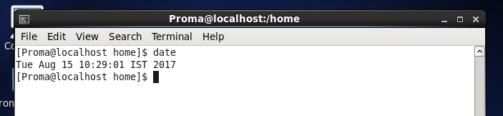

**Touch-**

To create a blank file.

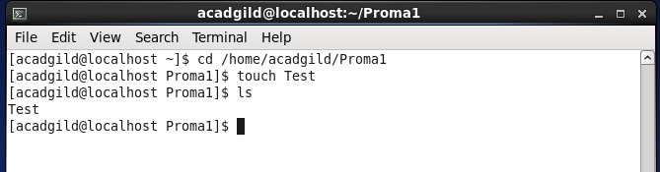

**vi-**

To edit a file.

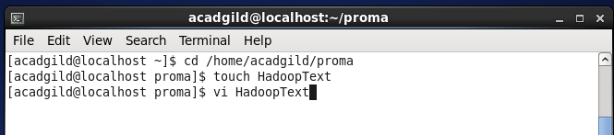

To get into the ex mode, press [Esc] key and then : (the colon). For example, to exit from vi saving changes, press [Esc], : (colon) and type **wq**:

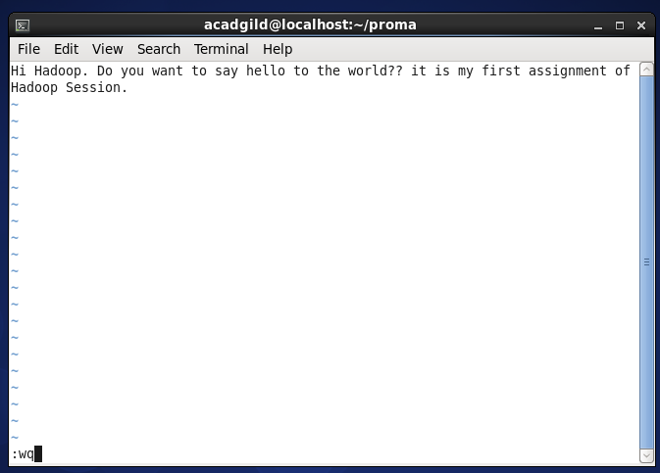

**Cat-**

To read a file.

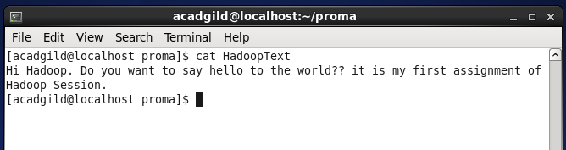

**Cal-**

To get the current month calendar.

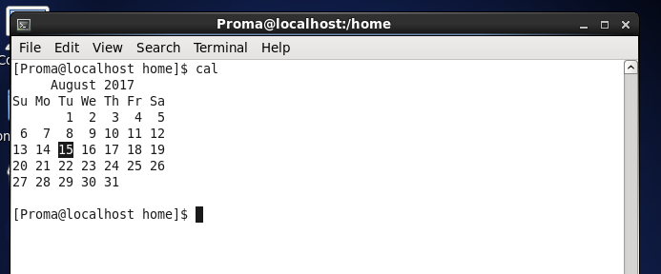

**Who-**

The command prints information about all users who are currently logged in.

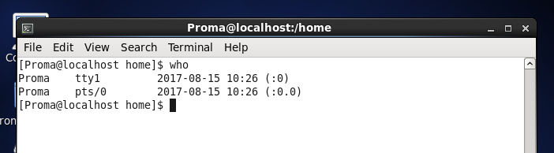

**Rm-**

To remove a file or directory.

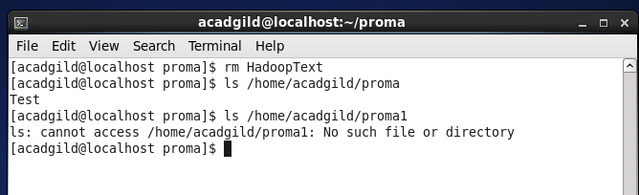

**mv-**

To move the file from source directory to destination directory.

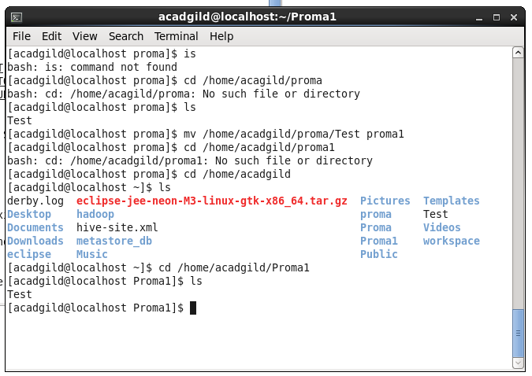

**Cp-**

To copy the file from source directory to destination directory.

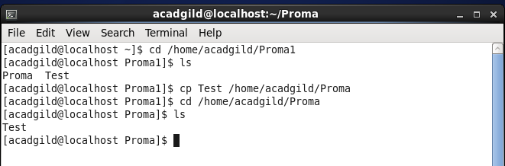

**Which-**

To show the full path of (shell) commands.

