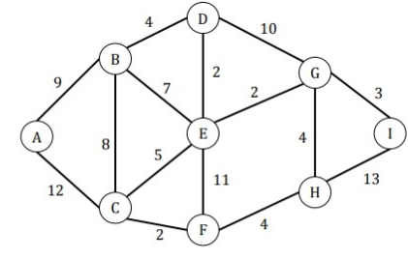

1. Write a program to represent the above graph using Adjacency Matrix by any programming language.
2. Write a program to represent the above graph using Adjacency List by any programming language.
3. Write a program for a binary search tree using any programming language.