

American International University-Bangladesh (AIUB)

**Department of Computer Science**

**Faculty of Science &Technology (FST)**

**Fall 20_21**

**CSC 2210 Object Oriented Analysis and Design (OOAD)**

**Section: D  
Group No: 06**

**Metrorail Ticket Booking System**

An Object-Oriented Analysis and Design (OOAD) project submitted

By

|  |  |  |  |
| --- | --- | --- | --- |
| SL No | Student Name | Student ID | Contribution |
| 1 | Proma Das | 19-39625-1 | 25% |
| 2 | Syed Bisal Ahmed | 19-39584-1 | 25% |
| 3 | Mithun Chanda Shuvo | 19-39592-1 | 25% |
| 4 | Ashrafi Mahjabin | 19-40137-1 | 25% |

# CHAPTER 1: PROBLEM DOMAIN

## Project Background Analysis

Metrorail Ticket Booking System is an online based ticket booking system where user can login to the system by using their user id and password and book metro rail ticket from anywhere. All over the world booking their all-transportation ticket in online. . Metrorail management system is a full online based system and the most important part of the system is booking ticket, so in this project we are only concentrating on the following part.

We know that in Bangladesh Metrorail is too much important transportation nowadays. In our cities so public transport is the sole way of many people to travel from home to their workstations and people has to spend their valuable time by waiting in line to get on a bus to go to work also because of the narrow roads and rickshaws traffic jam is meant to happen which doubles the stress and kills more time. If we use this online system, we can save our time easily because offline method we are waiting a huge time in ticket line to collect our ticket.

## Project Solution and Feasibility Analysis

In this project in the first part now we are going to talk about the sole solution. As the world is daily approaching to the peak of technological achievement, our country is trying its best to cope up with the rest of the world by digitalization of its traditional systems and people are more into online based solutions to their problems rather than solving them offline Our system is the best online based solution on following problem. By making an online based ticket booking system for the public transport people will find easy to travel through public transport and which will eventually help to eliminate traffic jam as part of the population will rely less on their personal vehicles.

This online booking system will be both available on mobile application and open browsers, people can access to their account to their accounts in both platform.

Though online ticket booking systems has been used in our country for travelling outside of the city there were no such platforms for the public to travel inside the city areas.

In this project we are trying to represent some things, Metrorail online ticket booking system first time in Bangladesh. User easily buy a ticket by using app or browsing. As metro rail opens a new way of travelling inside the city our system of booking metro rail tickets online is unique and interesting in its own way. No, it is not available in market but many of companies are making online based ticket booking system.

# CHAPTER 2: UML DIAGRAM

## 2.1Use Case Diagram

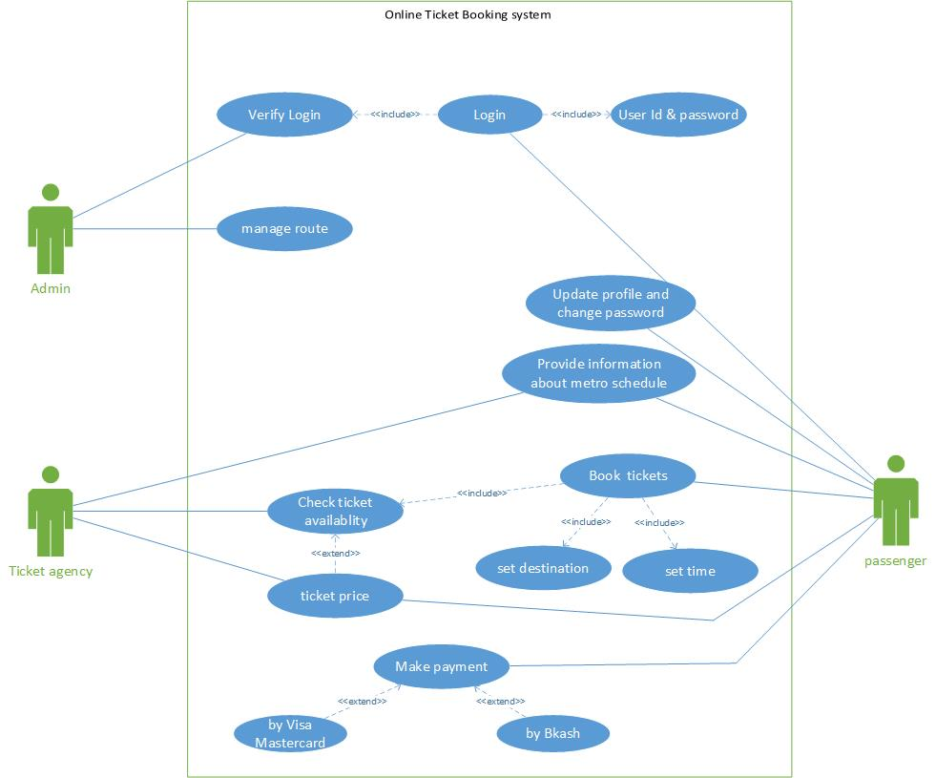In a metro rail ticket booking system passenger can log in account with his id and password and admin can check login validity. Anytime passenger can update profile and change password.Admin manage routes. Passenger can book ticket. While booking they can set their time and destination. Before book their ticket, ticket agency let them know if there any ticket available. Ticket agency also provide information about metro schedule in which it will arrive. They can handle the system to take record of the passenger. Passenger make their payment through bkash or visa/master card.Passenger can know the price of the ticket by ticket agency.Passsenger also view information about metro schedule.

## 2.2Class Diagram

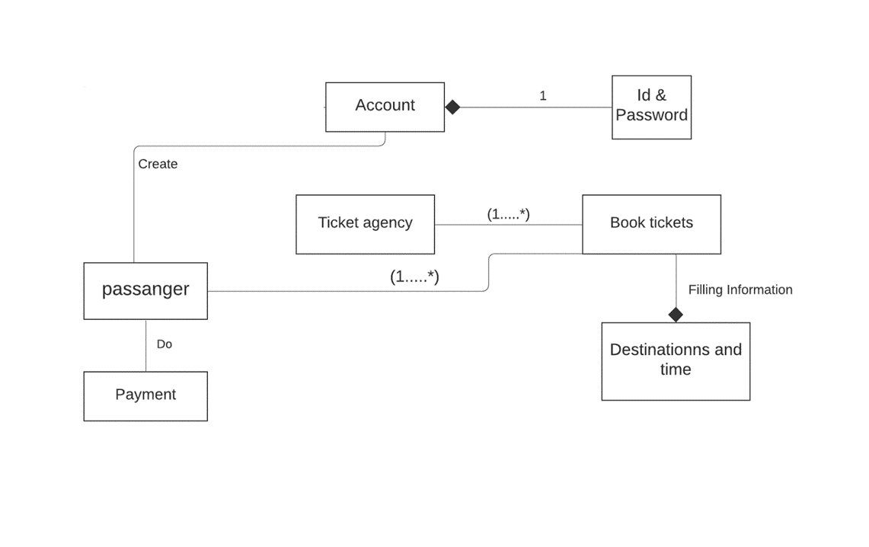In a metro rail ticket booking system. Passenger have to create their own account. He can see any details by logging it by himself. While logging passenger have to use exactly one id and one password. A ticket agency can book many tickets of passenger by filing information about destination and time. He also provide information about metro schedule. One passenger can book 1 or more tickets. After the ticket booking the passenger has to do payment for the ticket.

## 2.3 Sequence Diagram

## In a metro rail ticket booking system, firstly a passenger needs to log in to account with id and password. Then log in will be verified by the admin. If the account is valid log in will be successful else log in will not be successful and passenger can’t be able to enter in the account. The admin will check the metro details. Passenger will have necessary information about metro schedule as time and date from ticket agency. If ticket is available passenger will get ticket else agency will notify that ticket is not available. Then passenger will book ticket from booking management and make payment from payment list. Lastly, Ticket agency will send confirmation message to the passenger.

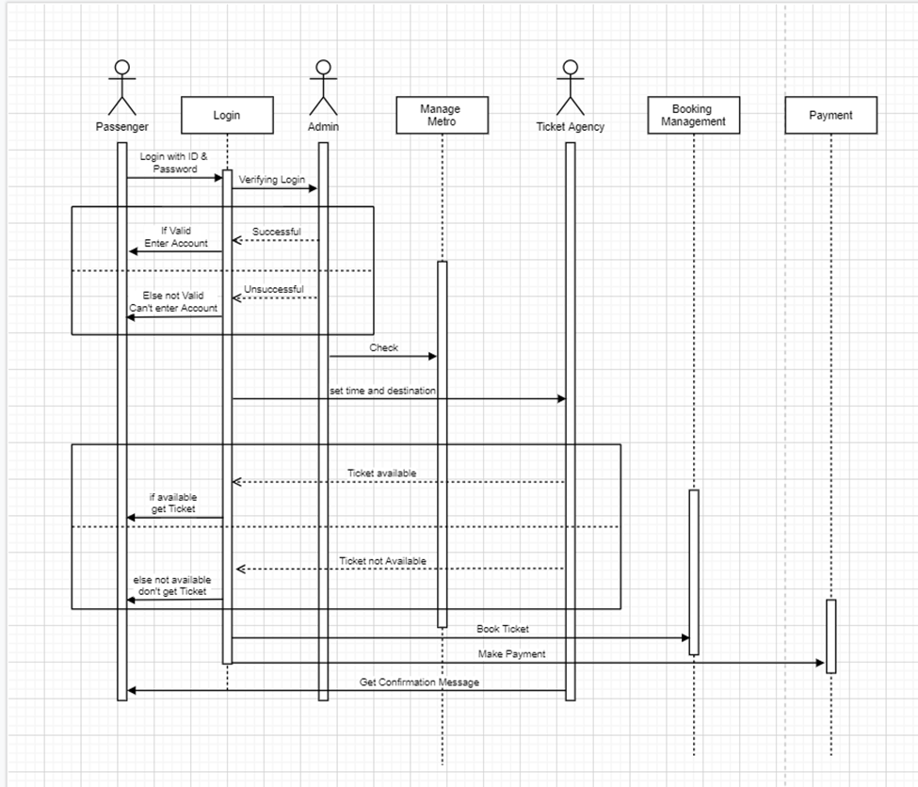

**2.4 State chart Diagram**

In a metro rail ticket booking system, User have his own account. He can see any details by logging it by himself. In account he can change his profile picture and change the password any time. He can see any details about metro and set its time and destination. Sometimes he may not be sure about his destination or he may want to recheck he can also do that. He can also change his destination to go to the metro details option. After setting all things he can confirm his ticket by himself if he booking in online. Now he can enjoy his destination.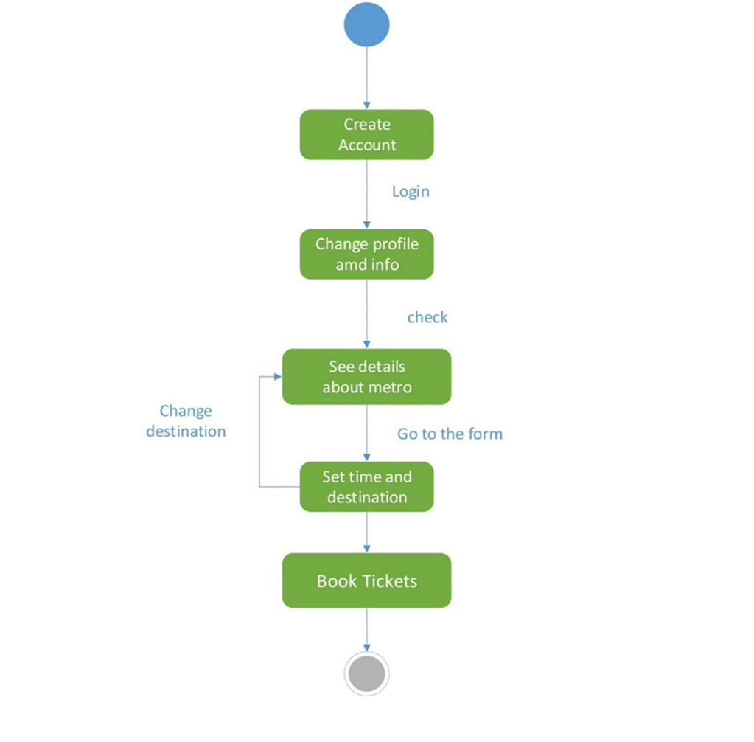

**2.5 Activity Diagram**

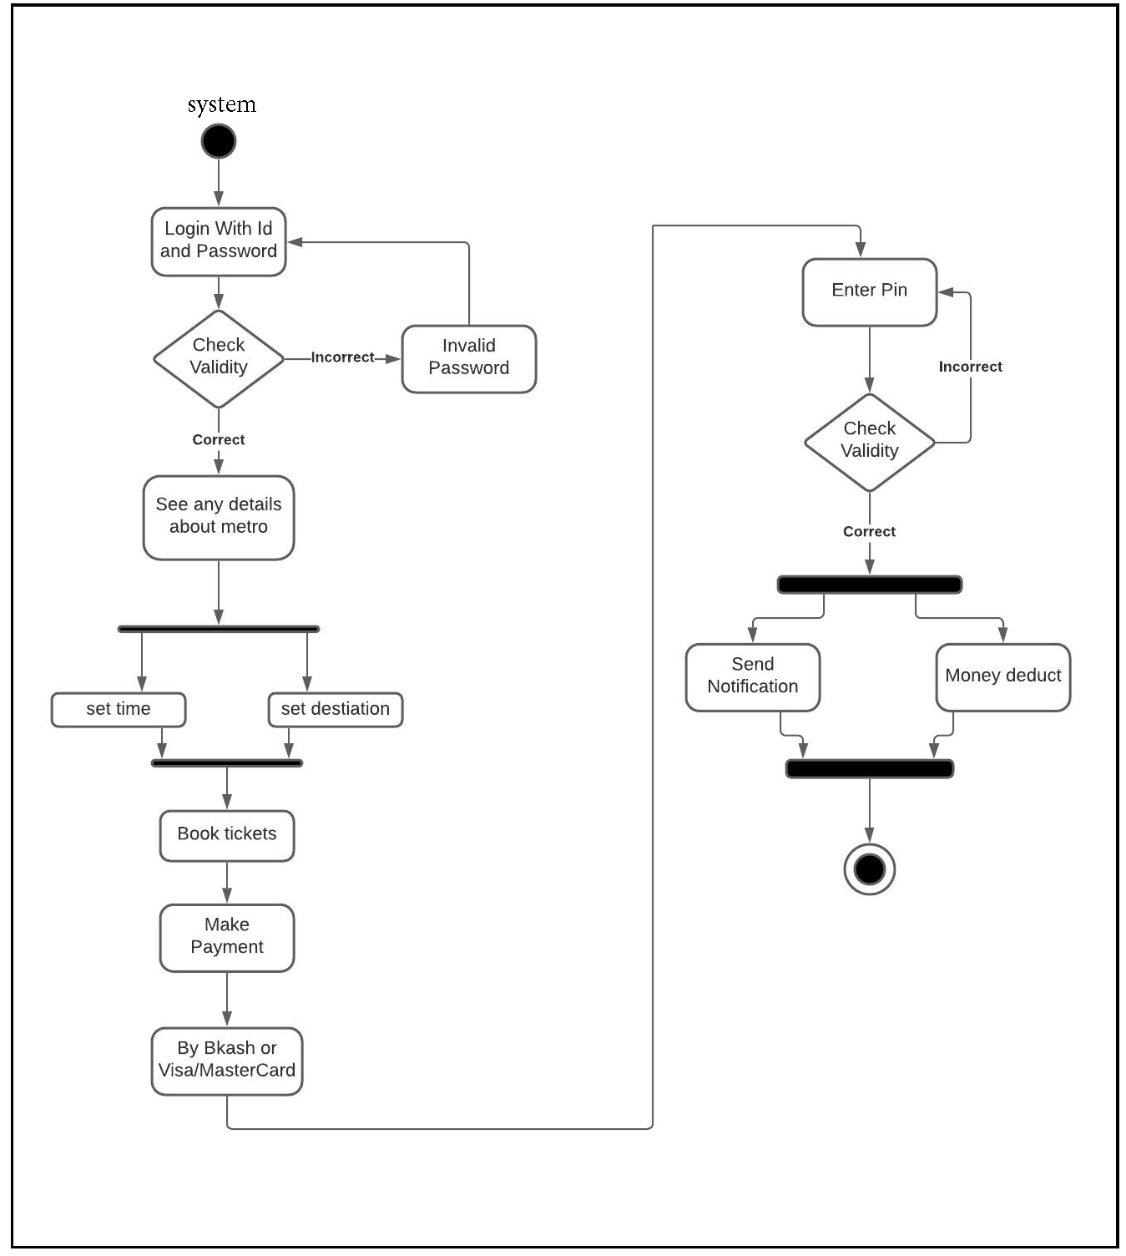In a metro rail ticket booking system, system uses login id and password to login to the system. The system checks if the login id and password is valid or not. If the information valid then the passenger sees any details about metro. If it’s incorrect passenger has to log in again. Passenger also set his time and destination to book the ticket. After booking passenger has to make payment through Bkash or visa/master card. Passenger has to enter pin to access the account. After entering pin if its correct then user get notification that some cash is out from his account if it’s not, he has to enter pin and try to make the payment again.