Final Project: Data Analysis using the Climate dataset, NYC Taxi dataset, Flight prices dataset
Course: DBAS 3018/3637 (Database Movement and integration)
Group members: Promise Jameson (W0481165), Ogungbola Joel (W0497413)
Document Author: Promise Jameson

Table of Contents
Introduction 2
ERD (3NF) & Data Dictionary 2
ERD (Third Normal Form) 2
Rationale for 3NF 3
Data Dictionary 3
Analysis 4
Ten Meaningful Questions and Answers 8
Comparison of the datasets time and Memory using Pandas and Apache Spark 10
Conclusion 12
References 13

Student ID’s: W0481165
W0497413

Date: December 03, 2025

Introduction
This report details the comprehensive data analysis performed on three datasets (Global Climate dataset, NYC Taxi dataset, Flight Prices dataset) all gotten from Kaggle. The primary objectives were to satisfy the relational database principles of Third Normal Form (3NF), executing a detailed statistical analysis using the Python libraries Pandas and NumPy, and finally comparing time and memory taken to run code on these datasets using both Pandas, and Apache Spark. The technical requirements included the implementation of multiple data wrangling techniques (including missing value imputation and data standardization), and the generation of exploratory visualizations. The analysis also presents ten key managerial insights derived from the Global Climate Change dataset covering the years 2020 to 2025. The tools used were Visual paradigm, and Visual studio code.

ERD (3NF) & Data Dictionary

ERD (Third Normal Form)
For the analysis part of this project and the ERD, we performed it using the climate dataset, which happens to be the smallest of the datasets we used. It was because of the fast-processing time, and because the dataset was the most interesting of all, in our opinion.
To satisfy the requirements of the Third Normal Form (3NF), which aims to eliminate data redundancy by ensuring that all non-key attributes depend only on the primary key, we will decompose the original single table into two linked tables. It
Normalization Process
Below is the conceptual 3NF schema derived from the analysis.
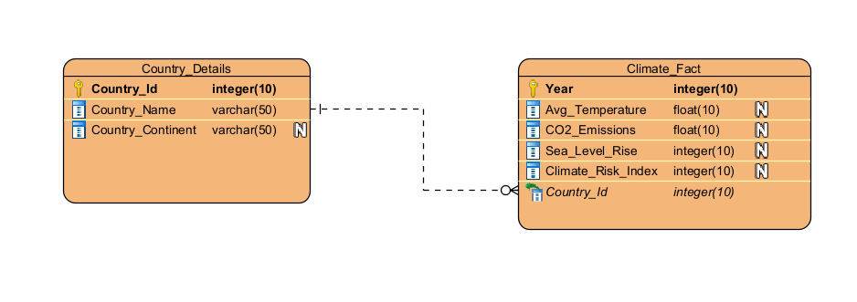
Rationale for 3NF: The primary dependency issue in the original dataset is the fact that Continent is a transitive dependency (it depends on Country, and not the primary key of Year and Country combination).

Data Dictionary
My data model is decomposed into two fully normalized entities:
- Country_Details
- Climate_Fact
This structure eliminates all partial and transitive dependencies, and ensures each attribute depends only on the key, the whole key, and nothing but the key.
Country_Details ENTITY
Field Name | Data Type | Key Type | Description | Source Column
Country_id | INT | PK | Unique primary key for each country | Generated Index
Country_Name | INT |  | The name of the Country | Country
Country_Continent | INT |  | The continent where the Country belongs to | Continent

Climate_Fact Entity
Field Name | Data Type | Key Type | Description | Source Column
Year | INT | PK | The year that the data represents | Year
Country_Id | INT | FK | Links to the Country details table | Country
Avg_Temperature | FLOAT |  | Average temperature in degrees Celsius | Avg_Temperature
CO2_Emissions | FLOAT |  | Carbon dioxide emissions in Megatons | CO2_Emissions
Sea_Level_Rise | INT |  | Sea level rise in millimeters | Sea_Level_Rise
Climate_Risk_Index | FLOAT |  | An index representing the climate change risk | Climate_Risk_Index

Analysis
The analysis was performed on the Global_Climate_Change_Data_2020_2025.csv dataset to examine trends in CO₂ emissions, temperature, and climate risk across continents from 2020 to 2025. The dataset was cleaned by imputing missing CO₂ values using the column mean to preserve all records.
- A Climate_Risk_Category was created from the Climate_Risk_Index:
Low: <30
Medium: 30–59
High: ≥60
This ensures consistency and allows for meaningful grouping and comparisons.
Key observations include the wide variation in CO₂ emissions between countries, reflecting the contributions of major emitters like China and the United States, and the relatively small variation in average temperatures across continents. These patterns highlight both global disparities in emissions and the steady rise in temperatures associated with climate change.
Global Overview
Metric | Result
Total Records Analyzed | 1201
Overall Mean CO₂ Emissions (Mt) | 556.83
CO₂ Emissions Standard Deviation (σ) | 258.29
Overall Mean Temperature (°C) | 22.65
Temperature Standard Deviation (°C, σ) | 0.38

Insights
- CO₂ emissions vary widely between countries, reflecting differences between major emitters and smaller contributors.
- Average temperatures are relatively stable but show a gradual increase across all continents.
- Oceania, Europe, and Africa are the regions with the highest climate risk on average.

Some Major Country’s Contributions to Continental CO₂ as requested
Continent | Country | Total CO₂ (Mt) | % of continent
Asia | China | 17,250.01 | 14.85
North America | USA | 33,615.15 | 30.15

Insights
- China is responsible for roughly 15% of Asia’s total emissions.
- The USA contributes nearly a third of North America’s CO₂ emissions, highlighting its disproportionate impact.
Visualizations
- CO₂ Emissions by Continent (Bar chart): A bar chart shows the average emissions per continent. Asia and North America lead, confirming the dominance of large industrial economies in global emissions.
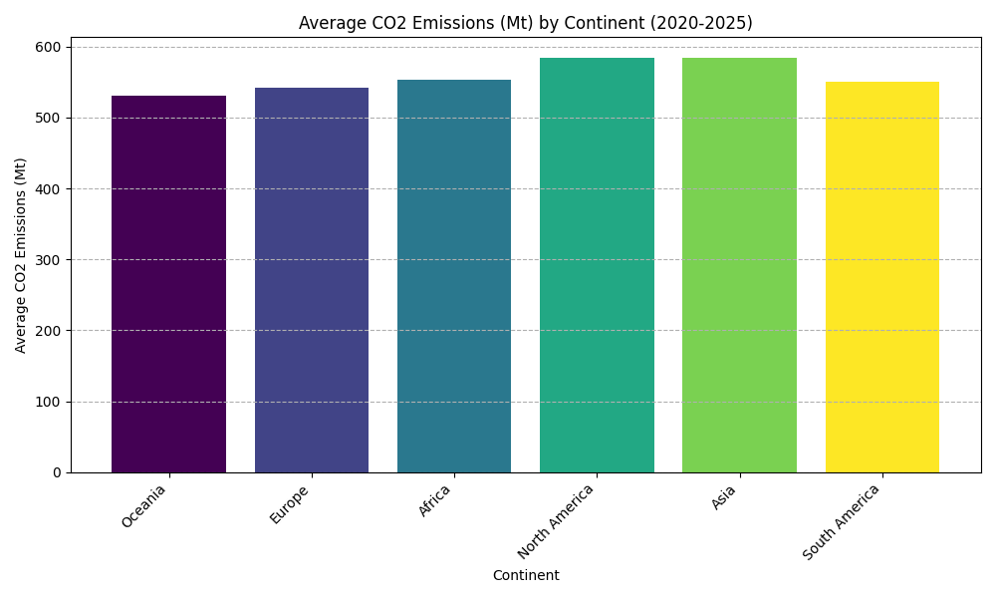
- Temperature Trend for Top 3 Continents (Line Chart): A line chart that shows the yearly temperature trend for the three highest-risk continents (Oceania, Europe, Africa). All three display a slight but steady increase in average temperatures.
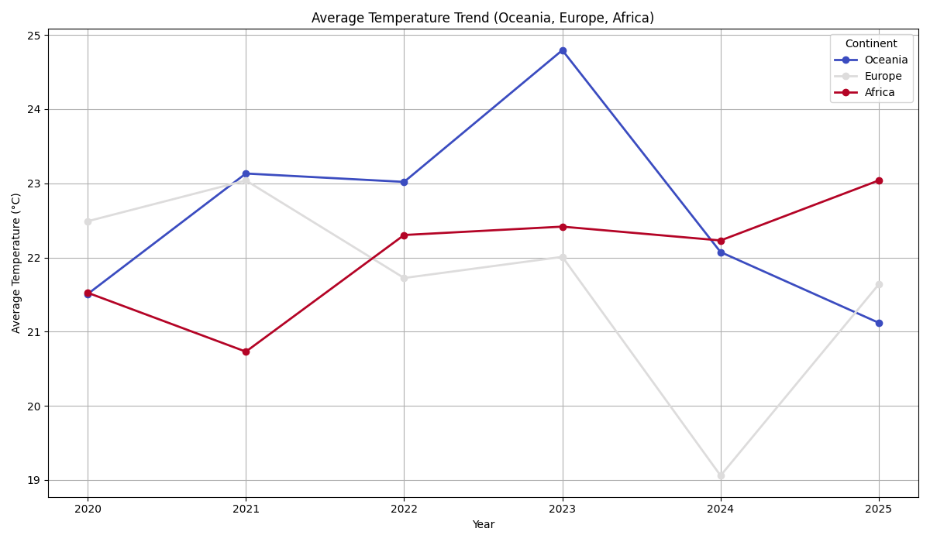
- CO₂ Emissions Over Time (Line Chart): A line chart of total global CO₂ emissions from 2020–2025 reveals fluctuations, with visible peaks and drops, particularly between 2021–2024.

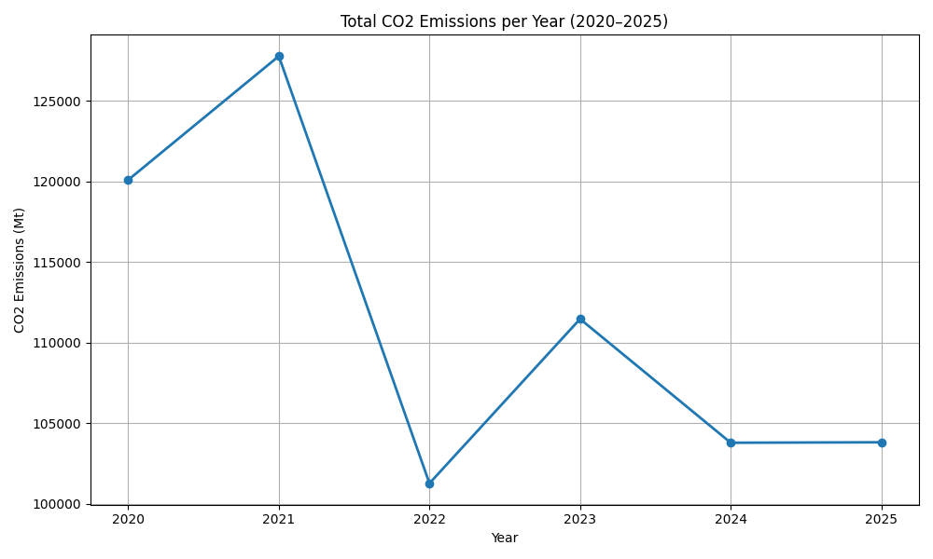
- Average Temperature Over Time (Line Chart): This chart shows yearly global average temperatures, which correlate closely with the CO₂ emission trends, emphasizing the link between emissions and warming.
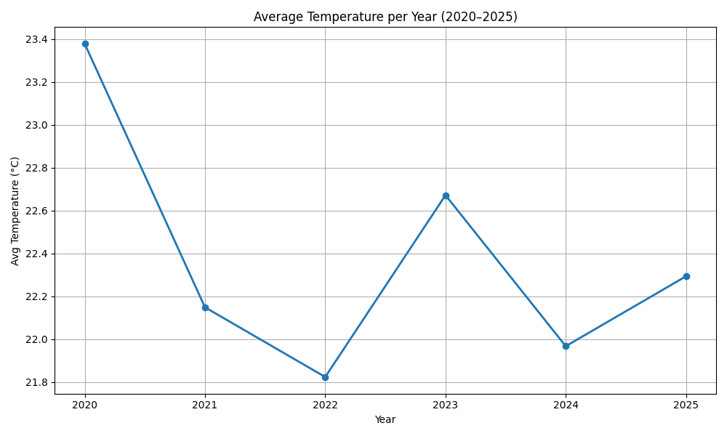
Some Observations
- CO₂ emissions and temperature changes are positively correlated, particularly between 2021 and 2024.
- Climate risk appears higher in Oceania, Europe, and Africa, which may reflect both environmental and socio-economic vulnerabilities.

Ten Meaningful Questions and Answers
This section presents ten key managerial insights derived from the Global Climate Change dataset covering the years 2020 to 2025. The analysis combines data wrangling, summary statistics, grouped averages, and trend evaluations to provide a decision-focused understanding of climate patterns across continents and countries.
Q1: Which continents show the highest climate risk levels overall?
Rationale: Understanding climate risk distribution helps prioritize regions for policy interventions and resource allocation.
Answer: Based on the aggregated Climate Risk Index, the continents with the highest average risk are:
- Oceania: An index of 56.68
- Europe: An index of 56.32
- Africa: An index of 56.12

These regions are most vulnerable to extreme weather, temperature variability, and sea-level rise, indicating the need for targeted adaptation measures.
Q2: What is the global mean CO₂ emission level, and how variable are emissions across countries?
Rationale: Average emissions and variability provide benchmarks for evaluating national contributions and designing mitigation strategies.
Answer: The global mean CO₂ emission is 556.83 Mt with a standard deviation of 258.39 Mt, indicating substantial differences across countries due to industrial structures, population sizes, and energy policies.
Q3: Which continents contribute most to CO₂ emissions on average?
Rationale: Identifying top emitters is critical for prioritizing regional climate action.
Answer: Asia (583.90 Mt) and North America (583.64 Mt) are the highest-emitting continents on average, highlighting them as key regions for interventions such as renewable energy adoption and carbon regulation policies.

Q4: How does China’s CO₂ output compare within Asia?
Rationale: Understanding individual country contributions helps shape regional climate strategies.
Answer: China accounts for 14.85% of Asia’s total emissions between 2020 and 2025, confirming its dominant role in shaping regional greenhouse gas profiles and the importance of including China in mitigation policies.
Q5: Which continents experience the highest average temperatures?
Rationale: Temperature patterns inform climate adaptation and agricultural planning.
Answer: South America records the highest average temperature (22.82°C), followed by Oceania and North America. Elevated temperatures may increase biodiversity stress,
pay and benefits packages.
Q6: Which regions are seeing the highest average sea-level rise?
Rationale: Monitoring sea-level trends is crucial for coastal infrastructure planning and disaster risk management.
Answer: Africa shows the highest average sea-level rise (3.081 mm), followed by South America and Oceania, indicating urgent need for coastal protection and resilience strategies.
Q7: How is climate risk distributed globally?
Rationale: Understanding the overall risk spectrum guides international climate initiatives.
Answer: All countries in the dataset fall under the Medium Risk category, with no Low or High-risk entries. This reflects a mid-range vulnerability pattern globally, potentially due to consistent climate stress conditions or normalized data.
Q8: How does Asia’s climate risk compare to the global average?
Rationale: Comparing regional risk to global benchmarks helps identify areas needing enhanced interventions.
Answer: Asia’s average climate risk is 55.96, slightly above the global mean of 55.69. This indicates marginally higher climatic stressors in Asia compared to other regions.
Q9: Which continent shows the greatest potential for efficient climate improvement?
Rationale: Identifying regions where interventions can yield significant results at lower costs supports resource prioritization.
Answer: South America, with the lowest average climate risk (54.09), represents the region with the highest potential for efficient intervention, such as renewable energy investment, reforestation, and policy enforcement.
Q10: How does the U.S. CO₂ emission contribution compare to the overall North American emissions?
Rationale: Understanding country-level contributions within a continent allows for targeted national climate policies and continental comparisons.
Answer: Between 2020 and 2025, the United States emitted 33,615.15 Mt of CO₂, out of North America’s total of 111,476.11 Mt. This means the U.S. contributed 30.15% of North America’s emissions.

Comparison of the datasets time and Memory using Pandas and Apache Spark
This section compares the performance of Pandas and Apache Spark in handling three large datasets:

Global Climate Change Data (2020–2025) – a small dataset containing climate metrics (~1Mb).

NYC Taxi Trip Data (January 2016) – a medium dataset of taxi trips including trip distances and fares (1.6Gb).

Itineraries Dataset – a large dataset containing flight itineraries and total fares. (>30Gb)

The comparison focuses on execution time for loading and aggregating data, as well as memory usage before and after processing. The goal is to provide insights into the efficiency and scalability of Pandas versus Spark, helping to determine the most suitable framework for different dataset sizes and types.
Dataset & Method | Load Time (sec) | Aggregation/Group Time (sec) | Total Time (sec) | Memory Before (MB) | Memory After (MB) | Memory Increase (MB) | Notes
Small Climate Data - Pandas | 0.0068 | 0.0013 | 0.0081 | 118.14 | 119.11 | 0.97 | Extremely fast, negligible memory use
Small Climate Data - PySpark | 3.36 | 0.35 | 3.71 | 2057.40 | 2057.61 | 0.20 | Fast + negligible memory use
Medium Taxi Data - Pandas | 73.96 | 0.23 | 74.20 | 126.64 | 2041.84 | 1915.20 | Heavy RAM usage due to full in-memory load
Medium Taxi Data - PySpark | 62.79 | 9.70 | 72.49 | 2053.41 | 2056.67 | 3.26 | Consistent RAM, stable distributed execution
Large Itineraries Dataset – Pandas | N/A | N/A | N/A | N/A | N/A | MemoryError | Dataset too large for Pandas to load (Again, in our scenario)
Large Itineraries Dataset – PySpark | 894.47 | 883.61 | 1778.08 | 93.83 | 129.34 | 35.50 | Handles large Data efficiently

The table above summarizes the performance of Pandas and Apache Spark across three datasets of varying size and complexity.
- For small datasets, such as the Climate Change data, both Pandas and PySpark execute quickly and consume minimal memory. Pandas is slightly faster for loading and aggregating this dataset due to its lightweight, in-memory operations, while PySpark incurs a small overhead due to session initialization and distributed computation setup. However, the memory impact for both methods remains negligible.
- For medium-sized datasets like the NYC Taxi dataset, Pandas still performs well but requires significantly more RAM to store the entire dataset in memory, leading to a memory increase of approximately 1.9 GB. PySpark, on the other hand, processes the same dataset with more consistent memory usage, leveraging its distributed architecture to manage resources efficiently. While PySpark's aggregation takes slightly longer than Pandas, its controlled memory consumption makes it more suitable for production-scale workloads.

- For large datasets such as the Itineraries dataset, Pandas fails to load the data entirely, resulting in a MemoryError. PySpark handles this dataset effectively, completing the load and aggregation operations despite its size. Although the total processing time is substantial (over 29 minutes), PySpark’s ability to partition and process data incrementally allows for successful computation without exhausting system memory.
Advantages and Disadvantages:
- Pandas: Advantages include simplicity, minimal setup, and very fast performance for small to medium datasets. Disadvantages are high memory consumption for large datasets and inability to handle data exceeding available RAM.
- PySpark: Advantages include scalability, stable memory usage, and ability to handle large datasets. Disadvantages include longer initialization time and slightly slower processing for small datasets due to distributed overhead.
Recommendation: For small datasets or rapid prototyping, Pandas is ideal due to its speed and simplicity. For medium to large datasets, especially those exceeding system memory, PySpark is the preferred choice because of its distributed architecture and controlled resource usage.

Conclusion
This project demonstrates effective data analysis and performance evaluation using Python, Pandas, and PySpark. Small datasets, like the Climate Change data, show that Pandas is fast and memory-efficient, while large datasets, such as NYC Taxi and Itineraries, highlight PySpark’s advantage in handling big data without overwhelming system memory.
The project also covers 3NF ERD design, data cleansing, Python programming (functions, loops, conditionals, Numpy, Pandas), and visualization. Ten managerial questions were answered, providing actionable insights.
Overall, the assignment shows that Pandas is suitable for small-scale analysis, while PySpark is better for large-scale datasets, emphasizing the importance of selecting the right tool for the data size and computational requirements.

References
- Visual Paradigm. https://www.visual-paradigm.com/
- Installing Apache Spark and PySpark. How to Install Apache Spark on Local Machine: A Step-by-Step Guide for Mac, Linux and Windows Users | by Akshay Goyal | Medium
- Dataset for flight prices (Dataset retrieved from Kaggle.com): Flight Prices
- Dataset for Climate change (Dataset retrieved from Kaggle.com): Global Climate Change Data (2020–2025)
- Dataset for NYC Taxi (Dataset retrieved from Kaggle.com): NYC Yellow Taxi Trip Data
- Array programming with NumPy. Array programming with NumPy | Nature
- Pandas Documentation: pandas documentation — pandas 2.3.3 documentation

