EMI Locker
Three-Tier Service Guide
Investor-facing service separation for Normal, Premium, and VIP EMI protection
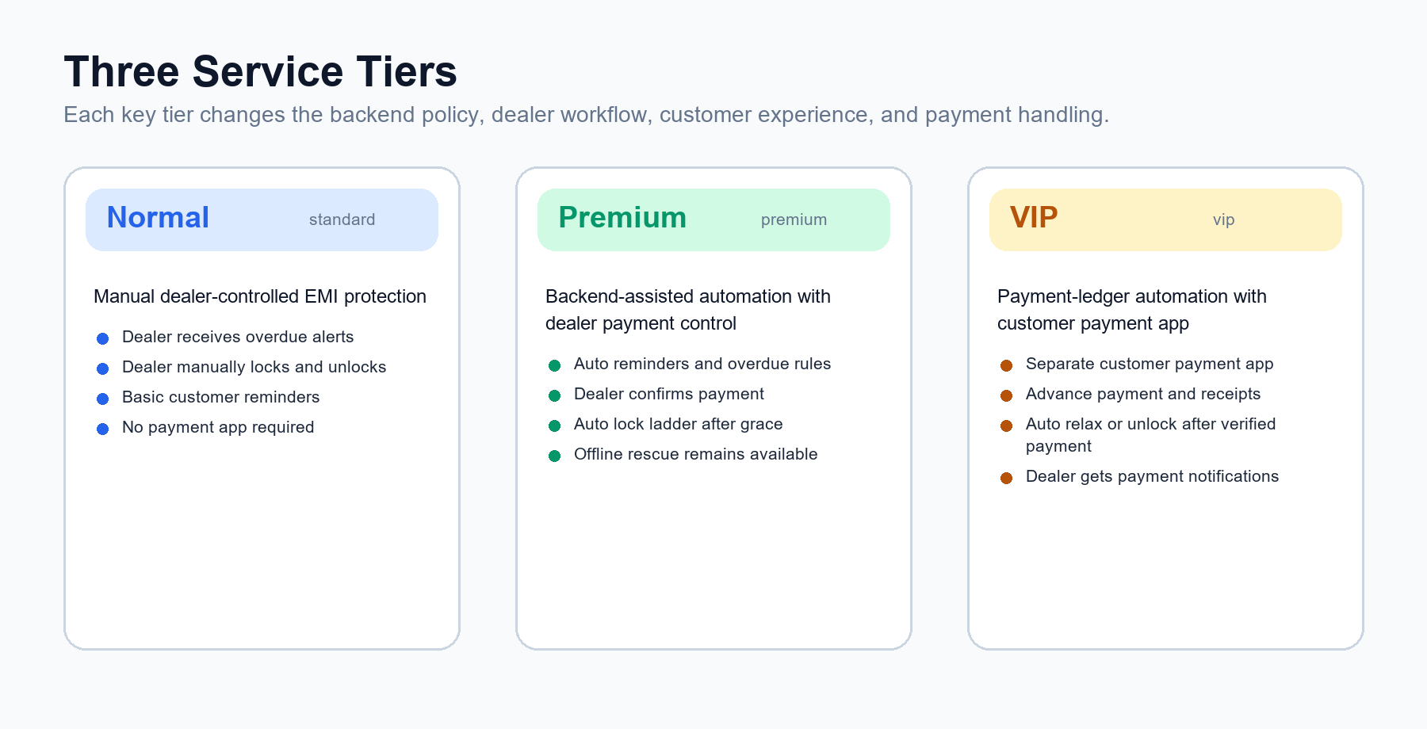

Product Position
EMI Locker protects both parties: dealer confidence without customer humiliation. The platform starts with reminders, then disturbance, then restriction, and uses full lock only when business rules justify it.

Executive Summary
The three tiers are not just pricing labels. Each tier defines a different operating model for payment handling, backend automation, customer experience, and dealer workload.
Tier | Best For | Payment Handling | Lock Behavior | Dealer Workload
Normal | Small shops | Manual by dealer | Dealer manual lock/unlock | High
Premium | Serious dealers | Dealer confirms payment | Backend reminders + auto lock ladder | Medium
VIP | Large partners | Verified payment ledger + payment app | Auto relax/unlock after verified payment | Low

Runtime Policy Flow
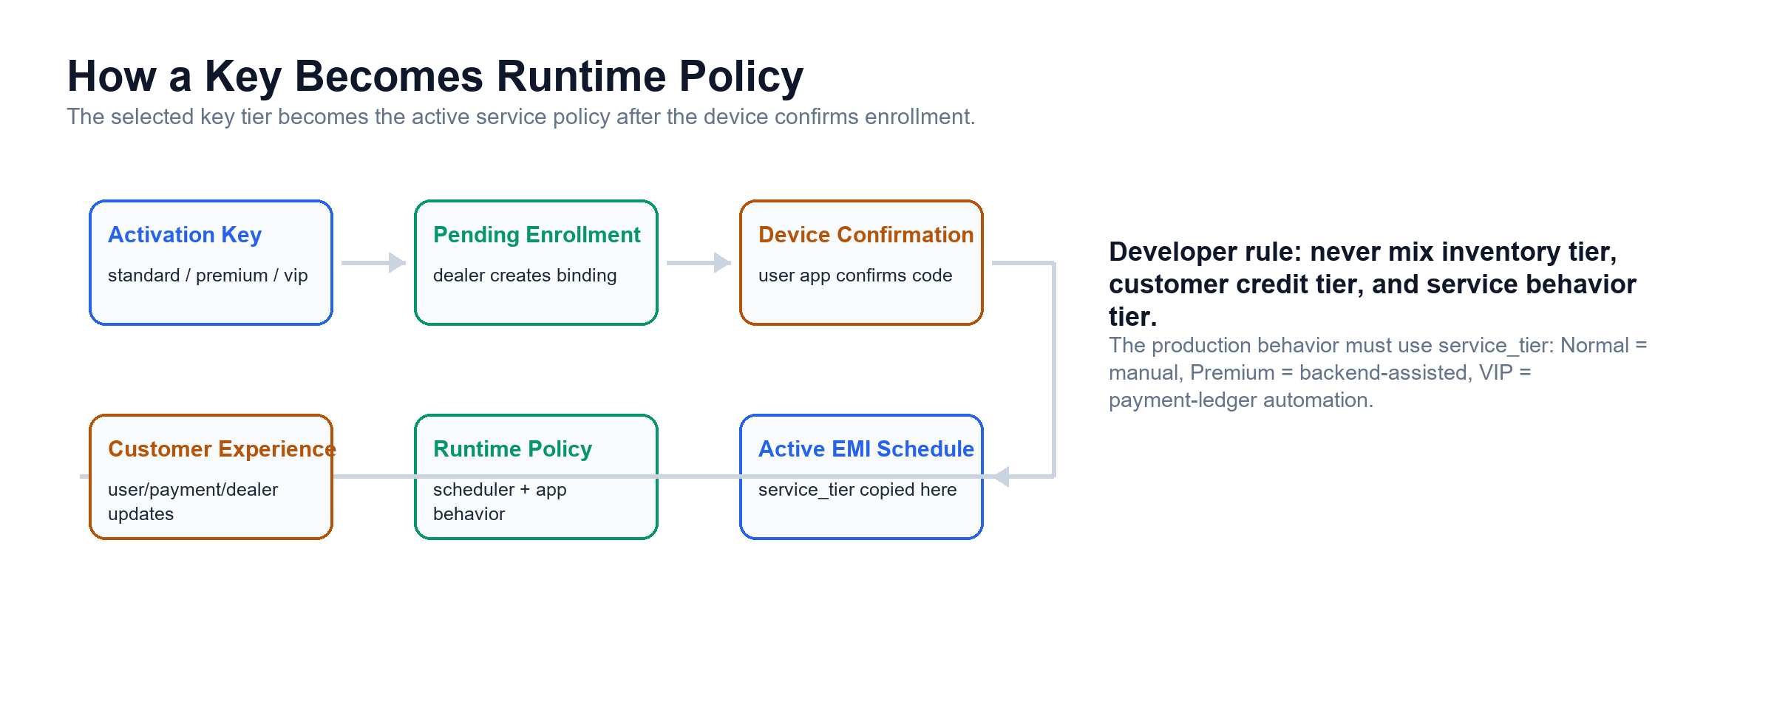
Implementation Rule
Key tier must become service_tier during confirmed enrollment. The scheduler, dealer app, user app, and VIP payment app must all read service_tier behavior.

Normal Tier
Normal is the low-cost, dealer-operated tier. The platform gives the dealer tools, but the dealer makes the business decisions.
- Backend stores EMI schedule and notifies the dealer about due or overdue state.
- Backend does not auto-lock by default.
- Dealer manually locks and unlocks from the dealer app.
- User app acts as the core managed device agent and reports heartbeat, lock state, permissions, and location when requested.
- No separate payment app is required.

Premium Tier
Premium reduces dealer workload. The backend watches EMI dates and applies rules automatically, but payment confirmation remains dealer-controlled.
- Backend sends reminders before due dates and alerts at overdue state.
- Backend applies reminder mode, partial lock, and full lock based on grace/overdue rules.
- Dealer records or confirms payments and controls unlock or grace decisions.
- Dealer app shows automation timeline: reminder sent, warning shown, partial/full lock applied, device confirmed.
- User app explains EMI status, lock reason, due date, grace period, and dealer contact.

VIP Tier
VIP is the PalmPay-style experience: payment becomes part of the customer journey, while the dealer receives payment notifications and exception alerts.
- VIP devices receive a separate customer payment app or portal in addition to the core user app.
- Payment ledger tracks due, pending, verified, rejected, refunded, and dealer settlement states.
- Customer can see balance, installments left, pay-now, advance payment, receipt history, and support contact.
- Verified payment automatically relaxes or unlocks the device when business rules allow.
- Full lock is not the first response. VIP uses persistent disturbance mode first, keeping payment/support paths usable.

VIP Lock Ladder
Stage | Trigger | Customer Impact
Friendly reminder | Before due date | Notification and payment-app prompt
Payment due | Due date or grace start | Persistent payment card in payment/user app
Disturbance mode | After grace if unpaid | Front message that obstructs view but keeps payment/support usable
Partial restriction | Continued overdue or tamper | Restrict non-essential/distraction apps when policy allows
Full lock | Serious default or fraud | Kiosk/lock mode with emergency, payment, and dealer contact only

App Separation
Decision
Use one core user app for all tiers, plus one optional VIP payment app. Do not create separate Normal, Premium, and VIP user apps.
App | Installed On | Responsibility
Core user app | Every EMI-managed phone | Device Owner/admin behavior, FCM commands, lock overlay/kiosk, heartbeat, schedule sync, offline unlock, location report
Dealer app | Dealer/reseller device | Enrollment, key purchase, device status, lock/unlock, payment confirmation, notifications
VIP payment app | VIP devices only | Customer payment UX, payment initiation, payment status, receipt history, advance payment, support

For Device Owner / AMAPI-managed phones, the backend can force-install the VIP payment app through managed Google Play policy using the app package name.

Backend Readiness Work
Workstream | Required Change
Source of truth | Add/copy service_tier into active device or schedule during confirmed enrollment
Tier-aware scheduler | standard = notify only; premium = auto lock ladder; vip = payment-ledger automation
Payment ledger | Normalize payment states and add idempotent payment events/webhooks
Command lifecycle | Track created, sent, received, applied, failed, expired
Dealer UI | Show tier detail sheet, tier badge, tier-specific actions, and command timeline
User/VIP app | Read tier from backend; VIP opens/links payment app and applies disturbance mode first

Heartbeat And Scaling
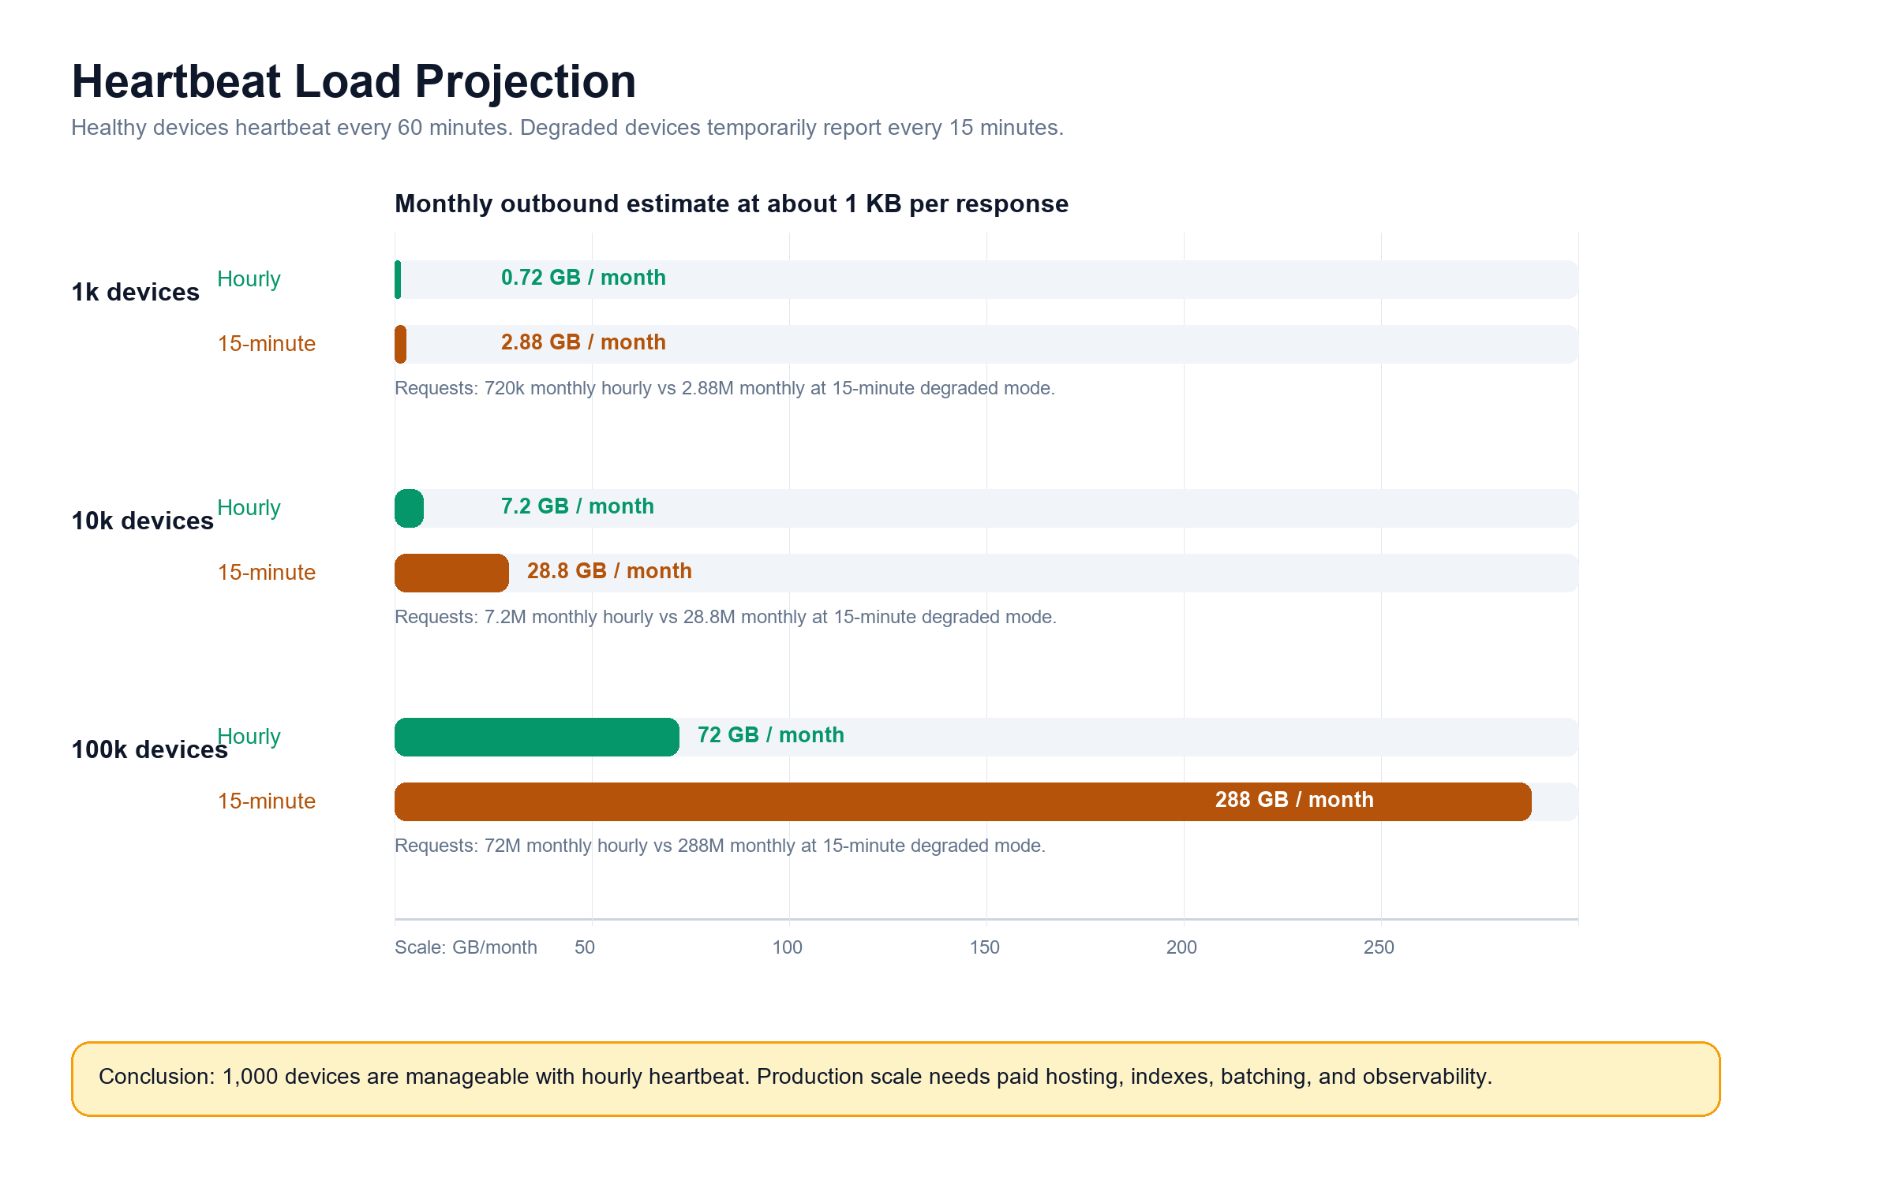
Heartbeat is necessary, but it must be controlled. Healthy devices should report about once per hour. Permission-degraded or recently changed devices can report more often temporarily.
Devices | Hourly Heartbeat | 15-Minute Degraded Heartbeat
1,000 | 720,000/month, about 0.7 GB outbound at 1 KB | 2.88M/month, about 2.9 GB outbound at 1 KB
10,000 | 7.2M/month, about 7.2 GB outbound at 1 KB | 28.8M/month, about 28.8 GB outbound at 1 KB
100,000 | 72M/month, about 72 GB outbound at 1 KB | 288M/month, about 288 GB outbound at 1 KB

Infrastructure Note
Render free tier is acceptable for development testing only. Production needs paid hosting, database indexes, batching, and observability.

References
- Android Management API: Distribute apps through managed Google Play policy - https://developers.google.com/android/management/apps
- Render free tier limitations - https://render.com/docs/free
- Render outbound bandwidth pricing - https://render.com/docs/outbound-bandwidth

