**CHAPTER TWO**

**LITERATURE REVIEW**

**2.1 Online Technology and Its Related Concepts in Connection to**

**Inventory**

An online application is a computer software application that is coded in a browser-supported language (such as HTML, JavaScript, Java, etc.) and reliant on a common web browser to render the application executable. Also, it can still be accessed by an authorized person anywhere and anytime. The use of a database or other software can make the inventory management systems much easier by quickly and efficiently cataloguing all the information, including the quantity on hand, cost of the item, and location within the warehouse (Lerdorf *et al.*, 2008).

The introduction of computer in information processing has tremendously improved the information need, data acquisition and increase in business / organization efficiency. Information processing began decades ago as businesses and governments sought to be able to process large amounts of data, often statistical or calculated from gathered data (Kakeeto, 2013).

Watkins (2018) defined computer as a programmable device that can automatically perform a sequence of calculations or other operations on data once programmed for the task. It can store, retrieve, and process data according to internal instructions. A computer system, therefore, is a computer combined with peripheral equipment and software so that it can perform desired functions. Often the terms "computer" and "computer system" are used interchangeably, especially when peripheral devices are built into the same unit as the computer or when a system is sold and installed as a package. The term "computer system," however, may also refer to a configuration of hardware and software designed for a specific purpose, such as a manufacturing control system, a library automation system, or an accounting system. Or it may refer to a network of multiple computers linked together so that they can share software, data, and peripheral equipment.

Information processing refers to the manipulation of digitized information by computers and other digital electronic equipment, known collectively as information technology (IT). Information processing systems include business software, operating systems, computers, networks and mainframes. Whenever data needs to be transferred or operated upon in some way, this is referred to as information processing. A computer information processor processes information to produce understandable results. The processing may include the acquisition, recording, assembly, retrieval or dissemination of information. For example, in printing a text file, an information processor works to translate and format the digital information for printed form (Kakeeto, 2013).

Davidson (2018) reveals that computerization has revolutionized inventory management, as technologies ranging from automatic scanners to radio frequency identification chips now allow businesses to track their inventory. They also create a perfect real-time record of how much stock remains on the shelves, how much is available in on-site storage, and whether a new shipment is necessary from the warehouse. When this information is combined with warehousing data, and your business can create additional alerts to key management when a bottleneck occurs. Computerization provides a real-time picture of this entire work flow process, and allows managers to reduce purchasing costs through minimizing inventory, increase the efficiency of internal shipping systems, and reduce the possibility of theft or damage by being able to track each item down to the individual staffer who takes responsibility for it.

Kakeeto (2013) in his research, reports that Inventory management software is a computer-based system for tracking inventory levels, [orders](https://en.wikipedia.org/wiki/Order_(business)), [sales](https://en.wikipedia.org/wiki/Sales) and [deliveries](https://en.wikipedia.org/wiki/Delivery_(commerce)). It can also be used in the manufacturing industry to create a [work order](https://en.wikipedia.org/wiki/Work_order), [bill of materials](https://en.wikipedia.org/wiki/Bill_of_materials) and other production-related documents. Companies use inventory management software to avoid product overstock and outages. It is a tool for organizing inventory data that before was generally stored in hard-copy form or in [spreadsheets](https://en.wikipedia.org/wiki/Spreadsheet). It is often associated with and is similar to distribution software, as distributors that can compete with less cash tied up in inventories have a distinct advantage over their competitors. Inventory control is also about knowing where all stock is and ensuring everything is accounted for at any given time. An inventory control system or a computerized inventory system is a process for managing and locating objects or materials

Katende (2015), reveal that the purpose of automation of Inventory Management Process System is to help management have a computerized storage system that produces stock level reports on time for important decision making. Data-flow diagrams, Entity relationships are some of the tools that are used to develop the required system. The Inventory database contains the inventory information for all the items and the system will also capture inventory data that is to be stored and processed for the day to day running of the Company. Once the quantity of an item in stock drops below the reorder value, the alert level (flag) changes and indicates the item need to be re stocked. This flag is then checked at the end of the day to determine whether more of the product should be ordered. The system has forms that are used to capture and insert data into the database, delete records, view reports and provide user rights to only authenticated users.

Computerising your inventory system brings you the potential for improving sales and profits through better analysis of inventory trends, including patterns of delivery and demand. It will almost certainly pay a significant return on your investment. This really spells why the automation of inventory is apparently very much needed and not only computerisation but also with the appropriate software.

The usage of a database or other software can make the inventory management systems much easier by quickly and efficiently cataloguing all the information, including the quantity on hand, cost of the item, and location within the warehouse / store. As an organization grows, it is required to deal with a lot of paper-based records for each transaction, necessitating a lot of documentation in hardcopies. As an alternative, an online based inventory system’s records can be digitally archived, thus reducing filing activity at the end of each term’s end (Lerdorf *et al.*, 2008).

Currently there are a lot of technologies that can enable online inventory applications. Example are Personal Home Page Pre-Processor (PHP),Visual Basic.Net, Adobe Dreamweaver, MYSQL, JAVA.

Personal Home Page Pre-Processor (PHP) and Visual Basic are used to communicate with and the manipulate the database.

Adobe Dreamweaver, an integrated Development Environment is used to create the user interface and to write the codes.

MYSQL Server, a Relational Database Management System, is used to create the database tables and data. MYSQL is very fast, reliable and easy to use and its connectivity, speed and security make it highly suited for accessing databases (Ukem et al, 2012).

Java is a programming language used to build programs that can work on stand-alone computers on the internet. Its primary features are that it is object-oriented and a cross platform language.

By cross platform, it means that the programs can run across several platforms such as Microsoft Windows, Apple Macintosh and Linux. There are undoubtedly several other similar programming Language for Database management systems in existence.

**2.2 Inventory Management**

According to WebFinance (2018), inventory is the value of materials and goods held by an organization; (1) to support production (raw materials, sub-assemblies, work in progress); (2) for support activities (repair, maintenance, consumables). Inventory is often the largest item in the current assets category, and must be accurately accounted and valued at the end of each accounting period to determine a company’s profit or loss. Organizations whose inventory items have a large unit cost generally keep a day to day record of changes in inventory (called perpetual inventory method) to ensure accurate and on-going control. Organizations with inventory items of small unit cost generally update their inventory records at the end of an accounting period or when financial statements are prepared (called periodic inventory method).

According to Sunitha (2014), the term inventory refers to the stock file of products an organization is offering for sale, or used in day-to-day operation and the components that make up the products. In other words, inventory is composed of assets that will be showed in future in the normal course of the business operations. The assets which firms store as inventory in anticipation of need are: Raw materials, Work in process (Semi Finished goods), Finished goods. The raw material inventory contains item that are purchased by the firm from others and are converted into finished goods through the manufacturing (production) process. They are an important input of the final product. The working process inventory consists of items currently being used in the production process.

Survival of any business concern depends to a very great extent on the firm's ability to effectively manage and control its inventory. The inability to achieve this feat has caused the failure of many industries. Inventory therefore plays a central role in any business.

Good inventory management in a firm would lead to greater profits, minimized losses, greater customer satisfaction, stabilized employment, enhanced product quality and other latent benefits of inventory. Failure to meet demand in any company usually compromises customer satisfaction and attracts high cost that characterizes emergency production. Efficient management of inventory system is therefore very critical in the operations of any firm.

From observations it can be said that a lot of failed investments did so as a result of inefficient inventory management.

Power utilities (transmission) companies are faced with steady demands for capital investments to upgrade and maintain infrastructure. An electric transmission company inventory can mean millions of dollars in valuable capital that could be used to meet its growing list of demands. Optimizing inventory levels is a careful balancing act. Carry too much inventory and a company will unnecessary burden its supply of capital that could otherwise be reinvested in other strategic demands. Too little inventory, on the other hand, may reduce the reliability of operations by impairing the company’s ability to respond to damaged transmission assets, replace critical equipment / instruments, etc. (Madden, 2016).

The chief motive of an organization is profit maximization. Inventory is an essential part of an organization since it is one of the major factors that affect the profit earned by the organization. Hence managing inventory is one of the most important tasks necessary to achieve organizational goal of earning maximum profit and reducing costs and expenses.

Inventory management deals primarily with determining the size and placement of semi-finished and finished items or goods within a facility or within multiple locations of a supply chain network. One way of managing inventory is to have a web-based system in place that can instantly track and update the information about the products, tools or equipment (Karim *et al.,* 2013)**.** Inventory is often the largest priced asset of a business after the fixed asset. Keeping the inventory also means keeping a tab on the realizable value, market value of all the stocks, stock in production and finished stock (Abisoye *et al.*, 2013).

Inventory Management System is a real-time inventory database capable of connecting multiple stores. This can be used to track the inventory of a single store, or to manage the distribution of stock between several functional departments / branches of an organization. However, the system merely records sales and restocking data and provides notification of low stock at a specified interval. The goal is to reduce the strain of tracking rather than to handle all store maintenance. Further features may include the ability to generate reports of sales, but again the interpretation is left to the management. In addition, since theft does occasionally occur, the system provides solutions for confirming the store inventory and for correcting stock quantities (Ramlee *et al.,* 2016).

Inventory System is a resource management system for handling and managing user profiles and allowing search facilities for users to find out information of equipment in detail. It is a better solution with many flexible and convenient features, allowing administrators and users to maximize efficiency while reducing time wastage. It gives detailed information about users and equipment with vendor and salesman details and keeps track of available equipment and issued equipment (Nakandalage, 2015).

In his research on inventory management, Ogbu (2008), found that inventory management is the system used in a firm to control the firms’ investment in stock. The system involves recording and monitoring of stock levels, forecasting future demands and deciding when and how to order with overall objective of minimizing in total, the cost associated with stock. However, inventory management is the ability of an organization to use all the techniques at its disposal to hold the quantity of stock (inventory) that will be enough to produce its required goods needed by the customers at the appropriate time and at least cost to the organization with the view to maximize profit.

Inventory management is achieved by:

* Purchasing items at proper time and price, and in right quantity.
* Provision of suitable storage locations with sufficient space.
* Maintaining proper level of stocks.
* Adequate inventory identification system.
* Up-to-date and accurate record keeping.
* Appropriate requisition procedures.

**2.3 Purpose of Using Inventory**

According to Nweze (2001), as firm’s product could not be supplied instantaneously to meet the demand, therefore the need for inventory storage arises. Firms use inventory to improve supply - demand coordination and to lower overall costs. As it is impractical and impossible to know future demand with certainty and because the availability of supplies cannot be guaranteed at any given moment, inventories are accumulated to assure an availability of goods and to minimize the overall costs of producing and distribution of goods.

The purpose of using inventory are:

1. Improve customer service: Provides immediacy in product availability.
2. Encourage production, purchase and transportation economies: Allows for long production runs, Takes advantages of price-quantity discounts and allows for transport economies from larger shipment sizes.
3. Act as a hedge against prices changes: Allows purchasing to take place under most favourable price terms.
4. Protect against uncertainties in demand and lead time: Provides a measure of safety to keep operations running when demand levels and lead time cannot be known for sure.
5. Act as hedge against contingencies: Buffers against such events as strikes, fires and disruption in supply.

**2.4 Types of Inventories**

According to Office of Inspector General (2016), these include the following:

1. Raw materials inventory as input to manufacturing system.
2. Bought-out-parts (BOP) inventory which directly go to the assembly of parts as it is.
3. Work-in-Progress (WIP) or work-in-process inventory or pipeline inventory.
4. Finished goods inventory for supporting the distribution to the customers.
5. Maintenance, repair, and operating (MRO) supplies. These include spare parts, indirect materials, and all other sundry items required for production/service systems.

It may be noted that the basic definition of inventory being a “usable but idle resource remains valid irrespective of the type of inventory being managed.

**2.5 Modes of Inventory Processing System**

Basically, there are two modes of inventory processing namely: the manual mode system and computerized mode system. Inventory can be processed with the use of antiquated tools such as Bin Cards, calculators, etc. Computerized processing in general in such a way as to reduce to a minimum, the need for manual processing is referred to as automated data processing. Inventory processing mainly done by computers is referred to as electronic inventory processing.

Generally, the inventory processing methods are:

1. Manual System
2. Computerised System

**2.5.1 Manual System**

This is the case where the inventory processing is done manually. The manual system of inventory processing poses many challenges, among which are:

1. Delay in carrying out inventory activities due to tediousness.
2. Missing items due to carelessness or misplacement.
3. Miscalculation of quantity in stock.

Kakeeto (2003), stated the problems that exist with manual inventory record system as being inconsistencies incurred when entering products onto stock cards, increasing volumes of stationery used, making it hard for the workers to identify the stock cards in time. Inventory management is one aspect of business computing that enhances a company is business performances so as to reap big from the business venture being undertaken. Maintaining too high level of stock items with a limited shelf life can only result in wastage and unsold stock.

The simplest manual system is the stock book, which suits small businesses with few stock items. It enables you to keep a log of stock received and stock issued. It can be used alongside a simple re-order system. For example, the two-bin system works by having two containers of stock items. When one is empty, it's time to start using the second bin and order more stock to fill up the empty one.

According to Canada Business Network (2009), stock cards are used for more complex systems. Each type of stock has an associated card, with information such as:

1. description
2. value
3. location
4. re-order levels, quantities and lead times (if this method is used)
5. supplier details
6. information about past stock history

More sophisticated manual systems incorporate coding to classify items. Codes might indicate the value of the stock, its location and which batch it is from, which is useful for quality control.

Cameron (2008), came up with the following manual Inventory system:

1. **Fixed re-order stock level:** The fixed re-order stock level is whereby the business decides the minimum level of stocks it can tolerate and then re-orders before the stocks reach this level. The exact timing will depend how long the stocks take to arrive. This minimum level is set so as to be able to give time to the suppliers.
2. **Fixed time re-ordering:** Fixed time re-ordering, the firm re-orders stocks at a fixed time each month or week. Organisations set up different times depending on their convenience to re-order stocks.
3. **Economic order quantity:** Economic order quantity, firms usually estimates what is needed and order at once. This method is used at the beginning of each yearly quarter.
4. **Just-in-time production:** This method involves keeping stocks to an absolute minimum and the raw materials are ordered only when they are needed. It was developed in Japan. It deals with the production of goods. This can be wonderful for helping to reduce the need for working capital, but requires a very high level of organisational skill and a very close relationship with suppliers.

These fours methods would suit the company that employs them but still, the manual work is too much, and also the related problems that come with it. Combining the four methods and automating the whole inventory control process will give that particular organisation a very big boast in managing its inventory.

**2.5.2 Computerized System**

According to Abisoye(2013), Computerization means; to control, perform, process, or store (a system, operation, or information) by means of or in an electronic computer or computers; to equip with or automate by computers: to computerize a business. The definition of computerization involves the process of taking activities or tasks not previously done on the computer and shifting them to being done on the computer. Shifting from keeping inventory records on paper to keeping the records in the computer is an example of computerization.

Computerised inventory control systems run on similar principles to manual ones, but are more flexible and information is easier to retrieve. You can quickly get a stock valuation or find out how well a particular item of stock is moving.

Here steps to take when automating a system more especially when it has to do with inventory processing are discussed. Inventory processing is one of the most important elements of an organisation. Inventory in any organisation must be done under effective management to ensure:

1. Substantial saving of time and decreasing cost.
2. Efficiency and speedy output when reports are generated.

Automation offers many advantages which include an improved process while decreasing cost. The following are some of the benefits of automating inventory process:

1. Successful automation can improve quality, increase throughput and reduce costs. A capable integrator recognizes what to automate and what not to automate and make sure that simple parts meet necessary tolerance for automation.
2. Provide the primary goals you want to accomplish with automation (reducing, cost, increasing throughput, improving quality and efficiency).

According to Kibera (2008), inventory in most organisations is the largest single investment. It is therefore sensible that the management understands what it is and also effectively controls it. In this era of system automation, there is need to computerize every system in an organisation in order to reduce the problems associated with manual systems. Effective inventory management is, therefore implementation strategies to meet or exceed customers need related to product availability. This is achieved by maintaining a sufficient stock of each item, which will also maximize convenience and organizations profits. How can one maintain this aspect or come up with it? Automation of inventory will effectively maintain a sufficient buffer stock for the smooth running of the organization.

Amoro (2008) in his project Automation of Business Transaction, focused on the system ability to track the records of customers, orders and drugs as well as providing the reports on business transaction. His system further calculated the discount on large purchases of drugs and also carry out registration of drugs and customers particulars. The project dealt mainly with production and sale of drugs in the organisation, emphasising on production organisations. This particular inventory information is what managers need to make vital decisions for an organisation. The automation of the inventory system will hence help managers make the right decisions, because information will be rightly available and in a correct format. Computerized inventory system brings the potential for improving sales and profits through better analysis of inventory trends, including patterns of delivery and demand. It also certainly yield a significant return on investment, hence the significance of automating inventory management system

**2.6 Inventory Systems**

According to Ramlee *et al.* (2016), Inventory systems answer the questions: When to order and how much to order.  
There are two categories:

1. **Fixed-Order Quantity System**  
   An order of fixed quantity, Q, is placed when inventory drops to a reorder point (ROP).

Fixed - Order Quantity System:  
a. Assumes a constant demand rate of d.

b. The inventory position, (IP) is reduced by a rate of d.  
c. Order placed when the reorder point (ROP) is reached.  
d. When inventory is received, the IP is increased by the order quantity, Q

There are two main variables to calculate in the Fixed-Order Quantity System:

1. Order Quantity(Q) – EOQ is the most Economic Order Quantity
2. Reorder Point(ROP)

Assume:

Demand(d), Lead Time(L), Holding cost(H), Stock-out Cost(S), and Unit Price(C ) are constant

**Economic Order Quantity (EOQ)**

The EOQ minimizes the total annual inventory cost.

Total Cost = Purchase Cost + ordering Cost + Holding Cost

TC DC + (DQ)S + (Q2)H-----------------------------------------(1)

Where: TC = Total Cost, D = Annual Demand, C = Unit Cost, Q = Order quantity, S = Ordering Cost, H = Holding cost

**Reorder Point (ROP)**

The ROP provides enough inventory to ensure that demand is covered during the lead time().

ROP Demand during Lead Time = d ----------------------------------(2)

Given: Lead Time = 1week

D = 250 items/week

ROP = d = (1) x (250) = 250items

That means order is placed when inventory level is 250 items.

**ii. Fixed-Time Period System**  
Inventory is checked in fixed time periods, T, and the quantity ordered varies. In Fixed-Time Period System,

1. Inventory levels are checked in fixed time periods, T.
2. A target inventory level, R is restored when order is received.
3. It is sometimes called Periodic Review System
4. Quantity ordered varies: Q = R – IP

Where Q = order quantity

R = target inventory level

IP = inventory position

According to Canada Business Network (2009), stock control, otherwise known as inventory control, is used to show how much stock to have at any one time, and how to keep track of it. Efficient stock control allows an organization to have the right amount of stock in the right place at the right time. It ensures that capital is not tied up unnecessarily, and protects production if problems arise with the supply chain. Deciding how much stock to keep depends on the size and nature of business, and the type of stock involved. If there is shortage of space, organization may be able to buy stock in bulk and then pay a fee to their supplier to store it, calling it off as and when needed (Katende, 2009).

Katende (2009), reported the advantages and disadvantages of keeping little or no stock and negotiating with suppliers to deliver stock as a firm need it, (see table 2.1).

Table 2.1: Advantages and Disadvantages of Keeping Little or no stock

|  |  |
| --- | --- |
| **Advantages** | **Disadvantages** |
| Efficient and flexible - organization only have what it need, when needed | Meeting stock needs can become complicated and expensive |
| Lower storage costs | Organization might run out of stock if there's a hitch in the system |
| It can keep up to date and develop new products without wasting stock | It dependent on the efficiency of suppliers. |

This might suit a business if it's in a fast-moving environment where products develop rapidly, the stock is expensive to buy and store, the items are perishable or replenishing stock is quick and easy.

Similarly, Katende (2009) reported the advantages and disadvantages of keeping lots of stock(see table 2.2).

Table 2.2: Advantages and Disadvantages of Keeping Lots of stock

|  |  |
| --- | --- |
| **Advantages** | **Disadvantages** |
| Easy to manage | Higher storage and insurance costs |
| Low management costs | Certain goods might perish |
| It never run out | Stock may become obsolete before it is used |
| Buying in bulk may be cheaper | Capital is tied up |

**2.7 Transmission Company of Nigeria Enugu Sub-Region Inventory Method**

The Store Department is charged with sourcing of material, equipment, to mention a few, directly from the TCN Procurement Department at Lagos and gets from Vendors where possible, stocking it for future and present use; and dispensing same to the departments at their presentation of authorized stock requisition and issue note (SRIIN).This particular stock (material/equipment) is managed manually by recording it in the manual stock cards called bin cards. At the end of every month, a detailed report of every item issued out and received within the month are sent to Audit Department for review/assessment.

Also at the end of every year, stock taking is carried out on each item. Stock taking is done to cross reference the details of the bin card, to compare them to the quantity of items on hand (physical quantity). This is also used to find out obsolete or bad items. An item that is confirmed to be obsolete or bad is declared obsolete or bad and thus is removed from the warehouse. At the end of the annual stock taking, the report is forwarded to TCN, corporate headquarter, Abuja, for assessment.

The whole process is manually done, it is paper based, time consuming and is quite cumbersome. Also authorized papers can tear, wear or be misplaced.

The following are some of the materials/tools handled by the Store Department of the Sub Region.

1. **Equipment:** High Voltage (330kV, 132kV and 33kV) instruments such as Circuit Breakers, Current Transformers (CT), Voltage transformers (VT), Earthen Transformers, Current Voltage Transformers (CVT), 110V DC and 50V DC Battery Banks and Battery chargers.
2. **Materials:** Conductors, Armoured cables, Clamps, Control Cables, Aluminium Steel Reinforced Conductor (ASRC), Battery Banks, Distilled Water, Ladder, Transformer Oil, Scaffolding material, Lighting bulbs, Miniaturized Circuit Breakers (MCBs), Multi Meters, Tool Kits
3. **PPE Equipment:** Fire Extinguishers, Safety Boot, Safety Overall,
4. **Stationeries**: (Stock Requisition and Issues Note, Cash Advance, Router, Travel Authorization, Statement of Expenses),
5. **Computer Consumables:** Toner, Ink, Photocopier Paper, Printers,
6. Fuel, to mention a few needed for day-to-day operation of the Sub-Region is handled by the Store (Inventory) Department.

The importance of implementing an online inventory management system for Transmission Company of Nigeria Enugu Sub-Region is thus vital. This is because inventory information are accessible instantly, making the details of the usage of the equipment available, and improving the movement and anticipation of their demand as well as the productivity of the system as a whole.

Several benefits of the Online Inventory Management System over the manual process for Transmission Company of Nigeria, Enugu Sub-Region can be listed as follows: Reduce errors and eliminate long and repetitive manual processing; improved efficiency and effectiveness in administration and management of records; More economical as it minimizes the time usage; Easy to take corrective actions in a timelier manner; Easy access to equipment details as it has search functionality and Increased productivity.

**2.8 Review of Related Works**

Abisoye et al (2013) designed and implemented a computerised inventory management system for Supermarkets. This is an inventory management system that is able to order and update stocks for supermarkets(to ascertain stock levels, when to order for more goods, keep status and updates of transactions) thereby helping managerial decisions, progress level and stock taking. The work explored the challenges of manual inventory management system for Supermarkets and proffered solution to the organizational challenges by designing a computerized inventory management system to order and update stocks. Data were collected from five heterogenous supermarkets through interview and used as a tool for obtaining facts. The system was evaluated to be effective and met the needs of the supermarket.

Daryl *et al* (2012) designed and implemented an online inventory and monitoring system for Cagayan De Oro City Health Office. The project took care of the Organisation’s Inventory and monitoring system on medical supplies. It provided the CHO (City Health Office) with a system that allows all users to make supply-related transactions easily and speedily. The system also allows for an accurate tracking of inventory records. The new system which replaced the manual system provides the organisation with an efficient and convenient system for inventory of their medical supplies, and thus was an effective and efficient inventory system.

Katende (2006) designed and implemented an Automated Inventory Management Process System for Victoria Insglass Ltd, Uganda. The work helped the Management to have a computerized storage system that produces stock level reports on time for important decision making. The new system replaced the manual system with its inconsistencies like entering products onto stock cards, increasing volumes of stationaries, making it hard for the workers to identify stocks on time, and thus the design and implementation of the automated inventory management system for the company is successful, as it reduces time spent processing manual bin cards, theft, to mention a few.

Kanyanyuz (2005) studied fixed asset inventory system. The main objective of the project was to design and develop a database that will maintain the asset register. Kanyanyuz (2005) developed a Web based database system to register and assist in tracking the assets. The project emphasis was mainly put on tracking the assets of the organisation hence development of a register that will be used by the auditors who come to audit the organization. After the implementation of the design, it was found that the database was able to maintain the asset register.

A similar project was done on Stores Management Information System by Bwire (2004). The project main objective was to determine the stock levels by computing the received and distributed commodities and also to account for the stores rental goods by calculating the rented date and date of return. The aim of the study was to provide an Automated Computerised System for securing, quick evaluation and manipulation of records of goods received and distributed at the store. The implemented system was able to collect, store, retrieve, communicate and use data for the purpose of efficient and effective management, and thus achieve the purpose of the design.

Mustafizul *et al* (2011) in their work Development of a Prospective Web-Based Inventory System for Management of Lab Facilities of an Engineering Department in a large public university in Malaysia developed an online system that would help the personnel in charge of the laboratories find out the capacity of the labs as well as the relevant information of asset availability.The new system replaced the former practice of extensive manual recording of asset documentation thus holding a key for an organization like university to gaining competitive advantage through efficient operational performance.

Ogbu (2008), in his work on Evaluation of Usefulness of Inventory Management(a study of some selected Beverage Companies) evaluated the application of inventory management in Nigeria manufacturing concerns so as to know whether they operate efficiently like in other countries of the world such as Japan, United States of Nigeria and Britain among others. Data were collected using questionnaire method and were analysed. The result showed that they place order at the right time and right quantity thereby overcoming the setbacks of lead time. The companies also minimize costs of holding inventories and maximize their profits. This showed that Manufacturing concerns in Nigeria meet the target requirement of their customers, stakeholders and the society where they operate.

Chan (2005), conducted a study on the design and implementation of Management Information System using web-based technologies for steel nuts inventory. Integrated for a leading steel nut company in the world, the system simplified process flow resulting into a faster production and a concomitant reduction by seven days, on average, of the lead time delivery to customers.

Blauth and Ducati (2010) presented a web-based system of open-source coding for monitoring, research and management of grape production in a particular state in Brazil by integrating spatial information from remote sensing images, GPS measurements and inventory data. The newly implemented system, as shown by the authors, allowed both monitoring of grape production and investigations either on regional land and soil cover, or in other applications derived from image classification.

Cakir and Canbolat (2008) proposed an inventory classification system based on the fuzzy analytic hierarchy process (AHP) by integrating fuzzy concepts with real inventory data. The authors designed a decision support system assisting a sensible multi-criteria inventory classification and validated the design of the proposed multi-criteria inventory classification system and its underlying fuzzy AHP model in a small electrical appliances company. The implemented system using fuzzy logic was able to classify inventory successfully, and thus it was an efficient system.

Siong *et al* (2008) researched on the development and application of a web based, low cost, user friendly inventory analysis tool for stock availability optimization and enhanced delivery performance in the National Heart Center Singapore. The authors contended that by gathering all up-to-date information, the tool could effectively track the level of re-order, replenishment and safety stock of finished goods within minutes, thereby lowering inventory cost and keeping forecasting error under control. After implementation, the web-based system was able to satisfy the design purpose.

Otis et al (2004) wrote on a web-based performance management and inventory system that includes site evaluation and design tools for onsite wastewater treatment regulation. The code was built on the concept of performance management comprising not only treatment performance of systems themselves, but also that of system owners, practitioners and regulators, each having defined roles, responsibilities and performance expectations.

A software technology has been used successfully by Mongeau *et al* (2004) to create, correct and complete records in extracting inventory and configuration data from in-service networks without degrading network performance. The study mentioned that its application for several large wireless service providers and smaller network operators resulted in their ability to optimize critical network management tasks and in substantial reduction in their operating expenses.

Zeng *et al* (2006) presented a web & knowledge-based intelligent decision support system (IDSS) for spare parts inventory control in a nuclear power

plant. As the study mentioned, the proposed IDSS was successful in decreasing inventory holding costs significantly by modifying the unreasonable purchase applications while maintaining the target service level.

Nwako, (2017) designed and implemented an automated inventory control system for Nigeria Breweries Plc Enugu to replace the manual system. She designed an automated inventory control system to ascertain stock level of Nigeria Breweries, 9th Mile Enugu which assists the organisation to order for more products, keep status and updates of transaction, thereby helping managerial decision, progress level and stock taking.

Ogbu, (2017) designed and implemented an electronic inventory control system for the National Open University of Nigeria. The new system was designed to efficiently handle the dissemination and tracking of items to replace the manual method which is labour intensive, costly, error prone and cannot ensure that the inventory remains up-to-date due to oversight and internal shrinkage.

Moses, (2016) designed and implemented a computerised inventory control system for Nigeria Breweries Plc 9th Mile Enugu. He designed a system that will efficiently handle the movement and tracking of goods through the replacement of human workers by technology which replaced the manual method which is labour intensive, costly and error prone and cannot ensure the inventory remains up-to-date due to oversight and internal shrinkage.

**2.8 SUMMARY OF REVIEWED WORKS**

From the reviewed literature, it was shown that previous works carried out using several programming languages proved to be efficient and effective.

There is however room for improvement hence this research work; the design and implementation of online inventory management system for the Transmission Company of Nigeria Enugu Sub-Region. This is aimed at developing an inventory management system which will monitor and make available inventory status of materials, consumables and equipment in the warehouse electronically anywhere and at any time through the web thus, assist the management in decision taking without delay. The new application is also intended to reduce complexity and greater ease of use in order to enhance maintainability while still retaining good speed and accuracy.

**CHAPTER THREE**

**RESEARCH METHODOLOGY**

* 1. **Design Considerations**
     1. **Functional requirements of the proposed system**

The proposed system will be designed to perform the following functional requirements:

1. The system should provide the required figures of the inventory at hand at any time.

2. The system should have the ability to produce inventory reports that managers can apply in decision-making process.

3. The system should accept data from users through the use of standard interfaces and interactive forms.

4. The system should be able to provide remote access of inventory information.

**3.1.2 Non-functional requirements of the proposed system**

The non-functional requirements of the system are:

1. The system should be easy to maintain and adapt to by users.
2. The system should enable backup and recovery to be performed at specific times.

3. The system should provide security to the database by use of passwords.

**3.2 Design Architecture**

**SERVER**(Inventory System/database)

**INTERNET**



**CLIENTS**(Store keeper, manager, ICT Administrator)

Fig. 3.1: The design architecture

Figure 3.1 is the design architecture of the proposed system which illustrates a three tier Client/Server architecture in which the Client (Storekeeper/Manager/ICT Admin) interacts with the Server (the inventory system/database) via the web/internet. Access to the server by intruders is restricted through the use of password. Whereas the store keeper and the manager have limited access to the server to view and use inventory information for decision making, the administrator has full access to manage the entire system for the Store Department and the Management of TCN Enugu Sub-region.

**HOME PAGE**

Staff Login

Notifications

Administrator Login

About Us

Contact Us

Search

Logout

Generate inventory reports

Update Inventory

Add Database

Delete

Issue

Insert

Receive advice report

Inventory Status Report

Re-order alert report

Requisition and consignment report

Issued item report

Fig 3.2. Client Side Block Diagram

Figure 3.2. illustrates the structure of the system.

The new Inventory system runs on XAMPP local server environment currently. When hosted on the WEB it will run on any server. It consists of Login page and Inventory Management System page.

With the Admin login, the administrator manages the entire system and this gives him access to all the pages. Whereas the Store Keeper or the Manager logs in with Staff login and this gives him access to View inventory status and print/email reports which will enable him take decisions.

**Database menu** displays the Database creation page for database (staff, department, level, position, category, tag and item) creation and view.

**Inventory menu** displays Bincard, Receive Advice, Requisition and Issue note sub-menu.

**Bincard sub-menu** gives the Admin access to either add new inventory item to the database or view and print the status of inventory items in the database.

**Receive Advice sub-menu** gives the admin access to either update the database with receive advice form or view and print receive advice documents.

**Requisition sub-menu** gives the Admin access to either update the database with the stock requisition and consignment form or view and print stock requisition and consignment documents.

**Issue notes sub-menu** gives the Admin access to either issue item out of the database or view and print issue note documents.

**Search menu** enables the user to search for details of inventory items.

**Notifications menu** displays all the notifications from the system.

**Logout menu** logs one out of the system.

The STORE KEEPER and the MANAGER only have access to Notifications, Search, view and print out Inventory status, receive advice documents, requisition and consignment documents and issue notes documents.

**3.3 Data Collection Method**

The data collection methods used includes interviews, observation and record inspections methods. This is done by gathering all possible facts about the existing system which is very essential to ensure that all its weaknesses were taken care of.

The following three methods were adopted which are:

**Interview Method:** 6 staff of the Store department were interviewed to know the problems they face so far from the use of the current system.

**Observation Method:** The procedures (which includes stock supplies, stock receiving, stock requisition, etc.) of inventory processing in the Store department were observed.

**Record Inspections:** Inspections of the input data and processing techniques or procedures were employed to develop the outputs which are the various inventory reports.

* 1. **System Design**

The proposed system design include the input/output format for the new system. In the design of the proposed system, there is need for one to have a detailed description of how the design was carried out. That is, knowing what kind of input that will generate the output.

* + 1. **Input design**

These are the input documents worked on. The input documents in this study are the Bin Card, Stock Receive Advise Form, Stock Requisition and Consignment Form and the Stock Requisition Form/Issue Note. The keyboard would be used as the main input device. Whenever the Store keeper processes any of these documents, there is automatic updates of inventory information in the system database.

|  |  |  |  |  |  |  |  |  |  |
| --- | --- | --- | --- | --- | --- | --- | --- | --- | --- |
| **STORE BIN CARD FORM** | | | | | | | | | |
| **LEVELS** | | | |  | | | | | |
| **MAXIMUM** |  | | | **VOCAB NO:** | | |  | | |
| **MINIMUM** |  | | |
| **RE-ORDER** |  | | | **UNIT OF ISSUE:** | | |  | | |
| **DESCRIPTION** | | | | | | | | | |
| **UNIT:** | | **LOCATION:** | | | **MIN STOCK:** | | | | |
| **DATE RECEIPT/ISSUE** | | **REFERENCE** | **STATION** | | **IN** | **OUT** | | **BALANCE** | **INITIAL** |
|  | |  |  | |  |  | |  |  |
|  | |  |  | |  |  | |  |  |
|  | |  |  | |  |  | |  |  |
|  | |  |  | |  |  | |  |  |
|  | |  |  | | **SUBMIT** |  | | **RESET** | **CANCEL** |

Fig 3.3 Bin Card form design

Figure 3.3 is a form known as the Bin Card which contains detailed particulars of an item kept in the Store. Information in the Bin Card is used to update the database for the system.

|  |  |  |  |  |  |  |  |  |  |  |
| --- | --- | --- | --- | --- | --- | --- | --- | --- | --- | --- |
| **STOCK RECEIVE ADVISE FORM DESIGN** | | | | | | | | | | |
| STORES RECEIVED ADVICE | | | | 00147 | | | | | | |
| DATE: |  | | | COST CENTER: | | |  | | | |
| LOCAL PURCHASE ORDER NO: | | | |  | |  | | | | |
| CONSIGNMENT NOTE NO: | | | |  | |  | | | | |
| INDENT NUMBER AND ITEM NO: | | | |  | |  | | | | |
| SUPPLIER’S NAME AND INVOICE NUMBER: | | | | | |  | | | | |
| CASE MARKINGS: | | | | | |  | | | | |
| ACCOUNT-CHARGEABLE: | | | | | |  | | | | |
| PROJECT: | | | | | |  | | | | |
| REFERENCE TO OTHER S.R. AS | | | | |  | | | | | |
| Vocab | | Description | QTY | | Price | | | | Value | |
| # | | | K | # | K |
|  | |  |  | |  | | |  |  |  |
|  | |  |  | |  | | |  |  |  |
| INVOICE VALUE  INWARDS FRIGHT  CUSTOM DUTY  TOTAL | | | | | | | | |  |  |
|  |  |
|  |  |
|  |  |
| REMARKS | | | | | | | | | | |
|  | | RAISED | RECEIVED | | POSTED ON STOCK CONTROL CARD | | | PROGRESSED IN PURCHASING | POSTED BY ACCOUNTS | |
| SIGNATURE | |  |  | |  | | |  |  | |
| DESIGNATION | |  |  | |  | | |  |  | |
| DATE | |  |  | |  | | |  |  | |
| These items are for use by central store only.  **CANCELT**  **RESET**  **SUBMIT** | | | | | | | | | | |

Figure 3.4 Stock Receive Advise form design

Figure 3.4 is used to receive supplied item(s) from the Suppliers.

|  |  |  |  |  |  |  |  |  |  |  |  |  |  |  |  |  |  |  |  |  |
| --- | --- | --- | --- | --- | --- | --- | --- | --- | --- | --- | --- | --- | --- | --- | --- | --- | --- | --- | --- | --- |
| **STOCK REQUISITION AND CONSIGNMENT FORM** | | | | | | | | | | | | | | | | | | | | |
| DATE |  | | | | | | | | | |  | RF NO: | | | |  | | | | |
| ISSUING STORES | | | |  | | | | | | |  | | | | | | | | | |
| LORRY NUMBER | | | |  | | | | | | | DRIVER’S NAME | | | |  | | | | | |
| LOCATION | | | |  | | | | | | |
| Date | | | |  | | | | | |
| STOCK CODE | | DESCRIPTION OF THE STOCK | | | | UNIT OF ISSUE | QUANTITY REQUIRED | | | | QUANTITY ISSUED | | | | | | UNIT PRICE  # | | VALUE | |
| FIGURE | WORDS | | | FIGURE | | WORDS | | | |  | | # | K | |
|  |  | | |  | |  | | | |
|  | |  | | | |  |  |  | | |  | |  | | | |  | |  |  | |
|  | |  | | | |  |  |  | | |  | |  | | | |  | |  |  | |
|  | |  | | | |  |  |  | | |  | |  | | | |  | |  |  | |
| **TOTAL:** | | | | | | | | | | | | | | | | | | | | |
|  | | | **REQUISITIONING** | | | | **ISSUE** | | | | | | | | | | | BIN CARED POSTED | STORES LEDGER POSTED | |
| PREPARED BY | | APPROVED BY | | APPROVED BY | | MADE BY | DESPATCHED BY | | | | RECEIVED BY | | | |
|  | |  | |  | |  |  | | | |  | | | |  |  | |
| DESIGNATION | | |  | |  | |  | |  |  | | | |  | | | |  |  | |
| DATE | | |  | |  | |  | |  | **SUBMIT** | | | | **RESET** | | | | **CANCEL** |  | |

Fig. 3.5 Stock Requisition and Consignment form design

Figure 3.5 is used by the Store Department to book item(s) from another TCN Store. That is for external booking.

|  |  |  |  |  |  |  |  |  |  |  |  |  |  |  |  |  |  |
| --- | --- | --- | --- | --- | --- | --- | --- | --- | --- | --- | --- | --- | --- | --- | --- | --- | --- |
| **STOCK REQUISITION/ISSUE NOTE FORM** | | | | | | | | | | | | | | | | | |
| Location: | | | | | | | | | | | | | | | |  | |
| Project/job description: | | | | |  | | | | | | | | | | | | |
| Sanction number Allocation Code: | | | | |  | | | Works Order Number: | | | | |  | | | | |
| Stock Code | | Description | | | | | | Unit of issued Stock | | Quantity Issued | | | | Unit Price | | Value | |
|  | |  | | | | | |  | | |  | | |  | |  | |
| Requisitioned by: | | |  | | | | | | | | Date: | | |  | | | |
|  | Approved | | | Issued | | Received | Bin card posted | | Stores Ledger Posted | | | | | | Stores | |  |
|  |  | | |  | |  |  | |  | | |  | | |  | |  |
| Designation |  | | |  | |  |  | |  | | |  | | |  | |  |
| Date |  | | |  | |  |  | |  | | |  | | |  | |  |

**CANCEL**

**RESET**

**SUBMIT**

Fig 3.6: Stock Requisition/Issue Note form design

Figure 3.6 is used for internal booking of item(s) by the storekeepers.

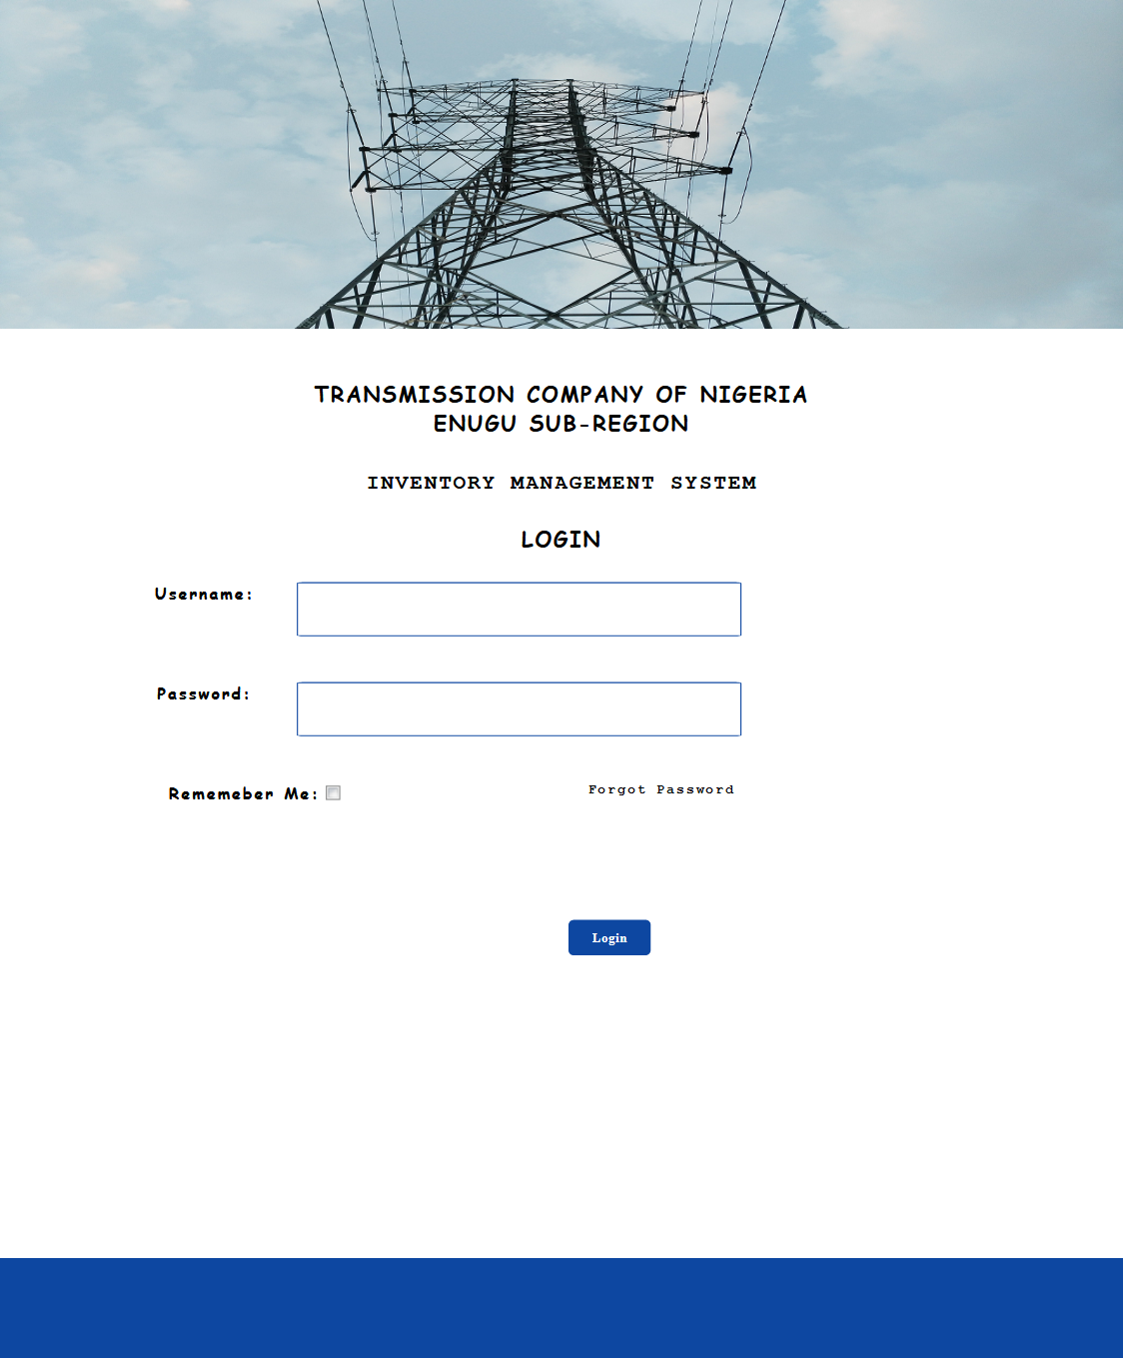

Fig 3.7 Login design form

Fig 3.7 is a display of the login form that is seen on the proposed system of the Transmission Company of Nigeria, Enugu Sub-Region. This will login both the Admin and users into the homepage of the system.

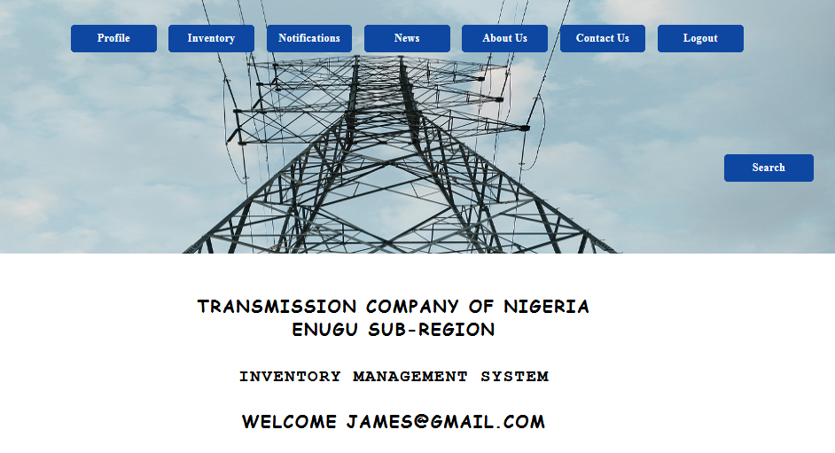

Fig 3.8a User Home Page design form

Fig 3.8a is the Home Page display of the proposed system which pops up once the users logs into the system. This comprises of the Profile, Inventory, Notifications, News, About us, Contact us, Logout and Search button on its menu bar.

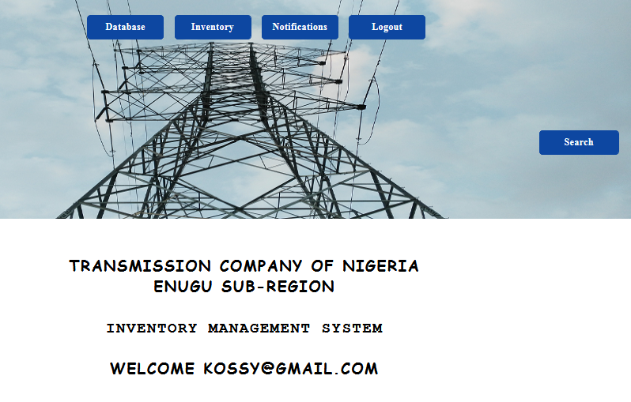

Fig 3.8b Admin home Page design form

Fig 3.8b is the Home Page display of the proposed system which pops up once the admin logs into the system. This comprises of the Database, Inventory, Notifications, Logout and Search button on its menu bar.



Fig 3.9 Search form

Fig 3.9 is a result form displaying a search result for the word “Helmet” made on the system.



Fig 3.10 Contact us form

Fig 3.10 above is the contact form where email and phone numbers to reach the inventory officers can be accessed on the Inventory Management System.



Fig 3.11 News form

Fig 3.11 shows the news platform from the where general information such as announcements is being posted on the system.

**Note:** News is for posting general information on the system and notifications is for alerting the Admin/Manager of items that need to be re-ordered.

**3.4.2 Process Design**

Step 1: start (Login to Transmission Company of Nig. Enugu Sub-Region Inventory Portal)

Step 2: If user = ICT Admin

* 1. Manage inputs/updates/reports/create profiles for users
  2. Go to step 5

Else

Step 3: if user = Store manager

3.1 View/Print/Email Inventory(Issues, Requisitions, Inventory status)

3.2 go to step 5

Else

Step 4: If user = Store keeper

* 1. View/Print/Email inventory(issues, requisitions, inventory status)

Step 5: stop(log out)

The ICT Administrator to this system is the only role that has full access to the entire stocking activities on the system; he/she can create, edit, update and delete any inventory, password, or stock from the system. After the Administrator must have created access roles for the Store Keepers (whose main job is to receive and send inventory reports on the inventory status) and the Store Manager (whose major role is to supervise the Store Keeper’s activities and manage the inventory of stocks received from the Store Keepers Inventory Status report, and then communicate with the Store Keepers), then all activities can effectively be managed and controlled via one Database which is hosted on the internet. Figure 3.12 above illustrates it all best.

**3.4.3 Output design**

In view of the system, the monitor will be used as the main output device, which will enhance a better view documents before producing the hard copies. The output documents will be the generated reports from the database which include the Inventory status report, stock receive advice document.

**TRANSMISSION COMPANY OF NIGERIA ENUGU SUB-REGION**

ALL ITEMS IN THE STORE

|  |  |  |  |  |
| --- | --- | --- | --- | --- |
| S/N | TITLE | QUANTITY | UNIT | CATEGORY |
|  |  |  |  |  |
|  |  |  |  |  |
|  |  |  |  |  |
|  |  |  |  |  |
|  |  |  |  |  |
|  |  |  |  |  |
|  |  |  | **EMAIL**  **PRINT** |  |

Fig 3.12: Inventory Status Report Design

Fig 3.12 shows the inventory status report which contains the status of all the inventory items in the store.

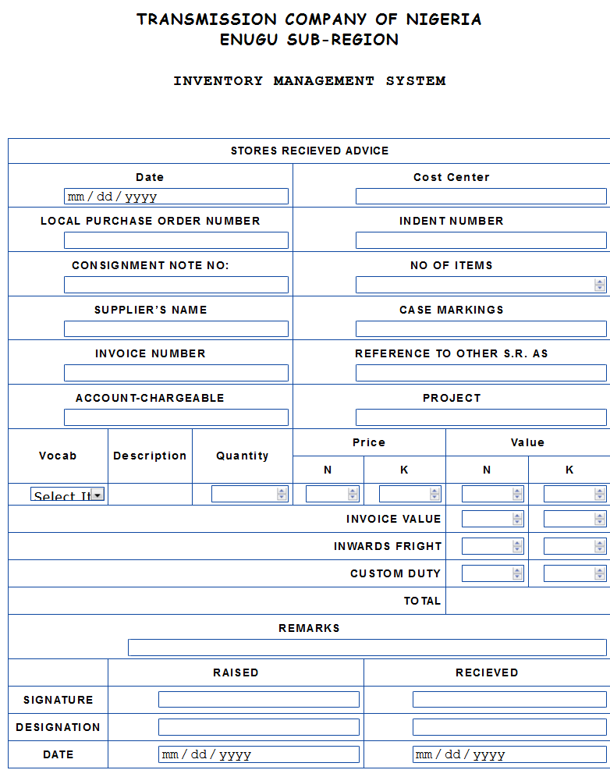

**EMAIL**

**PRINT**

Fig 3.13 The Store Received Advice Report design

Fig 3.13 shows the store received advice document which contains the particulars of items received into the system.

**ISSUE NOTE**

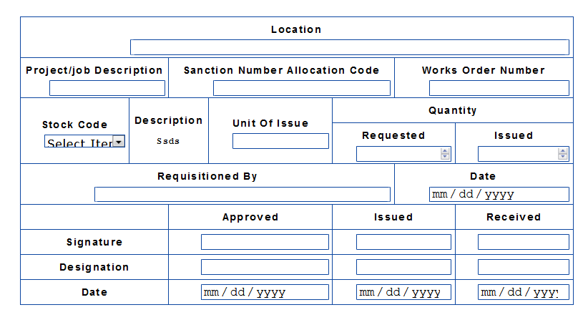

**EMAIL**

**PRINT**

Fig 3.14 The Issue Note Report design

Fig 3.14 shows the issue note document design which contains the particulars of items out of the system.